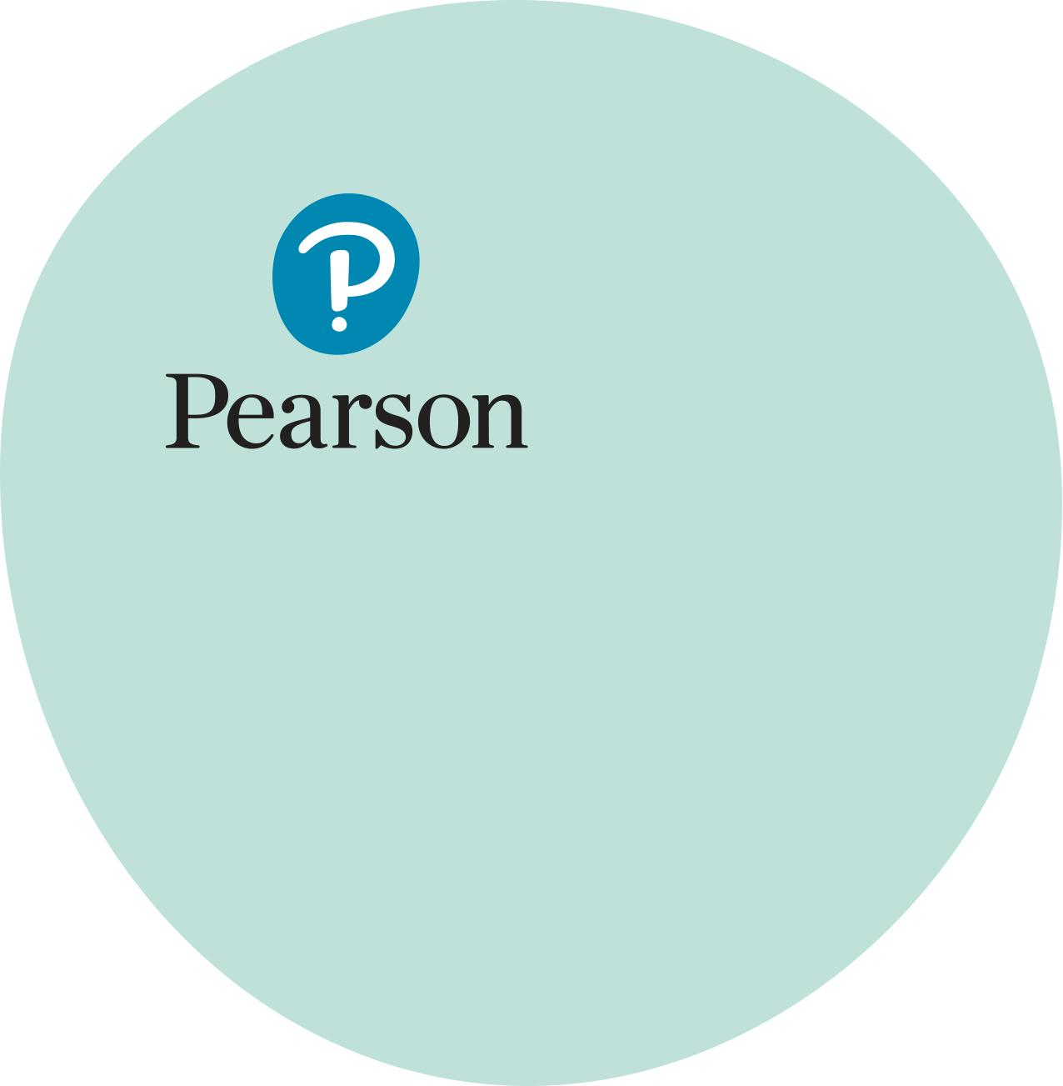

## BTEC Workskills and Personal Growth & Wellbeing

## SSV Internal Assessment Report

2023-24

Contents

Introduction 3

Qualification Update 5

Level 2 PGW unit commentary – Unit 4 Maintaining Sexual Health and wellbeing 7

Level 2 Workskills Unit commentary – Unit 14 Anticipating and Meeting Customer Needs and Expectations 10

Final thoughts 14

|  |
| --- |
| Introduction |
| Workskills  The BTEC Workskills qualification, fully redeveloped in 2021, was initially introduced by Pearson in 2010. This suite is available at various levels: Entry 1 and Entry 2 (Award: 45 GLH, Certificate: 120 GLH), Entry 3 (Subsidiary Award: 35 GLH, Award: 70 GLH, Extended Award: 105 GLH), and Levels 1 and 2 (Subsidiary Award: 35 GLH, Award: 70 GLH, Extended Award: 105 GLH, Certificate: 210 GLH). These qualifications were developed in consultation with employers and educational centres to meet their needs and those of learners to enable them to flourish in the workplace.  Offering different sizes of qualifications at each level provides centres with the flexibility to top up qualifications throughout a learner’s enrolment, a benefit utilised by many centres.  The purpose of these qualifications is to develop work-related skills, attitudes, and behaviours to support employability, providing opportunities for learners to practice workplace skills. They are comprehensive, flexible, and suitable for a wide range of learners, including those who are differently abled, NEET (not in education employment or training), home-schooled, in the justice system, adult learners returning to work, or those with other needs requiring the development of work-related skills for future employment.  The Workskills qualifications consist of optional units, allowing for the selection of units based on learner needs. These units focus on developing key work-related skills to help learners acquire and develop transferable skills for the workplace.  The qualification suite is assessed on a pass/fail basis, providing clarity for centres in recognising achievement and motivating learners. Upon completion, learners can progress to the next step in their journey.  To pass, learners must complete routine and directed tasks by applying the knowledge and skills gained during the teaching period. It is expected that learner’s complete tasks fully with some guidance, assessed in line with the assessment criteria and essential information for tutors.  The assessment criteria are designed to be evidenced through real-life (or simulated) workplace experiences or activities linked to employment. This approach adds relevance to activities, increasing motivation and reducing the opportunity for learners to present work that is not entirely their own.  Centres are encouraged to consider the distance from workplace ability as an indicator of the suitable level for their learners, rather than basing decisions solely on academic ability.  The qualifications include units that guide learners from self-reflection through recruitment to specific workplace skills, incorporating key digital competencies, resilience, teamwork, and problem-solving. They also support a broader practical understanding of equalities, health and safety legislation, and the concepts of enterprise and sustainability. Centres are encouraged to develop learning pathways using a selection of units that align with the progression goals of their cohorts.  Personal Growth and Wellbeing  The BTEC Personal Growth and Wellbeing qualification was introduced for teaching in 2020. This suite is available at Entry 3 and Level 1 (Subsidiary Award: 30 GLH, Award: 60 GLH, Certificate: 120 GLH, Extended Certificate: 210 GLH), and Level 2 (Subsidiary Award: 24 GLH, Award: 48 GLH, Certificate: 120 GLH, Extended Certificate: 192 GLH). In Wales, the qualification is also offered at Level 2 as an Award (72 GLH). These qualifications were developed in consultation with further education providers and centres to meet their needs and those of learners, while retaining the essence of the successful precursor Personal and Social Development Suite.  Offering different sizes of qualifications at each level provides centres with the flexibility to top up qualifications throughout a learner’s enrolment, a benefit utilised by many centres.  The purpose of these qualifications is to develop skills, attitudes, and behaviours to support responses to everyday life situations. Units 1-4 were developed in direct response to the statutory Relationships and Sex Education requirements in England and Wales. The qualifications are comprehensive, flexible, and suitable for a wide range of learners, including those who are differently abled, NEET (not in education, employment or training), home-schooled, in the justice system, adult learners, or those with other needs requiring the development of personal and transferable skills. The remaining units address wider personal development skills identified as core barriers to effective personal and workplace progression.  The Personal Growth and Wellbeing qualifications consist of optional units, allowing for the selection of units based on learner needs. These units focus on developing personal skills to help learners acquire and develop skills for life and living.  The qualification suite is assessed on a pass/fail basis, providing clarity for centres in recognising achievement and motivating learners. Upon completion, learners can progress to the next step in their journey.  To pass, learners must complete routine and directed tasks by applying their knowledge and skills. It is expected that learners’ complete tasks fully with some guidance, assessed in line with assessment criteria and essential information for tutors.  The units encourage a holistic approach to assessment, allowing centres to consider personalized projects that learners can undertake to evidence knowledge and skills through practical application and reflection.  Both qualification suites are discussed here as they are designed to work together to create learning programs that support progression. It is common for centres to run both qualifications simultaneously, mapping the learner journey through the selection of units from both qualifications. This approach recognises that barriers to successful workplace progression often stem from a strong foundation of both personal and employment-related skills. |
| Qualification Update |
| With research from LinkedIn suggesting that 75% of employers value soft skills as essential to effective employment the importance of a framework for the development of these skills remains highly valued. As a result both qualifications remain popular choices among centres aiming to support the personal and employability skills of learners. As detailed in the introduction, these qualifications have broad appeal, and the depth and range offered by the suite enable the personalisation of curricula to meet learner progression needs.  These principles build upon the success of the precursor 2017 Workskills qualifications and the Personal and Social Development Suite, which was replaced by Personal Growth and Wellbeing (PGW) in 2020.  Centres have now transitioned from the old suites as certification opportunities have lapsed. However, many have continued to use resources generated for the old qualifications as many are still adaptable to new opportunities, demonstrating their portability.  The old suites strongly encouraged unit combination and project-based approaches. Strong centres have maintained this ethos, selecting units that align directly with the stages learners need to progress through to achieve their goals. This learner first ethos creates much more buy-in from learners and produces better quality outcomes.  The core principles behind the qualifications remain closely linked to the essential skills sought by employers. For PGW, core social skills are combined with a broader understanding of the world, fostering the development of resilient citizens. The importance of these skills is highlighted in key policies for schools, colleges, and adult education providers, emphasising the need for resilience and the ability to respond to social, economic, and workplace challenges. While consultation is still underway on the PSEQ framework, the skills developed within these programs and the innovative, engaging delivery methods used by staff will enable learners to thrive and provide centres with a strong platform for supporting future cohorts.  The new qualifications differ from their precursors by allowing centres to assess learners on their own terms, demonstrating skills and knowledge that are meaningful to them. A common issue observed during standards verification last year was centres adopting overly prescriptive and limiting assessment approaches, which often curtailed learners’ options. This was frequently seen in an over-reliance on written rather than practical evidence. While workbooks can be useful assessment tools, they often limit learners by providing insufficient space for responses. For example, asking learners to evaluate a task with only five lines for a response is unlikely to elicit the necessary depth.  In a large proportion of cases where support was required following standards verification centres have often not supported learners to explore higher order command verbs such as analyse, explain or evaluate. These command verbs appear often when reflection is necessary on knowledge-based aspects of units or following practical activity**,** particularly at Level 2. To effectively meet the verb learners should detail the relevance of the content to the employability skill or be able to recognise strengths or weaknesses in their own performance. This recognition should then flow into a justification or validation of these opinions utilising examples, before drawing a conclusion on their impacts. The depth of responses here will of course be determined by the level of qualification the learner is completing but the elements will be indicative of whether the higher order verbs have been met.  In most cases where standards verification outcomes were not straightforward DCS(direct claim status), the problems stemmed from the design of the assessment instruments. Mistakes often included asking learners to provide fewer examples than required by the guidance for assessors. Centres are encouraged to develop assessments with close attention to the guidance for assessors and to share them early with their Standards Verifier to address issues before sampling takes place.  As detailed earlier, best practice within centres involves considering the progression needs of their learners and selecting units that closely match these needs. This approach adds genuine relevance to assessments, motivating learners to complete them. For example, a provider seeking to re-engage NEET young people or progress individuals into particular job roles as part of a sector-based work academy could choose to combine elements of Workskills, PGW and vocational unit**s** from a Level 1 graded qualification. In this way learners will be motivated to develop skills needed for workplace readiness, often involving a combination of social skills, employability skills, and the opportunity to contextualize Maths and English. Such a program could program could include:  *Level 1 Award in Workskills*   * + *10 Using technology in the workplace*   + *14 Meeting customer needs*   *BTEC Level 1 Award in Personal Growth and Wellbeing*   * + *Respecting Rights and Responsibilities*   + *Developing Resilient Behaviour*   *BTEC Level 1 Introductory Award in Business*   * + *Developing a Personal Progression Plan*   + *Developing Routine Office Administration Skills*     *Functional Skills Maths and or English* |
| Level 2 PGW unit commentary – Unit 4 Maintaining Sexual Health and wellbeing |
| With rising media coverage of increased risks of sexually transmitted diseases in younger populations, coupled with high profile storylines in soaps covering boundaries and consensual relationships centres have been drawn to deliver this unit as a framework for discussions that may feel uncomfortable for some staff to deliver without guidance and boundaries.  The unit investigates both topic areas and in common with many in the PGW seeks to ground assessment in lived experiences were possible, whilst offering scope for the use of case studies where learners are not yet at that level of personal experience.  Unit teaching encourages understanding of personal intimate relationships and defines the characteristics of relationship types, before exploring concepts of expectations and boundaries within those relationships. Centres are encouraged to work with external agencies to support this topic area with case studies to offer lived experiences of the impacts of positive and negative relationships.  Sexual health and wellbeing is then considered, again often supported by external agencies such as NHS partners and local charities who can provide a wealth of resources as part of their preventative health agendas, before the unit culminates in exploration of ways to stay safe within intimate relationships.  Assessment canbe focused upon learners’ own experiences and reflections, however if centres are working in environments were doing so may have a negative impact on learner wellbeing or if learners have not yet had lived experience this can be scenario based. Many centres take a holistic view of this unit and prompt learners to consider two scenarios and situations and then match the assessment activities to these scenarios. Centres should consider whether a holistic approach is possible for their learners as it does present a situation where more evidence is produced for B.P2 than is required, however this often generates sufficient depth of response to meet the full ’explain’ command verb.  On a simpler criterion by criterion level A.P1 asks for learners to discuss the features of intimate relationships and the impact that these have on wellbeing. The guidance for assessors expanding this to describe the characteristics of an intimate relationship before focusing on one example and describing its impact on personal wellbeing.    In the example here you can see that the learner has been given limited space to respond to the criterion and whilst there is an outline of what an intimate relationship is and an identification of its features it falls short of a full description as would be expected of a level 2 learner. The expectation on a minimum level would be for each of the features to be expanded so that the assessor could determine for example what is a ‘deep connection’ as opposed to a connection within a non-intimate relationship and is able to understand what the shared responsibility is inthe context of intimate relationships.  The centre in question here has chosen to break the criterion down across a number of tasks within a workbook, although this approach is not encouraged in many BTEC’s**,** within PGW it is acceptable particularly due to the broad nature of the criterion.    Whilst the task does effectively guide the learner to cover the criterion in full the response is brief and only touches on themes without expansion for example getting praised (sic) should be discussed in context of improved self-confidence.  For B.P2 learners are to be tasked with explaining at least two potential risks that intimate relationships may pose on personal wellbeing which should be expanded in line with the guidance to incorporate detailed examples and how to avoid the risks.    In this example the centre has left space where a learner could potentially meet these demands and has requested three risks (a third is not shown) but has asked the learners to only list risks and not requested that this be expanded. To meet the full explain criterion it would be expected, **(**to use one of the learners’ examples) that in the case of sexually transmitted disease that the learner discusses what the risk is, why it is a risk to physical health and the potential likelihood going on to detail the steps that could be taken to avoid it, e.g. the use of barrier methods. |
| Level 2 Workskills Unit commentary – Unit 14 Anticipating and Meeting Customer Needs and Expectations |
| As Workskills remains a core qualification for demonstrating employability skills to employers, units like Unit 14: Anticipating and Meeting Customer Needs and Expectations are becoming increasingly popular. This unit, which focuses on essential customer service skills, is crucial across many employment sectors and is often a key component of a potential employee’s toolkit.  Additionally, this unit is frequently used with ESOL learners or those undertaking learning packages that include Functional Skills in English, as it provides work-related opportunities to showcase key English competencies.  Like all Workskills units, the content details includecore skills that learners need to develop, including recognizing customer needs and expectations and understanding the importance of these skills.  The unit also prepares learners for a range of potential scenarios. While none of the content is mandatory, it is good practice to prepare learners for as many scenarios as they are likely to face in their next career or learningsteps. These scenarios should be tailored to the learners’ level of understanding. For example, if learners are preparing for retail placements in a supermarket, use examples from that environment. If the unit is used in a school setting with 14-year-olds, choose products they are likely to use themselves.  Learners should then be exposed to the core skills necessary to be effective in a customer service environment. Whilst it is possible to describe these more practical teaching methods using demonstrations, video, animation etc. followed by role play activity are most effective.  As with all Workskills units**,** assessment in LearningAim A allows learners to demonstrate understanding, whilst Learning Aim B focuses assessment on practical demonstration of skills.  For Learning Aim A the two criteria utilise the command verb ‘explain’**. t**o meet this is you would expect to see adefinition, followed by a discussion of the importance or relevance and then some examples based upon scenarios provided.  For A.P1 learners should be provided with a range of scenarios, a range being more than 2 and for each scenario offer explanations (including the what and the why) of a customer’s likely needs and expectations in the scenario.  The example shown here is one of three scenarios set by the centre.    The learner response, (although concise) does cover a basic explanation of what and why.    For the same scenarios learners must be able to offer an explanation of the skills knowledge and behaviours that would be expected of an employee dealing with each scenario.    Again in this situation the learner demonstrates a concise answer detailing key points with justification.  Learning Aim B must be assessed using practical means, either through role play, as will be seen here, or within a workplace environment. The nature of this role play can meet a range ofdiverse needs for example if learners are non-verbal**,** a simulated webchat would be suitable**.** For learners who lack confidence a telephone-based role play may reduce anxieties. As customer service activity is delivered in a range of ways there is considerable flexibility in the form this activity could take. The activity must however be ‘live’ so an entirely written communication in the form of response to a complaint letter would not enable learners to address B.P3. This criterion requires communication to establish the needs and expectations of the customer. Entirely letter / e-mail-based communication would make it very difficult to be seen to establish these needs and expectations ahead of response.  Learning Aim B seeks for effective demonstration of customer service skills to meet B.P3 and B.P4. These criteria must be assessed together in a single activity. This interaction should be recorded through video / audio or text transcript and accompanied by a detailed observation record that offers clear line of sight within the narrative that details how learners have met the detail, expressed within the guidance for assessors, to demonstrate achievement of the criterion. The exemplar detail below was accompanied by an audio recording.      These transcripts which feature across 3 scenarios offer suitable detail as required. |
| Support Materials |
| [BTEC Level 2 Workskills Standardisation Materials 2023 Unit 2 (pearson.com)](https://qualifications.pearson.com/content/dam/pdf/WorkSkills/Level-2/2021/btec-level-2-workskills-standardisation-materials-unit-2-2023.pdf)  [BTEC Workskills 2023 Standardisation Materials Level 2 Unit 2 SSV Overview (pearson.com)](https://qualifications.pearson.com/content/dam/pdf/WorkSkills/Level-2/2021/btec-workskills-standardisation-materials-2023-ssv-overview.pdf)  [BTEC Workskills Level 2 unit 2 Sample Learner Work Learner 1 (pearson.com)](https://qualifications.pearson.com/content/dam/pdf/WorkSkills/Level-2/2021/SampleLearnerWork/sample-learner-work-level-2-unit-2-workskills.pdf)  [BTEC Workskills Level 2 unit 4 Sample Learner Work (pearson.com)](https://qualifications.pearson.com/content/dam/pdf/WorkSkills/Level-2/2021/SampleLearnerWork/sample-learner-work-level-2-unit-4-workskills.pdf)  [BTEC Workskills Level 2 unit 7 Sample Learner Work (pearson.com)](https://qualifications.pearson.com/content/dam/pdf/WorkSkills/Level-2/2021/SampleLearnerWork/sample-learner-work-level-2-unit-7-workskills.pdf)  [BTEC Workskills Level 1 unit 2 Sample Learner Work (pearson.com)](https://qualifications.pearson.com/content/dam/pdf/WorkSkills/Level-1/2021/Samplelearnerwork/sample-learner-work-level-1-unit-2-workskills.pdf)  [BTEC Workskills Level 1 unit 16 Sample Learner Work (pearson.com)](https://qualifications.pearson.com/content/dam/pdf/WorkSkills/Level-1/2021/Samplelearnerwork/sample-learner-work-level-1-workskills-unit-16.pdf)  [BTEC Workskills Entry 3 Unit 1 Sample Learner Work (pearson.com)](https://qualifications.pearson.com/content/dam/pdf/WorkSkills/Entry-Level-3/2021/Samplelearnerwork/sample-learner-work-entry-3-unit-1-workskills.pdf)  [Pearson Centre Resources for BTEC Personal Growth and Wellbeing - Level 2 - Unit 4](https://qualifications.pearson.com/content/dam/pdf/btec-entry-level-and-level-1-introductory/personal-growth-and-wellbeing-level-2/2020/teaching-and-learning-materials/pgw-level-2-unit-4-centre-resource-guide-mapped-to-rse.pdf) |
| Final thoughts In today’s rapidly evolving employment landscape, where the impact of personal health and  wellbeing on workplace performance is under more scrutiny than ever, it is imperative that we  equip our current and future workforce to face these challenges head-on.  By leveraging qualifications like Personal Growth and Wellbeing and Workskills, we liberate our delivery and assessment staff from the arduous task of identifying the most effective skill combinations and their components.  This freedom empowers teachers, trainers, and assessors to delve into innovative pedagogies that  truly motivate and inspire their learners.  This qualification suite is not just a tool for building resilience; it stands as a robust, standalone  vehicle designed to fortify our learners. Moreover, it seamlessly integrates with other programs,  enhancing the positive progression opportunities for learners of all ages and abilities. |