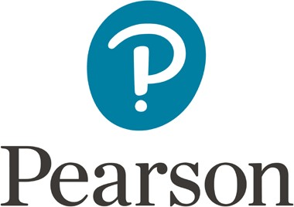

P303 - Project Proposal form

|  |  |
| --- | --- |
| **Learner Name** | **Learner number** |
| **Centre Name** | **Centre Number** |
| **Teacher Assessor** | **Date** |
| **Unit** | **P303** |
| **Proposed project title** | |

|  |
| --- |
| Section One: Title, objectives, responsibilities |
| Title or working title of project (in the form of a question, commission or design brief):  Project objectives (eg, what is the question you want to answer? What do you want to learn how to do? What do you want to find out?)  If it is a group project, what will your role or responsibilities be? |

|  |
| --- |
| Section Two: Reasons for choosing this project |
| Reasons for choosing the project (eg links to other subjects you are studying, personal interest, future plans, knowledge/skills you want to improve): |

|  |  |
| --- | --- |
| Section Three: Activities and timescales | |
| Activities to be carried out during the project (rehearsal techniques, production meetings and administration etc.) | How long this will take? |
| Milestone one:  Target date (set by tutor-assessor): Milestone two:  Target date (set by tutor-assessor): | |

|  |  |
| --- | --- |
| Section Four: Resources | |
| What resources will you need and what will you use them for? (eg libraries and research, rehearsal space, technology and equipment, venue etc.) | |
| Section Five: Contingencies | |
| What problems might you have? | What will you do if this does happen? |

|  |
| --- |
| Comments and agreement from tutor-assessor |
| Comments (optional):  I confirm that the project is appropriate.  Agreed: (name) (date) |
| Comments and agreement from proposal checker |
| Comments (optional):  I confirm that the project is appropriate.  Agreed: (name) (date) |