
Feedback for Centres

International GCSE
Greek (First Language) (9-1) Paper 2: Writing
4GK1_02

Question 1 Feedback

Overview
Question 1 was a letter of complaint about a trip that went wrong. Many candidates successfully provided pertinent details without unnecessary and long-winded explanations about the trip, highlighting the problems encountered and requesting either a refund or a discount on future trips. Successful essays adopted a formal tone, gave a balanced account of the trip, and provided ample justification about the compensation requested.
Common errors included a tendency to provide long preambles about preparation for the trip, or lingering on content that would not normally be included in such a letter. Another pattern concerned a tendency to over-emphasise the positive aspects of the trip, so that when, finally, the negative aspects were mentioned they did not follow naturally from the previous information and the essay seemed both disjointed and unconvincing. Others cited problems for which the travel agency could not be responsible, such as bad weather, flight delays, unfriendly customs officials, lost luggage, polluted beaches, unfriendly natives or accidents. Finally, some requests for compensation were framed as polite requests and seemed too feeble and unconvincing, given that this was supposed to be a letter of complaint.

Example 1
Communication and Content: 7
Application and Accuracy of Language: 6
Total marks: 13
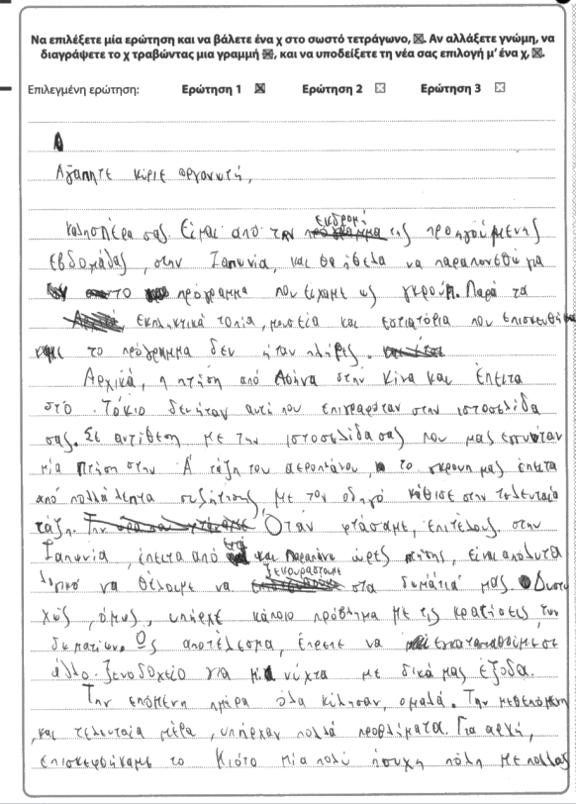

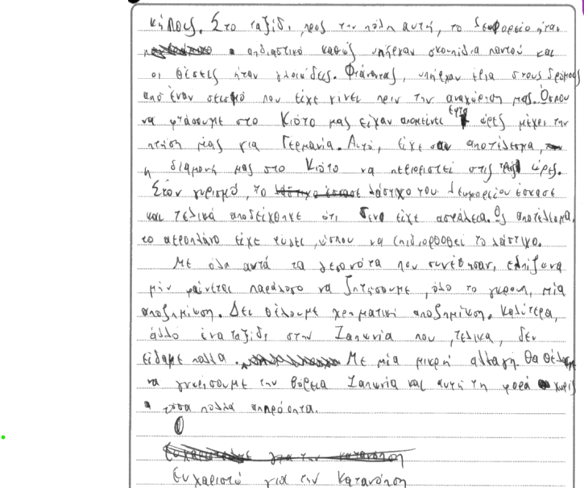

This is a representative response that is only partially successful in fulfilling the requirements for this question. The candidate makes a range of relevant points which are not developed appropriately and often result in non-sequiturs and ambiguity. For a letter of complaint to be successful, it needs to be rooted in realistic situations and pragmatics that do not challenge the feasibility of the events described or the suspension of disbelief. In terms of language, fluency without accuracy and efficient organisation of the material is not adequate for achieving marks from the higher bands in an examination that assesses first language competences.
Clearly a three-day excursion from Greece to Japan is already a concept which evokes disbelief (in reality, the flight alone is more than 16 hours). The candidate employs a register which is at times successful and at times too conversational for the genre in question. Language is generally appropriate to the task and a range of suitable vocabulary is employed, but with some intrusive errors in expression, syntax, choice of vocabulary and spelling. Infelicities such as: Α’ τάξη instead of θέση, οδηγό instead of πιλότο, γλοιώδεις instead of βρώμικες, to mention but a few, often detract from the appropriacy of the language and clumsiness in expression takes away from the persuasiveness of the piece as a whole.

Example 2
Communication and Content: 12
Application and Accuracy of Language: 9
Total marks: 21

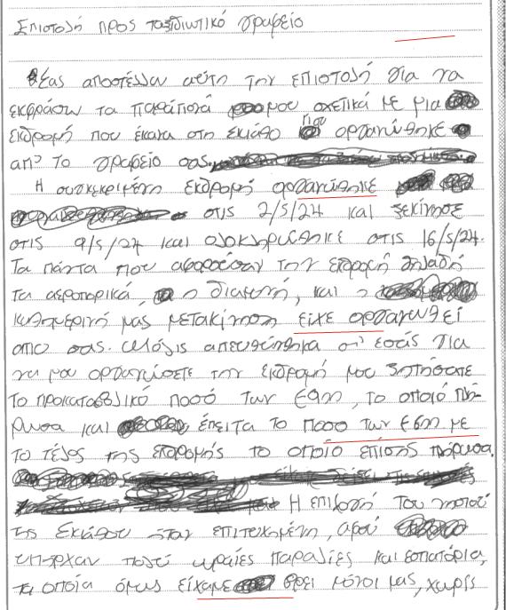
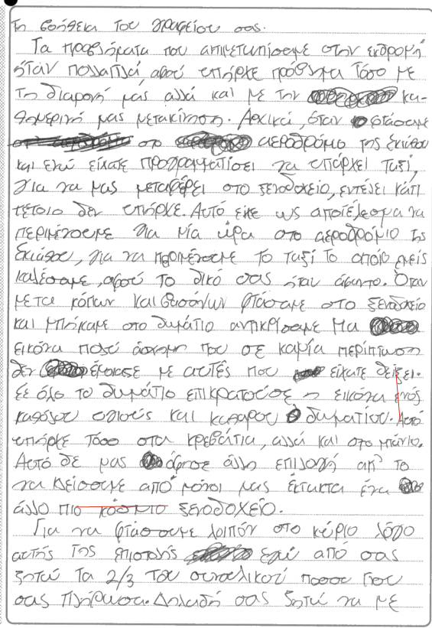
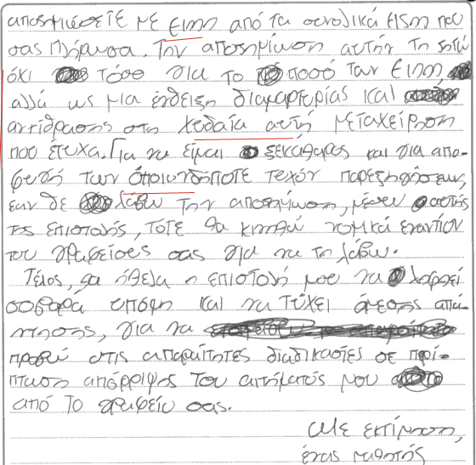

This is a good response that earned marks from the top tiers of the assessment criteria. There were several positive aspects to this essay: effective and clear explanation of the things that went wrong, which seemed plausible; good organisation of description and narration using paragraphs with mostly smooth transitions; a strong closing paragraph; an awareness of audience and purpose sustained often, albeit with some infelicities in expression, for example “χυδαία μεταχείρηση”; collocations that did not entirely work, for example “εικόνα υγιούς δωματίου”; the omission of the addressee at the beginning of the letter or email; the omission of a signature (it should not be a real name, but it should be a name, nevertheless); some ambiguity regarding the time line and the significance of distinguishing between when the trip was organised and when it took place (for example, why was this important to mention and what does it mean in actual terms, what did it add to the overall argument?); some clumsiness in vocabulary, “είχε σαν αποτέλεσμα να περιμένουμε…για να περιμένουμε” .There was also an instance of implausibility when there was mention that the last part of the payment was sent after the trip was concluded. This would lead us to believe that since the trip went so terribly wrong, this payment could have been withheld, instead of forwarded and then followed by a letter and a request for a refund. Another area where the reader’s disbelief was not suspended was when the request for a refund was cited as 2/3 of the total cost. This seemed like an arbitrary number, as there was no explanation regarding why this percentage was chosen. These details detracted from both the subtlety and the sharp focus of the piece and prevented an evidently very able candidate from earning marks from the 13-15 band for content.

Example 3
Communication and Content: 9
Application and Accuracy of Language:7
Total marks: 16

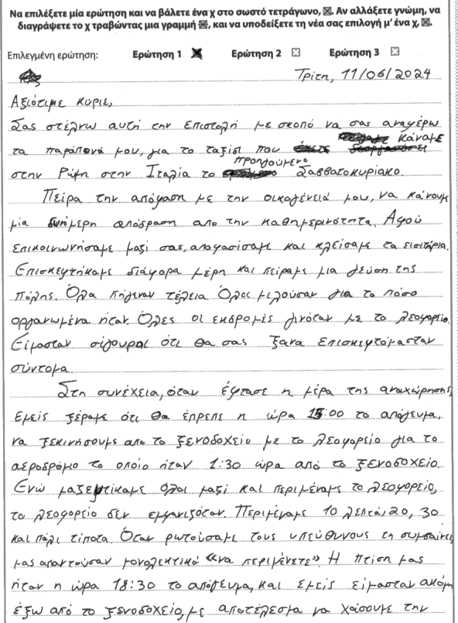

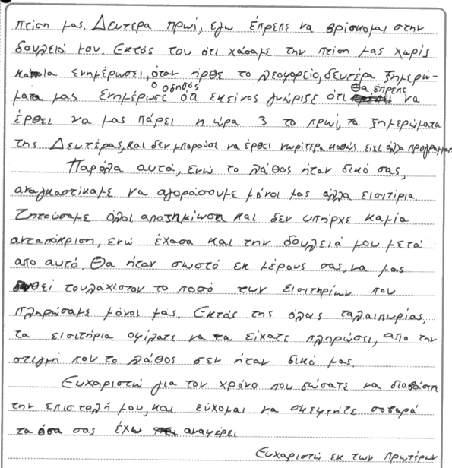

The essay succeeds in communicating clearly and makes a relevant point regarding the issue faced and the request for reimbursement. The response is clear, and the register and tone are clearly focused on the purpose and intended reader. There is evidence of linking the piece in a cohesive way with some breakdown in the long paragraph that enumerated the challenges with transportation. At the same time, the response lacks the subtlety and sophistication needed for gaining marks from the higher band for content and communication. The response does not contain enough variety and interest and the paragraph about all the wonderful things that happened throughout the excursion does not transition well into the narrative about the misunderstanding about transportation that followed. For example, the phrase employed “Στη συνέχεια”, which signals the shift to the main part of the essay does not fit the tone that follows and a phrase that introduces a transition from the positive to the negative could have been a better fit: for example, Δυστυχώς όμως οι θετικές μας εντυπώσεις δεν κράτησαν πολύ … or something to that effect. The request for a refund lacks the emphatic tone that would be expected on this occasion and the claim about having lost one’s job because of the delay hangs in the air without adequate explanation, on plausibility. Regarding language, intrusive errors in the spelling of grammatical inflections or high frequency vocabulary and a tendency to shy away from complex structures and lexis, contributed to the candidate not earning marks from the top band for language.

Question 2 Feedback

Overview

Question 2 invited a critical discursive essay whose aim was to inform the readers of the key arguments about online remote learning, by identifying the pros and cons, evaluating facts and providing a critical interpretation of the various issues involved. The fact that this piece was meant to be an article required that the candidates avoid bias or judgmental statements, employ structural characteristics such as a title, introduction to the topic, evidence of background research or knowledge, which could be experiential, and a balanced exploration of the issue with enough variety, interest, sophistication and originality to engage and inform the readers. A good response examined the topic of remote learning methodically, providing context and illustrating the circumstances that gave rise and necessitated its adoption as an educational practice, for example issues of accessibility to schools, health factors, cost saving etc.
In terms of structure, a successful response presented a different point in each paragraph, identifying benefits and drawbacks, without resorting to scaremongering and exaggerations, but instead with a neutral and informative tone. The conclusion wrapped everything up without introducing new arguments with content consistent with the information and the arguments presented earlier. Even though explanation was a small part of this response, the essay invited examination of issues beyond step-by-step, and often unnecessarily lengthy, explanations of how people participate in remote learning by downloading zoom, switching on a computer, connecting to the internet and muting or unmuting their microphones. Unfortunately, such explanation often formed a lengthy introduction and detracted from the required focus of the article.
Those who approached it solely from the perspective of personal experience failed to capture the purpose of an article and adopted a narrative tone that was not entirely fit for purpose. In addition, the small number of candidates who misunderstood online remote learning as learning with emerging technologies in a traditional face to face environment failed to earn marks. When there is no content worthy of credit, there are no marks for language either.

Example 1
Communication and Content: 0
Application and Accuracy of Language: 0
Total marks: 0

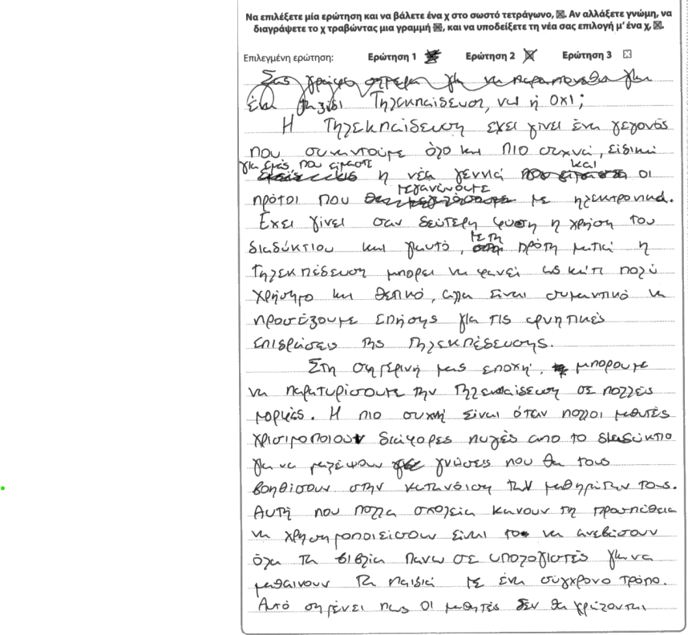
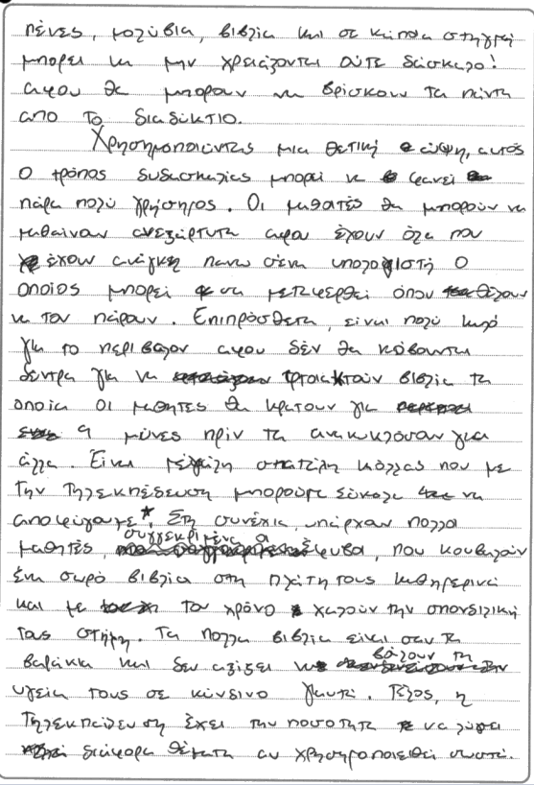
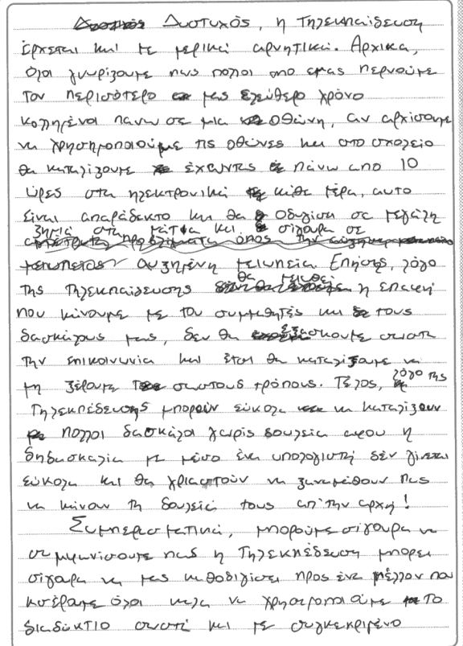
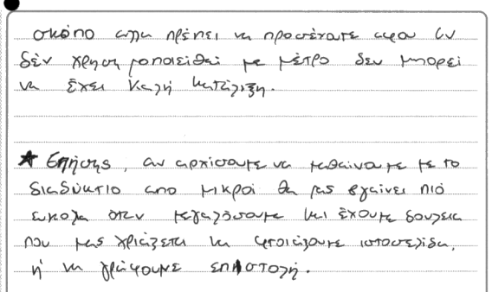

This is a question that did not receive any marks because it was considered to be off topic. Across languages, essays that do not merit any marks for content, do not gain any marks for language. This is not a negotiable point and arguing otherwise would give rise to malpractice and the disadvantaging of able and well-prepared candidates. The primary focus of assessment in this paper is on responding to the task at hand and demonstrating understanding of the topic that is posed in the question. Language skills alone cannot and will not compensate for not answering the question. Arguing otherwise, would allow any candidate to present pre-learnt material as response to any question and would compromise the standards of essay writing.
In this essay the candidate clearly misunderstands the concept of ‘remote learning’ and argues along the wrong lines consistently. If an occasional relevant sentence emerges, it is not because the candidate intends it to be an argument for or against what we understand as τηλεκπαίδευση but as an argument about the uses and misuses of technology. Relevance must be intended and cannot be up to the examiner to strive for interpretation of what is offered, in other words, to extract relevance. As this is GCSE as first language, the expectations are exactly what we’d anticipate a native speaker of Greek in a Greek/Cypriot high school that has Greek as a primary medium of instruction to produce.

Example 2
Communication and Content: 13
Application and Accuracy of Language: 9
Total marks: 22

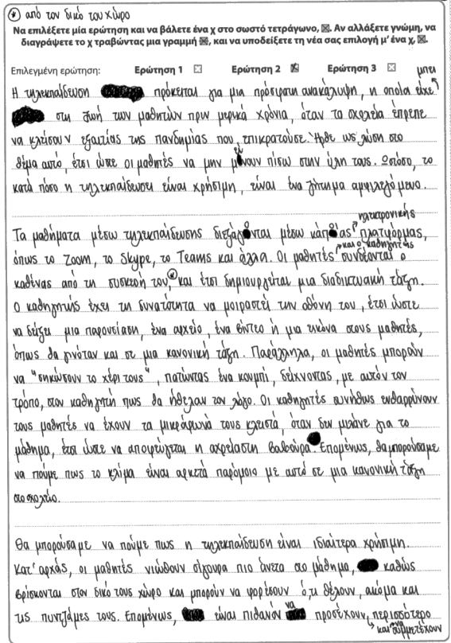
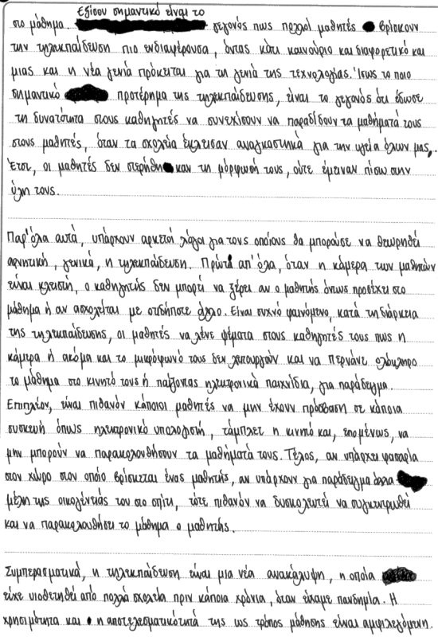

This is a fluent and relevant response, sharply focused on the purpose and intended reader, well linked and organised in paragraphs that address a different point each. The response is mostly marked by sophisticated and well-articulated arguments. The opening introduces the topic in a succinct and direct way, establishing the main question, while also veering away from platitudes and basic descriptions of what remote learning is. The second paragraph gives an overview of how the remote learning platforms work and even though the information presented is expressed well and without superfluous detail, the focus is restricted to the widely known mechanics of the process (e.g. shared screens and muted microphones) and does not expand to address the ways in which online remote learning in the post-pandemic era has adapted to include hybrid forms of learning. The paragraphs that follow present the pros and cons of remote learning clearly and, often, eloquently and persuasively. The conclusion emphasises facts, it is neutral, confident and follows naturally from what has been presented earlier, without exaggerated statements. It is in a register that has remained faithful to the genre, an article, and has not slipped into conversational Greek or vocabulary that is incompatible with the overall tone of an article. What distinguishes this article is its seriousness and its precise and respectful tone. The absence of a title and the handling of the topic only within the context of the pandemic were minor aberrations in an otherwise excellent response.
In terms of application and accuracy of language, this was a well-organised and unambiguous response that employed suitable vocabulary and avoided verbosity. Spelling was consistently accurate and barring occasional clumsy uses of linguistic structures, this was a confident and fluent essay.

Example 3
Communication and Content: 7
Application and Accuracy of Language: 6
Total marks: 13

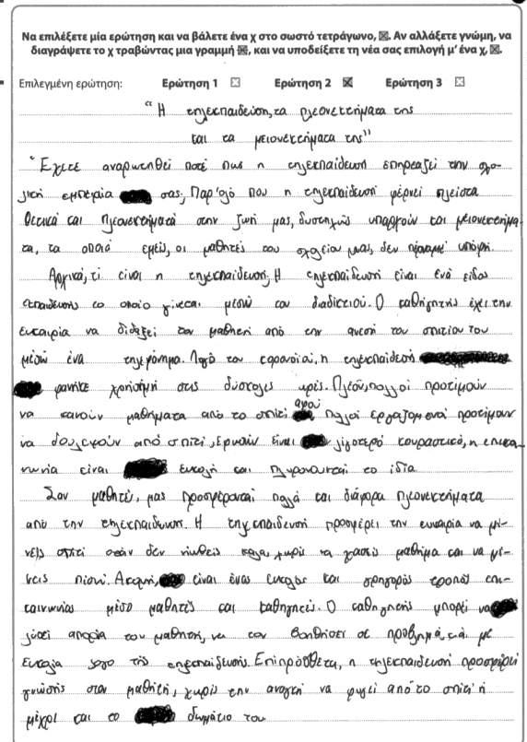
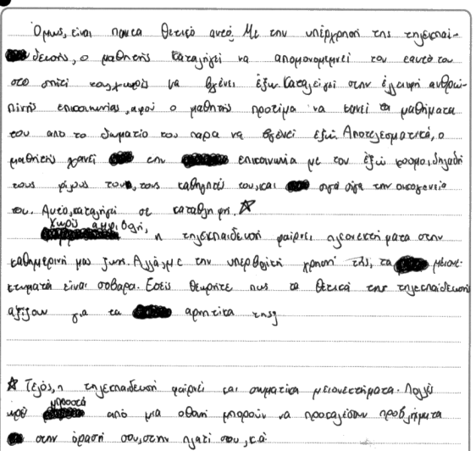

There are positive aspects to this response. The title is apt, the essay is organised in paragraphs, there is evidence of understanding what online remote learning is, and the introduction poses with succinctness the main question that the candidate proceeds to attempt to answer.
Some of the arguments that identify the benefits are a little feeble and not specific to online remote learning. For example, there is no adequate or convincing explanation as to why this medium lends itself to a more effective communication between teacher and students and why it leads to better understanding of the material. In addition, in the penultimate paragraph, long distance learning is presented as a choice, which is not accurate, within the context of the candidate’s argument which refers to the pandemic. One of the caveats against it, refers to abuse or overuse, but again there is no development regarding the contexts within which such abuse would take place and what the alternatives would be (for example, hybrid delivery). Overall, the arguments for and against are rather narrow and one- dimensional, without enough range or development. The conclusion is not really appropriate for an article as it ends by posing the kind of question one would pose in a speech or a conversational piece.
The language, although fluent in places, suffers from awkwardness in expression, with some unsuccessful collocations and choice of word (for example, αποτελεσματικά, τα θετικά αξίζουν για τα αρνητικά,), intrusive spelling errors (λόγο, θεωρήτε), grammatical errors (μέσω ένα τηλεφώνημα, μέσο μαθητές και καθηγητές) and consistent misapplication of the position of the stress.

Question 3 Feedback

Overview

Question 3 required a speech to the school audience on the topic of environmental dangers that affect the local environment. Candidates were encouraged to examine the impact of these problems and suggest possible solutions. This was the question where performance was more successful than in any other question. Clearly, candidates had been well trained and were in possession of specialist vocabulary that allowed them to expand on various environmental issues using apt terminology.
Many candidates wrote motivational speeches that adopted an interactive approach and posed well-articulated questions to the audience appealing to reason, emotion and a sense of responsibility to rouse people to action.
Certain patterns of not so successful performance were identified in cases where the essays focused on global environmental issues and provided no distinguishing detail with regard to a local environment, local issues and local solutions. Another area that was of concern was a hyperbolic approach that used vocabulary and examples that turned a crisis into a drama that was not always grounded in reality or realistic examples.

Example 1
Communication and Content: 6
Application and Accuracy of Language: 6
Total marks: 12

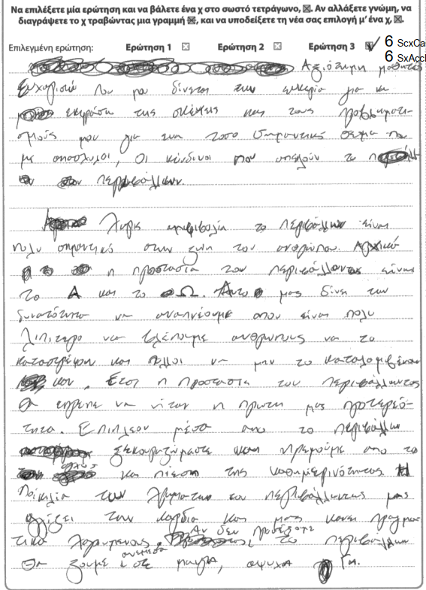
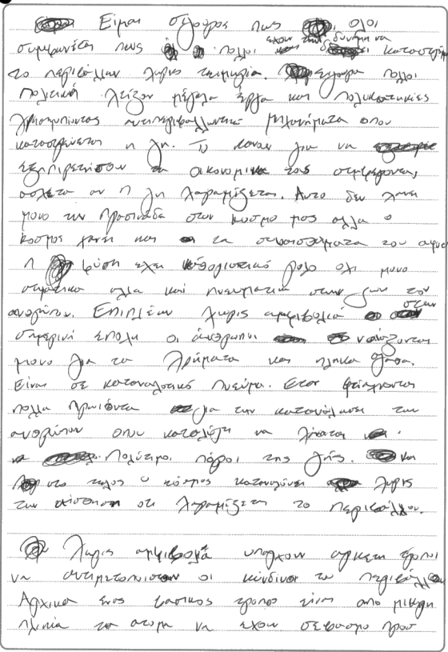

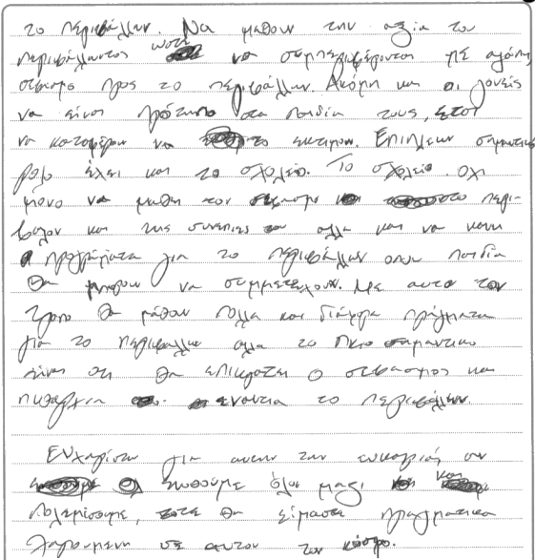

Communication in this essay is generally clear and the task is generally focused on the intended audience. There is some very broad relevance to the descriptions and arguments offered and there is evidence of ability to structure the response in its constituent parts, an introduction, a main argument and an epilogue. These attributes aside, the response is marked by focus which is too general for the specific requirements of the question. The candidate approaches the topic in a conceptual manner which lacks the attention to place-specific environmental issues and local solutions. The main argument on pages 4-6 is constructed is a hasty manner, both in terms of the quality of the argument and the actual writing which is often indecipherable, without attention to expression, limited range of topic-specific vocabulary and cohesive devices that make the transitions work effectively. There are intrusive errors in spelling (including the word περιβάλλων (sic), inconsistent indication of the position of the stress, and a noticeable clumsiness in expression: for example, Η γη χαραμίζεται, χάνει την πρασινάδα στον κόσμο, όπου καταλύγη να χάνονται, χαραμίζεται το περιβάλλον (p.5) , …το σεβασμό στο περιβάλλον και της συνέπιες του…, … σεβασμός και πυθαρχία ενάντια το περιβάλλον (p.6) etc.

Example 2
Communication and Content: 12
Application and Accuracy of Language: 7
Total: 19

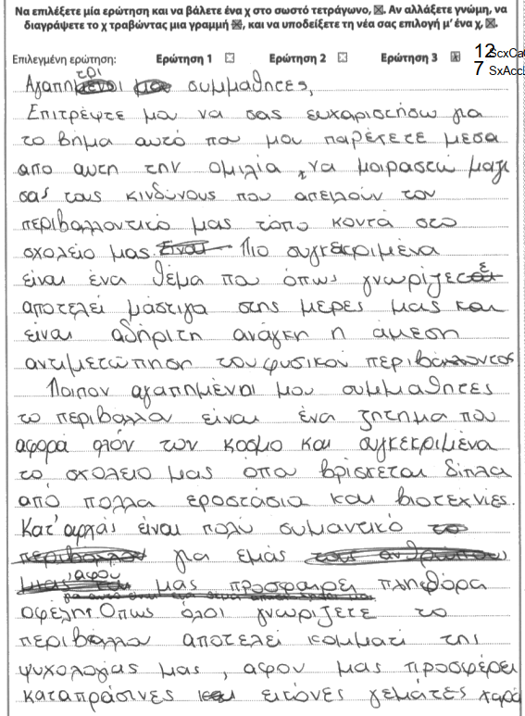
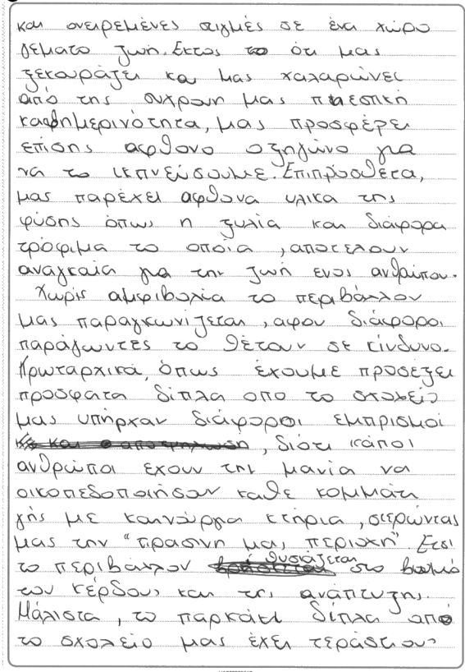
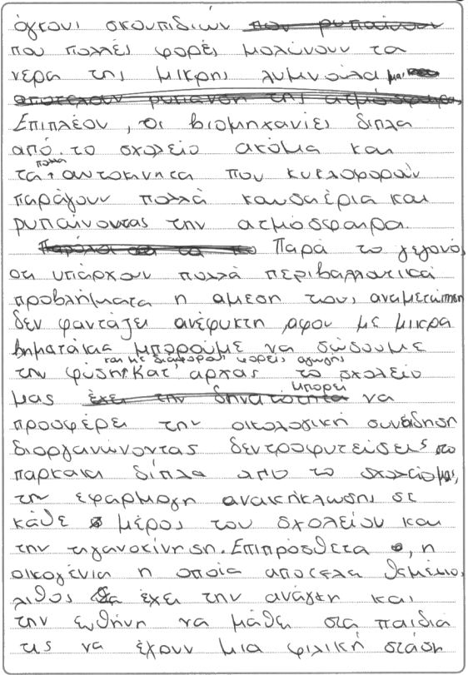
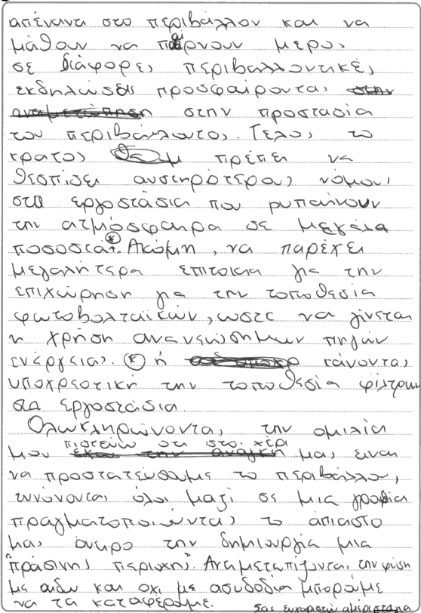

The response communicates a range of relevant points effectively. The piece is well linked using a range of structural techniques. Task is securely focused on the purpose and intended reader.
The essay introduces the topic purposefully, albeit with some awkwardness in expression; for example, … απειλούν τον περιβαλλοντικό μας τόπο.
Τhe main part of the essay focuses on local environmental problems, offering a range of examples that affect the community, such as the pollution from neighbouring factories and the fires that aim to turn green areas into building sites. The candidate maintains an engaging and direct rapport with their peers, even though language often works against the argument, containing frequent spelling errors, grammatical errors, wrong use of vocabulary, as well as expressions that are not fit for the purpose of this task: for example, πληθόρα οφέλη, καταπράσινες εικόνες γεμάτες χαρά (p.4), οξηγώνο για να το εκπνεύσουμε, το περιβάλλον παραγκωνίζεται (p.5), όγκονι σκουπιδιών, έχει την ανάγκη και την ευθύνη (p.6), εννόνοντας όλοι μαζί σε μία γροθιά (p.7), etc. The solutions put forward consider local resources and action plans, such as tree planting near the school and fall within the intended framework of the question.

Example 3
Communication and Content: 14
Application and Accuracy of Language: 9
Total: 23

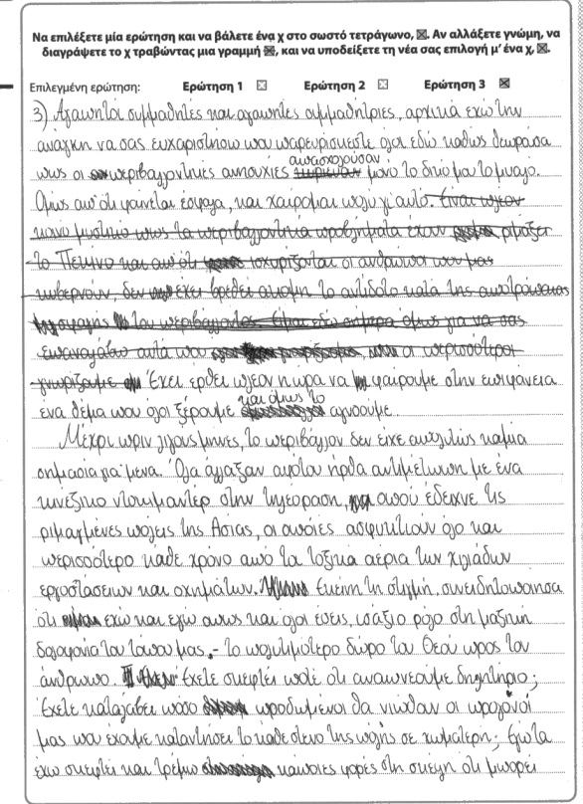
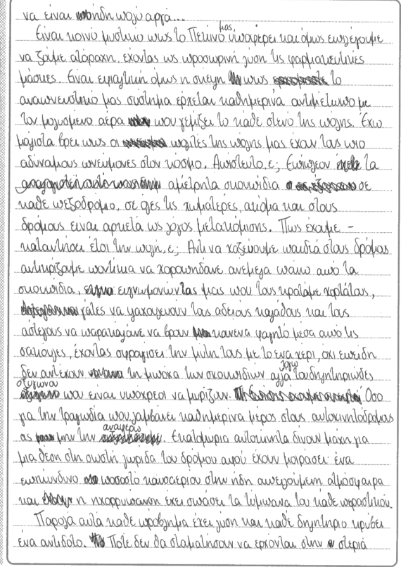
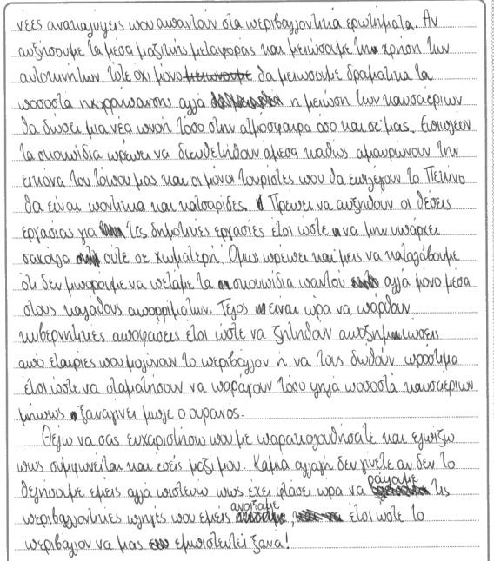

This is a well-organised and subtle response that adopts an individual and relevant approach to the topic. The focus on the local manifestations of the environmental crisis take us to Beijing and the candidate enumerates eloquently the range of issues that threaten the environment there. Rarely, the narrative seems to slip into a generic overview, rather than a local view of the environment (p. 4). A moment of awkwardness occurs before we are able to ascertain the narrator’s position within their environment. We are initially alerted to the environmental issues in China through the reference that the writer, who seems to be geographically removed from China, is simply watching a documentary on television. However, this impression is reversed soon after, with the mention of το Πεκίνο μας… (p. 5), when we are compelled to assume that the candidate’s local environment is in fact Beijing, and they are looking to save the planet by focusing on their immediate surroundings. In this respect, despite the initial disbelief and transitional challenges when the word “Beijing” is mentioned, the essay succeeds in addressing the most important aspects of the question. In addition, it is well structured and despite spelling errors, we have an individual and effective treatment of the question.

