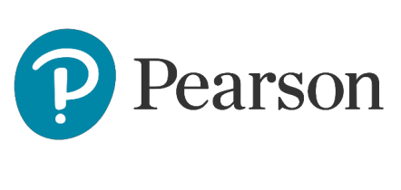

Feedback for Centres

International GCSE

Greek (First Language) (9-1) Paper 1: Reading, Summary & Grammar  
4GK1_01

**Question 1**

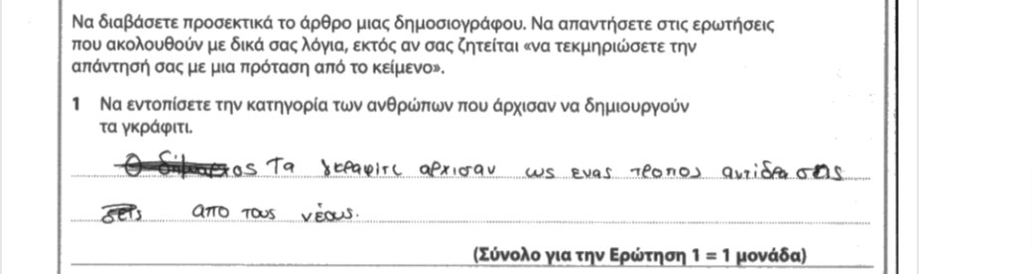

This candidate did not earn any marks, as the response was not complete and did not identify fully the type of person who looked at graffiti as an outlet from the financial and social challenges that they faced. There was a noticeable pattern of incomplete responses, when candidates, answered by simply writing simply Νέοι instead of explaining which category of young people in specific, Νέοι που αντιμετώπιζαν οικονομικά ή/και κοινωνικά προβλήματα. ​

**Question 2**

**Example 1**

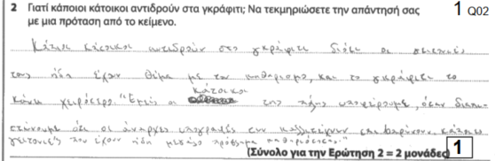​

The candidate fails to pinpoint clearly, unambiguously and in good Greek the required detail. The substantiation is correct.

**Example 2**

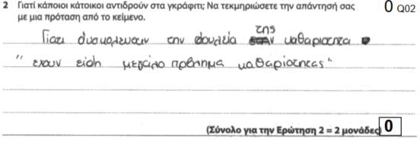

The appropriate details are missing.

**Question 3**

**Example 1**

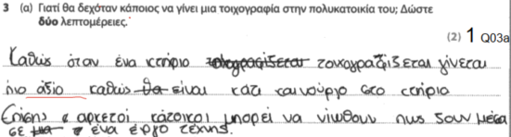

The first detail that the candidate offers is unclear. The second provided detail is correct.

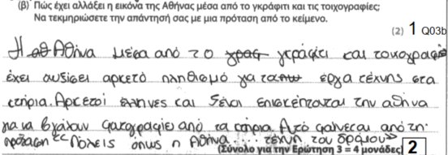

The candidate’s language skills do not allow them to express meaning clearly. The attempt to describe the ways in which Athens has changed because of graffiti is not expressed in a clear and unambiguous way. The examiner cannot select the correct detail out of an array of information that contains irrelevance.

The substantiation is correct.

**Question 4**

**Example 1**

​ 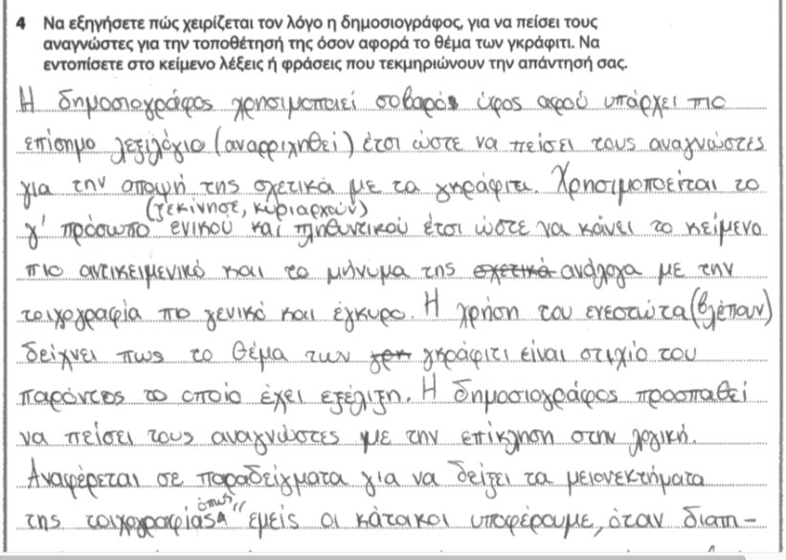

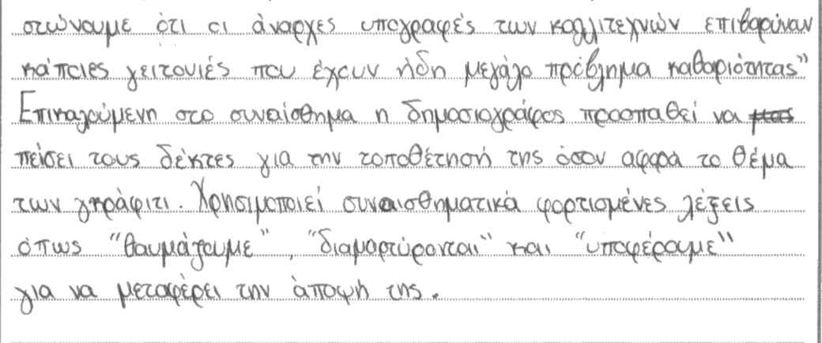

​

This response merited 6 marks. The overall response is clear with some areas of ambiguity and omissions.​

​

In the first part of this response the candidate attempts to identify stylistic features in a way that relies on generic observations that lack persuasion and adequate substantiation. Any argument regarding the use of grammatical person needs to be firmly rooted in appropriate examples, as “person” is not always a stylistic choice but a communicative necessity. ​

​

The third person plural, as cited here, is not necessarily a device that gives validity and gravitas to the text, it may simply be the articulation of a specific meaning that requires this grammatical structure: a third person in order to show the relationship between a verb and a subject. Although the use of the Present tense may add a diachronic quality to the meaning expressed, unless properly explained and substantiated, it may simply be the tense that describes something happening right now or a habit. The examiner’s report may give you more information regarding the citing of stylistic features and modes of persuasion without adequate explanation.​

​

What we have here so far is a tentative attempt to an argument, which does not convince or provide the required precision. We have the making of points, but we cannot talk of “full points”.​

​

The candidate fares better in the second part of the response, by identifying a discourse feature (appeal to reason), the technique employed (examples), the purpose (to showcase the negative aspects of graffiti) and the substantiation, in the form of a quotation from the text. The conclusive remark also has the makings of a point but finishes rather abruptly, without explaining fully the impact of these emotionally charged words; which is mainly to highlight the challenges that the residents face on account of graffiti and the intensity of their feelings, therefore evoking feelings of empathy from the readers.

**Example 2**

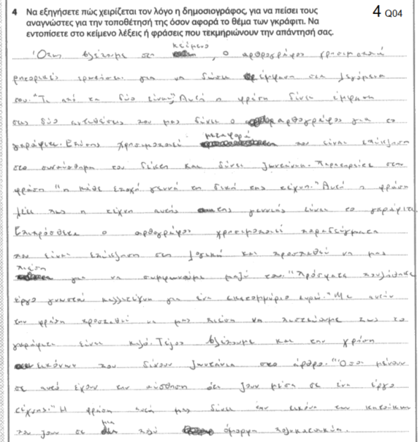

The response offers an underdeveloped explanation with two points that identify the correct means of persuasion and are accompanied by the relevant substantiation. In both of these cases the explanation is superficial and contains some wrong use of words.

**Question 5**

**Example 1**

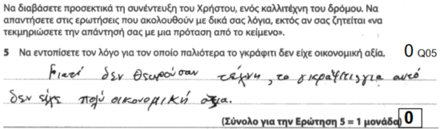

The use of the wrong punctuation and the placement of graffiti between commas make this sentence hard to decipher. Had the candidate used an object pronoun in a strategic place (e.g. δεν το θεωρούσαν τέχνη, το γκράφιτι), the mark could have perhaps been salvaged. It is not enough to communicate a message; the message must be grammatically correct, and this includes the conventions of punctuation, when they are essential for clarity.

**Question 6**

**Example 1**

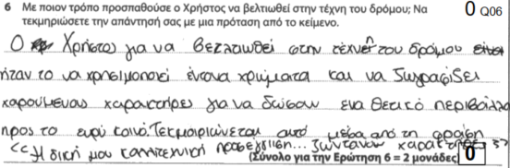

The appropriate detail and substantiation are missing.

**Example 2**

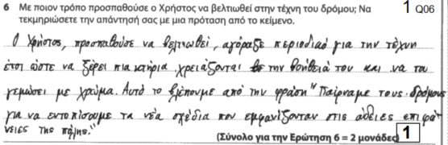

The candidate provides a lengthy answer which starts off well but ultimately shows confusion. The subordinate clause is not clear enough to compel us to consider the response as correct.

**Question 7**

**Example 1**

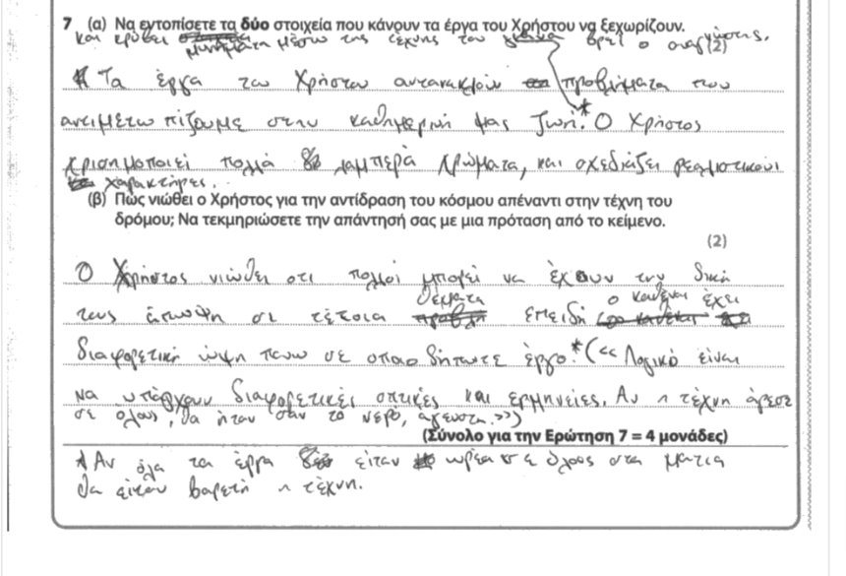

​

The response earned 3 marks out of 4, I mark for 7a and 2 marks for 7b.​

​

It serves as a good example of a pattern of errors, not so much in terms of failure to identify the correct details, as much as in terms of exam technique.​

The candidate begins by giving us one detail which is wrong, as it is not supported by evidence in the text. The second detail, which identifies the hidden messages merits the mark. There is a third detail, which, even though correct, cannot be considered, as the candidate provided three details instead of two and only the first two count. ​

​

7b merits two marks. One for the identification of the correct detail (people are entitled to their own opinion) and one for the correct substantiation. ​

**Example 2**

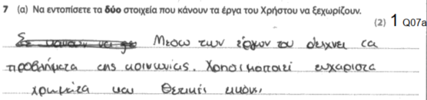

The first piece of information makes it look as if Christos’ graffiti is depicting social problems as opposed to including hidden messages about social problems. There is a degree of emphasis that is not in the source text. At this level of competence, responses must capture nuance.

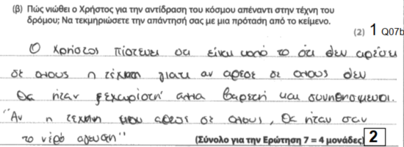

The candidate overinterprets “λογικό” as “καλό”, attributing to the speaker a position that he does not hold.

**Question 8**

**Example 1**

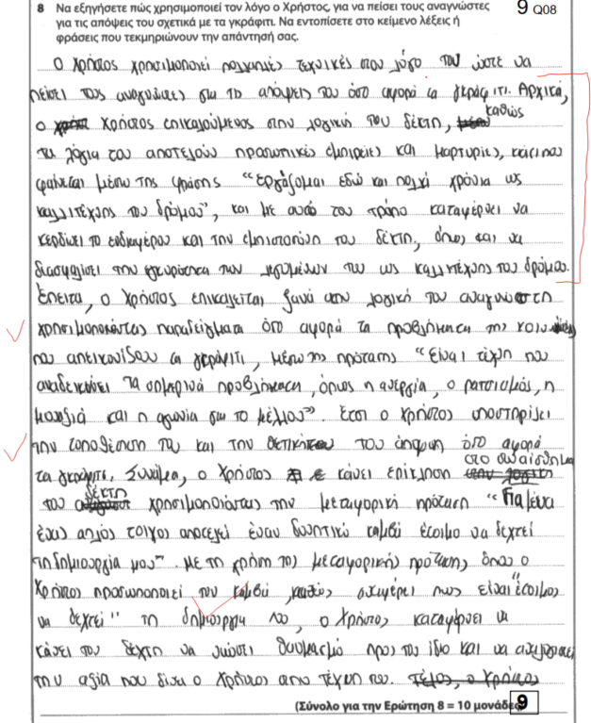

The response contains 4 complete points, 2 about appeal to reason and 2 about appeal to emotion (and the conscience of the reader). Despite some syntactical anomalies in the first point and some consistent awkwardness in expression and wrong use of vocabulary (all of which affect the effectiveness of the piece), the arguments contain good explanation and substantiation, as well as references to the techniques that the means of persuasion employ.

**Example 2**

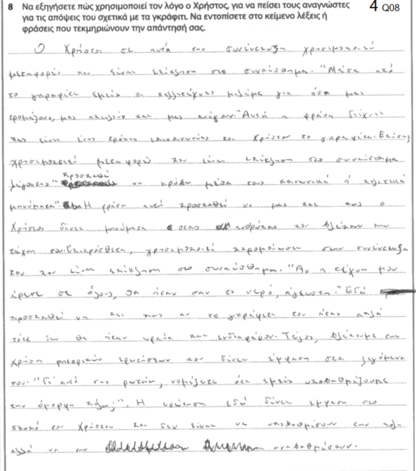

The response considers a range of points, all of which remain undeveloped and minimally expanded upon. The three references to stylistic devices, like metaphors and simile, serving as techniques that appeal to emotion are not accompanied by an explanation of how this affects the readers. What we see, instead, is an explanation of what these stylistic devices are supposed to mean, which does not serve the purpose of the argument.

**Question 9**

**Example 1**

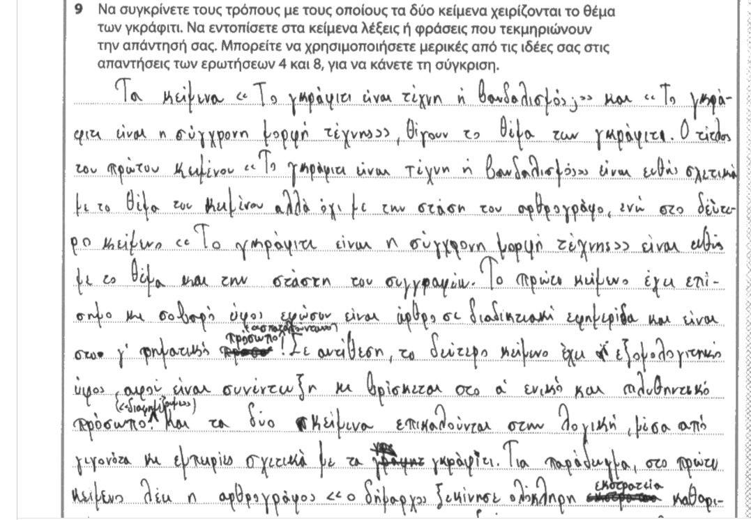

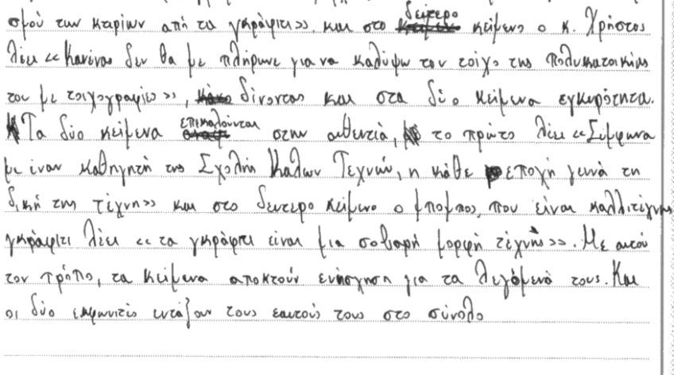

​

This response merited 11 marks. It was purposeful and well-organised as it articulated the various discourse devices employed by the two texts in a consistently comparative framework. The following points are posed:​

​

* The introduction identifies the way in which the titles preempt the message and prepare the reader for what follows​
* There are references to tone and grammatical person, but these remain undeveloped.​
* There is a complete point about the writers appealing to reason​
* There is a complete point about the writers’ use of authoritative sources.​

​

In general, this response serves as an excellent example of how succinctness and clarity, rather than long list-like responses, can earn marks from the higher bands.​

​

What the candidate needed in order to gain more marks was another complete point that follows the pattern of point/explanation/ substantiation within a comparative framework. The examiner’s report may give you more details about this requirement, but let’s look at the next slide to see the association of levels performance and marks.

**Example 2**

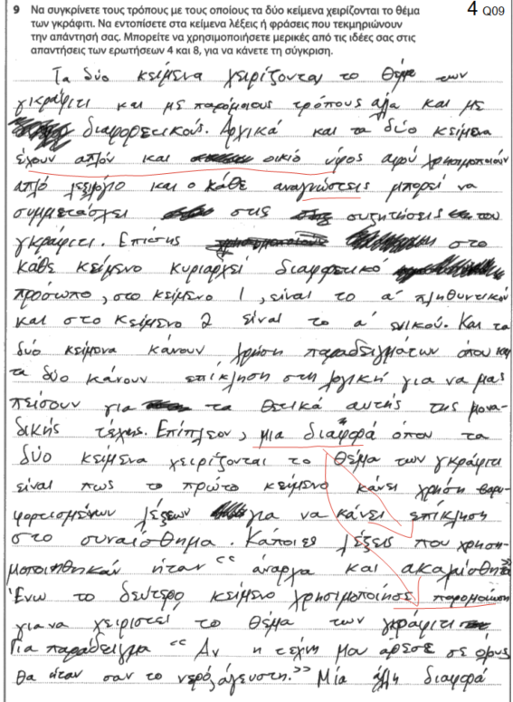

The response considers obvious, and at times basic, comparisons and remains largely undeveloped, with some relevant, but often irrelevant, evidence from the text.

The information presented is poorly organised and shows confusion about the structure of the response. The claim about stylistic devices, grammatical person in particular, makes sweeping generalisations and does not explore the persuasive function of the technique. The comparison often lacks symmetry, comparing, for example, the appeal to emotion in the first text with the use of a simile in the second. It seems that the mark is made up of half points here and there, rather than the assemblage of complete points.

**Question 10**

**Example 1**

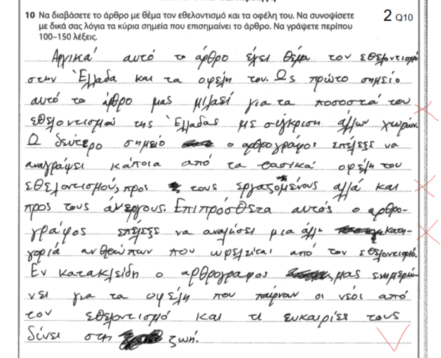

The summary includes only one point expressed in rather broad terms; the last one about the benefits of volunteerism for young people. One point was awarded for this point and one for language. The remaining points lacked any distinguishing details and did not represent adequately the essence of the source text.

**Example 2**

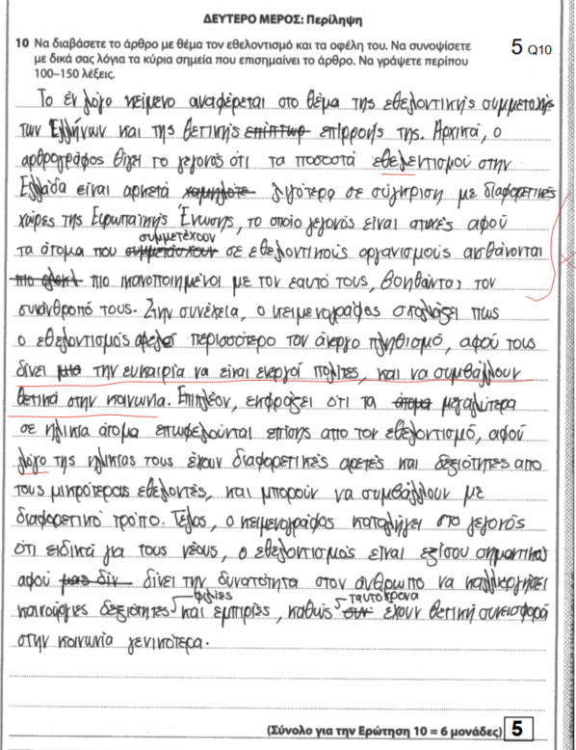

The summary identifies main points, 3 of which fairly successfully. Some details are missing regarding the benefits to older people and the unemployed. For example, the point about the benefits to the unemployed relied on conjectures not based on the text and ignored other important details, such as “… τους επιτρέπει να κοινωνικοποιηθούν, να βελτιώσουν τις γνώσειςτους και ίσως να βρουν δουλειά”