Pearson Edexcel International GCSE in Biology (9-1)
Exemplar student answers
with examiner comments

Contents
About this booklet 3
How to use this booklet 3
Paper 1 5
Exemplar Question 1 5
Exemplar Question 2 18
Exemplar Question 3 30
Exemplar Question 4 35
Paper 2 44
Exemplar Question 5 44
Exemplar Question 6 48

About this booklet
This booklet has been produced to support science teachers delivering the new International GCSE in Biology.

The booklet looks at questions from the Sample Assessment Materials, and some relevant questions from past papers. It shows real student responses to these questions, and how the examining team follow the mark scheme to demonstrate how the students would be awarded marks on these questions.

How to use this booklet

Our examining team have selected student responses to 6 questions. Following each question you will find the mark scheme for that question and then a range of student responses with accompanying examiner comments on how the mark scheme has been applied and the marks awarded, and on common errors for this sort of question.
Student response
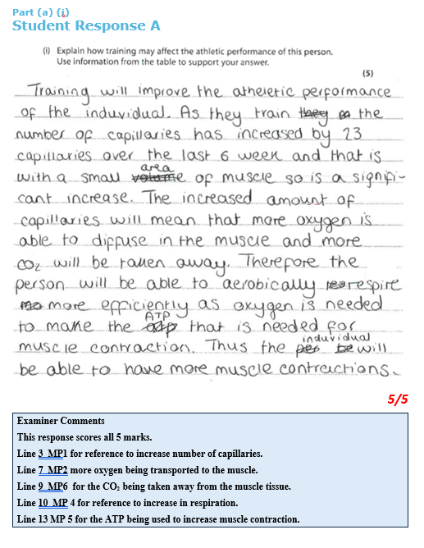

Marks awarded for the question or question parts
Examiner commentary on the student response

Paper 1
Exemplar Question 1
3. A study investigates the effect of training on athletic performance.
In the study, the number of capillaries in the muscle tissue of a person is measured before and after a six-week period of training.

(a) The table shows the results.
Mean number of capillaries per mm²
before training | after training
437 | 460
(i) Explain how training may affect the athletic performance of this person.
Use information from the table to support your answer.
(5)

(ii) Give two ways in which the design of the study could be improved.
(2)
1

2

(b) The diameter of a capillary is 8.0µm and the diameter of the aorta is 25.0mm.
1000µm = 1mm.
(i) Calculate the ratio of the diameter of the aorta to the diameter of the capillary. Show your working.
(2)
ratio = ..................................

(ii) Explain why the aorta has a thicker wall than the capillary.
(2)
(Total for Question 3 = 11 marks)
Mark Scheme
Question | Answer | Mark
3(a)(i) | An explanation that makes reference to the following five points:  • training improves performance by increasing the number of capillaries (1)  • better supply of oxygen/aerobic (1)  • better supply of glucose (1)  • respiration/energy/ATP (1)  • muscle contraction (1)  • better removal of lactic acid/carbon dioxide (1)  • can run for longer/equivalent (1) | 5

Question | Answer | Mark
3(a)(ii) | An answer that makes reference to two of the following points:  • use more people (1)  • extend training period (1)  • compare different ages/genders (1) | 2

Question | Answer | Additional guidance | Mark
3(b)(i) | Multiplication  • 0.008 (1)  Division  • 25 ÷ 0.008 = 3125 = 3100 (1) | award full marks for correct numerical answer without working  accept 3125  the final answer should reflect the precision of the least precise data (in this case two sig figs) | 2

Question | Answer | Additional guidance | Mark
3(b)(ii) | An explanation that makes reference to two of the following points:  - wall contains muscle/elastic tissue (1)  - blood is under high pressure from the left ventricle (1)  - aorta needs to expand (1)  - need to transport more blood (1) | allow converse | 2

Part (a) (i)
Student Response A
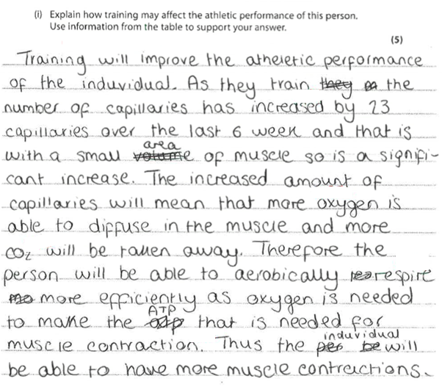
5/5
Examiner Comments
This response scores all 5 marks.
Line 3 MP1 for reference to increase number of capillaries.
Line 7 MP2 more oxygen being transported to the muscle.
Line 9 MP6 for the CO₂ being taken away from the muscle tissue.
Line 10 MP 4 for reference to increase in respiration.
Line 13 MP 5 for the ATP being used to increase muscle contraction.

Part (a) (i)
Student Response B
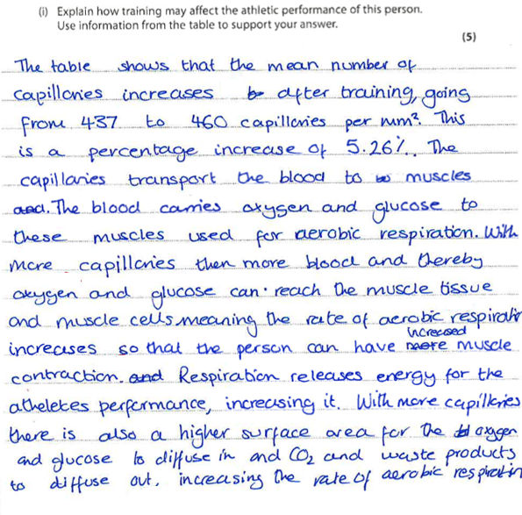
5/5
Examiner Comments
An excellent example giving 6 clear marking points for a maximum of 5 marks.
Line 2 MP1 reference to increase number of capillaries.
Line 9 MP2 more oxygen available to muscle cells.
Line 9 MP3 more glucose available to muscle cells.
Line 10 MP 4 these lead to increased rate of respiration.
Line 11 MP5 more respiration enables more muscle contraction.
Line 16 MP6 credit for CO2 being taken away from the muscle tissue.
Part (a) (i)
Student Response C
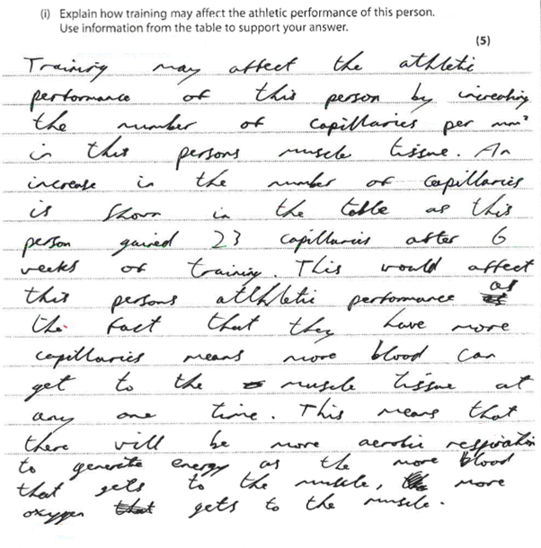
3/5
Examiner Comments
Scores 3 marks.
Line 3 credit for MP1 increase number of capillaries.
This candidate has wasted time writing out the stem of the question making reference to improved athletic performance.
Line 14 scores MP2 aerobic which is an alternative to oxygen and MP4 for increased respiration.
Therefore, no credit on line 16 for MP2 as already awarded.

Part (a) (i)
Student Response D
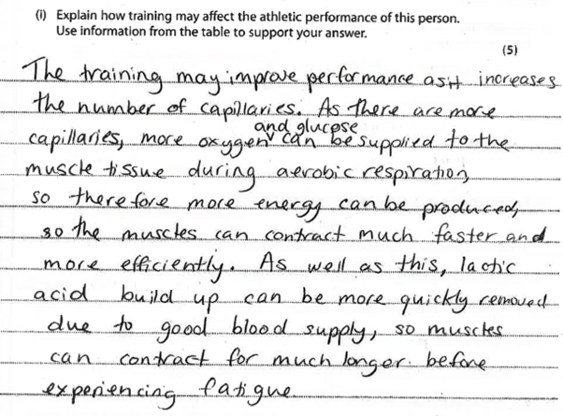
5/5
Examiner Comments
This is an excellent answer showing 7 of the marking points. No time is wasted rewriting the stem and the response concisely describes the effect of increasing blood flow on respiration and thus muscle contraction.
It gains marks for increasing the number of capillaries, providing more glucose and oxygen for increased respiration. Muscles can thus contract faster lactic will not build up and the athlete can run for longer.

Part (a) (ii)
Student Response A
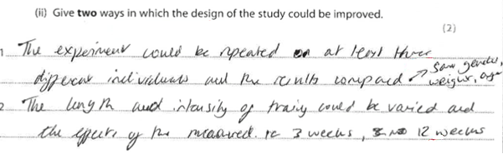
2/2
Examiner Comments
Both marks gained for MP1 use more people and MP2 extend training period to 12 weeks.

Part (a) (ii)
Student Response B
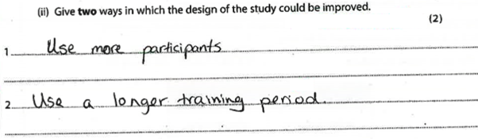
2/2
Examiner Comments
Both marks gained for MP1 use more participants and MP2 use longer training period.

Part (a) (ii)
Student Response D
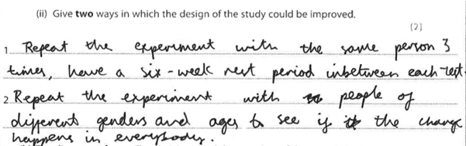
2/2
Examiner Comments
Scores MP 3 use different genders
No credit for MP1 on line 1 as repeat with same person.
But then gets MP1 for repeat with people of = using different people on line 3.
Different ages same MP as different genders.

Part (b) (i)
Student Response A
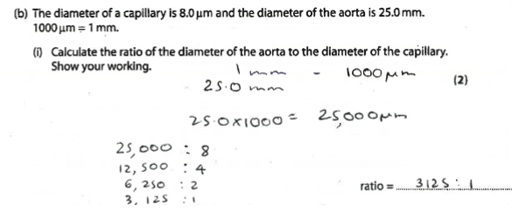
2/2
Examiner Comments
Gains full marks for correct numerical answer without working.
We would encourage candidates to show working as computational error in one stage might gain some credit for method if answer wrong.

Part (b) (i)
Student Response C
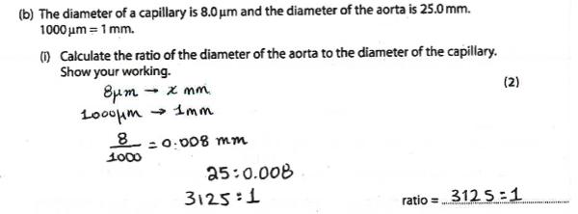
2/2
Examiner Comments
Again full credit and working clearly shown.
Part (b) (i)
Student Response D
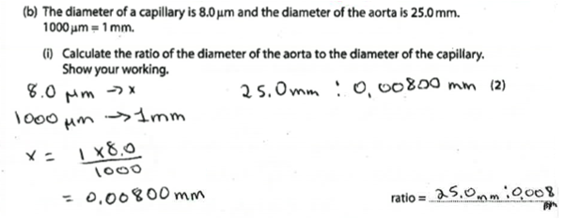
1/2
Examiner Comments
This candidate fails to get the correct answer but scores 1 mark for 0.008 (multiplication) mark stage.

Part (b) (ii)
Student Response A
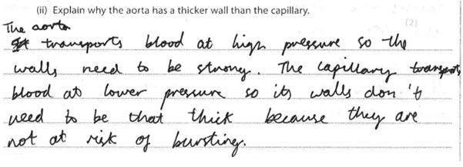
1/2
Examiner Comments
Scores 1 for MP2 for idea of higher pressure in arteries.

Part (b) (ii)
Student Response B

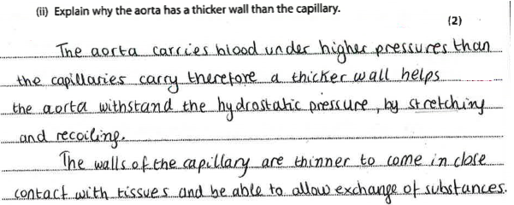
2/2
Examiner Comments
Scores 2 marks for MP2 carry blood under high pressure and then MP3 for stretching and recoiling as equivalent to expand.
Part (b) (ii)
Student Response C
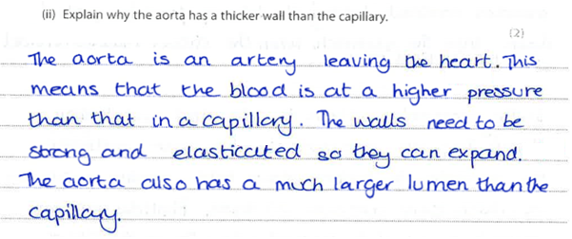
2/2
Examiner Comments
This excellent answer scores 2 max, but has 3 clear marking points.
Higher pressure with strong and elasticated walls so they can expand earning MP2, MP2 and MP1.

Exemplar Question 2
7. The diagram shows parts of the human digestive system.
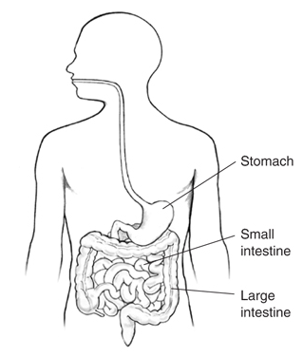

(a) Describe how food passes from the mouth to the stomach.
(2)

(b) Explain what happens to protein in the stomach.
(4)

(c) Gluten is a protein found in wheat.

In some people, the lining of the small intestine can be damaged by gluten. This causes a condition called coeliac disease.

The diagram shows the lining of the small intestine of a child unaffected by gluten and a child with coeliac disease.

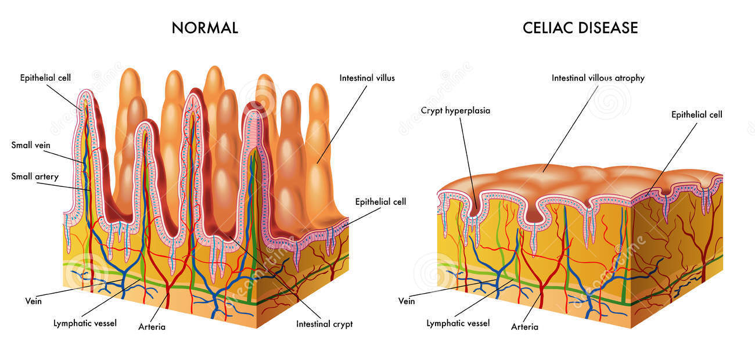
Suggest how coeliac disease could affect the growth of a child.
(4)

(Total for Question 7 = 10 marks)

Mark Scheme

Question number | Answer | Mark
7(a) | A description that makes reference to two of the following points:  - softened by saliva/bolus (1)  - muscle contraction in oesophagus (1)  - peristalsis (1) | 2

Question number | Answer | Mark
7(b) | An explanation that makes reference to four of the following points:  - churning/equivalent (1)  - digested/broken down (1)  - protease/pepsin (1)  - amino acids (1)  - hydrochloric acid/low pH/optimum pH (1) | 4

Question number | Answer | Mark
7(c) | An explanation that makes reference to four of the following points:  - growth reduced (1)  - lack of villi (1)  - fewer capillaries/fewer lacteals/less surface area (1)  - less absorption of named food molecule (1)  - function of named food molecule linked to growth (1) | 4

Part (a)
Student Response A
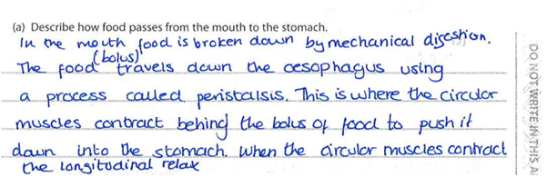
2/2
Examiner Comments
Scores 2 marks for MP3 food moved by peristalsis and MP2 muscles in oesophagus contract.

Part (a)
Student Response B
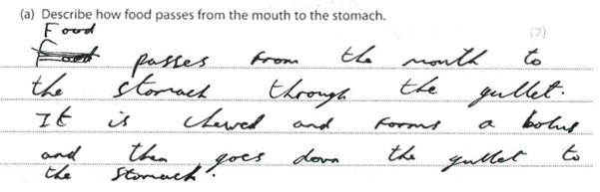
1/2
Examiner Comments
This scores one for MP1 chewed and bolus formed.

Part (a)
Student Response C
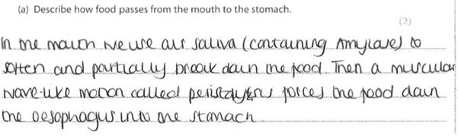
2/2
Examiner Comments
2 marks for softened by saliva MP1 and MP3 peristalsis moving food down oesophagus.

Part (a)
Student Response D

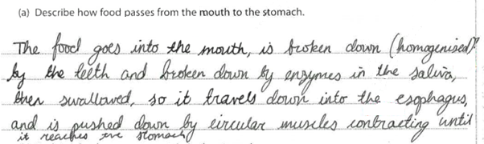
1/2
Examiner Comments
This response scores 1.
No credit to reference to enzymes in the saliva breaking down food. The marking point MP 1 is for the action of saliva to soften food. Credit MP2 for muscles contract in oesophagus.

Part (b)
Student Response A
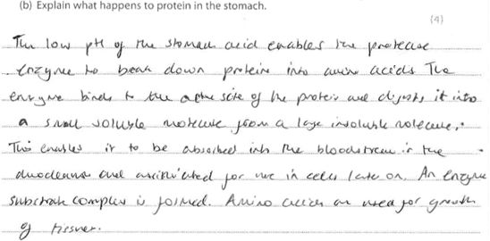
4/4
Examiner Comments
Scores 4 marks. Line 1 MP for low pH of the stomach and MP3 for protease named as a correct enzyme. On line 2 MP 2 for protease breaking down protein into amino acids MP4.
While the marker credited MP2 for break down I would prefer the use of the term digestion.

Part (b)
Student Response B
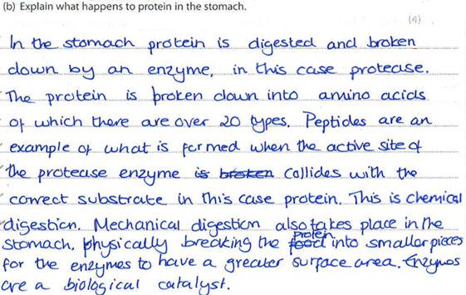
4/4
Examiner Comments
This response also scores 4 marks but makes 5 points.
Line 1 protein digested MP2.
Line 2 by protease, MP3, into amino acids MP4.
The next 4 lines do not earn any credit but MP1 is given on line 8 for reference to mechanical digestion in the stomach, I would have preferred churning.

Part (b)
Student Response C
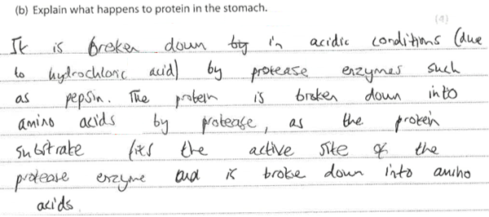
4/4
Examiner Comments
Scores 4 Line 1 MP2 protein broken down (again I would prefer digested) in acidic conditions MP 5 by protease MP3.
Line 4 MP broken down into amino acids MP4.

Part (c)
Student Response A
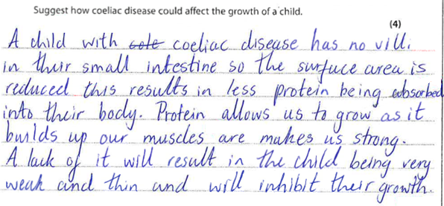
4/4
Examiner Comments
This example scores 4.
Line 1 no villi gains MP2.
Line 2 and 3 this reduces surface area MP3.
Line 3 no credit for MP4 absorption of protein as the intestine absorbs amino acids not protein,
Line 5 function of amino acids allowed MP5 . (as idea of absorption of protein already penalised)
Line 7 inhibit growth MP1.

Part (c)
Student Response B
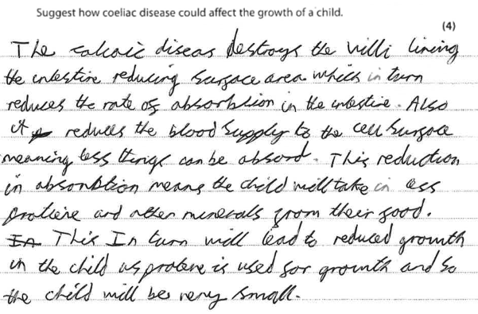
3/4
Examiner Comments
MP 2 no villi
MP3 surface area reduced
No credit for less protein absorbed as it is not absorbed
MP1 reduced growth

Part (c)
Student Response C

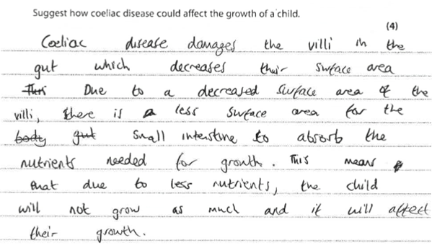
3/4
Examiner Comments
Scores 3
Line 1 damages villi.
Line 2 decreases surface area for absorption.
No credit for absorption of nutrients in line 6 as must give named food molecule.
Line 8 child will not grow is MP1.

Part (c)
Student Response E
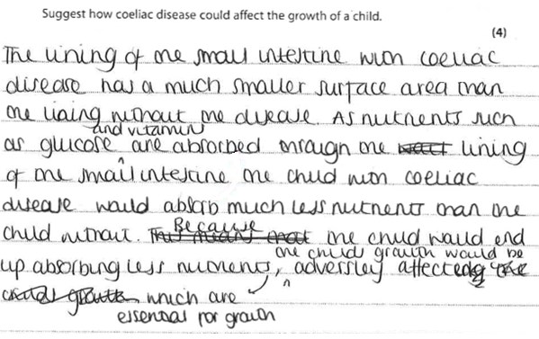
3/4
Examiner Comments
Scores 3
Line 2 reduced surface area MP3.
Line 4 – 6 reduces absorption of glucose MP4 for named food molecule.
Line 8 child’s growth adversely affected MP1.

Exemplar Question 3
8. Male infertility can be caused by reduced sperm production and reduced sperm movement.

Scientists investigated the effect of a drug called letrozole on male infertility.

A large group of infertile men was divided into two smaller groups.

Group 1 received 2.5 mg of letrozole per day for six months and Group 2 received no treatment.

The scientists measured the following at the start of the investigation and after six months:
- sperm concentration
- percentage of moving sperm
- blood testosterone level
- blood oestrogen level
- side effects such as hair loss and skin rash

The table below shows the results.
Factors measured | Group 1 (letrozole) |  | Group 2 (no treatment)
 | Start | After 6 months | Start | After 6 months
Sperm concentration/number per cm³ | 450 | 1.4 × 10⁶ | 475 | 450
Percentage of moving sperm | 2 | 18 | 2 | 2
Blood testosterone level/arbitrary units | 249 | 1198 | 266 | 266
Blood oestrogen level/arbitrary units | 44 | 0 | 44 | 48
Number of men with side effects | 0 | 8 | 0 | 0

The scientists concluded that letrozole is a safe and effective treatment for male infertility.
Evaluate this conclusion.
(6)

(Total for Question 8 = 6 marks)
Mark Scheme
Question number | Answer | Additional guidance | Mark
8 | An evaluation that makes reference to the following points:  - letrozole does improve male fertility (1)  - sperm concentration increases/sperm motility increases (1)  - letrozole increases testosterone levels/ decreases oestrogen levels (1)  - letrozole causes side effects/equivalent (1)  - need to know group size (1)  - matched groups (1)  - need to know other factors controlled (1) | e.g. age, diet, smoking, drugs | 6

Student Response A
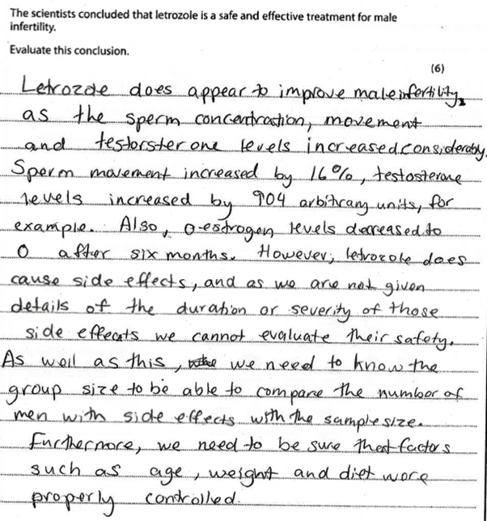
6/6
Examiner Comments
Scores 6 marks
Line 1 MP1 is effective treatment.
Line 2 MP2 sperm concentration increases.
Line 3 MP3 testosterone level increases.
Line 8 MP4 causes side effects.
Line 12 MP5 we need to know group size.
Line 16 MP7 need to know other factors such as age.
Student Response B
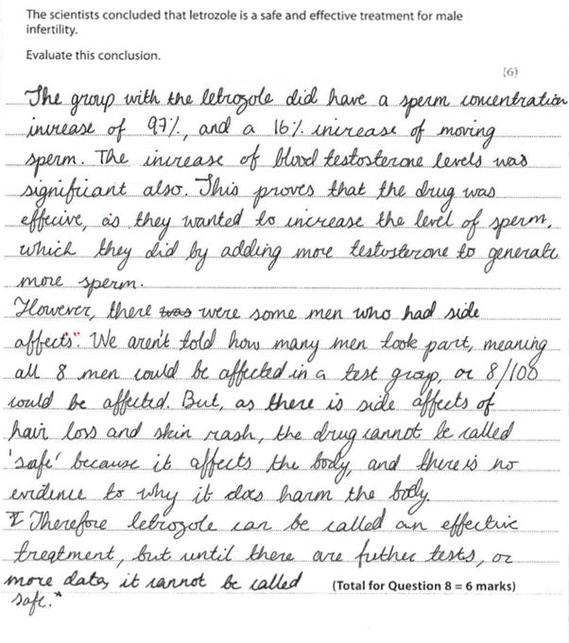
5/6
Examiner Comments
Scores 5 marks
Line 2 MP2 sperm concentration increases.
Line 3 MP3 testosterone level increases.
Line 5 MP1 drug is effective
Line 8 and 9 MP4 drug causes side effects.
Line 9 MP5 not told how many men took part.
No credit for references to safety.

Student Response C
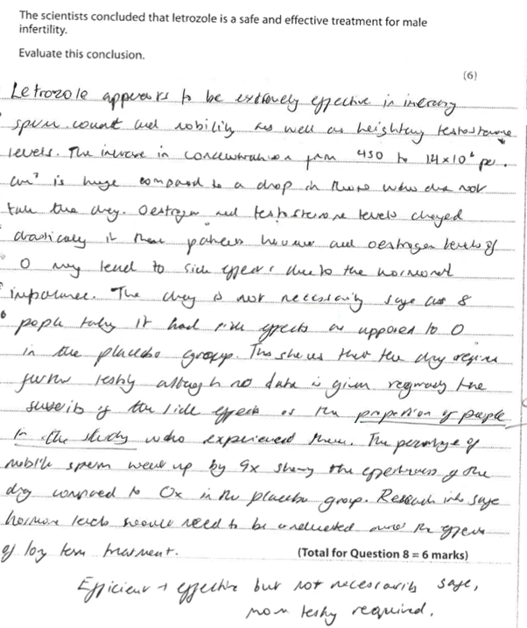
4/6
Examiner Comments
Scores 4 marks
Line 1 MP1 drug is effective.
Line 2 MP2 sperm concentration increases.
Line 2 MP3 heightening testosterone level (increases)
Line 9 MP4 had side effects.
Line 13 no credit for proportion of people that had side effects.

Exemplar Question 4
9 Genetic conditions can be controlled by dominant alleles or by recessive alleles.
(a) Explain the differences between a dominant allele and a recessive allele.
(2)

(b) Pedigree analysis can be used to find out if characteristics are controlled by
dominant or recessive alleles.
The diagram below shows a family pedigree for albinism.

Explain, using information in the pedigree, whether albinism is controlled by a recessive allele or a dominant allele.
(3)

(c) Sickle cell anaemia is a genetic condition that results in the formation of abnormal red blood cells.
Sickle cell anaemia is controlled by a gene with two alleles. The allele (N) produces normal red blood cells and the allele (n) produces abnormal red blood cells.
Two parents who are both heterozygous plan to have children.
Use a genetic diagram to show the parent genotypes, the gametes produced and all the possible genotypes and phenotypes of their offspring.
(3)

Parent genotypes

Gametes

Offspring genotypes

(d) Individuals who are heterozygous for sickle cell anaemia are protected from malaria.
Suggest how this would affect the number of individuals born with sickle cell anaemia in parts of the world where malaria is common.
(4)

(Total for Question 9 = 12 marks)

Mark Scheme
Question number | Answer | Additional guidance | Mark
9(a) | An explanation that makes  reference to two of the following points:  - dominant allele always expressed (1)  - dominant expressed in heterozygote (and homozygote)/recessive allele not expressed in heterozygote (1)  - recessive allele only expressed in phenotype of homozygote/equivalent (1) | allow seen/visible | 2

Question number | Answer | Mark
9(b) | An explanation that makes reference to three of the following points:  - Karen and Brian unaffected (1)  - they both are heterozygous/carriers/have a recessive allele (1)  - Sam is albino (1)  - Sam is aa/homozygous recessive (1) | 3

Question number | Answer | Additional guidance | Mark
9(c) | A genetic diagram including:  - parents Nn and Nn (1)  - gametes N or n (1)  - genotypes of offspring NN Nn Nn nn and phenotypes correctly assigned (1) | allow max 3 for transfer error  allow all marks from Punnett square | 3

Question number | Answer | Additional guidance | Mark
9(d) | An answer that makes reference to the following points:  - Nn not affected/killed by malaria/survive (1)  - reproduce (1)  - so number of Nn individuals increase (1)  - so number of nn individuals increases/frequency of (n) allele increases (1) | allow converse for NN | 4

Part (a)
Student Response A
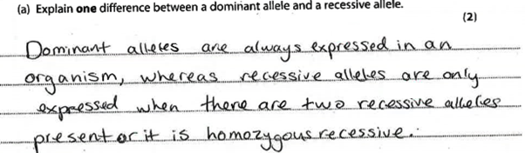
2/2
Examiner Comments
Excellent concise answer well expressed.
MP1 dominant always expressed.
MP3 recessive only expressed in homozygous

Part (a)
Student Response B
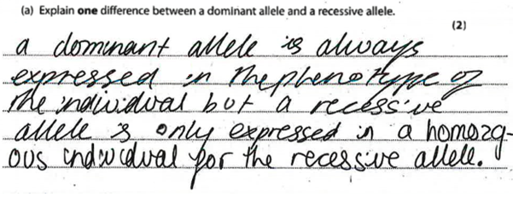2/2
Examiner Comments
Also scores 2 marks for MP1 and MP3.

Part (b)
Student Response A
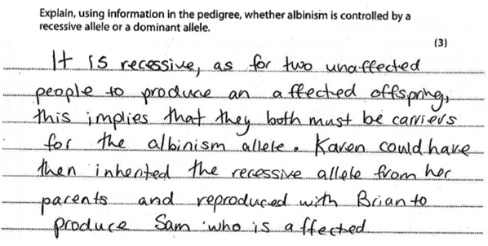
3/3
Examiner Comments
Scores 3 marks
Line 1 MP1 parents unaffected.
Line 3 MP2 both parents are carriers.
Line 7 MP3 Sam is affected.

Part (b)
Student Response B
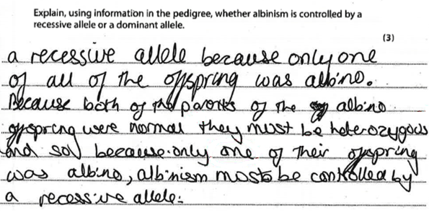
2/3
Examiner Comments
Scores 2 marks
Line 4 MP1 parents normal.
Line 4 MP2 both heterozygous.
Line 5 no credit for one of offspring is albino as does not state which one.

Part (c)
Student Response A
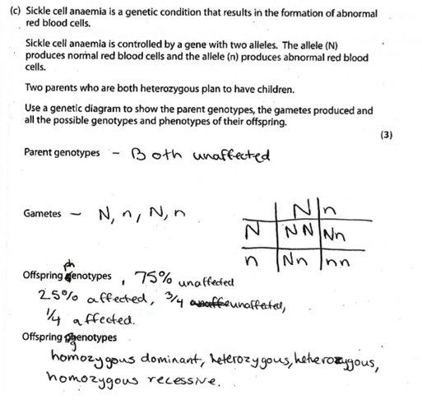
3/3
Examiner Comments
Scores 3
MP1 parents Nn and Nn from Punnett square.
MP2 gametes N or n from Punnett square.
MP3 genotypes of offspring NN Nn Nn nn and phenotypes correctly assigned.

Part (c)
Student Response B
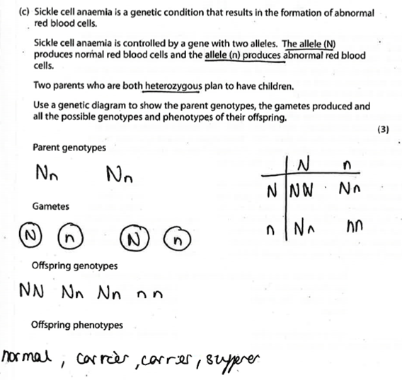
3/3
Examiner Comments
All 3 marks awarded.

Part (d)
Student Response A
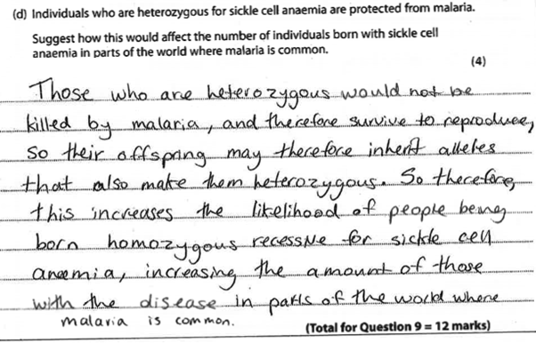
4/4
Examiner Comments
A very good answer that clearly gains all 4 marks.
Line 2 MP1 heterozygous not killed by malaria.
Line 2 MP2 so they reproduce.
Line 3 MP3 so offspring inherit alleles that make them heterozygous equivalent to individuals increase.
Lines 5 and 6 MP4 so number of homozygous recessive individuals increases.

Paper 2
Exemplar Question 5
2 Mammoths were large animals that existed from 5 million to 4500 years ago, but are now extinct. They shared a common ancestor with modern-day elephants.
The drawing shows a mammoth.
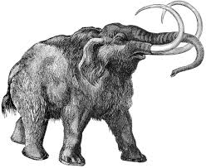

Scientists recently found a thigh bone of a frozen mammoth in Russia.
The bone had been frozen for 40 000 years. The scientists intend to use the bone cells to clone a mammoth.
Describe the method that could be used to clone a mammoth.
(4)
(Total for Question 2 = 4 marks)
Mark Scheme
Question number | Answer | Mark
2 | A description that makes reference to four of the following points:  - mammoth cell nucleus put into enucleated (elephant) egg cell (1)  - electric shock/equivalent (1)  - cell division/mitosis (1)  - embryo (1)  - uterus/womb (1)  - surrogate mother (elephant) (1) | 4
Student Response A
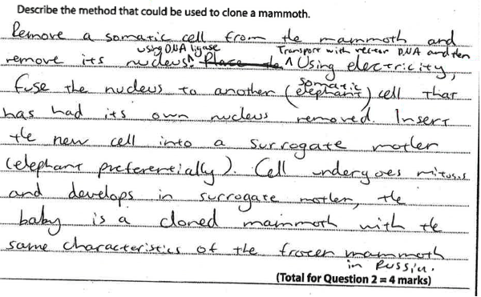
4/4
Examiner Comments
All 4 marks awarded
Line 2 MP2 use electricity to fuse nucleus into cell
Line 4 MP1 mammoth cell nucleus put into enucleated (elephant) egg cell
Line 5 MP6 use of surrogate
Line 6 MP3 cell undergoes mitosis

Student Response B
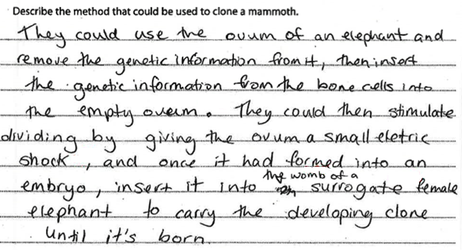
4/4
Examiner Comments
Very Good response scores 4 max but with 5 clear points.
Line 4 MP1 genetic information (I would prefer nucleus) from mammoth put into empty elephant ovum
Line 6 MP2 stimulate division by giving electric shock.
Line 7 MP4 becomes embryo.
Line 7 MP5 insert into womb
Line 7 MP6 of surrogate elephant.

Student Response C
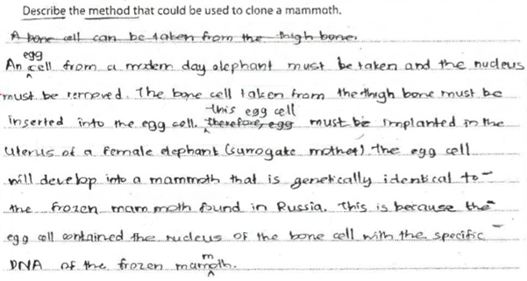
3/4
Examiner Comments
Scores 3 marks
Line 2 no credit for bone cell inserted as no reference to nucleus.
Line 4 MP5 into uterus
Line 4 MP6 of surrogate mother
Line 9 now allow reference to nucleus of bone so award MP1.

Exemplar Question 6
5 The DNA molecule codes for the production of proteins in cells.
(a) Describe the structure of a DNA molecule.
(3)

(i) DNA is used as a template for protein synthesis.
Which of the following is the correct sequence for this synthesis?
(1)
[ ] A DNA transcription mRNA translation amino acid chain
[ ] B amino acid chain mRNA transcription DNA translation
[ ] C DNA translation mRNA transcription amino acid chain
[ ] D mRNA translation transcription amino acid chain DNA

(ii) A codon is made of three bases. There are four different bases.
How many different codons can be produced?
(1)

(i) Describe how a mutation in the DNA of a cell can affect the functioning of an enzyme.
(3)

(ii) Explain why some mutations have little effect on the phenotype of an organism.
(2)

(iii) State one factor that will increase the incidence of mutations.
(1)

(Total for Question 5 = 11 marks)

Mark Scheme
Question number | Answer | Mark
5(a) | A description that makes reference to three of the following points:  - helix (1)  - double stranded (1)  - paired bases (1)  - A with T and C with G (1) | 3

Question number | Answer | Mark
5(b)(i) | A | 1

Question number | Answer | Mark
5(b)(ii) | 4³ = 64 | 1

Question number | Answer | Mark
5(c)(i) | A description that makes reference to three of the following points:  - change in the order of bases/equivalent (1)  - leads to different codon (1)  - different amino acid in protein (1)  - different-shaped enzyme/change to active site/enzyme not made/equivalent (1) | 3

Question number | Answer | Mark
5(c)(ii) | An explanation that makes reference to two of the following points:  - change in base may code for same amino acid (1)  - amino acid may not be involved in active site (1)  - enzyme still made/still functions/equivalent (1)  - could be recessive allele (1)  - so not expressed in phenotype (1) | 2

Question number | Answer | Mark
5(c)(iii) | An answer that makes reference to x-rays/ultraviolet radiation/gamma radiation/tar/ carcinogens/equivalent | 1

Part (a)
Student Response A
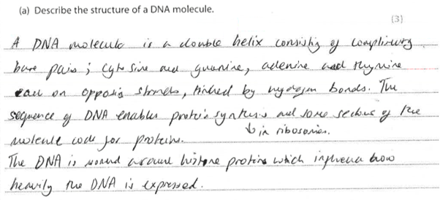
3/3
Examiner Comments
Very good example clearly shows 4 marking points.
Line 1 MP2 molecule described as double
Line 1 MP1 molecule described as helix.
Line 1 MP3 reference to base pairs between
Line 2 MP4 adenine and thymine and cytosine and guanine.

Part (c) (i)
Student Response A
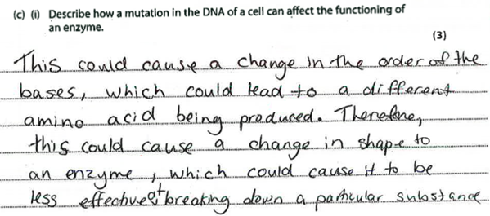
3/3
Examiner Comments
Good example scores 3
Line 1-2 MP1 change in the order of bases
Line 2-3 MP3 leads to different amino acid being produced
Line 5 MP4 causes production of different-shaped enzyme.

Part (c) (i)
Student Response B
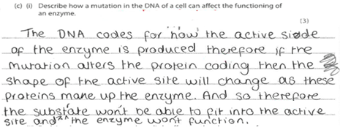
1/3
Examiner Comments
Only scores MP4 for correct reference to change in active site.
No credit for line 3 alter protein as no reference to amino acids being changed.
Part (c) (i)
Student Response C
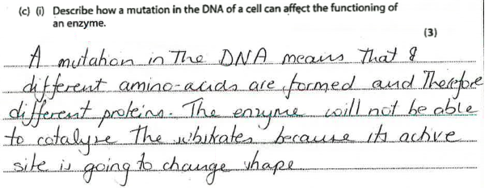
2/3
Examiner Comments
Scores 2
Line 2 MP3 different amino acids formed.
Line 4 MP4 changes shape of active site.

Part (c) (ii)
Student Response A
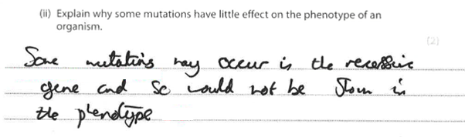
2/2
Examiner Comments
Scores 2
Line 1 – 2 MP4 could be recessive gene (would prefer allele)
Line 3 MP5 not shown in phenotype

Part (c) (ii)
Student Response B
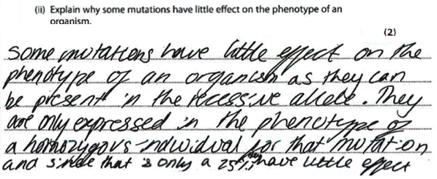
2/2
Examiner Comments
Scores 3 nicely composed.
Line 1 MP4 little effect on phenotype
Line 3 MP5 as present in recessive allele.
Part (c) (ii)
Student Response C
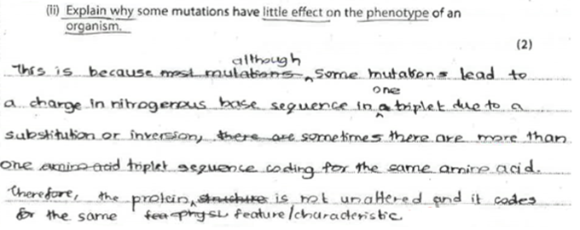
1/2
Examiner Comments
Scores only 1 for MP1 change in base may code for same amino acid lines 1-4.
No credit for protein not unaltered as suggests it will change.

