

Comparison of key skills specifications 2000/2002 with 2004 standardsX015461July 2004Issue 1

Commentaries

Summer 2024

International A Level

In Spanish (WSP04) Unit 1

**Commentary 1 – Awarded 11 Marks**

**9b** *Describe los productos y/o los servicios principales de la región o del país que has estudiado. Analiza la relación entre estos productos y/o servicios y el estilo de vida de la zona.*

**1**

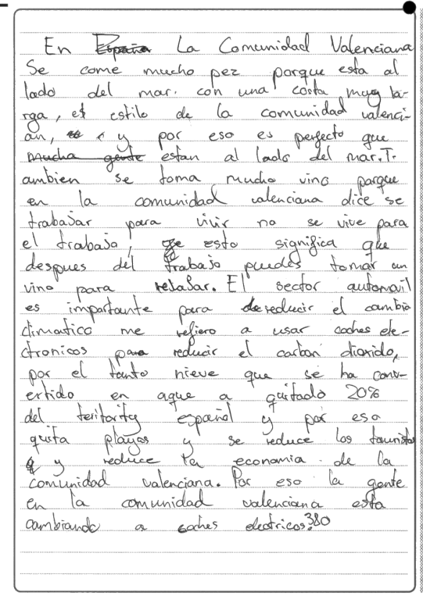 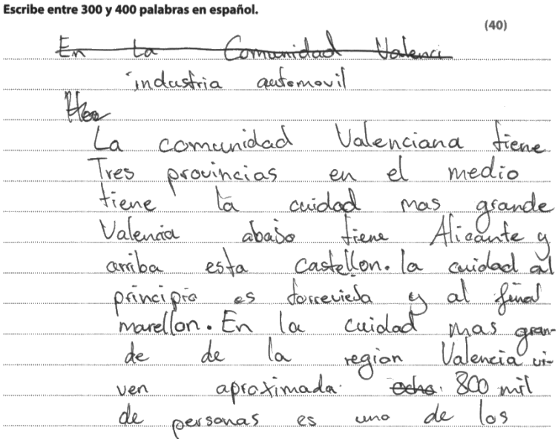

**3**

**2**

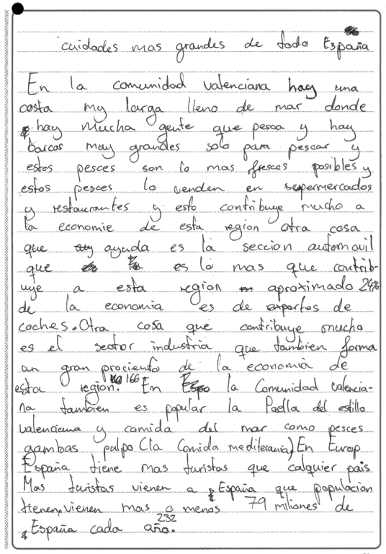

**Content and Communication (4 marks)**

The introductory paragraph focuses on the Valencia region. It begins by outlining the principal cities of the area and then concentrates on Valencia itself, one of the largest cities in Spain with 800,000 inhabitants.

The second paragraph deals with the coastal region and the importance of the fishing industry which contributes to the economy of the region. No specific details are given. The attention then turns to the car industry which accounts for 24% of the economy through exports. Again, no specific detailed information is provided to support the claim. A passing mention is made of the industrial sector and the popularity of paella, especially that made with seafood such as prawns and octopus. Finally, there is the general observation that Spain is the most popular country for tourists, 79 million of whom visit the country each year.

The third paragraph returns to the consumption of fish and seafood because of the region’s proximity to the sea. Passing mention is made of the consumption of wine before returning to the automobile industry and the importance of electric cars to reduce carbon dioxide emissions. Then follows a sentence about CO2 responsible for converting snow into water and consequently reducing Spain’s territory by 20%, taking away some of the beaches and consequently losing tourism and therefore economy.

The essay gives a very general outline of the Valencia area and its produce and services. It unfortunately lacks specific detail and cohesion in the organisation of ideas. The information given is basic, there is limited depth and more supporting evidence could be provided.

For these reasons the best fit would be the 4-6 box in the mark grid and, given that there are elements of the box below, the final mark awarded was 4.

**Quality of Language (4 marks)**

There is communication achieved most of the time, although one sentence towards the end is not easily understandable. Grammar usage is mainly good and there is an acceptable range of vocabulary. For these reasons, a mark of 4 would be the best fit.

**Critical Analysis, Organisation and Development (3 marks)**

The ideas in this essay lack development and are often unconnected. There is some repetition and there are no conclusive remarks to substantiate the essay content. For these reasons a mark of 3 would be appropriate.

**Commentary 2 – Awarded 19 Marks**

**10a** *Explica las circunstancias que resultaron en un período difícil durante la época que has estudiado. Analiza cuáles eran los factores clave en esta situación.*

**1**

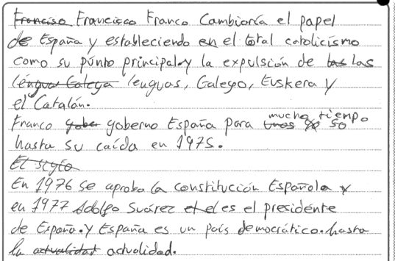 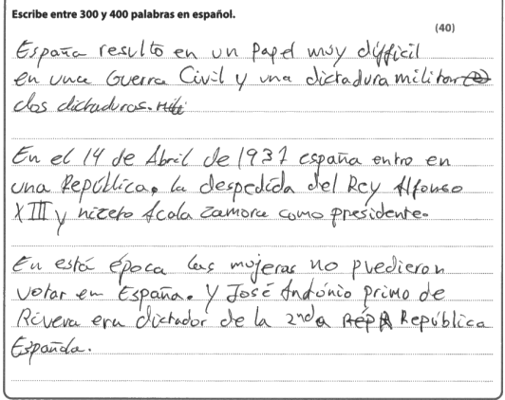

**3**

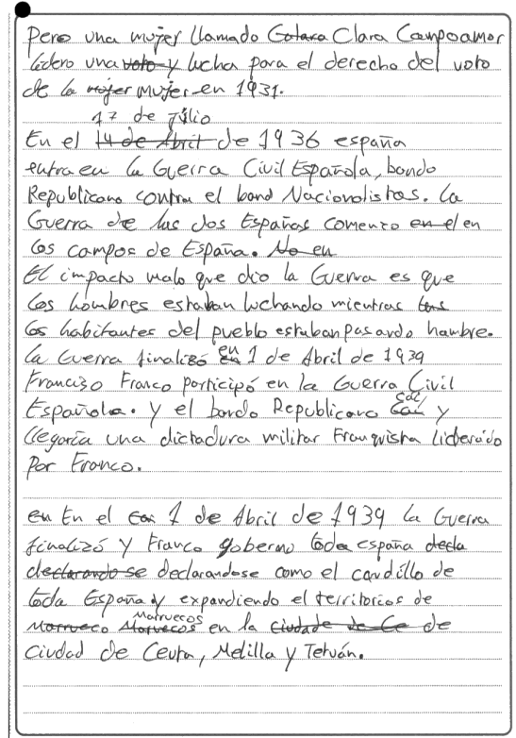

**2**

**Content and Communication (7 marks)**

The introduction is poorly written and has elements which are factually incorrect (dos dictaduras). The use of the verb ‘resulto’ is misleading, although we can guess what the candidate was trying to say.

The second paragraph is just one sentence and does not explain fully the circumstances which led to the king deciding to go into exile in Rome. The name of the president, Alcalá Zamora, is mis-spelt.

Paragraph 3, again very short, produces two unrelated sentences, with the second sentence being factually incorrect; José Antonio’s father, General Primo de Rivera, was the dictator who effectively ruled Spain from 1923 – 1930. José Antonio was the founder of the Falange party but was never dictator.

Paragraph 4 introduces another unrelated fact that remains unexplained and undeveloped.

Paragraph 5 is a simplistic survey of the progress of the Civil War and the outcome. There is no attempt to supply any detail.

Paragraph 6 simply tells us that Franco emerged as the leader who governed Spain as ‘caudillo’ and concludes with the notion that he ‘expanded’ the Spanish possessions in Morocco.

Paragraph 7 tells us how Franco established ‘total Catholicism’ in Spain and ‘expelled’ the Galician, Basque and Catalan languages.

Paragraph 8 informs us that Franco ruled Spain until he ‘fell’ (should be died) in 1975.

The last paragraph mentions the approval of the Spanish Constitution in 1976 and Adolfo Su**á**rez’s premiership in 1977 and reaches the conclusion that Spain is now a democratic country.

The essay is often factually incorrect and composed of unrelated short paragraphs with ideas that are undeveloped and unexplained. The essay fits the descriptors in the 7–9 box, although there are elements of the box below. For these reasons, a mark of 7 was awarded.

**Quality of Language (5 marks)**

Communication is achieved most of the time although there are many basic errors of language, especially spelling (e.g.difficil) and essential accents (entro). The vocabulary is acceptable, although sometimes inappropriate and grammatical structures are mostly used correctly. Despite minor mistakes, the essay received the full 5 marks.

**Critical Analysis, Organisation and Development. (7 marks)**

The response to the question is minimal and lacks detail. There is no linking of ideas between paragraphs and the presentation of ideas is frequently incoherent. The concluding remarks are brief and do not summarise the substance of the essay. For these reasons, the essay fits neatly into the 5-8 box in the mark grid and the final mark awarded was 7.

**Commentary 3 – Awarded 33 Marks**

**11a** *Explica el efecto que tiene* *Mam**á Elena en los otros personajes de la novela. Analiza hasta qué punto ella es un producto de la sociedad en la que vive.*

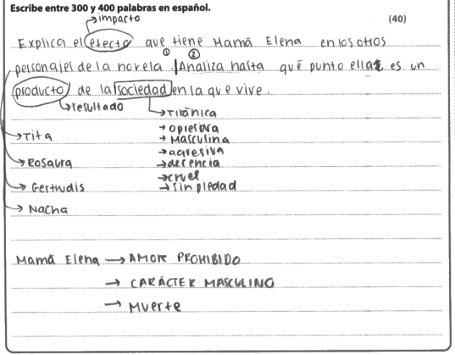

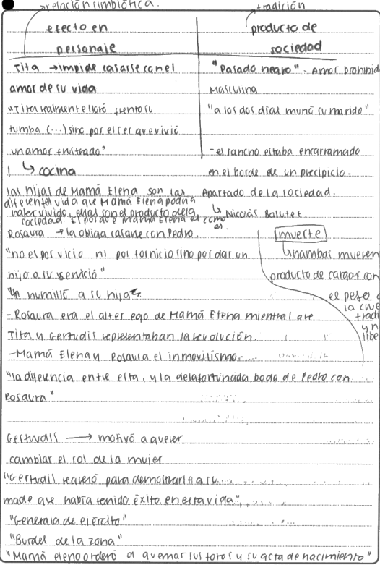

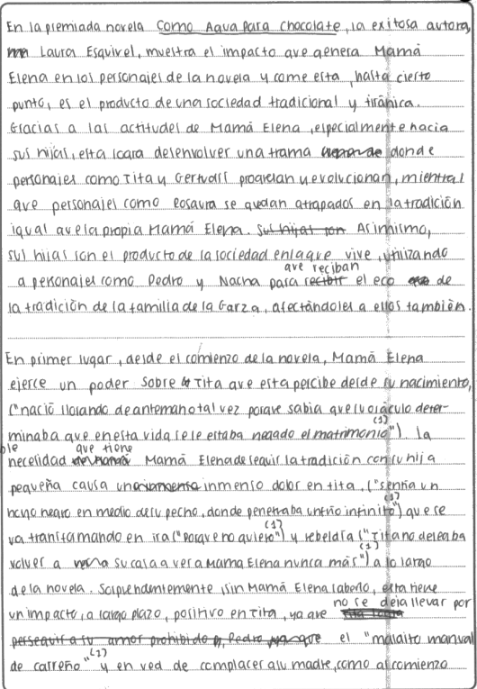

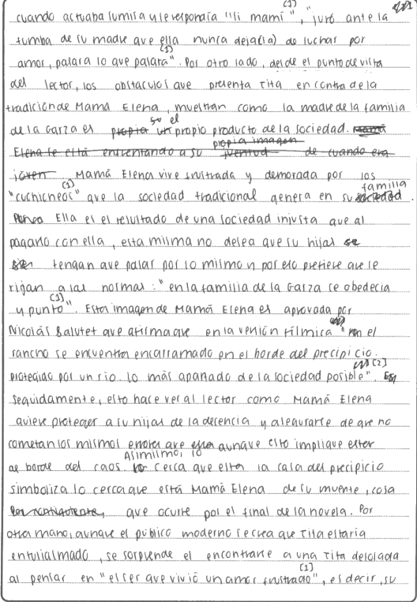

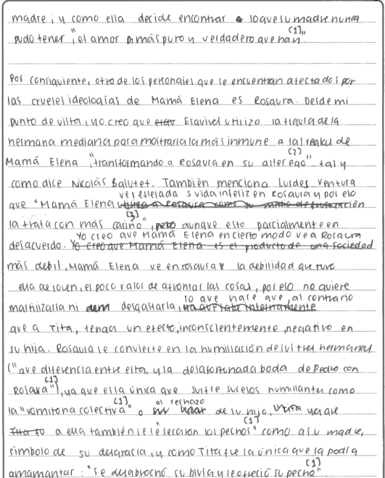

**Content and Communication (13 marks)**

In the introductory paragraph the student outlines the essential requirements of the essay title and furthermore how Mamá Elena’s attitude leads to revolt from Tita and Gertrudis whilst Rosaura remains trapped within the traditional social framework just like her mother. Her daughters are the product of the society in which they live whilst characters such as Pedro and Nacha are also affected by the same Garza family tradition.

Paragraph 2 concentrates on the power that Mamá Elena has exercised over Tita ever since she was born, and this point is substantiated by a carefully chosen and relevant quote. Mamá Elena’s insistence on following that tradition leads to Tita’s suffering and her rebellion. Another well-chosen lengthy quote illustrates the point. This portrayal of Mamá Elena is echoed in the film version and the student refers to a particular sequence to make the point. In the film Mamá Elena’s proximity to the river symbolises how close she is to the death which awaits her towards the end of the novel. Tita’s awareness that her mother also suffered frustration in love only compounds her own pain.

In Paragraph 3 the student focuses on Rosaura and how she too is affected by Mamá Elena’s cruel ideology. The student quotes from several critics, although does not entirely agree with the views they express and postulates the opinion that Mamá Elena recognises in Rosaura the weakness that she too displayed when young: the lack of courage in facing up to things. As a result, Rosaura suffers humiliation when she rejects her child and has to leave it to Tita who is the only one who can suckle him. Another quote makes the point. Rosaura is obliged to betray her sister by marrying the one that Tita is in love with and on her marriage to Pedro she gains an authority quite different from the submissiveness that she displayed towards her mother. Mamá Elena’s affectionate attitude towards Rosaura, quite different from the way she behaves towards her other daughters, again reflects the fact that she is a product of the society within which she lives. Specific references to the text clinch the point. The manner of Rosaura’s death, the student suggests, is deliberately used by Laura Esquivel to lay blame on Mamá Elena for the unhappy life that Rosaura led and at the same time to blame the traditional society that prevented Mamá Elena from living a liberal, revolutionary life. The student maintains that the author uses both their deaths to criticise the Mexican social tradition and unethical values that led to Mamá Elena’s tyranny and had an unhappy influence on Rosaura.

Paragraph 4 focuses on the youngest daughter, Gertrudis, who, although also affected by her mother’s values, is used by the author to represent sexuality and defiance of her mother’s values. A further quote is used to illustrate the point. Once again, the student refers to a critic to show how the author uses Gertrudis and Tita to demonstrate the uncontrollable power that such women have over any obstacle that gets in their way.

The concluding paragraph summarises how the author uses Mamá Elena’s daughters to portray the effect she has on them, how they decide to make use of that tradition, how they grow and develop and how they change the destiny of the Garza family.

This is a very detailed and well researched essay with lots of relevant quotes and references to the text to illustrate and substantiate the points being made. It would have been helpful if the candidate had defined exactly what the social tradition is and how it originated. However, the student has read widely beyond the text and has carefully organised the ideas into a coherent framework. For these reasons, the essay fits appropriately into the top box in the mark grid and a final mark of 13 was awarded.

**Quality of Language (5 marks)**

Communication is fluent and clear with a wide range of grammatical structures and excellent vocabulary. A full 5 marks is appropriate.

**Critical Analysis, Organisation and Development (15 marks)**

The essay is carefully constructed in paragraphs that lead one from the other coherently. The title of the essay is evaluated with some perceptive observations and the concluding remarks, mostly substantiated by the essay content, are linked to the essay. A mark of 15 was awarded.

**Commentary 4 – Awarded 14 Marks**

**14a** *Describe los actos de solidaridad entre los personajes de la obra. Analiza por qué se desarrolla este sentimiento entre los vecinos.*

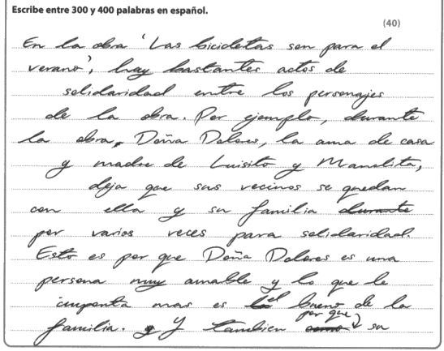

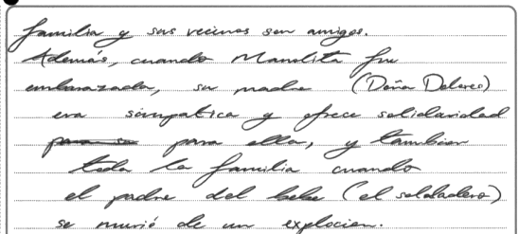

**Content and Communication (6 marks)**

The opening paragraph, rather than introducing the outline of the essay, opens with an example of solidarity between the neighbours. The example given is Doña Dolores, housewife and mother of Luisito and Manolita, who allows the neighbours to stay with her and her family several times through solidarity. This is because she is very kind and what matters to her most is the good of the family. Moreover, her family and the neighbours are friends.

Paragraph 2 recounts how, when Manolita was pregnant, Doña Dolores showed kindness and offered solidarity for her and for all the family when the baby’s father, the soldier, was killed in an explosion.

The essay appears to be only half finished and is consequently only a basic response to the question. Only one example, that of Doña Dolores, is offered. There are no concluding remarks and the paragraphs, although linked, are lacking in detail and remain unsubstantiated by reference to the text. Because of the limited depth and content of the essay, a mark of 6 was awarded.

**Quality of Language (4 marks)**

Communication is achieved most of the time and the grammatical structures and vocabulary are adequate. However, there is a lack of range of vocabulary and no evidence of anything other than common grammatical usage. For these reasons, a mark of 4 was awarded.

**Critical Analysis, Organisation and Development (4 marks)**

The essay is short and lacks detail in response to the question. There is minimal engagement with the work and ideas are limited. The essay ends abruptly and consequently there are no concluding remarks.The essay fits the descriptors in the bottom box of the mark grid and a mark of 4 was awarded.

**Commentary 5 – Awarded 23 Marks**

**14b** *Describe la primera escena entre Luis y Pablo. Analiza la importancia de esta escena en la obra.*

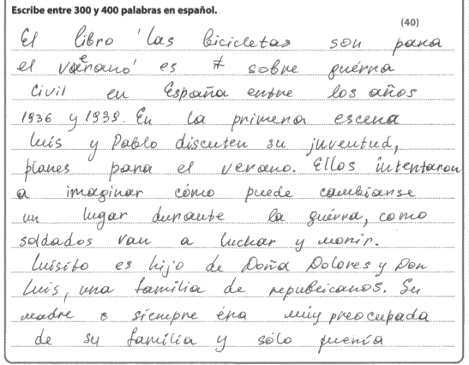

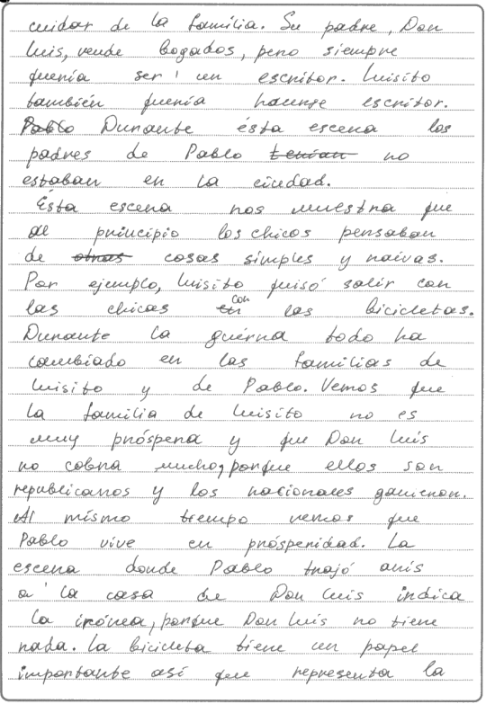

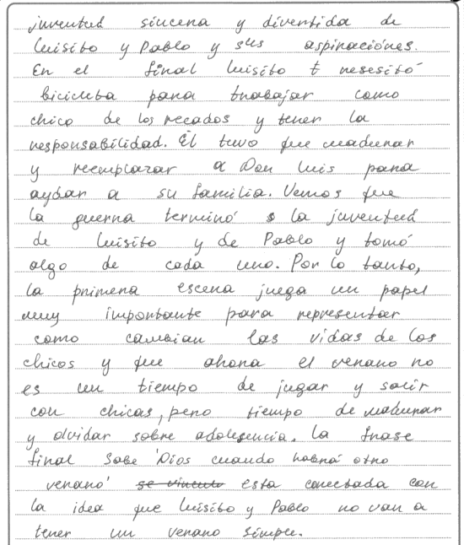

**Content and Communication (7 marks)**

The opening paragraph introduces Luis and Pablo and explains how they are discussing their plans for the summer and for the future. However, their dreams and aspirations, we are told, will come to nothing when the Civil War in Spain reaches Madrid. As a result, we see how they adapt and evolve as characters over the course of the play, affected by the problems caused by the war. Mention should have been made of their war games and their discussion of books and films. The candidate should have emphasised the irony of this opening scene in the light of the subsequent development of the story. Similarly, the character of Luisito as an imaginative young boy and his passion for reading should have been mentioned.

Paragraph 2 takes up the story and provides more information. Luis and Pablo are in the university city in Madrid; it is a sunny day in summer. They are discussing their plans and the weather, and the time of year reflect the fact that it is the time of year to have a good time and enjoy the holidays. The inclusion of a quote shows how Luis asks Pablo to imagine the possibility of a war, an idea to which they both respond with incredulity. Another quote gives Pablo’s reply; he thinks the idea is preposterous and asks who they are likely to go to war with – the French or the Portuguese? Clearly, their thoughts are with the summer holidays, and they can see nothing getting in the way of their enjoyment. The candidate should have stressed the importance of the summer which, in the play, represents a time of freedom and happiness. Pablo adds that even if there were a war, it would never reach Madrid. The student comments how the film director creates humour from the situation since the audience are only too aware of what is going to happen.

Paragraph 3 analyses the importance of this scene in the work as it is one of the few scenes in the play that take place before the onset of the war. As a result, we can compare how Pablo and Luis behave prior to the war and how they change as they adapt to the critical situation they later find themselves in.

Paragraph 4 develops this idea and tells us that the scene also has significant importance since Pablo and Luis have families with different ideologies; Luis’s family supports the Republican ideals while Pablo’s family is more conservative. Because of this difference in ideologies, Pablo’s later experience will be a happier one than Luis’s. This first scene also provides a significant contrast with the later scene where we see Luis and his father in reduced circumstances because of the effects of the war. The presence of Luis and his father and the absence of Pablo shows how Luis’s family have suffered more. The student quotes Don Luis who, in saying God knows when we shall have another summer, reminds us of the contrast with the first scene when Luis and Pablo were looking forward to a peaceful, enjoyable summer.

The concluding paragraph summarises how the play shows the change in the characters of Luis and Pablo before and after the war and how the inhabitants of the city experienced benefits or disadvantages according to their ideologies.

The essay addresses the requirements of the title, although there is a good deal of storytelling rather than analysis and explanation. The candidate should have commented on the circular structure of the play whereby the ideas and the location are reflected in the epilogue, thereby contrasting the situation before and after the war. The essay is mainly narrative rather than incisive and for these reasons a mark of 7 was awarded.

**Quality of Language (5 marks)**

The essay communicates the ideas fluently using a wide variety of grammatical structures and appropriate vocabulary. For these reasons, a mark of 5 is appropriate.

**Critical Analysis, Organisation and Development (11 marks)**

The essay is coherent and well-structured in paragraphs that are linked in the development of ideas. The student knows the play well and shows moderate engagement with the text. The conclusive remarks are linked to the essay and sometimes substantiated by the essay content. The essay fits the descriptors in the 9-12 box in the mark grid and for these reasons a mark of 11 was awarded.

**Commentary 6 – Awarded 39 Marks**

**15a** *Describe el uso que hace Lorca de los contrastes en Yerma. Analiza el efecto dramático que produce esta técnica.*

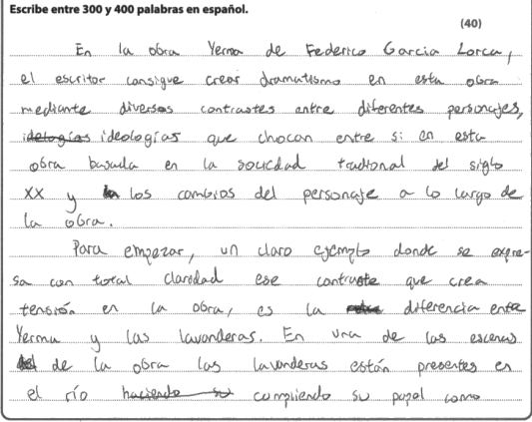

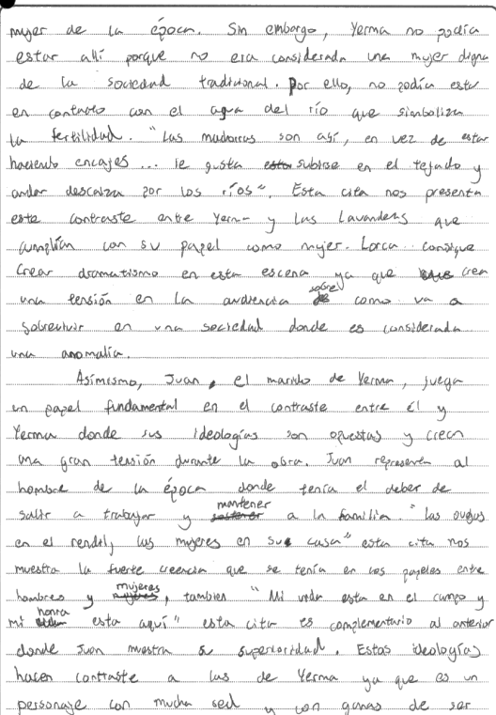

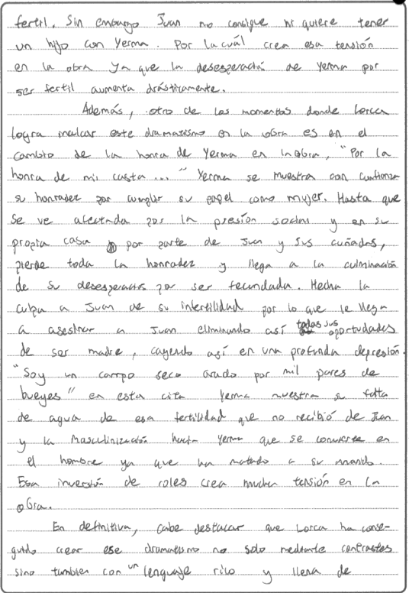

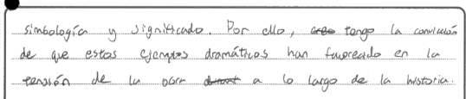

**Content and Communication (15 marks)**

The introduction to the essay is clear and concise, explaining how the candidate plans to analyse the contrasts between characters and ideologies set against the traditional values of Spanish society at the time.

The second paragraph focuses on the contrast between Yerma and the washerwomen. Yerma is depicted as excluded from traditional society; she is barren whereas the washerwomen are in touch with fertility as symbolised by the river. A relevant quote clinches the point, and the candidate explains how dramatic tension is created when the audience wonders how Yerma will survive in a society where she is regarded as an anomaly.

Paragraph 3 examines the contrast in ideologies between Yerma and her husband, Juan. Juan is seen as a typical man of his time whose values are centred on work and the support of his family and who believes that a woman’s place is in the home. A carefully chosen quote makes the point. The candidate explains how dramatic tension is heightened by the contrast between Yerma’s growing despair in her desire for a child and Juan’s rejection of the idea.

Paragraph 4 concentrates on how Yerma attaches the importance of honour to her role as a woman in society and how she becomes increasingly desperate in her desire for motherhood. She blames her husband for the lack of a child and feels trapped when Juan brings his sisters in law to keep an eye on her. Again, relevant quotes make the point, and the killing of her husband is seen as the culmination of her despair.

The final paragraph summarises how Lorca has created dramatic tension through contrast but also through the richness of the language and imagery.

Clearly this is a well-constructed essay that goes to the heart of the essay title. Perhaps the candidate could have referred to the significance of Victor in the examination of contrasts but nevertheless the central ideas of the title are addressed in full. For these reasons, the essay is worth a full 15 marks.

**Quality of Language (5 marks)**

The candidate writes fluently and clearly with very few minor errors, for example the odd accent here and there. Communication is maintained throughout; the language and vocabulary are varied and appropriate. The use of language is clearly worth a full 5 marks.

**Critical Analysis, Organisation and Development (19 marks)**

The essay is carefully constructed in connecting paragraphs that develop the central ideas and are always substantiated by relevant quotes and references to the text; however, there is some repetition. There is clear evidence of engagement with the text and the concluding paragraph is linked to the essay content and shows perceptive comments that summarise the main arguments of the essay. The essay fits the top box of the mark grid and for these reasons a mark of 19 was awarded.

**Commentary 7 – Awarded 19 Marks**

**15b** *Explica cómo se presenta el papel del hombre en la obra. Analiza hasta qué punto los hombres son responsables de la situación en la que Yerma se encuentra.*

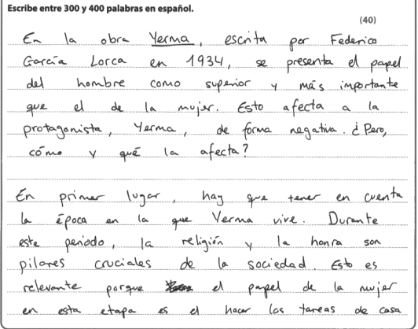

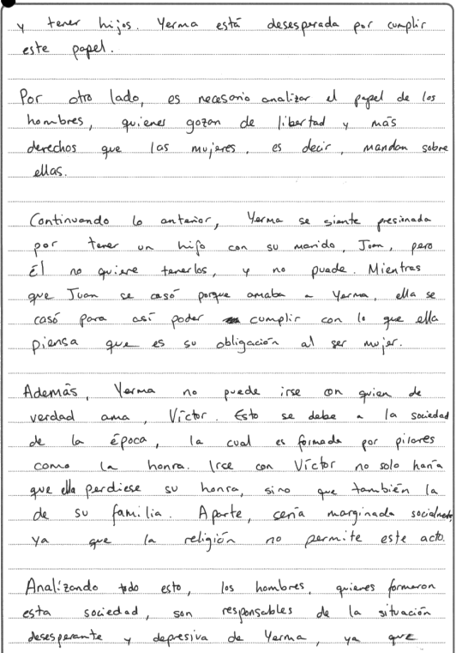

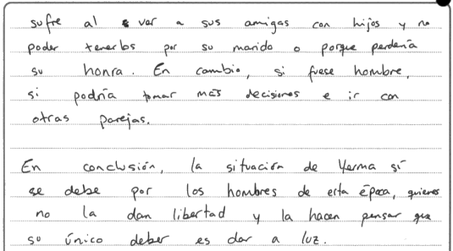

**Content and Communication (6 marks)**

The introduction tells us that in the play the role of the man is portrayed as superior to and more important than that of the woman and this has a negative effect on the protagonist Yerma.

Paragraph 2 focuses on the age in which Yerma lived and how religion and honour were the main pillars of society. This is relevant to the role of the woman who was expected to run the home and look after the children. Yerma, we are told, is desperate because of the role she must play.

Paragraph 3 looks at the role of the man who enjoys freedom and more rights than those afforded to women. The man has control over the woman.

Paragraph 4 expands this idea and shows how Yerma feels pressured into having a child with her husband Juan (and odd observation) whereas he does not want a child and is incapable of having one (a dubious claim). Whereas Juan married Yerma through love, she married because of what she saw as her duty as a woman. The student does not mention the fact that Yerma’s was an arranged marriage.

In Paragraph 5 we are told that Yerma could not go off with the man she really loves, Victor, because of the emphasis that society placed on honour. If she ran away with Victor, she would compromise not only her own honour but that of her family. She would also become socially marginalised because religion did not accept such behaviour.

Paragraph 6 maintains that because of social conventions men are responsible for the Yerma’s desperate situation. Her suffering is compounded by seeing her friends with children and her realisation that she is unable to have her own child with her husband and any other option would lead to her loss of honour. However, if she were a man she would be able to take her own decisions and do what she wanted.

The final paragraph concludes that Yerma’s situation is indeed due to the men of that age who take away the woman’s freedom and make her think that her only duty is to give birth.

The essay makes simple points and lacks detail. Some assertions made by the student are at least doubtful. There is little or no reference to the text to substantiate the arguments. For these reasons, a mark of 6 was awarded.

**Quality of Language (5 marks)**

The essay communicates adequately, and the grammatical structures and vocabulary are mostly used correctly. For these reasons, a mark of 5 is appropriate.

**Critical Analysis, Organisation and Development (8 marks)**

The essay is organised in paragraphs and has a conclusion, however the response is lacking in detail and incomplete. There is little evidence of engagement with the play and as a result the ideas are limited and superficial. For these reasons, the essay was given 8 marks.

**Commentary 8 – Awarded 23 Marks**

**16a** *Explica el papel de los maquis en la trama. Analiza cómo la película presenta el tema de la resistencia.*

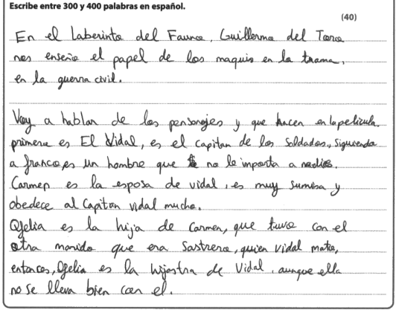

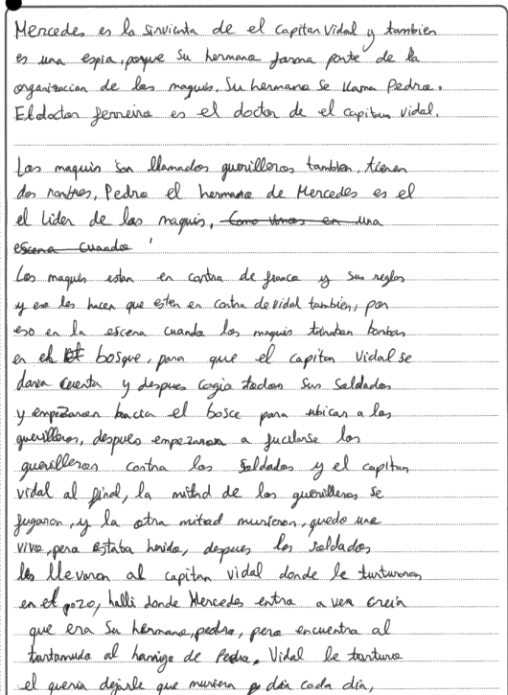

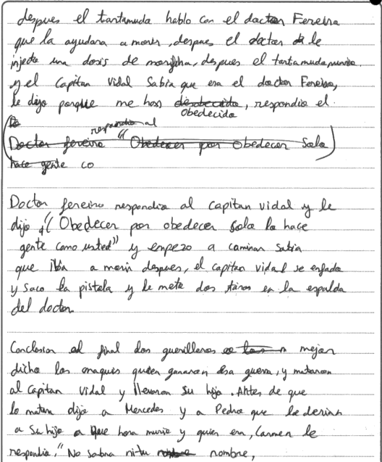

**Content and Communication (8 marks)**

The opening four paragraphs are introductory and simply tells us who the main protagonists are, their relationships to each other and a little about their characters.

Paragraphs 5 and 6 concentrate on the maquis, explaining that they are guerillas led by Pedro, Mercedes’ brother. We are informed that the maquis are opposed to Franco and therefore against Vidal. There follows a lengthy, rambling sentence relating the episode in which Vidal’s soldiers pursue the maquis in the forest, killing some of them and capturing one who is wounded. They escort him to Vidal, and he is tortured. We are told how the doctor gave the stammering prisoner a dose of morphine to relieve his pain and how Vidal takes him to task for disobedience. When the doctor angers Vidal by saying the obedience for the sake of it is only practised by people like you (a relevant quote is provided here), Vidal shoots him in the back.

The final paragraph simply provides a summary of what happens at the end of the film and does not offer any concluding remarks to substantiate the essay content.

The essay largely consists of storytelling with little depth of analysis. The student shows factual knowledge of the film and there is some supporting evidence, both through quotes and through reference to the content of the film. The essay fits the descriptors in the 7-9 box of the mark grid and a final mark of 8 was awarded.

**Quality of Language (4 marks)**

Communication is achieved most of the time, although some sentences are lengthy and lack precision. Grammatical structures are generally sound, although sometimes poor control of grammar results in confusion in the sentence structure – for example paragraph 5 where the sentences lose clarity. Vocabulary is of a reasonable range and variety. For these reasons, a mark of 4 was awarded.

**Critical Analysis, Organisation and Development (11 marks)**

The student addresses the essay title and shows some engagement with the film. There are links between ideas and paragraphs are generally organised coherently. The conclusive remarks resort to storytelling and do not provide a comprehensive summary of the substance of the essay. The essay fits the descriptors in the 9-12 box of the mark grid and for these reasons a final mark of 11 was awarded.

**Commentary 9 – Awarded 22 Marks**

**17b** *Explica lo que hace Rafa para hacerse pasar por vasco. Analiza hasta qué punto el humor asociado con los estereotipos en la película tiene éxito.*

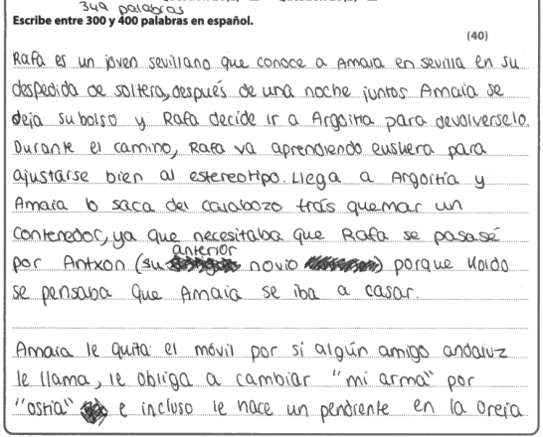

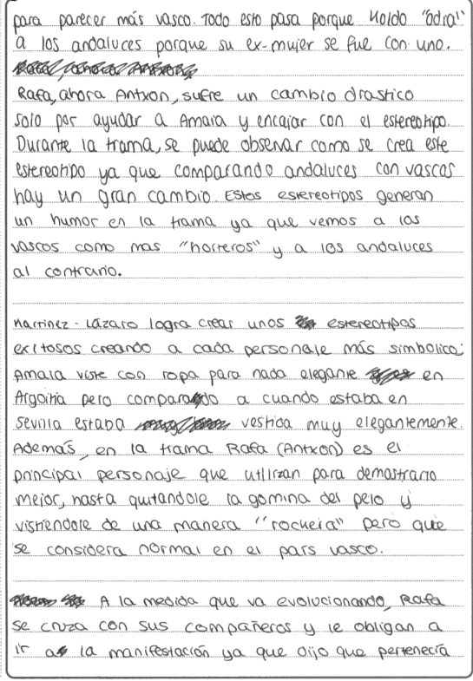

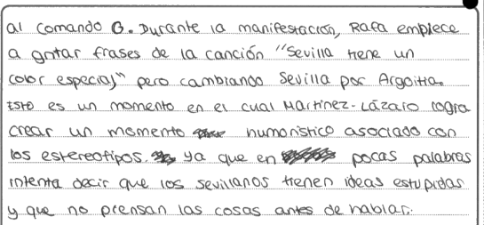

**Content and Communication (9 marks)**

The introductory paragraph is largely storytelling and the only relevant information is that Rafa starts to learn the Basque language and changes his name to Antxon in order to pass himself off as a native.

Paragraph 2 continues the story telling, although we learn that Rafa wears an ear-ring in order to appear more authentically Basque.

In Paragraph 3 the candidate tells us that Rafa (now Antxon) suffers a drastic change because of how he helps Amaia and how he tries to fit into his new role as a Basque. The humour, we learn, comes from the stereotype that he adopts and how the stereotypical Basque is more vulgar than the Andalusians.

Paragraph 4 develops the idea of stereotypes and suggests that the characters become more symbolic. An example is given of Amaia who now dresses down and loses the elegance with which she dressed in Sevilla. Similarly, Rafa loses his hair gel and dresses in a manner that is more normal among the Basques.

Paragraph 4 concentrates on the episode when Rafa is coerced by his friends to attend the demonstration and passes himself off as a member of an ETA commando unit. The candidate shows how humour is generated by Rafa shouting out lyrics from a Sevillian song but changing the reference from Sevilla to Argoitia. We are told that the humour comes from the portrayal of a typical Sevillian stupid enough not to think through his ideas before opening his mouth.

There is no concluding paragraph.

The candidate does address both parts of the question, although there is much more in the film that could have been referred to. The student does show acceptable factual knowledge and there is some variety of supporting evidence. For these reasons, the essay was given 9 marks.

**Quality of Language (5 marks)**

Communication is fluent and there is a good variety of grammatical structures and range of vocabulary. A full 5 marks is appropriate.

**Critical Analysis, Organisation and Development (8 marks)**

There is critical analysis in the essay and the candidate knows the film in some detail. The paragraphs are linked and develop the central ideas of the essay. There are no conclusive remarks. For these reasons, a final mark of 8 was awarded.

**Commentary 10 – Awarded 25 Marks**

**19a** *Describe la relación entre* *María y Blanca. Analiza cómo esta amistad cambia a lo largo de la película*.

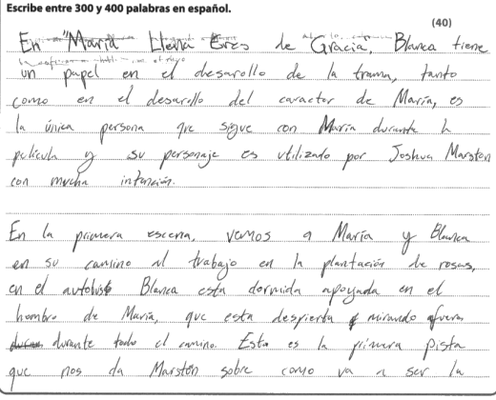

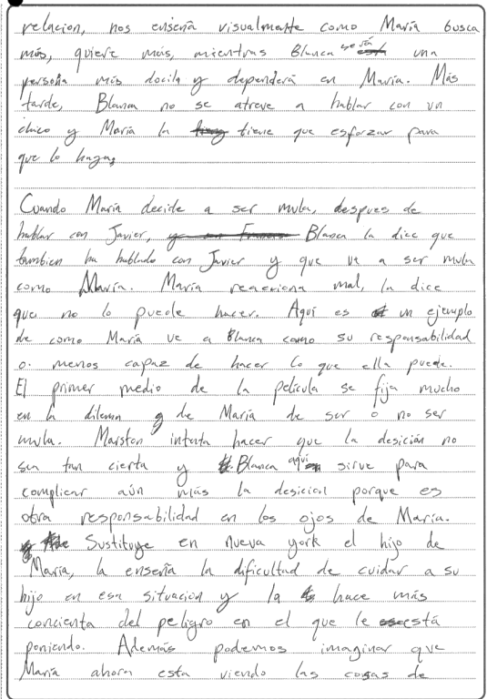

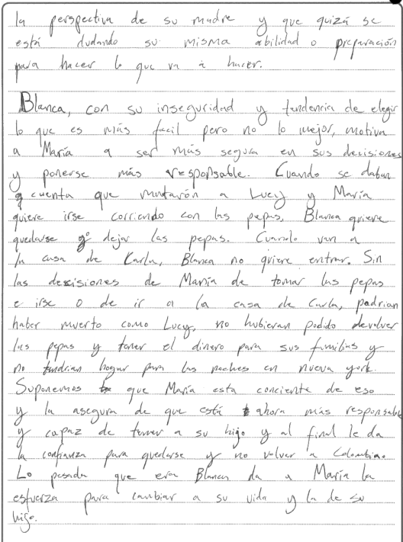

**Content and Communication (11 marks)**

The introductory paragraph simply indicates that Blanca is the only person who is with María throughout the film and the student maintains that the director portrays and uses the character with a good deal of intuition.

The second paragraph looks at the opening scene where María and Blanca are on the bus on their way to work at the florists. Blanca is asleep, leaning on María’s shoulder while María is awake and gazing out of the bus throughout the journey. The student interprets this as the first example of the relationship between them; María is looking for and wanting more while Blanca is more docile and dependent on María. Later Blanca does not dare to talk to a boy and María has to make her do so.

Paragraph 3 continues the story telling and relates how, after talking to Javier, María decides to become a drug mule only for Blanca to tell her that she too has spoken to Javier and will do the same. María becomes angry and the student sees this as an example of how María see Blanca as her responsibility. The first half of the film concentrates on María’s dilemma, wondering whether to become a drugs mule. The student says that the director intends to show how the decision has not been made and Blanca complicates the matter because it is another responsibility in the eyes of María. The next sentence is unclear but in New York María discovers how difficult it is to care for her son in that situation and becomes increasingly conscious of the danger she is getting into. María is seen as questioning her own ability to carry out what she is planning.

In the final paragraph we are told how Blanca is insecure and tends to choose the easiest rather than the best option and how she motivates María to become more responsible and confident in her decisions. The student then continues with storytelling and relates the death of Lucy and how María wants to run away with the pills while Blanca wants to remain and reject the pills. Without María’s decision to take the pills or to go to Carla’s house, they could have died like Lucy. They would not have been able to return the pills and take the money for their families and would be homeless in New York. We are informed that María is aware of this and assures Blanca that she is more responsible and capable of looking after her son and at the end she has the confidence to remain and not return to Colombia. Blanca’s example gives María the strength to change her life and that of her son.

The essay relies heavily on narrative and the points made are sometimes unclear. The student tries to address the demands of the question and shows moderate engagement with the film. Instead of conclusive remarks, the essay ends by outlining the final denouement of the film. For these reasons, a mark of 11 was awarded.

**Quality of Language (4 marks)**

Communication is achieved most of the time, although some sentences and ideas lack clarity – for example the opening sentence. The grammatical structures are generally sound, and the vocabulary is of an appropriate range. For these reasons, a mark of 4 was awarded.

**Critical Analysis, Organisation and Development (10 marks)**

The student addresses the main points of the question, although critical analysis is thin and storytelling takes over. There are some links between ideas and there is evidence of some organisation and development. The conclusive remarks do not summarise the essence of the essay but simply tell us the end of the story. The essay fits the descriptors in the 9-12 box in the mark grid and for these reasons, a mark of 10 was awarded.

Pearson Education Limited. Registered company number 872828   
with its registered office at 80 Strand, London, WC2R 0RL, United Kingdom