

Comparison of key skills specifications 2000/2002 with 2004 standardsX015461July 2004Issue 1

Commentaries
June 2406

International A Level
In Greek (WGK02) Unit 2
Introduction

This unit is a three-hour examination which is externally assessed and consists of three sections: Section A, Translation into Greek; Section B, Essay; Section C, Research-based Essay. Total marks for this paper are 80 and its weighting is 50% of the total IAL marks. It is available once a year, in June. The candidates who study this specification are required to demonstrate skills in the transfer of meaning from English into Greek, in advanced level Greek reading and in continuous writing (Sections A and B). In addition to the discursive or creative essay, and to promote research and a deeper knowledge and understanding of Greek speaking cultures and/or societies, students are asked to produce one Greek-language essay in response to questions related to their chosen topic or text in Section C.

Content in Sections A and B draws from a variety of contexts and in relation to the following general topic areas: • Youth matters • Lifestyle, health and fitness • Environment and travel • Education and employment • Technology in the Greek-speaking world • Society in the Greek-speaking world • Ethics in the Greek-speaking world.

Candidates who sit this examination generally perform very well, particularly in Sections A and B of the question paper.

Please see below for script-specific feedback for WGK02/01

GRADE A

Sample Script 1
Total Mark: 61

Question 1

Part 1: 9
Part 2: 9
Total: 18

This is a very good response that employed correct vocabulary and grammar and rendered successfully challenging phrases such as είχε καλή διάθεση, αίσθηση υπερηφάνειας and αποτελούν έμπνευση. There are some insignificant errors and rarely some more intrusive vocabulary and spelling errors that detract from the overall excellent communication of the piece. For example, the use of κατέχει instead of έχει or είναι ιδιοκτήτης and the inaccurate rendering of “with admiration” cost the candidate one mark in part 1. In part 2, the unsuccessful handling of “role model”, the absence of the article in front of a proper noun and spelling errors in high frequency words stopped the candidate from earning full marks.

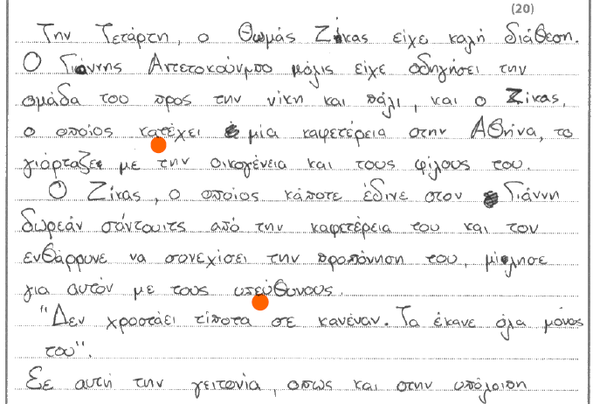

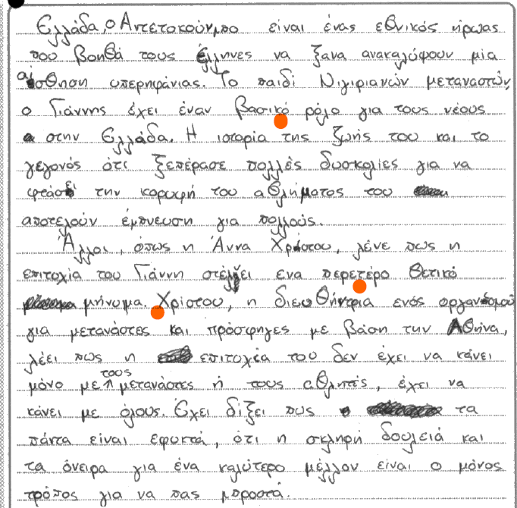

Question 2(a)

Content and Communication: 12
Quality of Language: 11
Total: 23

This is a good response that addressed in some detail the requirements of the question, which were to discuss the impact of the modern way of life and answer the questions that the blogger poses in the short stimulus text.

The piece is coherent, and the ideas follow a logical sequence, albeit with occasional omissions and shift of focus from the topic, which is the modern way of life, rather than just technology. For example, the first two paragraphs of the main part of the essay on page 6 conclude correctly that technology is something that we should exercise a degree of control over, to avoid negative repercussions, such as addiction and isolation. This argument, however, does not offer any details as to how this might happen, and, as such, the point remains undeveloped. The essay continues in a similar vein, staying within the broad framework of the question, but posing questions instead of answering them with examples. The issue of “the meaning of life” is skirted over and the candidate tends to repeat some of the ideas mentioned in the source text, without enough new contributions that might earn them marks from a higher tier. There is good range of vocabulary and grammatical structures generally used appropriately and effectively to address the needs of the task. Occasional lapses in lexical and grammatical control and some reliance on unambitious structures and vocabulary do not affect the comprehensibility of the piece.

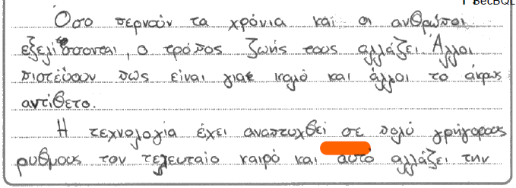

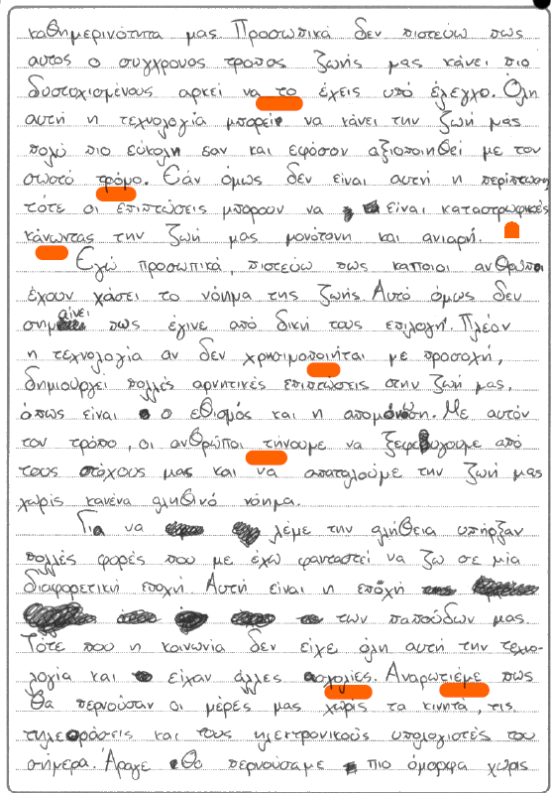
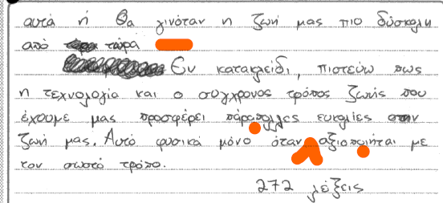
Question 7(b)

Content and Communication: 7
Quality of language: 5
Critical analysis, organisation and development: 8

This is a good response that earned 20 out of the available 30 marks. The poems selected are appropriate for the required focus, the treatment of love, and the candidate adopted an efficient way to organise the response in separate paragraphs, each tackling a different poem. The piece is coherent, comprehensible and stays clear of digressions and irrelevance. Areas of weakness have to do with omissions in the development of the argument, with regard to Η αρχή των, in particular, and the links between the description presented and the critical conclusions required at this level of competence. The candidate is clearly focused on the topic, but as in the response to question 2b, there is not adequate depth and substantiation to merit marks from higher bands that require a full evaluation in response to the question and conclusive remarks that are justified by preceding arguments.

In terms of content and communication, there is evidence of good factual knowledge of the poems, particularly with regard to the first poem under discussion, Μέρες του 1896, demonstrated through descriptive summaries and only one direct quotation from one poem, the word σεμνότυφη. Knowledge of the last two poems is hampered by a preference for description without links to an argument and absence of direct quotations, even minimal ones, which is what is expected in this question. In fact, the discussion of the last poem Η αρχή των fails to explain the relevance of the title, which is at the crux of a critical analysis of the poem, and to identify the significance of desire as the experience that inspires poetic imagination. Similarly, the treatment of Ο Ήλιος του Απογεύματος, despite the detailed description of what transpires in the poem and a cursory reference to the ending of the affair, remains undeveloped, as the candidate does not formulate a lucid argument about the transient nature of relationships. The conclusive remarks make a hasty and not very eloquently articulated reference to claims which are pertinent, but, unfortunately, not fully substantiated by the essay content.

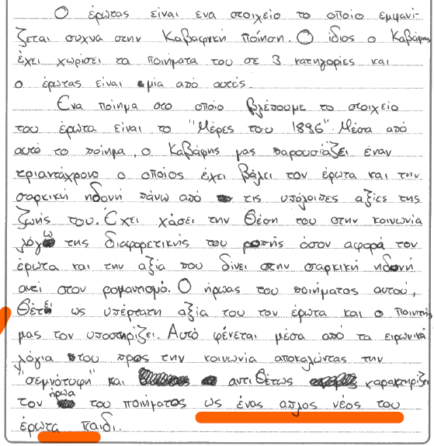
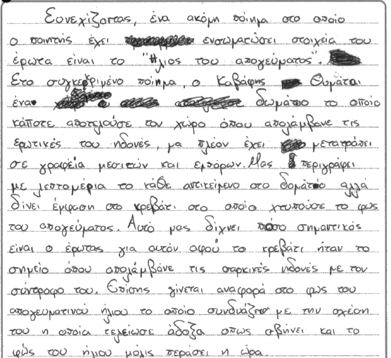
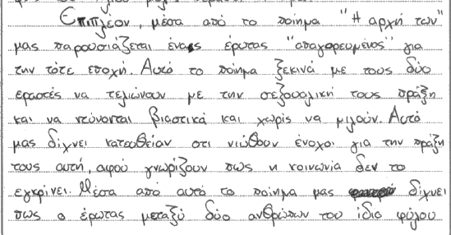
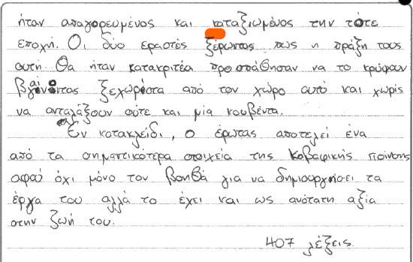

Sample Script 2
Total Mark: 63

Question 1

Part 1: 9
Part 2: 9
Total: 18

The translation is marked by overall excellent communication and use of correct vocabulary and grammar. Despite an awkward start with ήταν σε καλή διάθεση and καθοδηγήσει, the first part reads well, spelling is generally accurate and there is no miscommunication of meaning.
The second part shows excellent command of language, with one intrusive error, βασίζεται, which impacts meaning and stops the candidate from earning full marks.

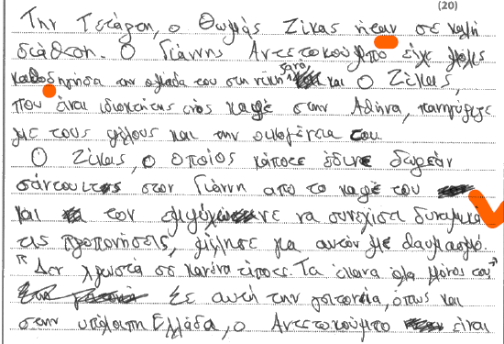

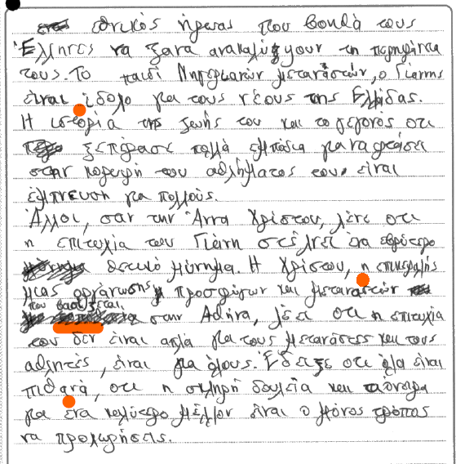

Question 2(a)

Content and Communication: 9
Quality of Language: 12
Total: 21

This is a clear and individual response, with only a partial focus on the topic and some digression and omissions. As has often been the case with responses to this question, this candidate too approached the issue in a one-dimensional way, discussing one aspect of technology, instead of the modern way of life in general. The source text poses questions and claims that candidates are expected to grapple with and offer their views on and what we have here is an indirect way of addressing these through personal experience, rather than through a discursive essay.
The piece, even though partly relevant, focuses on the use of mobile phones and does not venture into other areas of what living in this day and age consists of. Because of these omissions and a somewhat inappropriate style of response, a clearly able candidate, did not manage to earn marks from the top tiers of the assessment grid.

The mark of 12 for quality of language reflects appropriately the candidate’s performance, which is characterised by a wide range of vocabulary and grammatical structures generally used appropriately and effectively to address the needs of the task. Occasional lapses in lexical control render the tone of the essay overly dramatic or inappropriate and affect meaning; for example, δεν είχα κάποιο λόγο επιβίωσης, τον ήλιο που έβραζε το άσπρο μου δέρμα etc.

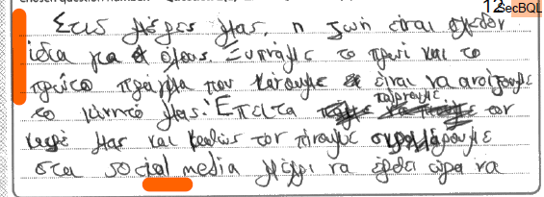

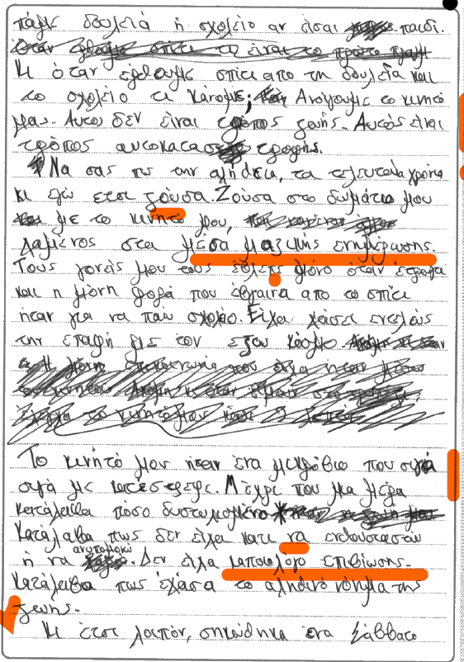

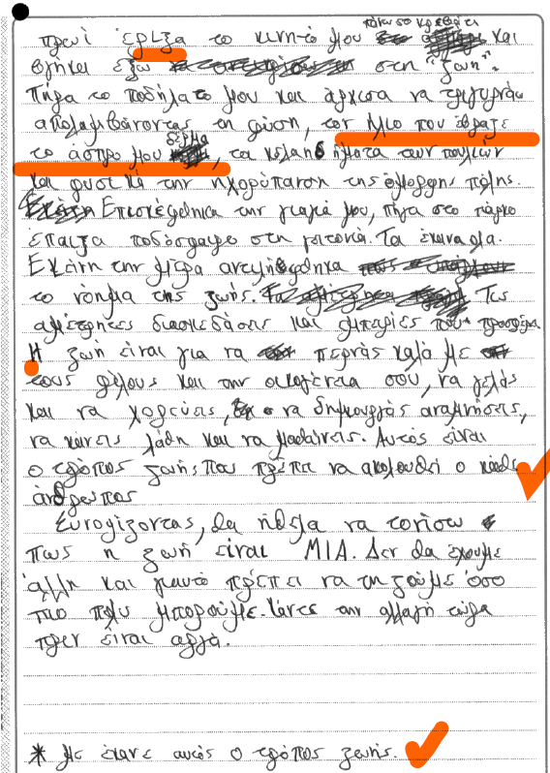

Question 4(b)

Content and Communication: 8
Quality of language: 5
Critical analysis, organisation and development: 11

The candidate has shown good factual knowledge of the topic with a good range of relevant supporting evidence and depth in the response. The treatment of the issues around the three plans engineered by Harding, Radcliffe and MacMillan is comprehensive, albeit a little hasty at times and with some omissions. For example, one of the important issues in the disagreement between Harding and Makarios, which had to do with Harding’s refusal to allow a Greek-Cypriot majority in the parliament, is not mentioned, when in fact it was a major reason behind the failure of the diplomatic negotiations. The reference to the UN appeals could have benefited from some development, both in terms of supporting details and in terms of their critical role.
In general, the essay offers good critical analysis in response to the question with mostly justified links between facts and points made.

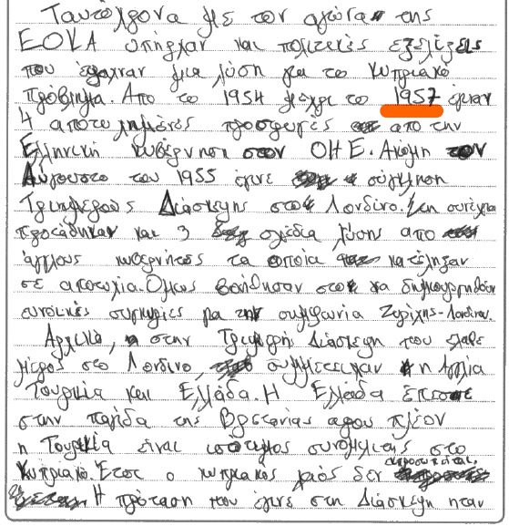
Examples of essays from Section C that achieved high marks.

#1
Question 4(a)
Content and Communication: 10
Quality of language: 5
Critical analysis, organisation and development: 15
Total marks: 30

This is a purposeful, comprehensive and well-organised response that frames the events under scrutiny clearly, citing their causes and their aftermath with abundant detail. Despite the occasional factual carelessness, it was impressive to witness the scope of the answer and the candidate’s emphasis on providing consistently justified links between ideas, leading to a well-organised and coherently developed argument throughout. Even though the breadth of the response exceeds expectations, leading into the 1950s and ‘60s, the candidate never loses sight of the question and succeeds in making convincing connections between their argument and the events they describe.
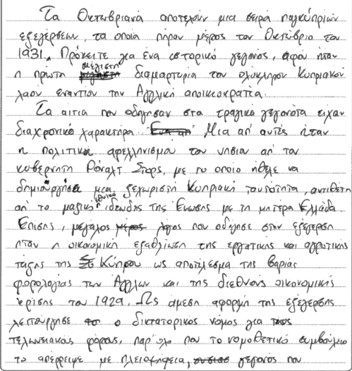
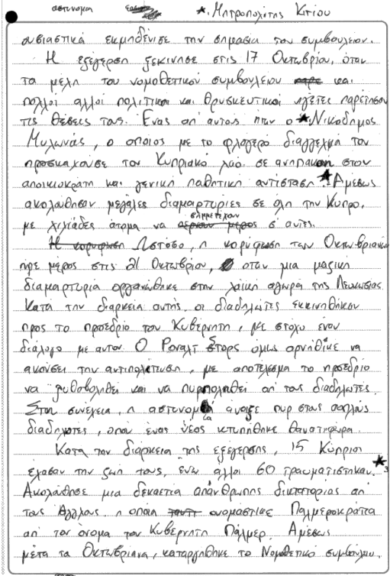

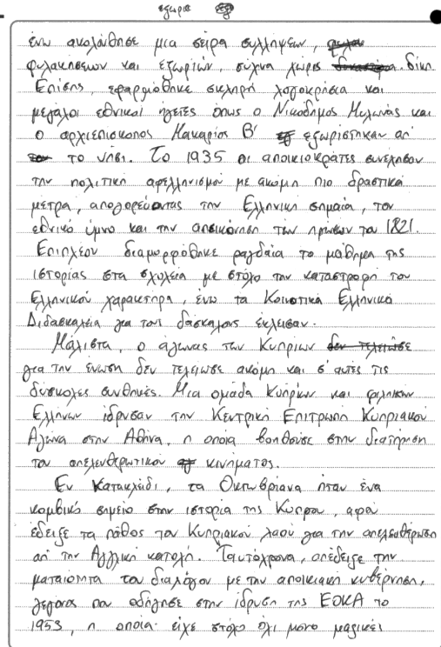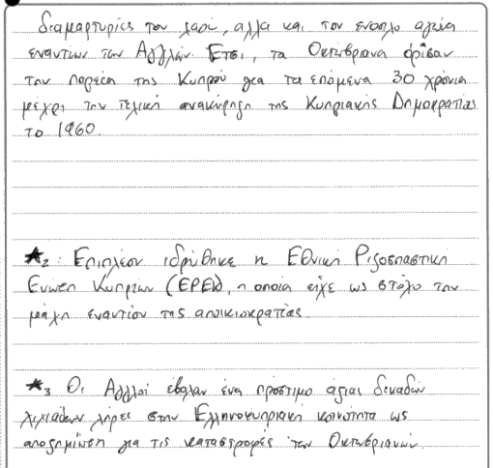

#2
Question 6(a)

Content and Communication: 10
Quality of language: 5
Critical analysis, organisation and development: 12
Total marks: 27

This is a response that shows excellent knowledge of the films, coherent organisation and development of ideas and mostly justified links between the information presented and its relevance to the question that is being asked: the impact of various forms of separation on the protagonists.
The introduction is cogent, succinct and relevant and the conclusion follows naturally from the preceding arguments. The main part of the essay is clearly organised into three parts, each addressing the theme in relation to a different film. Even though there is no irrelevance in the somewhat lengthy descriptions, there is a tendency to stop shy of drawing a conclusion that links all three films with the common thread of a new realisation and coming to terms with the new reality that comes after the trauma of separation. In Ένα τραγούδι δεν φτάνει the development that opens up a path to the reconciliation between Olga and Eirini is left our completely, therefore weakening an otherwise lucid, relevant and aptly substantiated treatment of the topic.

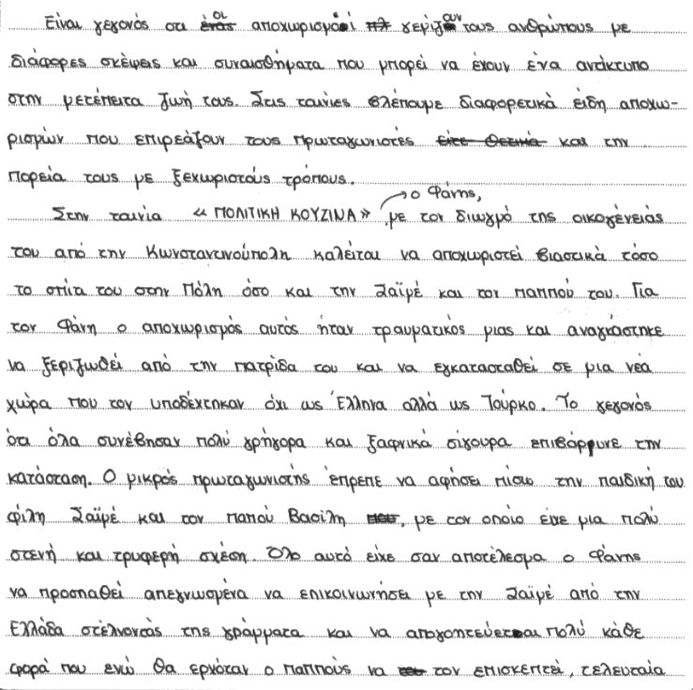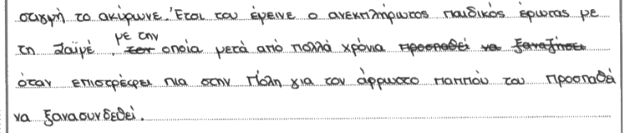

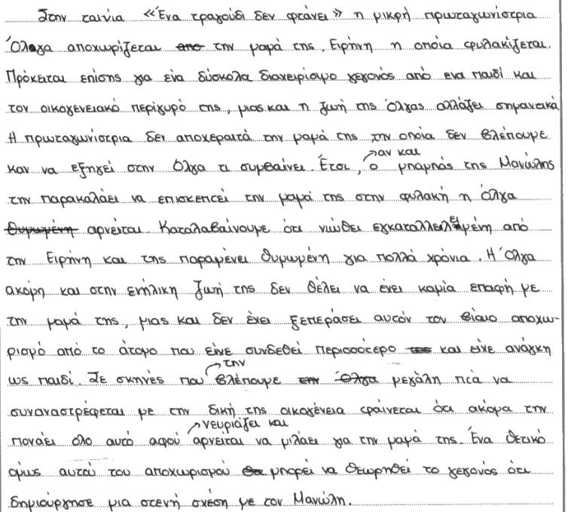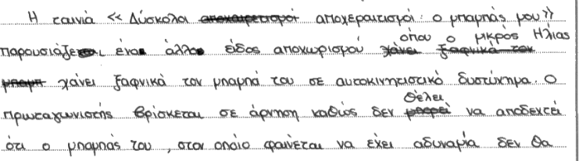

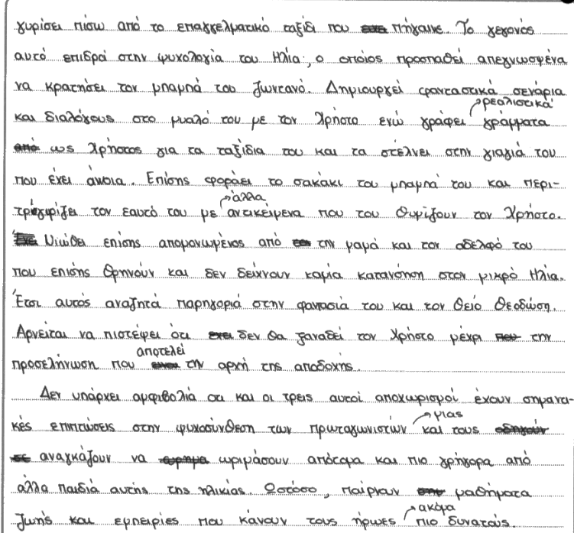

GRADE C

Sample Script 1
Total Mark: 48

Question 1

Part 1: 6
Part 2: 7
Total: 13

The mark of 13 for this translation reflects acceptable and occasionally good use of grammar and lexis with lapses that occasionally hinder and obscure meaning. Communication is at times strained due to mistranslations of individual words or expressions, but some meaning emerges; for example, είχε μια καφετερία (instead of έχει), τον έπισε (instead of ενθάρρυνε), πέρασαι πολλά εμπόδια (instead of ξεπέρασε). Often, however, use of incorrect vocabulary and omissions obscure or alter meaning significantly; for example, ήταν σε καλή όρεξη, μόλις είχε γυρίσει, με αυτοπεπίθηση, τη σημασία των ομόφιλων, εγκαταλίπτες, βασισμένο etc.
The last paragraph of part 2, in particular, is rife with lapses, to the extent that very little meaning emerges. As such, my assessment is that the second part of this translation was slightly overmarked.

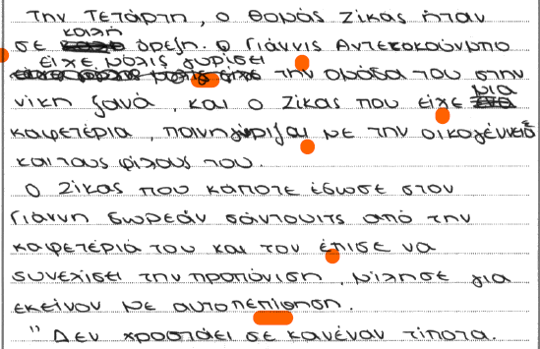

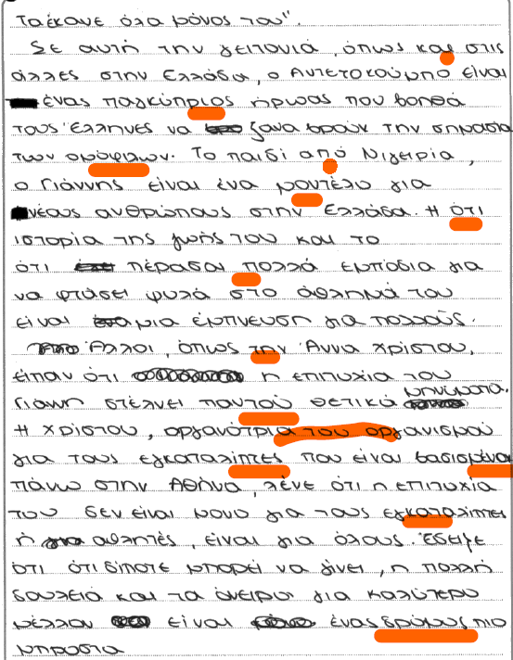

Question 2(a)

Content and Communication: 11
Quality of Language: 11
Total: 22

The mark of 22 reflects the ability to compose a comprehensible response with pertinent details that sometimes follow a logical sequence, expressed through a good range of vocabulary and grammatical structures. Occasional lapses in spelling pertaining to grammatical inflections and high frequency vocabulary do not impact meaning significantly. The response addresses many aspects of how modern life affects individuals, with examples that range from misuse of technology, to changes in family life and the generational gap caused by stressful routines and lack of communication. There is some evidence of a tentative engagement with the questions asked in the source text, but this remains undeveloped or contains omissions. Some claims appear as ungrounded conclusions, as there has not been enough explanation expressed in a logical sequence to substantiate them; for example, the reference to living in a different era focuses entirely on technology and the use of mobile phones and ignores other aspects alluded to immediately before, such as the way family life has ‘lost its real meaning’; a concept which is also not properly integrated into the sequence of ideas in this essay.
Occasionally, grammar and syntax work against a more eloquent and persuasive expression, with sentences that are hastily put together and do not do justice to the ideas that the candidate attempts to express; for example, αυτό αφορά όλους γύρω τους (perhaps επηρεάζει instead of αφορά?); αυτό έρχεται λόγω της δουλειάς (perhaps ‘συμβαίνει’ instead of έρχεται, and also, whose ‘work’?); μπορεί να μην είχαν καλή μέρα (who is being referred to here?), etc.

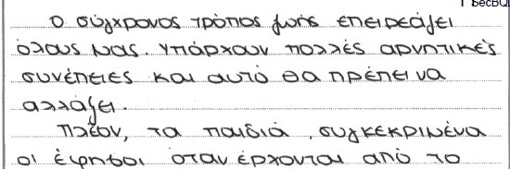
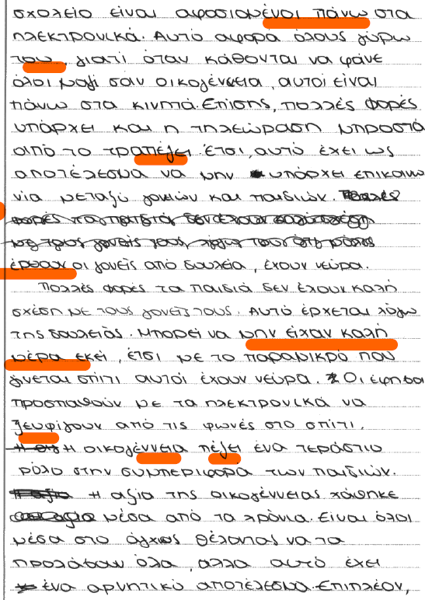
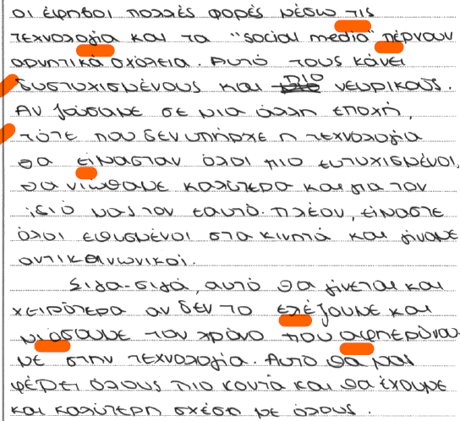

Question 7(b)

Content and Communication: 3
Quality of language: 4
Critical analysis, organisation and development: 6
Total: 13

The marks of 3 for content and communication and 6 for critical analysis reflect the qualities of this response accurately. This is a brief essay, marked by basic and often superficial knowledge of the poems with limited or no supporting evidence. There is limited depth in the response and the links between description and argument are forced and mostly unjustified. Conclusive remarks are clumsily expressed and only tangentially linked to the essay content. The discussion of the three poems is reliant on broad and superficial details that all seem to blend with one another. As such, there is not enough evidence of close reading and the brief points that are made remain undeveloped and generic.

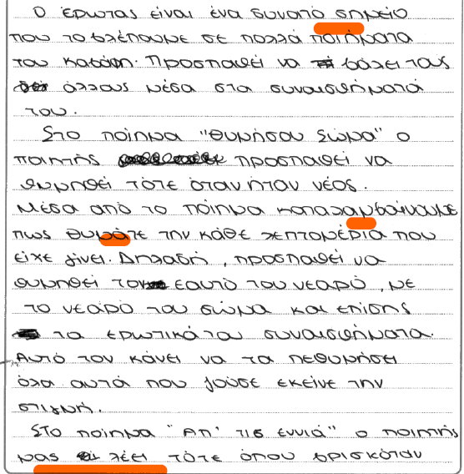
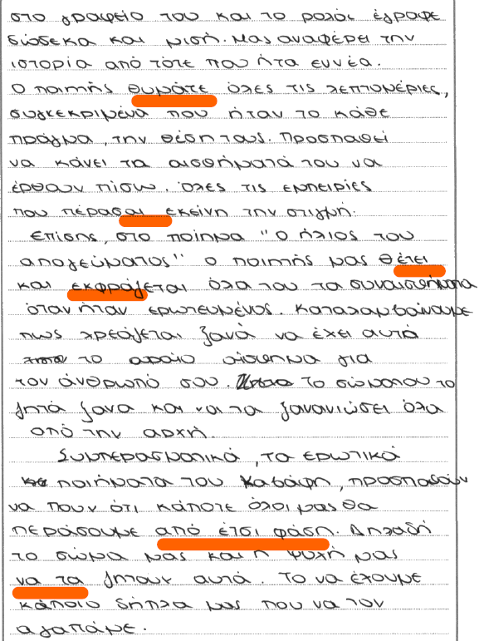

Sample Script 2
Total Mark: 49

Question 1

Part 1: 8
Part 2: 6
Total: 14

The first part of the translation shows mostly good use of correct vocabulary and grammar with occasional lapses in structure/lexis that affect meaning. In particular, the rendering of ‘victory’ and ‘training’ as δόξα and καλή δουλειά respectively, the translation of a past tense with a present tense, accompanied by use of incorrect vocabulary (μιλά γι’ αυτόν με σεβασμό) are examples of these lapses. Overall, however, despite these errors, communication in part 1 is sound.

Part 2 is not as successfully translated as part 1 with more frequent lapses, even in high frequency words, such as migrants and refugees which have dominated the Greek media for decades. The last paragraph, in particular, is marked by successive errors and slips, for example the omission of “his”, which alters the meaning, the translation of ‘an organisation’ as της διοργάνωσης, etc.

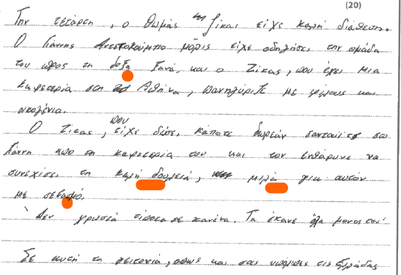
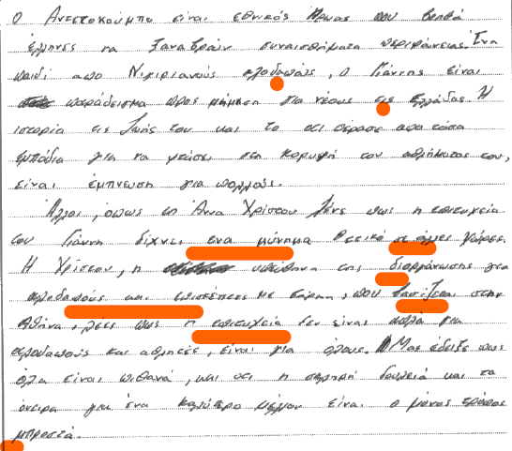

Question 2(a)

Content and Communication: 7
Quality of Language: 8
Total: 15

The essay is comprehensible, but this cannot compensate for the amount of digression from the requirements of the question and the shift of focus to the abuse of mobile phones and electronic devices, which is only one aspect of the issue under scrutiny. The candidate completely ignores the questions posed by the blogger and adopts an unnecessarily dramatic tone (e.g. όλοι μαζί με μια γροθιά), which would have been more fitting in a different type of essay. Even though the purpose of the argument is clear throughout, it is a purpose attached only to the overuse of technology and fails to address other parameters that frame our modern way of life; for example, long hours of work, lack of contact with loved ones, consumerism etc. In addition, other than a brief reference to the claim that technology “makes us forget”, there are no concrete examples of the perils associated with electronic devices.
The mark of 8 for the quality of language reflects an ability to handle a range of vocabulary and grammar in a satisfactory way, but also a noticeable carelessness in syntax, expression and in the use of complex structures; for example, δεν μας αφήνει να φτάσουμε, συμβάλλουν με αυτό το γεγονός, θα κυριαρχήσει τους ανθρώπους, etc. Moreover, for the quality of language to be rewarded from the higher tiers of the assessment criteria, the language needs to address the needs of the specific task; which is not the case here.

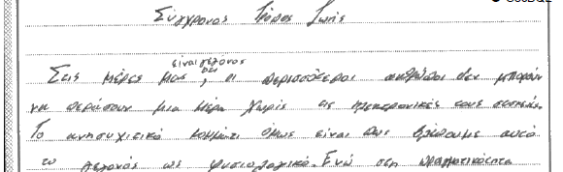

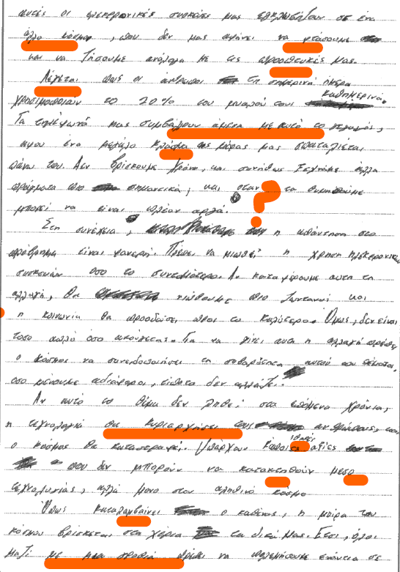

Question 7(a)

Content and Communication: 7
Quality of language: 5
Critical analysis, organisation and development: 8
Total: 20

The mark of 7 for content and communication and 8 for critical analysis reflect the candidate’s good factual knowledge of the poems, evidenced by descriptive summaries of key events, personalities and themes in three different poems, and some justified links between these descriptions and the points made. There are no supporting quotations to substantiate these descriptions, and there is no consistent evidence of depth in the response, as some of the conclusions drawn are basic. For example, the summing up of what transpires in ‘Waiting for the Barbarians’ is rather drawn out and the brief conclusive remark fails to address the intricate message of the poem, which includes the inherent critique of vanity and superficiality that characterise political leaderships. The discussion of the poem Το πρώτο σκαλί lists the symbols employed in the poem and what they stand for but does not develop into a cogent argument that identifies the deeper meanings that this symbolism conveys. The discussion of Η μάχη της Μαγνησίας identifies Cavafy’s use of history to convey a message, but this point is too similar to the point made in the discussion of Περιμένοντας τους Βαρβάρους and this overlap does not contribute much new to the argument. In addition, other more obvious aspects of Cavafy’s poetry (the use of irony, for example) are left out.

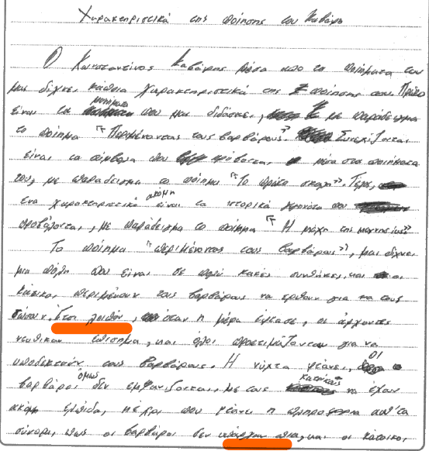

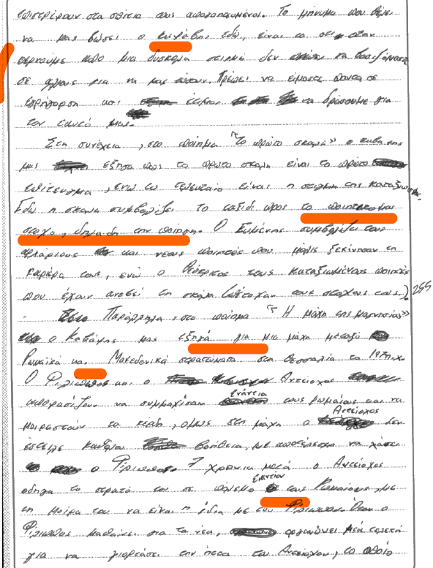

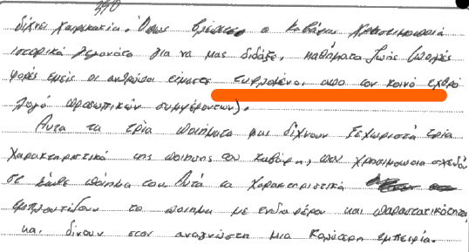

Sample Script 3
Total Mark: 50

Question 1

Part 1: 6
Part 2: 5
Total: 11

The first part of the translation is slightly better than the second one, with frequent evidence of good use of correct vocabulary and grammar and occasional lapses in structure/lexis that affect meaning in certain parts, whereas in others they simply impact the fluency of the piece. In particular, the rendering of ‘celebrated’ as διασκέδαζε still conveys a similar sentiment, but, elsewhere, the incorrect translation of ‘encouraged’, ‘admiration’ and “neighbourhood”, for example, show insecure knowledge of common vocabulary. The last sentence of part one, in particular, is impacted by serious lapses in vocabulary, grammar and spelling; for example, βοηθούσε instead of βοήθησε, ίδως instead of είδος and τιμής instead of υπερηφάνειας. Overall, however, communication is achieved.

The second part of the translation is marked by acceptable use of correct vocabulary and grammar in the penultimate paragraph but some basic errors which interfere with meaning in the last paragraph. In particular, words such as migrants, refugees, director, based, and hard are either mis rendered or not translated at all. Within the context that these words occur, such lapses either impact or obscure meaning; as, for example, in the sentence “Christou, the director… about everyone”. In this respect, the mark awarded reflects the fact that, in part, meaning does not emerge on account of errors.

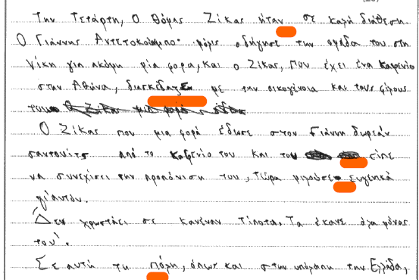

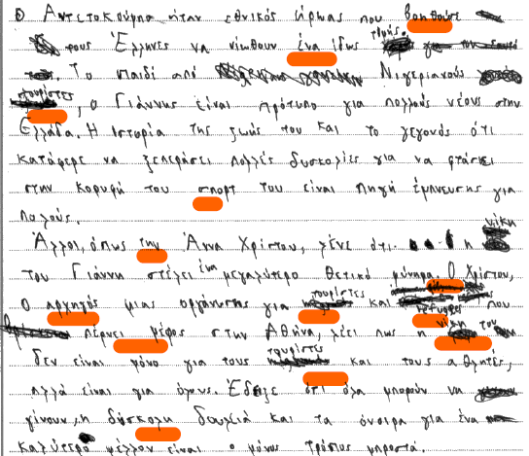

Question 2(a)

Content and Communication: 10
Quality of Language: 12
Total: 22

The mark of 10 for content and communication reflects the essay’s comprehensibility, coherence and relevance to the question. As with many other examples, the candidate’s focus remains fixed on technology and social media, but there is a concerted effort to answer the questions posed by the blogger, albeit in a cursory and, at times, superficial manner. The strengths of the response are to be found in the concrete examples about the impact of social media on the lives of users and the tentative treatment of the issues contained in some of the questions of the source text, in particular the degree to which technology causes unhappiness. On the other hand, the repetition, absence of detail and development in the responses about the ‘meaning of life’ and a conclusion that is not fully substantiated by the preceding content are the essay’s weaknesses.

The mark of 12 for quality of language reflects the candidate’s good range and mostly appropriate use of vocabulary and grammatical structures to address the needs of the task. Occasional lapses in lexical and grammatical control pertain to poor spelling of grammatical inflections and awkwardness in expression and collocations; for example, λόγο, μας έκανε να μην διαπιστόνουμε, ευτηχισμένη, etc.



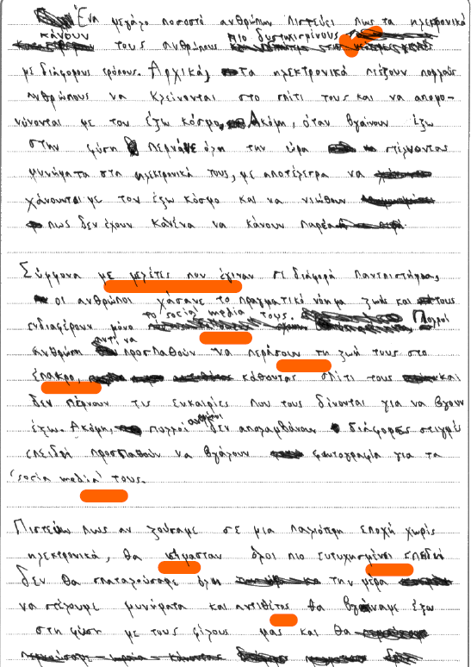
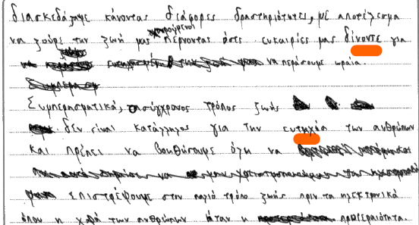
Question 7(b)

Content and Communication: 6
Quality of language: 4
Critical analysis, organisation and development: 7
Total: 17

The mark of 6 for content and communication and 7 for critical analysis reflect the essay’s qualities: acceptable knowledge of the poems with occasional but superficial supporting evidence, some justified links between the content and ideas and a weak link between the conclusive remarks and the essay content.
The introduction makes a claim that cannot be applied universally to the so called “love poems”, as the power of love and desire as a stimulus for poetic creation is only one aspect of the way Cavafy treats the theme of love. The discussion of Θυμήσου σώμα is mostly descriptive, containing repetitions and language which is not entirely appropriate to the style expected in an essay. The conclusion, that love brings enjoyment, is basic and does not articulate the main idea, about the power of memory to offset the ills of aging and the loss of love and youth. The discussion of Ο ήλιος του απογεύματος and Η αρχή των shares similar characteristics. It stays descriptive without distinguishing details or direct quotations from the poems, favours repetition and shows that perhaps the candidate did not have enough practice in composing literary essays.

The content is broadly correct, but it lacks the depth and the specificity that would allow it to merit higher marks. In addition, language is often applied inconsistently and intrusive grammatical errors and some clumsiness in expression, as well as the lack of specialist terms and appropriate style, resulted in the rare occasion of rewarding the candidate with a 4 for quality of language (the majority of candidates for this qualification achieve full marks for this category).

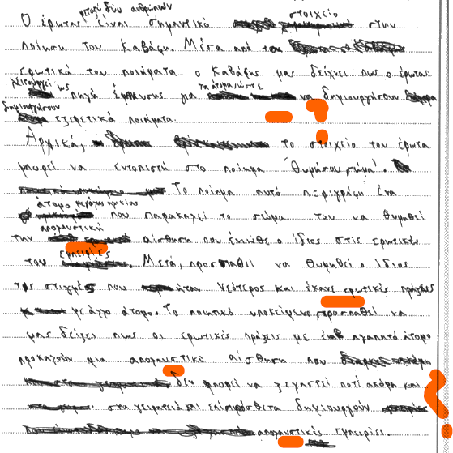
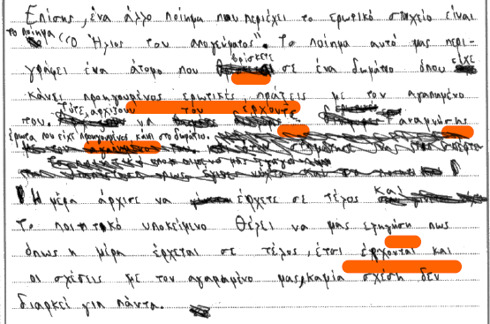

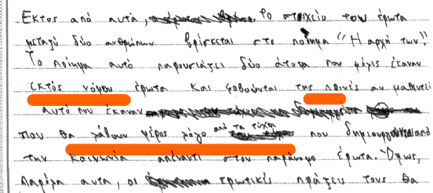
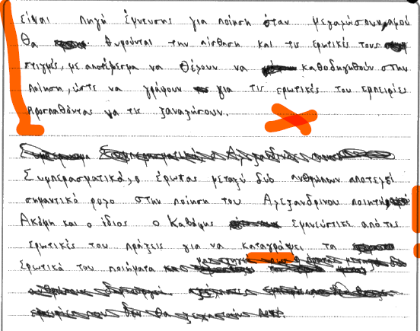

Additional example of a response that achieved marks representative of a C grade.

#1
Question 4(b)

Content and Communication: 5
Quality of language: 4
Critical analysis, organisation and development: 5
Total marks: 14

This essay contains barely acceptable material to address the needs of the question. The introduction ignores the time parameters of 1954-1958 and cites efforts between 1954-1955 that focus on the idea of Enosis, which is not quite what the question requires.

The information presented is often superficial and it suffers from lack of factual detail, such as dates and the names of important stakeholders and diplomatic initiatives (for example, the 1954 appeal to the UN, the 1955 tripartite conference on Cyprus in London, the Marshall plan, etc.) and skirts over the issue of how the demand for Enosis transitioned into the declaration of independence. There is some critical engagement with the issue through the framing of Enosis as a driving force for many of the diplomatic efforts and a tentative conclusion that comes abruptly and without enough justification.

In terms of application of language, there is not adequate relevant material for the candidate to merit marks from the top band.

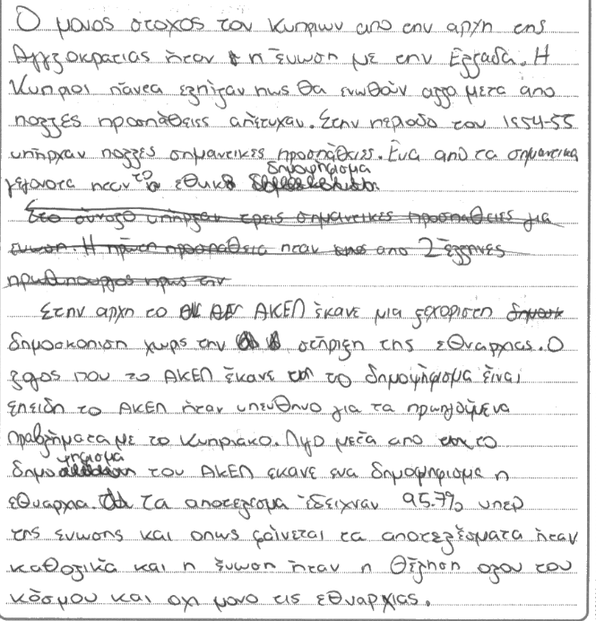

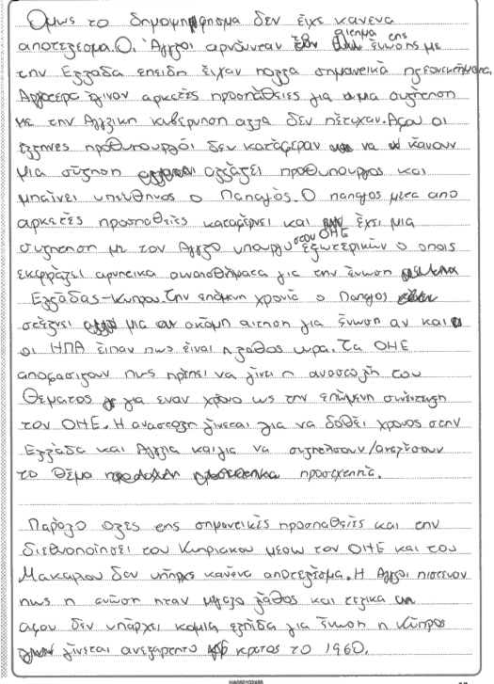

Grade E

Sample Script 1
Total Mark: 35

Question 1

Part 1: 7
Part 2: 7
Total: 14

This is a good example of a translation that communicates the overall meaning of the source text, despite frequent, small lapses in vocabulary. The candidate may have occasionally erred in expression and grammar, but the errors are usually not intrusive and do not obscure meaning significantly. Overall, the translation is more correct than incorrect with evidence of the familiar patterns of mistranslation and unsuccessful collocations that we encountered in A candidates also. For example, ήταν σε μια καλή διάθεση, αίσθηση χαράς, βασισμένο, etc.

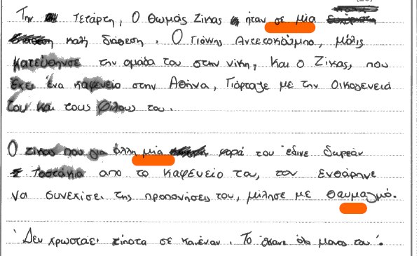
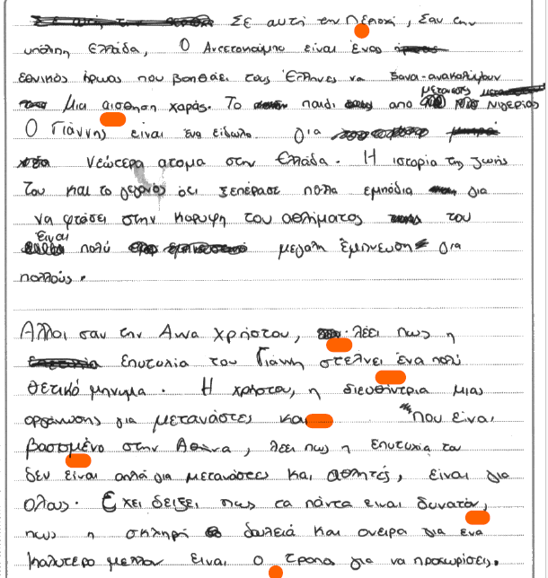

Question 2 (b)

Content and Communication: 9
Quality of Language: 10
Total: 19

Despite a good introduction and a generally comprehensible argument that situates the reader in the topic to be discussed, the essay is occasionally marked by poor organisation and omissions regarding aspects of the question; in particular the part where the candidates are asked to engage directly with some of the ideas contained in the stimulus text. In the introduction, there are references to a different era that was more appealing because of its fashion and lifestyle, but the argument does not stay focused on the reasons why one would be at home in a different era and instead transitions abruptly to an emphasis on the overuse of screens in today’s era. In addition, the conclusion is abrupt and inappropriate, ending on a confusing note about “οι γονείς μας ποτέ δεν θα καταλάβουν».
A generous 10 for quality of language, rewards a good range of vocabulary and grammatical structures that are unfortunately employed inconsistently and with varying degrees of success in terms of appropriacy of style and turn of phrase.

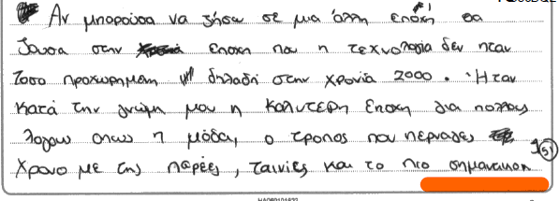

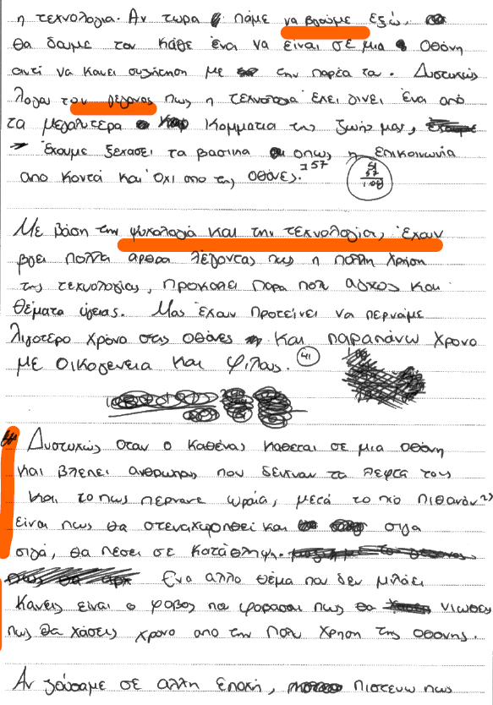

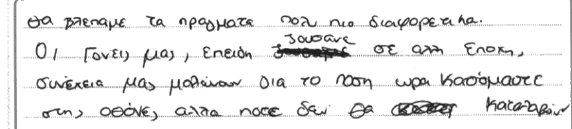

Question 3(b)

Content and Communication: 1
Quality of language: 1
Critical analysis, organisation and development: 0
Total: 2

This is a representative E response. The candidate relied on their language skills to enter this examination and there is no evidence of research on a topic or text. The generous 2 marks awarded, recognise the fact that the candidate wrote a few lines in Greek, which contained the name of an iconic figure in Greek music and culture.

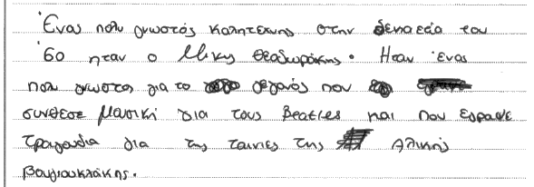

Sample Script 2
Total mark: 36

Question 1

Part 1: 3
Part 2: 4
Total: 7

The mark of 7 reflects a performance marked by occasional use of correct vocabulary and grammar and frequent lapses in basic structures/vocabulary. Overall, communication is infrequent due to weak language skills. Part 2 is slightly better than part 1, with some impressive stretches of correct vocabulary, for example, μεγάλο θετικό μήνυμα, η επιτυχία του δεν είναι μόνο … etc. Insecure knowledge of basic grammar (for example noun cases, verb tenses) and some confusion over the letters of the alphabet are responsible for many areas where meaning is obscured; for example, εδόκε ο Γιάννης ελέυθερα σαντοιτψ, δεν δοσει κανιαν etc.

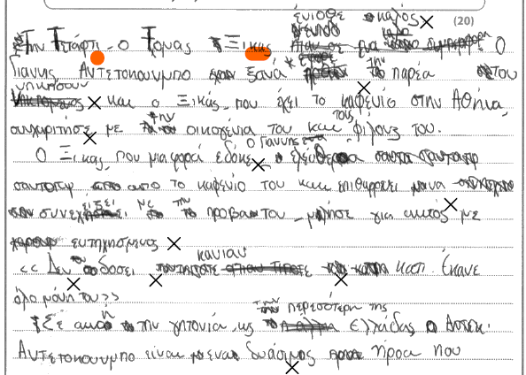
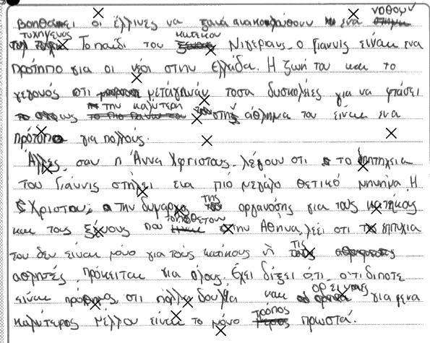

Question 2(a)

Content and Communication: 8
Quality of Language: 6
Total: 14

This response is clearly composed by someone with enough maturity and analytical skill to tackle the requirements of this question, but weak language skills get in the way of comprehensibility. The candidate understands what is expected, they try to answer the questions posed by the source text to the best of their ability, but incorrect application of language and vocabulary lead to confusion and possible misunderstanding. The phrase “η τεχνολογία δεν μας κανουμε δυστυχισμένους γιατί δεν ηνμπορούμε να ζούμε χωρίς την τεχνολογία και έτσι είναι λίγο κυνδινός…” suggests that the candidate attempts to answer the question “Μήπως τελικά τα μέιλ, η τεχνολογία και ο σύγχρονος τρόπος ζωής μας κάνουν δυστυχισμένους”, but, in fact, they probably end up articulating clumsily the opposite of what they intended to say. This results in a confusing non-sequitur which is corroborated further down, when one would expect that the conclusion of the first paragraph on page 6 should in fact be that ‘η τεχνολογία μας κάνει δυστυχισμένους’, but what is articulated is the opposite.

Similar examples of trying to grapple with the issues under scrutiny but being hampered by language skills are present throughout this essay. As such, this essay falls in the category of a response that is marked by: “Around a third of what is written will have shown the ability to express ideas in a form that would be comprehensible to a native reader…. The piece is occasionally coherent and while there is some digression from the topic, the overall theme or purpose is generally clear”.

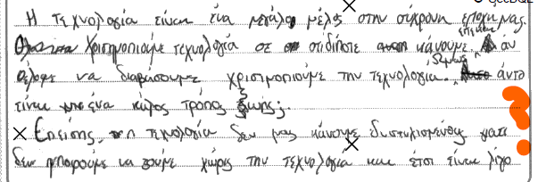
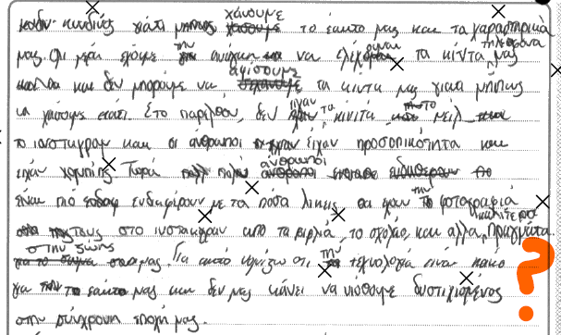
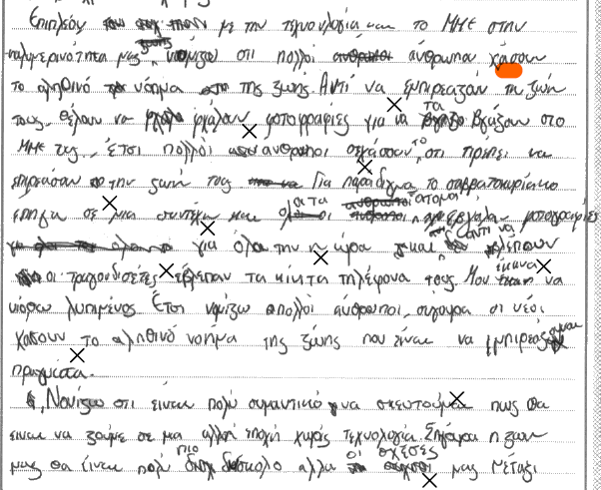
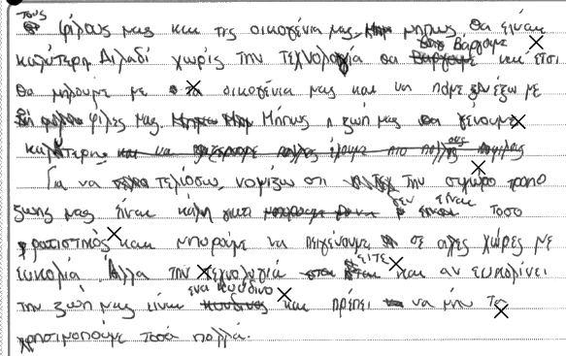

Question 7(b)

Content and Communication: 6
Quality of language: 3
Critical analysis, organisation and development: 6
Total: 15

This is an unusual response, but it is also very much in line with the type of answer we would come to expect from this candidate. One gets the impression that with one more year of study, this candidate would have been able to achieve a higher grade, as they clearly have the analytical and cognitive skills to compose pertinent responses. Unfortunately, in this response too, weak language skills impact meaning significantly and a lot of the relevance that is extracted is reliant on the examiner’s willingness to interpret and guess what the candidate means.

The essay contains what many other essays in this cohort did not: apt quotations that would have been excellent substantiating evidence, had the points they are attached to been expressed in a clear and comprehensible way. The treatment of Θυμήσου σώμα on page 12 is a good example of this pattern of articulating a thought that has the makings of relevance, which, however, ultimately fails to be persuasive because of its incomprehensibility. In this respect, despite its ambitious tendencies, this essay can only be assessed as a ‘partial response’.

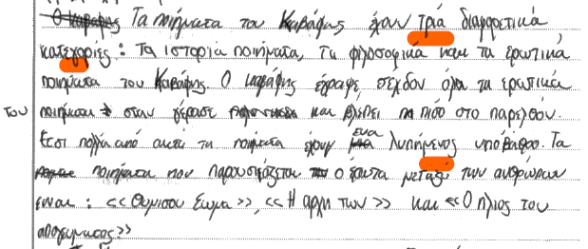

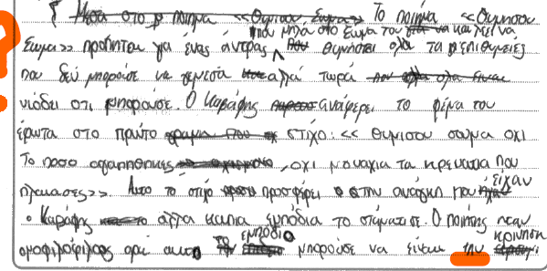
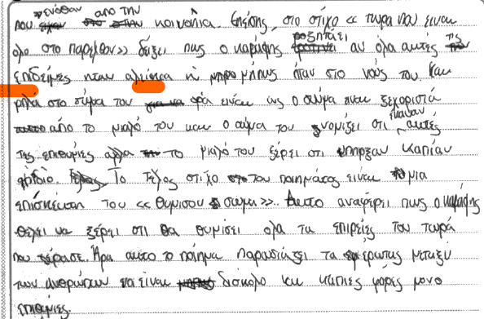

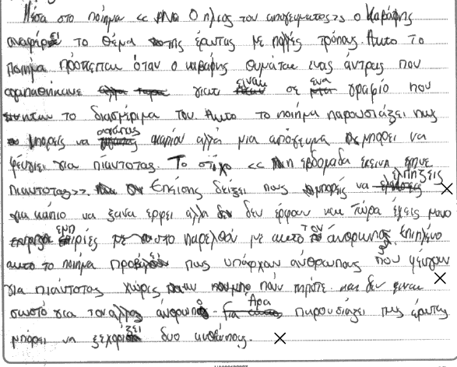

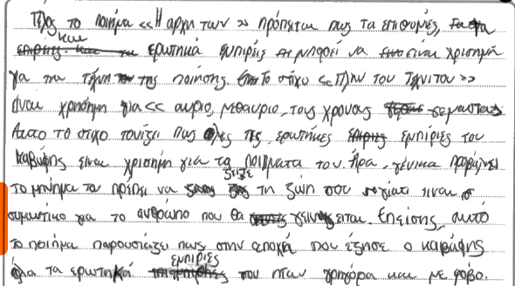

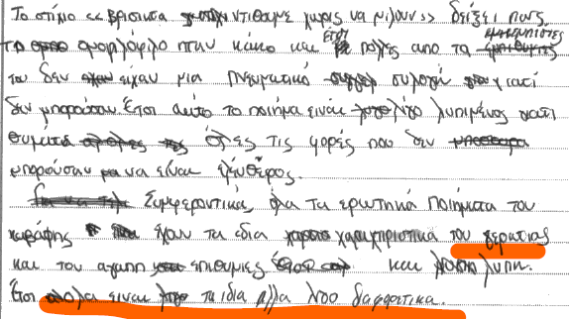

Additional examples of responses at E grade and below

#1
Question 1

Part 1: 4
Part 2: 4
Total: 8

In this translation some isolated words and short phrases are translated correctly but overall meaning is infrequent, as no single sentence can sustain accuracy, lexical or grammatical. The translation has been awarded a total of 8 on account of the candidate’s facility with basic vocabulary and structures.

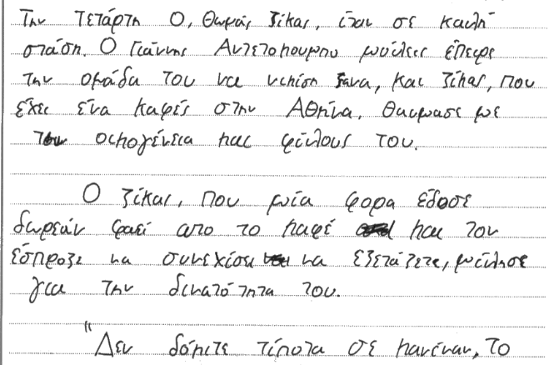

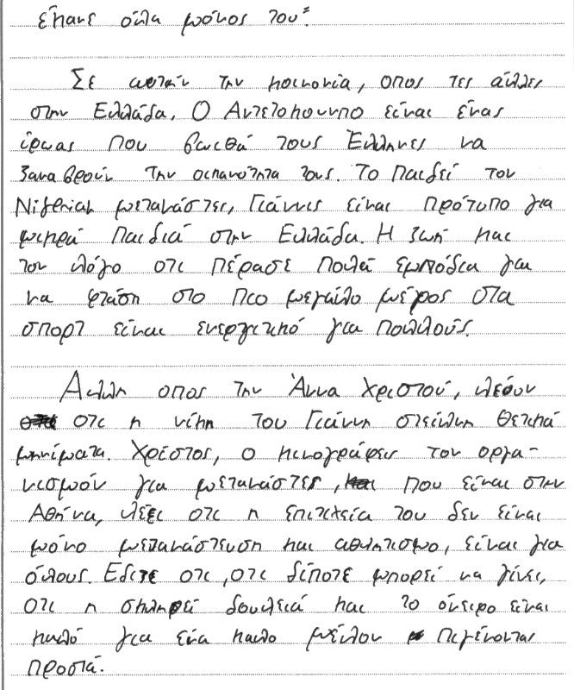

#2
Question 7(b)

Content and Communication: 1
Quality of language: 1
Critical analysis, organisation and development: 0
Total: 2

Question 7(b) invites the candidate to consider the portrayal of love and desire in the poems of Cavafy. This essay is completely off topic and discusses in a superficial and often vague way three poems that do not seem to be linked to the question or even relate thematically to one another. One can only assume that this was a prepared response. As such, the mark of 1 for content and communication recognises that there is minimal knowledge of relevant content and no relevant supporting evidence from the texts. Even though the candidate names three poems, it is clear that they do not understand the question or the poems themselves. Regarding critical analysis, because of the irrelevance of the response, there is no evidence of a critical, analytical understanding of the text in relation to the specific question. As such, the response was not worthy of credit.

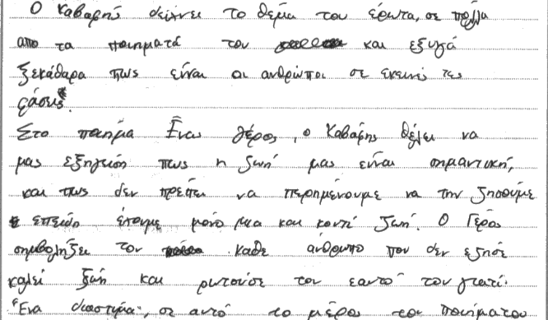
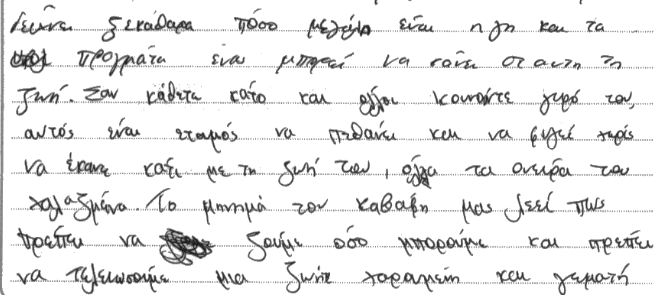
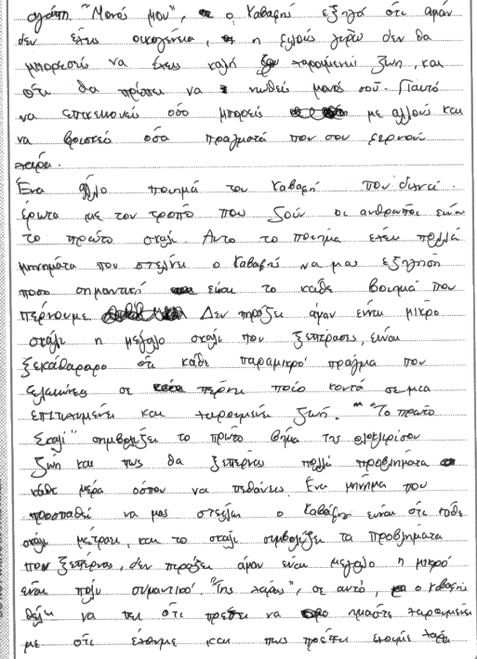
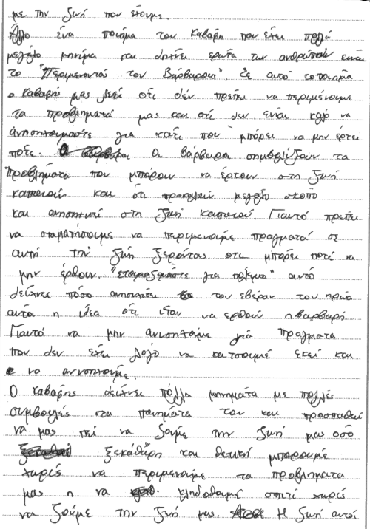
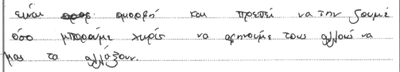

Pearson Education Limited. Registered company number 872828
with its registered office at 80 Strand, London, WC2R 0RL, United Kingdom

