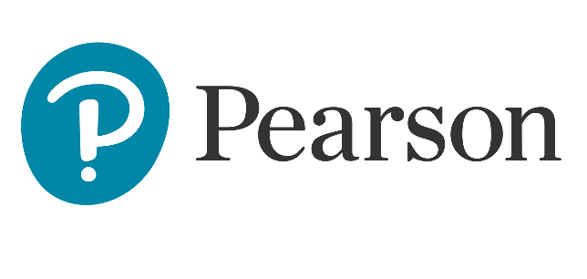

Comparison of key skills specifications 2000/2002 with 2004 standardsX015461July 2004Issue 1

Commentaries
June 2406

International A Level
In Greek (WGK01) Unit 1

Introduction

This paper is a two-and-a-half-hour examina􀆟on which is externally assessed and consists of three sections: Section A: Reading; Section B: Grammar; Section C: Writing.
Total marks for this paper are 80 and its weighting is 50% of the total IAL marks. It is available every June.

The students who study for this specification are required to demonstrate skills in the comprehension of written Greek (Section A), in the manipulation of Greek language, grammar and lexis (Section B), as well as in the production of a Greek-language discursive essay (Section C).

There are no options: all questions must be answered.
Content in Sections A, B and C draws from a variety of contexts and in relation to the following general topic areas:
- Youth matters
- Lifestyle, health and fitness
- Environment and travel
- Education and employment

In general, most students completed the paper successfully. They responded to the different sections of the paper showing good reading comprehension skills, good language usage skills and familiarity with the specification.

Please see below for detailed feedback on sample responses from the 2024 examination series.

GRADE A

Sample Script 1
Total marks: 56

Question 1
Total marks: 5
The candidate earned full marks in this multiple-choice question.

Question 2
Total marks: 5
The candidate earned full marks in this multiple-choice question.

Question 3
Total marks: 10
The candidate earned full marks in this multiple-choice question.

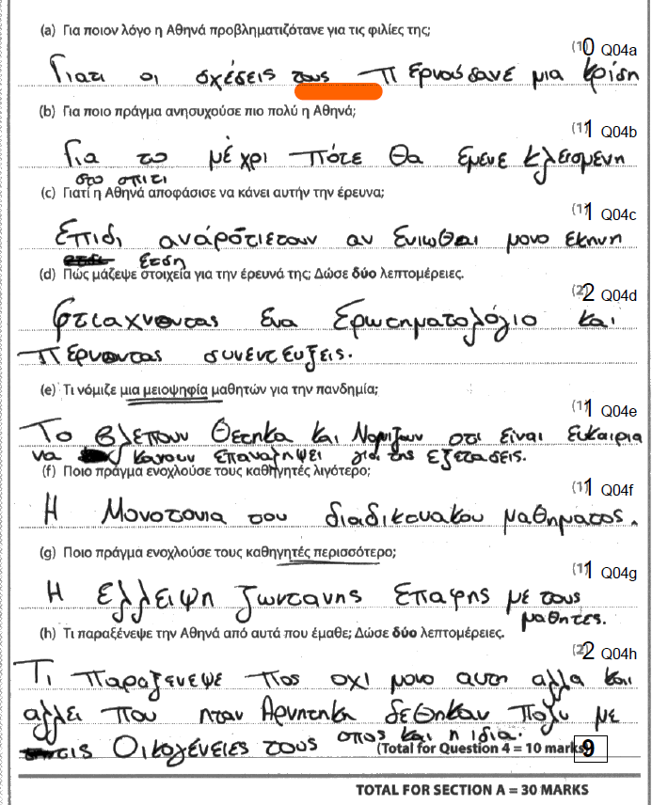
Question 4
Total marks: 9

This was a very good response. The candidate missed only one point when they answered question 4(a) without sufficient detail. The correct response would have identified the fact that Athena’s was worried about her friendships because she had not seen her friends for a long time. The response ‘οι σχέσεις τους περνούσανε μια κρίση’, in addition to being copied from the text almost verbatim, is tautologous to the question being asked- therefore it cannot serve as an answer, as it does not add anything new to the information.

Question 5
Total marks: 5

The candidate achieved half of the available 10 marks. Incorrect answers were:
c) The incorrect spelling of the article is not within tolerance.
e) The use of the present tense (είναι) instead of the past tense (ήταν) alters the meaning of the source text.
h) The use of με έμαθε is not correct, as the participle in Greek cannot serve as a subject to the verb. The correct form of the verb is έμαθα. In addition, the use of όλλους instead of άλλους is incorrect.
i) It seems that one mark was deducted because the position of the stress is not indicated correctly in half of the words.
j) The omission of αξέχαστο renders the sentence ambiguous and incomplete.

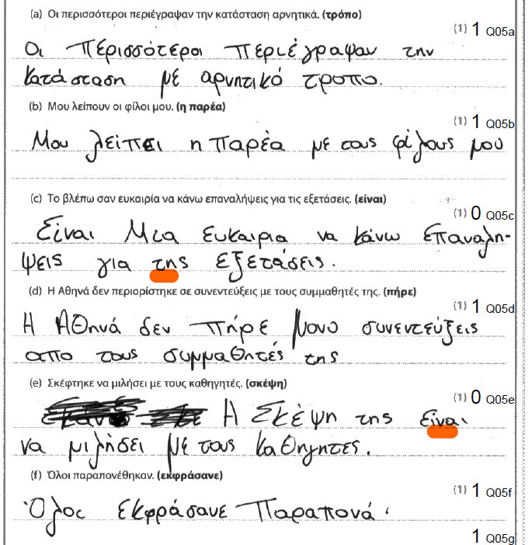
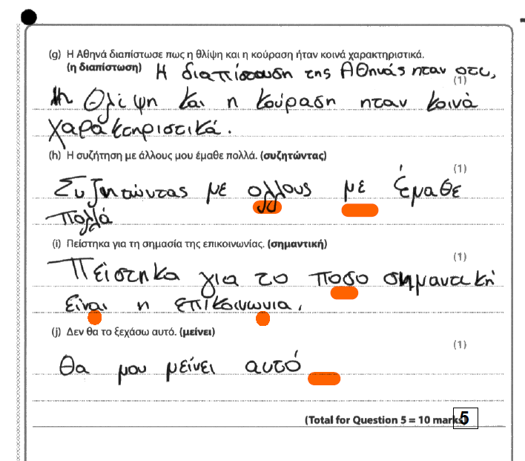

Question 6
Total marks: 4

The candidate made 6 mistakes in this exercise, which tests grammar skills alongside comprehension. These are:
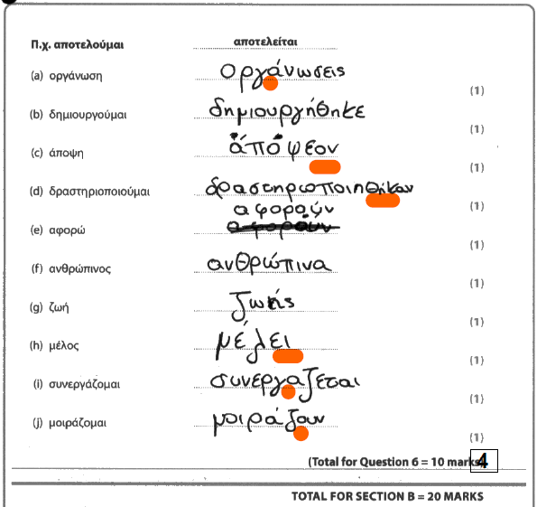
a) The position of the stress is incorrect. It should be οργανώσεις.
c) The genitive case is not indicated correctly. It should be απόψεων.
d) The verb form is incorrect. It should be δραστηριοποιούνται.
h) The inflection is incorrect. It should be μέλη
i) The position of the stress is not indicated.
j) The verb form is in the incorrect voice, active instead of passive. If the prompt is a verb, it should be left in the voice that is given. In this case, it should be μοιράζονται.

Question 7
Content and Communication: 10
Quality of Language: 8
Total: 18

In terms of content and communication, the essay is mostly coherent and has been awarded a generous 10. The response begins with an awkward introduction that contains a syntactical anomaly, the omission of που in order to lead into a relative clause and a transition from ‘one’, to ‘we’, to ‘you’ that affects the cohesion of the piece. In the main part of the essay, content is comprehensible and organised according to the given prompts. There is no digression from the topic, but the cohesion of the piece is marred by weak organisation skills, a relative lack of depth in the response and unjustified claims that seem to be forced. For example, the argument that everyone’s aim in life is to be like a chosen role model, which appears in the beginning on page 14, is hastily expressed and reads like a sweeping generalisation. The repeated emphasis on πειθαρχία detracts from the variety of ideas that one would expect at a higher level of competence. The middle paragraph on page 15 ends in conclusive remarks that shows little control on the ability to construct a cogent argument. The paragraph that discusses celebrity role models lacks depth and the reference to Τραπες at the bottom of page 15 (one can only assume that what is meant is Τράπερ) causes ambiguity. On the other hand, the paragraph that discusses the candidate’s chosen role model contains relevant and sensitively phrased material.

In terms of quality of language, the essay has been awarded a generous 8. Performance is marked with a certain facility in vocabulary use that could have been mistaken for fluency, had it not been for consistent, intrusive errors in grammatical inflection and common vocabulary, almost in every single line of the essay.
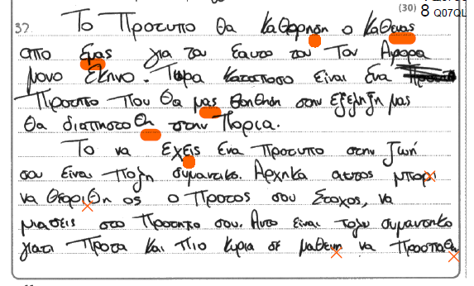
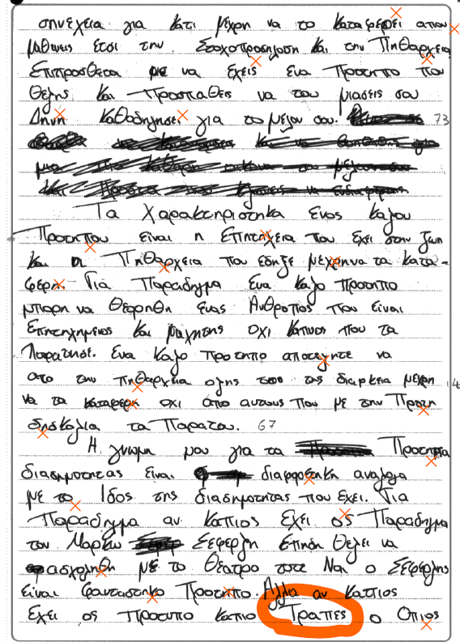

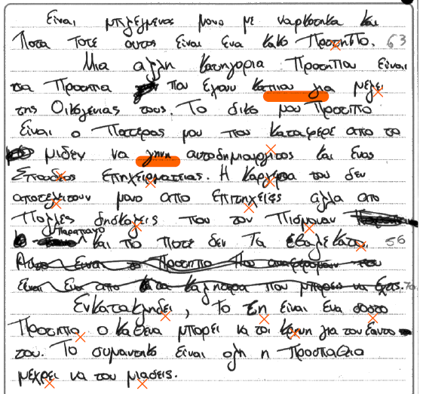

Sample Script 2
Total marks: 57

Question 1
Total marks: 5

The candidate earned full marks in this multiple-choice question.

Question 2
Total marks: 3

The candidate earned 3 marks out of 5. Incorrect responses were in sub questions a) and b) which went against the actual rubric that stated that the siblings still live in a village permanently; therefore, they could not have left. In addition, even though grammatically correct, the two sentences go against the semantic thread that runs through the text, which presents a point of view consistent with a positive outlook on village life.

Question 3
Total marks: 9

The candidate earned 9 marks out of 10 in this multiple-choice question. The incorrect response at 3 (e) wrongly identified συναντιόμουν instead of γνώριζα as the correct response. For συναντιόμουν to have been correct, the preposition με should have been present in the source text.

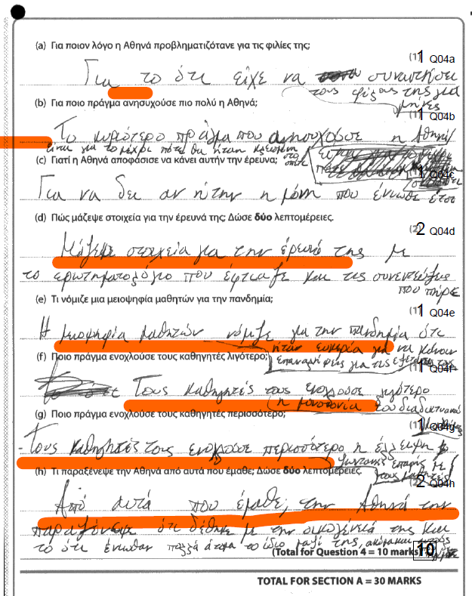
Question 4
Total marks: 10

This response that entails short answers in Greek gained full marks. One observation that needs to be stated is that the candidate’s answers are unnecessarily long and provide details beyond the scope of the questions.

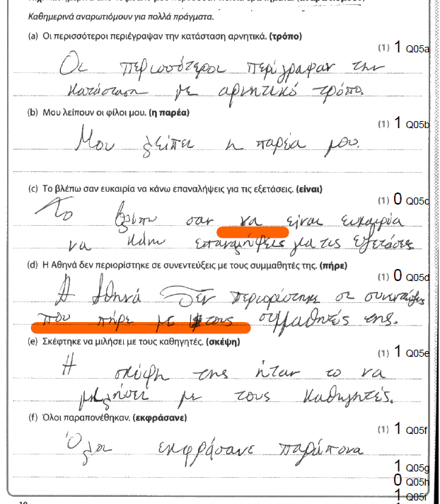
Question 5
Total marks: 7

In this grammar transformation exercise, the assessor identified three errors:
c) The inclusion of να είναι rendered the sentence incorrect.
d) The inclusion of που πήρε με altered the meaning of the sentence, as it suggests that Athena conducted the interviews together with her fellow students.
h) The use of με έμαθε is not correct as the participle in Greek cannot serve as a subject to the verb.

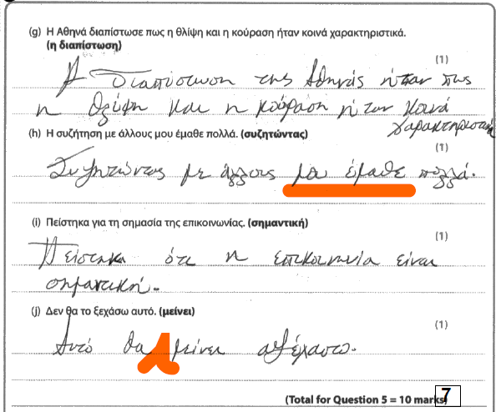

Question 6
Total marks: 7
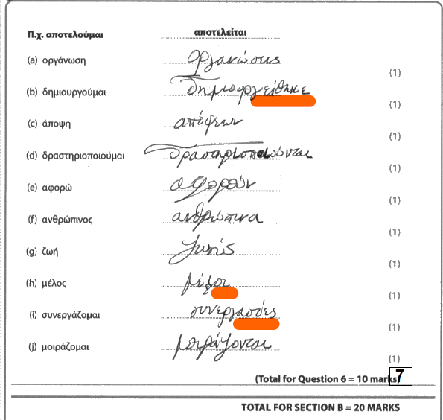
In this grammar fill-in-the gap exercise, there were three errors:
b) The spelling error in the inflection of the verb is not within tolerance.
h) The spelling error in the inflection of the noun is not within tolerance.
i) The use of the noun συνεργασίες instead of the verb form συνεργάζεται is incorrect.

Question 7
Content and Communication: 8
Quality of Language: 8
Total: 16

In this essay, the candidate has shown a moderate ability to express ideas in a form that would be comprehensible to a native reader. Even though there is some evidence of ideas following a logical sequence, there is not enough development of these ideas into a natural and grounded conclusion, or there is a breakdown in communication that renders some of these ideas incomplete or obscure.

The claim on page 14, that having a role model is important for the rich, is surprising, unfounded and leads to a non-sequitur in further arguments. The attempt to compose an answer to the first bullet point is therefore unsuccessful. The discussion of the characteristics of a good role model succeeds in making some pertinent claims but some of the ideas, for example ‘kindness’ and ‘healthy diet’ make up disparate characteristics and the transition from the one to the other, as well some incorrect vocabulary, affect the coherence of the piece. The paragraph about celebrities who may also be role models contains a few ideas which, however, need further development and substantiation. In general, many of the claims as not fleshed out with details and examples that would make them more compelling and interesting.

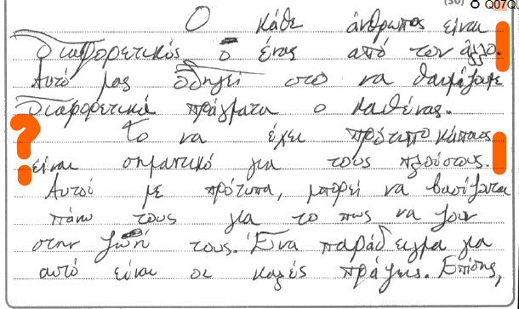
The quality of language for this essay is marked by satisfactory range of vocabulary and grammatical structures, sometimes used appropriately and effectively to address the needs of the task. Most errors, particularly when the candidate attempts to express more complex thoughts, have to do with unsuccessful collocations and incorrect use of vocabulary which affect the comprehensibility of the ideas; for example, τα χαρακτηριστικά … είναι καθαρά, θα δίδασκε τους ακόλουθούς του, συμπαίχτες, να κρατήσουν ένα υγιές βάρος, αυτό έχει πιθανότητα να είναι κίνδυνος, etc.
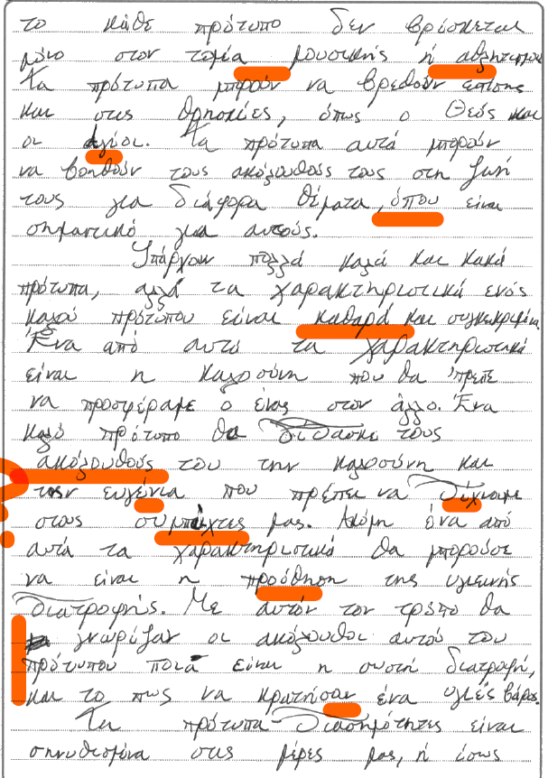

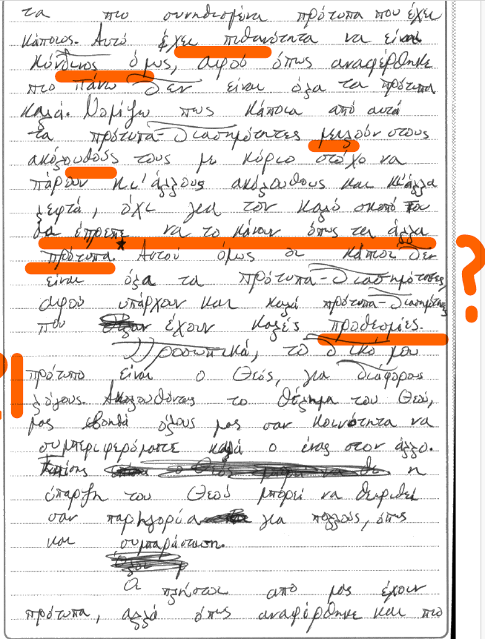
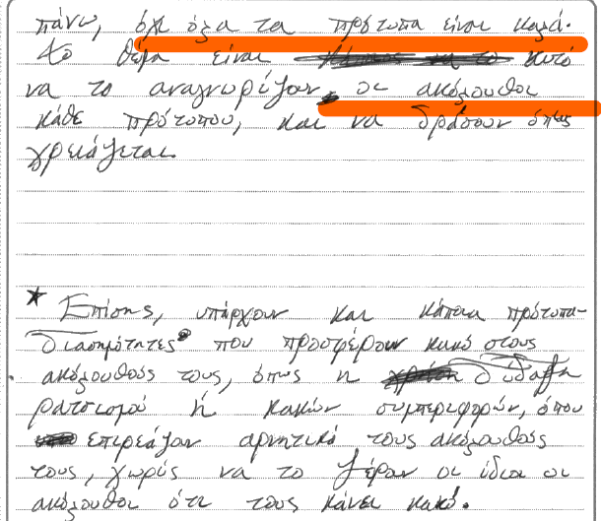

Sample Script 3
Total marks: 58

Question 1
Total marks: 5

The candidate earned full marks in this multiple-choice question.

Question 2
Total marks: 5

The candidate earned full marks in this multiple-choice question.

Question 3
Total marks: 9

The candidate earned 9 marks out of 10 in this Multiple-Choice question. The incorrect response at 3(a) wrongly identified φαντάστηκε instead of βρήκε as the correct response.

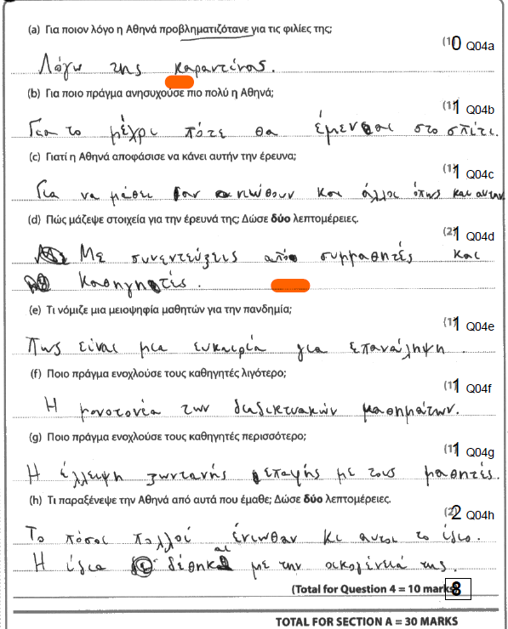
Question 4
Total marks: 8

In this response that entails short answers in Greek, there are two errors. In 4 (a), the candidate did not provide the required detail, that the reason Athena was worried about her friendships was that she had not seen her friends in a while. In 4 (d), the candidate identified only one source i.e. the interviews. The missing detail was ‘the questionnaire’.

Question 5
Total marks: 8

In this grammar transformation exercise, there were two errors:
i) The omission of Πείστηκα alters the meaning of the sentence.
j) The omission of αξέχαστο renders the sentence ambiguous.
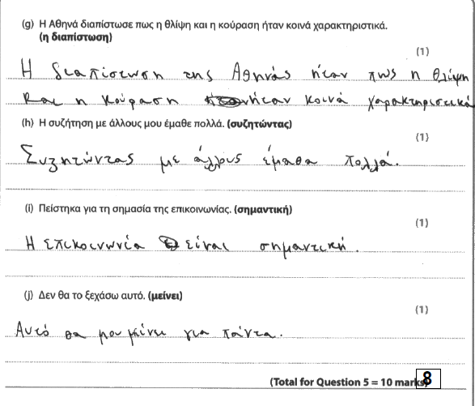
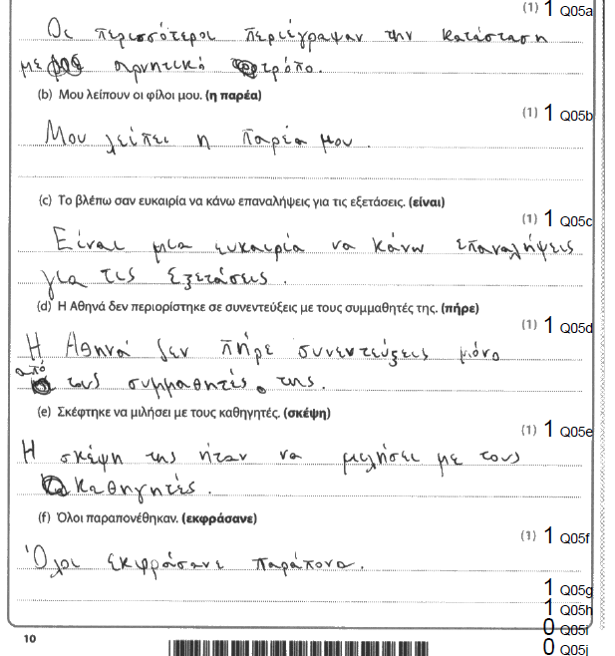

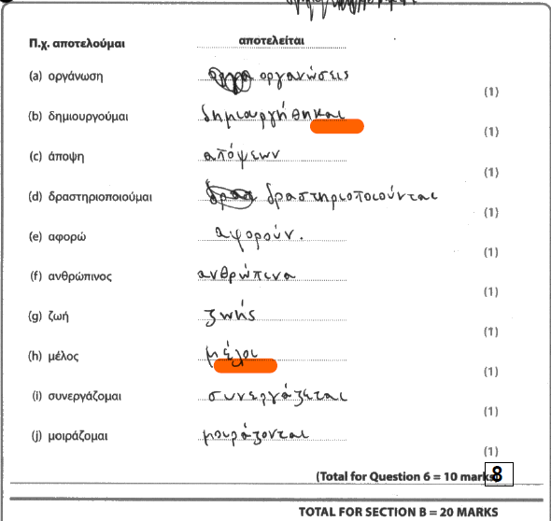
Question 6
Total marks: 8

In this grammar fill-in-the gap exercise, there were two errors both of which have to do with spelling errors in inflection:
b) The spelling error in the inflection of the verb is not within tolerance.
h) The spelling error in the inflection of the noun is not within tolerance.

Question 7
Content and Communication: 8
Quality of Language: 7
Total: 15

This is an essay that has the makings of a very good response but is impacted negatively by weak organisation skills and the tendency to compose intricate sentences with unexplained claims. The assessor awarded 15 marks out of 30 for this essay, which is sometimes coherent and relies on generalisations and description, without enough explanation and justification, especially when it comes to addressing the 3rd and 4th bullet prompts. For example, the candidate cites a role model but fails to justify the reasons behind their choice, other than the brief statement that they have football in common. The discussion of the characteristics of celebrities on page 16 is a polemic without enough substantiation, whereas the qualities of a professional footballer are cited as a benchmark for integrity of character, which is also a sweeping generalisation. In addition, even though the candidate is clearly fluent, the coherence of the piece is affected negatively by overly long sentences and lack of control over syntax, which weaken the argument and sometimes render it incoherent. For example, the paragraph devoted to the discussion of celebrities as role models on page 15 contains a long, rambling sentence with various subordinate and syntactically mismatched clauses ending on page 16 with a conclusion that is not very well aligned with what transpired earlier. The conclusion itself is brief and superficial, ending in a claim that is new information and does not derive naturally from the previous content.

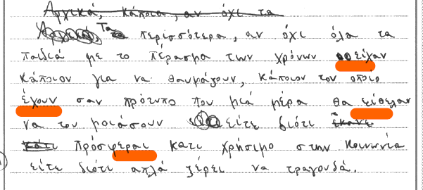
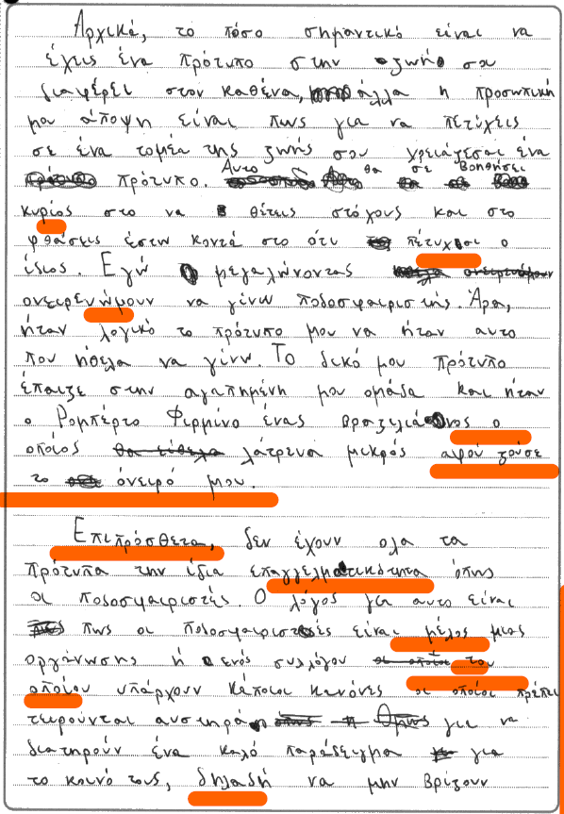

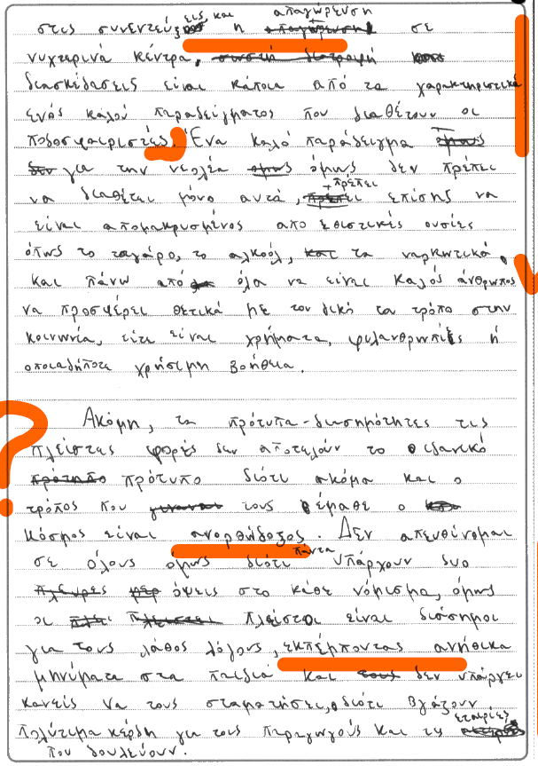

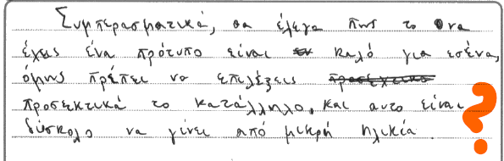

GRADE C

Sample Script 1
Total marks: 43

Question 1
Total marks: 5

The candidate earned full marks in this multiple-choice question.

Question 2
Total marks: 2

The candidate earned 2 marks out of 5. Incorrect responses were in sub questions a) and c) which go against the narrative thread that runs through this exercise and d) which resulted in a sentence that does not make much sense.

Question 3
Total marks: 7

The candidate earned 7 marks out of 10, in this multiple-choice question. Incorrect answers pertained to sub questions d), έπεσε instead of ξέσπασε, g) διάλεξε instead of απέλυσε, and h) συμπεριλαμβάνεται instead of βασίζεται.

Question 4
Total marks: 7

This response that requires short answers in Greek earned 7 marks. 3 marks were lost in the following incorrect responses:
- The candidate did not identify the specific reason why Athena is worried about the state of her friendships. Her concern was that she had not seen her friends for a long time.
- The response did not identify the 2 correct details regarding what surprised Athena, which was that ‘δέθηκε με την οικογένειά της’ and ‘Οι άλλοι ένιωσαν το ίδιο με αυτήν’.

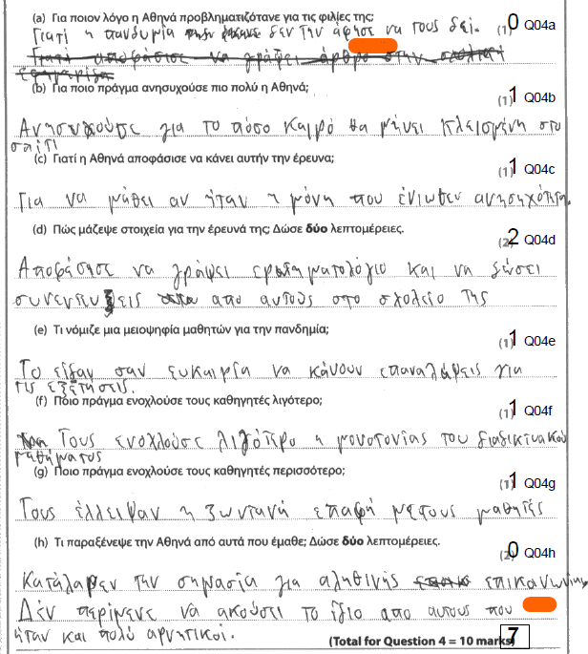

Question 5
Total marks: 3

In this grammar transformation exercise, there were seven incorrect responses:
a) The transformed sentence has a different meaning from the source sentence
d) The transformed sentence has a different meaning from the source sentence.
e) The collocation ήταν σκέψη is incorrect.
f) The noun should be in the plural. Παράπονο would have been appropriate had it been accompanied by an article and a possessive; for example, το παράπονό τους.
g) Τhe transformed sentence is incomplete and incorrect.
i) The omission of πείστηκα renders the sentence incorrect.
j) The transformed sentence is clumsy.
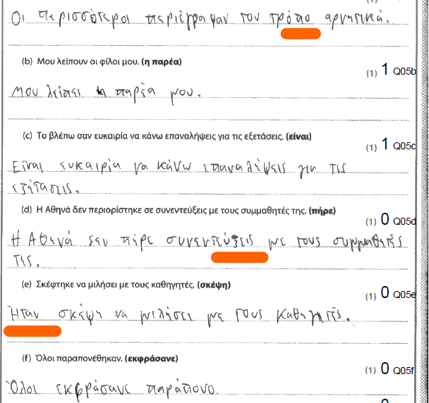
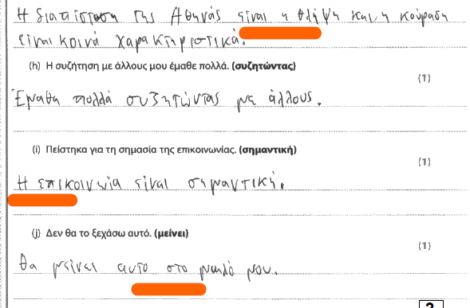

Question 6
Total marks: 3

In this grammar fill-in-the gap exercise, there were seven errors:

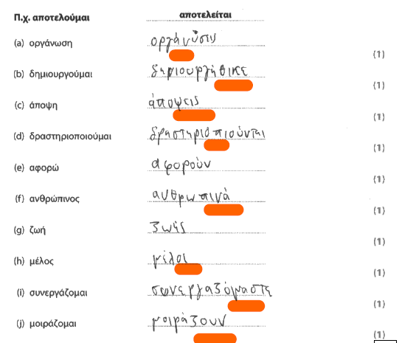
- The incorrect position of the stress is not within tolerance.
- The verb inflection is incorrectly spelled.
- The required case is a genitive: απόψεων.
f) The incorrect position of the stress is not within tolerance
e) The required verb form is αφορούν.
h) The required noun form is μέλη.
i) The required form is συνεργάζεται
j) The verb form is in the incorrect voice, active instead of passive. Ιt should be μοιράζονται not μοιράζουν.

Question 7
Content and Communication: 8
Quality of Language: 8
Total: 16

In this essay, the candidate has shown a moderate ability to express ideas in a
form that would be comprehensible to a native reader with a noticeable tendency for unsuccessful transitions and weak organisation of ideas in places. The introduction serves as a segue into the first bullet point, which contains some pertinent information, albeit clumsily expressed and with some syntactical anomalies. For example, the clause ‘όπος ένα που εκβραζεται ρατσιστικά’, its intrusive errors aside, should have been placed immediately after πρότυπο for the sentence to make sense (page 14).
The paragraph that discusses the characteristics of a good role model contains pertinent material, but again, this is badly organised and articulated in a tone and vocabulary that are not appropriate for the task and resemble a GCSE level performance, both in terms of language as well as content. For example, ένας αθλητής που είναι ηγειηνός, να τρώναι καλό φαγητό, να γυμνάζουν, etc. (page 15). Even though there is some evidence of ideas following a logical sequence towards the end, the essay contains some sweeping generalisations with the type of hyperbole that is often a pattern in these essays. A noticeable weakness is the lack of a conclusion.

The quality of language for this essay is correctly assessed as 8. There is evidence of satisfactory range of vocabulary and grammatical structures, sometimes used appropriately and effectively to address the needs of the task. There is good control of basic language, but there are errors, particularly with more complex structures/lexis. For example, να γίνουν και αυτοί πρότυποι είτε από τα παιδιά τους, να γήνουν παραπάνο σαν τα πρότυπά τους, etc. (page 15).

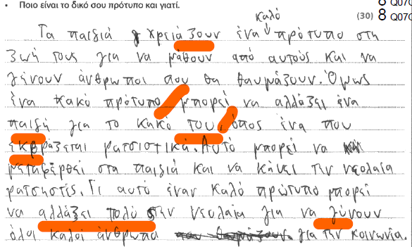

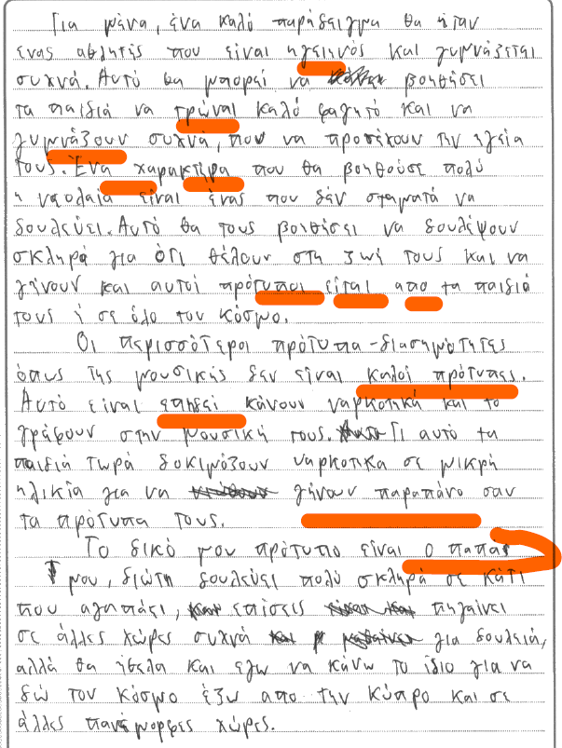

Sample Script 2
Total marks: 42

Question 1
Total marks: 4

The candidate earned 4 marks in this multiple-choice question. The response to question 1(d) wrongly identified συναυλία instead of διαλέξεις as the correct answer.

Question 2
Total marks: 3

The candidate earned 3 marks out of 5. Incorrect responses were in sub questions b) and c).

Question 3
Total marks: 10

The candidate earned full marks in this multiple-choice question.

Question 4
Total marks: 3

This response that entails short answers in Greek earned 3 marks out of 10. The incorrect responses are:
- The candidate did not identify the specific reason why Athena is worried about the state of her friendships. The quarantine was what caused Athena to be worried in general but regarding her friendships, her concern was that she had not seen her friends for a long time.
- The response did not identify the correct detail, that Athena was mostly worried about ‘Πόσον καιρό θα μείνει κλεισμένη στο σπίτι’.
- The response did not identify the correct detail regarding the reason why Athena carried out her study, which was ‘Για να δει αν νιώθουν οι άλλοι όπως αυτή’.
- The assessor’s original view was that there was not sufficient detail. The response did not identify the 2 correct details regarding Athena’s methods, which were ‘ερωτηματολόγιο’ and ‘συνεντεύξεις’.
h) The response did not identify the 2 correct details regarding what surprised Athena, which was that ‘δέθηκε με την οικογένειά της’ and ‘Οι άλλοι ένιωσαν το ίδιο με αυτήν’. The phrase πολλά άτομα ‘ένιωθαν τα ίδια με την καραντίνα’ does not convey the comparison between Athena’s and other people’s feelings.

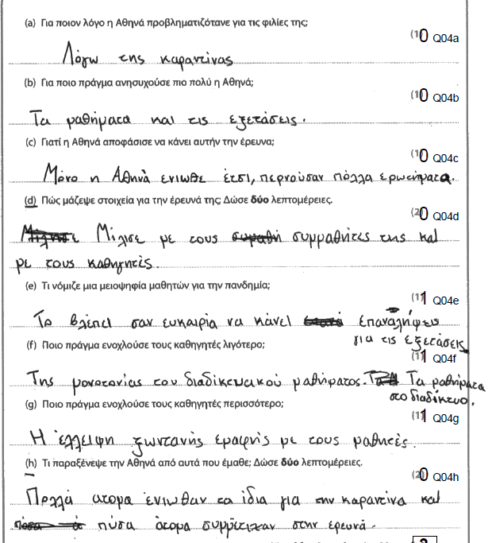

Question 5
Total marks: 4

In this grammar transformation exercise, there were six errors:
d) The transformed sentence has a different meaning from the source sentence.
e) The collocation πήρε σκέψη is incorrect.
f) The use of the word παραπονία renders the sentence incorrect.
g) the transformed sentence is incomplete and incorrect.
i) The omission of πείστηκα renders the sentence incorrect.
j) The omission of αξέχαστο renders the sentence incorrect and ambiguous.

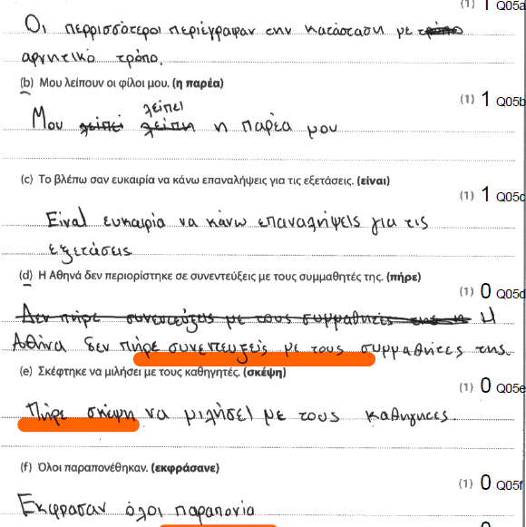

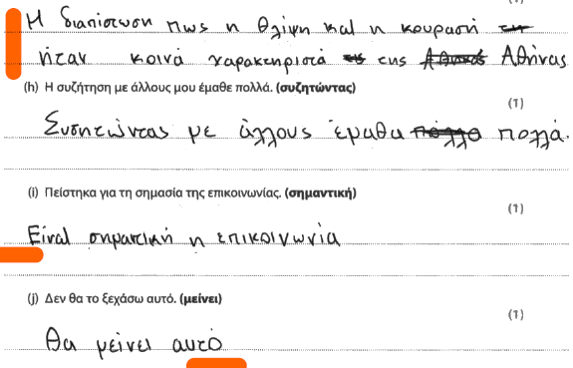

Question 6
Total marks: 5

In this grammar fill-in-the gap exercise, there were five errors:
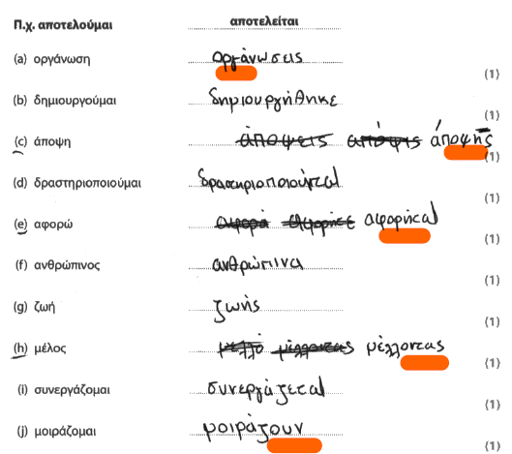
d) The incorrect position of the stress is not within tolerance.
c) The required genitive should be in the plural: απόψεων.
e) The required verb form is αφορούν.
h) The required noun form is μέλη.
j) The verb form is in the incorrect voice, active instead of passive. If the prompt is a verb, it should be left in the voice that is provided. In this case, it should be μοιράζονται not μοιράζουν.

Question 7
Content and Communication: 7
Quality of Language: 6
Total: 13

In this essay, the candidate has shown a moderate ability to express ideas in a
form that would be comprehensible to a native reader with some communication breakdown in the paragraph that discusses the characteristics of a good role model (page 15). Even though there is some evidence of ideas following a logical sequence, there is not enough development of these ideas into a properly substantiated conclusion. For example, the argument about celebrities is short and barely developed and there is no mention of what these σωστά χαρακτηριστικά are (page 15). In general, with the exception of the paragraph about the candidate’s own role model (page 15), the ideas are tentative and do not go beyond superficial observations.
The quality of language for this essay is correctly assessed as a 6. The candidate has shown adequate but predictable range of vocabulary and grammatical structures, only occasionally used appropriately and effectively to address the needs of the task. In addition to basic errors with common vocabulary, the handwriting consistently violates the conventions of the Greek writing system with the letter ι written as an Ι. Phrases such as πρέπει να αντιγράψει ένα παιδία, ο πρότυπος, αν είναι συνεχιά κρίνεί τι, να γίνεις στεναχορημένος are some examples of insecure control of vocabulary and structures.

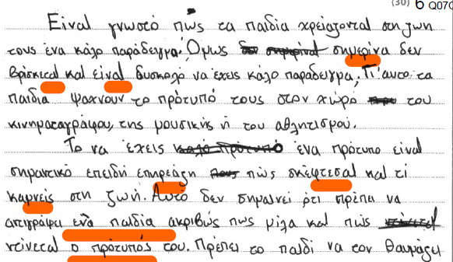
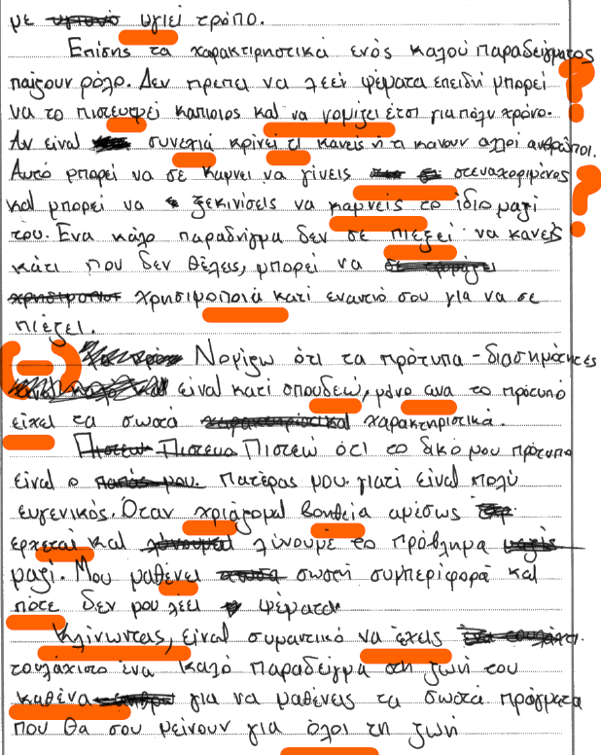

GRADE E

Sample Script 1
Total marks: 32

Question 1
Total marks: 4

The candidate earned 4 marks in this multiple-choice question. The response to question 1(c) wrongly identified μόνο στην Πάτρα instead of μια φορά τον χρόνο as the correct answer.

Question 2
Total marks: 2

The candidate earned 2 marks out of 5. Incorrect responses were in sub questions a), b) and c). Candidates are reminded that it is not enough for the matching sentences to be grammatically correct, they must align to the narrative thread that runs through the text and be conducive to the overall meaning.

Question 3
Total marks: 5

The candidate earned half of the available marks. The incorrect responses were d), e), f), i), and j). The selected options were not in alignment either with the communication implied in the source text or its syntax/grammar.

Question 4
Total marks: 2

This response that entails short answers in Greek earned 2 marks. Weak language skills often got in the way of communicating understanding of the passage. The incorrect answers were:
- The candidate did not identify the specific reason why Athena is worried about the state of her friendships. The response contained words copied from the text combined with the candidate’s own poorly articulated phrases.
- This is an incomplete response.
- The sentence tries to communicate something, but it remains vague. Athena conducted this search specifically to find out: πώς νιώθουν οι άλλοι για την καραντίνα. / Για να δει αν νιώθουν οι άλλοι όπως αυτή.
- The response included three separate details. Only the first two could be considered and the candidate earned one mark for συνεντεύξεις. Candidates are reminded that they must answer succinctly and not offer a list of details for the examiner to choose from.
- Τhe response did not identify the correct detail, that the quarantine Είχε θετικά στοιχεία
- The response did not earn any marks because the sentence is copied from the text verbatim
- The response did not identify the 2 correct details regarding what surprised
Athena, which was that ‘δέθηκε με την οικογένειά της’ and ‘Οι άλλοι ένιωσαν το ίδιο με αυτήν’. Insecure control over language obscured meaning in this response.

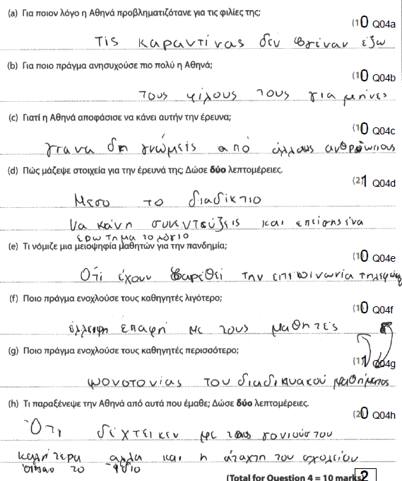
Question 5
Total marks: 2

In this grammar transformation exercise, there were eight errors:
- The assessor deducted one mark for αρνητικόν.
- The spelling error in the verb inflection (λείπη) is not within tolerance.
- The transformed sentence with the use of σαν lacks the accuracy expected at this level of competence.
- The transformed sentence has a different meaning from the source sentence.
- The collocation είχε μια σκέψη is clumsy. The correct would have been Είχε / Έκανε τη σκέψη.
- The use of the word παραπονοιμένη renders the sentence incorrect.
i) The omission of πείστηκα renders the sentence incorrect.
j) The omission of μου renders the sentence ambiguous.

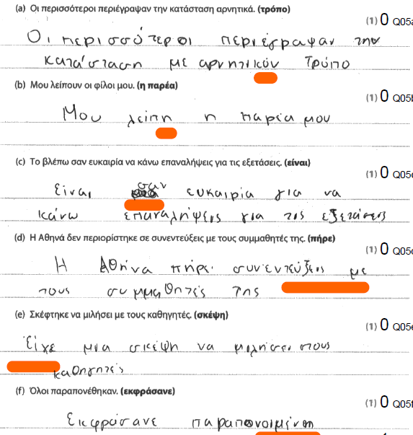

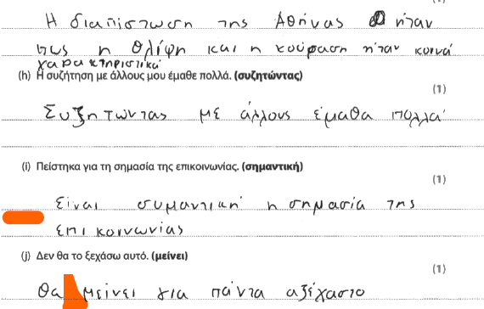

Question 6
Total marks: 5

In this grammar fill-in-the gap exercise, there were five errors:

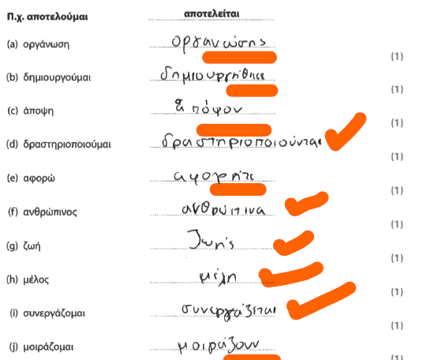
α) The plural form of the noun (οργανώσεις) is not formed correctly.
b) The verb inflection is misspelled (-ικε).
c) The required genitive should be απόψεων.
e) The required verb form is αφορούν.
j) The verb form is in the incorrect voice, active instead of passive. If the prompt is a verb, it should be left in the voice that is provided. In this case, it should be μοιράζονται not μοιράζουν.

Question 7
Content and Communication: 6
Quality of Language: 6
Total: 12

In this essay, the candidate has shown some basic ability to express ideas in a form that would be comprehensible to a native reader with some evidence of ideas following a logical sequence and digression that renders some of the material irrelevant. For example, the argument about celebrities as role models goes off in a tangent that does not establish any convincing relevance to the issue discussed (page 15-16). The paragraph that discusses the candidate’s role model offers as explanation traits that have nothing to do with what the candidate identified as the desired traits of a role model (page 16). Most of the ideas presented are carelessly articulated and do not go beyond superficial observations. There is no conclusion, and the essay finishes abruptly in a way that does not link logically to the claims made earlier.

The quality of language for this essay is correctly assessed as a 6. The candidate has shown adequate but predictable range of vocabulary and grammatical structures, only occasionally used appropriately and effectively to address the needs of the task. There are basic errors with common vocabulary and the style of the language adopted is often not appropriate for an essay. Phrases such as να τροις ηζηνα φαγητά, όσων καλλός από άλλους, άλλο κάποιοι που θα ήθελα να είμουν are some examples of insecure control of vocabulary and structures.

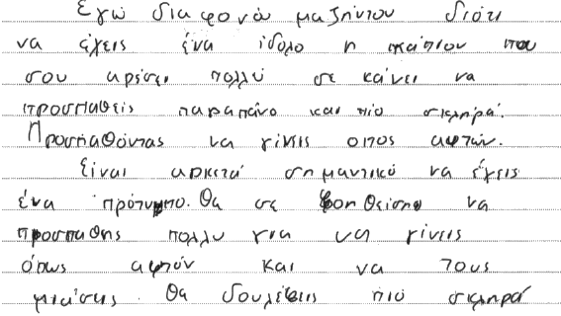
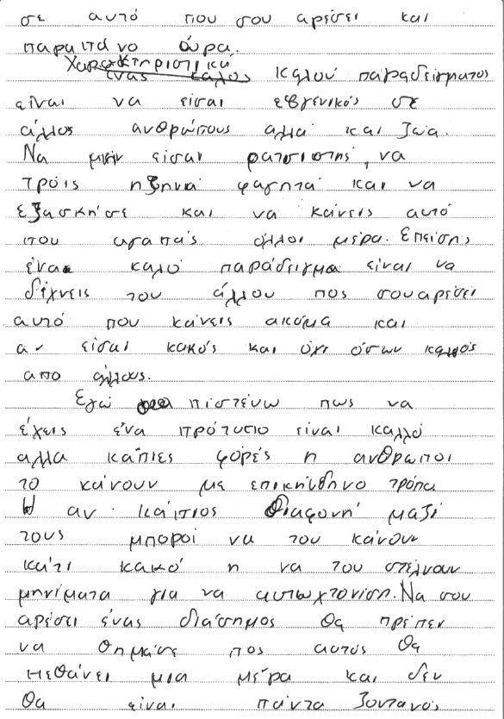

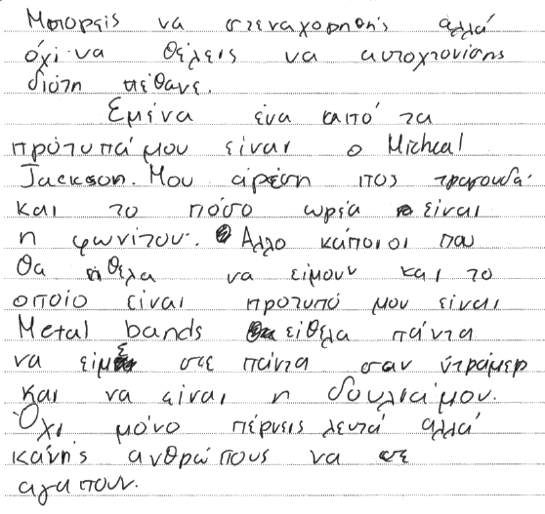

Sample Script 2
Total marks: 31

Question 1
Total marks: 5

The candidate earned full marks in this multiple-choice question.

Question 2
Total marks: 5

The candidate earned full marks in this question.

Question 3
Total marks: 8

The candidate earned 8 marks in this multiple-choice question. The two incorrect responses were:
- The candidate opted for κάλεσε instead of the correct απέλυσε.
j) The candidate opted for δυσκολεύτηκε instead of the correct γεννήθηκε.

Question 4
Total marks: 2

This response that entails short answers in Greek earned 2 marks. The incorrect responses are:
- The response did not identify the correct detail, that Athena was mostly worried about ‘Πόσον καιρό θα μείνει κλεισμένη στο σπίτι’.
- The response did not identify the correct detail regarding the reason why Athena carried out her study, which was ‘Για να δει αν νιώθουν οι άλλοι όπως αυτή’.
- Even though the articulation of one of Athena’s methods was not as detailed as it should have been, te original assessor deemed that the response it was more correct than incorrect in identifying that she sought the views of others online.
- The candidate did not answer the question.
- The candidate did not answer the question.
- The candidate did not answer the question.
- The candidate did not answer the question.

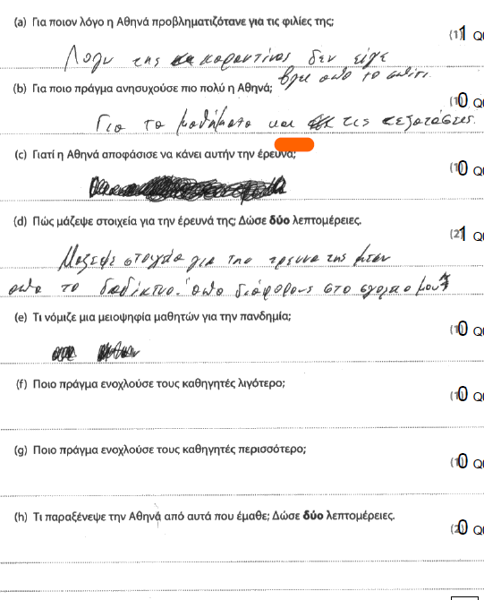

Question 5
Total marks: 3

In this grammar transformation exercise, there were seven errors:
- The sentence contains a word that is not easy to identify and consists of non-Greek characters.
c)The sentence is incorrect and contains spelling and grammatical errors (σαν να
είναι, της).
d) The transformed sentence has a different meaning from the source sentence.
e) The transformed sentence is incomplete and incorrect.
g) The transformed sentence is incorrect (έδωσε την διαπίστοση).
h) The transformed sentence is grammatically incorrect (μου έμαθε) and the position of the stress is not indicated in most words.
- The candidate did not answer the question

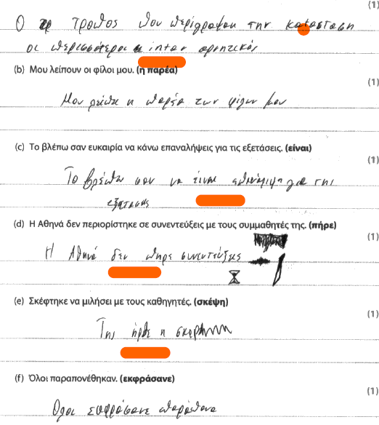
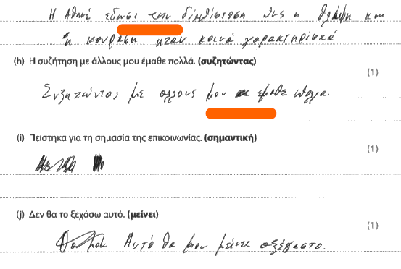

Question 6
Total marks: 6

In this grammar, fill-in-the gap exercise, there were four errors:

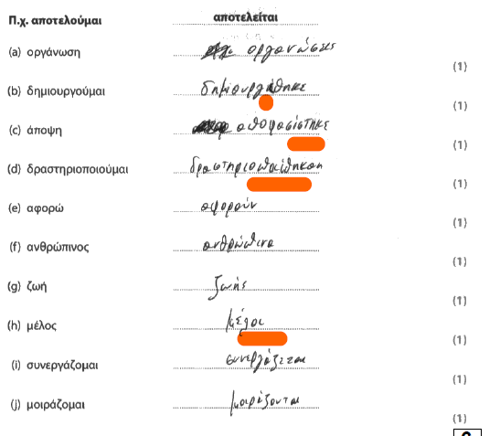
- The verb inflection is incorrect (-ίθηκε).
- The candidate inserted a random verb, αποφασίστηκε, instead of the correct form of the prompt, απόψεων.
- The verb tense and spelling are incorrect.
- The required noun form is μέλη.

Question 7
Content and Communication: 1
Quality of Language: 1
Total: 2

Three and a half lines show some basic connection to the question asked. One can only assume that the candidate ran out of time or used their time for mathematical doodling.

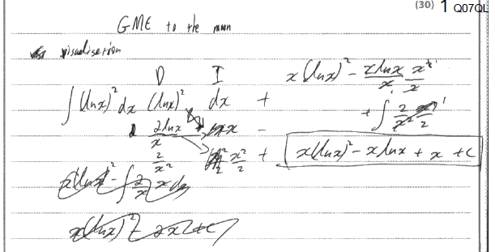
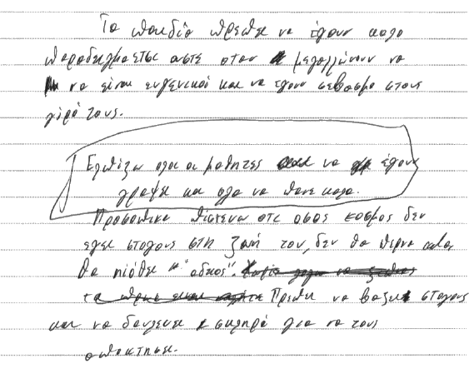

Sample Script 3
Total marks: 27

Question 1
Total marks: 3

The candidate earned 3 marks out of 5 in this multiple-choice question. In a) the candidate opted for όποιος ήθελε instead of μία τάξη του σχολείου and in d) for μια συναυλία instead of the correct διαλέξεις.

Question 2
Total marks: 2

The candidate earned 2 marks out of 5 in this question. Candidates are reminded that matching sentences make up a text that contains a sequence of events and justifications and it is not enough to match segments that simply fit together grammatically.

Question 3
Total marks: 9

The candidate earned 9 marks out of 10 in this question. The incorrect response was in g. The correct response was απέλυσε.

Question 4
Total marks: 0

This response that entails short answers in Greek did not earn any marks. Some responses were left blank and some contained combinations of phrases in poor Greek or phrases copied from the source text. There is no evidence that the candidate was able to articulate comprehension of the texts clearly and in their own words.

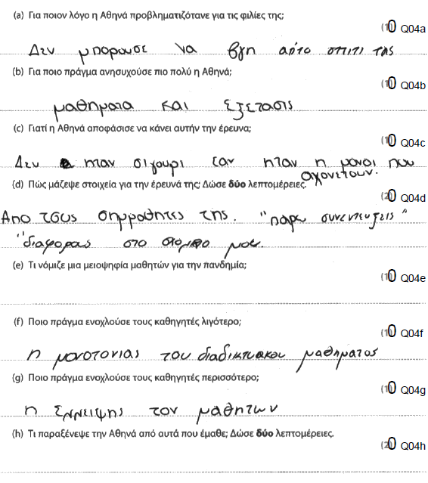

Question 5
Total marks: 0

The candidate did not earn any marks in this grammar transformation exercise. There is no indication of the position of the stress, and this automatically renders the sentences incorrect. The indication of the stress in a single word, είναι, in b does not suffice for the mark to be awarded.

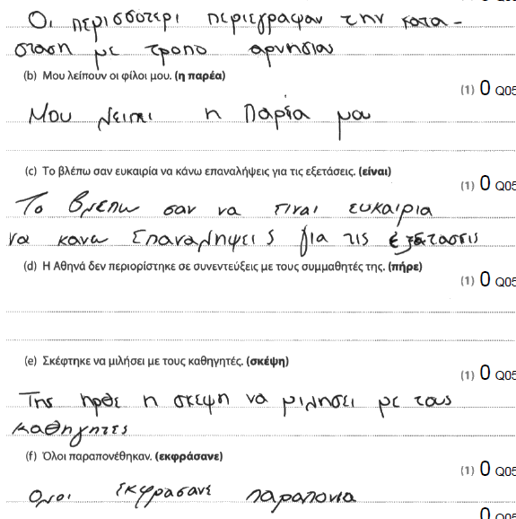
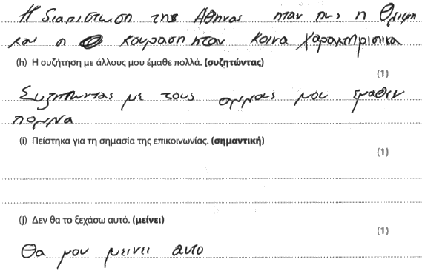
Question 6
Total marks: 0
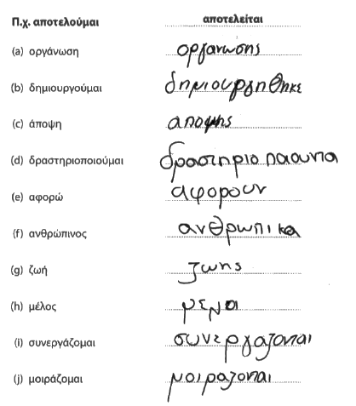
In this grammar, fill-in-the gap exercise, there were no marks awarded on account of grammatical errors, the omission of the stress in particular.

Question 7
Content and Communication: 7
Quality of Language: 6
Total: 13

In this essay, which was awarded a generous 7 for content and communication and a 6 for quality of language, the candidate has shown some basic ability to express ideas in a form that would be comprehensible to a native reader with occasional evidence of ideas following a logical sequence and considerable digression that renders some of the material obscure or irrelevant. The essay begins with a generalisation about parents and proceeds to discuss the importance of role models with an argument and examples that are hard to understand or find convincing. The explanation of what constitutes a good role model contains basic and occasionally difficult to understand arguments, particularly the point about work ethos, as there are many errors that mostly hinder meaning (page 15). The point about speaking frankly and from the heart is articulated a little more clearly, but again, in basic terms. There are omissions with regard to the bullet point about celebrity-role models.
The argument about the candidates’ role models is fraught with similar challenges but some meaning emerges about the significance of Muhammad Ali for black youth. What is impressive in this last part of the essay is the integrity of the candidate’s social conscience which identifies as role models those who help, guide and give visibility to historically underrepresented groups (page 16). There is no conclusion, and the essay finishes abruptly with the discussion of the last bullet point.
The quality of language for this essay is assessed with a generous 6. The candidate has shown barely adequate but predictable range of vocabulary and grammatical structures, only occasionally used appropriately and effectively to address the needs of the task. There are basic errors with common vocabulary and the style of the language adopted is often not appropriate for an essay.

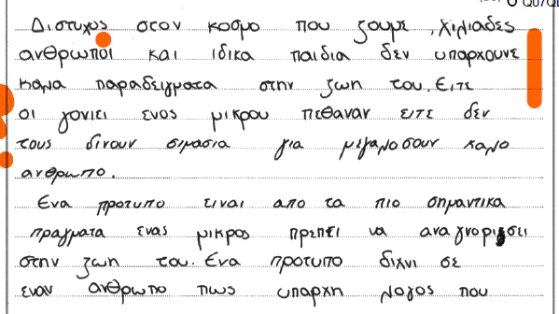

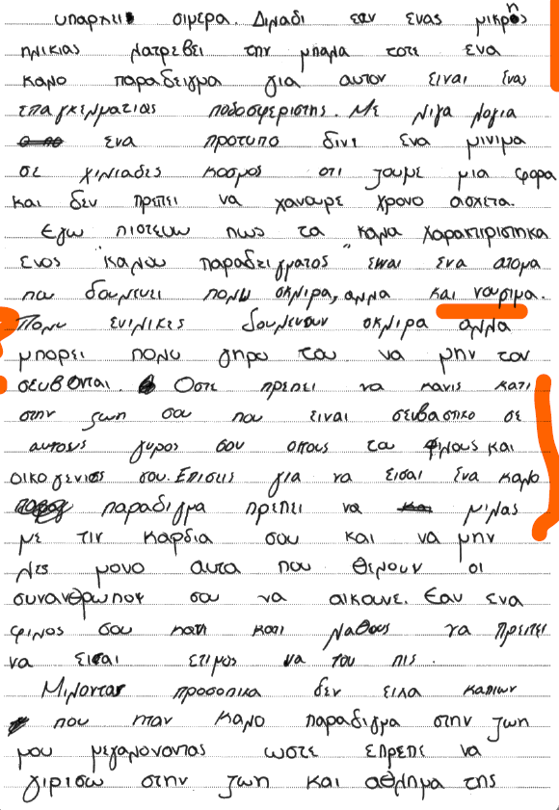

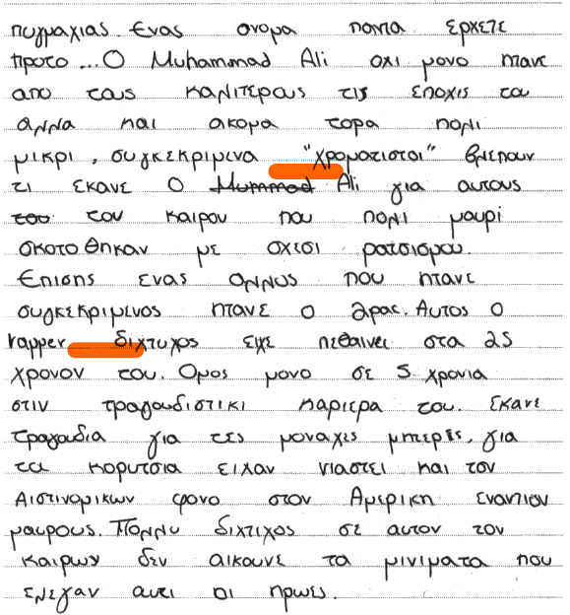

Pearson Education Limited. Registered company number 872828
with its registered office at 80 Strand, London, WC2R 0RL, United Kingdom

