

Comparison of key skills specifications 2000/2002 with 2004 standardsX015461July 2004Issue 1

Commentaries
Summer 2024

International A Level
In German (WGN04) Unit 1

Commentary 1 – Awarded 14 marks
Question 9(a)
Beschreiben Sie die Hauptstadt oder den Hauptort der von Ihnen gewählten deutschsprachigen Region. Analysieren Sie die Bedeutung dieses Ortes für die Bewohner der Region.
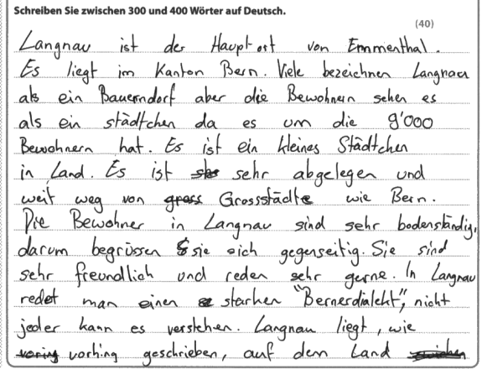
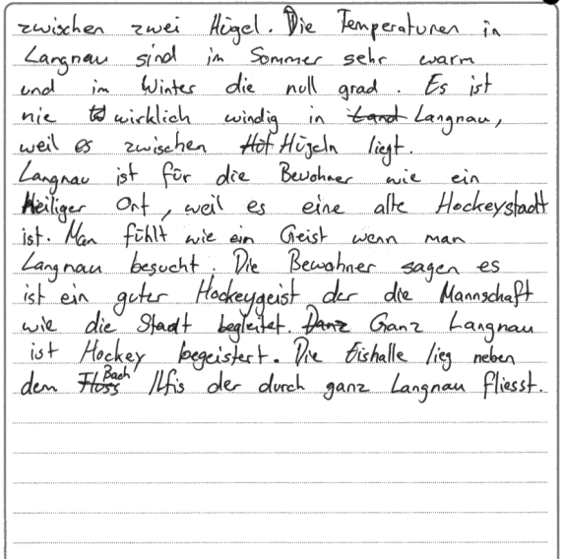
Content and Communication (5 marks)
The student has shown some basic, generic factual knowledge about the village of Langnau, including details of its size, the geographical location and the weather conditions. The second part of the question is addressed with reference to the local passion for ice hockey. Supporting evidence is limited: mention of the Bernerdialekt could have been supported with some concrete examples.
However, the essay is mostly characterised by limited depth. General statements such as Sie sind sehr freundlich und reden sehr gerne add very little of significance to the content of the essay. Nevertheless, the student still manages to give some insight into why Langnau can be described as a Heiliger Ort due to the passion of ice hockey.
The best fit for Content and communication is in the middle of the 4-6 band.

Quality of Language (4 marks)
Communication is achieved throughout albeit with occasional errors, eg von Grossstädte. Despite some fluency in the language, there is an overreliance on es ist and not enough evidence of the language of analysis. The register tends to be more chatty than appropriate to essay writing. For these reasons, the mark of 4 is the best fit.

Critical Analysis, Organisation and Development (5 marks)
The main issue with this essay is that there is no overall structure with an introduction and no clear paragraphs which lead to a strong concluding paragraph. What he student has written seems more like a random list of unrelated thoughts without purpose. This is clearly seen in the use of wie vorhin(g) geschrieben.
A mark in the 1-4 band might be considered since this is a superficial response. However, there is some attempt to analyse towards the end with the details about sporting interests.
For this reason, the essay can just be awarded a mark at the lower end of the 5-8 band.

Commentary 2 – Awarded 26 marks
Question 9(a)
Beschreiben Sie die Hauptstadt oder den Hauptort der von Ihnen gewählten deutschsprachigen Region. Analysieren Sie die Bedeutung dieses Ortes für die Bewohner der Region.
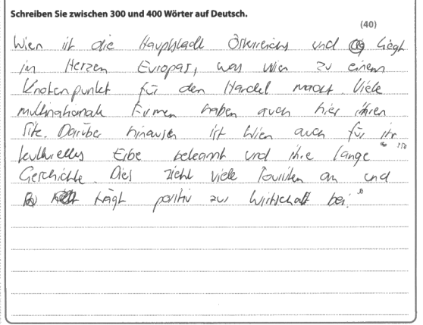
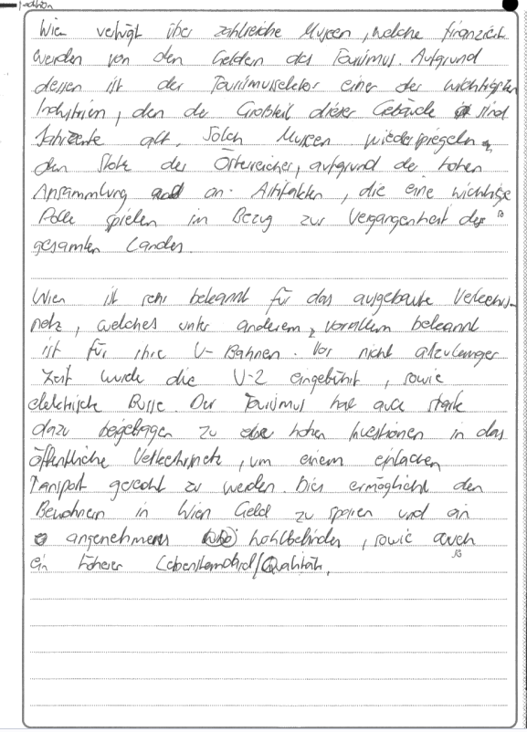
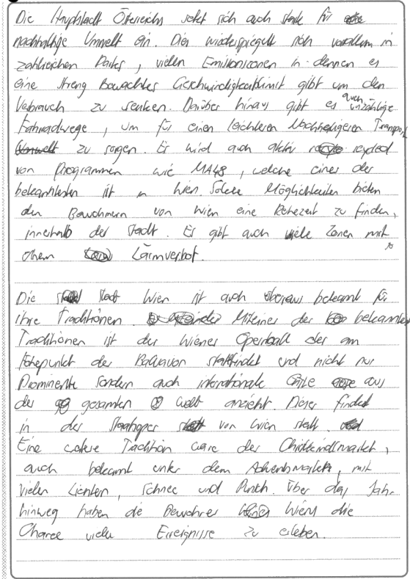
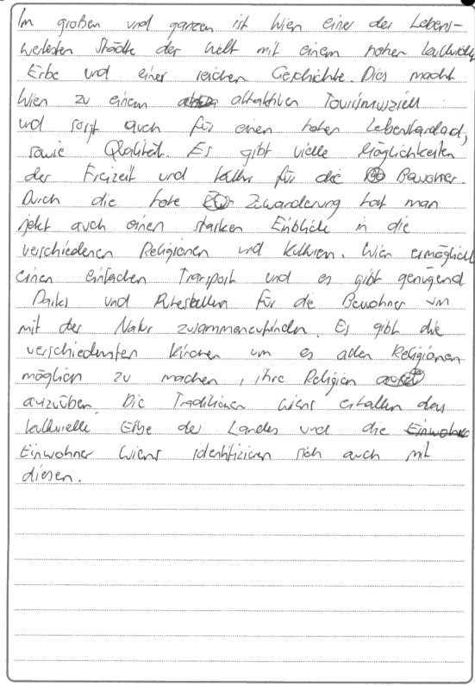

Content and Communication (9 marks)
The student has shown acceptable factual knowledge of Vienna and chooses to focus on the positive aspects of museums, public transport, the environment and traditions.
There is some variety of supporting evidence. The details about the Opernball are good, but more detail could be given for example about the museums: the reasons for a specific museum, eg the Leopold Museum, being important would support the argument more appropriately.
The second part of this question asks about the relevance of the place to its inhabitants. The student only occasionally touches on this important aspect of the question, particularly with reference to the rich variety of cultural events. Otherwise, the focus is on what the city offers tourists – which is a different question.
The best fit for Communication and Content is at the top of the 7-9 band.

Quality of Language (5 marks)
Communication is fluent and varied throughout and the register appropriate. Grammatical structures are varied with evidence of correct use of the genitive, subordination and infinitive clause and a good range of relevant vocabulary. This gains a mark in the top band.

Critical Analysis, Organisation and Development (12 marks)
This is a full explanation in response to the question, although to achieve variety and to strengthen the response overall, the positive about Vienna aspects could have been contrasted with some negative views of the capital, eg that some residents no longer feel that the Opernball has relevance.
The essay is clearly structured in paragraphs, although the central section is simple a list of positive points with no real linking between the paragraphs. The introduction and conclusion are strong, but in the final paragraph the student introduces the new ideas of immigration and religious diversity which would have been better dealt with earlier in the essay.
With a tighter argument and more critical analysis the essay might well have scored in one of the two top bands, but in this instance a mark at the top of the 9-12 band is the best fit.

Commentary 3 – Awarded 32 marks
Question 10(b)
Beschreiben Sie die Arbeit einer wichtigen Figur des von Ihnen gewählten Zeitraum der Geschichte. Analysieren Sie die Wirkung dieser Arbeit.

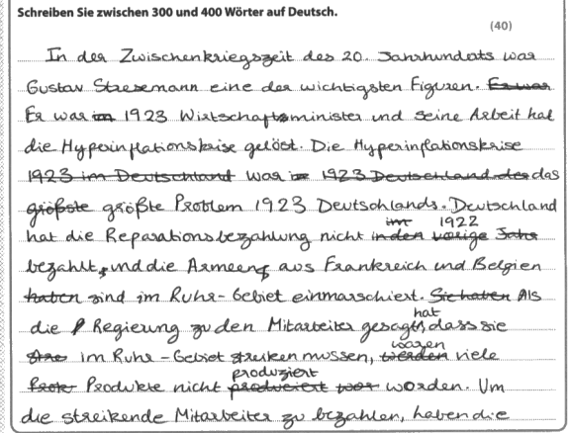
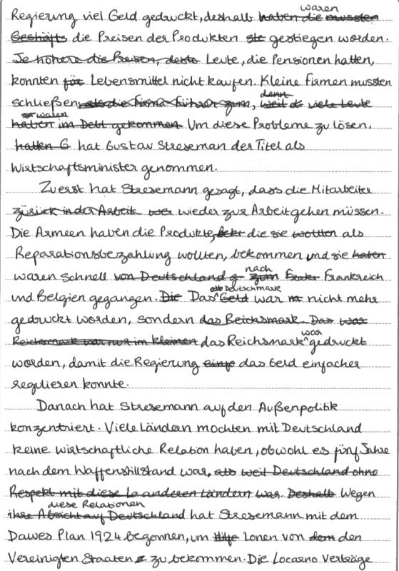
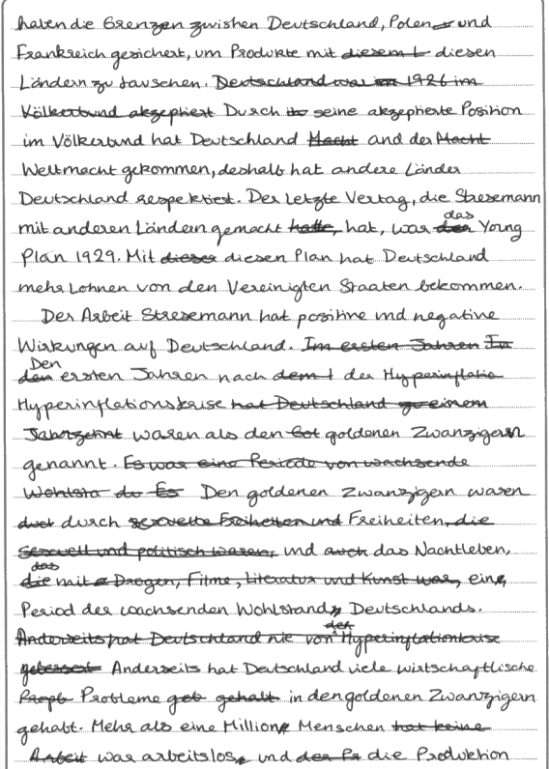
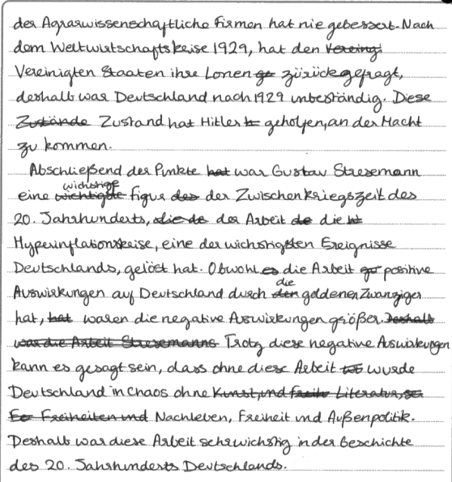

Content and communication (12 marks)
The student has chosen to write about the work Gustav Stresemann and places him clearly within the definable historical period of the Zwischenkriegszeit. Throughout the essay the student shows good factual knowledge of the topic. There is an explanation of how Stresemann came to adopt the title of Wirtschaftsminister and a description of his involvement in the Dawes Plan in an attempt to solve the issue of reparations in the aftermath of World War I. In addition, the student explores different aspects of Stresemann’s work, including internal and foreign affairs.
Supporting evidence is generally good, although in the second half of the essay, the details of the Roaring Twenties could have been better supported. Evidence here tends to be more superficial rather than being supported by hard facts, eg Den goldenen Zwanzigern waren durch Freiheiten und das Nachtleben ein Period des wachsenden Wohlstand Deutschlands. For this reason, the mark for Communication and content is best placed at the top of the 10-12 band.

Quality of Language (4 marks)
Communication is achieved almost all of the time. Vocabulary includes specialist terms as befits the topic, eg Reparationsbezahlung, Hyperinflationskriise, and a good range of common grammatical structures is used correctly, eg infinitive clauses with and without um/zu, subordination with damit and the genitive in Geschichte des 20. Jahrhunderts. On the other hand, some structures are less successful which leads to some sentences having to be read twice to gain a clear grasp of what is meant, eg Nach dem Wirtschaftskrise 1929, hat den Vereinigten Staaten ihre Lonen zurückgefragt. There are grammatical errors throughout and in particular wrong verb formations, eg haben die Regierung, hat Deutschland an der Weltmacht gekommen, hat nie gebessert, lead to a mark of 4 being awarded.

Critical Analysis, Organisation and Development (16 marks)
The essay shows substantial engagement with the topic and the student displays genuine interest in Stresemann’s work. Although there is good knowledge of this, the student does not always evaluate main points at each stage of the essay. For example, the regulation of currency is described but there is no evaluation of whether Stresemann’s decisions were sound or not.
The essay is clearly structures in paragraphs although each paragraph could be more clearly structured with a main point, followed by some hard evidence and concluding with an evaluation before making the next main point. This is most evident in the description of the effects of Stresemann’s efforts to stabilise Germany. Here, the student could have written two paragraphs rather than one, separating the positive and negative effects. This could have made the argument clearer and led to a stronger collusion.
The essay has a strong introduction stating clearly the challenges which Stresemann faced and explaining why he was a significant figure. In the concluding paragraph, the student not only sums up the content of the essay but also gives an evaluation, stating that the negative effects outweighed the positive aspects.
Overall, the essay is well structured and insightful but does not always give enough of a personal and perceptive response to merit going into the top band. However, a mark at the top of the 13-16 band is appropriate.

Commentary 4 – Awarded 19 marks
Question 10(b)
Beschreiben Sie die Arbeit einer wichtigen Figur des von Ihnen gewählten Zeitraum der Geschichte. Analysieren Sie die Wirkung dieser Arbeit.

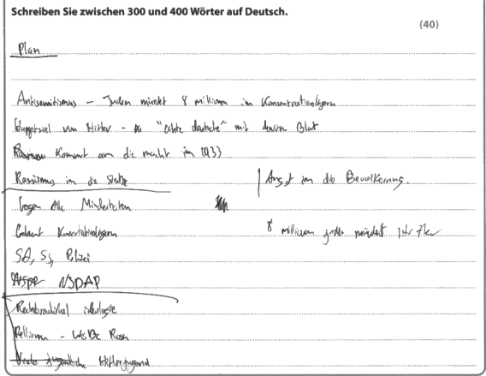
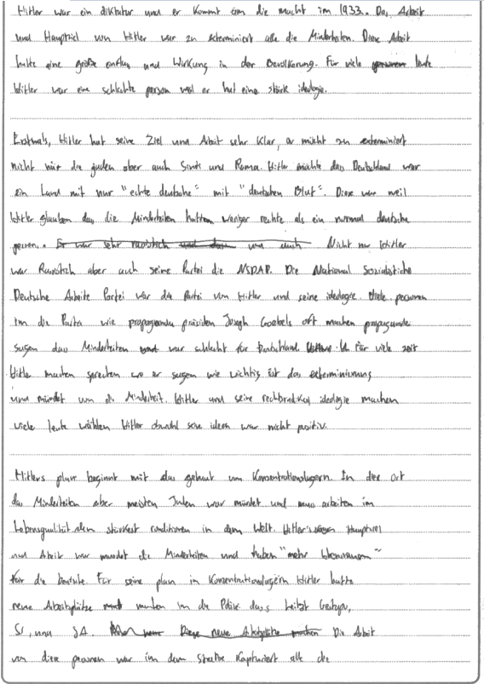
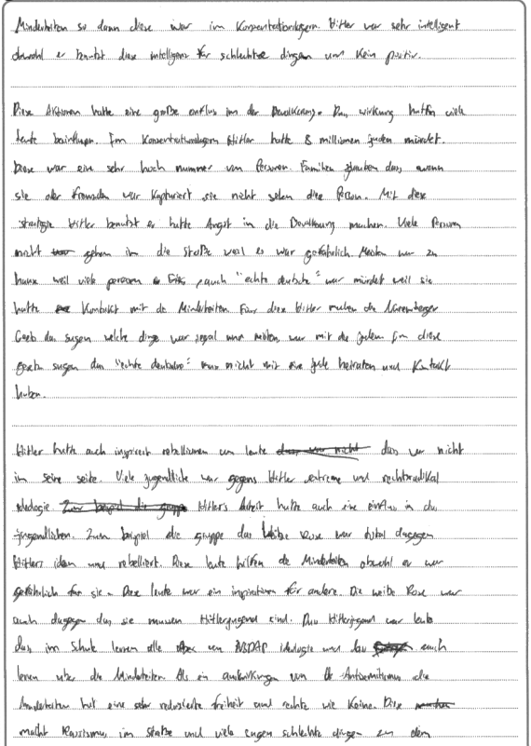
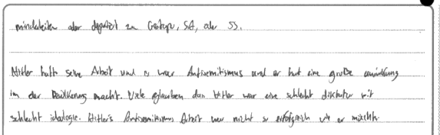

Content and Communication (8 marks)
The essay about the work of Adolf Hitler shows acceptable factual knowledge of the topic, describing mostly antisemitism and the persecution of ethnic minorities in the Third Reich. The effects of this work focus on the catastrophic consequences for the Jewish population and the opposition by young people, for example within the group Die Weiße Rose. Other supporting evidence includes mention of the Hitlerjugend and the Nürnberger Gesetze, although mention of these is only fleeting and lacks detail.
There is some depth in the response. For example, the student concludes that Hitler’s influence was negative although he was an intelligent individual. Otherwise, there are some shallow statements such as Hitler war eine schlechte person weil er hat eine stärk(?) ideologie or Diese war ein sehr hoch Nummer von Personen. However, the essay only sometimes goes beyond the superficial and does not consider different aspects of the question. For example, the student could have contrasted what are considered positive achievements of Hitler’s work such as the reduction of unemployment or the protection of the environment. This would have provided a good contrast to the more important negative aspects of his work.
The best fit for Content and communication is the middle of the 7-9 band.

Quality of Language (3 marks)
Communication is achieved most of the time. Despite regular errors the writing is comprehensible throughout. The reader sometimes struggles to understand immediately what is being conveyed, eg Hitlers plan beginnt mit das Gebaut von Konzentrationslagern, and even when the lexis is faulty, eg Viele glauben, dass Hitler war eine schlecht diktatur, the meaning is conveyed. Although the student shows knowledge of appropriate vocabulary for the topic, the syntax is often wrong, there are few successful complex structures and there are many errors.
The best fit for Quality of language is the mid band of 3.

Critical Analysis, Organisation and Development (8 marks)
In assessing this essay, the examiner will have looked at the 5-8 and the 9-12 bands. The student has clearly engaged with the cultural topic and makes some personal observations. Opinions tend to be simplistic and the essay lacks the more mature and insightful comments which would allow a mark in the higher bands to be considered. For example, the student could have explored why so many Germans were blind to the inhumane treatment of minorities and willing to accept his word rather than state cumbersomely Hitler und seine rechtsradikale Ideologie machen viele Leute wählen Hitler obwohl seine ideen war nicht positiv.
There is a clear introduction which states basic points which are then explored in the essay. The paragraph structure is clear and each paragraph has an identifiable point made, though often without an insightful observation. For example, the paragraph about opposition might have concluded that not all were blinded by the ideology and figures such as Sophie Scholl showed tremendous courage in their protests.
The concluding paragraph makes an attempt to summarise the essay but in doing so it highlights the one-sided nature of the content.
The best fit for this mark category is at the top of the 5-8 band bordering on the band above.

Commentary 5 – Awarded 22 marks
Question 12(a)
Erklären Sie, warum die Güllener Claires Angebot nicht widerstehen können. Untersuchen Sie, inwiefern das Stück beweist, dass alle Menschen käuflich sind.

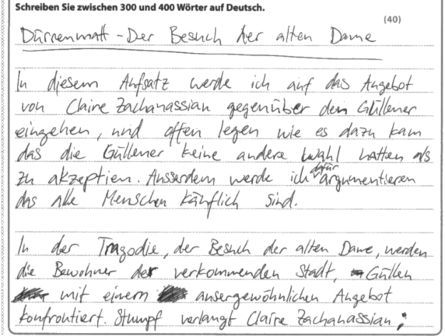
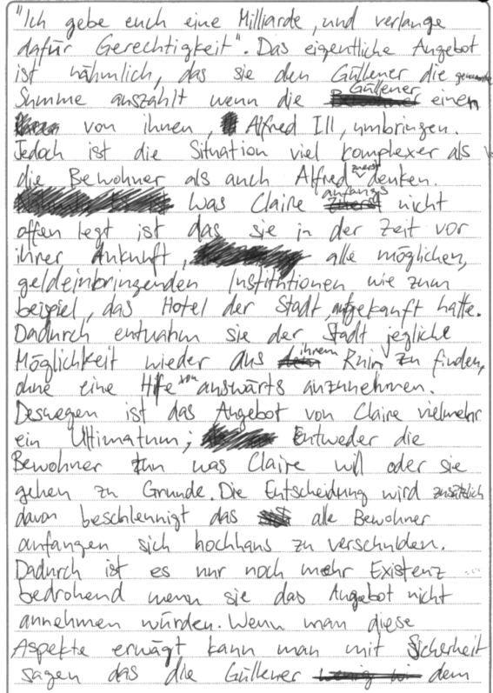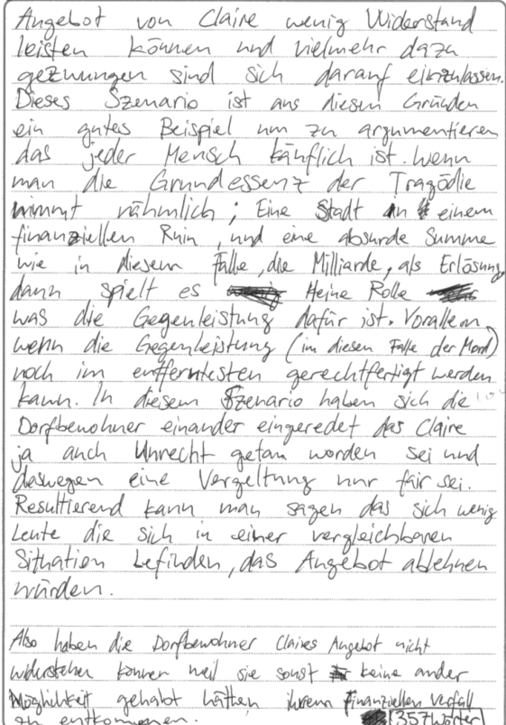

Content and Communication (9 marks)
The student has shown acceptable factual knowledge of the text. Claire’s offer is clearly explained and supported with a relevant quotation from Act I. Further supporting evidence from the text tends to be general rather than specific. For example, the student mentions the idea of Widerstand leisten, but does not give any details of how this is borne out in the play, eg by the teacher’s attempts to resist the offer or by his and the doctor’s attempts at the beginning of Act III to convince Claire to help the town without demanding the murder of Alfred Ill. Similarly, there is mention of the townspeople convincing themselves of Alfred’s guilt but without any detailed reference to the text, eg in the oath taken by them all before he is killed. Instead, the student focuses mainly on the economic ruin of the town and the predicament in which the townspeople find themselves. This results in a mostly one-sided view of the play which does not take into account the crucial word inwiefern in the second part of the essay question.
Although the essay could be place in the 10-12 band for communication and content, a mark at the top of the 7-9 band is more appropriate because of the lack of hard evidence from the text.

Quality of Language (5 marks)
Communication is fluent and varied throughout with only very minor errors, eg das rather than dass at the end of the first paragraph. There is a wide range of both common and less common grammatical structures, eg good use of modal and reflexive verbs, infinitive clauses and the passive, and relevant vocabulary is used throughout such as außerdem, umbringen, verschulden and Vergeltung. There is no reason to award this less than top marks.

Critical Analysis, Organisation and Development (8 marks)
The introduction sets out in basic terms what the essay aims to achieve and the conclusion is short but to the point. The central section of the essay is simply one long paragraph which does not lead the reader through a coherent set of linked ideas. This could have been achieved by separating the ideas into individual paragraphs which lead on from each other and in which the first sentence alone can be read to follow the line of the argument.
There are some individual thoughts. For example, towards the end of the second page, the student concludes that not accepting Claire’s offer would threaten their existence even more than rejecting it. But such points of view are rarely justified fully enough.
A mark at the top of the 5-8 band is the best fit.

Commentary 6 – Awarded 11 marks
Question 12(a)
Erklären Sie, warum die Güllener Claires Angebot nicht widerstehen können. Untersuchen Sie, inwiefern das Stück beweist, dass alle Menschen käuflich sind.

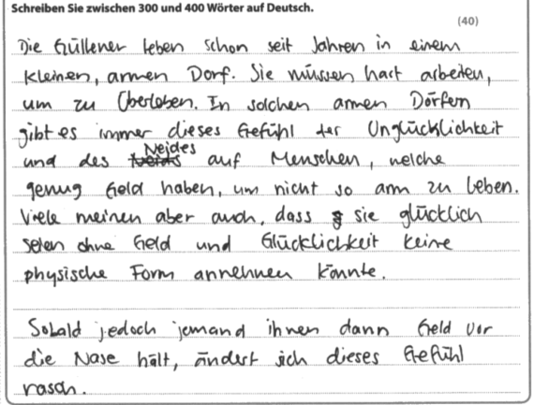
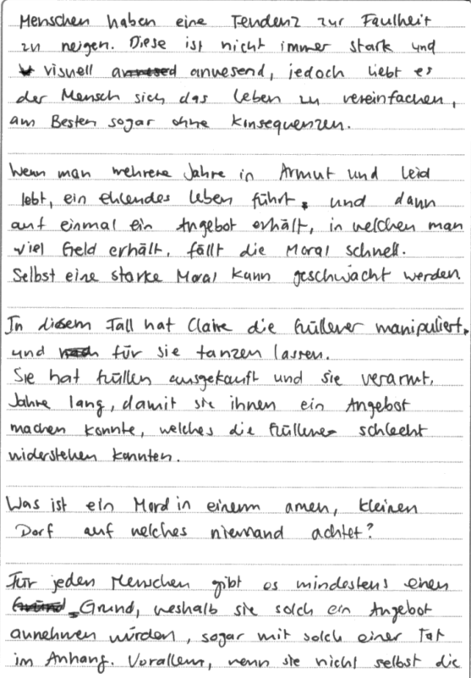
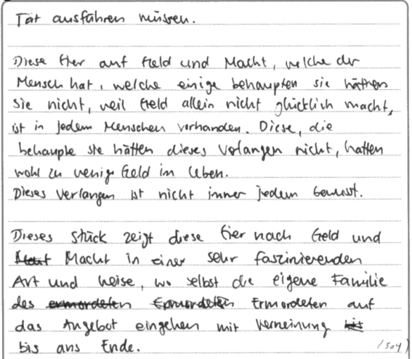
Content and Communication (3 marks)
Apart from the first two sentences, one paragraph in the middle of the second page and the final paragraph, there is little reference to Dürrenmatt’s play. Instead, the student embarks on some general ethical considerations of the power of money over those who live in poverty. This means that there is very little supporting evidence from the play to support the ideas put forward and as a literature essay the response is no more than superficial. In addition, the important second part of the question about the extent to which human beings are bribable is not addressed.
Nevertheless, the relevant sections of the essay are correct and show some understanding of the plot. This means that a mark at the top of the 1-3 band can be awarded.

Quality of Language (5 marks)
In this instance, the language of the whole of the essay can be taken into account since what is written still touches on the topic of the question. There is a wide variety of grammatical structures including infinitive clauses, conditional of modal verbs, subordination with a variety of conjunctions and a sound sense of case and gender. Syntax is correct throughout and communication is fluent and varied. This can be awarded the mark in the top band.
Critical Analysis, Organisation and Development (3 marks)
Unfortunately, the student has not shown enough analysis of the play to merit more than a mark in the 1-4 band. Successful critical analysis relies on observations about the play which has been studied. Here, for example, there could have been reference to the fact that although the majority of the townspeople immediately succumb to Claire’s offer, the teacher at first tries to resist the temptation but ultimately is too weak to be able to remain true to his humanistic ideals.
There is an attempt to structure the essay in paragraphs and a conclusion which tried to summarise the ideas. However, the paragraphs do not flow easily to create a coherent argument and the conclusion introduces the new idea of Ill’s family’s reaction to the offer.
The student clearly wants to engage with the question but falls short of the approach which is expected in a literature essay.

Commentary 7 – Awarded 37 marks
Question 12(a)
Erklären Sie, warum die Güllener Claires Angebot nicht widerstehen können. Untersuchen Sie, inwiefern das Stück beweist, dass alle Menschen käuflich sind.

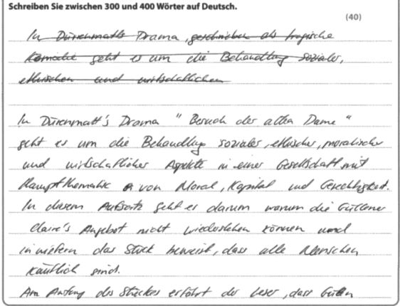
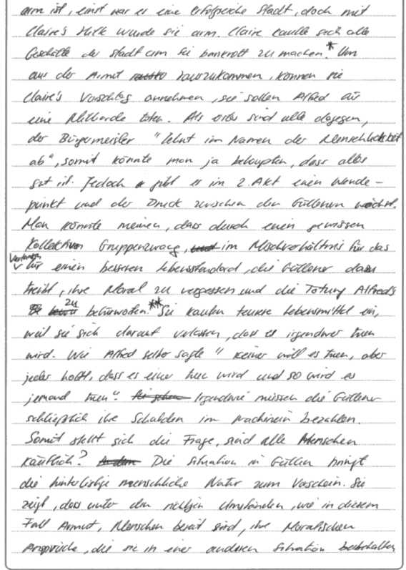
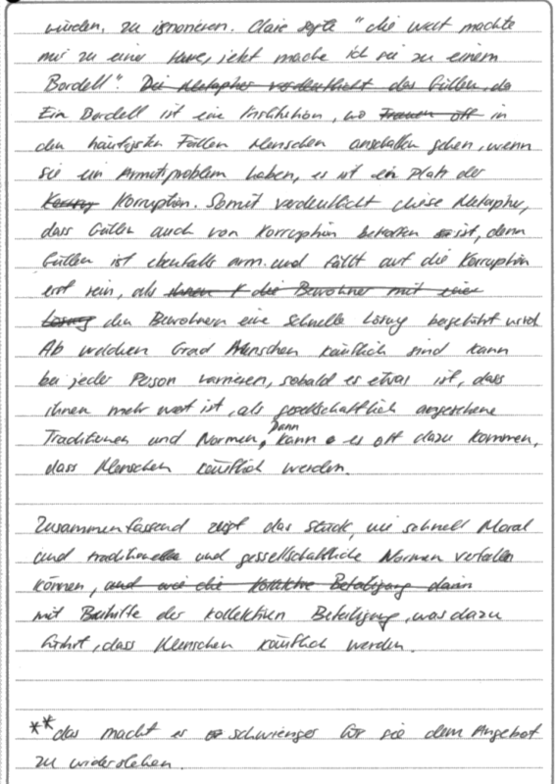

Content and Communication (14 marks)
The student shows excellent factual knowledge of the play. Main points are often supported with a relevant quotations and good examples from the play, mostly avoiding generalisations. The essay achieves depth of understanding by going beyond the superficial. For example, the student illustrates how the situation in Güllen brings out die hinterlistige, menschliche Natur. In addition, the student manages to consider some different aspects of the question by referring to the mayor’s initial rejection of Claire’s offer and by mentioning later in the essay that each individual reacts differently but ultimately that everyone is käuflich.
The essay covers a wide range of ideas, but could also have explored the chorus’ explanation in the epilogue that poverty drives human beings to desperate actions, that Claire herself has learned how to buy and dispose of other human beings or that being bought ultimately has its price.
All in all, this essay is worth a mark in the middle of the 13-15 band.

Quality of Language (5 marks)
Communication is fluent and varied throughout and the student displays a secure command of a wide range of grammatical structures to express conceptually challenging ideas. Vocabulary is excellent and shows knowledge of may specialist terms such as Drama and Stück (while many less successful students refer to the work using Buch) and Metapher. A mark in the top band is clearly the most appropriate.

Critical Analysis, Organisation and Development (18 marks)
In the introduction, the student makes a connection between the overall themes of the play with the aims of this essay. The final paragraph pulls together the argument and answers the question set, linking the bribability of human beings to the lowering of moral standards.
The student shows genuine interest throughout and evaluates at each stage. For example, the mayor’s rejection of Claire’s offer is said to suggest that this may suggest that all is well with the useful phrase somit könnte man ja behaupten.
It would have been useful if the student had divided the central section of the essay into carefully constructed paragraphs. Nevertheless, a line of argument can be traced with each section beginning as follows:
- Am Anfang des Stückes erfährt der Leser ...
- Als erstes sind alle dagegen ...
- Jedoch gibt es im zweiten Akt einen Wendepunkt ...
- Irgendwie müssen die Güllener schließlich ihre Schulden im Nachhinein bezahlen.
- Ab welchem Grad die Menschen käuflich sind ...
The ideas are linked with carefully chosen adverbs which help the reader to understand how the analysis progresses.
Such an insightful response can be awarded a mark towards the lower end of the 17-20 band.
Commentary 8 – Awarded 15 marks
Question 17(b)
Beschreiben Sie den Charakter von Barbara. Analysieren Sie, wie sie im Laufe des Filmes zu einer Heldin wird.

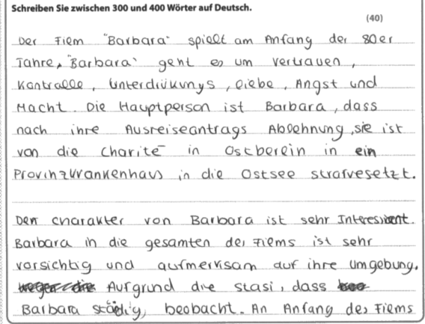
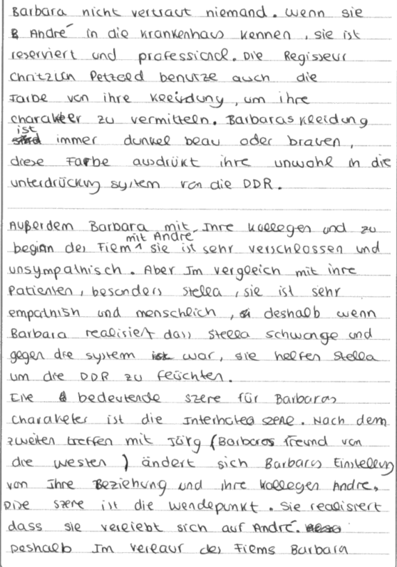
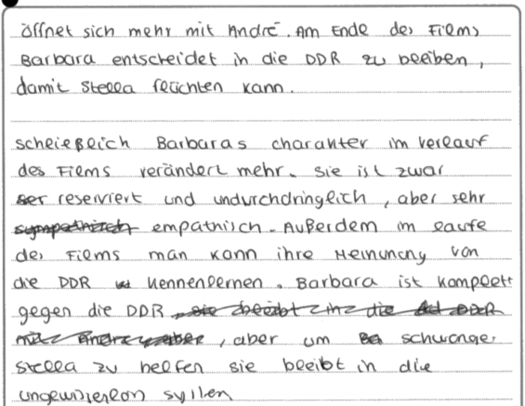

Content and Communication (5 marks)
Although the student has shown acceptable factual knowledge of the film, there is limited depth in the response. On the one hand, there is plenty of information about Barbara’s character, highlighting her anxiety about being observed and her initial reservation about André which develops into deeper feelings for him. In these sections of the essay, the supporting evidence is relevant but could be more detailed. On the other hand, the essay shows limited depth. For example, there is no real consideration of how Barbara tries to adapt to her situation and a lack of detail to support mention of her professional qualities.
For this reason, the best fit for Communication and content is in the middle of the 4-6 band.

Quality of Language (3 marks)
Communication is achieved most of the time. Common grammatical structures are used mostly correctly, eg basic syntax and a reasonable sense of case and gender. However, some more complex structures become muddled and verb agreements are often wrong. This occasionally hinders communication, eg …deshalb wenn Barbara realisiert dass Stella schwange und gegen die System war, sie helfen Stella um die DDR zu flüchten.
The overall quality of language is better than basic (band 2) and a mark of 3 is the most appropriate.
Critical Analysis, Organisation and Development (7 marks)
This is a partial explanation in response to the question. There is no mention of how she becomes a heroic figure, apart from the fact that she saves Stella which is described in only general terms. The student could have explored more deeply her willingness to put her own life in danger and her courageous decision to return to the hospital and André after Stella’s escape and what this might mean for her own future.
There is some attempt to organise the material into meaningful paragraphs and the conclusion tries to pull together the various strands of the essay content but without making an insightful final statement.
Overall, the essay lacks the necessary individual opinions which would merit a mark in a higher mark band. The best fit is towards the top of the 5-8 band.

Commentary 9 – Awarded 20 marks
Question 19(a)
Erklären Sie, warum Canan eine wichtige Figur im Film ist. Analysieren Sie Ihre Beziehungen zu den anderen Charakteren im Film.

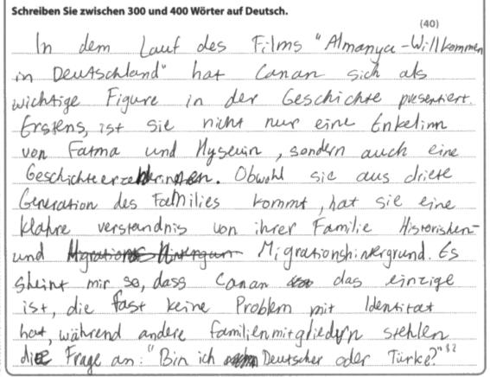
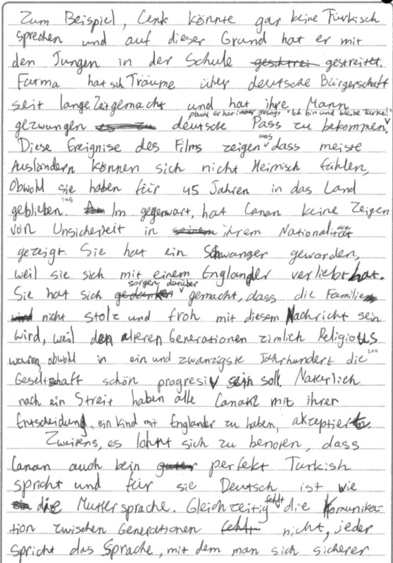
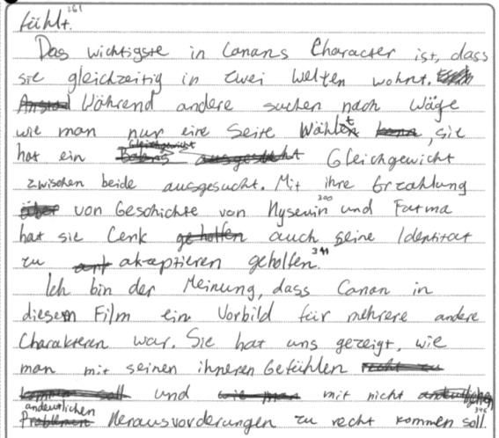

Content and Communication (9 marks)
The student has shown acceptable to good knowledge of the film and considers various aspects of the question. Canan, in contrast to other family members who have problems with their identity, is more aware of her background and accepting of her identity as a German. Her concerns about her pregnancy are also mentioned to highlight the differences between the generations in the family and in particular to explore her relationship with Fatma. Main points are supported with details from the film, although occasionally mor specific references could be given, for example when explaining how she helps Cenk to accept his identity.
For the most part, the student keeps to the point. However, at the top of the second page there is a tendency to stray into relating the plot about her grandparents’ acquisition of German passports.
There is some depth in the response and the student manages to categorise aspects of Canan’s role and character, for example by highlighting towards the end of the essay the most important point that Canan manages to like in two worlds at the same time.
This essay is placed best at the top of the 7-9 band.

Quality of Language (3 marks)
Communication is achieved most of the time. There are some awkward corners where the message is not immediately clear or where there are basic errors, eg aus driete Generation des Families, stehlen die Frage an, weil den alteren Generationen zimlich Religious waren. However, some structures are used correctly, eg subordination, a range of verb forms, reasonably secure syntax, and there is an acceptable range of vocabulary.
The mark of 3 is the best fit.

Critical Analysis, Organisation and Development (8 marks)
The essay is structured in four paragraphs. It is not clear where the introduction ends, and the body of the essay begins. However, there is a definite conclusion which summarises at least part of the essay content, ie that Canan is a role model and shows how others can cope with the challenges.
However, at this point in the essay her relationship with others seems to have been forgotten. This important aspect of the question is dealt with less successfully that the description of her character with only occasional mention of for example potential conflicts with her grandparents and her care for Cenk.
The most appropriate mark is at the top end of the 5-8 band.

Commentary 10 – Awarded 20 marks
Question 20(b)
Beschreiben Sie die Aktionen der Jugendlichen. Analysieren Sie, inwiefern die Jugendlichen naiv sind.

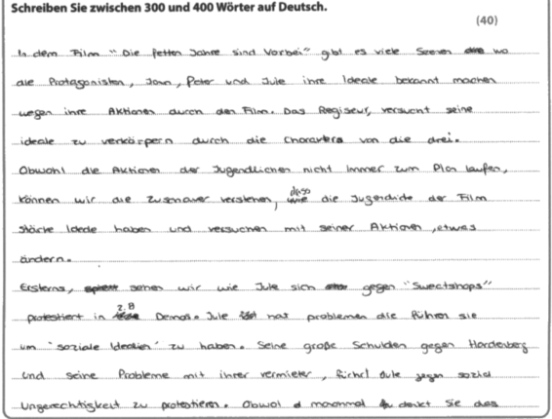
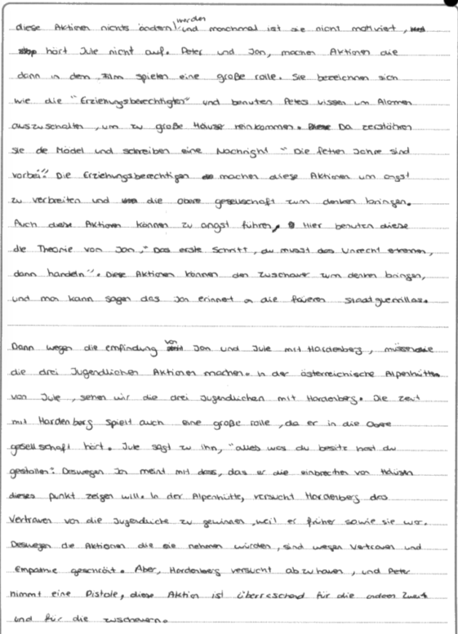
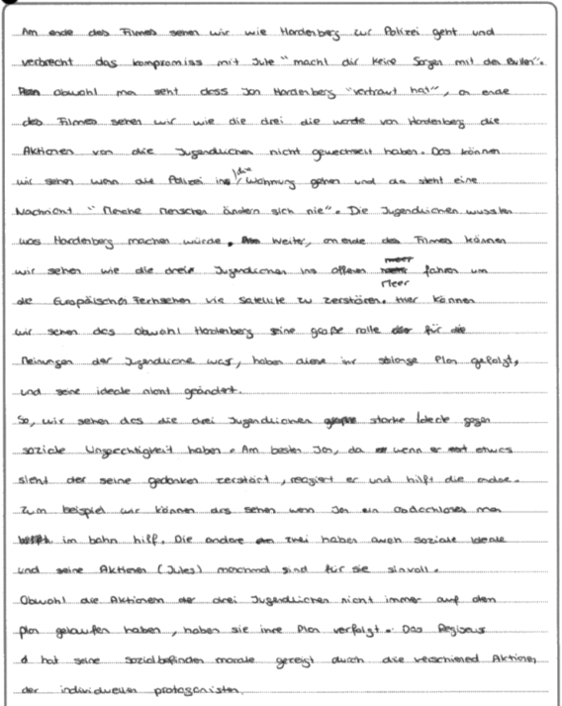

Content and Communication (9 marks)
The student addresses the first part of the question well and gives full descriptions of the actions of the three protagonists, whether this be Jule’s protests against sweatshops, Jan’s and Peter’s break-ins or Peter’s use of the pistol in the Alpine chalet. For each action, there is some evidence to support a main point made and the student shows depth of understanding by considering what the actions means or how it is perceived. For example, the break-ins are described as a way of making the audience consider the ethics of these actions.
On the other hand, the student does not address the second more important part of the question. In fact, there is no consideration at all of whether the protagonists’ can be regarded as naive.
Given that the the response to first part of the question is full and has some depth, the mark for Communication and content can still be placed at the top of the 7-9 band.

Quality of Language (4 marks)
Communication is achieved almost all of the time and there is some variety of grammatical structures including successful subordination, use of infinitive clauses and a fair range eof relevant vocabulary.
However, there are some basic errors, particularly with the confusion of the possessive pronouns sein and ihr, which sometimes delay clear communication. In some sentences the incidence of error is too frequent to merit a mark in the top band, eg Obwohl die Aktionen der drei Jugendlichen nicht immer auf den Plan gelaufen haben, haben sie ihre Plan verfolgt. A mark of 4 is, therefore, the best fit.

Critical Analysis, Organisation and Development (7 marks)
Because of the omission of the second part of the question, the essay has to be categorised as a partial response. There is some evaluation of the actions and some attempt to give an individual response, but the overall feeling is that the student might have a different essay title in their mind.
There is an attempt to structure the essay with an introduction and a conclusion, but the body of the essay (three paragraphs) does not flow with linking to make a coherent argument, but simply lists three separate examples of actions.
For these reasons, the best fit is a mark towards the top of the 5-8 band.

Pearson Education Limited. Registered company number 872828
with its registered office at 80 Strand, London, WC2R 0RL, United Kingdom

