

Comparison of key skills specifications 2000/2002 with 2004 standardsX015461July 2004Issue 1

Commentaries
Summer 2024

International A Level
In French (WFR04) Unit 4

Commentary 1 – Awarded 38 marks
Essay question: Faiza Guène – Kiffe kiffe demain
Décrivez le thème de l’adolescence dans le film. Analysez la façon dont Guène présente ce thème.

Content and communication:
The essay shows excellent factual knowledge of the book. All evidence is relevant and focused on the question. There is a wide range of relevant supporting evidence and the candidate presents different perspectives. The candidate includes a range of characters, passages and quotes. Each paragraph contains a number of examples.
The example below shows a range of evidence, quotes and depth.

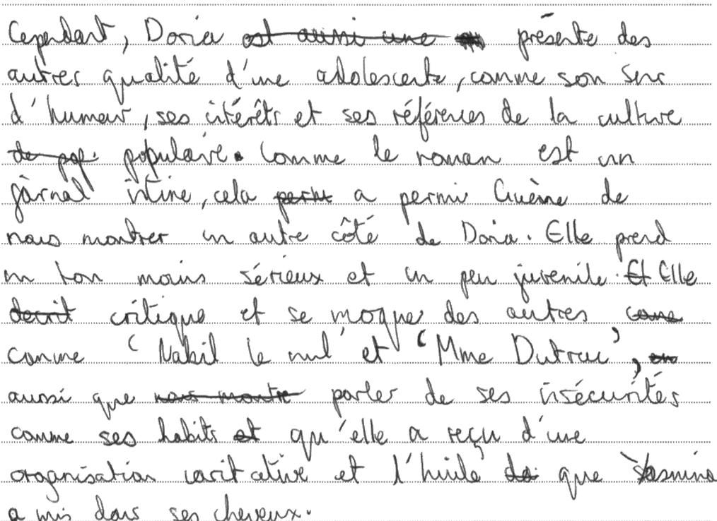

Quality of language
Communication is excellent and the essay flows very well. The response is not error free, but errors are rarely impacting on communication. The essay contains less common structures and they are used with confidence.
The vocabulary used in this essay is rich, varied and interesting. There is hardly any repetition, and the vocabulary is specific to the work.
The following examples highlight the complexity of the grammar, the variety of vocabulary and the specific terminology.

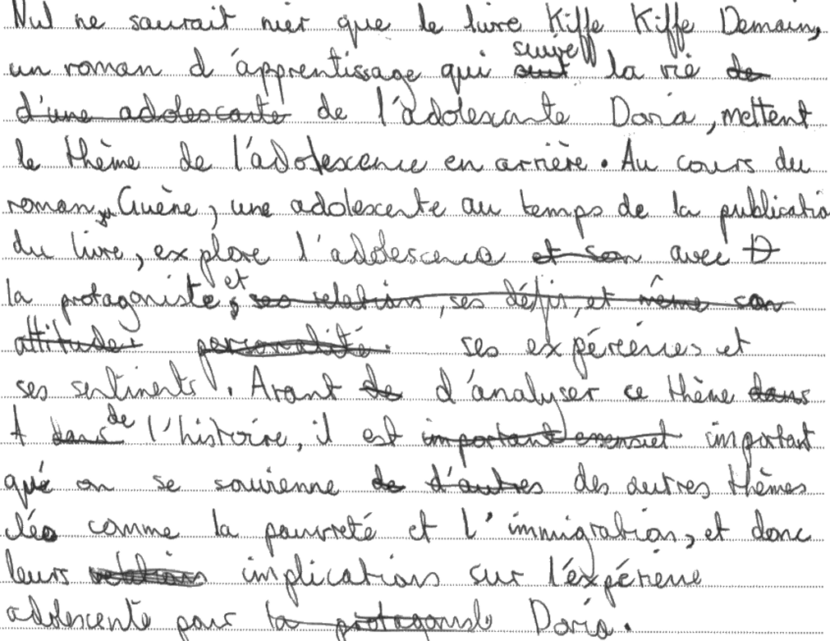

Critical analysis, Organisation and development
The essay addresses both parts of the questions; it focuses on adolescence and shows how the author presents the theme. We are presented with different perspectives and the candidate uses the evidence well to support their ideas and draw conclusions.
The organisation has been clearly planned and is coherent. There is a sense of progression in the ideas within the essay. Each paragraph is clearly indicated and introduced with adverbs: There are of insightful observations of the book and conclusive remarks are always supported by evidence.
Each paragraph is very well organised, and the candidate stays focused on the question throughout. The introduction is effective in introducing what the candidate is going to write about. The candidate, however, fails to end the essay in an effective manner; the last paragraph looks rushed.
The example below shows analysis; how Guene presents the theme of adolescence, using evidence from the book.

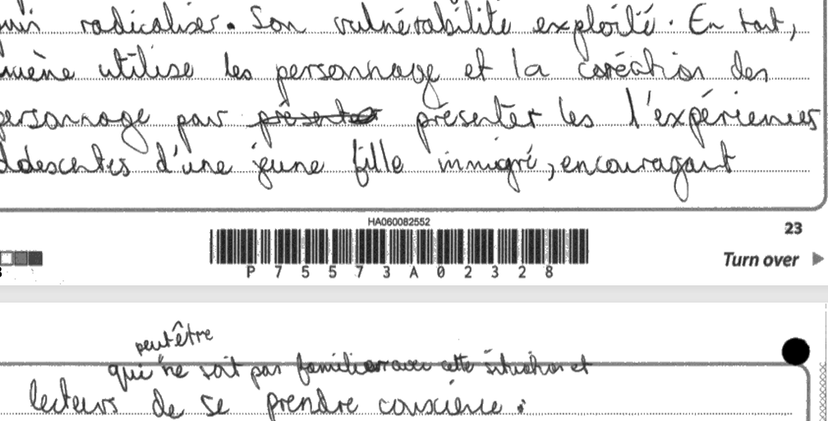

Commentary 2 – Awarded 38 marks
Essay question: Falardeau : Monsieur Lazhar
Décrivez le début du film. Analysez les sentiments que les téléspectateurs peuvent ressentir en regardant le début du film.

Content and communication:
The essay shows excellent factual knowledge of the film. The candidate selected all evidence carefully and the examples used are relevant to the question. There is a wide range of relevant supportive examples and the candidate presents different perspectives, such as scenes, camera techniques, characters, sounds….. Each paragraph contains a number of examples, and the language used illustrates well the story, being the language specific to the film.
The example below shows a range of evidence.
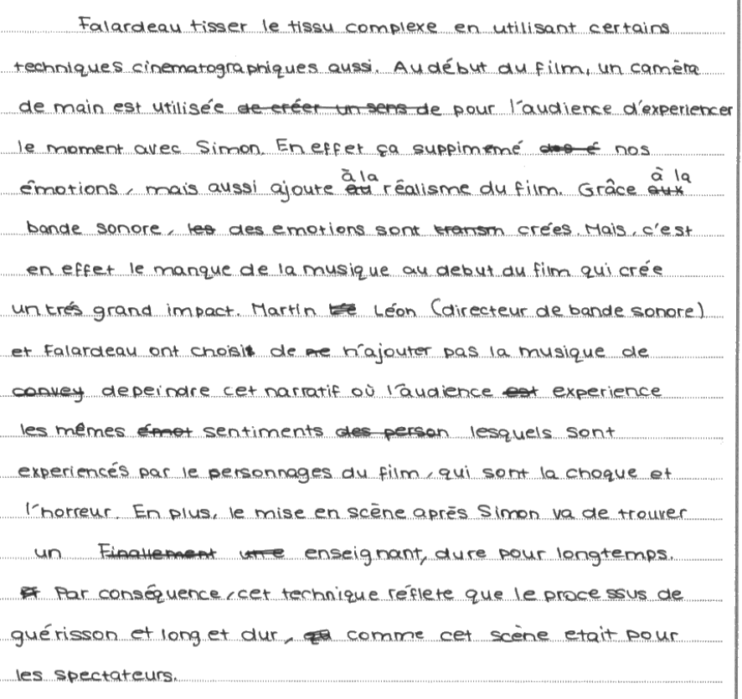
Quality of language
The quality of language in this essay isn’t worthy of the top band due to major errors like verb endings, wrong lexis and stilted sentence constructions, but the candidate tried their best to include a varied, specific and interesting vocabulary and a range of structures.
The following example highlight the variety and complexity of the vocabulary used and the specific terminology with words such as en revanche, on constate que, les berlingots, choquante, nous découvrons, poignant, le deuil, chagrin, pas seulement, mais également, mener, guérison, suivre…

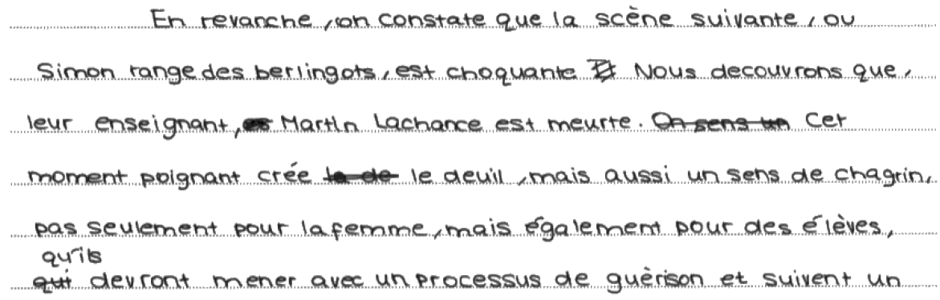

Critical analysis, Organisation and development
The essay addresses both parts of the questions; it focuses on the beginning of the film and shows how the viewers may feel. The candidate uses the evidence well to support their ideas and draw conclusions.
The organisation has been clearly planned and is coherent. There is a sense of progression in the ideas within the essay. Each paragraph is clearly indicated and introduced with adverbs: Conclusive remarks are always supported by evidence.
Each paragraph is very well organised, and the candidate stays focused on the question throughout. There are regular insightful comments throughout, like the one below. Both the introduction and the conclusion are brief and effective.

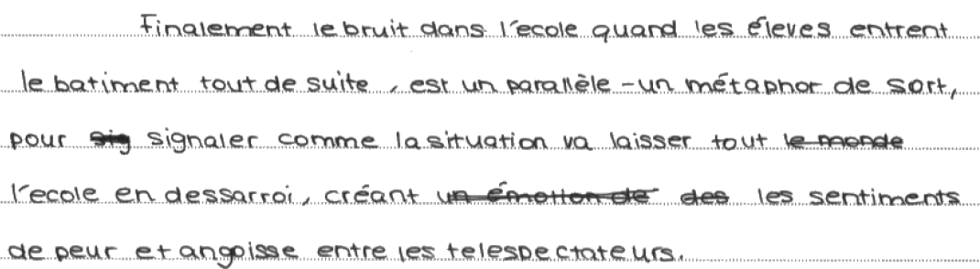

The example below shows analysis; how the techniques may affect the viewers.

Commentary 3 – Awarded 28 marks
Essay question: Faiza Guène – Kiffe kiffe demain
Décrivez le thème de l’adolescence dans le film. Analysez la façon dont Guène présente ce thème.

Content and communication:
The essay shows good factual knowledge of the book. The length of the essay suggests that the candidate provides a good range of evidence, and that the development is satisfactory. All evidence is mostly relevant and focused on the question.
The examples below are evidence of good factual knowledge and range.
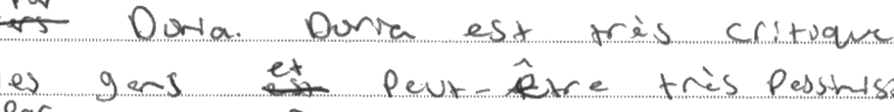

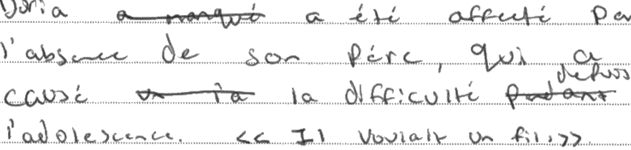

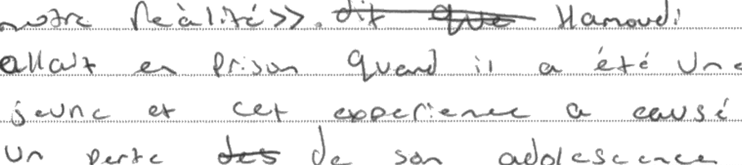

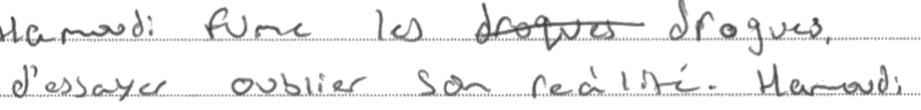
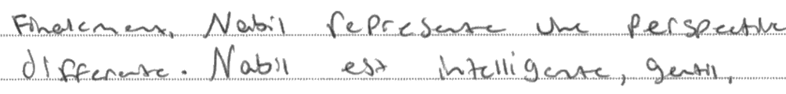

Quality of language
Communication is achieved most of the time but there are regular grammar and spelling mistakes. The essay contains some less common structure, but they are not all used with confidence. Sentences are regularly stilted.
The vocabulary used in this essay is acceptable in range but there is limitation to what the candidate can use and produce.
The following examples are attempts to use less common structures; the candidate is not in control of the language, making regular spelling and grammar mistakes. Communication breaks down.

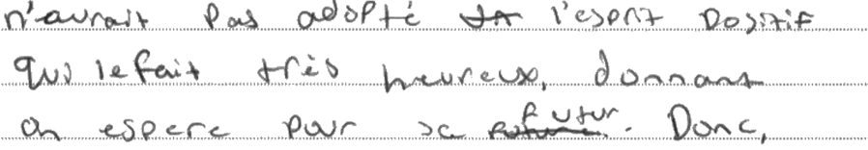

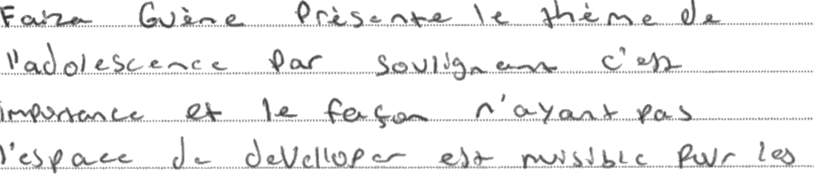

Critical analysis, Organisation and development
The essay addresses both parts of the questions; it focuses on adolescence and shows how the author presents the theme.
We are presented with three perspectives:

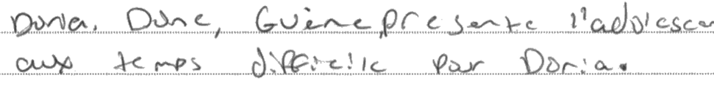

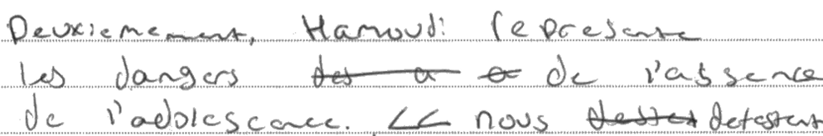

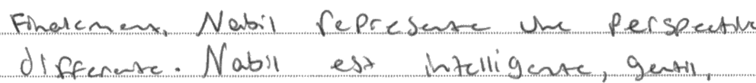

There is a sense of organisation overall, with an introduction and a main body with three parts. The essay doesn’t contain a conclusion, unless the candidate uses the last paragraph as a conclusion. A conclusion, albeit brief, is an opportunity to summarise the key points and to provide an evaluation. This is lacking here.
Each paragraph is clearly indicated and introduced with adverbs: Premièrement, deuxièment and finalement. Paragraphs contain an idea, supported by evidence from the book. There is also an attempt to draw conclusions, but it is not always well executed.
This essay is a critical analysis in response to the question, but the analysis and the organisation are not always well presented. There is inconsistency in this essay: evidence is not always relevant, there is sometimes lack of focus on the question and the organisation is sometimes confusing and the conclusive remarks are not always well drawn or not substantiated.

The example below shows a lack of focus and irrelevant evidence; the use of verlan highlights the social context. The link of the social context and adolescence is not well-made and therefore adds ambiguity in the development.
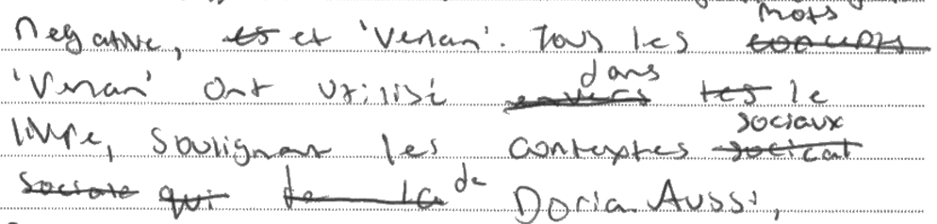

Here is another example of ambiguity in the analysis and development that detracts from the question.

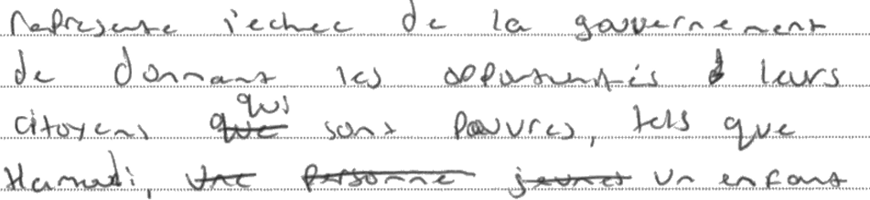

Commentary 4 – Awarded 25 marks
Essay question: Etcherelli : Elise ou la vraie vie.

Content and communication:
The essay shows good factual knowledge of the book and the context. However, not all evidence is well used and some evidence is not relevant to the question. As we read the essay, it is very easy to lose track of the essay question. A more focused approach would have been more beneficial. Even tough the candidate tried to use their knowledge to demonstrate immigration in the book, the theme of immigration is only addressed in the last paragraph.
The example below is evidence of good factual of the book but not really focused on the question.
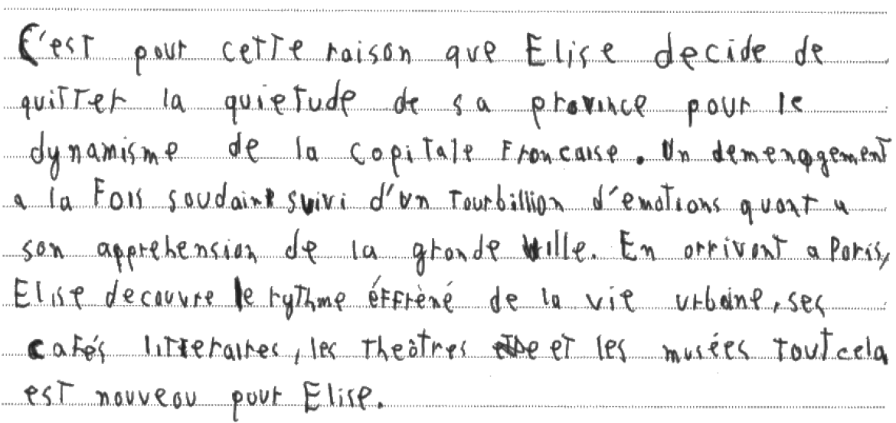

Quality of language
Communication is achieved most of the time but there are regular grammar and spelling mistakes. The essay contains some less common structures. Vocabulary is good in range. The quality of the language in this essay is higher in standards than an average C grade essay, that will display regular breaks in communication, a limited range of vocabulary and simpler sentence constructions.
The example below shows a good range of lexis and structures. Missing accents often cause ambiguity, but the language is rich.
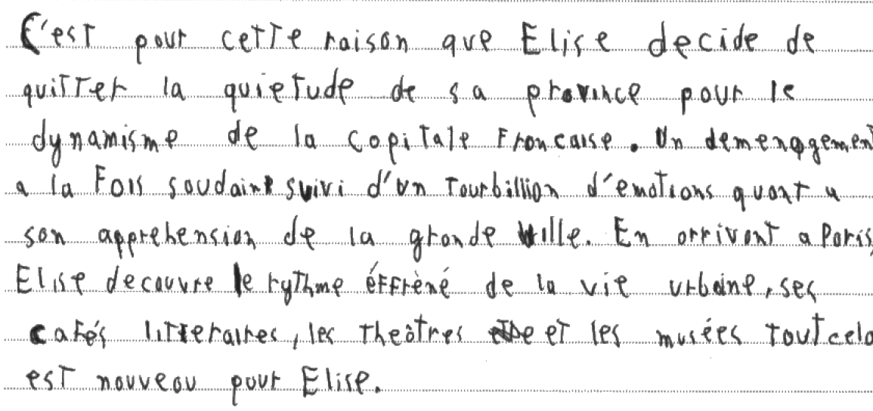

Critical analysis, Organisation and development
The essay addresses the theme of immigration but is not well focused. The theme of immigration is only clearly discussed in the last paragraph. The links between the previous paragraphs and the last one on immigration is made with “voici comment”, which then make the reader re-read the essay to find how the theme is introduce. There is a sense of analysis but not well executed. The ideas and conclusions in the essay should have been linked more clearly to the question.
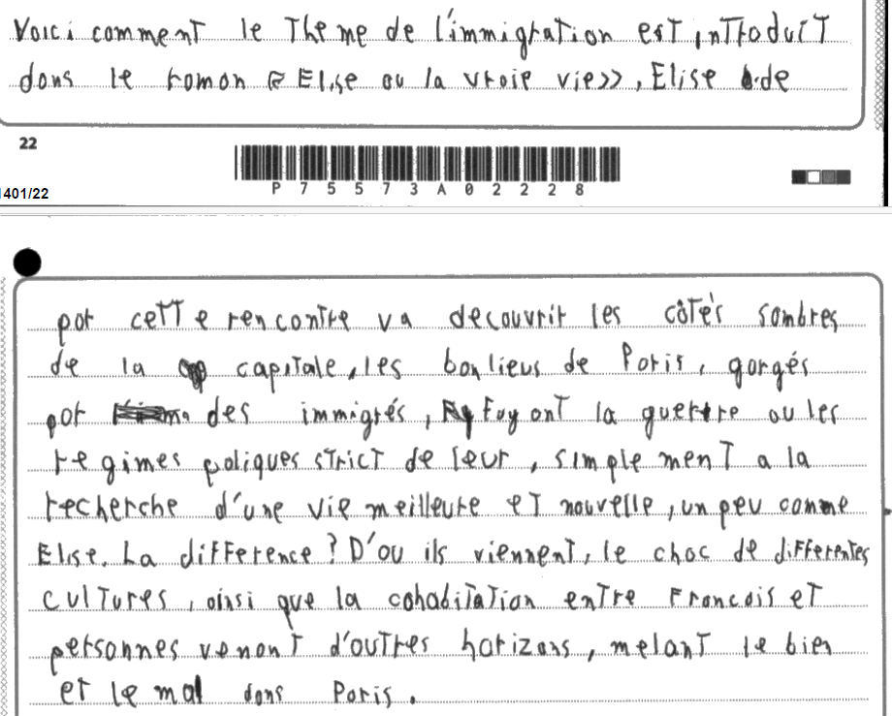
There is a sense of organisation overall, with an introduction, a main body and a conclusion.
Each paragraph contains an idea,.There is also an attempt to draw conclusions, but it is not always well executed.
This essay is a critical analysis in response to the question, but the analysis and the organisation are not always well presented. There is inconsistency in this essay: evidence is not always relevant, there is sometimes lack of focus on the question and the organisation is sometimes confusing and the conclusive remarks are not always well drawn or not substantiated.

Commentary 5 – Awarded 13 marks
Essay question: Faiza Guène – Kiffe kiffe demain
Décrivez le thème de l’adolescence dans le film. Analysez la façon dont Guène présente ce thème.
Content and communication:
The essay shows some basic and generic factual knowledge of the book. The length of the essay also suggests that the candidate does not provide enough evidence, and that the development is limited. There is limited supporting evidence; ideas are rarely supported by specific examples from the book.
The examples below are evidence of ‘basic knowledge’ and ‘factual knowledge’.
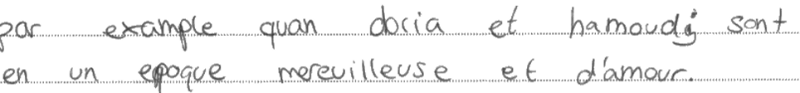
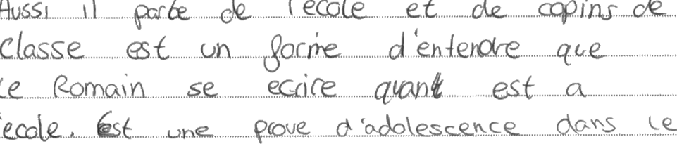
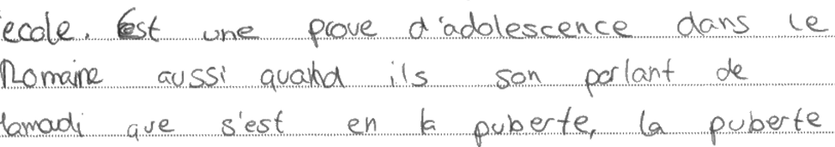

Quality of language
The candidate uses common structures, and these are sometimes used correctly. Spelling and grammar mistakes are very common, and they impact regularly on communication. There is also interference of the mother tongue. Vocabulary is limited in range; there is regular repetition of vocabulary and when the candidate tries to vary their vocabulary, it is inaccurate either in spelling or in meaning. In the section below, the following mistakes hinder communication: peur/ nous poudrai / le romaine/ le romain/ activités/ come / quan / en un / merevilleuse
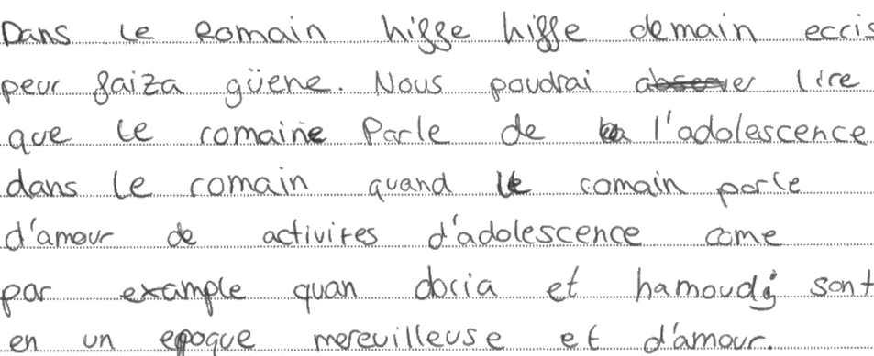

Critical analysis, Organisation and development
The essay addresses the theme of adolescence but doesn’t really address the second part of the question; for that reason, we can say that it is partial engagement. The essay doesn’t show how the author presents the theme. The essay only contains evidence of the theme of adolescence.
Overall, there is a sense of organisation, with a main body and a conclusion. However, the main part contains all the evidence, without a clear organisation between ideas and within ideas and supporting evidence.
The essay lacks conclusive remarks. When an attempt is made to draw conclusion from an example, this is done in a very awkward manner.
In the example below, the candidate tries to draw conclusion from the two examples ( Hamoudi who smokes cannabis and Doria and Hamoudi), but this is proving unsuccessful. The links between the evidence and the conclusion are missing.

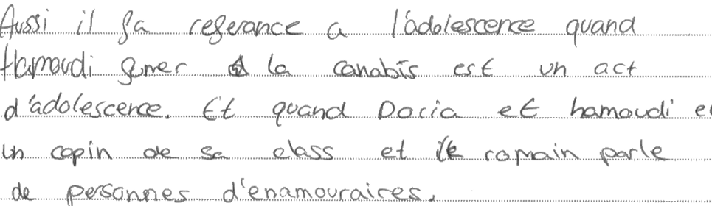

Commentary 6 – Awarded 12 marks
Essay question: Histoire
Content and communication:
The essay shows some basic and generic factual knowledge of the date. What’s more, the essay, fousing on the rafle du Vél d’Hiv’ provides a wrong date for that event. The rafle du Vél d’Hiv’ took place on the 16th and 17th July 1942, not in 1939.
The length of the essay also suggests that the candidate does not provide enough evidence, and that the development is limited.
The examples below are evidence of ‘basic knowledge’ and ‘factual knowledge’.

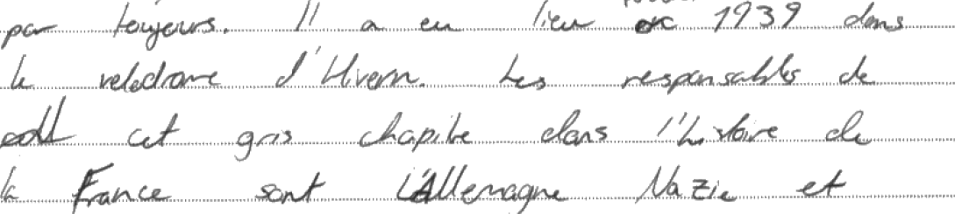

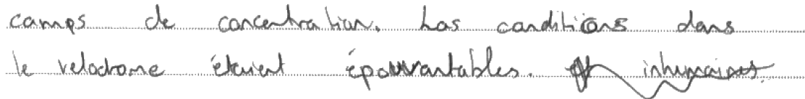
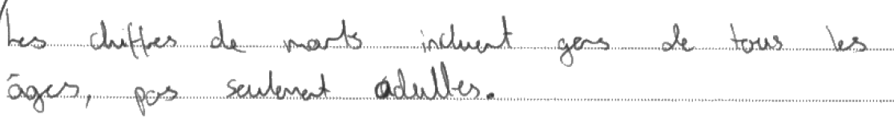

Quality of language
The candidate uses common structures, and these are sometimes used correctly. Spelling and grammar mistakes are very common, and they impact regularly on communication. There is also regular interference from the mother tongue.
Vocabulary is limited in range; there is regular repetition of vocabulary and when the candidate tries to vary their vocabulary, it is inaccurate either in spelling or in meaning.
In the section below, the following mistakes hinder communication: represent, murte, mil, jeuxs, entasses, norriture, las…
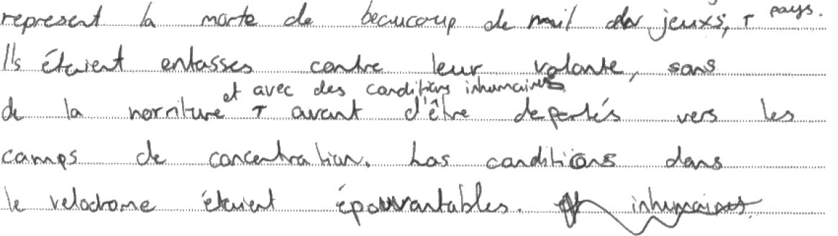

Critical analysis, Organisation and development
The essay presents the date and tries to explain why it is important. It includes reference to the death of so many Jewish people and how it represents the anti Semitic laws of the time, but the analysis stops there and it is not fully developed due to the length of the essay.
Overall, the candidate attempts to give a sense of organisation to their essay. The candidate either lacked time to continue the essay or ran out of ideas.

The two examples below show an attempt to produce and develop an analysis.

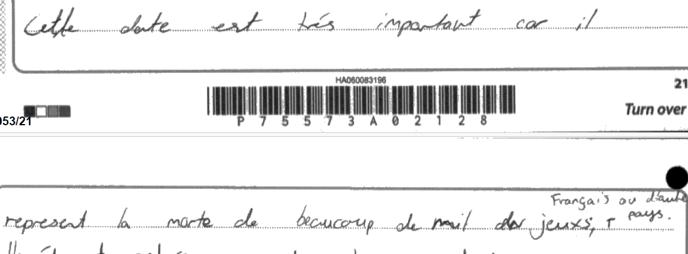

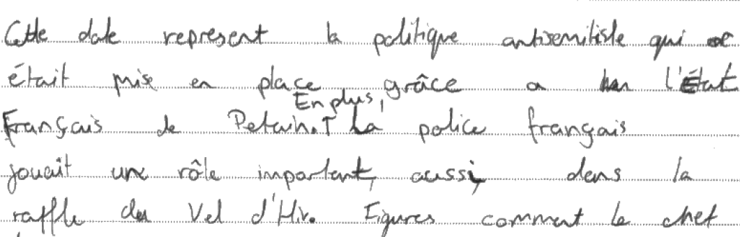

Pearson Education Limited. Registered company number 872828
with its registered office at 80 Strand, London, WC2R 0RL, United Kingdom

