Digital submission of authentication sheets
Each candidate must sign an authentication sheet to confirm that the work submitted for assessment has been carried out without assistance other than that which is acceptable under the scheme of assessment. The authentication sheets must also be signed by the teacher/assessor.
This signed authentication sheet for each candidate should be uploaded digitally onto our Digital Learner Work Transfer (DLWT) platform, alongside the digital submissions of their work and the Excel Candidate Assessment Booklet (CAB).
The authentication sheets are available in a Word format and PDF format. They can be found here for GCSE D & T and here for A-level (both under ‘Forms and administration’).
There are two ways of signing and submitting the authentication sheets to Pearson:
- Printing the sheets, signing them by hand and then scanning into your computer.
- Commenting on the Word version of the form using the ‘Comment’ function to show the date and time stamp of when the document was signed by both teacher/assessor and candidate.
This guidance will walk you through how to sign the authentication sheets using Option 2.

Commenting on a Word Document
Attaching a comment to the signature boxes on the Word version of the Authentication Form allows the moderator to see which user made the comment and at what time and date.
The teacher and candidate should sign the boxes on their own individual user accounts so that the moderator can verify that it was the teacher and candidate who signed the authentication sheet. If either party do not have their own identifiable Word account then sheets should be printed, handsigned and scanned (see Option 1).
Before commenting with the signatures, the rest of the form should be completed first by filling in the relevant boxes.
To make a comment on a Word Document, users should follow these steps:
- Select the content you want to comment on (the Teacher/assessor or Candidate declaration).
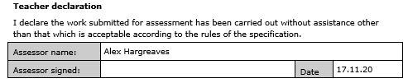
The date in the ‘Date’ box should match the timestamp date of the comment.
- Go to Review > New Comment.
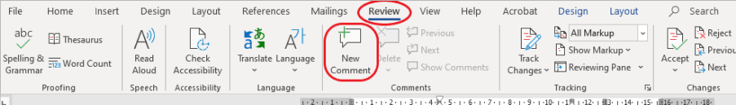
- Type your name to sign the Authentication Form. If you want to make changes to any of your comments, you are able to go back and edit them.
