

Contents
Migrants in Britain thematic study

Sample assessment materials – exemplar answers
© artwork: Mark Bolitho | Origami photography Pearson Education Ltd/Naki Kouyioumtzis
GCSE (9–1) History

Introduction 3
Sources for use with Section A 5

Question 1 6
Question 2(a) 8
Question 2(b) 13
Question 3 16
Question 4 19
Question 5 24
Question 6 30

Annotated versions
Question 1 36
Question 2(a) 38
Question 3 42
Question 4 44
Question 5 48
Question 6 52

Highlighted versions
Question 1 57 and 69
Question 2(a) 58 and 70
Question 3 60 and 72
Question 4 61 and 73
Question 5 63 and 75
Question 6 66 and 77

Introduction

This exemplar booklet has been created using student-style responses to the Sample Assessment Materials for the new option 13, which is being assessed for the first time in Summer 2022.
- Migrants in Britain, c800–present and Notting Hill, c1948–c1970.
This booklet contains four full sets of exemplar answers, A–D, and these are provided below in three formats: in plain form (pp.6–35), with annotated comments (pp.36–56), and with highlighted sections (pp.57–78). Annotating or highlighting answers is a good way to work with your students to analyse how responses are constructed.
The answers and examiner commentaries in this guide can be used to show the application of the mark schemes in the assessment of GCSE History. We intend to provide student exemplar answers for Migrants in Britain and Notting Hill following the summer 2022 series.
Exemplar answers for Paper 1 Crime and Punishment, Medicine, and Britain in the summer 2019 series can be found on the Edexcel website here.
The Paper 1 examination paper:
- is 1 hour and 15 minutes in duration
- is marked out of 52 marks
- is worth 30% of the qualification
- covers AO1, AO2 and AO3.
The structure of the question paper is as follows:
 | Total marks | AO | Question description | Example question stem
Section A: historic environment
1 | 4 | AO1 | Description of features | Describe two features of…
2(a) | 8 | AO3 | Analysis and evaluation of source utility | How useful are Sources A and B for an enquiry into…?
2(b) | 4 | AO3 | Framing historical questions | How could you follow up Source [A/B] to find out more about…?
Section B: thematic study
3 | 4 | AO1/ AO2 | Comparison of similarity and/or difference (over time) | Explain one way in which xxxx was similar to yyyy
4 | 12 | AO1/ AO2 | Explanation of the process of change | Explain why…  + two stimulus points
5/6 | 16 +  4 SPaG | AO1/ AO2 | Judgement relating to one of the following:  the extent of change; patterns of change; process of change; impact of change | ‘[Statement.]’ How far do you agree? Explain your answer.  + two stimulus points
NB. In summer 2022 no SPaG marks are available for Q5/6.
The question papers provided answer spaces to give guidance as to the maximum length of response that might be expected (although candidates may use more space).
Tables and structured spaces are provided for some question types (Q1 and Q2b) and stimulus points are provided as prompts on higher-tariff questions (Q4 and Q5/6).

For further guidance on Paper 1, please refer to the Getting Started Guide and to the Paper 1 Guide.

Assessment Objectives
NB. AO4 does not appear on Paper 1.
AO1  35% | Demonstrate knowledge and understanding of the key features and characteristics of the periods studied.
AO2  35% | Explain and analyse historical events and periods studied using second-order historical concepts*.
AO3  15% | Analyse, evaluate and use sources (contemporary to the period) to make substantiated judgements, in the context of historical events studied.
AO4  15% | Analyse, evaluate and make substantiated judgements about interpretations (including how and why interpretations may differ) in the context of historical events studied.

Support for teaching Migrants in Britain
Support for the new Migrants in Britain thematic study can be found on the Edexcel website here, including the topic booklet, scheme of work, guides produced in partnership with The Black Curriculum, mapping of the specification content to Our Migration Story, and information on endorsed published resources.*
On the Historical Association website there is a podcast about the new Migration option, written and delivered by two of our senior examiners: https://www.history.org.uk/student/categories/495/module/8782/podcast-series-pearson-edexcel-migrants-in-britai

*You do not need to purchase any resources to deliver our qualifications.

Sources for use with Section A

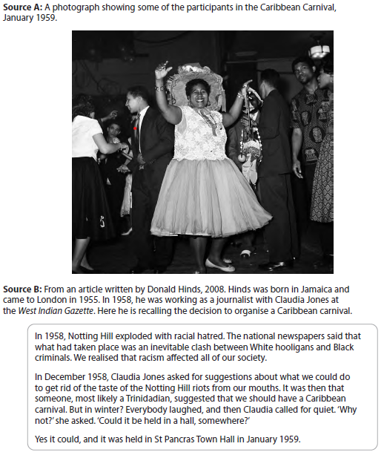

Section A: Historic Environment
Question 1
Mark Scheme

Answer A
Feature 1
Many migrants in Notting Hill lived in Houses of Multiple Occupation. There were many large houses in the area which landlords split into bedsits for single people to rent.
Feature 2
Migrants could not afford high rents and therefore ended up in very basic housing. Many of the houses in Notting Hill had been damaged during the Second World War and were in poor condition but landlords found they could rent them to migrants.
Comment
This answer would receive the full 4 marks. Both features are clearly focused on housing available to migrants in Notting Hill. They are each supported by additional relevant detail, which is rooted in the Notting Hill environment.

Answer B
Feature 1
The available housing was very poor. Migrants had to live in very unhygienic conditions.
Feature 2
People had to live in overcrowded houses. This was because migrants couldn’t afford high rents.
Comment
Both of the features given here are valid but they are very generalised. Feature 1 would receive 1 mark for the comment that available housing was poor, and Feature 2 would receive 1 mark for the comment about overcrowded houses, but in both features the additional detail is not clearly rooted in Notting Hill.

Answer C
Feature 1
Much of the housing available to migrants in Notting Hill was of a poor quality.
Feature 2
The housing in Notting Hill that was available to migrants was often overcrowded.
Comment
This answer gives two features of the housing available to migrants but they have not been developed with supporting information. This answer would receive 2 of the 4 available marks.

Answer D
Feature 1
Much of the housing available to migrants in Notting Hill was of a poor quality. The area was seen as an unattractive place to live but was often the only place that some migrants, such as those from the Caribbean, were accepted.
Feature 2
The housing in Notting Hill that was available to migrants was often overcrowded as landlords split large houses into Houses of Multiple occupation (HMOs). What was originally one house could be split in to many separate flats or bedsits.
Comment
This answer gives 2 features of the housing available to migrants. Both features have been developed with supporting information which is grounded in the historic environment. This answer would receive 4 of the 4 available points-based marks.

Question 2(a)
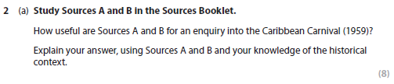
Mark Scheme
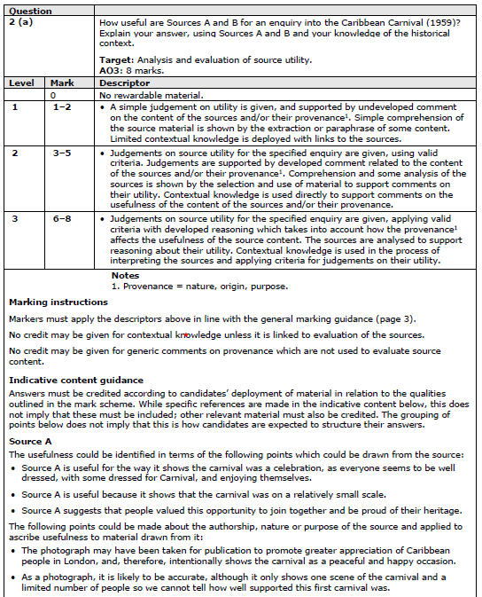
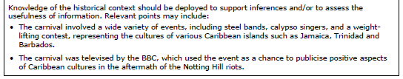
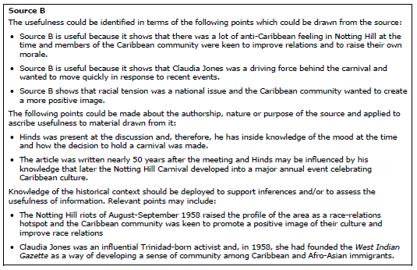
Answer A
Source A is useful evidence of what happened at the carnival. It shows people dancing and they are dressed on smart clothes, so they obviously felt this was a special event. The carnival was intended to celebrate Caribbean culture and it included music from steel bands. It seems fairly crowded, meaning this was a popular event, although it is difficult to get a sense of scale from a photograph showing only a section of the room. The carnival started in 1959 and therefore this photograph of the first carnival was possibly taken to show the success of the event in the hope that it would increase in popularity in later years. By the mid-1960s, it had become much larger and was an outdoor event, held in August, so this source is useful for showing how the carnival began indoors.
Source B is very useful for explaining the origins of the carnival. Notting Hill contained many migrants from the Caribbean but there was also a lot of racism from groups such as Teddy Boys and migrants were often unwelcome in dance halls and pubs. The source tells us about the circumstances that led people to organise the event and how they wanted to present a positive view of Caribbean culture, for example, music was an important element of Caribbean culture.
The author seems to have been present at the meeting, so his memories provide an insight into the aims and attitudes of the organisers. Since he is writing 50 years later, his memories may be over-positive and he clearly wants to suggest it was a special event but that doesn’t make the details of his account unreliable. The source is very useful for providing details about how the carnival began and the attitudes of the people involved.
Comment
This answer would be awarded Level 3 – 8 marks. It shows the usefulness of the content of the sources but also takes into account the way the provenance of the sources affects the reliability and usefulness of the content. Additional contextual knowledge is used to confirm some of the details or provide additional explanation to show why the source is useful. This additional knowledge is integrated into the answer rather than being presented as a separate section of the answer.

Answer B
Source A is useful because it shows us what happened at the carnival. We can see people dancing and everyone is dressed up smartly, so we can tell that it was a happy event. It shows quite a lot of people, suggesting it was a popular event. Source A is a photograph so it shows the actual event and therefore is reliable.
Source B is useful because it explains how the carnival started. It gives details about why the people of Notting Hill wanted to celebrate their heritage and the role of Claudia Jones in organising the carnival. However, the author is a journalist, so he might want to exaggerate some points, and this article was written 50 years afterwards, so the author might have forgotten some details, making this source less reliable.
Comment
This answer would receive Level 2 – 4 marks. Both sources are evaluated at Level 2. It shows that that the sources can be used to make inferences about what happened at the carnival and why it started. There is no use of contextual knowledge to develop comments based on the source content, so it cannot receive the top mark in Level 2.
Comments are made about the provenance of the sources but these are generic comments based on the nature or the date of the source. There is no consideration how the provenance of the photograph might affect its use beyond the assertion that, as a photograph, the Source A is reliable. Similarly, the reliability of Source B is questioned based on generic comments that journalists exaggerate and details are forgotten over time but there are no references to specific details in the sources which could support these comments. These judgements also lack an awareness that the focus of the question is on the usefulness of the sources and that unreliable source can still be extremely useful.

Answer C
Source A would be very useful for an enquiry into the Caribbean Carnival of 1959. The photograph shows us that it was members of the Afro-Caribbean community who attended the event. It shows that those who attended enjoyed themselves; we can see people dancing and socialising with each other. Other aspects included a beauty show and performances from popular singers. The carnival was also televised on the BBC. Although this photograph only shows a small number of attendees, the event was well attended and ran for 6 years.
The source is a first-hand account which is useful as it gives an insight into the development of the carnival. Claudia Jones was a successful anti-racism leader and editor of the West Indian Gazette. The article was however written in 2008 which is some time after the event. Hinds, who was in attendance at this first meeting would obviously attribute significance to the meeting as the Notting Hill Carnival is still a popular and important event. This does not however make the account unreliable. It gives an important insight into the thoughts and views of those present at the meeting.
Comment
This is a Level 2 – 5 mark response. For Source A the candidate discusses utility in relation to content, adding in some contextual knowledge, and makes comments on the usefulness of the source. For Source B the provenance of the source is the focus with links again being made to utility.
When marking question 2(a), the mark scheme is applied to the answer of Source A and then Source B; a ‘best-fit’ approach is then used to decide the final mark. Here, both sources have been evaluated in different ways but are both strong in Level 2. A 'best-fit' approach results in mark of Level 2 – 5 marks. The inclusion of supporting contextual knowledge allows the answer to be awarded 5 marks at the top of Level 2 but it does not get into Level 3 because it does not discuss usefulness in terms of content and provenance, linked to contextual knowledge for either source.

Answer D
Source A would be very useful for an enquiry into the Caribbean Carnival of 1959. The photograph shows us that it was members of the Afro-Caribbean community who attended the event. It shows that those who attended enjoyed themselves; we can see people dancing and socialising with each other. Other aspects included a beauty show and performances from popular singers. The carnival was also televised on the BBC. Although this photograph only shows a small number of attendees, the event was well attended and ran for 6 years. The provenance of this source adds to its usefulness. Being a photograph the source allows us to actually gain a snapshot of events, this is important to gain an understanding of the first carnival and to sense its positive atmosphere. As it was taken in 1959 at the first carnival, perhaps it was a publicity photograph to encourage more people to attend in future and therefore deliberately offers a positive impression of the event in order to show the Caribbean community in a good way.
The content of source B would be very useful for an enquiry about the Caribbean carnival as it describes the origins of the event. The source explains the decision to hold a carnival was made at a meeting following the Notting Hill Riots. The riots took place in 1958 amid a climate of racism. During a discussion about how to move forward the idea of a carnival was put forward. Whilst others laughed Claudia Jones looked for solutions about how the carnival could be held. Jones was a successful anti-racism leader and editor of the West Indian Gazette, so she was an influential person in the community and the source describing her role is very useful. The source does not detail anything about the event itself but it is a first-hand account which is useful as it gives an insight into the development of the carnival. The article was, however, written in 2008 which is some time after the event. Hinds, who was in attendance at this first meeting, would obviously attribute significance to the meeting as the Notting Hill Carnival is still a significant and important event. Therefore his account of the origins of the carnival is affected by his knowledge of how the carnival developed later but this does not, however, make the account unreliable. It gives an important insight into the thought and views of those present at the meeting, which is useful for understanding why the carnival began.
Comment
This answer would be rewarded Level 3 – 8 marks. For both sources the candidate discusses utility in relation to content and provenance, with some contextual knowledge being used in support. In each case, there is a clear focus on the usefulness of the source, with the understanding that the criterion of reliability is only part of the evaluation of utility.
Note: Level 3 – 8 marks requires that utility is evaluated in relation to content and provenance, and with the application of context. The response here is very comprehensive but any response adequately covering all three strands of the marks scheme in relation to the Level descriptor should be rewarded at the top of Level 3.

Question 2(b)
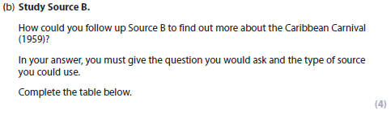
Mark Scheme
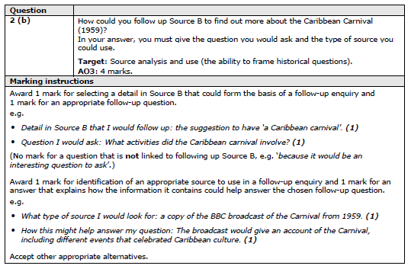
Answer A
- Detail in Source B that I would follow up: ‘it was held in St Pancras Town Hall in January 1959.’
- Question I would ask: Why was St Pancras Town Hall chosen as the place for the Caribbean carnival?
- What type of source I would look for: minutes from meetings about the discussions and planning of the Carnival.
- How this might help answer my question: It would explain what they looked for when they discussed possible venues.

Comment
This would get the full 4 points-based marks. The question is linked to a detail in Source B and a specific contemporary source is suggested, with a clear explanation of what information would be provided by that source that could be used to answer the enquiry.

Answer B
- Detail in Source B that I would follow up: In December 1958, Claudia Jones asked for suggestions about what we could do to get rid of the taste of the Notting Hill riots from our mouths.
- Question I would ask: Why did Claudia Jones organise the Carnival?
- What type of source I would look for: I would try to interview Claudia Jones.
- How this might help answer my question: She could explain her motives.
Comment
This would receive 2 marks. It is a valid question and is linked to a detail in the source but it is suggesting that a new source be created rather than identifying an existing source that could be used. If the suggested source was Claudia Jones’ diary or an article written to promote the Carnival, together with an explanation that this source could explain her motives, the answer could have received the full 4 marks.

Answer C
- Detail in Source B that I would follow up: ‘In 1958, Notting Hill exploded with racial hatred.’
- Question I would ask: What was the role of Claudia Jones?
- What type of source I would look for: A newspaper article.
- How this might help answer my question: The newspaper article would explain what happened.
Comment
This answer would be awarded 0 of the 4 available points-based marks. An aspect of the source has been selected to follow up but it is not directly related to the enquiry focus on the Caribbean Carnival (1959). This means that while a valid question is identified, it cannot be rewarded as it is not linked to the detail identified in the first part. In part 3, the selected source is generic and is not linked to the Notting Hill Carnival while the explanation in part 4 does not explain what sort of relevant information a newspaper article might provide.

Answer D
- Detail in Source B that I would follow up: ‘In 1958, Notting Hill exploded with racial hatred.’
- Question I would ask: Why did racial hatred in Notting Hill in 1958 lead to the establishment of the carnival?
- What type of source I would look for: A newspaper article which describes the Caribbean community’s reactions to the events of 1958.
- How this might help answer my question: The newspaper article would explain why people would want to create a positive view of the migrant community, which would inform my understanding of why the carnival was created.
Comment
This answer would receive the full 4 points-based marks. It identifies an area of enquiry, an appropriate question, identifies a source which could give more information and explains how it would support the enquiry.

Section B: Thematic Study
Question 3
Mark Scheme
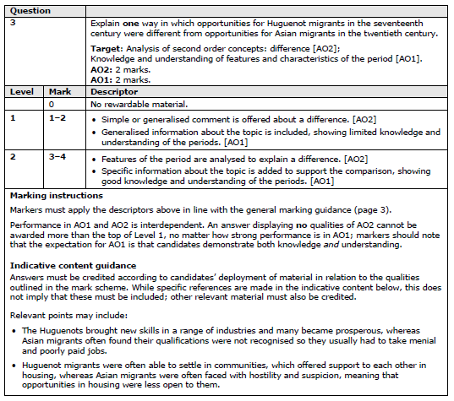

Answer A
There were better opportunities for Huguenot migrants in the seventeenth century than for Asian migrants in the twentieth century because attitudes towards their skills were different. Huguenots found their skills in trades such as textiles and paper making were respected and there were opportunities for them to become prosperous. In contrast, Asian migrants in the twentieth century often found that their qualifications and skills were not accepted so that many migrants were forced to accept low-paid jobs and so found it difficult to become successful.
Comment
This answer explains the overall difference and then provides specific detail about each group of migrants that clearly illustrate this difference. It would gain the full Level 2 – 4 marks.

Answer B
Huguenot migrants in the seventeenth century often joined existing Huguenot communities, who supported them and often helped them find jobs. Asian migrants in the twentieth century often took jobs in the textile industry or low-paid jobs for example, cleaners.
Comment
The most this answer could receive is Level 1 – 2 marks. It cannot reach Level 2 because, although the details in this answer are all valid (AO1), this answer does not explain the difference in the opportunities open to the migrants and a difference cannot be inferred from the details provided (AO2). The detail about Huguenot migrants is about the support offered to the migrants whereas the detail about Asian migrants is about the type of jobs open to them. These are two different aspects of opportunities for migrants and therefore they cannot be compared, in order to show a difference.

Answer C
The Huguenots often moved to areas where many other Huguenots already lived and so were welcomed to England by fellow countrymen and women. This support made it quite easy for them as opportunities for employment were often provided by friends and other members of their community. Asian people in the C20th often experienced racism when they arrived in the UK. They sometimes struggled to gain employment in companies that were owned by White British people.
Comment
This is a Level 1 – 2 mark response. It demonstrates knowledge of relevant specific information about the two groups of migrants which meets AO1. However, it does not offer a comment about a difference between the two groups of migrants, which is the focus of AO2.

Answer D
A difference in the opportunities available to Huguenots and Asian migrants is the acceptance and support they received. The Huguenots often moved to areas where many other Huguenots already lived and so were welcomed to England by fellow countrymen and women. This support made it much easier for them as opportunities for employment were often provided by friends and other members of their community. In contrast Asian people in the twentieth century often experienced racism when they arrived in the UK. They sometimes struggled to gain employment in companies that were owned by White British people and their qualifications were not recognised. This accounts for the different experiences of the two groups, with opportunities more readily available to Huguenots than to Asian migrants.
Comment
This is a Level 2 – 4 mark response. A difference in the opportunities open to these two migrant groups is explained (AO2). Specific supporting information about each group of migrants is used to support the difference (AO1).

Question 4
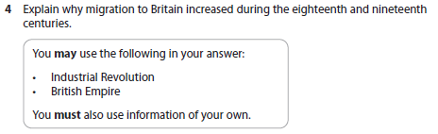
Mark Scheme
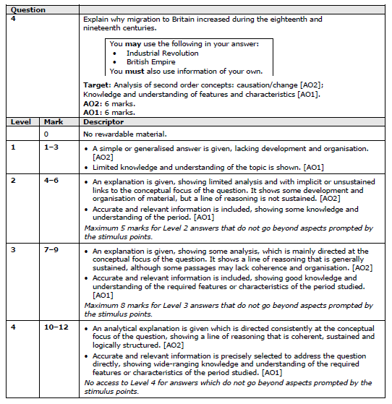
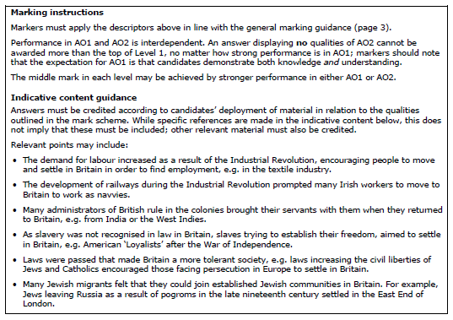
Answer A
Migration to Britain increased during the eighteenth and nineteenth centuries because the Industrial Revolution created job opportunities for workers. The expansion of the road, canal and railway networks led many Irish workers to come to Britain to work as navvies. They were usually single men, moving to different sites where they dug tunnels, laid railway track etc but some of them then settled in Britain.
Some people came as forced migrants. These were often African or Caribbean people who had been enslaved or Asians who had worked as servants for British officials overseas. British plantation owners and officials who returned to Britain often wanted to keep their lifestyle, and therefore brought servants with them. Although slavery was not legal in Britain, it was seen as a status symbol to have African or Indian servants, especially as Queen Victoria accepted Sarah Forbes Bonetta Davies, who was a member of a royal African family, as her god-daughter and developed a close friendship with her Indian servant, Mohammed Abdul Karim.
Britain was also increasingly seen as a place of religious and political tolerance. In 1709, approximately 13,000 Palatine Germans came to Britain because they were Protestant and could not practise their religion in Germany. Although they did not settle here permanently, other religious refugees such as Huguenots continued to come here and Jews also came here. They were also encouraged to migrate here because support was provided by existing migrant communities in places such as Whitechapel in London. The tolerance that drew them can be seen in various acts of parliament in the nineteenth century, for example, giving Jews the right to attend university and become an MP. Political refugees such as Karl Marx, also felt that Britain offered tolerance for radical ideas, such as communism.

Comment
This response would be awarded the full Level 4 – 12 marks. It covers three different aspects of content; the work of migrant navvies is prompted by the ‘Industrial Revolution’ stimulus point, and the example of forced migration is prompted by ‘British Empire’. An additional aspect of content is covered by looking at religious and political refugees. The answer has a clearly focused line of reasoning explaining why people came to Britain (AO2), not just describing groups of migrants, and the explanation is supported by relevant, specific details (AO1). Furthermore, the whole period in the question has been covered.
Notice that there is no requirement for an introduction or conclusion, nor is it necessary to show the interaction or prioritisation of causes.
Answer B
Migration to Britain increased during the eighteenth and nineteenth centuries because lots of people came looking for work as a result of the Industrial Revolution. There were new jobs created as engineers or navvies on roads, canals and railways, and in factories, especially textile factories.
There were also groups who came to escape persecution. About 13,000 German Palatines came to Britain because they were Protestant. They settled temporarily in camps around London, in Blackheath and Camberwell. However, these were mainly poor labourers rather than skilled workers so it was hard for them to find employment and afford housing. Many of them wanted to move on and settle in America but the British government tried to resettle them in rural areas around Britain. This was not successful and eventually most of them were taken to America.
People were also brought to Britain as servants or as enslaved people. Transatlantic slavery increased in this period and large numbers of enslaved people were taken to work on the plantations in America and the Caribbean. However, Britain ended slavery in the British Empire and the slave trade during the nineteenth century, reducing the number of migrants who came here.
Comment
This answer contains accurate detail but much of it is not relevant to the question. The first paragraph makes a valid point about migrants being attracted by job opportunities as a result of the Industrial Revolution but the supporting details are about the types of job opportunities rather than the groups of migrants.
The second paragraph identifies a group of migrants who came and their motive to escape religious persecution. However, the details then describe what happened to the Palatines rather than focusing on explaining why Britain was attractive for Protestant refugees.
The final section covers forced migration but again, the details are about what happened rather than why they came to Britain.
This answer has identified three types of migrants and stated three different reasons why these groups came to Britain. These are valid points but the explanation has limited analysis with only implicit links to the conceptual focus of the question meaning that this answer fits low Level 2 of the mark scheme for AO2. The information provided is accurate but not always relevant, so this is also Level 2 of the mark scheme for AO1. The relevant information is limited, so this is not a strong response and a ‘best-fit’ approach produces a mid-Level 2 – 5 marks.
Answer C
Migration increased for a number of reasons. In Russia there were a series of pogroms against Jewish people which caused many to seek safety in Britain, over 100 000 Jewish people in the last decade of the 1800s. Generally these Jewish people were well treated in the communities to which they moved, soup kitchens and charities were established.
Canals were vital in the transportation of goods and a network was developed by the 1820s connecting manufacturing cities and ports. Roads were developed and by 1840 a network ran between London and all major cities. Railways were also expanding, there were 22,000 miles of track by 1900 and steam power made international travel easier. All of these developments increased migration.
Comment
This a Level 2 – 5 mark response. In terms of AO2 there are some implicit links to the question but little focus on the conceptual demands. The situation is described but the reason why that situation led to increased migration to Britain is not explicit, making this Level 2.
The candidate has an understanding of some of the features and characteristics of the period but the coverage is quite limited, which again fits Level 2 of the mark scheme for AO1. The response, whilst using material from beyond the stimulus points, has only discussed 2 aspects of content, thus limiting the mark to mid-level.

Answer D
One reason why migration to Britain increased during the eighteenth and nineteenth centuries was industrialisation. British manufacturing increased in scale and scope and so the demand for workers increased significantly, for example in the textile industry, the iron industry and the construction of canals and railways. People migrated from rural parts of the country and also from other European countries to meet the demand. A range of different skill levels were needed in the factories so this meant there were opportunities for all sorts of people. Migrant communities grew in cities such as Liverpool and Cardiff.
The development of established and safe migrant communities in Britain meant people facing persecution abroad saw England as a good location to move to. This increased the number of migrants in the period. For example in Russia there was a series of pogroms against Jewish people which caused many to seek safety in Britain, over 100,000 people in the last decade of the 1800s. Generally these Jewish people were well treated in the communities to which they moved, soup kitchens and charities were established. This must have encouraged the arrival of more migrants.
Political change may also have attracted migrants and caused the numbers of those migrating to increase. In 1829 the Catholic Emancipation Act was passed which gave Catholic people almost all the civil rights which Protestants experienced. Many Irish migrants were Catholics and they may have been attracted by this greater protection in law. Britain’s slave trade was abolished in 1807 and slavery was ended in the Empire in 1833. This meant that many African and Black American migrants saw Britain as a place of freedom and safety. In addition the 1832 Reform Act gave the vote to more men. People may have thought that British people had more rights, which may have encouraged more migrants to come to Britain.
By 1900, steam power made international travel easier, allowing more people to move to Britain from abroad, particularly from parts of the Empire. UK transport networks also allowed migrants to arrive in British port cities and then move to establish communities further inland. The improved transport networks also stimulated economic growth which created jobs.
Comment
This is a Level 4 – 12 marks response. The analytical explanation is directed fully at the conceptual focus of the question. Here several different causal reasons have been explained, which demonstrate a structured line of reasoning that is coherent and sustained (AO2). Accurate and relevant information has been selected in support of the answer and wide-ranging knowledge has been demonstrated showing understanding of key features across the period (AO1).

Question 5
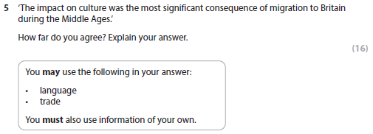
Mark Scheme
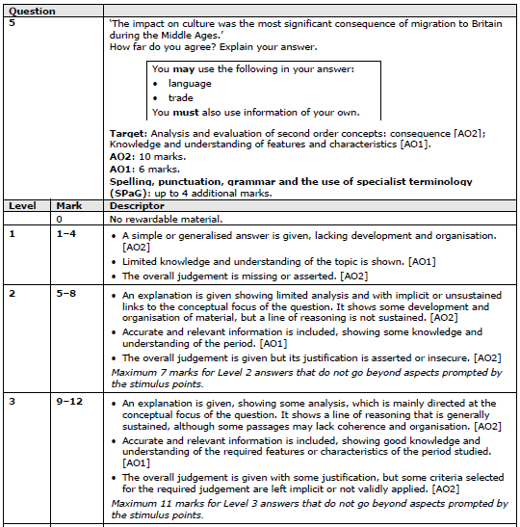
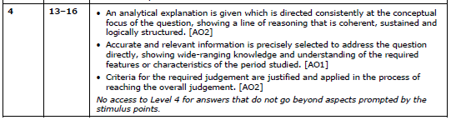
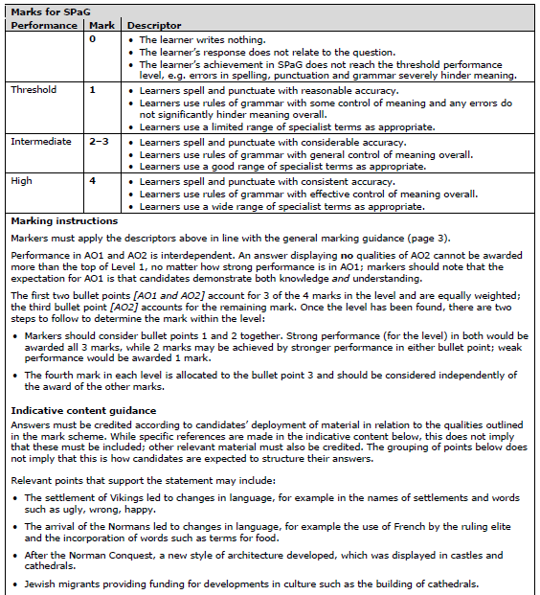
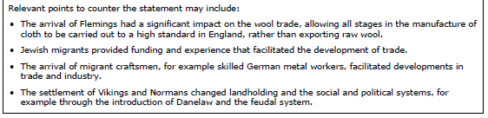

Answer A
Migration to Britain during the Middle Ages had various consequences but the impact on culture was the most significant. Language changed at different times. When the Vikings settled in England, words such as husband, sister and sky became integrated into English. After the Norman Conquest, words such as beef, pork and lamb were introduced and French was used as an official language by government.
Migrants also affected the built environment. Normans built castles in order to control the population and many migrants from Europe were skilled workers who came here to help build cathedrals and monasteries. A new style of architecture developed, using tall, pointed arches and windows.
However, this also shows the impact of migrants on the economy. Jewish migrants often provided loans that helped trade and business to expand and their importance is shown by the fact that the king provided special conditions and protection for them. After Jewish people were expelled from England in 1290, bankers from Lombardy arrived and took over as money-lenders and this again had an impact on the economy.
Flemish migrants settled here and had an impact on the textile trade. Previously wool was exported to Flanders to be prepared for weaving but Edward III forbade the export and wool and the import of cloth and he encouraged Flemish workers to settle here and produce high quality cloth, which benefited English trade. German metal workers also brought new techniques and helped industry to expand.
Although there was a significant impact on the economy, the impact of migrants on culture was more important because it was longer lasting. For example the impact on language and the built environment lasted for centuries whereas the impact on the economy changed when Jewish people were expelled or trade declined.

Comment
This is a strong answer for a number of reasons. It is focused on the question, looking at the impact of migrants and weighing up the relative importance of the impact on culture against the impact on other aspects of society. The conclusion also makes it clear how the significance of the impact of migrants on different aspects of society has been evaluated.
The analysis is sustained and supported by relevant knowledge. Several different aspects have been considered: language, the built environment, the economy, and specific examples have been provided in each case. The examples included cover the whole period, from the Vikings in the ninth century, the Norman Conquest, Jewish migrants from the eleventh to the thirteenth century and European migrants from the thirteenth to the fifteenth centuries.
Both AO1 knowledge and understanding and AO2 explanation and analysis of significance meet the Level 4 descriptor of the mark scheme, as well as AO2 judgement. It would, therefore, be awarded the full Level 4 - 16 marks.

Answer B
Migrants had a range of impacts on English society. The impact on culture was important because so many aspects of life were affected. Language changed as a consequence of Viking and then Norman settlers. French became the official language of government and words such as egg, cake, knife, beef and pork were introduced into English. Other aspects of culture that were impacted by migrants include religion, food, clothes and daily life.
However, the impact of migrants on the economy was also very important. Some Jewish migrants were money-lenders and their loans helped to build cathedrals and monasteries around the country. Jewish people often faced hostility; there were attacks on Jewish people in York in 1190, and in London in 1262 and during the thirteenth century, Jewish people were required to wear a patch on their clothing which identified them as Jewish. In 1290, the Jewish population was expelled from England.
Migrants also had an impact on government. Viking migrants set up the Danelaw where Viking customs and laws were established. After the Norman Conquest, new laws were introduced.
Therefore, the impact of migrants on culture was important but the impact on the economy was more significant.

Comment
This answer has a number of good points. It has recognised the focus of the question is about the impact of migrants and that a judgement needs to be made. It also includes three aspects of content: language, the economy and government, and includes some accurate knowledge.
However, it is not consistently focused on the question, for example the details about the treatment of Jewish migrants is not relevant here. Other points are stated but not supported with specific examples. There is a judgement given but there is no explanation of how the significance of different aspects has been evaluated.
The analysis is mainly sustained and there is enough reasoning to reach low Level 3 of the mark scheme for AO2 explanation and analysis. Some accurate knowledge is included but it is limited and not all of it is relevant, so mid-Level 2 is more appropriate for AO1. The AO2 Level 2 judgement is given but its justification is asserted. A ‘best-fit’ approach suggests that a mark in Level 3 cannot be justified and a mark of 8, at the top of Level 2, is awarded.

Answer C
I agree because the impact on culture was significant in this period. Viking place names, surnames and words have all entered our language. As did words from the Normans; following the conquest in 1066, words such as pork and beef entered the English language. The Anglo-Saxons were very keen to spend their wealth on possessions such as clothing and jewellery whereas the Normans focused on developing the built environment.
I also disagree because migration had significant impacts on other aspects of life in England. Systems of government in both Scandinavia and France were different and so there were developments to the English system. Parliament and trial by jury are two examples of how the Vikings influenced the English system of democracy and justice.
Changes in society were also seen, there were developments in food and customs, for example the Normans brought a new code of chivalry. Jewish people also made positive contributions to society by giving money to support educational institutions and religious buildings.
I agree with the statement, the impact on culture was the most significant consequence due to language.
Comment
This answer is a Level 2 response. There is a focus on the question with the candidate providing limited analysis and organising ideas into ‘agree’ and ‘disagree’ paragraphs; however, this approach is not used to evaluate the statement in the question. An overall judgement is given but the attempt to justify is merely asserted. In terms of AO1, the candidate demonstrates some factual knowledge covering the impact of both Viking and Norman migrants. This answer is Level 2 for all three AO elements, and it has covered three aspects of content, therefore, it would be awarded Level 2 – 8 marks.

Answer D
In this essay I will discuss whether I agree that the impact on culture was the most significant consequence of migration to Britain.
I agree because the impact on culture was significant in this period. Viking place names, surnames and words have all entered our vocabulary. As did words from the Normans following the conquest in 1066, when words such as pork and beef entered the English language. The Anglo-Saxons were very keen to spend their wealth on possessions such as clothing and jewellery but the Normans had a huge impact on the built environment. Westminster great hall was the largest in Europe whilst Canterbury's priory had the largest stained-glass windows in Europe.
I also disagree because migration had significant impacts on other aspects of life in England. Systems of government in both Scandinavia and France were different and so there were developments to the English system as a result of Viking and Norman migration. The development of parliamentary democracy and trial by jury are two examples of Viking practices which influenced the English system of democracy and justice. The Normans respected the English system of governance but also made changes, the introduction of forest laws and the murdrum are good examples. These changes suggest that the impact on culture was not the only significant area of impact after the arrival of migrants.
There was also a significant impact on the economy. Some Jewish migrants in England at this time acted as money lenders to the monarchy. This allowed the king to finance significant projects and also to fund day to day living expenses. Jewish people also lent money to local people to start businesses and to develop business links overseas. Migrants from Europe also helped to develop manufacturing in England as many were weavers and merchants. This changed the economy from one mainly based on raw materials to one of crafting and manufacturing.
Societal changes were also seen. There were developments in food and customs, for example the Normans brought a new code of chivalry, Dutch brewers introduced the use of hops to brew beer and Jewish people donated money to support the development of educational institutions.
Overall, whilst cultural changes were important and long lasting, the changes to the economy were probably the most significant consequence of migration. This is because there was a shift in the economy for the whole country from a primary economy, based on raw materials, to a secondary one, based on manufacturing. This changed the types of employment open to many people and shaped their working lives.
Comment
This answer is a Level 4 response. It is an analytical answer which is consistently focused on the conceptual demands of the question about the consequences of migration. A thread runs through each section which evaluates whether the impact on culture was the most significant consequence (AO2 analysis and explanation). Wide-ranging accurate and relevant information is selected to answer the question, showing the candidate has a thorough understanding of the period (AO1). An overall judgement is reached and the answer clearly explains why the impact on the economy was the most significant consequence of migration (AO2 judgement). Therefore, it would receive the full Level 4 – 16 marks.

Question 6
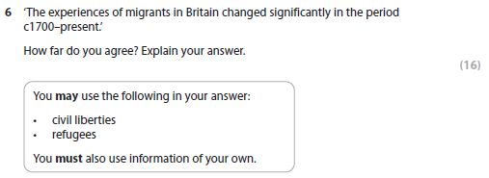
Mark Scheme
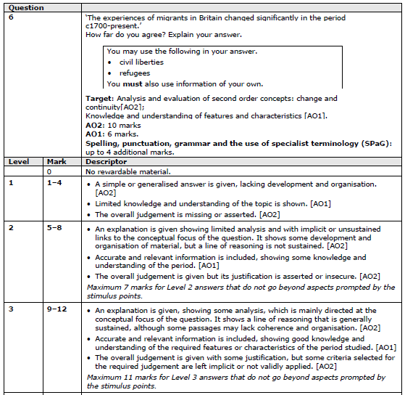
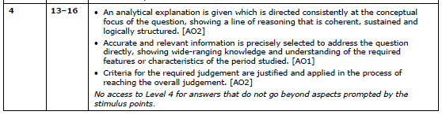
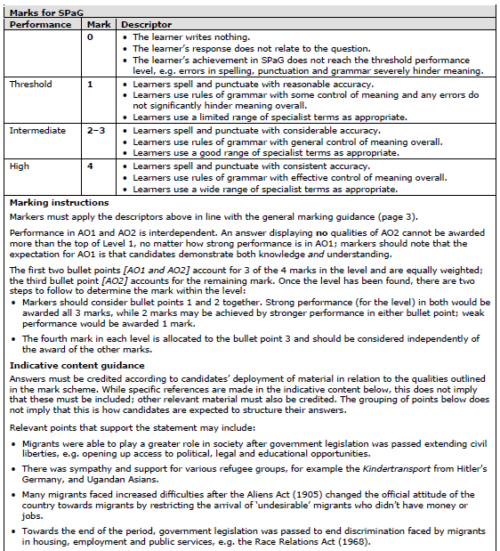
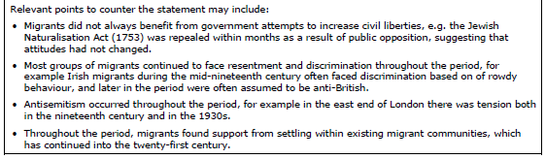

Answer A
There were several significant points of change in migrants’ experiences in the period since c1700. Some of these has made life easier for migrants and other changes have made their experiences more difficult.
Many European migrants during the eighteenth and nineteenth centuries were Catholic or Jewish. Other migrants from the British Empire were brought here as servants or enslaved people. These people had few rights and often experienced discrimination. However, in the mid-nineteenth century, laws were passed that gave Catholics and Jewish people rights, such as to attend university and become MPs. These legal changes had a significant impact on the experiences of migrants because they were protected from some forms of discrimination and also more opportunities were now open to them. More legal changes during the twentieth century affected the experiences of migrants. The Aliens Act in 1905 and British Nationality Acts controlled the status of migrants, which sometimes resulted in resentment and discrimination but the Race Relations Act in 1965 made discrimination based on race or colour illegal. Therefore, legal changes had both positive and negative results for migrants. For example increased support for migrants can be seen in the recent campaign for the rights of ‘Windrush’ migrants to be recognised but some resentment of migrants still goes on. Overall, the changes in migrants’ legal position and civil liberties were significant improvements but attitudes were slower to change, meaning that their personal experiences did not improve as significantly.
Improved legal rights also meant that the experiences of migrants improved in other ways. They were more widely accepted and could build places of worship, set up schools, gain qualifications etc. A number of migrants became successful entrepreneurs, for example the founders of Reuters, Burtons and Marks and Spencer. Greater public acceptance also meant that migrants could also celebrate their culture, for example Chinese New Year celebrations or the Notting Hill carnival.
The treatment of refugees changed several times during this period. During the eighteenth century, German Palatines found they had limited support but Belgian migrants during the First World War were helped, and support was offered to Asians from Uganda and Vietnamese refugees in the 1970s. However, the increase in the number of migrants arriving here as a result of free movement in the EU led to some anti-migrant attitudes. Therefore, there have been significant changes in the experiences of migrants in this period but the changes have not been consistent.
However, in some ways the experiences of migrants did not change very much. During the Industrial Revolution many migrants had to take low-paid jobs and therefore could only afford poor quality housing. This is still true in the modern period; migrants often do not have their qualifications recognised and therefore can only get low-paid jobs, which means they live in cramped and poor conditions. Many still experience discrimination in various ways, for example in employment and their treatment by organisations such as the police and the media. There was also a number of riots in the late-twentieth century, which showed that life was difficult for migrants, for example in Burnley, Brixton and Toxteth.
Comment
This answer analyses the experiences of migrants in order to evaluate whether there were significant changes in this period. The analysis offers a line of reasoning to show that there were significant changes and then shows that it could be argued that significant changes did not take place. This fits the mark scheme descriptor for Level 4 AO2 explanation and analysis of second-order concepts.
A range of specific examples have been given to support the analysis. Detail is precise and wide-ranging, covering the whole period, which also fits the mark scheme descriptor for Level 4.
The answer is clearly secure Level 4 for AO1 and AO2 (explanation and analysis) but no judgement is stated. At Level 4, a judgement should make clear how far the answer agrees with the statement in the question and explain the criteria being used. For example, a judgement could be based on whether changes only affected certain groups of migrants, whether changes occurred throughout the whole period, or consider the impact of changes on legal status / employment / daily life etc in order to evaluate the significance of changes. In this answer, both sides of the question are considered but there is no conclusion, providing an overall judgement, and no sense of a running evaluation weighing up the two sides within the answer. However, there is some sense of evaluation in the introduction. This means that the response best meets Level 1 for AO2 (judgement).
A ‘best-fit’ approach rewards the response at Level 4 – 13 marks, as AO1 and AO2 (explanation and analysis) are strong Level 4.

Answer B
The experiences of migrants did not change significantly in the period c1700-present.
There were laws passed to improve the civil liberties of migrants, for example allowing Catholics and Jews to go to university or to become MPs. Other laws gave migrants the rights of citizenship and also protected them against discrimination in employment and housing.
However, these laws could not make people change their attitude and often migrants continued to have negative experiences. They found it difficult to get accepted in professions and because they were often in low-paid jobs, many migrants continued to live in the poorer sections of towns. Attitudes to migrants were often hostile and tension led to some riots.
Refugees arrived in Britain throughout the period. Sometimes they were welcomed and supported but at other times, they faced hostility, for example. sometimes laws were passed to restrict the number of migrants arriving.
Therefore, although there were some things that should have made things better for migrants, overall their experiences did not improve.
Comment
The analysis here makes several valid points but they are not developed. There is a focus on the question and some reasoning, which fits the mark scheme descriptors for AO2 (explanation and analysis) at Level 2.
There is very little specific detail included to support the analysis. The knowledge shown here is relevant but generalised and there is little sense of context. This fits low Level 2 of the mark scheme for AO1.
A judgement is offered but it is based on a one-sided analysis. A judgement may be offered which completely agrees or disagrees with the statement in the question, giving reasons why an alternative view is not convincing but a judgement is not secure if only one side of the issue has been considered. This AO2 judgement, therefore, also fits Level 2 of the mark scheme.
Although this answer meets Level 2 on all 3 strands of the mark scheme, the weaker performance in AO1 means that Level 2 – 7 marks is more appropriate than Level 2 – 8 marks, since a mark at the of top of a level means that all the mark scheme descriptors have been met securely.

Answer C
I agree with the statement that there were changes in the migrant experience. Civil rights laws led to migrants being able to play a larger role in society with more political, legal and educational opportunities. A good example is the Race Relations Act of 1976 which made it illegal to discriminate on the grounds of nationality, race or ethnic origin. This opened up opportunities for migrants which they had not had before. There was also increasing support for refugee groups who came to Britain seeking safety. These changing attitudes changed the experience of migrants for the better. Some laws did however change the migrant experience in a negative way, the 1905 Aliens Act limited the number of ‘undesirable’ migrants which changed the reception that migrants received and their experience.
I also disagree, there are many examples which suggest that the migrant experience changed very little in this period 1700 to the present. Firstly in the 1800s many migrants faced discrimination either based on race or sometimes on perceived behaviours. For example in Liverpool crime was often blamed on Irish migrants and some newspapers even complained about their presence in the city. In the present day recent migrants can be blamed for social problems and denied opportunities, suggesting little has changed.
Comment
This answer is a Level 2 response. There is a focus on the question with the candidate providing limited analysis and organising ideas into ‘agree’ and ‘disagree’ paragraphs; however, this approach is not used to evaluate the statement in the question. This fits AO2 (explanation and analysis) at Level 2 of the mark scheme. However, a judgement is merely asserted in the opening sentence, which is Level 1 for the AO2 judgement. In terms of AO1, the candidate demonstrates some factual knowledge but limited coverage across the period. Two different examples of government action are included, so the answer covers three aspects of content but the Level 1 AO1 judgement means that a ‘best-fit’ approach would result in Level 2 – 7 marks.

Answer D
I agree with the statement because a number of developments led to changes in the migrant experience. Government civil rights legislation led to migrants being able to play a larger role in society with more political, legal and educational opportunities. A good example of this is the Race Relations Act of 1965 which made it illegal to discriminate on the groups of nationality, race or ethnic origin. This opened up opportunities for migrants which they had previously been denied. There was also increasing support for refugee groups who came to Britain seeking safety. These shifting attitudes mainly changed the experience of migrants for the better. However, some government legislation did change the migrant experience in a negative way, for example, the 1905 Aliens Act restricted the number of ‘undesirable’ migrants which in turn changed the reception that migrants received and therefore their experience.
I also disagree, there are many examples which suggest that the migrant experience changed very little in this period 1700 to the present. Firstly in the 1800s many migrants faced discrimination either based on race or sometimes on perceived behaviours. For example in Liverpool, crime was often blamed on Irish migrants and some newspapers even complained about their presence in the city. In the present day, recent migrants are sometimes blamed for societal problems and denied opportunities, suggesting little has changed.
The experiences of Jewish migrants could also be said to have changed very little in this period. Antisemitism was experienced by Jewish migrants in the 1700s. In Spitalfields and Whitechapel for example, Jewish people faced discrimination and often worked in the terrible conditions of the area’s sweatshops. These attitudes changed little in the 1800s, when Jewish people faced similar levels of discrimination and continuing poor working conditions. The murders by ‘Jack the Ripper’ also suggest that antisemitic views were still held by many in Whitechapel when Jewish people were wrongly accused.
Finally many migrants continued to move to areas where migrants already resided, in order to benefit from their support and the local services provided. Jewish migrants moving to Spitalfields in the late 19th century is a good early example of this, whilst Leicester and its British Asian community is a good example from the twentieth century. This illustrates continuity.
Overall I think that the experience of migrants has not changed significantly as many migrant experiences saw continuity across the time period in question.
Comment
This answer is a Level 4 response. It is an analytical answer which is consistently focused on the conceptual demands of the question about change and continuity. A thread runs through each section which evaluates whether the experiences of migrants changed significantly. The answer is Level 4 for AO2 (analysis and explanation). The candidate’s conclusion is less secure with its justification asserted, which is Level 2 for AO2 judgement. Accurate and relevant information is selected to answer the question showing the candidate has a thorough understanding of the period. This is strongest when discussing government legislation, where several specific details are provided. Overall, AO1 is Level 4. A ‘best-fit’ approach suggests a mark of Level 4 – 14 marks.

Annotated answers
Annotating answers is a good way to work with your students to analyse how responses are constructed. You can use the plain versions at the start of this set of exemplars and ask students to comment on the key features of the answers.

Section A: Historic Environment
Question 1

Answer A
Feature 1
Key feature identified
Many migrants in Notting Hill lived in Houses of Multiple Occupation. There were many large houses in the area which landlords split into bedsits for single people to rent.
Additional detail offered in support of the key feature
Feature 2
Key feature identified
Migrants could not afford high rents and therefore ended up in very basic housing. Many of the houses in Notting Hill had been damaged during the Second World War and were in poor condition but landlords found they could rent them to migrants.
Additional detail offered in support of the key feature
Comment
This answer would receive the full 4 marks. Both features are clearly focused on housing available to migrants in Notting Hill. They are each supported by additional relevant detail, which is rooted in the Notting Hill environment.

Answer B
Generalised comment, not supporting the key feature with specific detail
Feature 1
Key feature identified
The available housing was very poor. Migrants had to live in very unhygienic conditions.
Generalised comment, not supporting the key feature with specific detail
Feature 2
Key feature identified
People had to live in overcrowded houses. This was because migrants couldn’t afford high rents.
Comment
Both of the features given here are valid but they are very generalised. Feature 1 would receive 1 mark for the comment that available housing was poor, and Feature 2 would receive 1 mark for the comment about overcrowded houses, but in both features the additional detail is not clearly rooted in Notting Hill.

Answer C
Feature 1
Valid feature identified
Much of the housing available to migrants in Notting Hill was of a poor quality.
Feature 2
Second valid feature identified
The housing in Notting Hill that was available to migrants was often overcrowded.
Comment
This answer gives two features of the housing available to migrants but they have not been developed with supporting information. This answer would receive 2 of the 4 available marks.

Answer D
Feature 1
Valid feature identified
Much of the housing available to migrants in Notting Hill was of a poor quality. The area was seen as an unattractive place to live but was often the only place that some migrants, such as those from the Caribbean, were accepted.
Supporting detail
Feature 2
Second valid feature identified
The housing in Notting Hill that was available to migrants was often overcrowded as landlords split large houses into Houses of Multiple occupation (HMOs). What was originally one house could be split in to many separate flats or bedsits.
Supporting detail
Comment
This answer gives 2 features of the housing available to migrants. Both features have been developed with supporting information which is grounded in the historic environment. This answer would receive 4 of the 4 available points-based marks.

Question 2(a)
Adds contextual knowledge to explain what is happening
Answer A
Shows the usefulness of source content to make an inference
Source A is useful evidence of what happened at the carnival. It shows people dancing and they are dressed on smart clothes, so they obviously felt this was a special event. The carnival was intended to celebrate Caribbean culture and it included music from steel bands. It seems fairly crowded, meaning this was a popular event, although it is difficult to get a sense of scale from a photograph showing only a section of the room. The carnival started in 1959 and therefore this photograph of the first carnival was possibly taken to show the success of the event in the hope that it would increase in popularity in later years. By the mid-1960s, it had become much larger and was an outdoor event, held in August, so this source is useful for showing how the carnival began indoors.
Identifies usefulness of source overall
Adds contextual knowledge
Includes contextual knowledge
Identifies limitation based on nature of source
Considers effect of an aspect of provenance on reliability
Makes inference based on source content
Source B is very useful for explaining the origins of the carnival. Notting Hill contained many migrants from the Caribbean but there was also a lot of racism from groups such as Teddy Boys and migrants were often unwelcome in dance halls and pubs. The source tells us about the circumstances that led people to organise the event and how they wanted to present a positive view of Caribbean culture, for example, music was an important element of Caribbean culture.
Contextual knowledge included to explain an aspect of the source content
Overall comment on usefulness of the source
Identifies key feature of usefulness of the source
The author seems to have been present at the meeting, so his memories provide an insight into the aims and attitudes of the organisers. Since he is writing 50 years later, his memories may be over-positive and he clearly wants to suggest it was a special event but that doesn’t make the details of his account unreliable. The source is very useful for providing details about how the carnival began and the attitudes of the people involved.
Overall comment about usefulness of the source

Considers aspects of provenance to consider reliability
Comment
This answer would be awarded Level 3 – 8 marks. It shows the usefulness of the content of the sources but also takes into account the way the provenance of the sources affects the reliability and usefulness of the content. Additional contextual knowledge is used to confirm some of the details or provide additional explanation to show why the source is useful. This additional knowledge is integrated into the answer rather than being presented as a separate section of the answer.

Answer B
Identifies useful information in the source content and makes an inference
Source A is useful because it shows us what happened at the carnival. We can see people dancing and everyone is dressed up smartly, so we can tell that it was a happy event. It shows quite a lot of people, suggesting it was a popular event. Source A is a photograph so it shows the actual event and therefore is reliable.
Asserts the source is reliable because of its provenance
Source B is useful because it explains how the carnival started. It gives details about why the people of Notting Hill wanted to celebrate their heritage and the role of Claudia Jones in organising the carnival. However, the author is a journalist, so he might want to exaggerate some points, and this article was written 50 years afterwards, so the author might have forgotten some details, making this source less reliable.
Questions the reliability of the source based on the provenance
Shows the usefulness of the source content
Comment
This answer would receive Level 2 – 4 marks. Both sources are evaluated at Level 2. It shows that that the sources can be used to make inferences about what happened at the carnival and why it started. There is no use of contextual knowledge to develop comments based on the source content, so it cannot receive the top mark in Level 2.
Comments are made about the provenance of the sources but these are generic comments based on the nature or the date of the source. There is no consideration how the provenance of the photograph might affect its use beyond the assertion that, as a photograph, the Source A is reliable. Similarly, the reliability of Source B is questioned based on generic comments that journalists exaggerate and details are forgotten over time but there are no references to specific details in the sources which could support these comments. These judgements also lack an awareness that the focus of the question is on the usefulness of the sources and that unreliable source can still be extremely useful.
Answer C
Asserts usefulness
Source A would be very useful for an enquiry into the Caribbean Carnival of 1959. The photograph shows us that it was members of the Afro-Caribbean community who attended the event. It shows that those who attended enjoyed themselves; we can see people dancing and socialising with each other. Other aspects included a beauty show and performances from popular singers. The carnival was also televised on the BBC. Although this photograph only shows a small number of attendees, the event was well attended and ran for 6 years.
Some contextual knowledge
Details about the content of the source with utility implied
The source is a first-hand account which is useful as it gives an insight into the development of the carnival. Claudia Jones was a successful anti-racism leader and editor of the West Indian Gazette. The article was however written in 2008 which is some time after the event. Hinds, who was in attendance at this first meeting would obviously attribute significance to the meeting as the Notting Hill Carnival is still a popular and important event. This does not however make the account unreliable. It gives an important insight into the thoughts and views of those present at the meeting.
Considers reliability based on NOP
Details about the NOP
Comment
This is a Level 2 – 5 mark response. For Source A the candidate discusses utility in relation to content, adding in some contextual knowledge, and makes comments on the usefulness of the source. For Source B the provenance of the source is the focus with links again being made to utility.
When marking question 2(a), the mark scheme is applied to the answer of Source A and then Source B; a ‘best-fit’ approach is then used to decide the final mark. Here, both sources have been evaluated in different ways but are both strong in Level 2. A 'best-fit' approach results in mark of Level 2 – 5 marks. The inclusion of supporting contextual knowledge allows the answer to be awarded 5 marks at the top of Level 2 but it does not get into Level 3 because it does not discuss usefulness in terms of content and provenance, linked to contextual knowledge for either source.

Answer D
Source A would be very useful for an enquiry into the Caribbean Carnival of 1959. The photograph shows us that it was members of the Afro-Caribbean community who attended the event. It shows that those who attended enjoyed themselves; we can see people dancing and socialising with each other. Other aspects included a beauty show and performances from popular singers. The carnival was also televised on the BBC. Although this photograph only shows a small number of attendees, the event was well attended and ran for 6 years. The provenance of this source adds to its usefulness. Being a photograph the source allows us to actually gain a snapshot of events, this is important to gain an understanding of the first carnival and to sense its positive atmosphere. As it was taken in 1959 at the first carnival, perhaps it was a publicity photograph to encourage more people to attend in future and therefore deliberately offers a positive impression of the event in order to show the Caribbean community in a good way.
Considers effect of NOP
Asserts usefulness
Contextual knowledge to explain further
Details about the content of the source
Asserts usefulness
The content of source B would be very useful for an enquiry about the Caribbean carnival as it describes the origins of the event. The source explains the decision to hold a carnival was made at a meeting following the Notting Hill Riots. The riots took place in 1958 amid a climate of racism. During a discussion about how to move forward the idea of a carnival was put forward. Whilst others laughed Claudia Jones looked for solutions about how the carnival could be held. Jones was a successful anti-racism leader and editor of the West Indian Gazette, so she was an influential person in the community and the source describing her role is very useful. The source does not detail anything about the event itself but it is a first-hand account which is useful as it gives an insight into the development of the carnival. The article was, however, written in 2008 which is some time after the event. Hinds, who was in attendance at this first meeting, would obviously attribute significance to the meeting as the Notting Hill Carnival is still a significant and important event. Therefore his account of the origins of the carnival is affected by his knowledge of how the carnival developed later but this does not, however, make the account unreliable. It gives an important insight into the thought and views of those present at the meeting, which is useful for understanding why the carnival began.
Details about NOP
Utility based on NOP
Contextual knowledge
Contextual knowledge
Asserts usefulness
Considers reliability based on NOP
Comment
This answer would be rewarded Level 3 – 8 marks. For both sources the candidate discusses utility in relation to content and provenance, with some contextual knowledge being used in support. In each case, there is a clear focus on the usefulness of the source, with the understanding that the criterion of reliability is only part of the evaluation of utility.
Note: Level 3 – 8 marks requires that utility is evaluated in relation to content and provenance, and with the application of context. The response here is very comprehensive but any response adequately covering all three strands of the marks scheme in relation to the Level descriptor should be rewarded at the top of Level 3.

Section B: Thematic Study
Question 3

Answer A
Identifies a difference between the opportunities for the two groups
There were better opportunities for Huguenot migrants in the seventeenth century than for Asian migrants in the twentieth century because attitudes towards their skills were different. Huguenots found their skills in trades such as textiles and paper making were respected and there were opportunities for them to become prosperous. In contrast, Asian migrants in the twentieth century often found that their qualifications and skills were not accepted so that many migrants were forced to accept low-paid jobs and so found it difficult to become successful.
Provides supporting details about opportunities for each group
Comment
This answer explains the overall difference and then provides specific detail about each group of migrants that clearly illustrate this difference. It would gain the full Level 2 – 4 marks.

Answer B
Provides detail about the two groups
Huguenot migrants in the seventeenth century often joined existing Huguenot communities, who supported them and often helped them find jobs. Asian migrants in the twentieth century often took jobs in the textile industry or low-paid jobs for example, cleaners.
Comment
The most this answer could receive is Level 1 – 2 marks. It cannot reach Level 2 because, although the details in this answer are all valid (AO1), this answer does not explain the difference in the opportunities open to the migrants and a difference cannot be inferred from the details provided (AO2). The detail about Huguenot migrants is about the support offered to the migrants whereas the detail about Asian migrants is about the type of jobs open to them. These are two different aspects of opportunities for migrants and therefore they cannot be compared, in order to show a difference.

Answer C
The Huguenots often moved to areas where many other Huguenots already lived and so were welcomed to England by fellow countrymen and women. This support made it quite easy for them as opportunities for employment were often provided by friends and other members of their community. Asian people in the C20th often experienced racism when they arrived in the UK. They sometimes struggled to gain employment in companies that were owned by White British people.
Information about Asian migrants
Information about Huguenot migrants
Comment
This is a Level 1 – 2 mark response. It demonstrates knowledge of relevant specific information about the two groups of migrants which meets AO1. However, it does not offer a comment about a difference between the two groups of migrants, which is the focus of AO2.

Answer D
A difference in the opportunities available to Huguenots and Asian migrants is the acceptance and support they received. The Huguenots often moved to areas where many other Huguenots already lived and so were welcomed to England by fellow countrymen and women. This support made it much easier for them as opportunities for employment were often provided by friends and other members of their community. In contrast Asian people in the twentieth century often experienced racism when they arrived in the UK. They sometimes struggled to gain employment in companies that were owned by White British people and their qualifications were not recognised. This accounts for the different experiences of the two groups, with opportunities more readily available to Huguenots than to Asian migrants.
Summary linked to the focus of the question
Information about Asian migrants
Efforts to provide a comparison
Information about Huguenot migrants
Response to the demands of the question
Comment
This is a Level 2 – 4 mark response. A difference in the opportunities open to these two migrant groups is explained (AO2). Specific supporting information about each group of migrants is used to support the difference (AO1).

Question 4
Answer A
Identifies job opportunities as a factor leading to increased migration
Migration to Britain increased during the eighteenth and nineteenth centuries because the Industrial Revolution created job opportunities for workers. The expansion of the road, canal and railway networks led many Irish workers to come to Britain to work as navvies. They were usually single men, moving to different sites where they dug tunnels, laid railway track etc but some of them then settled in Britain.
Offers details of jobs created by the Industrial Revolution
Some people came as forced migrants. These were often African or Caribbean people who had been enslaved or Asians who had worked as servants for British officials overseas. British plantation owners and officials who returned to Britain often wanted to keep their lifestyle, and therefore brought servants with them. Although slavery was not legal in Britain, it was seen as a status symbol to have African or Indian servants, especially as Queen Victoria accepted Sarah Forbes Bonetta Davies, who was a member of a royal African family, as her god-daughter and developed a close friendship with her Indian servant, Mohammed Abdul Karim.
Identifies a second reason why migration increased
Provides supporting detail
Britain was also increasingly seen as a place of religious and political tolerance. In 1709, approximately 13,000 Palatine Germans came to Britain because they were Protestant and could not practise their religion in Germany. Although they did not settle here permanently, other religious refugees such as Huguenots continued to come here and Jews also came here. They were also encouraged to migrate here because support was provided by existing migrant communities in places such as Whitechapel in London. The tolerance that drew them can be seen in various acts of parliament in the nineteenth century, for example, giving Jews the right to attend university and become an MP. Political refugees such as Karl Marx, also felt that Britain offered tolerance for radical ideas, such as communism.
Provides a range of supporting detail
Identifies a third reason why migration increased
Comment
This response would be awarded the full Level 4 – 12 marks. It covers three different aspects of content; the work of migrant navvies is prompted by the ‘Industrial Revolution’ stimulus point, and the example of forced migration is prompted by ‘British Empire’. An additional aspect of content is covered by looking at religious and political refugees. The answer has a clearly focused line of reasoning explaining why people came to Britain (AO2), not just describing groups of migrants, and the explanation is supported by relevant, specific details (AO1). Furthermore, the whole period in the question has been covered.
Notice that there is no requirement for an introduction or conclusion, nor is it necessary to show the interaction or prioritisation of causes.

Answer B
Supporting detail offered but brief and generalised
Migration to Britain increased during the eighteenth and nineteenth centuries because lots of people came looking for work as a result of the Industrial Revolution. There were new jobs created as engineers or navvies on roads, canals and railways, and in factories, especially textile factories.
Limited supporting detail offered
Second reason for increased migration identified in generalised terms
Identifies reason why migration increased
There were also groups who came to escape persecution. About 13,000 German Palatines came to Britain because they were Protestant. They settled temporarily in camps around London, in Blackheath and Camberwell. However, these were mainly poor labourers rather than skilled workers so it was hard for them to find employment and afford housing. Many of them wanted to move on and settle in America but the British government tried to resettle them in rural areas around Britain. This was not successful and eventually most of them were taken to America.
Additional detail about what happened to the Palatines offered here but not relevant for a question about reasons for increased migration
Identifies a third reason why migration increased
People were also brought to Britain as servants or as enslaved people. Transatlantic slavery increased in this period and large numbers of enslaved people were taken to work on the plantations in America and the Caribbean. However, Britain ended slavery in the British Empire and the slave trade during the nineteenth century, reducing the number of migrants who came here.
This is not about migration to Britain
This is not relevant to a question on increased migration to Britain
Comment
This answer contains accurate detail but much of it is not relevant to the question. The first paragraph makes a valid point about migrants being attracted by job opportunities as a result of the Industrial Revolution but the supporting details are about the types of job opportunities rather than the groups of migrants.
The second paragraph identifies a group of migrants who came and their motive to escape religious persecution. However, the details then describe what happened to the Palatines rather than focusing on explaining why Britain was attractive for Protestant refugees.
The final section covers forced migration but again, the details are about what happened rather than why they came to Britain.
This answer has identified three types of migrants and stated three different reasons why these groups came to Britain. These are valid points but the explanation has limited analysis with only implicit links to the conceptual focus of the question meaning that this answer fits low Level 2 of the mark scheme for AO2. The information provided is accurate but not always relevant, so this is also Level 2 of the mark scheme for AO1. The relevant information is limited, so this is not a strong response and a ‘best-fit’ approach produces a mid-Level 2 – 5 marks.

Answer C
Suggests Britain as a place of safety as a factor – implicit links to the question
Migration increased for a number of reasons. In Russia there were a series of pogroms against Jewish people which caused many to seek safety in Britain, over 100 000 Jewish people in the last decade of the 1800s. Generally these Jewish people were well treated in the communities to which they moved, soup kitchens and charities were established.
Supporting information
Canals were vital in the transportation of goods and a network was developed by the 1820s connecting manufacturing cities and ports. Roads were developed and by 1840 a network ran between London and all major cities. Railways were also expanding, there were 22,000 miles of track by 1900 and steam power made international travel easier. All of these developments increased migration.
Limited links to the question focus
Details about developing transport networks
Comment
This a Level 2 – 5 mark response. In terms of AO2 there are some implicit links to the question but little focus on the conceptual demands. The situation is described but the reason why that situation led to increased migration to Britain is not explicit, making this Level 2.
The candidate has an understanding of some of the features and characteristics of the period but the coverage is quite limited, which again fits Level 2 of the mark scheme for AO1. The response, whilst using material from beyond the stimulus points, has only discussed 2 aspects of content, thus limiting the mark to mid-level.

Answer D
Industrialisation stated as a factor
One reason why migration to Britain increased during the eighteenth and nineteenth centuries was industrialisation. British manufacturing increased in scale and scope and so the demand for workers increased significantly, for example in the textile industry, the iron industry and the construction of canals and railways. People migrated from rural parts of the country and also from other European countries to meet the demand. A range of different skill levels were needed in the factories so this meant there were opportunities for all sorts of people. Migrant communities grew in cities such as Liverpool and Cardiff.
Specific supporting detail
The development of established and safe migrant communities in Britain meant people facing persecution abroad saw England as a good location to move to. This increased the number of migrants in the period. For example in Russia there was a series of pogroms against Jewish people which caused many to seek safety in Britain, over 100,000 people in the last decade of the 1800s. Generally these Jewish people were well treated in the communities to which they moved, soup kitchens and charities were established. This must have encouraged the arrival of more migrants.
Links to question focus
Detailed supporting information
Second factor given
Political change may also have attracted migrants and caused the numbers of those migrating to increase. In 1829 the Catholic Emancipation Act was passed which gave Catholic people almost all the civil rights which Protestants experienced. Many Irish migrants were Catholics and they may have been attracted by this greater protection in law. Britain’s slave trade was abolished in 1807 and slavery was ended in the Empire in 1833. This meant that many African and Black American migrants saw Britain as a place of freedom and safety. In addition the 1832 Reform Act gave the vote to more men. People may have thought that British people had more rights, which may have encouraged more migrants to come to Britain.
Returns to the focus of the question
Supporting detail about political change
Third factor given
By 1900, steam power made international travel easier, allowing more people to move to Britain from abroad, particularly from parts of the Empire. UK transport networks also allowed migrants to arrive in British port cities and then move to establish communities further inland. The improved transport networks also stimulated economic growth which created jobs.
Supporting detail
Fourth factor given
Comment
This is a Level 4 – 12 marks response. The analytical explanation is directed fully at the conceptual focus of the question. Here several different causal reasons have been explained, which demonstrate a structured line of reasoning that is coherent and sustained (AO2). Accurate and relevant information has been selected in support of the answer and wide-ranging knowledge has been demonstrated showing understanding of key features across the period (AO1).

Question 5

Answer A
Offers an example of the impact of migration on culture
Judgement asserted
Migration to Britain during the Middle Ages had various consequences but the impact on culture was the most significant. Language changed at different times. When the Vikings settled in England, words such as husband, sister and sky became integrated into English. After the Norman Conquest, words such as beef, pork and lamb were introduced and French was used as an official language by government.
Examples of changes in culture covering a wide timescale
Migrants also affected the built environment. Normans built castles in order to control the population and many migrants from Europe were skilled workers who came here to help build cathedrals and monasteries. A new style of architecture developed, using tall, pointed arches and windows.
Supporting detail offered
Another aspect of the impact on culture identified
However, this also shows the impact of migrants on the economy. Jewish migrants often provided loans that helped trade and business to expand and their importance is shown by the fact that the king provided special conditions and protection for them. After Jewish people were expelled from England in 1290, bankers from Lombardy arrived and took over as money-lenders and this again had an impact on the economy.
Another aspect of the impact of migrants
Supporting detail offered covering a wide timescale
A third aspect of the impact on culture identified
Flemish migrants settled here and had an impact on the textile trade. Previously wool was exported to Flanders to be prepared for weaving but Edward III forbade the export and wool and the import of cloth and he encouraged Flemish workers to settle here and produce high quality cloth, which benefited English trade. German metal workers also brought new techniques and helped industry to expand.
Good range of supporting detail, showing the nature of the impact on the economy
Although there was a significant impact on the economy, the impact of migrants on culture was more important because it was longer lasting. For example the impact on language and the built environment lasted for centuries whereas the impact on the economy changed when Jewish people were expelled or trade declined.
Judgement given and criteria explained

Comment
This is a strong answer for a number of reasons. It is focused on the question, looking at the impact of migrants and weighing up the relative importance of the impact on culture against the impact on other aspects of society. The conclusion also makes it clear how the significance of the impact of migrants on different aspects of society has been evaluated.
The analysis is sustained and supported by relevant knowledge. Several different aspects have been considered: language, the built environment, the economy, and specific examples have been provided in each case. The examples included cover the whole period, from the Vikings in the ninth century, the Norman Conquest, Jewish migrants from the eleventh to the thirteenth century and European migrants from the thirteenth to the fifteenth centuries.
Both AO1 knowledge and understanding and AO2 explanation and analysis of significance meet the Level 4 descriptor of the mark scheme, as well as AO2 judgement. It would, therefore, be awarded the full Level 4 - 16 marks.
Supporting detail offered about impact of migrants’ language

Answer B
Judgement is outlined
Migrants had a range of impacts on English society. The impact on culture was important because so many aspects of life were affected. Language changed as a consequence of Viking and then Norman settlers. French became the official language of government and words such as egg, cake, knife, beef and pork were introduced into English. Other aspects of culture that were impacted by migrants include religion, food, clothes and daily life.
Statement about the impact on migrants on other aspects of culture but no support given
Supporting detail given
An alternative aspect of the impact of migrants is offered
Valid point of analysis
However, the impact of migrants on the economy was also very important. Some Jewish migrants were money-lenders and their loans helped to build cathedrals and monasteries around the country. Jewish people often faced hostility; there were attacks on Jewish people in York in 1190, and in London in 1262 and during the thirteenth century, Jewish people were required to wear a patch on their clothing which identified them as Jewish. In 1290, the Jewish population was expelled from England.
A third aspect of the impact of migrants identified
Judgement is stated but no reason is given for the view that the impact of migrants on the economy was more important than their impact on culture
This is descriptive and focuses on the experiences of Jewish migrants rather than the impact of migrants
Generalised support offered about Vikings' impact on government, generalised statement but no details given about the impact of Norman migrants
Migrants also had an impact on government. Viking migrants set up the Danelaw where Viking customs and laws were established. After the Norman Conquest, new laws were introduced.
Therefore, the impact of migrants on culture was important but the impact on the economy was more significant.
Comment
This answer has a number of good points. It has recognised the focus of the question is about the impact of migrants and that a judgement needs to be made. It also includes three aspects of content: language, the economy and government, and includes some accurate knowledge.
However, it is not consistently focused on the question, for example the details about the treatment of Jewish migrants is not relevant here. Other points are stated but not supported with specific examples. There is a judgement given but there is no explanation of how the significance of different aspects has been evaluated.
The analysis is mainly sustained and there is enough reasoning to reach low Level 3 of the mark scheme for AO2 explanation and analysis. Some accurate knowledge is included but it is limited and not all of it is relevant, so mid-Level 2 is more appropriate for AO1. The AO2 Level 2 judgement is given but its justification is asserted. A ‘best-fit’ approach suggests that a mark in Level 3 cannot be justified and a mark of 8, at the top of Level 2, is awarded.

Answer C
Judgement asserted
I agree because the impact on culture was significant in this period. Viking place names, surnames and words have all entered our language. As did words from the Normans; following the conquest in 1066, words such as pork and beef entered the English language. The Anglo-Saxons were very keen to spend their wealth on possessions such as clothing and jewellery whereas the Normans focused on developing the built environment.
A counter to the explanation offered in the question is given
Supporting detail
I also disagree because migration had significant impacts on other aspects of life in England. Systems of government in both Scandinavia and France were different and so there were developments to the English system. Parliament and trial by jury are two examples of how the Vikings influenced the English system of democracy and justice.
Supporting detail
Changes in society were also seen, there were developments in food and customs, for example the Normans brought a new code of chivalry. Jewish people also made positive contributions to society by giving money to support educational institutions and religious buildings.
Judgement asserted but not supported
Relevant details but generalised rather than being deployed to answer the question
I agree with the statement, the impact on culture was the most significant consequence due to language.
Comment
This answer is a Level 2 response. There is a focus on the question with the candidate providing limited analysis and organising ideas into ‘agree’ and ‘disagree’ paragraphs; however, this approach is not used to evaluate the statement in the question. An overall judgement is given but the attempt to justify is merely asserted. In terms of AO1, the candidate demonstrates some factual knowledge covering the impact of both Viking and Norman migrants. This answer is Level 2 for all three AO elements, and it has covered three aspects of content, therefore, it would be awarded Level 2 – 8 marks.

Answer D
Focus on the demands of the question
In this essay I will discuss whether I agree that the impact on culture was the most significant consequence of migration to Britain.
I agree because the impact on culture was significant in this period. Viking place names, surnames and words have all entered our vocabulary. As did words from the Normans following the conquest in 1066, when words such as pork and beef entered the English language. The Anglo-Saxons were very keen to spend their wealth on possessions such as clothing and jewellery but the Normans had a huge impact on the built environment. Westminster great hall was the largest in Europe whilst Canterbury's priory had the largest stained-glass windows in Europe.
Agreement with the position given in the question
Supporting detail about the impact of culture
Counter to the statement in the question
I also disagree because migration had significant impacts on other aspects of life in England. Systems of government in both Scandinavia and France were different and so there were developments to the English system as a result of Viking and Norman migration. The development of parliamentary democracy and trial by jury are two examples of Viking practices which influenced the English system of democracy and justice. The Normans respected the English system of governance but also made changes, the introduction of forest laws and the murdrum are good examples. These changes suggest that the impact on culture was not the only significant area of impact after the arrival of migrants.
Return to the focus of the question
Supporting detail
There was also a significant impact on the economy. Some Jewish migrants in England at this time acted as money lenders to the monarchy. This allowed the king to finance significant projects and also to fund day to day living expenses. Jewish people also lent money to local people to start businesses and to develop business links overseas. Migrants from Europe also helped to develop manufacturing in England as many were weavers and merchants. This changed the economy from one mainly based on raw materials to one of crafting and manufacturing.
Supporting details about the economy
A further factor asserted
Societal changes were also seen. There were developments in food and customs, for example the Normans brought a new code of chivalry, Dutch brewers introduced the use of hops to brew beer and Jewish people donated money to support the development of educational institutions.
Supporting detail
A final factor given
Overall, whilst cultural changes were important and long lasting, the changes to the economy were probably the most significant consequence of migration. This is because there was a shift in the economy for the whole country from a primary economy, based on raw materials, to a secondary one, based on manufacturing. This changed the types of employment open to many people and shaped their working lives.
Supporting information
Judgement asserted
Comment
This answer is a Level 4 response. It is an analytical answer which is consistently focused on the conceptual demands of the question about the consequences of migration. A thread runs through each section which evaluates whether the impact on culture was the most significant consequence (AO2 analysis and explanation). Wide-ranging accurate and relevant information is selected to answer the question, showing the candidate has a thorough understanding of the period (AO1). An overall judgement is reached and the answer clearly explains why the impact on the economy was the most significant consequence of migration (AO2 judgement). Therefore, it would receive the full Level 4 – 16 marks.
Question 6

Answer A
Generalised introduction
There were several significant points of change in migrants’ experiences in the period since c1700. Some of these has made life easier for migrants and other changes have made their experiences more difficult.
Explains context but the answer has not yet addressed the question
Many European migrants during the eighteenth and nineteenth centuries were Catholic or Jewish. Other migrants from the British Empire were brought here as servants or enslaved people. These people had few rights and often experienced discrimination. However, in the mid-nineteenth century, laws were passed that gave Catholics and Jewish people rights, such as to attend university and become MPs. These legal changes had a significant impact on the experiences of migrants because they were protected from some forms of discrimination and also more opportunities were now open to them. More legal changes during the twentieth century affected the experiences of migrants. The Aliens Act in 1905 and British Nationality Acts controlled the status of migrants, which sometimes resulted in resentment and discrimination but the Race Relations Act in 1965 made discrimination based on race or colour illegal. Therefore, legal changes had both positive and negative results for migrants. For example increased support for migrants can be seen in the recent campaign for the rights of ‘Windrush’ migrants to be recognised but some resentment of migrants still goes on. Overall, the changes in migrants’ legal position and civil liberties were significant improvements but attitudes were slower to change, meaning that their personal experiences did not improve as significantly.
Judgement about the significance of the effects of legal changes on the experiences of migrants
Analysis of the effects of these legal changes
Precise details of legal changes given
Analysis explains the importance of these legal changes
Identifies legal changes affecting migrants
Improved legal rights also meant that the experiences of migrants improved in other ways. They were more widely accepted and could build places of worship, set up schools, gain qualifications etc. A number of migrants became successful entrepreneurs, for example the founders of Reuters, Burtons and Marks and Spencer. Greater public acceptance also meant that migrants could also celebrate their culture, for example Chinese New Year celebrations or the Notting Hill carnival.
Examples of changes in the experiences of migrants given but limited analysis of how significant these changes were
Identifies other changes in the experiences of migrants, some precise examples given
The treatment of refugees changed several times during this period. During the eighteenth century, German Palatines found they had limited support but Belgian migrants during the First World War were helped, and support was offered to Asians from Uganda and Vietnamese refugees in the 1970s. However, the increase in the number of migrants arriving here as a result of free movement in the EU led to some anti-migrant attitudes. Therefore, there have been significant changes in the experiences of migrants in this period but the changes have not been consistent.
Some analysis of the significance of these changes
Description of changes in attitude towards refugees
However, in some ways the experiences of migrants did not change very much. During the Industrial Revolution many migrants had to take low-paid jobs and therefore could only afford poor quality housing. This is still true in the modern period; migrants often do not have their qualifications recognised and therefore can only get low-paid jobs, which means they live in cramped and poor conditions. Many still experience discrimination in various ways, for example in employment and their treatment by organisations such as the police and the media. There was also a number of riots in the late-twentieth century, which showed that life was difficult for migrants, for example in Burnley, Brixton and Toxteth.
Valid supporting points being made but mainly in generalised terms
Alternative view being used to challenge the statement in the question
Comment
This answer analyses the experiences of migrants in order to evaluate whether there were significant changes in this period. The analysis offers a line of reasoning to show that there were significant changes and then shows that it could be argued that significant changes did not take place. This fits the mark scheme descriptor for Level 4 AO2 explanation and analysis of second-order concepts.
A range of specific examples have been given to support the analysis. Detail is precise and wide-ranging, covering the whole period, which also fits the mark scheme descriptor for Level 4.
The answer is clearly secure Level 4 for AO1 and AO2 (explanation and analysis) but no judgement is stated. At Level 4, a judgement should make clear how far the answer agrees with the statement in the question and explain the criteria being used. For example, a judgement could be based on whether changes only affected certain groups of migrants, whether changes occurred throughout the whole period, or consider the impact of changes on legal status / employment / daily life etc in order to evaluate the significance of changes. In this answer, both sides of the question are considered but there is no conclusion, providing an overall judgement, and no sense of a running evaluation weighing up the two sides within the answer. However, there is some sense of evaluation in the introduction. This means that the response best meets Level 1 for AO2 (judgement).
A ‘best-fit’ approach rewards the response at Level 4 – 13 marks, as AO1 and AO2 (explanation and analysis) are strong Level 4.

Answer B
Valid points being made about the effect of legal changes on migrants but rather generalised and no sense of when these changes occurred
The experiences of migrants did not change significantly in the period c1700-present.
Judgement asserted
There were laws passed to improve the civil liberties of migrants, for example allowing Catholics and Jews to go to university or to become MPs. Other laws gave migrants the rights of citizenship and also protected them against discrimination in employment and housing.
However, these laws could not make people change their attitude and often migrants continued to have negative experiences. They found it difficult to get accepted in professions and because they were often in low-paid jobs, many migrants continued to live in the poorer sections of towns. Attitudes to migrants were often hostile and tension led to some riots.
Some supporting detail offered but lacks precision
Valid point of analysis about the impact of legal changes on the experiences of migrants
Refugees arrived in Britain throughout the period. Sometimes they were welcomed and supported but at other times, they faced hostility, for example. sometimes laws were passed to restrict the number of migrants arriving.
Judgement asserted but it does not evaluate different aspects of change or give a reason for the statement
Descriptive statement, not analysing change
Therefore, although there were some things that should have made things better for migrants, overall their experiences did not improve.
Comment
The analysis here makes several valid points but they are not developed. There is a focus on the question and some reasoning, which fits the mark scheme descriptors for AO2 (explanation and analysis) at Level 2.
There is very little specific detail included to support the analysis. The knowledge shown here is relevant but generalised and there is little sense of context. This fits low Level 2 of the mark scheme for AO1.
A judgement is offered but it is based on a one-sided analysis. A judgement may be offered which completely agrees or disagrees with the statement in the question, giving reasons why an alternative view is not convincing but a judgement is not secure if only one side of the issue has been considered. This AO2 judgement, therefore, also fits Level 2 of the mark scheme.
Although this answer meets Level 2 on all 3 strands of the mark scheme, the weaker performance in AO1 means that Level 2 – 7 marks is more appropriate than Level 2 – 8 marks, since a mark at the of top of a level means that all the mark scheme descriptors have been met securely.

Answer C
I agree with the statement that there were changes in the migrant experience. Civil rights laws led to migrants being able to play a larger role in society with more political, legal and educational opportunities. A good example is the Race Relations Act of 1976 which made it illegal to discriminate on the grounds of nationality, race or ethnic origin. This opened up opportunities for migrants which they had not had before. There was also increasing support for refugee groups who came to Britain seeking safety. These changing attitudes changed the experience of migrants for the better. Some laws did however change the migrant experience in a negative way, the 1905 Aliens Act limited the number of ‘undesirable’ migrants which changed the reception that migrants received and their experience.
Supporting detail about the changing migrant experience
Link to the question
Supporting detail about the changing migrant experience
I also disagree, there are many examples which suggest that the migrant experience changed very little in this period 1700 to the present. Firstly in the 1800s many migrants faced discrimination either based on race or sometimes on perceived behaviours. For example in Liverpool crime was often blamed on Irish migrants and some newspapers even complained about their presence in the city. In the present day recent migrants can be blamed for social problems and denied opportunities, suggesting little has changed.
Return to the focus of the question
Supporting detail
Link to the question
Comment
This answer is a Level 2 response. There is a focus on the question with the candidate providing limited analysis and organising ideas into ‘agree’ and ‘disagree’ paragraphs; however, this approach is not used to evaluate the statement in the question. This fits AO2 (explanation and analysis) at Level 2 of the mark scheme. However, a judgement is merely asserted in the opening sentence, which is Level 1 for the AO2 judgement. In terms of AO1, the candidate demonstrates some factual knowledge but limited coverage across the period. Two different examples of government action are included, so the answer covers three aspects of content but the Level 1 AO1 judgement means that a ‘best-fit’ approach would result in Level 2 – 7 marks.

Answer D
Focus on the question
I agree with the statement because a number of developments led to changes in the migrant experience. Government civil rights legislation led to migrants being able to play a larger role in society with more political, legal and educational opportunities. A good example of this is the Race Relations Act of 1965 which made it illegal to discriminate on the groups of nationality, race or ethnic origin. This opened up opportunities for migrants which they had previously been denied. There was also increasing support for refugee groups who came to Britain seeking safety. These shifting attitudes mainly changed the experience of migrants for the better. However, some government legislation did change the migrant experience in a negative way, for example, the 1905 Aliens Act restricted the number of ‘undesirable’ migrants which in turn changed the reception that migrants received and therefore their experience.
Focus on the question
Supporting detail about the Aliens Act
Focus on the question
Supporting detail
I also disagree, there are many examples which suggest that the migrant experience changed very little in this period 1700 to the present. Firstly in the 1800s many migrants faced discrimination either based on race or sometimes on perceived behaviours. For example in Liverpool, crime was often blamed on Irish migrants and some newspapers even complained about their presence in the city. In the present day, recent migrants are sometimes blamed for societal problems and denied opportunities, suggesting little has changed.
Supporting detail about discrimination
Link back to the question
The experiences of Jewish migrants could also be said to have changed very little in this period. Antisemitism was experienced by Jewish migrants in the 1700s. In Spitalfields and Whitechapel for example, Jewish people faced discrimination and often worked in the terrible conditions of the area’s sweatshops. These attitudes changed little in the 1800s, when Jewish people faced similar levels of discrimination and continuing poor working conditions. The murders by ‘Jack the Ripper’ also suggest that antisemitic views were still held by many in Whitechapel when Jewish people were wrongly accused.
Final factor asserted linking the paragraph to the question
Supporting details
Link to the question
Finally many migrants continued to move to areas where migrants already resided, in order to benefit from their support and the local services provided. Jewish migrants moving to Spitalfields in the late 19th century is a good early example of this, whilst Leicester and its British Asian community is a good example from the twentieth century. This illustrates continuity.
Link to the question
Supporting detail
Overall I think that the experience of migrants has not changed significantly as many migrant experiences saw continuity across the time period in question.
Overall judgement but lacks support
Comment
This answer is a Level 4 response. It is an analytical answer which is consistently focused on the conceptual demands of the question about change and continuity. A thread runs through each section which evaluates whether the experiences of migrants changed significantly. The answer is Level 4 for AO2 (analysis and explanation). The candidate’s conclusion is less secure with its justification asserted, which is Level 2 for AO2 judgement. Accurate and relevant information is selected to answer the question showing the candidate has a thorough understanding of the period. This is strongest when discussing government legislation, where several specific details are provided. Overall, AO1 is Level 4. A ‘best-fit’ approach suggests a mark of Level 4 – 14 marks.

Highlighted answers
Highlighting answers is a good way to work with your students to analyse how responses are constructed. You can use the plain versions at the start of this set of exemplars and ask students to highlight features of the answers.
Answers A and B are provided first: these highlight different features for short answers (qus.1, 2a, 3) and AO requirements for extended answers (qus.4, 5, 6).
Answers C and D are provided separately: these highlight simple and developed statements, and statements which answer the question.
Section A: Historic Environment
Question 1
Green highlight = feature
Yellow highlight = supporting detail
Answer A
Feature 1
Many migrants in Notting Hill lived in Houses of Multiple Occupation. There were many large houses in the area which landlords split into bedsits for single people to rent.
Feature 2
Migrants could not afford high rents and therefore ended up in very basic housing. Many of the houses in Notting Hill had been damaged during the Second World War and were in poor condition but landlords found they could rent them to migrants.
Comment
This answer would receive the full 4 marks. Both features are clearly focused on housing available to migrants in Notting Hill. They are each supported by additional relevant detail, which is rooted in the Notting Hill environment.

Answer B
Feature 1
The available housing was very poor. Migrants had to live in very unhygienic conditions.
Feature 2
People had to live in overcrowded houses. This was because migrants couldn’t afford high rents.
Comment
Both of the features given here are valid but they are very generalised. Feature 1 would receive 1 mark for the comment that available housing was poor, and Feature 2 would receive 1 mark for the comment about overcrowded houses, but in both features the additional detail is not clearly rooted in Notting Hill.
Question 2(a)
Green highlight = usefulness of content
Blue highlight = consideration of provenance
Yellow highlight = additional contextual knowledge
Purple highlight = judgement of usefulness for this enquiry

Answer A
Source A is useful evidence of what happened at the carnival. It shows people dancing and they are dressed on smart clothes, so they obviously felt this was a special event. The carnival was intended to celebrate Caribbean culture and it included music from steel bands. It seems fairly crowded, meaning this was a popular event, although it is difficult to get a sense of scale from a photograph showing only a section of the room. The carnival started in 1959 and therefore this photograph of the first carnival was possibly taken to show the success of the event in the hope that it would increase in popularity in later years. By the mid-1960s, it had become much larger and was an outdoor event, held in August, so this source is useful for showing how the carnival began indoors.
Source B is very useful for explaining the origins of the carnival. Notting Hill contained many migrants from the Caribbean but there was also a lot of racism from groups such as Teddy Boys and migrants were often unwelcome in dance halls and pubs. The source tells us about the circumstances that led people to organise the event and how they wanted to present a positive view of Caribbean culture, for example, music was an important element of Caribbean culture.
The author seems to have been present at the meeting, so his memories provide an insight into the aims and attitudes of the organisers. Since he is writing 50 years later, his memories may be over-positive and he clearly wants to suggest it was a special event but that doesn’t make the details of his account unreliable. The source is very useful for providing details about how the carnival began and the attitudes of the people involved.
Comment
This answer would be awarded Level 3 – 8 marks. It shows the usefulness of the content of the sources but also takes into account the way the provenance of the sources affects the reliability and usefulness of the content. Additional contextual knowledge is used to confirm some of the details or provide additional explanation to show why the source is useful. This additional knowledge is integrated into the answer rather than being presented as a separate section of the answer.

Answer B
Source A is useful because it shows us what happened at the carnival. We can see people dancing and everyone is dressed up smartly, so we can tell that it was a happy event. It shows quite a lot of people, suggesting it was a popular event. Source A is a photograph so it shows the actual event and therefore is reliable.
Source B is useful because it explains how the carnival started. It gives details about why the people of Notting Hill wanted to celebrate their heritage and the role of Claudia Jones in organising the carnival. However, the author is a journalist, so he might want to exaggerate some points, and this article was written 50 years afterwards, so the author might have forgotten some details, making this source less reliable.
Comment
This answer would receive Level 2 – 4 marks. Both sources are evaluated at Level 2. It shows that that the sources can be used to make inferences about what happened at the carnival and why it started. There is no use of contextual knowledge to develop comments based on the source content, so it cannot receive the top mark in Level 2.
Comments are made about the provenance of the sources but these are generic comments based on the nature or the date of the source. There is no consideration how the provenance of the photograph might affect its use beyond the assertion that, as a photograph, the Source A is reliable. Similarly, the reliability of Source B is questioned based on generic comments that journalists exaggerate and details are forgotten over time but there are no references to specific details in the sources which could support these comments. These judgements also lack an awareness that the focus of the question is on the usefulness of the sources and that unreliable source can still be extremely useful.

Section B: Thematic Study
Question 3
Green highlight = identifies a difference
Yellow highlight = supporting detail

Answer A
There were better opportunities for Huguenot migrants in the seventeenth century than for Asian migrants in the twentieth century because attitudes towards their skills were different. Huguenots found their skills in trades such as textiles and paper making were respected and there were opportunities for them to become prosperous. In contrast, Asian migrants in the twentieth century often found that their qualifications and skills were not accepted so that many migrants were forced to accept low-paid jobs and so found it difficult to become successful.
Comment
This answer explains the overall difference and then provides specific detail about each group of migrants that clearly illustrate this difference. It would gain the full Level 2 – 4 marks.

Answer B
Huguenot migrants in the seventeenth century often joined existing Huguenot communities, who supported them and often helped them find jobs. Asian migrants in the twentieth century often took jobs in the textile industry or low-paid jobs for example, cleaners.
Comment
The most this answer could receive is Level 1 – 2 marks. It cannot reach Level 2 because, although the details in this answer are all valid (AO1), this answer does not explain the difference in the opportunities open to the migrants and a difference cannot be inferred from the details provided (AO2). The detail about Huguenot migrants is about the support offered to the migrants whereas the detail about Asian migrants is about the type of jobs open to them. These are two different aspects of opportunities for migrants and therefore they cannot be compared, in order to show a difference.

Question 4
Green highlight = analysis (AO2)
Yellow highlight = supporting detail (AO1)
Answer A
Migration to Britain increased during the eighteenth and nineteenth centuries because the Industrial Revolution created job opportunities for workers. The expansion of the road, canal and railway networks led many Irish workers to come to Britain to work as navvies. They were usually single men, moving to different sites where they dug tunnels, laid railway track etc but some of them then settled in Britain.
Some people came as forced migrants. These were often African or Caribbean people who had been enslaved or Asians who had worked as servants for British officials overseas. British plantation owners and officials who returned to Britain often wanted to keep their lifestyle, and therefore brought servants with them. Although slavery was not legal in Britain, it was seen as a status symbol to have African or Indian servants, especially as Queen Victoria accepted Sarah Forbes Bonetta Davies, who was a member of a royal African family, as her god-daughter and developed a close friendship with her Indian servant, Mohammed Abdul Karim.
Britain was also increasingly seen as a place of religious and political tolerance. In 1709, approximately 13,000 Palatine Germans came to Britain because they were Protestant and could not practise their religion in Germany. Although they did not settle here permanently, other religious refugees such as Huguenots continued to come here and Jews also came here. They were also encouraged to migrate here because support was provided by existing migrant communities in places such as Whitechapel in London. The tolerance that drew them can be seen in various acts of parliament in the nineteenth century, for example, giving Jews the right to attend university and become an MP. Political refugees such as Karl Marx, also felt that Britain offered tolerance for radical ideas, such as communism.
Comment
This response would be awarded the full Level 4 – 12 marks. It covers three different aspects of content; the work of migrant navvies is prompted by the ‘Industrial Revolution’ stimulus point, and the example of forced migration is prompted by ‘British Empire’. An additional aspect of content is covered by looking at religious and political refugees. The answer has a clearly focused line of reasoning explaining why people came to Britain (AO2), not just describing groups of migrants, and the explanation is supported by relevant, specific details (AO1). Furthermore, the whole period in the question has been covered.
Notice that there is no requirement for an introduction or conclusion, nor is it necessary to show the interaction or prioritisation of causes.
Answer B
Migration to Britain increased during the eighteenth and nineteenth centuries because lots of people came looking for work as a result of the Industrial Revolution. There were new jobs created as engineers or navvies on roads, canals and railways, and in factories, especially textile factories.
There were also groups who came to escape persecution. About 13,000 German Palatines came to Britain because they were Protestant. They settled temporarily in camps around London, in Blackheath and Camberwell. However, these were mainly poor labourers rather than skilled workers so it was hard for them to find employment and afford housing. Many of them wanted to move on and settle in America but the British government tried to resettle them in rural areas around Britain. This was not successful and eventually most of them were taken to America.
People were also brought to Britain as servants or as enslaved people. Transatlantic slavery increased in this period and large numbers of enslaved people were taken to work on the plantations in America and the Caribbean. However, Britain ended slavery in the British Empire and the slave trade during the nineteenth century, reducing the number of migrants who came here.
Comment
This answer contains accurate detail but much of it is not relevant to the question. The first paragraph makes a valid point about migrants being attracted by job opportunities as a result of the Industrial Revolution but the supporting details are about the types of job opportunities rather than the groups of migrants.
The second paragraph identifies a group of migrants who came and their motive to escape religious persecution. However, the details then describe what happened to the Palatines rather than focusing on explaining why Britain was attractive for Protestant refugees.
The final section covers forced migration but again, the details are about what happened rather than why they came to Britain.
This answer has identified three types of migrants and stated three different reasons why these groups came to Britain. These are valid points but the explanation has limited analysis with only implicit links to the conceptual focus of the question meaning that this answer fits low Level 2 of the mark scheme for AO2. The information provided is accurate but not always relevant, so this is also Level 2 of the mark scheme for AO1. The relevant information is limited, so this is not a strong response and a ‘best-fit’ approach produces a mid-Level 2 – 5 marks.

Question 5
Green highlight = analysis (AO2)
Yellow highlight = supporting detail (AO1)
Blue highlight = judgement (AO2)

Answer A
Migration to Britain during the Middle Ages had various consequences but the impact on culture was the most significant. Language changed at different times. When the Vikings settled in England, words such as husband, sister and sky became integrated into English. After the Norman Conquest, words such as beef, pork and lamb were introduced and French was used as an official language by government.
Migrants also affected the built environment. Normans built castles in order to control the population and many migrants from Europe were skilled workers who came here to help build cathedrals and monasteries. A new style of architecture developed, using tall, pointed arches and windows.
However, this also shows the impact of migrants on the economy. Jewish migrants often provided loans that helped trade and business to expand and their importance is shown by the fact that the king provided special conditions and protection for them. After Jewish people were expelled from England in 1290, bankers from Lombardy arrived and took over as money-lenders and this again had an impact on the economy.
Flemish migrants settled here and had an impact on the textile trade. Previously wool was exported to Flanders to be prepared for weaving but Edward III forbade the export and wool and the import of cloth and he encouraged Flemish workers to settle here and produce high quality cloth, which benefited English trade. German metal workers also brought new techniques and helped industry to expand.
Although there was a significant impact on the economy, the impact of migrants on culture was more important because it was longer lasting. For example the impact on language and the built environment lasted for centuries whereas the impact on the economy changed when Jewish people were expelled or trade declined.

Comment
This is a strong answer for a number of reasons. It is focused on the question, looking at the impact of migrants and weighing up the relative importance of the impact on culture against the impact on other aspects of society. The conclusion also makes it clear how the significance of the impact of migrants on different aspects of society has been evaluated.
The analysis is sustained and supported by relevant knowledge. Several different aspects have been considered: language, the built environment, the economy, and specific examples have been provided in each case. The examples included cover the whole period, from the Vikings in the ninth century, the Norman Conquest, Jewish migrants from the eleventh to the thirteenth century and European migrants from the thirteenth to the fifteenth centuries.
Both AO1 knowledge and understanding and AO2 explanation and analysis of significance meet the Level 4 descriptor of the mark scheme, as well as AO2 judgement. It would, therefore, be awarded the full Level 4 - 16 marks.

Answer B
Migrants had a range of impacts on English society. The impact on culture was important because so many aspects of life were affected. Language changed as a consequence of Viking and then Norman settlers. French became the official language of government and words such as egg, cake, knife, beef and pork were introduced into English. Other aspects of culture that were impacted by migrants include religion, food, clothes and daily life.
However, the impact of migrants on the economy was also very important. Some Jewish migrants were money-lenders and their loans helped to build cathedrals and monasteries around the country. Jewish people often faced hostility; there were attacks on Jewish people in York in 1190, and in London in 1262 and during the thirteenth century, Jewish people were required to wear a patch on their clothing which identified them as Jewish. In 1290, the Jewish population was expelled from England.
Migrants also had an impact on government. Viking migrants set up the Danelaw where Viking customs and laws were established. After the Norman Conquest, new laws were introduced.
Therefore, the impact of migrants on culture was important but the impact on the economy was more significant.

Comment
This answer has a number of good points. It has recognised the focus of the question is about the impact of migrants and that a judgement needs to be made. It also includes three aspects of content: language, the economy and government, and includes some accurate knowledge.
However, it is not consistently focused on the question, for example the details about the treatment of Jewish migrants is not relevant here. Other points are stated but not supported with specific examples. There is a judgement given but there is no explanation of how the significance of different aspects has been evaluated.
The analysis is mainly sustained and there is enough reasoning to reach low Level 3 of the mark scheme for AO2 explanation and analysis. Some accurate knowledge is included but it is limited and not all of it is relevant, so mid-Level 2 is more appropriate for AO1. The AO2 Level 2 judgement is given but its justification is asserted. A ‘best-fit’ approach suggests that a mark in Level 3 cannot be justified and a mark of 8, at the top of Level 2, is awarded.

Question 6
Green highlight = analysis (AO2)
Yellow highlight = supporting detail (AO1)
Blue highlight = judgement (AO2)

Answer A
There were several significant points of change in migrants’ experiences in the period since c1700. Some of these has made life easier for migrants and other changes have made their experiences more difficult.
Many European migrants during the eighteenth and nineteenth centuries were Catholic or Jewish. Other migrants from the British Empire were brought here as servants or enslaved people. These people had few rights and often experienced discrimination. However, in the mid-nineteenth century, laws were passed that gave Catholics and Jewish people rights, such as to attend university and become MPs. These legal changes had a significant impact on the experiences of migrants because they were protected from some forms of discrimination and also more opportunities were now open to them. More legal changes during the twentieth century affected the experiences of migrants. The Aliens Act in 1905 and British Nationality Acts controlled the status of migrants, which sometimes resulted in resentment and discrimination but the Race Relations Act in 1965 made discrimination based on race or colour illegal. Therefore, legal changes had both positive and negative results for migrants. For example increased support for migrants can be seen in the recent campaign for the rights of ‘Windrush’ migrants to be recognised but some resentment of migrants still goes on. Overall, the changes in migrants’ legal position and civil liberties were significant improvements but attitudes were slower to change, meaning that their personal experiences did not improve as significantly.
Improved legal rights also meant that the experiences of migrants improved in other ways. They were more widely accepted and could build places of worship, set up schools, gain qualifications etc. A number of migrants became successful entrepreneurs, for example the founders of Reuters, Burtons and Marks and Spencer. Greater public acceptance also meant that migrants could also celebrate their culture, for example Chinese New Year celebrations or the Notting Hill carnival.
The treatment of refugees changed several times during this period. During the eighteenth century, German Palatines found they had limited support but Belgian migrants during the First World War were helped, and support was offered to Asians from Uganda and Vietnamese refugees in the 1970s. However, the increase in the number of migrants arriving here as a result of free movement in the EU led to some anti-migrant attitudes. Therefore, there have been significant changes in the experiences of migrants in this period but the changes have not been consistent.
However, in some ways the experiences of migrants did not change very much. During the Industrial Revolution many migrants had to take low-paid jobs and therefore could only afford poor quality housing. This is still true in the modern period; migrants often do not have their qualifications recognised and therefore can only get low-paid jobs, which means they live in cramped and poor conditions. Many still experience discrimination in various ways, for example in employment and their treatment by organisations such as the police and the media. There was also a number of riots in the late-twentieth century, which showed that life was difficult for migrants, for example in Burnley, Brixton and Toxteth.
Comment
This answer analyses the experiences of migrants in order to evaluate whether there were significant changes in this period. The analysis offers a line of reasoning to show that there were significant changes and then shows that it could be argued that significant changes did not take place. This fits the mark scheme descriptor for Level 4 AO2 explanation and analysis of second-order concepts.
A range of specific examples have been given to support the analysis. Detail is precise and wide-ranging, covering the whole period, which also fits the mark scheme descriptor for Level 4.
The answer is clearly secure Level 4 for AO1 and AO2 (explanation and analysis) but no judgement is stated. At Level 4, a judgement should make clear how far the answer agrees with the statement in the question and explain the criteria being used. For example, a judgement could be based on whether changes only affected certain groups of migrants, whether changes occurred throughout the whole period, or consider the impact of changes on legal status / employment / daily life etc in order to evaluate the significance of changes. In this answer, both sides of the question are considered but there is no conclusion, providing an overall judgement, and no sense of a running evaluation weighing up the two sides within the answer. However, there is some sense of evaluation in the introduction. This means that the response best meets Level 1 for AO2 (judgement).
A ‘best-fit’ approach rewards the response at Level 4 – 13 marks, as AO1 and AO2 (explanation and analysis) are strong Level 4.

Answer B
The experiences of migrants did not change significantly in the period c1700-present.
There were laws passed to improve the civil liberties of migrants, for example allowing Catholics and Jews to go to university or to become MPs. Other laws gave migrants the rights of citizenship and also protected them against discrimination in employment and housing.
However, these laws could not make people change their attitude and often migrants continued to have negative experiences. They found it difficult to get accepted in professions and because they were often in low-paid jobs, many migrants continued to live in the poorer sections of towns. Attitudes to migrants were often hostile and tension led to some riots.
Refugees arrived in Britain throughout the period. Sometimes they were welcomed and supported but at other times, they faced hostility, for example. sometimes laws were passed to restrict the number of migrants arriving.
Therefore, although there were some things that should have made things better for migrants, overall their experiences did not improve.
Comment
The analysis here makes several valid points but they are not developed. There is a focus on the question and some reasoning, which fits the mark scheme descriptors for AO2 (explanation and analysis) at Level 2.
There is very little specific detail included to support the analysis. The knowledge shown here is relevant but generalised and there is little sense of context. This fits low Level 2 of the mark scheme for AO1.
A judgement is offered but it is based on a one-sided analysis. A judgement may be offered which completely agrees or disagrees with the statement in the question, giving reasons why an alternative view is not convincing but a judgement is not secure if only one side of the issue has been considered. This AO2 judgement, therefore, also fits Level 2 of the mark scheme.
Although this answer meets Level 2 on all 3 strands of the mark scheme, the weaker performance in AO1 means that Level 2 – 7 marks is more appropriate than Level 2 – 8 marks, since a mark at the of top of a level means that all the mark scheme descriptors have been met securely.

Section A: Historic Environment
Question 1
Yellow highlight = simple statements
Blue highlight = developed statements

Answer C
Feature 1
Much of the housing available to migrants in Notting Hill was of a poor quality.
Feature 2
The housing in Notting Hill that was available to migrants was often overcrowded.
Comment
This answer gives two features of the housing available to migrants but they have not been developed with supporting information. This answer would receive 2 of the 4 available marks.

Answer D
Feature 1
Much of the housing available to migrants in Notting Hill was of a poor quality. The area was seen as an unattractive place to live but was often the only place that some migrants, such as those from the Caribbean, were accepted.
Feature 2
The housing in Notting Hill that was available to migrants was often overcrowded as landlords split large houses into Houses of Multiple occupation (HMOs). What was originally one house could be split in to many separate flats or bedsits.
Comment
This answer gives 2 features of the housing available to migrants. Both features have been developed with supporting information which is grounded in the historic environment. This answer would receive 4 of the 4 available points-based marks.

Question 2(a)
Yellow highlight = simple statements
Blue highlight = developed statements
Green highlight = developed statements which answer the question

Answer C
Source A would be very useful for an enquiry into the Caribbean Carnival of 1959. The photograph shows us that it was members of the Afro-Caribbean community who attended the event. It shows that those who attended enjoyed themselves; we can see people dancing and socialising with each other. Other aspects included a beauty show and performances from popular singers. The carnival was also televised on the BBC. Although this photograph only shows a small number of attendees, the event was well attended and ran for 6 years.
The source is a first-hand account which is useful as it gives an insight into the development of the carnival. Claudia Jones was a successful anti-racism leader and editor of the West Indian Gazette. The article was however written in 2008 which is some time after the event. Hinds, who was in attendance at this first meeting would obviously attribute significance to the meeting as the Notting Hill Carnival is still a popular and important event. This does not however make the account unreliable. It gives an important insight into the thoughts and views of those present at the meeting.
Comment
This is a Level 2 – 5 mark response. For Source A the candidate discusses utility in relation to content, adding in some contextual knowledge, and makes comments on the usefulness of the source. For Source B the provenance of the source is the focus with links again being made to utility.
When marking question 2(a), the mark scheme is applied to the answer of Source A and then Source B; a ‘best-fit’ approach is then used to decide the final mark. Here, both sources have been evaluated in different ways but are both strong in Level 2. A 'best-fit' approach results in mark of Level 2 – 5 marks. The inclusion of supporting contextual knowledge allows the answer to be awarded 5 marks at the top of Level 2 but it does not get into Level 3 because it does not discuss usefulness in terms of content and provenance, linked to contextual knowledge for either source.

Answer D
Source A would be very useful for an enquiry into the Caribbean Carnival of 1959. The photograph shows us that it was members of the Afro-Caribbean community who attended the event. It shows that those who attended enjoyed themselves; we can see people dancing and socialising with each other. Other aspects included a beauty show and performances from popular singers. The carnival was also televised on the BBC. Although this photograph only shows a small number of attendees, the event was well attended and ran for 6 years. The provenance of this source adds to its usefulness. Being a photograph the source allows us to actually gain a snapshot of events, this is important to gain an understanding of the first carnival and to sense its positive atmosphere. As it was taken in 1959 at the first carnival, perhaps it was a publicity photograph to encourage more people to attend in future and therefore deliberately offers a positive impression of the event in order to show the Caribbean community in a good way.
The content of source B would be very useful for an enquiry about the Caribbean carnival as it describes the origins of the event. The source explains the decision to hold a carnival was made at a meeting following the Notting Hill Riots. The riots took place in 1958 amid a climate of racism. During a discussion about how to move forward the idea of a carnival was put forward. Whilst others laughed Claudia Jones looked for solutions about how the carnival could be held. Jones was a successful anti-racism leader and editor of the West Indian Gazette, so she was an influential person in the community and the source describing her role is very useful. The source does not detail anything about the event itself but it is a first-hand account which is useful as it gives an insight into the development of the carnival. The article was, however, written in 2008 which is some time after the event. Hinds, who was in attendance at this first meeting, would obviously attribute significance to the meeting as the Notting Hill Carnival is still a significant and important event. Therefore his account of the origins of the carnival is affected by his knowledge of how the carnival developed later but this does not, however, make the account unreliable. It gives an important insight into the thought and views of those present at the meeting, which is useful for understanding why the carnival began.
Comment
This answer would be rewarded Level 3 – 8 marks. For both sources the candidate discusses utility in relation to content and provenance, with some contextual knowledge being used in support. In each case, there is a clear focus on the usefulness of the source, with the understanding that the criterion of reliability is only part of the evaluation of utility.
Note: Level 3 – 8 marks requires that utility is evaluated in relation to content and provenance, and with the application of context. The response here is very comprehensive but any response adequately covering all three strands of the marks scheme in relation to the Level descriptor should be rewarded at the top of Level 3.

Section B: Thematic Study
Question 3
Yellow highlight = simple statements
Blue highlight = developed statements
Green highlight = developed statements which answer the question

Answer C
The Huguenots often moved to areas where many other Huguenots already lived and so were welcomed to England by fellow countrymen and women. This support made it quite easy for them as opportunities for employment were often provided by friends and other members of their community. Asian people in the C20th often experienced racism when they arrived in the UK. They sometimes struggled to gain employment in companies that were owned by White British people.
Comment
This is a Level 1 – 2 mark response. It demonstrates knowledge of relevant specific information about the two groups of migrants which meets AO1. However, it does not offer a comment about a difference between the two groups of migrants, which is the focus of AO2.

Answer D
A difference in the opportunities available to Huguenots and Asian migrants is the acceptance and support they received. The Huguenots often moved to areas where many other Huguenots already lived and so were welcomed to England by fellow countrymen and women. This support made it much easier for them as opportunities for employment were often provided by friends and other members of their community. In contrast Asian people in the twentieth century often experienced racism when they arrived in the UK. They sometimes struggled to gain employment in companies that were owned by White British people and their qualifications were not recognised. This accounts for the different experiences of the two groups, with opportunities more readily available to Huguenots than to Asian migrants.
Comment
This is a Level 2 – 4 mark response. A difference in the opportunities open to these two migrant groups is explained (AO2). Specific supporting information about each group of migrants is used to support the difference (AO1).

Question 4
Yellow highlight = simple statements
Blue highlight = developed statements
Green highlight = developed statements which answer the question

Answer C
Migration increased for a number of reasons. In Russia there were a series of pogroms against Jewish people which caused many to seek safety in Britain, over 100 000 Jewish people in the last decade of the 1800s. Generally these Jewish people were well treated in the communities to which they moved, soup kitchens and charities were established.
Canals were vital in the transportation of goods and a network was developed by the 1820s connecting manufacturing cities and ports. Roads were developed and by 1840 a network ran between London and all major cities. Railways were also expanding, there were 22,000 miles of track by 1900 and steam power made international travel easier. All of these developments increased migration.
Comment
This a Level 2 – 5 mark response. In terms of AO2 there are some implicit links to the question but little focus on the conceptual demands. The situation is described but the reason why that situation led to increased migration to Britain is not explicit, making this Level 2.
The candidate has an understanding of some of the features and characteristics of the period but the coverage is quite limited, which again fits Level 2 of the mark scheme for AO1. The response, whilst using material from beyond the stimulus points, has only discussed 2 aspects of content, thus limiting the mark to mid-level.

Answer D
One reason why migration to Britain increased during the eighteenth and nineteenth centuries was industrialisation. British manufacturing increased in scale and scope and so the demand for workers increased significantly, for example in the textile industry, the iron industry and the construction of canals and railways. People migrated from rural parts of the country and also from other European countries to meet the demand. A range of different skill levels were needed in the factories so this meant there were opportunities for all sorts of people. Migrant communities grew in cities such as Liverpool and Cardiff.
The development of established and safe migrant communities in Britain meant people facing persecution abroad saw England as a good location to move to. This increased the number of migrants in the period. For example in Russia there was a series of pogroms against Jewish people which caused many to seek safety in Britain, over 100,000 people in the last decade of the 1800s. Generally these Jewish people were well treated in the communities to which they moved, soup kitchens and charities were established. This must have encouraged the arrival of more migrants.
Political change may also have attracted migrants and caused the numbers of those migrating to increase. In 1829 the Catholic Emancipation Act was passed which gave Catholic people almost all the civil rights which Protestants experienced. Many Irish migrants were Catholics and they may have been attracted by this greater protection in law. Britain’s slave trade was abolished in 1807 and slavery was ended in the Empire in 1833. This meant that many African and Black American migrants saw Britain as a place of freedom and safety. In addition the 1832 Reform Act gave the vote to more men. People may have thought that British people had more rights, which may have encouraged more migrants to come to Britain.
By 1900, steam power made international travel easier, allowing more people to move to Britain from abroad, particularly from parts of the Empire. UK transport networks also allowed migrants to arrive in British port cities and then move to establish communities further inland. The improved transport networks also stimulated economic growth which created jobs.
Comment
This is a Level 4 – 12 marks response. The analytical explanation is directed fully at the conceptual focus of the question. Here several different causal reasons have been explained, which demonstrate a structured line of reasoning that is coherent and sustained (AO2). Accurate and relevant information has been selected in support of the answer and wide-ranging knowledge has been demonstrated showing understanding of key features across the period (AO1).

Question 5
Yellow highlight = simple statements
Blue highlight = developed statements
Green highlight = developed statements which answer the question

Answer C
I agree because the impact on culture was significant in this period. Viking place names, surnames and words have all entered our language. As did words from the Normans; following the conquest in 1066, words such as pork and beef entered the English language. The Anglo-Saxons were very keen to spend their wealth on possessions such as clothing and jewellery whereas the Normans focused on developing the built environment.
I also disagree because migration had significant impacts on other aspects of life in England. Systems of government in both Scandinavia and France were different and so there were developments to the English system. Parliament and trial by jury are two examples of how the Vikings influenced the English system of democracy and justice.
Changes in society were also seen, there were developments in food and customs, for example the Normans brought a new code of chivalry. Jewish people also made positive contributions to society by giving money to support educational institutions and religious buildings.
I agree with the statement, the impact on culture was the most significant consequence due to language.
Comment
This answer is a Level 2 response. There is a focus on the question with the candidate providing limited analysis and organising ideas into ‘agree’ and ‘disagree’ paragraphs; however, this approach is not used to evaluate the statement in the question. An overall judgement is given but the attempt to justify is merely asserted. In terms of AO1, the candidate demonstrates some factual knowledge covering the impact of both Viking and Norman migrants. This answer is Level 2 for all three AO elements, and it has covered three aspects of content, therefore, it would be awarded Level 2 – 8 marks.

Answer D
In this essay I will discuss whether I agree that the impact on culture was the most significant consequence of migration to Britain.
I agree because the impact on culture was significant in this period. Viking place names, surnames and words have all entered our vocabulary. As did words from the Normans following the conquest in 1066, when words such as pork and beef entered the English language. The Anglo-Saxons were very keen to spend their wealth on possessions such as clothing and jewellery but the Normans had a huge impact on the built environment. Westminster great hall was the largest in Europe whilst Canterbury's priory had the largest stained-glass windows in Europe.
I also disagree because migration had significant impacts on other aspects of life in England. Systems of government in both Scandinavia and France were different and so there were developments to the English system as a result of Viking and Norman migration. The development of parliamentary democracy and trial by jury are two examples of Viking practices which influenced the English system of democracy and justice. The Normans respected the English system of governance but also made changes, the introduction of forest laws and the murdrum are good examples. These changes suggest that the impact on culture was not the only significant area of impact after the arrival of migrants.
There was also a significant impact on the economy. Some Jewish migrants in England at this time acted as money lenders to the monarchy. This allowed the king to finance significant projects and also to fund day to day living expenses. Jewish people also lent money to local people to start businesses and to develop business links overseas. Migrants from Europe also helped to develop manufacturing in England as many were weavers and merchants. This changed the economy from one mainly based on raw materials to one of crafting and manufacturing.
Societal changes were also seen. There were developments in food and customs, for example the Normans brought a new code of chivalry, Dutch brewers introduced the use of hops to brew beer and Jewish people donated money to support the development of educational institutions.
Overall, whilst cultural changes were important and long lasting, the changes to the economy were probably the most significant consequence of migration. This is because there was a shift in the economy for the whole country from a primary economy, based on raw materials, to a secondary one, based on manufacturing. This changed the types of employment open to many people and shaped their working lives.
Comment
This answer is a Level 4 response. It is an analytical answer which is consistently focused on the conceptual demands of the question about the consequences of migration. A thread runs through each section which evaluates whether the impact on culture was the most significant consequence (AO2 analysis and explanation). Wide-ranging accurate and relevant information is selected to answer the question, showing the candidate has a thorough understanding of the period (AO1). An overall judgement is reached and the answer clearly explains why the impact on the economy was the most significant consequence of migration (AO2 judgement). Therefore, it would receive the full Level 4 – 16 marks.

Question 6
Yellow highlight = simple statements
Blue highlight = developed statements
Green highlight = developed statements which answer the question

Answer C
I agree with the statement that there were changes in the migrant experience. Civil rights laws led to migrants being able to play a larger role in society with more political, legal and educational opportunities. A good example is the Race Relations Act of 1976 which made it illegal to discriminate on the grounds of nationality, race or ethnic origin. This opened up opportunities for migrants which they had not had before. There was also increasing support for refugee groups who came to Britain seeking safety. These changing attitudes changed the experience of migrants for the better. Some laws did however change the migrant experience in a negative way, the 1905 Aliens Act limited the number of ‘undesirable’ migrants which changed the reception that migrants received and their experience.
I also disagree, there are many examples which suggest that the migrant experience changed very little in this period 1700 to the present. Firstly in the 1800s many migrants faced discrimination either based on race or sometimes on perceived behaviours. For example in Liverpool crime was often blamed on Irish migrants and some newspapers even complained about their presence in the city. In the present day recent migrants can be blamed for social problems and denied opportunities, suggesting little has changed.
Comment
This answer is a Level 2 response. There is a focus on the question with the candidate providing limited analysis and organising ideas into ‘agree’ and ‘disagree’ paragraphs; however, this approach is not used to evaluate the statement in the question. This fits AO2 (explanation and analysis) at Level 2 of the mark scheme. However, a judgement is merely asserted in the opening sentence, which is Level 1 for the AO2 judgement. In terms of AO1, the candidate demonstrates some factual knowledge but limited coverage across the period. Two different examples of government action are included, so the answer covers three aspects of content but the Level 1 AO1 judgement means that a ‘best-fit’ approach would result in Level 2 – 7 marks.

Answer D
I agree with the statement because a number of developments led to changes in the migrant experience. Government civil rights legislation led to migrants being able to play a larger role in society with more political, legal and educational opportunities. A good example of this is the Race Relations Act of 1965 which made it illegal to discriminate on the groups of nationality, race or ethnic origin. This opened up opportunities for migrants which they had previously been denied. There was also increasing support for refugee groups who came to Britain seeking safety. These shifting attitudes mainly changed the experience of migrants for the better. However, some government legislation did change the migrant experience in a negative way, for example, the 1905 Aliens Act restricted the number of ‘undesirable’ migrants which in turn changed the reception that migrants received and therefore their experience.
I also disagree, there are many examples which suggest that the migrant experience changed very little in this period 1700 to the present. Firstly in the 1800s many migrants faced discrimination either based on race or sometimes on perceived behaviours. For example in Liverpool, crime was often blamed on Irish migrants and some newspapers even complained about their presence in the city. In the present day, recent migrants are sometimes blamed for societal problems and denied opportunities, suggesting little has changed.
The experiences of Jewish migrants could also be said to have changed very little in this period. Antisemitism was experienced by Jewish migrants in the 1700s. In Spitalfields and Whitechapel for example, Jewish people faced discrimination and often worked in the terrible conditions of the area’s sweatshops. These attitudes changed little in the 1800s, when Jewish people faced similar levels of discrimination and continuing poor working conditions. The murders by ‘Jack the Ripper’ also suggest that antisemitic views were still held by many in Whitechapel when Jewish people were wrongly accused.
Finally many migrants continued to move to areas where migrants already resided, in order to benefit from their support and the local services provided. Jewish migrants moving to Spitalfields in the late 19th century is a good early example of this, whilst Leicester and its British Asian community is a good example from the twentieth century. This illustrates continuity.
Overall I think that the experience of migrants has not changed significantly as many migrant experiences saw continuity across the time period in question.
Comment
This answer is a Level 4 response. It is an analytical answer which is consistently focused on the conceptual demands of the question about change and continuity. A thread runs through each section which evaluates whether the experiences of migrants changed significantly. The answer is Level 4 for AO2 (analysis and explanation). The candidate’s conclusion is less secure with its justification asserted, which is Level 2 for AO2 judgement. Accurate and relevant information is selected to answer the question showing the candidate has a thorough understanding of the period. This is strongest when discussing government legislation, where several specific details are provided. Overall, AO1 is Level 4. A ‘best-fit’ approach suggests a mark of Level 4 – 14 marks.

