


Edexcel GCSE History B – revised for 2013
(Schools History Project)
Editable scheme of work

Detailed help on resources

Week by week content coverage

Exemplar activities

Learning outcome

Unit 2C Germany 1918–45

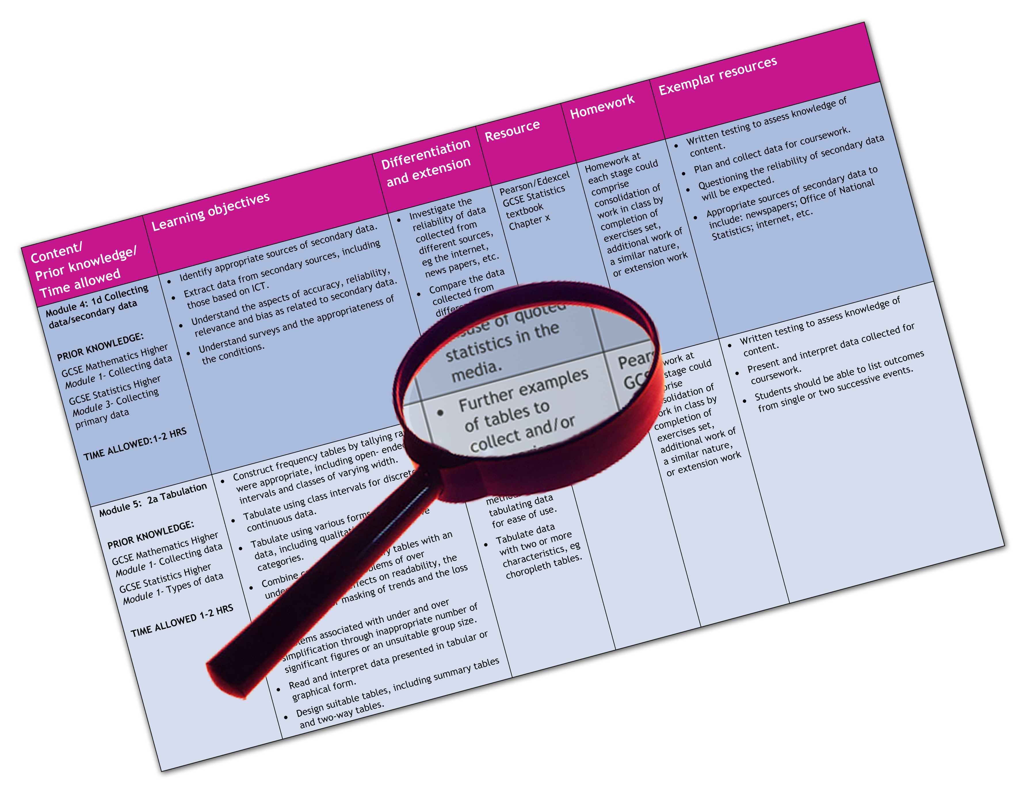
We are happy to provide this scheme of work for you to amend and adapt to suit your teaching purposes.

We hope you find this useful.

Practical support to help you deliver this Edexcel specification
Scheme of work
This scheme of work has been produced to help you implement this unit of the Edexcel specification. It is offered as an example of one possible model that you should feel free to adapt to meet your needs and is not intended to be in any way prescriptive. It is in editable Word format to make adaptation as easy as possible.
Please note that page references for the Pearson Edexcel Student Book refer to the current (2009) edition and will be updated when the revised 2013 edition is published.
Teaching resource exemplars
The scheme of work contains suggestions for resources that you can use to support your teaching. These are suggestions only of material you may find useful and you are encouraged to use a wide range of resources that suit the needs of your students.
Edexcel Subject Advisors
Edexcel has a team of specialist subject advisors available to help you with implementation of this specification. You can contact them by email or phone.
Email: TeachingHistory@pearson.com.
Phone: 0844 576 0034
Edexcel additional support
- Ask the Expert — puts you in direct email contact with over 200 of our senior subject experts.
- Edexcel’s community — these message boards are designed to enable you to access peer-to-peer support from fellow Edexcel teaching and delivery staff in schools and colleges.
Edexcel GCSE History B (Schools History Project)
Scheme of work: Unit 2C Germany 1918–45

Week | Key questions and specification coverage | Learning outcomes | Exemplar activities | Exemplar resources
1 | - What are the key features of a democracy and a dictatorship?  - Overview of Germany 1918–45 | - To understand the differences of living in a democracy and in a dictatorship.  - To understand the main events in Germany 1918–45. | - Categorise and sort the key features of a democracy and a dictatorship.  - Create a timeline to show the main events 1918–45.  - Put images of German history and personal recollections from letters and diaries into the correct chronological order on the timeline.  - Compare maps of Germany for 1919, 1938 and 1942.
2 | - What problems faced Weimar Germany in the years 1919–23?  The problems facing Germany in the immediate post-war years, including the Spartacist Uprising, the terms of the Treaty of Versailles and reactions to this within Germany. The formation and constitution of the Weimar Republic and the problems it faced in the years to 1923, including challenges from left and right, the Kapp Putsch, the formation of the National Socialist Party. | - To understand the effects of the Treaty of Versailles on Germany.  - To understand how both opposition groups and the constitution caused problems in early post-war Germany.  - To explain the beliefs of the Nazi Party in the early 1920s. | - Use sources to examine reactions to the Treaty of Versailles.  - Debate which terms of the Treaty of Versailles will cause the most problems for the Weimar Republic.  - Record similarities and differences between the Spartacist Uprising and the Kapp Putsch: aims, participants, how it was dealt with, reasons for failure.  - Define key terms: Weimar Constitution, President, Chancellor, Reichstag, Article 48, proportional representation.  - Read the Programme of the German Workers’ Party of 1920 and explain which groups of people each clause might appeal to. | - Pearson Edexcel GCSE History (SHP) Life in Germany Student Book Chapter 1.1  - BBC: The Nazis: a warning from history, Episode 1 Helped into Power, focuses on the early post-war years.  - National Archives site provides sources on the Treaty of Versailles: www.nationalarchives.gov.uk/education/greatwar/pdf/g5cs2all.pdf
3 | - Did the Weimar Republic recover from its early problems during the 1920s?  The challenges of 1923: the key events, including the invasion of the Ruhr, hyperinflation and the Munich Putsch. Recovery after 1923 – ‘The Golden Years’? The significance of the work of Stresemann 1923–29, including the introduction of the Rentenmark, the Dawes and Young Plans and Germany’s entry to the League of Nations. | - To understand people’s different experiences of hyper-inflation.  - To decide whether the Munich Putsch was a total failure for the Nazi Party.  - To decide if Stresemann successfully solved the problems facing Weimar Germany. | - Use personal recollections to examine the effects of the economic crisis of 1923.  - Write profiles, diary entries or role-play a businessman, farmer, housewife, ex-soldier, and retired person to show their reactions to events in 1923.  - Draw a storyboard of the events of the Munich Putsch.  - Produce a news report or create a radio broadcast about Hitler’s trial.  - In pairs, one writes a speech claiming that Germany’s problems were solved in the 1920s and another that the problems were not solved.  - Write an obituary for Stresemann. | - Personal recollections relating to the inflation years at: weimar.facinghistory.org/content/personal-accounts-inflation-years  - Pearson Edexcel GCSE History (SHP) Life in Germany Student Book Chapter 1.2  - BBC: The Nazis: a warning from history, Episode 1 Helped into Power, focuses on the Munich Putsch and also on the golden years and the political extremism beneath the surface of recovery.  - Nazi art commemorating the Munich Putsch: www.calvin.edu/academic/cas/gpa/9nov
4 | - Why did support for the Nazi Party grow so quickly after 1928?  Support for the Nazi Party from different social groups in the years to 1929. Reasons for growth including changes of tactics and in Nazi Party organisation. Reasons for its dramatic increase after 1929, including the appeal of Hitler, the role of propaganda, the role of the SA and the economic and political consequences for Germany of the Wall Street Crash of 1929. | - To understand the reasons why different social groups supported the Nazis.  - To understand the ways in which the Nazi Party developed in the 1920s.  - To understand the consequences of the Great Depression in Germany. | - Rank re-organisation, different methods to gain power, propaganda, appeal of Hitler and the SA as factors in the growth of the Nazi Party.  - Use propaganda posters to explain Nazi ideas and which groups posters were aimed at.  - In groups, write profiles for a character, explaining why they voted for the Nazis in the 1932 elections. | - BBC: The Nazis: a warning from history, Episode 1 Helped into Power, on the Nazi Party between 1924–28.  - Pearson Edexcel GCSE History (SHP) Life in Germany Student Book Chapters 1.2 and 1.3.  - Examples of Nazi propaganda: www.calvin.edu/academic/cas/gpa/pre1933.htm  - Images of the impact of the Great Depression at: http://weimar.facinghistory.org/content/economics  - BBC: The Nazis: a warning from history, Episode 1 Helped into Power, on the impact of the Great Depression.
5 | - Overview on the rise of the Nazi Party. | - To have a secure understanding and knowledge of rise of the Nazi Party. | - Write an obituary for the Weimar Republic.  - Debate: ‘The Treaty of Versailles was to blame for all of Germany’s problems.’  - Write a text on ‘The rise of the Nazi Party’ with deliberate errors for a partner to correct.  - Create a series of magazine articles ‘Review of the year’ for entries in 1919, 1923 and 1929.  - Create a series of ‘odd one out’ activities for the topic ‘the Rise of the Nazi Party’.
6 | - How was the Nazi State created by 1934?  The reasons why and steps by which Hitler was able to gain total power in Germany: the significance of the existing constitution, the elections of 1932 and the role of von Papen and von Hindenburg in 1932–33; the key events of 1933–34, including the Reichstag Fire, the Enabling Act, the banning and removal of rival power groups, political parties and trade unions; the significance of the Night of the Long Knives, the army oath of allegiance and the death of von Hindenburg. The nature of Hitler’s role as Führer. | - To examine the significance of different key events between January 1933 and August 1934 in Hitler’s rise to power.  - To understand how Germany changed from a democracy to a one-party state in the years 1933–34. | - Rate in order of significance the events between January 1933 and August 1934 for Germany to become a one-party state.  - Categorise the key events between January 1933 and August 1934 into Hitler’s political skill or mistakes by Hitler’s opponents.  - In groups, each person takes a different key event in Hitler’s rise to power and produces a newspaper report or radio broadcast.  - Create a storyboard of key events in Hitler’s rise to power in the years 1933–34. | - Pearson Edexcel GCSE History (SHP) Life in Germany Student Book Chapter 2.4.  - BBC: The Nazis: a warning from history, Episode 1 Helped into Power, on Hitler becoming Chancellor and Episode 2 Chaos and consent, on 1933–34.  - Sources on the Reichstag Fire: http://germanhistorydocs.ghi-dc.org/sub_image.cfm?image_id=1876  - Documents on the Enabling Act: http://www.germanhistorydocs.ghi-dc.org/sub_document.cfm?document_id=1496  - Images relating to Hitler’s consolidation of power: http://www.germanhistorydocs.ghi-dc.org/sub_imglist.cfm?sub_id=191&section_id=13  - History Channel: The Night of the Long Knives: Hitler’s murderous coup.
7 | - How did the Nazi government control Germany?  Nazi control of behaviour in Germany and influence on attitudes by national and local groups, methods and systems: the role of the SS and Himmler, concentration camps and local wardens; laws restricting civil liberties; control of the press, political parties and opposition groups and individuals; control of churches, including the establishing of the Concordat and the Reich Church. The role of Goebbels, the uses of censorship, and the purpose and effectiveness of different types of propaganda, including radio, films, posters, rallies. | - To explain the different elements of the police state: the SA, SS, Gestapo and early concentration camps.  - To explain the ways in which the Nazis spread propaganda.  - To explain the different methods that the Nazis used to deal with the Catholic and Protestant churches. | - Research a Nazi concentration camp.  - In pairs, each write a letter to a friend in Germany as if in 1936, which then your partner has to censor.  - Research the Berlin Olympics of 1936 as a case study to show how the Nazis used the event for propaganda purposes. | - Himmler by the BBC: www.bbc.co.uk/history/historic_figures/himmler_heinrich.shtml and www.spartacus.schoolnet.co.uk/GERhimmler.htm  - SS and police system: http://germanhistorydocs.ghi-dc.org/sub_doclist.cfm?sub_id=171&section_id=13  - BBC: The Nazis: a warning from history, Episode 2 Chaos and consent.  - Propaganda material: www.calvin.edu/academic/cas/gpa/ww2era.htm http://bytwerk.com/gpa/posters2.htm  - Berlin Olympics sources: www.ushmm.org/museum/exhibit/online/olympics/?lang=en  - Pearson Edexcel GCSE History (SHP) Life in Germany Student Book Chapter 2.5.
8 | - In what ways did Germans oppose the Nazi government?  The nature and extent of opposition and resistance, both in the pre-war  period and the war years, including the role of the Catholic and Protestant Churches, the significance of Pastor Niemöller, the White Rose Group (1942–3) and the July Plot of 1944. | - To understand the difficulties facing opposition groups living in a dictatorship.  - To understand the methods and motives of different opposition groups in Nazi Germany. | - Write an obituary for Niemöller and Bonhoeffer or another leading Church figure such as Galen, focusing on how they opposed the Nazis and how they were treated by the Nazis.  - Write a storyboard or an obituary for Sophie or Hans Scholl.  - Produce a newspaper report on the July Plot, 1944. | - Pearson Edexcel GCSE History (SHP) Life in Germany Student Book Chapter 2.6.  - Documents relating to church resistance: http://germanhistorydocs.ghi-dc.org/sub_doclist.cfm?sub_id=172&section_id=13  - The Fifth Broadsheet of the White Rose group (1943): http://www.germanhistorydocs.ghi-dc.org/sub_document.cfm?document_id=1515&language=english  - Information on Hans and Sophie Scholl: http://www.spartacus.schoolnet.co.uk/GERschollS.htm  - Pearson Edexcel GCSE History (SHP) Life in Germany Student Book Chapter 2.6.  - BBC: Days that Shook the World: the Eagle’s Lair provides a reconstruction of the July Bomb Plot.  - Information on Valkryie: www.mgm.com/#/our-titles/2088/Valkyrie
9 | - Overview on the Government of the Third Reich. | - To have a secure understanding and knowledge of the Third Reich. | - Debate: ‘The Nazis had total control of Germany’.  - Create a series of magazine articles ‘Review of the year’ for entries in 1934, 1935 and 1938.  - Write a text on ‘The Government of the Third Reich’ with deliberate errors for a partner to correct.  - Create a series of ‘odd one out’ activities for the topic ‘Government of the Third Reich’.
10 | - In what ways did the Nazi government change the lives of women and young people?  Nazi policies towards young people and women; their importance to the Nazi state and party, including the nature and purpose of education in schools for boys and girls; the role and effectiveness of youth movements 1933–45, including preparation for war, charity work and military role in the war years. The emergence of rebel groups, for example the Edelweiss Pirates. The role of women within the family, society and employment, and changes to their role during the pre-war period and the war years: women’s contribution to the German Home Front 1939–45. | - To understand why young people were so important to the Nazi government.  - To understand the importance of women to the Nazi government.  - To understand the contribution made by young people and women to the war effort. | - Explain, from images and documents, the activities that were offered by youth movements.  - Design a pamphlet encouraging children to sign up for a Hitler Youth Camp.  - Annotate Nazi propaganda images of German women.  - Read the document advertising the Reich School for Brides and Mothers and list the skills which were seen as important for women.  - Research images to show how the role of women changed during the Second World War. | - Pearson Edexcel GCSE History (SHP) Life in Germany Student Book Chapter 3.7.  - Nazi education, including extracts from textbooks: www.calvin.edu/academic/cas/gpa/ww2era.htm  - BBC History File: Nazi Germany, Programme 4: Youth in Hitler’s Germany.  - Images of Nazi Youth Movements and Nazi ideas about women at: http://germanhistorydocs.ghi-dc.org/sub_imglist.cfm?startrow=21&sub_id=198&section_id=13  - Nazi propaganda material, including magazine covers and articles relating to women: http://www.calvin.edu/academic/cas/gpa/fw.htm  - An article about the activities at the Reich School for Brides and Mothers: www.calvin.edu/academic/cas/gpa/fw8-22b.htm
11 | - Did the German economy improve under the Nazi government?  The impact of economic policies to reduce unemployment: the New Plan, labour service, construction of autobahns and rearmament. Changes in the standard of living for German workers, Strength Through Joy; wartime hardships. | - To explain the Nazi Party’s economic policies.  - To understand the changes to workers’ lives in Nazi Germany.  - To decide if the economy improved under the Nazi government. | - In pairs one write one speech that argues workers’ lives improved under the Nazis and another speech that workers’ lives did not improve.  - Write two diary entries: one for a German worker who has benefitted from the Nazi government and another who has suffered. | - Pearson Edexcel GCSE History (SHP) Life in Germany Student Book Chapter 3.8.  - BBC: The Nazis: a warning from history, Episode 2 Chaos and consent, on the economic recovery.  - Images relating to the economic recovery and to workers in Nazi Germany: http://germanhistorydocs.ghi-dc.org/sub_imglist.cfm?sub_id=197&section_id=13
12 | - What was the impact of Nazi beliefs on race?  The importance of Nazi beliefs in Aryan supremacy and the ‘master race’. The treatment of minority groups, including Jews, gypsies and disabled people. Changes in discrimination and persecution 1933–39, including concentrations camps, the shop boycott, Nuremberg Laws and Kristallnacht. The escalating persecution during the war years to 1945 including the use of ghettoes and the ‘Final Solution’. | - To understand Nazi beliefs about the Aryan master race.  - To understand the changes in Nazi persecution of the Jews in the years 1933 to 1939  - To understand the changes in the Nazi persecution of the Jews in the years 1939 to 1945 | - Draw a timeline showing the escalating persecution of Jews in Germany 1933-39.  - Research and write a biography of Himmler  - In groups research different Death Camps in Nazi-occupied territories  - Research memorial sites in Germany today to the Nazi persecution of minority groups | - BBC: The Nazis: a warning from history, Episode 3 The Wrong War, on Nazi beliefs about race.  - Nazi propaganda material relating to anti-Semitism: www.calvin.edu/academic/cas/gpa/ww2era.htm  - BBC: The Nazis: a warning from history, Episode 2 Chaos and consent, on the persecution 1933–38.  - Interactive timeline and presentation on Nazi persecution from the BBC: www.bbc.co.uk/history/worldwars/genocide/  - Information on the Nazi ‘euthanasia’ Programme: www.ushmm.org/wlc/  article.php?lang=en&ModuleId=10005200  - Pearson Edexcel GCSE History (SHP) Life in Germany Student Book Chapter 3.9.
13 | - Overview on the social impact of the Nazi State. | - To have a secure understanding and knowledge of the social impact of the Nazi State. | - Debate: ‘The lives of German workers improved under the Nazis’.  - Create a series of ‘odd one out’ activities for the topic ‘The Social Impact of the Nazi state’.
14 | - Overview of Life in Germany c.1918–c.1945. | - To have a secure understanding and knowledge of Germany c.1918–c.1945. | - Debate: ‘Weimar Germany had no chance of success’.  - Write a text on Germany c.1918–c.1945 with deliberate errors for a partner to correct.  - Write a magazine article where a journalist is interviewing a German person about their life from 1918 to 1945.  - Create a series of multiple-choice questions on Germany c.1918–1945.
15 | - End of Unit 2 Assessment Tasks. | - To understand the requirements of the Unit 2 examination. | - Examination questions | - Specimen assessment materials and past papers.

This grid is for you to create your own scheme of work if needed.

Week | Content coverage/  key questions | Learning outcomes | Exemplar activities | Exemplar resources

