Edexcel GCSE History B – revised for 2013  
(Schools History Project)



Editable scheme of work



Detailed help on resources

Week by week content coverage

Exemplar activities

Learning outcome

Unit 3C The impact of war on Britain c.1901–1954

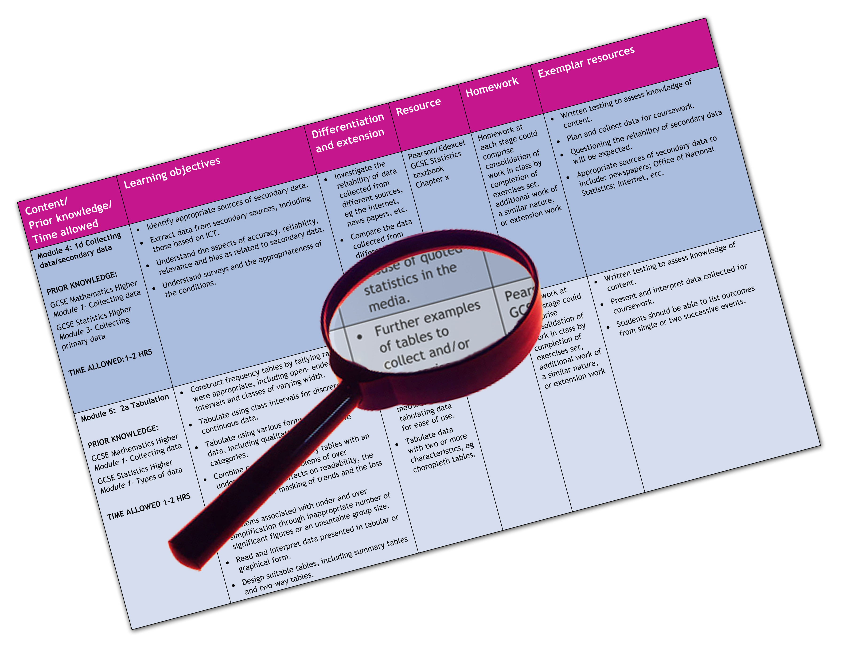

We are happy to provide this scheme of work for you to amend and adapt to suit your teaching purposes.

We hope you find this useful.

Practical support to help you deliver this Edexcel specification

Scheme of work

This scheme of work has been produced to help you implement this unit of the Edexcel specification. It is offered as an example of one possible model that you should feel free to adapt to meet your needs and is not intended to be in any way prescriptive. It is in editable Word format to make adaptation as easy as possible.

**Please note that page references for the Pearson Edexcel Student Book refer to the current (2009) edition and will be updated when the revised 2013 edition is published.**

Teaching resource exemplars

The scheme of work contains suggestions for resources that you can use to support your teaching. These are suggestions only of material you may find useful and you are encouraged to use a wide range of resources that suit the needs of your students.

Edexcel Subject Advisors

Edexcel has a team of specialist subject advisors available to help you with implementation of this specification. You can contact them by email or phone.

Email: [TeachingHistory@pearson.com](mailto:TeachingHistory@pearson.com).

Phone: 0844 576 0034

Edexcel additional support

* Ask the Expert — puts you in direct email contact with over 200 of our senior subject experts.
* Edexcel’s community — these message boards are designed to enable you to access peer-to-peer support from fellow Edexcel teaching and delivery staff in schools and colleges.

**Edexcel GCSE History B (Schools History Project)**

**Unit 3C The impact of war on Britain c.1901–c.1954**

| Week | Key questions and specification coverage | Learning outcomes | Exemplar activities | Exemplar resources |
| --- | --- | --- | --- | --- |
| 1 | * What impact did war have on attitudes in British society in the first half of the 20th century?   British society in the early 20th century and the social impact of war: concerns aroused by the fitness of recruits for the Boer War, the report of the Committee on Physical Deterioration 1904; Liberal social reforms 1906–11; the role of the First and Second World Wars in improving welfare and health provision; improved medical services in the First and Second World Wars; implementing Beveridge – Labour welfare reforms 1945–51. | * To understand the reasons why the Liberals introduced social reforms. * To understand the ways in which the First and Second World Wars improved health provision. | * Students categorise Liberal social reforms 1906-11 for the young, the elderly and workers * Students create a timeline for improvements in welfare and health provision for the first half of the 20th century | * [www.bbc.co.uk/bitesize/intermediate2/history/cradle_to_the_grave/liberal_reforms/revision/3/](http://www.bbc.co.uk/bitesize/intermediate2/history/cradle_to_the_grave/liberal_reforms/revision/3/) * The Boer War and National Efficiency <http://atschool.eduweb.co.uk/redschl/historydocs/Poverty%201830-1939%20A%20Level/Boer%20war%20and%20national%20efficiency%20notes.doc> * A government film *Your Very Good Health* from 1948 from the National Archives: Cabinet Papers at: [www.nationalarchives.gov.uk/cabinetpapers/alevelstudies/nhs.htm](http://www.nationalarchives.gov.uk/cabinetpapers/alevelstudies/nhs.htm) |
| 2 | * In what ways did war change social divisions in Britain in the first half of the 20th century?   The role of war in reducing social divisions – increasing social mobility and changing working opportunities. | * To understand the ways in which war changed social mobility and patterns of employment. | Students compare the significance of “Homes for Heroes” in 1918 with “Let Us Face the Future” in 1945   * Students create a spider diagram showing impacts of war on social divisions in the first half of the twentieth century. | * [www.nationalarchives.gov.uk/education/early-20th-century.htm](http://www.nationalarchives.gov.uk/education/early-20th-century.htm) * [www.nationalarchives.gov.uk/pathways/firstworldwar/aftermath/brit_after_war.htm](http://www.nationalarchives.gov.uk/pathways/firstworldwar/aftermath/brit_after_war.htm) |

|  |  |  |  |  |
| --- | --- | --- | --- | --- |
| 3 | * In what ways did war change the role and status of women in the first half of the 20th century?   The situation of women in the early 20th century: their role and status in the family and society, working opportunities; growing independence and changes in their activities during the First World War and the extent to which that continued in the interwar period; conscription and opportunity in the Second World War; situation by the mid-1950s. | * To understand the ways in which the role and status of women changed in the first half of the 20th century. | * Students research the changing number of women in different types of employment during the first half of the 20th century. * Students create a timeline of images of women in different types of employment c1900-c1955. * In pairs one student assesses the impact of the First World War and the other the Second World War on the role and status of women in Britain. | * Pearson Edexcel GCSE History (SHP) Warfare Student Book section 8. * Pearson Edexcel GCSE History (SHP) Warfare Teacher Guide. * Biographies of women in the First World War: [www.spartacus.schoolnet.co.uk/FWWwomen.htm](http://www.spartacus.schoolnet.co.uk/FWWwomen.htm) * The National Army Museum offers educational sessions free of charge and workshops on Women at War and at home [www.nam.ac.uk/](http://www.nam.ac.uk/) * BBC Radio 4 on women in the armed forces during the Second World War via *Woman’s Hour* Women’s History Timeline link: [www.bbc.co.uk/radio4](http://www.bbc.co.uk/radio4) * National Archives on how the government mobilised women for work during the First World War: [www.nationalarchives.gov.uk](http://www.nationalarchives.gov.uk) |
| 4 | * Source skills – inference and representation purpose. | * To understand that sources often provide the historian with more information that what is stated or shown. * To understand that sources are often created to give a certain message or image. | * Students look at advertisements, listen to speeches and look at posters to understand purpose and representation. | * Pearson Edexcel GCSE History (SHP) Warfare Student Book. * Pearson Edexcel GCSE History (SHP) Warfare Teacher Guide. |
| 5 | * How were propaganda and censorship used during the First and Second World Wars?   Civilian attitudes to the First and Second World Wars. The use of propaganda and the role of the media and the arts in maintaining morale and support for the war efforts, including the press, radio and cinema. | * To understand the nature and role of propaganda on the Home Front. | * In pairs, students write letters and diary entries for either the First or Second World Wars, deliberately including material for the other to censor. * Students analyse propaganda posters for the First and Second World Wars. | * Pearson Edexcel GCSE History (SHP) Warfare Student Book section 6. * Pearson Edexcel GCSE History (SHP) Warfare Teacher Guide. * First World War propaganda: [www.firstworldwar.com/posters/](http://www.firstworldwar.com/posters/) and [www.ww1-propaganda-cards.com](http://www.ww1-propaganda-cards.com) * Recruitment problems in the First World War: [www.schoolhistory.co.uk/](http://www.schoolhistory.co.uk/) * Second World War propaganda posters: [www.st-andrews.ac.uk/~pv/pv/courses/posters/](http://www.st-andrews.ac.uk/~pv/pv/courses/posters/) and [www.ww2poster.co.uk](http://www.ww2poster.co.uk) |
| 6 | * What was the civilian’s experience of air raids and bombing during the First and Second World Wars?   The impact of aerial warfare on civilians in the First and Second World Wars. | * To understand the impact of air raids and bombing during the First and Second World Wars. | * Students research the use of Zeppelins and aircraft during the First World War, including the limited air attacks on Britain. * Students research the main areas of Britain bombed during the Second World War and identify why they were a target. * Students research the impact of the Blitz on their local area. * Students research VI and V2 rockets. | * Pearson Edexcel GCSE History (SHP) Warfare Student Book section 6. * Pearson Edexcel GCSE History (SHP) Warfare Teacher Guide. * A good summary on the use of airpower during the First World War: [www.firstworldwar.com](http://www.firstworldwar.com/). Follow links to airwar. * An interactive diagram on the Blitz: <http://www.schoolhistory.co.uk/> * BBC History websites include detailed information on the Blitz and the varied experiences of evacuees: [www.bbc.co.uk/ww2peopleswar/categories/c1162/](http://www.bbc.co.uk/ww2peopleswar/categories/c1162/) and [www.bbc.co.uk/history/home_front](http://www.bbc.co.uk/history/home_front) |
| 7 | * Source skills – reliability | * To be able to explain the factors which can affect the reliability of a source. * To be able to reach a judgement on how far a source is reliable. | * Evaluate sources for (i) origins, (ii) content and selection of information, (iii) omission of content, (iv) language and tone. Then reach a judgement on how reliable you think the source is. | * Pearson Edexcel GCSE History (SHP) Warfare Student Book. * Pearson Edexcel GCSE History (SHP) Warfare Teacher Guide. |
| 8 | * How did civilians react to the Blitz?   Civilian responses to the Blitz including air-raid precautions, volunteers, morale – a Blitz Spirit? The composition and role of the Home Guard. | * To understand the different experiences of civilians during the Blitz. * To understand the idea of the ‘Blitz myth’. | * Students write about responses to the Blitz from the perspectives of different individuals. * In pairs, students write two different speeches to argue that the Home Guard was useful in the defence of Britain, and the other that it had very little impact. * Students sort photographs of the Blitz into various categories such as those the government would have allowed to have been published in newspapers and those that would have been censored. | * Pearson Edexcel GCSE History (SHP) Warfare Student Book section 6. * Edexcel GCSE History (SHP) Warfare Teacher Guide. * BBC History Site includes individual reminiscences: [www.bbc.co.uk/ww2peopleswar](http://www.bbc.co.uk/ww2peopleswar) * Interactive diagram on the the Blitz: [www.schoolhistory.co.uk/](http://www.schoolhistory.co.uk/) * The film *Hope and Glory* (1987) deals with many aspects of a British family living during the Blitz. * [www.liverpoolwarmuseum.co.uk/](http://www.liverpoolwarmuseum.co.uk/) includes information and exhibits on life during the Blitz. |
| 9 | * In what ways did government action change society and industry?   The effects on society of government action, including the Defence of the Realm Act, conscription in the First and Second World Wars, national service, reorganisation of industry; the introduction of rationing and evacuation. The creation of women’s services in the armed forces and mobilisation of women into the workforce. | * To understand the ways in which government intervention into people’s lives increases during wartime. | * Students work to categorise the various aspects of DORA during the First World War. * Students discuss the experience of evacuation from the point of view of the government, evacuees, parents and host families. * Students compare the role of FANYs during the First World War and their work in the armed forces during the Second World War. * Debate: ‘The evacuation of children during the Second World War was a failure’. | * Pearson Edexcel GCSE History (SHP) Warfare Student Book section 7. * Pearson Edexcel GCSE History (SHP) Warfare Teacher Guide. * Rationing during the Second World War: [www.schoolhistory.co.uk/](http://www.schoolhistory.co.uk/) * Imperial War Museum website on women during the Second World War. Access is via the online resources link on the home page: [www.iwm.org.uk/](http://www.iwm.org.uk/) * Recruitment problems in the First World War on: [www.SchoolHistory.co.uk](http://www.SchoolHistory.co.uk) * Dartmoor prison and conscientious objectors on: [www.ppu.org.uk/coproject](http://www.ppu.org.uk/coproject) * British government papers on conscientious objectors: [www.nationalarchives.gov.uk](http://www.nationalarchives.gov.uk) |
| 10 | * How did the Second World War affect Britain economically?   The economic legacy of the Second World War: nationalisation of key industries, debt and loans from the USA. | * To understand the economic effects of the Second World War. | * Students produce a radio broadcast explaining why the government has decided to nationalise key industries. * Students produce a government statement for the year 1945 explaining why Britain needs to borrow from the USA. | * [www.johndclare.net/wwii1_economic_effects.htm](http://www.johndclare.net/wwii1_economic_effects.htm) * [www.nationalarchives.gov.uk/cabinetpapers/themes/economy-second-world-war.htm](http://www.nationalarchives.gov.uk/cabinetpapers/themes/economy-second-world-war.htm) * [www.bbc.co.uk/history/british/modern/](http://www.bbc.co.uk/history/british/modern/) |
| 11 | * Source skills – reliability and explanation using source and own knowledge. | * To be able to explain the factors which can affect the reliability of a source. * To be able to reach a judgement on how far a source is reliable with reference to your own knowledge. | * Evaluate sources for (i) origins, (ii) content and selection of information, (iii) omission of content, (iv) language and tone. Then reach a judgement on how reliable you think the source is with reference to your own knowledge. | * Edexcel GCSE History (SHP) Warfare Student Book. * Edexcel GCSE History (SHP) Warfare Teacher Guide. |
| 12 | * What were the social effects of the Second World War?   The social legacy of war to 1954: rationing, shortages, an age of austerity? | * To understand the social effects of the Second World War. | * Students write two accounts to support and oppose the hypothesis that the Second World War made Britain a more equal society. | * <http://news.bbc.co.uk/onthisday/hi/dates/stories/july/4/newsid_3818000/3818563.stm> * [www.nationalarchives.gov.uk/education/topics/attlees-britain.htm](http://www.nationalarchives.gov.uk/education/topics/attlees-britain.htm) * [www.nationalarchives.gov.uk/education/topics/fifties-britain.htm](http://www.nationalarchives.gov.uk/education/topics/fifties-britain.htm) |
| 13 | * What factors influence these events? | * To understand the ways in which different factors affect change and continuity. | * Students annotate or colour-code a timeline to show the main factors contributing to the impact of war in early 20th-century Britain: the role of the government; the media; changes in industry. | * [www.nationalarchives.gov.uk/education/topics/attlees-britain.htm](http://www.nationalarchives.gov.uk/education/topics/attlees-britain.htm) |
| 14 | * Source skills – evaluating an interpretation. | * To be able to make a judgement on an issue about the Impact of War which is supported by sources and own knowledge. | * Sample assessment materials. | * Edexcel GCSE History (SHP) Warfare Student Book. * Edexcel GCSE History (SHP) Warfare Teacher Guide. |
| 15 | * End of Unit 3 Assessment Tasks. | * To understand the requirements of the Unit 3 examination. | * Examination questions. | * Specimen assessment materials and past papers. |

This grid is for you to create your own scheme of work if needed.

|  |  |  |  |  |
| --- | --- | --- | --- | --- |
| Week | Content coverage/ key questions | Learning outcomes | Exemplar activities | Exemplar resources |
|  |  |  |  |  |
|  |  |  |  |  |
|  |  |  |  |  |
|  |  |  |  |  |
|  |  |  |  |  |