Edexcel GCSE History A – revised for 2013  
(The Making of the Modern World)   
Unit 3A: War and the transformation of British society c.1903–28

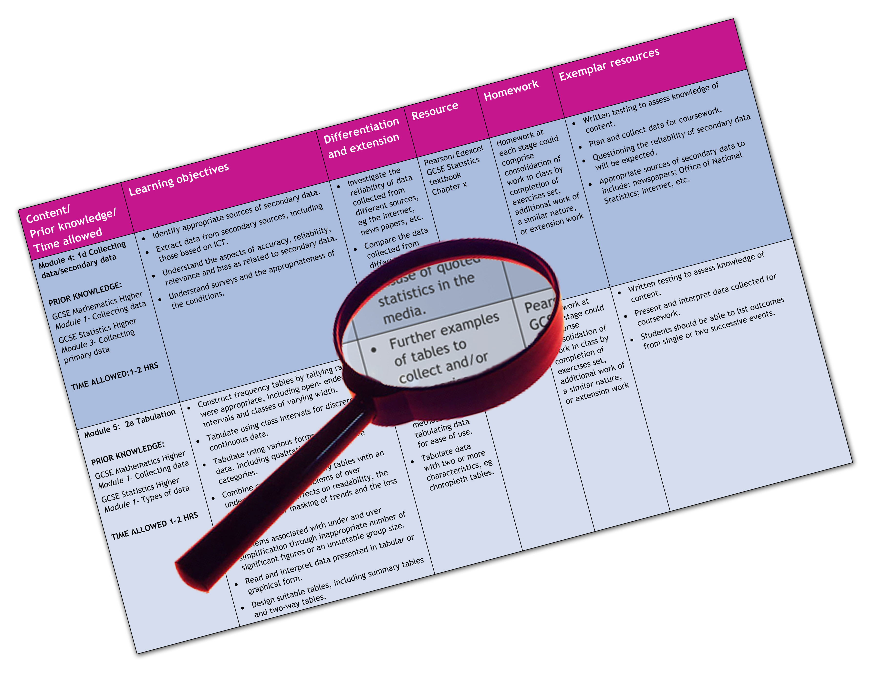

We are happy to provide this scheme of work for you to amend and adapt to suit your teaching purposes.

We hope you find this useful.



Editable scheme of work



Detailed help on resources

Week by week content coverage

Exemplar activities

Learning outcome

Practical support to help you deliver this Edexcel specification

Scheme of work

This scheme of work has been produced to help you implement this unit of the Edexcel specification. It is offered as an example of one possible model that you should feel free to adapt to meet your needs and is not intended to be in any way prescriptive. It is in editable Word format to make adaptation as easy as possible.

**Page references for the Pearson Edexcel Student Book refer to the 2009 edition and will be updated when the revised edition is published.**

Teaching resource exemplars

The scheme of work contains suggestions for resources that you can use to support your teaching. These are suggestions only of material you may find useful and you are encouraged to use a wide range of resources that suit the needs of your students.

Edexcel Subject Advisors

Edexcel has a team of specialist subject advisors available to help you with implementation of this specification. You can contact them by email or phone.

Email: [TeachingHistory@pearson.com](mailto:TeachingHistory@pearson.com).

Phone: 0844 576 0034

Edexcel additional support

* Ask the Expert — puts you in direct email contact with over 200 of our senior subject experts.
* Edexcel’s community — these message boards are designed to enable you to access peer-to-peer support from fellow Edexcel teaching and delivery staff in schools and colleges.

Edexcel GCSE History A (Modern World History)

Scheme of work Unit 3 Option A: War and the transformation of British society c.1903–28

| Week | Content coverage/ key questions | Learning outcomes | Exemplar activities | Exemplar resources |
| --- | --- | --- | --- | --- |
| 1 | Outline of the position of women in the early 20th century and the formation of action groups to win suffrage. | * To identify the main events and significance of the Suffragist and Suffragette movements. * To make inferences. | * Students summarise the main beliefs, methods and activities of the Suffragist and Suffragette movements in a table. * Students study Source B on page 9 of the Edexcel GCSE Modern World History Unit 3A Student Book for discussion on inferences. * Students study Source C on page 11 of the Edexcel GCSE Modern World History Unit 3A Student Book for a class debate. * Students study Sources A-D, and for each source explain whether they think it gives a positive or negative portrayal of Suffragettes. | * Pages 9–13 in the Pearson Edexcel GCSE Modern World History Unit 3A Student Book provide useful information. * Information about the Suffragette movement and information about Emmeline Pankhurst can be found at: [news.bbc.co.uk/1/hi/uk/3153388.stm](http://news.bbc.co.uk/1/hi/uk/3153388.stm)  and [www.bbc.co.uk/history/historic_figures/pankhurst_emmeline.shtml](http://www.bbc.co.uk/history/historic_figures/pankhurst_emmeline.shtml)  and  [www.spartacus.schoolnet.co.uk/wwspu.htm](http://www.spartacus.schoolnet.co.uk/Wwspu.htm) * Information on tactics can be found at the National Archives: [www.nationalarchives.gov.uk/education/cats-and-mice.htm](http://www.nationalarchives.gov.uk/education/cats-and-mice.htm) |
| 2 | Understanding the reactions to suffragettes. | * To understand the reasons for opposition to Suffragettes and its nature, including forced feeding and the Cat and Mouse Act. * To consider the purpose of representations. | * Students work in pairs to research opposition to the Suffragettes. * Students discuss the purpose of the well-known ‘Cat and Mouse Act’ poster. * Students debate the impact of Suffragettes and whether the movement did more harm than good. * Students create a timeline of the suffrage movement 1903–14. | * Pages 14–17 Pearson Edexcel GCSE Modern World History Unit 3A Student Book provide useful information and guidance. * [www.bl.uk/learning/histcitizen/21cc/struggle/suffrage/suffrageintro.html](http://www.bl.uk/learning/histcitizen/21cc/struggle/suffrage/suffrageintro.html) |

|  |  |  |  |  |
| --- | --- | --- | --- | --- |
| Week | Content coverage/ key questions | Learning outcomes | Exemplar activities | Exemplar resources |
| 3 | Overview of the socio-economic conditions in Britain at the beginning of the 20th century.  Legislation introduced by the Liberal government to improve conditions for the Young. | * To understand the wide gulf between rich and poor at this time. * To explain the reasons for and the details of the measures introduced to improve living conditions for the young. * To be able to make inferences from sources. | * Students study two conflicting images of the period to see the different life styles. They use three sources and consider the degree to which they agree on life in Britain in the period. * Students create a diagram of factors that led to welfare reforms. * Students practise inference skills with a contemporary letter. * Students design a poster as a synthesis exercise. | * Pages 18–21 in the Pearson Edexcel GCSE Modern World History Unit 3A Student Book provide useful information and guidance. * [www.nationalarchives.gov.uk/education/britain1906to1918/g1/gallery1.htm](http://www.nationalarchives.gov.uk/education/britain1906to1918/g1/gallery1.htm) |
| 4 | The work of the Liberal government in helping the elderly, unemployed and sick. | * To understand the lack of social security before the introduction of the Liberal reforms. * To understand the importance of the introduction of old-age pensions, Labour Exchanges and National Insurance. * To be aware of opposition to the Liberal reforms. * To evaluate historical sources. | * Students study a drawing of people drawing a pension for the first time and consider its reliability. * Class discussion on why some people opposed the introduction of old age pensions. * Students create a table of the merits and demerits of the welfare system. | * Pages 22–23 in the Pearson Edexcel GCSE Modern World History Unit 3A Student Book provide useful information. * Other sources of information are: [www.spartacus.schoolnet.co.uk/PRbannerman.htm](http://www.spartacus.schoolnet.co.uk/PRbannerman.htm)  and  [www.bbc.co.uk/schools/gcsebitesize/history/mwh/britain/liberalreformsrev1.shtml](http://www.bbc.co.uk/schools/gcsebitesize/history/mwh/britain/liberalreformsrev1.shtml) |
| 5 | Overview of how the First World War broke out and Britain’s role in the early fighting. | * To understand the early events in the war, particularly how the Schlieffen Plan should have worked, and how its failure led to trench warfare. * To understand the role of the BEF. * Evaluating the reliability of sources. | * Students write a definition of the BEF, its leader and its composition. Students identify a list of reasons which suggest the BEF was unlikely to win against the German army, and then identify why the BEF was able to halt the German advance. * Students sort reasons for the failure of the Schlieffen Plan into categories. * Students write a letter from the German commander General von Moltke, explaining why a line of trenches had been built across Belgium and France. * Students consider a written and pictorial source to gain a fuller understanding of how to answer reliability questions in the examination. | * Pages 27–29 in the Pearson Edexcel GCSE Modern World History Unit 3A Student Book provide useful information and guidance. * For more information see: [www.schoolhistory.co.uk/gcselinks/wars/firstwwlinks/ schlieffen_summary.html](http://www.schoolhistory.co.uk/gcselinks/wars/firstwwlinks/schlieffen_summary.html)  and  [www.bbc.co.uk/schools/gcsebitesize/history/mwh/ir1/ schlieffenplanrev1.shtml](http://www.bbc.co.uk/schools/gcsebitesize/history/mwh/ir1/schlieffenplanrev1.shtml) |

|  |  |  |  |  |
| --- | --- | --- | --- | --- |
| Week | Content coverage/ key questions | Learning outcomes | Exemplar activities | Exemplar resources |
| 6 | Overview of the nature of trench warfare.  Overview of the types of new weapons used in trench warfare and their impact on how battles were fought. | * To identify the main aspects of life in the trenches. * To consider why trench warfare led to such heavy losses. * To understand the development and impact of: machine guns, gas, artillery shells, creeping barrage, tanks. * To be able to make inferences from sources. | * Students examine a picture of a trench and identify its main features. * Students collate a table of problems for attacking troops created by trenches, and possible solutions to these problems. * Students make inferences from sources about trench warfare. * Students research new weapons used in the war from primary documents and stepped questions from the National Archives. | * Pages 30–31 in the Pearson Edexcel GCSE Modern World History Unit 3A Student Book provide useful information and guidance. * Other useful sources are:  [www.bbc.co.uk/schools/worldwarone/](http://www.bbc.co.uk/schools/worldwarone/) and  [www.spartacus.schoolnet.co.uk/FWWtrench.htm](http://www.spartacus.schoolnet.co.uk/FWWtrench.htm)  and  [www.schoolshistory.org.uk/trenchwarfare.htm](http://www.schoolshistory.org.uk/trenchwarfare.htm)   And [www.nationalarchives.gov.uk/education/greatwar/g3/cs1/](http://www.nationalarchives.gov.uk/education/greatwar/g3/cs1/) |
| 7 | Overview of the Somme.  The end of the First World War. | * To identify the main reasons for the failure of the British at the Battle of the Somme and the role of Haig. * To consider the purpose of a representation. * To evaluate a hypothesis. * To know the main details of the final German defeat; Ludendorff’s offensives and the allied drive to victory. | * Students study a scene from the government propaganda film to consider its purpose. * They also carry out a ‘true or false’ exercise to gain an understanding of the events at the Somme. * Teacher provides a variety of sources for students to consider whether the Somme was ‘a disaster from day 1’. * Students use a source and their own knowledge to explain why there were so many casualties at the Somme. * Students read a summary of the end of the war and list reasons why Germany lost. Students then turn these reasons into sentences of explanation. | * Pages 36–41 in the Pearson Edexcel GCSE Modern World History Unit 3A Student Book provide useful information and guidance. * <http://archive.iwm.org.uk/server/show/nav.2164> |

|  |  |  |  |  |
| --- | --- | --- | --- | --- |
| Week | Content coverage/ key questions | Learning outcomes | Exemplar activities | Exemplar resources |
| 8 | Overview of the restrictions placed on the civilian population in Britain during the First World War. | * To understand the reasons why the government introduced: censorship and propaganda; Defence of the Realm Act (DORA); rationing. * To make inferences. | * Students study a list of forbidden actions during the war and explain why each action was forbidden. * Students list ways in which the government censored material during the war. * Students list the measures used by the government to ensure that sufficient war materials were produced. * Students undertake an inference exercise based on a contemporary magazine article. | * Pages 45–47 in the Pearson Edexcel GCSE Modern World History Unit 3A Student Book provide useful information and guidance. |
| 9 | Overview of the way in which the government recruited troops in the war and reactions to its policies. | * To identify the methods used to bring about volunteering for the armed forces. * To consider the purpose of representations. * To understand the nature of opposition to fighting. * Reasons for the introduction of conscription. | * Students write a list of reasons why men volunteered to enlist into the army. * Students study a First World War recruitment poster to consider the methods used and how to analyse purpose. * Students discuss the question: How successful was the Pals battalions scheme? * In pairs, students consider the reasons why someone might not volunteer. They create a spider diagram of these reasons. | * Pages 48–51 in the Pearson Edexcel GCSE Modern World History Unit 3A Student Book provide useful information and guidance. * The following are useful resources for this topic: [www.spartacus.schoolnet.co.uk/FWWhome.htm](http://www.spartacus.schoolnet.co.uk/FWWhome.htm)  and  [www.ww1photos.com/TheHomefront.html](http://www.ww1photos.com/TheHomefront.html)  and  [www.schoolhistory.co.uk/gcselinks/wars/firstwwlinks/ homefront.html](http://www.schoolhistory.co.uk/gcselinks/wars/firstwwlinks/homefront.html) |
| 10 | To understand why Britain faced food shortages and how it dealt with them. | * To understand: the nature of submarine warfare; reasons why the government introduced rationing. * Making inferences. | * Students list reasons why Britain faced food shortages and how it dealt with them. They then rank the methods used to deal with food shortages on how successful they think each was. * Students discuss which method was the most successful, why they think compulsory rationing was introduced so late in the war, and why bread was never rationed. * Students make inferences from a source. | * Pages 52–53 in the Pearson Edexcel GCSE Modern World History Unit 3A Student Book provide useful information and guidance. |

|  |  |  |  |  |
| --- | --- | --- | --- | --- |
| Week | Content coverage/ key questions | Learning outcomes | Exemplar activities | Exemplar resources |
| 11–12 | Overview of the degree to which the role of women changed in Britain in the period 1918–28. | * To identify the main developments in the position of women in the period: women and the war; equality for women; changes in social attitudes. * To consider the purpose of representations. * To make inferences. | * Students write an interview with a ‘canary girl’ for a newspaper/magazine during the war. Questions might include: What does your work involve? How many other women are employed at the factory? Is the work dangerous? What is the pay like? * Students fill in a table to show: examples of change for women during the war; examples of continuity for women during the war. Students consider how far they think these changes in women’s positions would lead to permanent change after the war and why. * Students use a newspaper cartoon to consider purpose and a modern historian’s views for practice on an inference question. * Students record the dates when women were given the vote and the age at which they were allowed to vote at each stage. They consider why only women aged 30 and over were given the vote in 1918, while all men aged over 21 were given the vote in 1918. | * Pages 54–63 in the Pearson Edexcel GCSE Modern World History Unit 3A Student Book provide useful information and guidance. * Useful additional sources of information: [www.bbc.co.uk/history/british/britain_wwone/women_ employment_01.shtml](http://www.bbc.co.uk/history/british/britain_wwone/women_employment_01.shtml) |
| 13 | Overview of the industrial unrest in Britain 1900–25. | * To identify the main the reasons for, and significance of, the industrial unrest in Britain both before and after the First World War. * To interpret historical sources. * To have a knowledge of Black and Red Friday. * To understand the purpose of representations. | * Students are introduced to the serious nature of the unrest in Britain by considering a source showing tanks in the streets of Glasgow in 1919. * Students draw a timeline listing a brief description of the main industrial action taken 1910–13. Some years will have more than one event. They then add reasons why this industrial action was largely unsuccessful. * Students consider a ‘fat cat’ poster from a trade union newspaper and consider its purpose. * Students write an answer to the following question: Why was Red Friday more successful for the miners than Black Friday? | * Pages 64–67 in the Pearson Edexcel GCSE Modern World History Unit 3A Student Book provide useful information and guidance. |

|  |  |  |  |  |
| --- | --- | --- | --- | --- |
| Week | Content coverage/ key questions | Learning outcomes | Exemplar activities | Exemplar resources |
| 14 | Overview of the General Strike. | * To identify: the causes, outbreak, course, end and consequences of the strike and the reasons for its failure. * To understand reliability. | * Students put the events of the General Strike into a flow diagram. * Students study a poem published in a trade union newspaper and list reasons for joining the strike. * They also look at an account by a volunteer to compare his experience with that of a striker. * Students consider the reliability of a cartoon on the impact of the strike. * Students use their flow diagram to identify reasons why the strike failed. | * Pages 68–71 in the Pearson Edexcel GCSE Modern World History Unit 3A Student Book provide useful information and guidance. * Other useful information can be found at: [www.spartacus.schoolnet.co.uk/TUgeneral.htm](http://www.spartacus.schoolnet.co.uk/TUgeneral.htm)  and  [www.unionhistory.info/generalstrike/index.php](http://www.unionhistory.info/generalstrike/index.php)  and  [www.nationalarchives.gov.uk/](http://www.nationalarchives.gov.uk/)  and  [www.bbc.co.uk/schools/gcsebitesize/history/mwh/britain/generalstrikerev1.shtml](http://www.bbc.co.uk/schools/gcsebitesize/history/mwh/britain/generalstrikerev1.shtml) |
| 15 | Overview revision of whole topic. | * To gain an overview of the period 1903–28 to ensure a full knowledge of the main facts and events. * To ensure a full grasp of the different source skill types. | * Students re-study the introduction section at the beginning of the Pearson Edexcel GCSE Modern World History Unit 3A Student Book. * They then read pages 74-76 before undertaking the practice test on pages 77-80. | * The Pearson Edexcel GCSE Modern World History Unit 3A Student Book, pages 74–80. |

This grid is for you to create your own scheme of work if needed.

| Week | Content coverage/ key questions | Learning outcomes | Exemplar activities | Exemplar resources |
| --- | --- | --- | --- | --- |
|  |  |  |  |  |
|  |  |  |  |  |
|  |  |  |  |  |
|  |  |  |  |  |