Edexcel GCSE French (9-1):
Image Bank

We have provided this bank of images for you to use for Writing and Speaking practice*.
Contents
Theme: Identity and culture
Photo 1 (Topic: Who am I?) 3
Photo 2 (Topic: Who am I?) 4
Photo 3 (Topic: Who am I?) 5
Photo 4 (Topic: Who am I?) 6
Photo 5 (Topic: Daily life) 7
Photo 6 (Topic: Cultural life) 8
Photo 7 (Topic: Cultural life) 9
Photo 8 (Topic: Cultural life) 10
Theme: Local area, holiday and travel
Photo 9 (Topic: Holidays) 11
Photo 10 (Topic: Holidays) 12
Photo 11 (Topic: Holidays) 13
Photo 12 (Topic: Town, region and country) 14
Theme: School
Photo 13 (Topic: What school is like) 15
Photo 14 (Topic: What school is like) 16
Photo 15 (Topic: School activities) 17
Theme: Future aspirations, study and work
Photo 16 (Topic: Using languages beyond the classroom) 18
Photo 17 (Topic: Ambitions) 19
Photo 18 (Topic: Work) 20
Theme: International and global dimension
Photo 19 (Topic: Bringing the world together) 21
Photo 20 (Topic: Environmental issues) 22
Theme: Identity and culture
Photo 1 (Topic: Who am I?)

Theme: Identity and culture
Photo 2 (Topic: Who am I?)

Theme: Identity and culture
Photo 3 (Topic: Who am I?)

Theme: Identity and culture
Photo 4 (Topic: Who am I?)

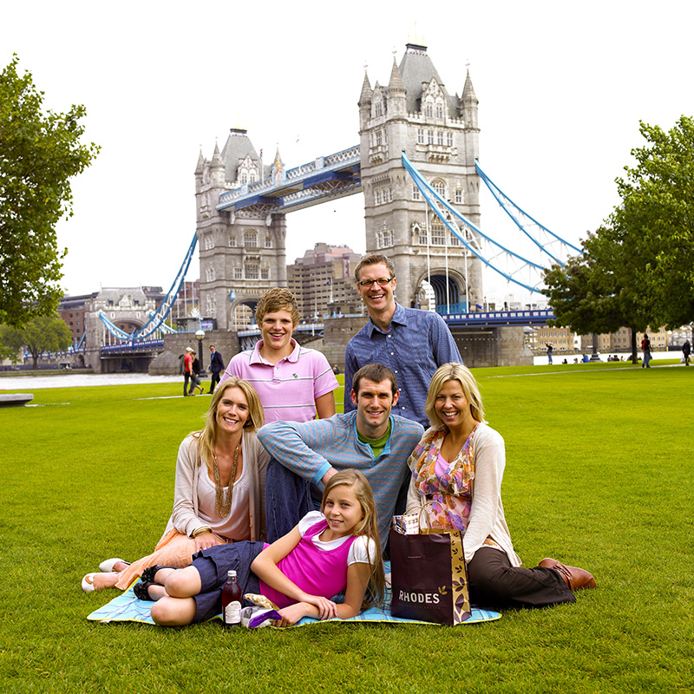
Theme: Identity and culture
Photo 5 (Topic: Daily life)

Theme: Identity and culture
Photo 6 (Topic: Cultural life)

Theme: Identity and culture
Photo 7 (Topic: Cultural life)

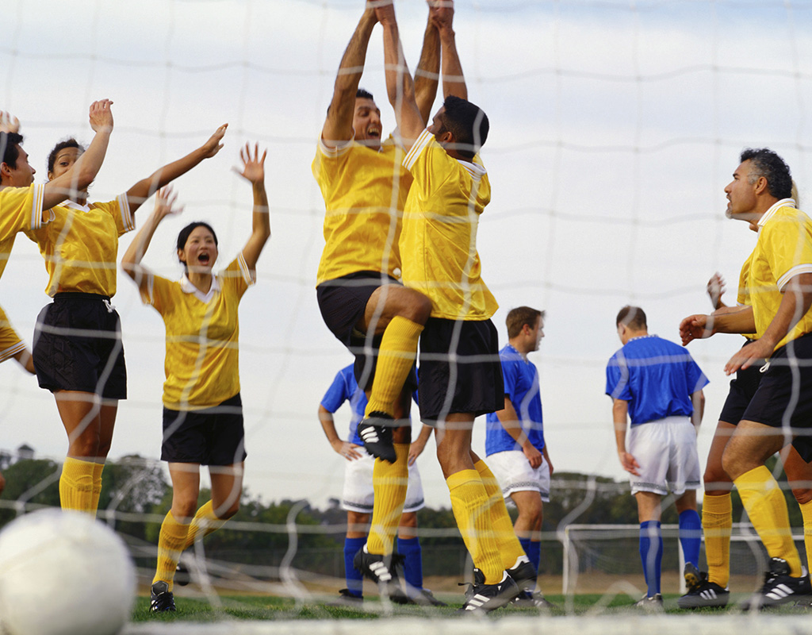
Theme: Identity and culture
Photo 8 (Topic: Cultural life)

Theme: Local area, holiday and travel
Photo 9 (Topic: Holidays)

Theme: Local area, holiday and travel
Photo 10 (Topic: Holidays)

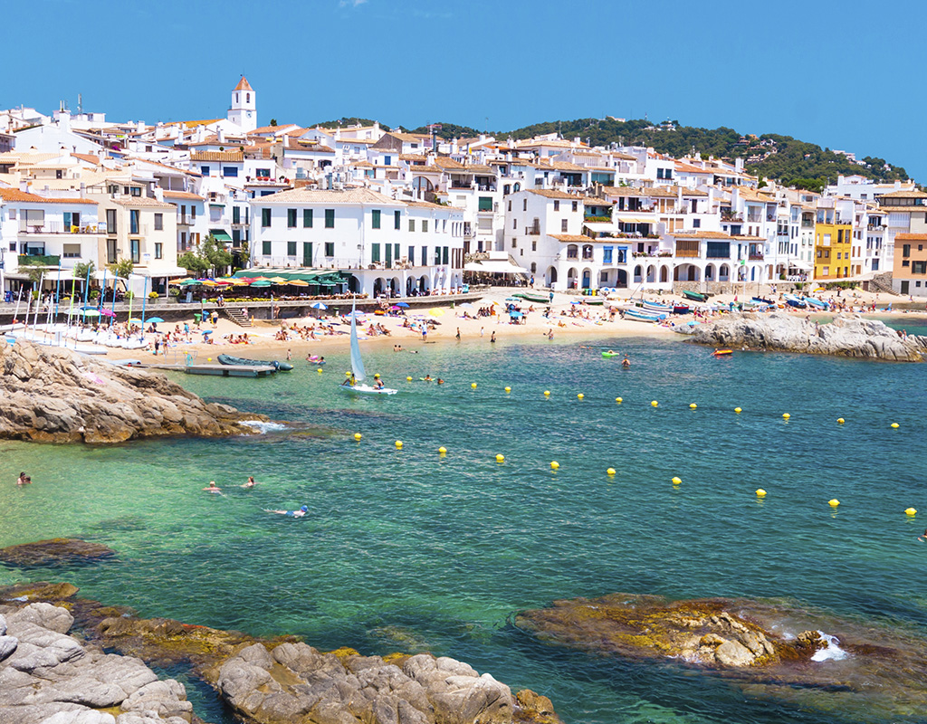
Theme: Local area, holiday and travel
Photo 11 (Topic: Holidays)

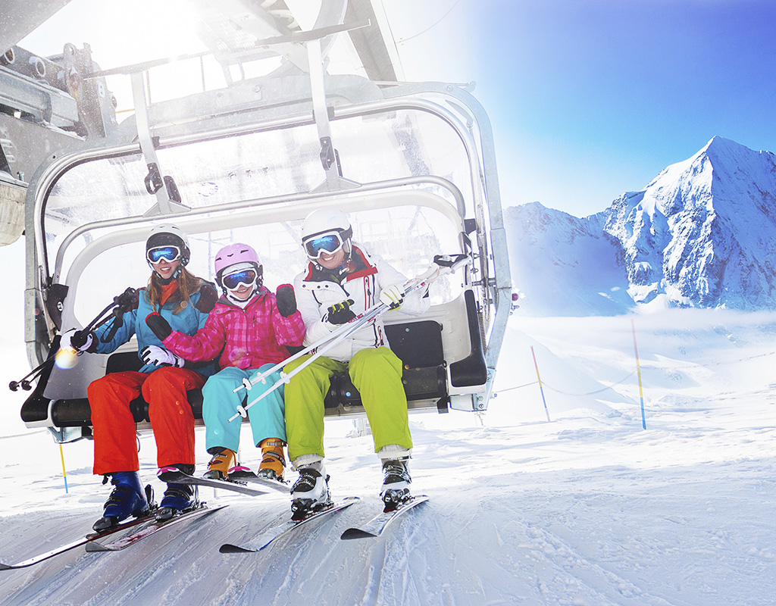
Theme: Local area, holiday and travel
Photo 12 (Topic: Town, region and country)

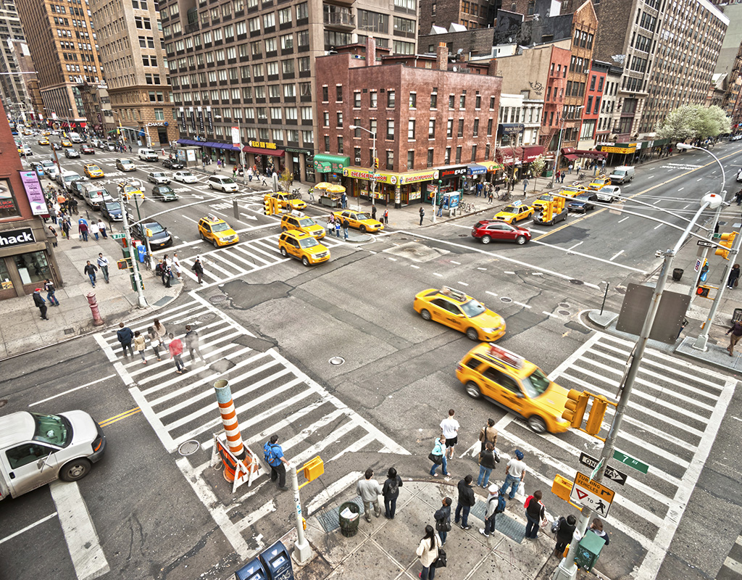
Theme: School
Photo 13 (Topic: What school is like)

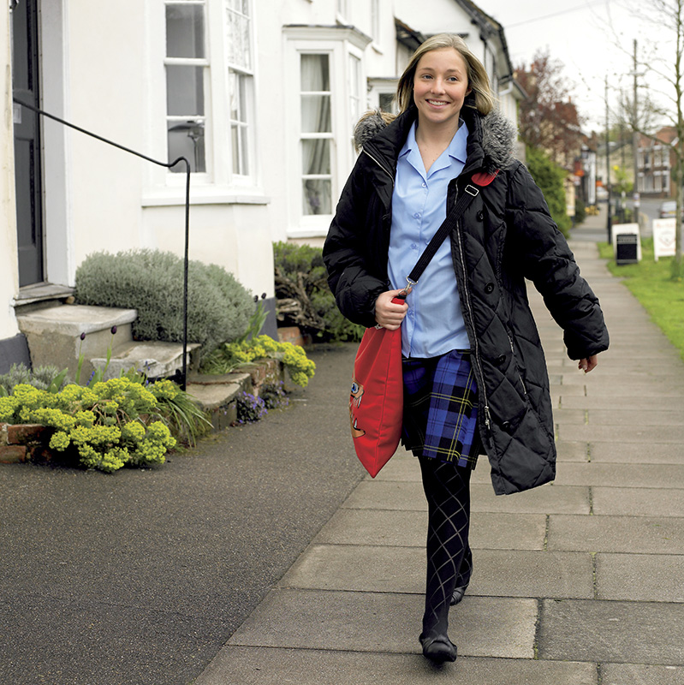
Theme: School
Photo 14 (Topic: What school is like)

Theme: School
Photo 15 (Topic: School activities)

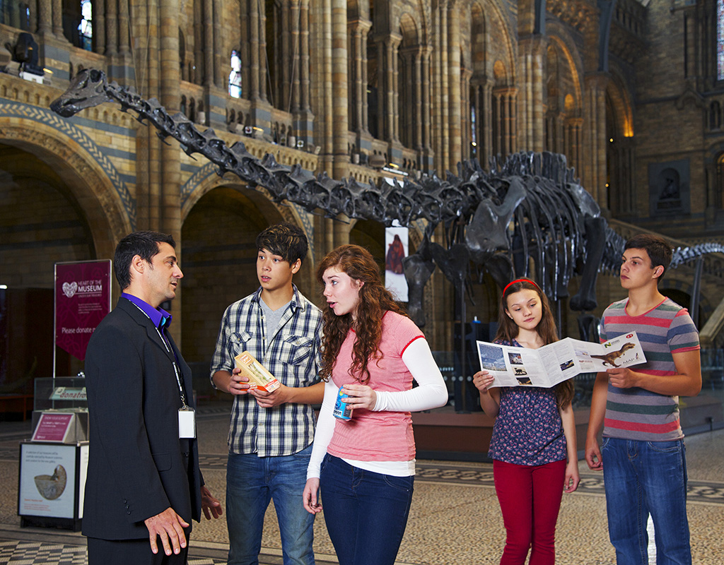
Theme: Future aspirations, study and work
Photo 16 (Topic: Using languages beyond the classroom)

Theme: Future aspirations, study and work
Photo 17 (Topic: Ambitions)

Theme: Future aspirations, study and work
Photo 18 (Topic: Work)

Theme: International and global dimension
Photo 19 (Topic: Bringing the world together)

Theme: International and global dimension
Photo 20 (Topic: Environmental issues)

