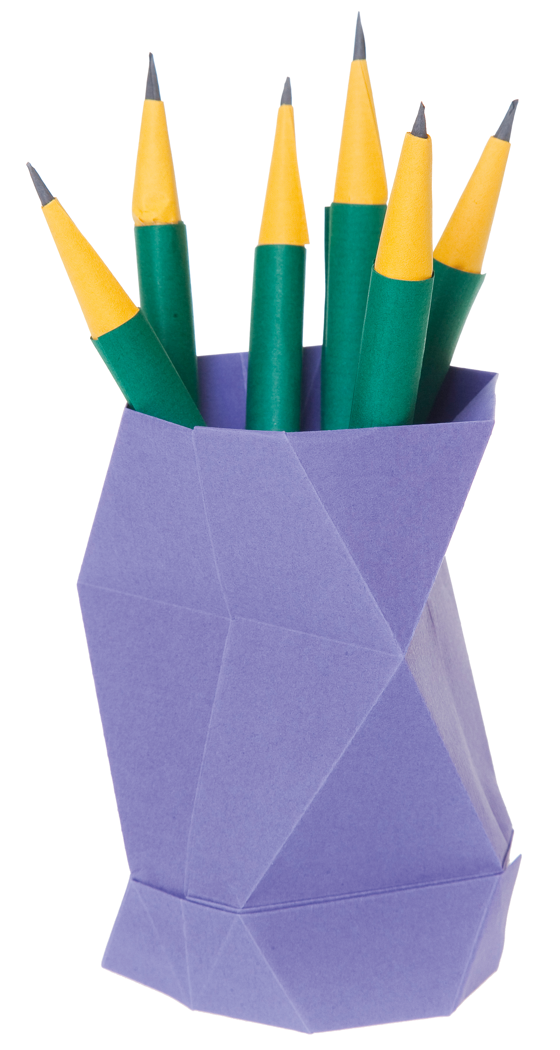


Top Ten Resources
by Julie Hughes
GCSE (9-1)
English Language
© artwork: Mark Bolitho | Origami photography Pearson Education Ltd/Naki Kouyioumtzis

Contents

Resource number | Notes | Page
1 | ‘Crunch it’ magic threes worksheet. Useful for any fiction or non-fiction text. Drop in a short extract and use it to prepare students for an AO2 answer. Try to keep questions/tasks in multiples of three [with three being the minimum achievement required] to aid differentiation and to stop the task being too daunting for weaker students. Keep the number of feature spotting questions in the ‘find it’ section to a minimum – extend once they are used to this style of task by asking questions that require students to think deeply and read carefully | 4
2a | ‘Four corners’. A very adaptable resource. Drop any text into the box and use it in the classroom or as a homework. ‘Draw it’ sounds simple but is very useful for prompting discussion of different reader responses to texts as each student will focus on a different part of the text according to their background/likes/viewpoint, etc. | 5
2b | A more detailed and sophisticated version of resource 2 that is useful to show students how reading can be a springboard into a writing task. | 6
3 | Self-explanatory project tasks. Ideal for online learning, homework or cover lessons. Works well for KS3. | 7
4 | ‘Beat the expert’. Most suitable for higher ability. Use three or four paragraphs of any article and summarise the idea of each paragraph in a bullet point. The students then write the article and compare their version with that of the expert. Ideal as a way to demonstrate evaluation skills, as well being useful for writing.  Extension: give students one of two student exemplars. Get them to summarise as for ‘beat the expert’ and give their summary to a partner to write up. AND/OR, get them to list the most impressive language/structure techniques in the exemplar and ask the partner to use them in their answer. | 8
5 | ‘Because, but, so’. An idea from a book called ‘The Writing Revolution’. Originally intended to develop students’ own ideas it is useful as an analytical tool as it necessitates careful reading and full understanding of a writer’s perspective.  Alternative idea for KS3:  Find interesting first lines to novels [Young Adult novels are particularly suitable] and ask students to extend them into three new sentences using ‘because, but, so’. | 9
6 | Genre swap. Find an interesting, enigmatic, or amusing line from a text and use it as a springboard for experimenting with format and tone. Works best if students don’t see the original first so they have no preconceived generic ideas. The original text can then be analysed. This works well with higher ability students as a way of moving them away from rigid and restrictive ‘GAP’ formulas for transactional writing. | 10
7 | Structure made easy. This uses a text from the anthology for GCSE Language 2.0 [The Hunger Games], but any short story or novel opening with alternate description/action/dialogue paragraphs would work. Before introducing or revising more complex structural concepts like sentence types/styles and punctuation, this activity prompts students to think about the way the order of narration is used to create atmosphere and introduce character.  Extension: This makes an ideal introduction to creative writing. One idea is to take the opening sentence to each paragraph section and get students to build it up into a short story, perhaps changing the genre as an additional challenge. | 11
8 | Evaluation through images. One feature of more developed evaluation answers is the ability to consider alternative reader responses. Use a selection of images on a particular topic and come up with questions that prompt students to consider a variety of viewer responses. Students also find it easier to evaluate images and writing two or three paragraphs in response to an image prompt can build confidence and create model paragraphs that can be followed when evaluating more complex material. | 12
9 | Model paragraphs – these can be written for any exam question and are an ideal way of providing students with an exemplar to follow. Students can match up the criteria with the appropriate part of the response and then perhaps write the next paragraph. The first also has analytical words missing for students to complete. | 13
10 | ‘Story mining’ – whilst listening to a short story [listening works better than reading sometimes, as they are required to concentrate!] ask students to complete a table of techniques or vocabulary that they would like to use in a story of their own. This table is divided into ‘language’, ‘openings’ and ‘wows’, but any categories can be used.  Alternative: mine the best of the language/techniques in advance and provide students with the table only. Give them a brief summary of the plot and ask them to create the story using the techniques/words on the grid. Evaluate their own version against the original.  Challenge: for higher ability students, use two stories and give one of each to pairs of students, then ask them to ‘mine’ for their partner and write a brief synopsis of the plot. This is then given to the partner, who writes the story using the synopsis and the ‘mined’ techniques and vocabulary. They can then evaluate their stories against the originals. | 14

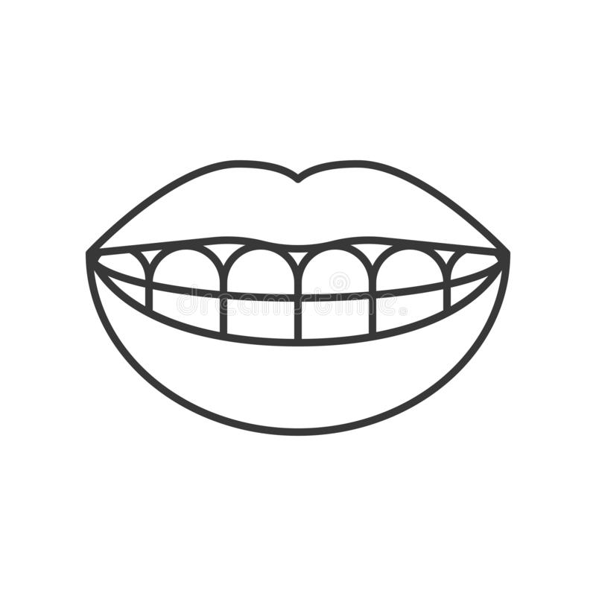
Crunch the article – find the 9 juiciest words
Resource 1
FIND :

- An example of the writer using humour.

- An example of the writer using hyperbole.

- Three action verbs used to emphasise the writer’s ideas.

Summarise
Drivers of hansoms have various ways of inflicting torture on a fellow-creature, one of which is to suddenly and loudly to shout out 'Hi!' when they have ample room to pass, or when you are only occupying your lawful position in a string of vehicles. Also, they love to share your handle-bars and wheels, passing so close that if you swerve in the slightest - which, if you are possessed of nerves, you are likely to do - it must bring you to serious grief. They are also fond of cutting in just in front of you, or deliberately checking you at a crossing, well knowing that by so doing they risk your life, or, at any rate, force you to get off.
I myself always ride peaceably about seven or eight miles an hour, and keep a good look-out some way ahead, as by that means you can often slip through a tight place or avoid being made into a sandwich composed of, let us say, a pedestrian who will not, and an omnibus which cannot, stop.

[From: a C19th text about cycling]
Reduce the writer’s perspective to:
Nine words

Six

Three
Summarise the text in 3 sentences
Resource 2a
Draw it | Find it  The appearance presented by the streets of London an hour before sunrise, on a summer’s morning, is most striking even to the few whose unfortunate pursuits of pleasure, or scarcely less unfortunate pursuits of business, cause them to be well acquainted with the scene. There is an air of cold, solitary desolation about the noiseless streets which we are accustomed to see thronged at other times by a busy, eager crowd, and over the quiet, closely-shut buildings, which throughout the day are swarming with life and bustle, that is  very impressive.  An hour wears away; the spires of the churches and roofs of the principal buildings are faintly tinged with the light of the rising sun; and the streets, by almost imperceptible degrees, begin to resume their bustle and animation. Market-carts roll slowly along: the sleepy waggoner impatiently urging on his tired horses, or vainly endeavouring to awaken the boy, who, luxuriously stretched on the top of the fruit-baskets, forgets,  in happy oblivion, his long-cherished curiosity to behold the wonders of London.
Transform it | Summarise it in three sentences

Correct it – Re-write, correcting any spelling, punctuation, and grammar mistakes. | Respond to it – imagine you are the Manager of the Hotel, what would your response be?  I’d rather sleep on the street!  No stars for this dump!! This is the worst plase I have ever stayd in I found a cats paw in my pillow case. Also the chest of draw with no draws in thema a cupboard with no back a double bed like a hammock made of lead. Communial toilets with no lock. It was like Alcatraz and staffed by monkeys.
Follow-it – imagine you stayed in the  hotel the following week, what was your  stay like? | Analyse it – find three interesting points to make about the language and structure.
Resource 2b
Resource 3

Create a dream island or planet that would appeal to teenagers  - write the brochure for it  - review it  - write a travel article about it  - make a model of it | Design a new school  - write a report explaining why it is necessary  - be a potential student and apply to go to the school  - write a newspaper article about it  - make a model of it
Invent a new revision product for home schooled teenagers  - write the sales pitch for it  - review it  - write a newspaper article about it  - make a model of it | Launch an exercise regime for lazy teenagers  - create a persona to be the figure head  - write the text for the website  - make a mock-up of the website  - write a celebrity review of it

Resource 4

BEAT AN EXPERT
You are going to read an article about the benefits of side lighting. In the article Caitlin Moran bemoans the following:
- that she lights many lamps in her house to create warmth, but her family don’t notice
- that only she ever turns them on; the rest of the family use harsh overhead lights
- that it takes her a long time to turn 15 different lamps on and off every day
- that all she wants is for them all to live in flattering lighting
The article is tongue in cheek.

Rewrite one of the paragraphs.

https://www.thetimes.co.uk/article/caitlin-moran-my-domestic-martyrdom-cxz55cqk6
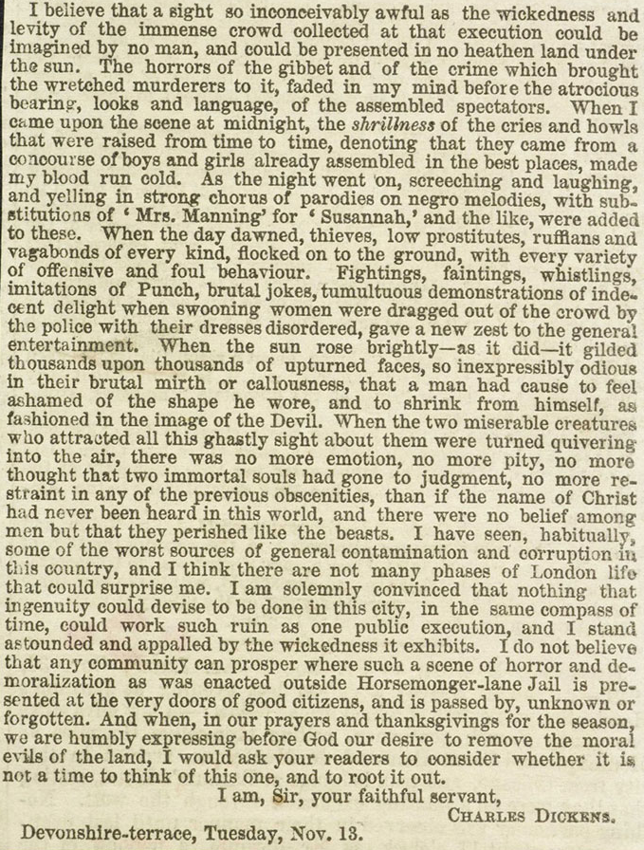
Resource 5

The author believes public executions should be stopped/banned/ended/...
because [what is his perspective?]
but [who might disagree, and why?]
so [what response does Dickens want from the reader?]

Resource 6

Genre swap
The girls I employed as ‘au pairs’ experienced another country, made new friends and went back home fluent in English; I got my ironing done and our children learnt to say ‘I don’t like peas’ in a variety of different languages.

Write the next paragraph as a review

Or an article

Or a letter of application

Resource 7
For a while I stand staring out of the train window, wishing I could open it again, but unsure of what would happen at such high speed. In the distance, I see the lights of another district. Seven? Ten? I don’t know. I think about the people in their houses, settling in for bed. I imagine my home, with its shutters drawn tight. What are they doing now, my mother and Prim? Were they able to eat supper? The fish stew and the strawberries? Or did it lie untouched on their plates? Did they watch the recap of the day’s events on the battered old TV that sits on the table against the wall? Surely, there were more tears. Is my mother holding up, being strong for Prim? Or has she already started to slip away, leaving the weight of the world on my sister’s fragile shoulders?

Structure – read each section carefully, then number them, using the white space to justify your ideas.

Prim will undoubtedly sleep with my mother tonight. The thought of that scruffy old Buttercup posting himself on the bed to watch over Prim comforts me. If she cries, he will nose his way into her arms and curl up there until she calms down and falls asleep. I’m so glad I didn’t drown him.

So I let the train rock me into oblivion.

If I’m going to cry, now is the time to do it. By morning, I’ll be able to wash the damage done by the tears from my face. But no tears come. I’m too tired or too numb to cry. The only thing I feel is a desire to be somewhere else. So I let the train rock me into oblivion.

Imagining my home makes me ache with loneliness. This day has been endless. Could Gale and I have been eating blackberries only this morning? It seems like a lifetime ago. Like a long dream that deteriorated into a nightmare. Maybe, if I go to sleep, I will wake up back in District 12, where I belong.

Probably the drawers hold any number of nightgowns, but I just strip off my shirt and trousers and climb into bed in my underwear. The sheets are made of soft, silky fabric. A thick, fluffy quilt gives immediate warmth.

Resource 8


Which image:

- Most closely resembles your perspective about school?
- Would your parents feel is most like your life at school?
- Would be most likely to be used in a government ‘return to school’ advertisement?
- Would be most likely to encourage mature learners back into the classroom?

Select one of the images and use it to answer the following question:

The photographer has attempted to engage the viewer through a description of a school setting.

Evaluate how successfully this is achieved.

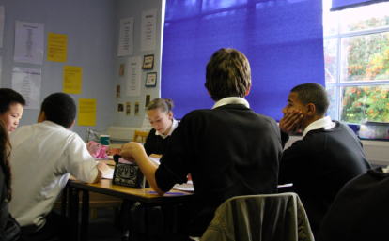



Resource 9
 |  | Compare how the pictures present ideas and perspectives about beach life.
Evidence from text A | Both photographers have chosen to present ideas about life on the beach. However, their perspectives are very different. For instance, picture 1 suggests the photographer thinks living near to beaches can be dangerous, as the house shown is sliding into the sea. In contrast, the photographer of picture 2 probably thinks living on the beach is calm and peaceful as he/she has chosen to focus on a man snoozing in a hammock right at the centre of an otherwise deserted beach. |  | Clear comparison of ideas and perspectives
Evidence from text B |  |  | Clear comparison of language and structure
Comparative connectives |  |  | Clear comparison of language and structure
In this extract, the writer tries to persuade his wife to join him in Australia.
How successful is he?
You must understand that there are not public houses allowed in or near the diggings―within five miles; but refreshment tents for the sale of lemonade, etc, for which is charged 6d. per half pint glass. There is a great deal of it drunk here; and the profits on the sale of it are very great; and I propose putting you into business in the above line, and I have no doubt our joint efforts will be productive of great benefit to us.

Refer to the question | The extract is ________ as the writer stresses that there are no public houses locally, which _______ that the area is safe for a family. ‘Refreshment tents’ sound much more family friendly than ‘public houses’, which makes the suggestion that his wife run one sound ________. ________, his wife might not be persuaded by the phrase ‘putting you into business’ as it suggests she will have little _______ in the matter. | Use a specific reference from the text
Analyse the writer’s ideas |  | Make a judgement about the text based on how readers will feel.

Resource 10
Picture this: a girl, cowering under a window in the half-light of a winter evening. Inside the window, a party is in full swing; coloured lights flicker and loud music throbs. Outside, the girl lifts her head for one more peek, then shuffles slowly away, shoulders hunched and feet dragging. Left out.

Feeling sorry for her? You should. There’s one in every school – and at my school it was me. I have no idea why, but I never quite made it into any of the exclusive school circles. I didn’t feel that different but I spent most of my time roaming the corridors alone.

Then, when I was fourteen, I met Sammy. My polar opposite – where I was short and clumsy, Sammy was slender and graceful. I’m not quite sure what she saw in me, but for two years we were inseparable.

Then Stella came along.

Words | Openings | Wows
cowering | outside | - and at my school…
flicker | Feeling | Left out.
hunched | Picture | Then...

