GCSE Business
Theme 1.4.1 – the options for start-up and small business

Booster Booklet
Specification

Subject content | What students need to learn:
- The options for start-up and small business  The concept of limited liability:  - limited and unlimited liability  - the implications for the business owner(s) of limited and unlimited liability  The types of business ownership for start-ups:  - sole trader, partnership, private limited company  - the advantages and disadvantages of each type of business ownership  The option for starting up and running a franchise operation:  - the advantages and disadvantages of franchising | This is the first booklet in Topic 1.4 – ‘Making the business effective’. This booklet examines the options for business start-up, and the considerations that entrepreneurs need to make when starting a business.  Students need to understand the difference between limited liability and unlimited liability, and to appreciate how these concepts can impact on a business.  Another key focus is the different types of business ownership, from sole trader to partnership to private limited company. One of the key features of these different structures is the idea of liability. Sole traders have unlimited liability, whilst owners of a private limited company have limited liability. The advantages and disadvantages of different types of business will be considered.  Students will also learn about franchise as an option for a business start-up, and will understand the advantages and disadvanatges of this model.

Key terms in this topic:

- Franchise – when one business gives another business permission to trade using its name and products in return for a fee and share of its products.
- Franchisee – an entrepreneur who pays a fee to trade using the name and products of an established business.
- Franchisor – an established business that gives permission to an entrepreneur to trade using its name and products.
- Limited liability - where the level of risk is limited to the amount of money that has been invested in the business or promised as an investment.
- Partnership – a business that is owned by a group of two or more people who share the financial risk, the decision-making and the profits.

- Private limited company - an incorporated business that is owned by shareholders who have limited liability. Shares are not traded on a public stock exchange.
- Sole trader – a type of unincorporated business that is owned by one person and who has unlimited liability.
- Unlimited liability – where the level of risk goes beyond the amount invested in a business, so the personal assets of the business owner can be used to pay off the business’s debts.

Key terms – examples
In the space below, write examples to illustrate the key terms:

Key term | Examples
Franchise
Franchisee

Franchisor

Limited liability
Partnership
Private limited company
Sole trader

Unlimited liability

Summary of the topic
The aim of this topic is to provide an insight into some key decisions for small businesses. In addition to the options for the type of ownership, the topic explores issues around business location, the marketing mix and business planning. All of these topics provide plentiful opportunities to use real-life examples.
Decisions taken regarding business start-up are important and can affect how the business performs. This booklet explores the importance of limited and unlimited liability and need to recognise the types of business organisation that each apply to. Limited liability significantly reduces the risk faced by owners, which may help the business in raising finance; for example, through a bank loan. The advantages and disadvantages of different types of business structure - sole trader, partnership and private limited companies – will be examined.

Franchise will be explored as a method of starting a new business. The terms franchisor and franchisee – a franchisee buys the right from a franchisor to use the business idea – will be used, and the advantages and disadvantages of franchise as an option for starting up a

business will be examined. You are encouraged to research this topic to identify franchise opportunities by using a franchise directory, such as www.franchisedirect.co.uk, to identify some of the costs, support and conditions connected to different franchise opportunities.

Synoptic links to this topic

This topic links with the following areas of the specification:

- 1.1.1 The dynamic nature of business
- 1.1.2 Risk and reward
- 1.1.3 The role of business enterprise

This topic has direct links with many areas of the specification and is a foundation for the whole course. All small businesses emerge from business ideas by entrepreneurs, and the entrepreneurship they demonstrate. When investigating the topics in Theme 1 you will explore the issues and skills involved in starting and running a small business.

Case study: Norther Tea Merchants… Local image but case study unchanged…

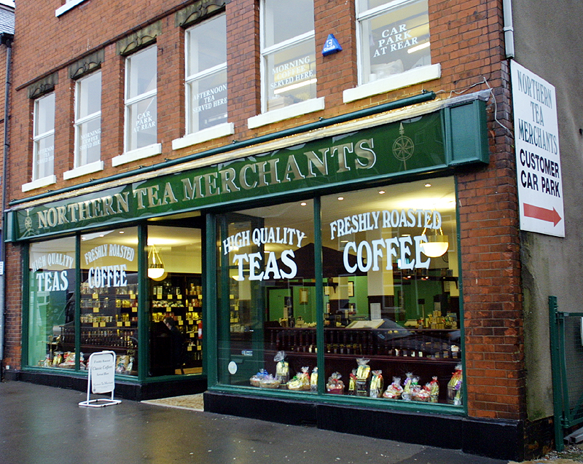

Eva has worked as a barista in a cafe for the past 2 years. She is now thinking of opening a small coffee shop in Manchester. She has looked at premises in the city centre, close to the train station, but rents are very expensive. There is also lots of competition from big coffee
shop chains such as Costa Coffee and Starbucks. Eva is therefore thinking of starting her business as a franchise operation, rather than as a sole trader.

With an investment of £5 000 Eva could start a ‘Coffee Bike’ franchise. This is a mobile coffee franchise where coffee is freshly made and sold from an adapted bicycle. The

franchisor would provide Eva with the bike and all equipment, as well as all the necessary training. Eva regards this option as less risky than starting as a sole trader or a partnership with friends.

Source: Adapted from Edexcel GCSE textbook p95

How this case study illustrates/exemplifies the specification content:
The case study illustrates ‘The options for start-up and small business and’ in a number of ways:
- Eva is an entrepreneur looking at different options for starting her own business.
- There are different options for starting up a new business. In the case study the options Eva considered are sole trader, partnership and franchise.
- There are some risks associated with starting a new business. For example, high levels of competition in the city centre.
- There are some advantages and disadvantages of starting a new business as a. franchise.

Check your knowledge:

- Give two advantages of starting a business as a franchise.
- State one advantage and one disadvantage of starting a business as a sole trader.
- What is meant by limited liability?

Check your knowledge: recall question (previous unit):

- What are two examples of short-term sources of finance?
- Give one advantage for a business of suing share capital as a source of finance.
- Give one disadvantage for a business of using crowd funding as a source of finance.

Activity - now try this

Identify 2 advantages and disadvantages of starting a new business for each of the 4 business types shown in the table below. The list below provides options (note that some can be used in more than one business type).

- Training and guidance provided
- Owner have unlimited liability
- Owner retains all profits
- Owners can share ideas and expertise

- The entrepreneur needs to pay a fee and share of the profits for the licence
- Owners have limited liability
- Risk is shared between partners
- Business’s financial information is published and available to the public
- Training is provided by the franchisor
- Quick and easy to set up
- Difficult to raise finance
- Limited companies more complex to set up than sole trader/partnership
- Profits are shared by all partners
- Finance can be raised by selling shares
- Franchise licences can be very expensive

 | Advantages | Disadvantages
Sole trader | 2. | 2.
Partnership | 2. | 1.  2.
Private Limited Company | 2. | 2.
Franchise | 1.  2. | 2.

Command Word corner: ‘State’

The booklet at the start of each topic will focus on a command word that is used in the exam. This will provide students with information on how the word is used in the exam and what you can expect. It will offer you advice on how to structure your answer and what examiners are looking for when marking these questions.

‘State’ questions

- Always worth 1 mark
- Designed to test Application (AO2)
- State questions appear in Sections B and C and are linked to the case study.
- State questions typically ask for one ‘benefit’, ‘way’, ‘method’, impact’, etc.

- To gain one mark, the response must be linked to case study. For example, consider the following question: ‘State one variable cost for Eva’s coffee shop’. The answer must be

in the context of this business. ‘Electricity’ would not be awarded 1 mark. ‘Coffee beans’ would be awarded 1 mark. Can you see why?

What have you remembered so far?

Question | True | False
A sole trader has limited liability.

A franchisor provides permission for another business to trade under its name.
A partnership has unlimited liability.

Exam Questions

- Multiple choice

Which one of the following is a characteristic of a private limited company? (1 mark)

Select one answer

A Can sell shares to anyone
B Have one single owner
C Owners have limited liability
D Shareholders work for the business

- Explain one benefit to an entrepreneur of starting a business as a sole trader. (3 marks)

- State one disadvantage of starting a business as a partnership. (1 mark)

- Outline one way that Eva meets customer needs. (2 marks)

- Analyse the impact on Eva of starting her business as a franchise. (6 marks)

