

Edexcel GCSE (9-1)
Astronomy 2017

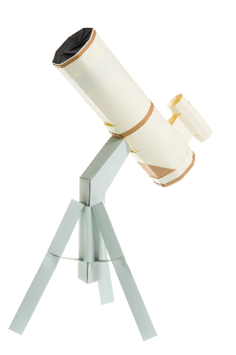

Question bank

To help complement the Specimen Assessment Materials, and provide teachers with some additional examination questions, we have produced a question bank.

The question bank consists of questions taken from GCSE Astronomy papers which were sat in June 2007, June 2008, June 2009 and June 2010.

Each question paper has been split up into individual questions, which you can access as either a pdf or a Word document.

In the zipped folder, along with the exam questions and a mark scheme, there is a Mapping Grid (the Excel file). This file shows how the questions from the 2007 – 2010 papers map to Topics in the new 2017 GCSE specification.

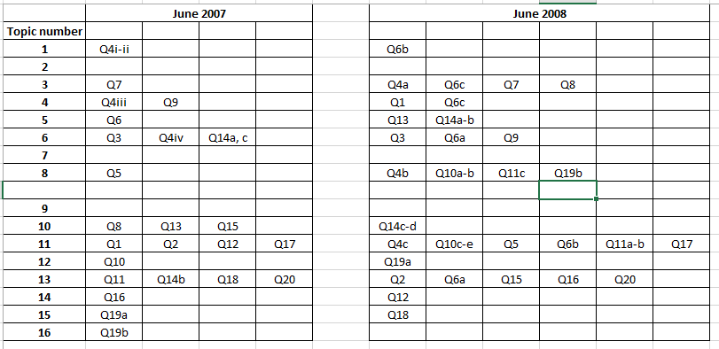

For example, if you want questions covering Topic 5, then you can use Q6 from the June 2007 paper, as well as Q13 and Q14a-b from the June 2008 paper.

Note that, in most cases, the mapping gives a “best fit” to a Topic – so that, in some cases, there may be a part of the question that is “out of Topic”, but this may help with synoptic assessment!

