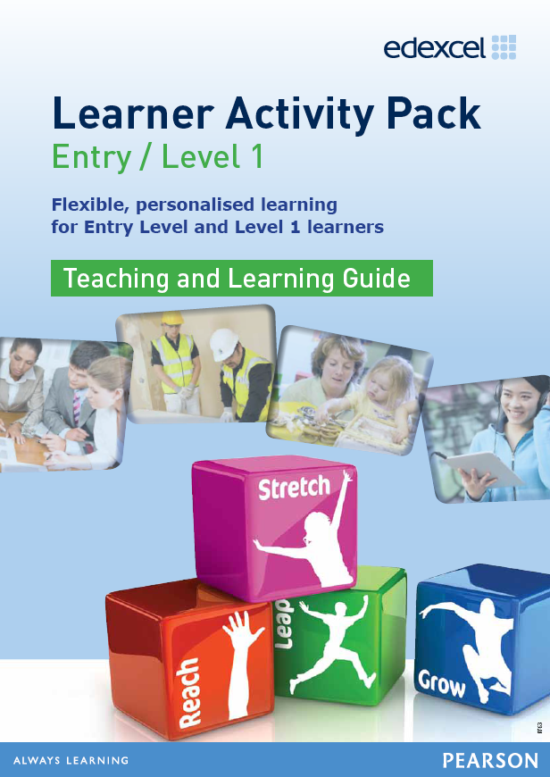
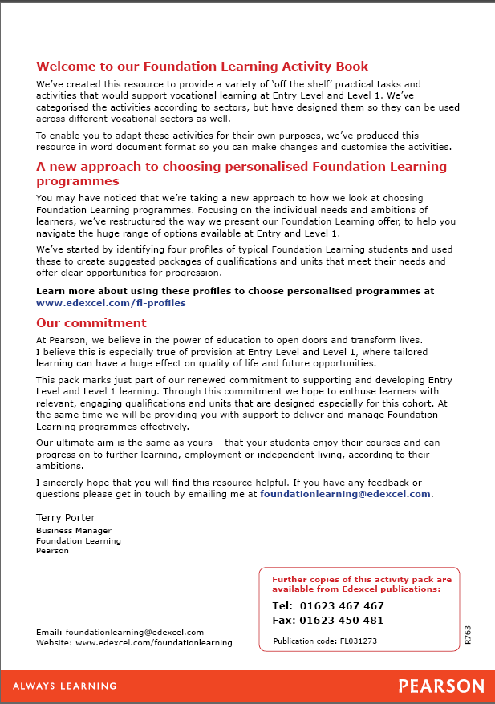
Contents

Activity Page no
Health & Social Care
Researching a topic on the internet (Learner Activity Pack page 7) - 5 -
Working with others in Health and Social care (Learner Activity Pack page 9) - 7 -
Childcare
Researching a topic on the internet – caring for children and young people (Learner Activity Pack page 13) 9
A day out with the children (Learner Activity Pack page 15) 11
Sport & Leisure
Making your case (Learner Activity Pack page 19) 13
Making the best use of space (Learner Activity Pack page 23) 15
Rules and regulations (Learner Activity Pack page 27) 19
What the customer thinks (Learner Activity Pack page 29) 20
Sports Centre Activities (Learner Activity Pack page 35) 23
Construction
Basic woodworking (Learner Activity Pack page 41) 27
Engineering
Bridge structures (Learner Activity Pack page 49) 31
Basic metal working (Learner Activity Pack page 61) 32
Car crash (Learner Activity Pack page 67) 36
Hair & Beauty
Planning time (Learner Activity Pack page 75) 37
Making Money (Learner Activity Pack page 79) 39
Land Based
Recycling (Learner Activity Pack page 87) 42
Well groomed (Learner Activity pack page 91) 44
Saddle up and ride your pony! (Learner Activity Pack page 95) 47
Animal needs (Learner Activity Pack page 99) 49
Healthy calves (Learner Activity Pack page 103) 52
Farm animal families (Learner Activity Pack page 105) 54
Does your animal need the vet? (Learner Activity Pack page 121) 57
Planning a visit (Learner Activity Sheet page 125) 59
Feeding time (Learner Activity Sheet page 129) 61
Move it! (Learner Activity Pack page 131) 64
Planting bulbs (Learner Activity Pack page 135) 67
Plant it (Learner activity Pack page 139) 69
Soil (Learner activity Pack page 143) 71
Health & Safety
Hazards in the workplace (Learner Activity Pack page 151) 73
Health and safety signs (Learner Activity Pack page 153) 75
It’s a risky business (Learner Activity Pack page 155) 77
Employment
What rights do you have at work? (Learner Activity Pack page 171) 79
You’re hired (Learner Activity Pack page 175) 82
Getting there on time (Learner Activity pack page 181) 86
Planning a trip (Learner Activity Pack page 187) 91
Job skills (Learner Activity Pack page 189) 93
Preparing for a job interview (Learner Activity Pack page 195) 97
Job hunting (Learner Activity Pack page 199) 99
Product Design/Business
Department names (Learner Activity Pack page 203) 102
Getting the right brand (Learner Activity Pack page 205) 105
Corporate Identity (Learner Activity Pack page 215) 107
Product analysis (Learner Activity Pack page 219) 109
Design specifications (Learner Activity Pack page 221) 110
Batch production (Learner Activity Pack page 223) 111
Industry sectors (Learner Activity Pack page 229) 113
Advertising your products (Learner Activity Pack page 233) 116
Designing a supermarket (Learner Activity Pack page 239) 120
Quality (Learner Activity Pack page 241) 123

Health and Social Care
Researching a topic on the internet (Learner Activity Pack page 7)
Description of the activity/task
The aim of this activity is for learners to undertake online research on types of social care and summarise the information found.
Level
Level 1
Time needed to complete task(s)
Approximately 45-60 minutes
Prior learning
n/a
Resources needed
Learner activity sheet, Resource sheet (information table)
Tutor note
Learners should start by looking at what services are available in their local area. Learners should be able to identify different types of care e.g. sheltered housing, care at home, (domiciliary care) care homes with/without nursing care, etc. Learners may not be able to find specific costs for care at home because this will vary according to individual circumstances.

For the homecare option, learners should be able to list some of the different services available e.g. assistance with bathing/washing, preparing meals, assistance with medication, etc.
Answers
No set answers, however, learners should have conducted suitable internet searches to identify the support available in the area. Summary information should be in the learners’ own words and not copied.

Some examples are provided for reference.
Links to other skills development
English – Read and extract information, summarise information
Maths – Perform calculations
ICT – Use search engines

This activity can also be used to explore care options for an elderly pet (Land Based)
Follow-up / adaptation
Learners could:
- Use an online glossary to complete a residential care crossword
- Create a fact sheet on local residential care
- Discuss pros and cons of different types of care
Task 1 – (example answers in bold)

 | Internet address | Summary of information
Types of elderly support | United Kingdom Homecare Association  020 8661 8188 | UKHCA is a national membership organisation for providers of care services. It provides a list of registered home care providers
Types of elderly support | www.payingforcare.co.uk | Lists different types of social care
Places to get more information (including telephone number of your local social services) | Plymouth City Council Adult Social Care  01752 668000  http://www.plymouth.gov.uk/support_at_home_contributions.pdf | Provides information on council funded services and links to other care agencies who provide support
Examples of costs per week for home care | www.lewishammylifemychoice.org.uk | Costs will depend on individual circumstances. This website provides a home care calculator to work out the cost of care at home.
Examples of costs per week for residential care | www.payingforcare.co.uk | Annual cost of care in London 2011-12 = £44,200 i.e. £850 per week  (Source: Laing & Buisson, Care of Elderly People Report 2011/12)

Health and Social Care
Working with others in Health and Social care
(Learner Activity Pack page 9)
Description of the activity/task
The aim of this activity is for learners to discuss a social care case study with a partner, and then take part in a whole class discussion on the subject.
Level
Entry 3/Level 1
Time needed to complete task(s)
Approximately 25 minutes depending on the class size:
Paired discussion - allow 10 minutes
Small group discussion - allow 10 minutes (each pair to share ideas with another pair)
Whole group discussion led by tutor - allow 15 minutes
Prior learning
n/a
Resources needed
Learner activity sheet (case study), Discussion planner
Tutor note
The case study is about an elderly man in residential care. His relatives are concerned about his well-being and bring their concerns to the care assistant. Learners must assume the role of the care assistant and have a discussion to decide how to address the family’s concerns.

The discussion planner resource sheet is to help learners capture discussion points and can be recreated on flipchart paper so that the learners could stick them up on the walls and use them to feed back to the whole group.
Answers
There are no set answers, but learners should base their discussion on the facts provided in the case study, along with any personal experiences they feel safe to share, and/or anything theoretical they may have learned. The tutor led-discussion should pick up on the key points made. These could include:
- Reassuring the family that Mr Hall will be well taken care of, that their concerns about his health and wellbeing will be closely monitored and they will be kept informed on his development, etc.
- Letting the family know that the care manager will be informed of their concerns and she will take whatever action is considered necessary (e.g. calling in the GP)
- Making sure that Mr Hall’s shirt is changed straight away
Links to other skills development
English – Take part in discussions

This activity can be used to discuss issues/concerns involving a child in a nursery setting (Childcare)
Follow-up / adaptation
Learners could:
- Write a meeting log or diary entry for the care manager

Resource sheet - Use the table below to record the main thoughts from the discussion with your partner and use it to prepare your notes for a whole class discussion

 | What should Lucy take into consideration before responding to each concern? | What should Lucy say to the family members? | What should Lucy do straight away? | What should Lucy report to her manager?
Mr Henry appears confused and doesn’t seem to remember things that were talked about a few minutes before.
His shirt has stains down the front. Lucy noticed that he spilt some of his lunch whilst eating earlier.
He seems depressed to his relatives.

Childcare
Researching a topic on the internet – caring for children and young people (Learner Activity Pack page 13)
Description of the activity/task
The aim of this activity is for learners to undertake online research on childcare options and summarise the information found.
Level
Level 1
Time needed to complete task(s)
Approximately 45-60 minutes
Prior learning
Basic childcare theory is helpful but not essential
Resources needed
Learner activity sheet, Resource sheet (summary table)
Tutor note
Learners should start by looking at what childcare options are available in their local area. Learners should be able to identify different types of childcare e.g. nannies, childminders, day nurseries, etc. Learners may not be able to find specific costs for care at home because this will vary according to individual circumstances.
Answers
No set answers, however, learners should have conducted suitable internet searches to identify the childcare options available. Summary information should be in the learners own words and not copied.
Links to other skills development
English – Read and extract information, summarise information
Maths – Perform calculations/conversions (e.g. cost per week)
ICT – Use search engines

This activity can also be used to explore fitness options e.g. personal trainer, gym, self, etc. (Sport & Leisure)
Follow-up / adaptation
Learners could:
- Complete a childcare crossword
- Create a frequently asked questions (FAQ) sheet on childcare
- Discuss pros and cons of different types of childcare
- Use a range of scenarios to make recommendations for appropriate childcare
- Create a flyer to promote the range of childcare options

Task 1 (example answers in bold)

 | Internet address | Summary of information
Types of childcare | NI Direct Government Services  http://www.nidirect.gov.uk/types-of-childcare | Government agency in Northern Ireland. It lists and explains 6 different childcare options: childminders; nannies; day nurseries; playgroups; crèches; home child carers.
Things to think about e.g. full or part time care | Direct Gov website  http://www.direct.gov.uk/en/Parents/Childcare/DG_180946 | UK Government advise on choosing child care
Places to get more information (including telephone number of Family Information Service) | Open family services  http://www.openfamilyservices.org.uk/ofs/#.UDZZbUQ81FQ | Website to search for Ofsted registered childcare
Examples of costs per week for childcare | Link to Queensbury Nursery fees page  http://www.queensberrynursery.co.uk/site/fees.php | Details of fees for Queensbury Nursery

Childcare
A day out with the children (Learner Activity Pack page 15)
Description of the activity/task
The aim of this task is for learners to plan an outing to a farm for two pre-school aged children.
Level
Level 1
Time needed to complete task(s)
Allow 50 minutes
Prior learning
n/a
Resources needed
Learner activity sheet, Resource sheet (activity table)
Tutor note
Learners need to think about the value of the trip for the children, how to prepare them before the trip, and then follow up afterwards. More able learners should be encouraged to link their suggestions to childcare theory, but not all learners are expected to have this information.
Answers
No set answers, but learners should be able to provide well-reasoned answers that are based on the facts given in the case study (e.g. different activities that suit the tastes of both children) and refer to all stages of planning (before, during and after). The activity table is to help learners capture their ideas.
Links to other skills development
English – Write short answers
ICT – Carry out online research e.g. types of animal/city farms

This activity can be used to plan a trip for clients in a care home (Health and Social Care)
Follow-up / adaptation
Learners could:
- Write an itinerary for the outing
- Write an email to your friend outlining your plans for the trip
Resource sheet - Use the table below to list activities you need to do before and after your outing. (Hint: you may need to look back at your notes on childcare theory to help you complete the table)

Activity | Reason for activity | Childcare theory linked to activity
Sport & Leisure
Making your case (Learner Activity Pack page 19)
Description of the activity/task
The aim of this task is for learners to use their knowledge as sports students to make the case for the development of a new interactive youth gym (called SHOKK) in a sports centre.
Level
Level 1
Time needed to complete task(s)
Approximately 45 minutes:
Task 1 (matching cards to the most appropriate headings) - allow 5 minutes
Task 2 (discuss answers in small groups) - allow 10 minutes
Task 3 (write a newspaper article) - allow 30 minutes (this can be an individual or group task)
Prior learning
n/a
Resources needed
Learner activity sheet
Materials: reason cards (need to be prepared beforehand)
Tutor note
Task 1: Learners have to match the cards to one of four headings as appropriate.
Task 2 (alternative extension task): Divide the class into 2 groups e.g. Sports Centre and Public, or those ‘for’ and those ‘against’ the SHOKK development. Using the answer cards from task 1, the groups could hold a debate to determine if the development should go ahead. If so, the tutor should decide who ‘wins’ the debate, or alternatively, a group of learners could be asked to act as a panel who have the final decision on the development.
Answers
Task 1 - answers provided (can be given orally)
Task 2 – learners should be able to expand on the cards to give well-reasoned answers for their views. If the learners hold a debate, the team with the most persuasive argument should be declared the winner
Task 3 – learners should produce an article within the word limits given. The layout should resemble newspaper format and content e.g. headline, by-line, paragraphs, etc.
Links to other skills development
English – Read and extract information, use persuasive language
ICT – word processing

This activity can also be used to debate other controversial issues e.g. a tanning salon for under 16s (Hair & Beauty)
Follow-up / adaptation
Learners could:
- Complete a quiz based on teenage health statistics
- Prepare a spreadsheet/calculations to show the potential sales revenue from the new gym
Task 1 answer sheet

Sports Centre  Reasons for |  | Sports Centre  Reasons against
Attract new customers |  | Need to buy the specialist equipment
Bring more money into the sport centre
Hire out the facility to schools and colleges during the day
Rooms are empty for many hours of the day. The centre is losing money.

General Public  Reasons for |  | General Public  Reasons against
Keep young people active |  | Too expensive for young people to use
Interest young people in keeping fit
Learn to use gym equipment safely

Sport & Leisure
Making the best use of space (Learner Activity Pack page 23)
Description of the activity/task
The aim of this task is for learners to describe the facilities and activities provided in a sports centre.
Level
Entry 3/Level 1
Time needed to complete task(s)
Approximately 25 minutes:
Task 1 (label the sports centre plan) – allow 5-10 minutes
Task 2 (word search) – allow 10-15 minutes
Prior learning
n/a
Resources needed
Learner activity sheet
Resource sheets (leisure centre plan, word search)
Answers
Task 1: Fully labelled plan of the sports centre provided. Learners should be able to correctly label the different sports areas (Based on the statements given, it is possible for the changing rooms and squash courts to be swapped over).
Task 2: Completed word search provided
Task 2a, b, and c: Suggested answers provided
N.B. The information sheet in Activity ‘Sports Centre Activities’ (Learner Activity Pack page 37) can be used to provide example answers for task 2c.
Links to other skills development
English – Understand directions

Task 2 can also be used to label a map of a residential care home (Health and Social Care) or nursery (Childcare)
Follow-up / adaptation
Learners could:
- Write a set of directions to 5 areas in the fitness centre
- Undertake activity sheet ‘Sports centre Activities’ Page 35 of the Learner Activity Pack

Task 1 answer sheet (answers in bold)


Parking

Conference rooms

Learner Pool

Main Entrance

Fitness Studio
Disabled Parking
Reception area
Changing Area
Main Pool
Small Hall
Squash Courts
Gents
changing rooms
Ladies changing rooms
Main Hall
Cafe

Task 2 answer sheet - There are 12 activities in the word search

f | h | p | b | i | o | c | s | s | o | r | o | m | g | s
o | a | i | i | e | n | b | a | o | h | a | m | n | i | p
o | n | l | k | a | e | a | s | s | r | o | i | i | z | e
t | d | a | i | e | p | d | n | k | e | n | f | e | u | h
b | b | t | n | e | m | m | e | e | i | h | s | e | m | e
a | a | e | g | c | f | i | c | a | p | p | b | a | b | i
l | l | s | m | e | e | n | r | i | h | f | p | l | a | r
l | l | y | o | g | a | t | a | e | r | o | b | i | c | s
n | o | u | t | r | t | o | l | r | t | c | w | n | n | l
i | e | e | o | h | o | n | p | r | l | h | u | a | g | g
t | h | e | g | s | w | i | m | m | i | n | g | i | a | t
m | e | i | f | r | a | e | e | e | n | c | o | e | t | s
w | e | a | f | r | t | e | y | e | o | e | o | t | c | s
w | c | n | i | a | t | a | l | a | r | u | r | e | h | r

Aerobics
Badminton
Biking
Circuits
Football
Handball
Pilates
Skipping
Swimming
Weight Training
Yoga
Zumba
Task 2a - (answers in bold)

Aerobics – Small Hall | Skipping – Main Hall
Badminton – Main Hall | Swimming – Main Pool
Circuits – Main Hall | Weight Training – Fitness Centre
Football – Main Hall | Yoga – Small Hall
Handball – Main Hall | Zumba – Small Hall
Pilates – Small Hall

Task 2b – answers

Biking

Task 2c– explanation of activities (answers in bold)

Circuits | Intensive workout involving working around a large number of different activities  Minimum age 15
Handball | Handball is a sport in which 2 teams (7 players in each team) try to throw the ball into their opponent’s goal
Pilates | Focusing on inner core (mat work), designed to give you longer and leaner muscles to improve posture.
Yoga | Tones muscles and improves flexibility whilst exploring relaxation and meditation techniques
Zumba | Use Latin American music to get fit

Sport & Leisure
Rules and regulations (Learner Activity Pack page 27)
Description of the activity/task
The aim of this task is for learners to create a set of rules for a sports centre and decide on the consequences when those rules are broken.
Level
Entry 3/Level 1
Time needed to complete task(s)
Approximately 30 minutes:
Task 1 (create a set of rules) – allow 10 minutes
Task 2 (consequences for customers who break the rules) – allow 10 minutes
Task 3 (consequences for staff who break the rules) – allow 10 minutes
Prior learning
n/a
Resources needed
Learner activity sheets (for tasks 1-3)
Materials: customer rule cards (1 set per group); staff rule cards (1 set per group). Cards need to be prepared in advance
Tutor note
This task requires learners to state their opinions about the rules and regulations needed in a sports centre for customers and staff.
Task 1: From the list given, learners need to choose the 5 rules they feel are the most important
Task 2: Learners have a choice of 4 consequences (as written on the customer rule cards) to choose from
Task 3: Learners have a choice of 4 consequences (as written on the staff rule cards) to choose from
Answers
Answers will depend on the reasons given e.g. a first offence for being noisy may warrant a verbal warning but customers may be asked to leave the sports centre if it happens again. Learners must give their opinions for each scenario, along with reasons for their answers. The tutor should explore whether the groups all agree or differ in their opinions and why.
Links to other skills development
English – Write imperative sentences

This activity can contextualised for all skills sectors e.g. staff rules in a metalwork workshop (Engineering)
Follow-up / adaptation
Learners could:
- Create a set of rules to go in the staff handbook

Sport & Leisure
What the customer thinks (Learner Activity Pack page 29)
Description of the activity/task
The aim of this task is for learners to understand the importance of market research by (1) analysing the results of a customer survey and (2) creating a questionnaire.
Level
Level 1
Time needed to complete task(s)
Approximately 80 minutes:
Task 1 (survey grid) – allow 15 minutes
Task 2 (questions) – allow 5 minutes
Task 3 (questionnaire design) – allow 45 minutes
Task 4 (graphs/pie charts) – allow 20-25 minutes
Prior learning
Basic understanding of questionnaires, graphs and pie charts
Resources needed
Learner activity sheets (for tasks 1-4)
Graph paper or a computer with MS Excel
Tutor note
This activity includes several sub-tasks so time management is important. At the start of the activity learners could be asked to think about any surveys they have completed.
For task 4 in particular, you may need to assess the skills levels of the learners and group them so that more able learners can assist less able ones
Answers
Task 1: Learners must correctly complete the survey grid. Answer sheet provided
Task 2: Learners must correctly answer the survey questions. Answers provided
Task 3: Learners must design a questionnaire containing 10 out of the 15 suggested questions provided on the learner activity sheet. Learners must be able to give logical reasons for their choice of questions – see the answer sheet for example answers
Task 4: Learners must create accurate bar graphs or pie charts for at least 2 questions on the customer feedback grid
Links to other skills development
English – Read and extract information
Maths – Perform calculations
ICT – Create graphs/charts

A survey is a generic activity and can be contextualised for all skills sectors
Follow-up / adaptation
Learners could:
- Write an email to the marketing manager explaining the main survey results – what is the sports centre doing well? What needs to be improved?

Task 1 answer sheet (answers in bold)

 | Men agreeing | Men disagreeing | Women agreeing | Women disagreeing | Total agreeing | Total disagreeing
The staff are friendly | 35 | 15 | 40 | 10 | 75 | 25
Good service at the tills | 46 | 4 | 36 | 14 | 82 | 18
Wide range of activities to take part in | 14 | 36 | 45 | 5 | 59 | 41
High quality equipment | 42 | 8 | 45 | 5 | 87 | 13
Helpful advice from the staff | 35 | 15 | 46 | 4 | 81 | 19
Centre is clean | 48 | 2 | 50 | 0 | 98 | 2
Swimming pool is warm | 45 | 5 | 50 | 0 | 95 | 5
Café has good opening hours | 25 | 25 | 45 | 5 | 70 | 30
There are sufficient activities for  teenagers | 40 | 10 | 30 | 20 | 70 | 30
Good value for money | 40 | 10 | 40 | 10 | 80 | 20

Task 2 answers
- Men
- Men
- Women
- Men
- Women

Task 3 - answer sheet (answers in bold)

Question |  | Example reason for inclusion
- What age are you? |  | Useful in order to group your respondents but try not to make it the first question as some people may be reluctant to answer this until they feel comfortable
- When do you visit the centre? |  | Useful information about customer behaviour and can identify the busiest times in the sports centre
- What activities do you take part in? |  | Useful information about customer behaviour and it can identify the most/least popular activities
- How often do you visit the centre? |  | Useful as it gives an idea of the commitment to the centre
- When did you last visit the centre? |  | Useful as it shows if the respondent’s experience is recent
- Who do you come to the centre with? |  | Useful for planning classes
- Is the café open when you visit? |  | If you find out when they visit you can work this out
- Are the prices too high? |  | This will always get a yes!
- Would you like to join a class to improve your skills? |  | Good for planning
- Are the prices reasonable for the activity you take part in? |  | Useful as the responses are likely to vary for the different activities
- Can you hire equipment? |  | Closed questions like this provided limited information so try not to have too many
- Is equipment available to hire for the sport you wish to take part in? |  | Useful to know for availability of equipment
- What activities would you like at the centre? |  | Useful for planning classes
- What additional activities should be on offer at the centre? |  | This one is better phrased than the previous question
- How do you get to the centre? |  | Useful for working out times of classes, parking facilities, etc.
Sport & Leisure
Sports Centre Activities (Learner Activity Pack page 35)
Description of the activity/task
The aim of this task is for learners to recognise the types of activities that are provided in a sports centre and prepare information that would be helpful to customers.
Level
Entry 3/Level 1
Time needed to complete task(s)
Approximately 60 minutes:
Task 1 (activity location table) – allow 10-15 minutes
Task 2 (FAQ sheet) – allow 35 minutes
Task 3 (prices) – allow 10 minutes
Prior learning
In order to complete this activity, learners will need to refer to/first complete activity ‘Making the best use of space’ (Learner Activity Pack page 23)
Resources needed
Task sheets (1-3) for learners
Calculator for task 3
Answers
Task 1: NB Learners will need to refer to/first complete activity ‘Making the best use of space’ (Learner Activity Pack page 23).
Answer sheet provided (i.e. for the venues). Learners must give logical answers for the target group stated (e.g. under 12s for Kids street dance). Some activities listed could be for more than one group type (men/ladies/young people) and learners need to be careful not to stereotype customers.
Task 2: Suggested answers provided. Learners must provide accurate answers based on the information sheet.
Task 3: Suggested answers provided.
Links to other skills development
English – Scan for information
Maths – Perform calculations
ICT – Data entry and calculations

This activity can also be used to say where services should be located in a hair & beauty salon (Hair & Beauty)
Follow-up / adaptation
Learners could:
- Use character cards to recommend particular classes
- Produce an activity calculator sheet for different customers
Task 1 answer sheet (answers in bold)

Activity | Main Hall | Small Hall | Fitness studio | Swimming pool | Who is the activity aimed at?  Men, women, young people
Aqua Aerobics |  |  |  | X
All over body workout |  |  | X
Badminton | X
Basketball | X
Boxercise |  |  | X
Circuits |  |  | X
Introduction to the gym |  |  | X
Indoor football | X
Indoor hockey | X
Kids street dance |  | X |  |  | Young people
Low impact aerobics |  | X
Pilates |  | X
Total floor workout |  | X
Weight training |  |  | X
Yoga |  | X
Zumba |  | X
Task 2 (answers in bold)
These answers are based on the ‘Information sheet about each class’ – Learner Activity Pack page 37

- Which activities involve being part of a team?
Answer: Basketball, Football, Hockey

- Which activities take place in the swimming pool?
Answer: Aqua Aerobics

- Which activities involve working out to music?
Answer: Zumba, Kids Street Dance, Low Impact Aerobics (possibly Boxercise)

- I’ve never been in a fitness studio. Which class I could join to find out more about fitness?
Answer: Introduction To The Gym

- Which classes are suitable for children?
Answer: Kids Street Dance

- Which classes have age restrictions?
Answer: Aqua Aerobics, Badminton, Circuits, Introduction To The Gym, Weight Training

- I am elderly but I would like to keep fit, which class would you suggest I join and why?
Answer: Aqua Aerobics, Low Impact Aerobics, Pilates, Yoga. (Caution – many elderly people are very active so be mindful of stereotyping)

- What’s the difference between Zumba and Pilates?
Zumba = exercise to Latin American music
Pilates = exercising to improve posture and muscle tone

- I can’t lift heavy weights, so is there any point in joining the weight training class?
Answer: yes, you don’t have to lift heavy weights to tone muscles

- Which class would help me relax and find out how to meditate?
Answer: Yoga
Task 3 (answers in bold)

- How much of a saving is there if you pay for 12 sessions?
Answer: £11.80

- How much do you save if you have a ‘Leisure – over 50 card’ for 12 sessions?
Answer: £10.00 (based on ‘Leisure – over 50 card’ holder paying for 12 single sessions at £5 each)

- How much is an annual season ticket?
Answer: £600.00

- How many classes would you need to attend to make it worthwhile?
Answer: 122. This is based on 600 divided by £4.92 (£4.92 is the discounted cost for 12 sessions)

- How many is that a week?
Answer: 3. This is based on 122 divided by 52 weeks (answer rounded up from 2.3 sessions per week to 3 sessions per week)

Construction
Basic woodworking (Learner Activity Pack page 41)
Description of the activity/task
The aim of this task is for learners to identify and explain the use of different types of equipment used in woodworking.
Level
Level 1
Time needed to complete task(s)
Approximately 45 minutes
Prior learning
Information from textbook/handouts/internet on hand tools, woodworking joints and wood-screws
Resources needed
Learner activity sheets
Answers
Learners must fill in the gaps with the correct label or purpose. Answer sheet provided.
Links to other skills development
This activity can be used to identify equipment in Hair and Beauty or Catering
Follow-up / adaptation
Learners could:
- Complete a hand tools crossword
- Complete a ‘What hand tool would I need to…?’ activity

Answer sheet - Woodworking hand tools (1 - answers in bold)

Hand Tools | Name | Use
 | Steel rule | For measuring
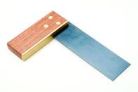 | Tri-square | For marking 90 degree angles/for checking corners, edges are square
 | Pencil | For marking out work
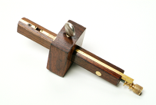 | Marking/mortise gauge | For marking lines parallel to the edge of a piece of wood
 | Mallet | Used with a chisel to remove waste wood when cutting joints
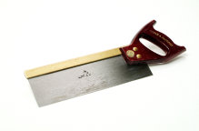 | Tenon saw | For cutting wood
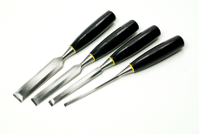 | Chisels | Sharp cutting tools for removing waste wood or carving wood
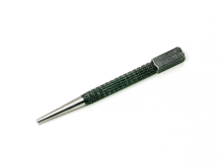 | Nail punch | For knocking-in nails below the surface
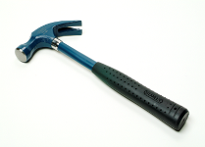 | Claw hammer | For knocking-in nails and removing nails
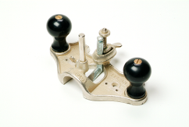 | Hand router | For cutting a channel in a piece of wood
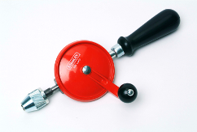 | Wheel brace | For drilling holes
Answer sheet - Woodworking hand tools (2 - answers in bold)

Hand Tools | Name | Use
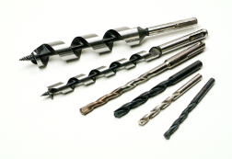 | Twist drill bits | Used in a drill to drill holes
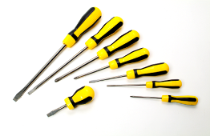 | Screwdrivers | For screwing in wood-screws
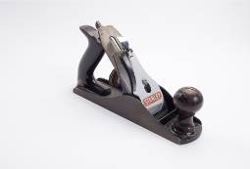 | Smoothing plane | For smoothing the surfaces of wood
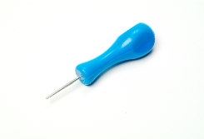 | Bradawl | To make an indentation in wood before screwing in a screw
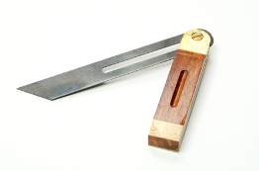 | Sliding bevel | For marking or measuring a line at an angle
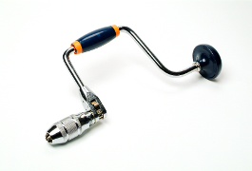 | Carpenter’s brace | For drilling holes
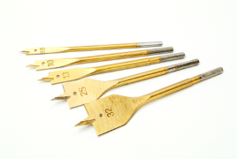 | Flat bits | Used in a drill to drill larger diameter holes
Answer sheet - Woodworking Joints and Wood-Screws (answers in bold)

Name the following woodworking joints.
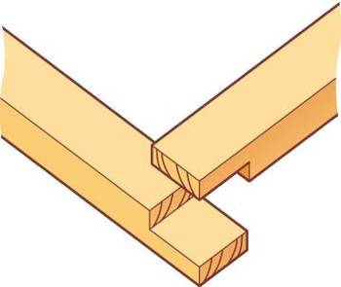 | 
Name: Corner halving joint | Name: Housing joint
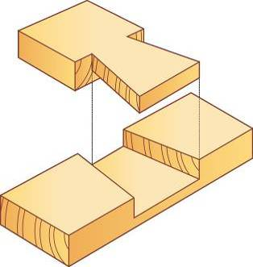 | 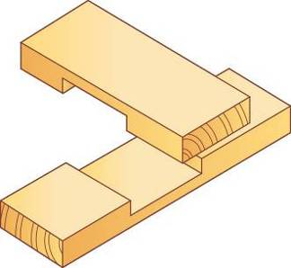
Name: Tee halving joint | Name: Cross-halving joint

Name the different types of wood-screws.
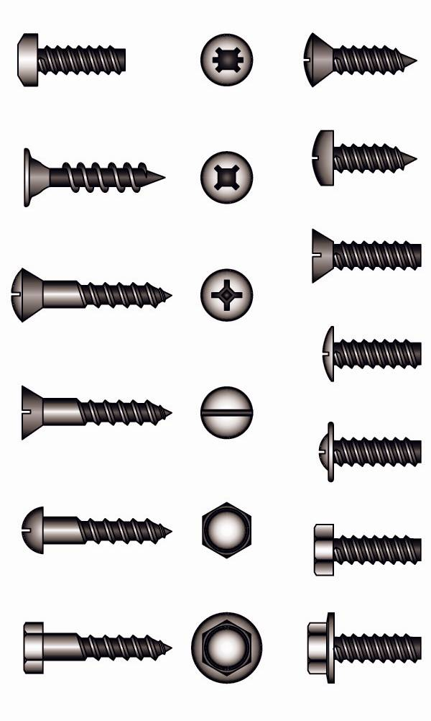
Name: Flatbed screw | Name: Roundhead screw
 | 
Name: Ovalhead screw | Name: Lag screw

Engineering
Bridge structures (Learner Activity Pack page 49)
Description of the activity/task
The aim of this task is for learners to construct and test model truss bridges
Level
Level 1
Time needed to complete task(s)
Approximately 45 minutes
Task 1 (model bridge making) – allow 20 minutes
Task 2 (bridge testing) – allow 25 minutes
Prior learning
Information on bridges - textbook/handouts/internet
Resources needed
Learner activity sheet (for tasks 1-2)
Materials: bridge templates; art straws; scissors; hot glue gun and glue sticks; weights for testing
Tutor note
This task will enable learners to:
- recognise the different types of truss bridge designs
- accurately construct a model truss bridge and test its strength
- determine the reasons why bridges fail
- work effectively as part of a team

Task 1: In pairs or small groups, learners must build a truss bridge using art straws. They should use one of the templates provided for a Warren, Pratt, Howe or K-Truss type of bridge design.

Task 2: Learners must test each truss bridge model by spanning a gap between two tables and hanging weights from them until they fail (break).
Answers
Task 1: Learners should be able to construct a bridge by following the instructions and using the materials provided.
Task 2: Learners should be able to complete the tests and correctly complete the task sheet provided. Learners should give well-reasoned answers to account for test failure.
Links to other skills development
English – following instructions, communication
Maths – measure accurately
Working with others – working effectively as part of a team

This activity could be used to create model items in Construction
Follow-up / adaptation
Learners could:
- Play a ‘Name that bridge’ matching activity
- Carry out research on truss bridges (regional/national/international)
- Visit a local bridge

Engineering
Basic metal working (Learner Activity Pack page 61)
Description of the activity/task
The aim of this task is for learners to identify and explain the use of different types of equipment used in metal working.
Level
Level 1
Time needed to complete task(s)
Approximately 45 minutes
Task 1 (naming hand tools) - allow 25 minutes
Task 2 (labelling a pillar drill) - allow 20 minutes
Prior learning
Information from textbook/handouts/internet on metal work hand tools
Resources needed
Learner activity sheet (for tasks 1-2)
Answers
Task 1: Learners must correctly match the hand tools to their names and purposes. Answer sheet provided
Task 2: Learners must correctly label the pillar drill. Answer sheet provided
Links to other skills development
This activity could be used to identify equipment in other sectors, e.g. Hair and Beauty or Catering.
Follow-up / adaptation
Learners could:
- Complete a hand tools crossword
- Complete a ‘What hand tool would I need to…?’ activity

Task 1 answer sheet - Metalworking Hand Tools (1 - answers in bold)

Hand Tools | Name | Use
 | Steel rule | For measuring
 | Engineer’s square | For marking 90 degree angles/ for checking corners and edges are square
 | Scriber | For marking out on the surface of metal
 | Bevel protractor | For measuring angles or marking accurate angles on a work piece
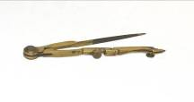 | Odd-leg callipers | For marking a line parallel to the edge of the work piece
 | Ball pin hammer | Used to strike a centre punch
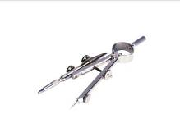 | Dividers | For marking arcs and diameters
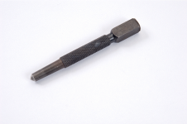 | Centre punch | For marking the centre of holes to be drilled
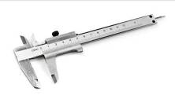 | Vernier callipers | For taking precise measurements
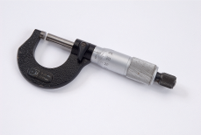 | Micrometer | For taking precise measurements of external diameters
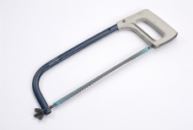 | Hacksaw | For cutting metal
Metalworking Hand Tools (2 - answers in bold)

Hand Tools | Name | Use
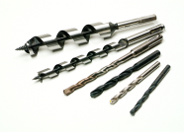 | Twist drill bits | Used in a drill to drill holes
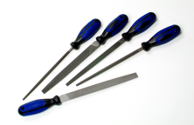 | Files | For removing waste metal/ for smoothing the edges of metal
 | Centre drill | To make a starting hole for a larger sized drill bit
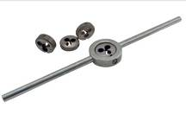 | Die set | For cutting external threads on metal bar
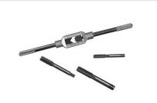 | Tap set | For cutting internal threads
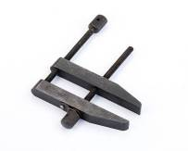 | Toolmaker’s clamp | For holding work pieces securely
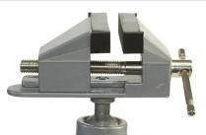 | Bench vice | Attached to a work bench to hold work securely
Task 2 answer sheet (answers in bold)

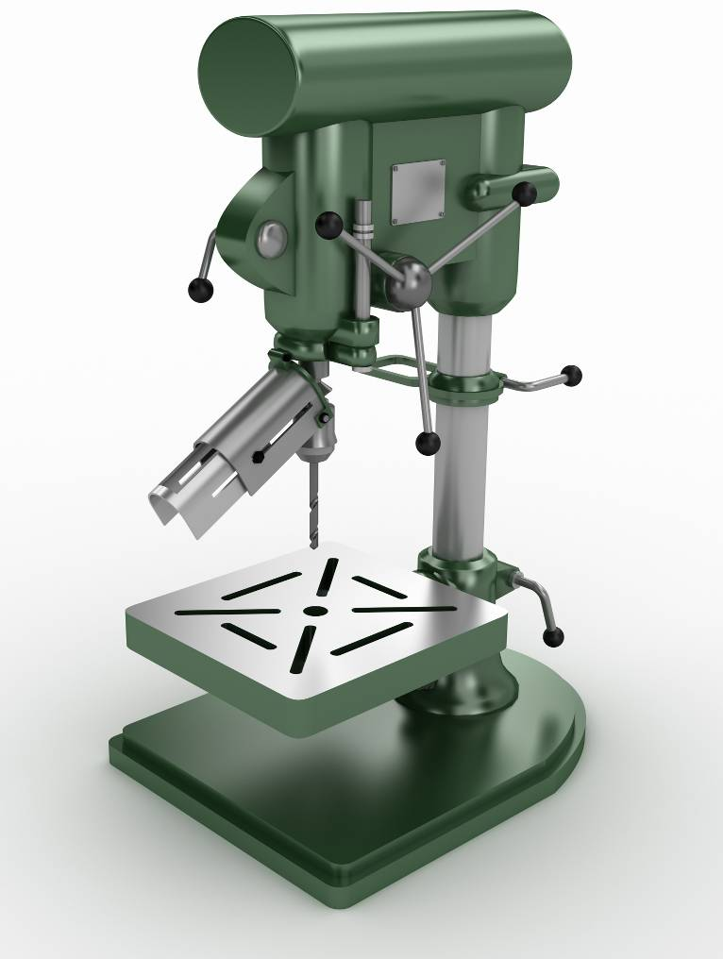
Chuck
Work-table
Column
Base
Motor
Lever A – Lowering handle
Lever B – Work table lock
Guard

What does lever A do? | The lowering handles rotate to lower the chuck assembly
What does lever B do? | The work-table lock holds the work table in position when the height has been selected.
Name the parts of the pillar drill.
Name these two work-holding devices used on a pillar drill.
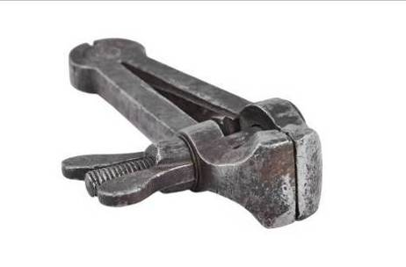 | 
Name: Hand vice | Name: Machine vice

Engineering
Car crash (Learner Activity Pack page 67)
Description of the activity/task
The aim of this task is for learners to design and make a car structure that will withstand an impact using a simulated car crash test.
Level
Level 1
Time needed to complete task(s)
Approximately 45 minutes
Task 1 – allow 15 minutes
Task 2 – allow 30 minutes
Prior learning
n/a
Resources needed
Learner activity sheets (for tasks 1-3)
Materials: photocopies of car template (net); scissors; art straws; glue gun and glue sticks; masking tape; test equipment – weighted crash vehicle and ramp
Answers

Task 1: Learners should describe what happens to a car in a frontal impact test, and what structure protects the occupants.

Task 2: In pairs, learners should build a paper model car that can withstand either a frontal, rear or side impact.

Task 3: Learners should test and evaluate a model paper car in either a frontal, rear or side impact.

N.B. Model cars should be taped down to the ramp in a suitable position which corresponds to the type of impact test. A suitable weighted vehicle should be rolled down the ramp to collide with the paper model i.e. a bought model car with additional weights attached.
Links to other skills development
Working with others – working effectively in a team
Follow-up / adaptation
Learners could:
- An additional task may be to protect an egg inside the structure.

Hair & Beauty
Planning time (Learner Activity Pack page 75)
Description of the activity/task
The aim of this task is for learners to schedule appointment times in a hair & beauty salon.
Level
Level 1
Time needed to complete task(s)
Approximately 45 minutes
Prior learning
n/a
Resources needed
Learner activity sheets (appointment book and notebook pages)
Answers
Answer sheet provided. Learners must use the instructions and appointment notes to complete the appointment book correctly
Links to other skills development
Planning and organisation

Scheduling appointments is a generic task so this activity can be used for clients in many sectors e.g. personal training (Sport & Leisure), interview schedules (Employment), parents’ meetings (Childcare), etc.
Follow-up / adaptation
Learners could:
- Add cancellations/changes to appointments

Task 1 - answer sheet (example answers in bold)

Times | Emma - Hair stylist | Mark - Hair stylist | Jen - Beautician
9.00 | Wet cut and blow dry
9.15
9.30 |  | Wet cut and blow dry short hair | Client 2: Pedicure
9.45 | Wet cut and blow dry short hair | Wet cut and blow dry short hair | Client 2: Pedicure
10.00 | Wet cut and blow dry short hair | Wet cut and blow dry short hair
10.15 | Wet cut and blow dry short hair
10.30 |  | Client 3: Cut And Blow Dry Short Hair | Client 1: Wax
10.45 | Break | Client 3: Cut And Blow Dry Short Hair | Client 1: Wax
11.00 |  | Break | Break
11.15 | Client 6: Lady Wet Cut | Client 6: Gent Wet Cut | manicure
11.30 | Client 4: Child’s Hair Cut | Client 4: Child’s Hair Cut | manicure
11.45 | Client 4: Child’s Hair Cut | Client 4: Child’s Hair Cut | pedicure
12.00 |  | Lunch | pedicure
12.15 |  | Lunch
12.30 |  | Lunch | Lunch
12.45 |  | Lunch | Lunch
1.00pm | Lunch | Wet cut and blow dry | Lunch
1.15 | Lunch | Wet cut and blow dry | Lunch
1.30 | Lunch | Wet cut and blow dry | wax
1.45 | Lunch | Client 8: Blow Dry And Straightening Long Hair | wax
2.00 | Wet cut and blow dry long hair | Client 8: Blow Dry And Straightening Long Hair | manicure
2.15 | Wet cut and blow dry long hair | Client 8: Blow Dry And Straightening Long Hair | manicure
2.30 | Wet cut and blow dry long hair | Break
2.45 | Wet cut and blow dry long hair |  | Client 10: Wax
3.00 | Break |  | Client 10: Wax
3.15 | Child hair cut |  | Break
3.30 | Child hair cut
3.45 | Client 7: Lady’s Wet Hair Cut | Client 5: Cut And Blow Dry
4.00 | Blow dry and straightening long hair | Client 5: Cut And Blow Dry
4.15 | Blow dry and straightening long hair | Client 5: Cut And Blow Dry | Client 9: Manicure
4.30 | Blow dry and straightening long hair |  | Client 9: Manicure
4.45 | Client 9: Cut And Blow Dry
5.00 | Client 9: Cut And Blow Dry | Gents dry cut
5.15 | Client 9: Cut And Blow Dry | Gents dry cut | pedicure
5.30 |  |  | pedicure

Hair & Beauty
Making Money (Learner Activity Pack page 79)
Description of the activity/Task
The aim of this task is for learners to calculate the day’s takings from a hair and beauty salon
Level
Level 1
Time needed to complete task(s)
Approximately 60 minutes
Task 1 (calculate day’s takings) – allow 10-15 minutes
Task 2 (calculate tips) – allow 10 minutes
Task 3 (poster/discount) – allow 35 minutes
Prior learning
Calculating percentages
Resources needed
Learner activity sheets (tasks 1-3)
Materials: calculator
Tutor note
Learners have to read the appointment book and transfer information to the table of salon takings (task 1). It may be helpful for learners to colour code the treatments (e.g. all children’s 0-7 cuts in yellow)
Task 1: Learners should complete the task 1 table to complete the day’s takings. They must correctly identify the number of treatments for each hairdresser and accurately calculate the takings by multiplying the total number of treatments by the cost of that treatment.
Answers
Tasks 1&2: Learners must correctly work out the day’s takings. Answer sheet provided.
Task 3(1): Learners must create a poster for membership card holders, clearly stated the pre and post discount prices. Answer sheet provided
Task 3(2): Learners must have completed the Scissors price list showing correct figures for a 15% discount off the standard rate
Links to other skills development
Maths – perform calculations

This activity can also be used to calculate takings in a leisure centre (Sport & Leisure)
Follow-up / adaptation
Learners could:
- Use character cards to calculate prices e.g. female non-member, child member, etc.

Task 1 answer sheet (answers in bold)

 | Cost | Number done by Emma | Number done by Mark | Total completed | Takings i.e. the total x cost | Total (£)
Example – gent’s cut | £10 | 0 | 3 | 3 | 3 x 10 | £30
Cut and blow dry | £15 | 3 | 3 | 6 | 6 x 15 | £90
Wet cut | £12 | 2 | 0 | 2 | 2 x 12 | £24
Gents cut | £10 | 0 | 3 | 3 | 3 x 10 | £30
Children’s cut  0-7 | £8 | 2 | 0 | 2 | 2 x 8 | £16
Children’s cut  8 – 15 | £10 | 0 | 1 | 1 | 1 x 10 | £10
Blow dry and straightening -short hair | £15 | 0 | 0 | 0 | 0 x 15 | £0
Blow dry and straightening - long hair | £20 | 1 | 1 | 2 | 2 x 20 | £40
Total takings for the day |  |  |  |  | £210

Task 2 (answers in bold)
- Emma made £10.50 in tips today.
- I will earn £5.50 in tips.
Task 3 (1) answer sheet (answers in bold)
Learners should create their own posters. Leisure complex prices at 10% off are as follows:
Scissors
Cuts |  |  | Tints
 | Cost | Special rate for Leisure Complex Members |  | Cost | Special rate for Leisure Complex Members
Women’s cuts and blow dry  Women’s wet cut  Gents  Children 0 - 7  Children 8 - 15 | £15  £12  £10  £8  £10 | £13.50  £10.80  £9.00  £7.20  £9.00 | Tints short  Tints long  Tints with flashes short  Tints with flashes long | £20  £25  £30  £35 | £18.00  £22.50  £27.00  £31.50
Blow dry and straightening |  |  | Foils
Short to medium lengths  Long | £10  £15 | £9.00  £13.50 | T-bar short  T-bar long  Half head short  Half head long  Full head short  Full head long | £25  £30  £30  £35  £40  £45 | £22.50  £27.00  £27.00  £31.50  £36.00  £40.50

Task 3 (2) answer sheet
15% discount for regular customer is as follows:
Scissors
Cuts |  |  | Tints
 | Cost | Special rate for valued customers |  | Cost | Special rate for valued customers
Women’s cuts and blow dry  Women’s wet cut  Gents  Children 0 - 7  Children 8 - 15 | £15  £12  £10  £8  £10 | £12.75  £10.20  £8.50  £6.80  £8.50 | Tints short  Tints long  Tints with flashes short  Tints with flashes long | £20  £25  £30  £35 | £17.00  £21.25  £25.50  £29.75
Blow dry and straightening |  |  | Foils
Short to medium lengths  Long | £10  £15 | £8.50  £12.75 | T-bar short  T-bar long  Half head short  Half head long  Full head short  Full head long | £25  £30  £30  £35  £40  £45 | £21.25  £25.50  £25.50  £29.75  £24.00  £38.25

Land Based
Recycling (Learner Activity Pack page 87)
Description of the activity/task
The aim of this task is for learners to understand the importance of recycling by (1) identifying key words and (2) recycling one model item (an old computer CPU) into another model item (a chair)
Level
Level 1
Time needed to complete task(s)
Approximately 45 minutes
Task 1 (word search) – allow 10–15 minutes
Task 2 (model furniture) – allow 30-35 minutes
Prior learning
n/a
Resources needed
Learner activity sheets (tasks 1-2)
Materials: CPU nets on card, scissors, glue
Tutor note:
Task 1 (word search) is a primer activity to get the learners thinking about recycling.
Task 2 is a practical group task, whereby learners must assemble as many CPUs as possible in the time provided (they will need approximately 6) to use them to build a chair
Answers
Task 1: Learners must find all the key words in the word search
Task 2: See tutor note
Links to other skills development
Working with others – working effectively as part of a team
Creative thinking

Task 1 can be adapted and used as an activity for Health and Safety
Follow-up / adaptation
Learners could:
- Produce a FAQ sheet on recycling

Task 1 - answers

j | r | e | d | u | c | e | k | g | l | a | l | a | k | b
q | v | r | y | r | e | t | a | j | s | h | s | l | r | x
m | u | i | e | o | p | t | k | k | y | s | t | b | o | a
f | a | t | r | c | c | j | e | y | a | n | q | r | s | b
h | s | e | n | e | y | r | r | l | i | n | x | i | s | i
a | h | y | v | e | b | c | g | e | o | w | t | n | e | f
z | x | b | h | s | m | o | l | i | u | a | c | g | c | e
a | w | r | i | a | v | n | t | e | d | s | z | b | o | n
r | u | d | h | l | t | c | o | n | d | t | e | a | r | d
d | e | o | h | a | e | c | a | r | f | e | a | n | p | d
o | y | i | o | l | v | r | e | h | i | c | p | k | e | o
u | f | y | l | x | l | y | m | v | v | v | m | w | r | k
s | f | o | x | j | d | l | l | i | f | d | n | a | l | r
q | c | g | m | h | v | q | n | f | x | a | g | e | i | q
c | l | q | k | y | s | q | c | o | m | p | o | s | t | k

Bring bank
Collection
Compost
Environment
Glass
Hazardous
Kerbside
Landfill
Recycle
Reduce
Reuse
Reprocessor
Waste

Land Based
Well groomed (Learner Activity pack page 91)
Description of the activity/task
The aim of this task is for learners to recognise the equipment and tools used to groom small animals.
Level
Entry 3/Level 1
Time needed to complete task(s)
Approximately 40 minutes:
Task 1 (gap filling) – allow 15-20 minutes
Task 2 (matching) – allow 15-20 minutes
Prior learning
n/a
Resources needed
Learner activity sheets (for tasks 1-2)
Materials: coloured pencils (for task 2)
Tutor note
Learners need to name different animal grooming tools and say which tool is best for which type of task.
Task 1: This can be presented as a quiz. Learners need to decide which words go in each gap. Some of these tools have more than one purpose; the answers shown are those most commonly used. The quickest and simplest way to complete this task is to circle the appropriate word and draw a line connecting it with the gap. The other way is for learners to copy the word into each gap, which helps to reinforce understanding as well as practicing their writing skills for technical terms.
Task 2: Learners need to match the pictures of the grooming tools/equipment with their names (in the left-hand column), then match them with their purpose (right-hand column). It helps to use different colours for each grooming tool

These tasks can be used independently or together, in either order. By using the gap filler task first, learners with little prior knowledge are most likely to be able to complete parts of the matching exercise.
Answers
See tutor note
Task 1 answer sheet provided
Task 2 answer sheet provided
Links to other skills development
English – read and understand instructions
Follow-up / adaptation
- See tutor note

Task 1 answer sheet (answers in bold)

1 | When you are going to groom an animal, it is useful to have a grooming table. This helps you to reach each part of the animal easily. It will also make easier to see which parts need to be groomed or trimmed.
2 | If you are grooming dogs, a grooming arm makes it easier to restrain the dog.
3 | If a small animal needs its claws or nails clipping use nail clippers.  Light coloured nails are the easiest as you can see the “quick” (the blood supply).
4 | If you need to trim delicate areas, such as round the paws or face, a pair of scissors can help you to do this accurately.
5 | If the animal is prone to tangles, they need regular grooming. A comb can help to reduce tangles, especially for short or medium length breeds. If the hair is long, a slicker brush can be more suitable, and this also smoothes the coat.
6 | If tangles are left and have become matted, you may need a special de-matting comb.
7 | A soft brush does not remove tangles, but will smooth the coat to give a glossy finish.
8 | Sometimes it is useful to be able to remove the fluffy undercoat and reduce tangles. An undercoat rake is a useful tool for this.
Task 2 answer sheet

Comb |  |  |  | Remove fluffy undercoat to reduce tangles
Soft brush |  | 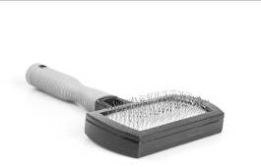 |  | Trimming delicate areas, e.g. the face
Scissors |  |  |  | Reduce tangles, especially for short or medium haired breeds
Slicker brush |  | 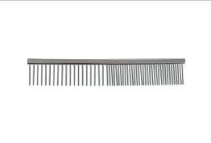 |  | Help to keep proper control of dogs while grooming
Undercoat Rake |  |  |  | Smooth or lift the coat for smooth, short breeds
Nail clippers |  | 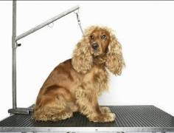 |  | Smooth the coat and reduce tangles, especially for long, curly or woolly breeds
Grooming table |  | 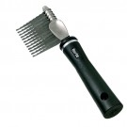 |  | For the animal to stand or lie on to make grooming easier
Grooming arm |  | 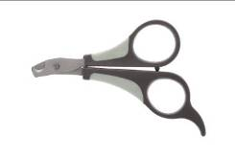 |  | Removes difficult matts, knots and tangles
De-matting comb |  | 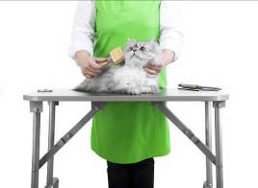 |  | Clip claws and toe nails

Land Based
Saddle up and ride your pony! (Learner Activity Pack page 95)
Description of the activity/task
The aim of this task is for learners to recognise and name the parts of the saddle.
Level
Entry 3/Level 1
Time needed to complete task(s)
Approximately 30 minutes:
Task 1 (fill in the blanks) – allow 10 minutes
Task 2 (word search)- allow 15-20 minutes
Prior learning
n/a
Resources needed
Learner activity sheets (tasks 1-2)
Answers
Task 1: Learners must use the word box given to correctly label the saddle. Answers are self-explanatory.
Task 2:Learners must complete the word search
Links to other skills development
English – Spell key words

Both activities can be used to label equipment in various vocational areas e.g. weight machines (Sport & Leisure)
Follow-up / adaptation
Learners could:
- Complete a saddle crossword

Task 2 - answer sheet

d | c | a | k | t | r | i | k | s | u | u | r | z | w
m | a | y | f | f | w | x | m | t | d | e | y | y | q
k | n | e | l | j | t | n | k | i | y | y | a | x | s
k | t | t | p | w | h | s | c | r | q | n | s | e | z
u | l | h | r | l | s | m | l | r | w | r | a | k | h
d | e | p | x | e | y | g | l | u | s | t | d | v | t
k | n | u | a | m | m | r | o | p | a | g | u | t | r
r | q | r | n | m | u | o | r | l | d | u | g | o | i
v | k | r | b | o | z | v | e | e | d | o | n | t | g
c | u | i | k | p | r | s | e | a | l | v | y | g | z
y | t | t | h | k | n | y | n | t | e | o | r | g | x
j | v | s | y | z | i | c | k | h | h | d | h | b | t
i | f | h | a | n | m | u | n | e | k | d | b | c | z
e | d | o | m | o | h | s | k | r | x | f | p | w | z

Cantle
Girth
Knee Roll
Numnah
Pommel
Saddle
Seat
Skirt
Stirrup
Stirrup Leather

Land Based
Animal needs (Learner Activity Pack page 99)
Description of the activity/task
The aim of this task is for learners to identify and describe the various needs of different animals i.e. small animals and farm animals.
Level
Entry 3/Level 1
Time needed to complete task(s)
Approximately 45 minutes
Prior learning
n/a
Resources needed
Task sheet for learners
Materials: small animals and farm animals templates; answer cards (preparation needed); glue (optional)
Tutor note
Each group of learners needs two templates (one for farm animals, one for small animals), plus one set of answer cards (cut up). They need to stick on all the answers in the relevant place in the template.
At the end of the activity each group could share one of their rows with the rest of the group, or the groups could stick their answers on the walls and look at each other’s answers. Alternatively, the tutor could go through the answers and explain why each is correct.
Answers
Model answer sheets provided. Learners must correctly identify the needs of the various small animals and farm animals as per the task sheet
NB –There is more than one possible answer for most of the template squares.
Links to other skills development
English – Read and understand instructions
Working with others – work effectively as part of a team
Follow-up / adaptation
Learners could:
- Use the answer cards as clues to play a ‘guess the animal’ game
- Include images

Task 1 - Small animal needs (possible answers in bold)
N.B. For many animals there are a range of possible answers. These are the most common suitable answers:

Animals | Type of feed | Method of feeding | Type of water drinker | Type of bedding | Method of cleaning out
A group of guinea pigs | Specialist dry food  Grass  Hay  Vegetables  Greens  Fruit (sparingly) | Bowl  Grazing  On floor | Bottle (usually best)  Bowl | Hay  Shavings  Shredded paper | Brush and dustpan
A cat | Specialist wet food  Specialist dry food | Bowl | Bowl | Fleece bed | Litter scoop
A pair of rats | Specialist dry food  Vegetables  Fruit  Greens | Bowl  On floor | Bottle (usually best)  Bowl | Shavings  Shredded paper | Brush and dustpan
Three budgerigars | Seed Mix  Grit (for digestion)  Vegetables  Fruit | Bowl | Water drinker | Bird sand | Brush and dustpan

Task 2 - Farm animal needs – possible answers in bold
N.B. For many animals there are a range of possible answers. These are the most common suitable answers:

Animals | Type of feed | Method of feeding | Type of water drinker | Type of bedding | Method of mucking out
A herd of dairy cattle over winter | Silage  Hay  Concentrates | Feed passage  Trough | Trough  Bowl drinker | Straw  Rubber matting | Tractor and muck scraper
A lactating sow | Concentrates | Trough | Bowl drinker  Bite drinker | Straw  None | Shovel  Fork
A calf | Milk replacer + water  High protein pellets  Straw | Bucket  Teated bucket | Bucket  Bowl drinker | Straw | Shovel  Fork
A flock of sheep | Grass  Hay  Concentrates | Grazing  Hayrack, Floor  Trough | Trough  Bowl drinker | Straw (when housed) | Shovel  Fork (when housed)

Land Based
Healthy calves (Learner Activity Pack page 103)
Description of the activity/task
The aim of this task is for learners to recognise the signs of healthy and unhealthy calves
Level
Entry 3/Level 1
Time needed to complete task(s)
Approximately 30 minutes
Main task (matching) – allow10-15 minutes
Additional task (poster) – allow 10-15 minutes
Prior learning
n/a
Resources needed
Learner activity sheet
Materials: paper and pens for poster design (additional task)
Resources: healthy/unhealthy cards (preparation needed, one card of each per group); signs of good health or poor health (one set per group)
Tutor note
Learners must:
- a) Check each of the calf health cards and decide if it is a sign that the calf is healthy or in poor health
b) Sort the cards into two groups – cards with the characteristics of a healthy animal and cards with the characteristics of an unhealthy animal.

- For an extension activity, learners could work in pairs to design a poster. The poster is for the stockperson who will be looking after a group of calves and checking if they are healthy. They must give the following title: “Please check these things every day”. The learners must use the cards they sorted for task 1 to decide what the stockperson should look for every day to check their calves are healthy.
Answers
Learner must correctly identify the signs of healthy and unhealthy calves
For the poster, learners must ensure the poster is titled correctly and that all the signs for a healthy calf are included
Links to other skills development
English – Read and understand instructions

Healthy/unhealthy task can be adapted for a safe/hazardous activity with a variety of vocational areas
Follow-up / adaptation
Learners could:
- Link signs of poor health in calves to the possible illnesses

Healthy/unhealthy calves – (answers in bold)

Healthy calf | Calf in poor health
Bright eyes  Drinking milk well  Breathing slowly and evenly  Shiny coat  Lively  Alert and interested  Moist nose  Erect ears | Sunken eyes  Refusing milk  Coat looks dull  Limping  Wet, swollen navel  Shivering  Fast breathing  Listless (no energy)  Scours (diarrhoea)  Coughing

Land Based
Farm animal families (Learner Activity Pack page 105)
Description of the activity/task
The aim of this task is for learners to learn the definitions of different farm animals at various stages in their lifecycle
Level
Entry /Level 1
Time needed to complete task(s)
Approximately 45 minutes:
Game – allow 20-30 minutes
Gap filling task – allow 15 minutes
Prior learning
n/a
Resources needed
Task sheet for learners (gap filling)
Materials: one set of animal cards per group of 3-5 learners; one set of definition cards; one animal families reference sheet per group
Tutor note
The object of the game is to have as many matched pairs (farm animal name plus its meaning) as possible. Similar to the game “go fish!”, the winner is the player who has the most correct pairs at the end of the game. This game is useful for reinforcing the farm animal terms and their meanings, as each player has to check their card and ask for the term or the meaning which fits. The reference sheet is designed to enable players to check their understanding of terms before asking. If players have a good level of understanding of the terms and their meanings, the game could be played without this sheet – this will make it more challenging.

The game and gap filling task could take place as part of the same lesson, or on separate occasions. Both can be used either to introduce the topic, to reinforce learning or to check understanding.
Answers
Game: Learners must use the reference sheet to check that the name and meanings have been correctly matched
Gap filling task: Answer sheet provided
Links to other skills development
English – Read and understand instructions

This game can also be used to learn definitions of different plants
Follow-up / adaptation
Learners could
- Play a ‘Guess who?’ game. Players start with the cards face up and ask each other questions (e.g. am I a male?) to eliminate the animals that do not fit with the statement given.
Farm animal families reference sheet

Cow | An adult female cow who has had at least one calf
Bull | An adult male cow
Calf | A young cow
Heifer | A female cow before her first calf
Bullock | A castrated male cow used for beef production
Steer | A castrated male cow used for beef production
Sow | An adult female pig who has had at least one litter
Boar | An adult male pig
Piglet | A young pig
Gilt | A female pig who has not yet had her first litter
Weaner | A piglet for the first eight weeks after weaning
Grower | A pig between eight weeks old and sale
Ewe | An adult female sheep
Ram | An adult male sheep
Tup | An adult male sheep
Lamb | A young sheep
Wether | A castrated male sheep
Store lamb | A lamb sold in the autumn for further feeding

Answer sheet – fill in the gaps (answers in bold)

- An adult female sheep is called a Ewe
- A young cow is called a Calf
- A female pig is called a Gilt before she has had her first litter
- An adult male cow used for breeding is called a Bull
- A Weaner is a piglet after it has been weaned from its mother
- A young sheep is called a Lamb
- An adult female pig who has had at least one litter is called a Sow
- A female cow who has not yet had a calf is a Heifer
- A Ram and a Tup are both terms used for an adult male sheep
- A young pig is called a Piglet
- A Wether is a castrated male sheep
- An adult female cow who has had at least one calf is called a Cow
- An adult male pig is called a Boar
- A Steer and a Bullock are both names for a castrated male cow used for beef production
- Pigs being kept for meat production are called weaners first and then Growers
- When lambs are sold in the autumn for further fattening they are called Store lambs
*Tutor note:
A number of these terms might have evolved to have slightly different meanings in different regions. For example, whilst a heifer is technically a term for a young cow before her first calving, on many farms a heifer will continue to be called a heifer up until her second calving.

Land Based
Does your animal need the vet? (Learner Activity Pack page 121)
Description of the activity/task
The aim of this task is for learners to identify the signs of a healthy dog and an unhealthy dog.
Level
Entry 3/Level 1
Time needed to complete task(s)
Approximately 30 minutes:
Main task (matching) – allow10-15 minutes
Additional task (poster) – allow 10-15 minutes
Prior learning
n/a
Resources needed
Learner activity sheets
Materials: dog health cards; paper and pens for poster
Tutor note
Learners need to choose which cards should be placed under the healthy dog sign and which cards should be placed under the unhealthy dog sign.

For an additional task, learners could work in pairs to design a poster for kennel hands who are looking after dogs in a boarding kennels, and who will need to check if the dogs are healthy. Learners must give their poster the following title: “Please check these things every day” and use the cards they sorted for task 1 to decide what the kennel hands should look for to check the dogs are healthy.
Answers
Learners must choose correctly which cards should be placed under the healthy dog sign and which cards should be placed under the unhealthy dog sign

If the poster is completed as an additional activity, learners must produce a poster that is correctly titled and which includes all the signs of a health dog
Links to other skills development
English – Read and understand instructions

This activity can also be used to identify signs of ill health or unhappiness in a child (Childcare) or someone in a care setting (Health and Social Care)
Follow-up / adaptation
Learners could:
- Link signs of poor health to possible illnesses

Does your animal need the vet? (answers in bold)

Healthy dog | Unhealthy Dog
Bright and shiny eyes  Eating and drinking normally  Breathing slowly and evenly  Shiny/glossy coat  Cool, moist nose  Walking normally  Ears are light pink and clean  Alert and interested  Stools are firm and brown  Pink gums  Smooth skin  Clear yellow urine | Runny watery eyes  Excessive drinking  Shivering  Fast breathing  Coat looks dull  Listless (no energy)  Limping  Yellow discharge from nose  Whining (for no apparent reason)  Loose or bloody stools  Redness inside ears  Scabs on skin

Land Based
Planning a visit (Learner Activity Sheet page 125)
Description of the activity/ask
The aim of this task is for learners to plan a group visit to the Blossom Tree Land Based Centre. Planning must include a risk assessment
Level
Entry 3/Level 1
Time needed to complete task(s)
Approximately 60 minutes:
Task 1 (planning tasks) – allow 45 minutes
Task 2 (group activity review sheet) – allow 10-15 minutes
Prior learning
n/a
Resources needed
Task sheets (1-2) for learners
Resource sheet: map A3 size
Materials: flipchart paper & pens (for ground rules)
Tutor note
This activity is designed as an introduction to group work, whilst building on health and safety and the learners’ areas of interest. It is not likely learners will complete all of the tasks within the timescales unless the group divides up the activity.
Task 1c - is designed to enable learners to work in an area that most interests them and it is suggested that learners are guided as to how many areas to design a poster for. This will depend on the nature and ability of the group, plus the time available.
Whilst designed as a one-hour activity, it could be adapted to be a smaller activity or could easily form the basis of a larger piece of work. Changing the number or type of posters required and how much information learners’ research for this activity will determine the amount of time required.

As an extension activity, learners could produce a short health and safety guide, which shows the main risks (as identified in part (b)) and sensible precautions to take.

Learners at this level are likely to find it difficult to manage their time completely independently so it is recommended that reminders are given when it is time to move on to the next part of the activity. It is also important that learners are reminded of the need to fill in the review activity sheet 10 minutes before the end of the session. This could then be discussed at a future session.

Land Based
Planning a visit (Learner Activity Sheet page 125) cont…
Answers
Task 1a: There is no right or wrong answer for the order of the visit, but the order given should be logical, with a trip to the wash basins included after each section is visited as well as before lunch
Task 1b: Again, there are no specific answers, however those given should be logical
Task 1c: Learners must ensure their posters address the instructions given in the task i.e. include interesting information about the area plus any relevant health and safety information
Task 2: Learners must use the task sheet to assess the performance of their groups
Links to other skills development
Follow instructions and directions
Work with others to achieve targets
Come up with ideas and possibilities
Be able to discuss issues and make decisions as part of a team

This activity can be linked with Health & Safety – risk assessment
See ‘A day out with the children’ (Childcare)

Follow-up / adaptation
See tutor note

Land Based
Feeding time (Learner Activity Sheet page 129)
Description of the activity/task
The aim of this task is for learners to identify the sequence of activities involved in feeding animals and understand why each activity is needed.
Level
Entry 3/Level 1
Time needed to complete task(s)
Approximately 20 minutes:
Task1 (gap filling) – allow 5-10 minutes
Task 2 (matching) – allow 10 minutes
Prior learning
n/a
Resources needed
Learner activity sheets (for tasks 1-2)
Answers
Learners must correctly complete the gap filler sentences, and then put each statement into the correct sequence. Answer sheets provided. N.B. The steps in task 2 correspond with the numbered statements in task 1
Links to other skills development
Place activities into a logical order

This activity can be used to place the steps involved in preparing lunch for children or a baby’s bottle (Childcare)
Follow-up / adaptation
Learners could:
- Write feeding steps on individual cards. Learners must arrange the steps in the correct order.
- Draw a feeding poster listing the steps in the correct order

Task 1 - Feeding an animal (answers in bold)

- First put on any protective clothes.
- Make sure you wash your hands.
- Check what sort of feed the animal needs
- Check how much feed the animal needs
- Weigh the feed out carefully
- Take the feed to the animal using correct lifting/carrying methods
- Feed the animal in the correct place, e.g. trough, floor or bowl
- Write down how much you fed in the record book
- Wash your hands again.
Task 2 - answer sheet (answers in bold)

Step in feeding (number) | Reason
4 | To make sure you know how much feed to give the animal
3 | To make sure you give the animal the type of feed it needs
2 | To make sure you don’t become ill with a stomach upset
1 | To make sure your clothes stay clean
5 | To make sure you give the animal the correct amount
8 | To help you to check how much feed the animal is eating
9 | To make sure you keep the animal’s feed clean
7 | To make sure the animal can reach the feed to eat it
6 | To make sure you don’t damage your back

Land Based
Move it! (Learner Activity Pack page 131)
Description of the activity/task
The aim of this task is for learners to work out how to move a group of animals from one pen to another and know how to dress appropriately when carrying out this job.
Level
Entry 3/Level 1
Time needed to complete task(s)
Approximately 25 minutes
Task 1 (movement plan) – allow 15-20 minutes
Task 2 (clothing checklist) – allow 5 minutes
Prior learning
n/a
Resources needed
Learner activity sheets (tasks 1-2)
Coloured pencils (for movement plan)
Tutor note
Learners must plan the route they want to take before they move the animals from one pen to another, as well as any barriers that are needed. It is helpful for learners to use bright colours to show the planned movements. Barriers should block off any possible escape routes. One of the people should be behind the pigs; the other could block off a further small gap where there are not enough barriers. All gates should be shut apart from A and B, which should be wide open to make movement easier.
Answers
Task 1: See tutor note
Task 2: Learners must identify the correct clothing needed for moving animals. Answer sheet provided
Links to other skills development
English – Read and understand simple instructions and directions

The activity can be adapted to create a plan for moving patients in a residential care setting (Health and Social Care)
Follow-up / adaptation
Learners could:
- Decide whether a worker in a picture is suitably dressed to move animals.

Task 1 – one example solution
(Barriers should block off any possible escape routes, and one of the people should be behind the pigs. The other person could block off a further small gap where there are not enough barriers. All gates should be shut apart from A and B, which should be wide open to make movement easier)
Person 1
Open gate A
Open gate B
Barrier 2
Barrier 1
Weaner pen A
Grower pen B

Person 2

Task 2 – example answers in bold

Item | Suitable
Sandals | No
Shorts | No
Wellington boots | Yes, but safety boots are better
Safety boots | Yes
Trainers | No
Overalls | Yes
Necklace | No (it could be caught on an animal, gate or cause injury
Watch | No (it could be caught on an animal, gate or cause injury)
Casual shoes | No
Warm hat | Optional

Land Based
Planting bulbs (Learner Activity Pack page 135)
Description of the activity/task
The aim of this task is for learners to understand the factors that are important when planting bulbs and the order in which bulbs are planted.
Level
Entry 3/Level 1
Time needed to complete task(s)
Approximately 45-60 minutes:
Task 1 (terrific for tulips matching task) – allow 15 minutes
Task 2 (best for bulbs sequencing task) – allow 15 minutes
Task 3 (poster) – allow 30 minutes
Prior learning
n/a
Resources needed
Learner activity sheets (tasks 1-3)
Materials: “planting bulbs” activity cards; “best for bulbs” activity cards; pens, papers and pencils for posters
Tutor note
Task 1: Copy enough sets of each of the two activity cards for the number of pairs/small groups (printing on different colour paper or card makes it easy to get them back into sets at the end of the activity). Cut up each set and shuffle the cards. For the first activity, learners have to decide whether each card from the “planting bulbs” activity cards is helpful for bulb planting (‘terrific for tulips’) or detrimental (‘disaster for daffodils’). The cards can be sorted into two piles, or stuck onto paper or card with ‘Blu-Tack’.
Task 2: Learners have to decide which order the stages on activity cards “best of bulbs” should take place. Note that whilst there is a “right” answer for the latter stages of the bulb planting exercise, steps 2, 3 and 4 could logically occur in any order. The purpose of this exercise is to get learners to think about the order of planting, which helps them to understand why each stage is needed.

Extension task: Learners should use what they have learned to (in pairs) design a poster called “Brilliant Bulbs” which shows how to successfully plant bulbs outdoors
Answers
See tutor note
Task 1: learners must correctly place the cards in either the “terrific for tulips” or “disaster for daffodils” pile.
Task 2: Learners must place the “best for bulbs” cards in a logical order
Links to other skills development
Collaborate with others to work towards common goals

This activity can be adapted to identify the steps involved in assembling a piece of specialist equipment across a variety of vocational areas
Follow-up / adaptation
Learners could:
- Write 5 Top Tips for planting bulbs for inclusion in a monthly gardening newsletter
Task 1 – answers in bold

Beneficial  (Terrific for tulips) | Detrimental  (Disaster for Daffodils)
Shoot facing upwards  Deep hole (2-3 times depth of the bulb)  Firm bulb  Good drainage  Plant in October  Plant in a sunny spot  Plant in a sheltered position | Shoot facing downwards  Shallow hole (just under the surface)  Soft bulb  Lots of water to sit in  Plant in February  Plant in the shade  Plant in an exposed position

Task 2 – One suggested order

- Put on protective clothing
- Choose bulbs for planting
- Choose a location for planting
- Choose tools from tool shed
- Dig over the soil
- Dig a hole big enough for your bulbs
- Mix some bone meal or bulb compost into the soil at the bottom of the hole
- Plant the bulbs with their shoot facing upwards
- Cover the bulbs over with the soil
- Gently firm in the bulbs
- Label where the bulbs are planted

Land Based
Plant it (Learner activity Pack page 139)
Description of the activity/task
The aim of this task is for learners to understand how to prepare for planting a container
Level
Entry 3/Level 1
Time needed to complete task(s)
Approximately 30-40 minutes:
Task 1 (choosing containers) – allow 10 minutes
(choosing plants) – allow 30 minutes
Task 2 (providing reasons for choosing two of the plants) – allow 10 minutes
Task 3 (choosing healthy plants) – allow 10 minutes
Prior learning
An introduction to planting a container is helpful but not essential as the task can be used to assess prior learning.
Resources needed
Task sheets for learners
Activity sheets
N.B. The activity sheets will be most effective if copied in colour, but the descriptions of the plants also indicate their colours so it could potentially be completed using black and white copies.
Answers
Task 1 – There are no specific answers, however, answers should be logical (further guidance given in example answer sheet), plants should be chosen that have similar needs based on the descriptions given e.g. four plants that require being kept in full sun. Plants should also be suitable for the type of container chosen in task 1.
Task 2 - There are no specific answers, however, example reasons include: size, height, colour, leaf type, leaf colour, goes well with other plants
Task 3 – No specific answers, however reasons could include: (healthy plant) - healthy green leaves, bright petals, in flower, (unhealthy plant) – brown leaves, flowers have died, looks dried out
Task 4 –Answers given on answer sheet.

All answers will depend on the choices the learners make.
Links to other skills development
English – Read and understand simple instructions
Follow-up / adaptation
Learners could:
- Complete a plant crossword

Task 1 – guidance for answers

 | Hanging basket | Tall narrow plant pot | Short wide plant pot
Moss | Can be used to line a hanging basket
Gravel |  | Can be used in the bottom of a pot to improve drainage and prevent soil washing out of the container. | Can be used in the bottom of a pot to improve drainage and prevent soil washing out of the container.
Polythene | Can be used to line a hanging basket
Compost | Organic matter - adds nutrients to the soil, absorbs and retains water, supports the health of plants in a confined environment.
Fertiliser | Organic or inorganic - increases plant growth and adds nutrients to the soil
Water retaining gels | In organic - retains moisture and may help reduce the demand of frequent watering during dry spells

Task 4 – (example answers in bold)
Learners were asked which of the following they should do, now that they have planted their container.

Correct answers | Incorrect answers
Put the container in a sunny spot  Water the plants  Put plant material (e.g. leaves) in the compost heap  Put equipment away  Clean equipment  Wash your hands  Use plant supports  Put compost away | Put the container in the shade  Throw away plant material (e.g. leaves)  Leave any spare compost out for next time

Land Based
Soil (Learner activity Pack page 143)
Description of the activity/task
The aim of this task is for learners to recognise the characteristics of two different soils and the soils for which they are best suited.
Level
Entry 3/Level 1
Time needed to complete task(s)
Approximately 60 minutes:
Task 1 (categorising) – allow 30 minutes
Task 2 (gap filling) – allow 30 minutes
Prior learning

Resources needed
Task sheets (1-2) for learners
Materials: soil card sets (1 per pair); soil card templates (1 of each per pair); ‘Blu-Tack’
Tutor note
The first part of the activity works best in pairs or a group of 3. First copy enough sets of the soil activity cards for the number of pairs/small groups. If you do each set on a different colour paper or card it is easy to get them back into sets at the end of the activity. Then cut up each set and shuffle the cards, and give each pair a set of cards. They need to decide which cards to put on the clay soil template and which in the sandy soil template. The learners can place the cards on the template, or they could use blue tack to stick them on.

The next part of the activity can be done individually or remaining in pairs. Learners have to decide whether each plant, based on the description given, will grow best in sandy soil or clay soil.
Answers
Task 1: Learners must place the soil cards in the correct soil-type card (sandy or clay)
Task 2: Learners must correctly fill in the gaps on the soil quiz sheet. Answer sheet provided
Links to other skills development
- This activity can be adapted to recognise the characteristics of two different wood types (Construction)
Follow-up / adaptation
Learners could:
- Undertake this activity using different plants or soil types
Task 1 answers in bold

Characteristics of Sandy Soil | Characteristics of Clay Soil
Gritty to touch  Large particles  Drains well  Large air gaps  Dries out quickly  Easy to dig  Low nutrient levels  Warms up quickly  Needs extra watering | Small particles  Hard to dig  Sticky to touch  Holds water  Can get compacted  Small air gaps  Slow to warm up  High nutrient levels  Can get waterlogged

Task 2 answers in bold

- Carrots like to grow in soil that drains well. They are likely to do best in a sandy soil.
- Cistus is a plant that likes warmth and does not need much water. It will prefer a sandy soil.
- Hydrangea is a plant that needs plenty of water. It will grow best in a clay soil.
- Poppies prefer a free draining soil. They will grow best in a sandy soil.
- The anemone prefers rich, fertile soil. It is likely to do best in clay soil.
- Roses need a good supply of water and nutrients. They are likely to prefer a clay soil.
- Lavender is a plant that likes loose, well draining soil. It will do best in a sandy soil.
- Cabbages need to get many nutrients from the soil. They are likely to do best in a clay soil.
- Apple trees need to have plenty of water from the soil. They are likely to have the best crop in a clay soil.
- The care instructions on a type of geranium say “tolerates any soil except boggy”. This plant will prefer a sandy soil.
Note – in many cases a loam soil would actually be the best type of soil, rather than either clay or sandy, as this is a well balanced soil which suits many plants. However, the purpose of asking learners to choose a clay or sandy soil is to help them to start to match the plant needs as a “best fit” to the two types of soil available. This should also help to consolidate their knowledge about the differences between these two soil types.

Health & Safety
Hazards in the workplace (Learner Activity Pack page 151)
Description of the activity/task
The aim of this task is for learners to identify common hazards and risks in the workplace and suggest suitable control measures.
Level
Entry 3/Level 1
Time needed to complete task(s)
Approximately 45 minutes:
Task 1 (spot the hazard) – allow 15 minutes
Task 2 (risk assessment) – allow 30 minutes
Prior learning
n/a
Resources needed
Learner activity sheets (for tasks 1-2)
Answers
Task 1: Learners must identify the hazards in the workplace and give an accurate description of each hazard
Task 2: Answers are dependent on hazards/risks chosen. Learners must complete an accurate risk assessment for 2 work activities
Links to other skills development
This activity can be used in any vocational setting e.g. a picture of potential hazards in a hair and beauty salon, on a construction site etc
Follow-up / adaptation
Learners could:
- ‘Risk or hazard’ card game. Players have to guess whether statements written on a card are a risk or a hazard. Answers are on the reverse.

Task 1 answer sheet


16
15
14
13
11
12
10
9
8
7
6
5
4
3
2
1
17
21
20
18
22
19
21

The hazards in the workplace shown are:

- Hot liquids next to computer  - Leaning back on chair  - Flooring has a hole  - Handbag left on floor  - Screwdriver left on floor  - Exposed electric cables  - Fixing electric appliance whilst it is turned on  - Food lying around has attracted mice  - Fire extinguisher stored incorrectly  - Overflowing bin  - Smoking in a workplace | - Overloaded electric socket  - Water overflowing from plant pot near electric socket  - Standing/balancing on a chair  - Changing light bulb whilst lights are turned on  - Books stacked  - Cupboard door left open  - Carrying a heavy/unwieldy load  - Cord could be tripped over  - Cleaning equipment not put away  - Spillage not cleaned up  21.Boxes blocking fire escape

Health & Safety
Health and safety signs (Learner Activity Pack page 153)
Description of the activity/task
The aim of this task is for learners to recognise the five main categories of health and safety signs
Level
Level 1
Time needed to complete task(s)
Approximately 15 minutes
Task 1 (define signs) – allow 15 minutes
Prior learning
n/a
Resources needed
Learner activity sheet
Tutor note
Learners should be made aware that:
- There are five main categories of health and safety signage
- Each category uses different colours and shapes
- Individual signs contain simple symbols to communicate warnings or instructions.
Answers
Task 1 Learners must give the correct meaning for the 8 signs presented
Links to other skills development
Signs can be used in a range of vocational settings e.g. using a picture of a residential care home, place healthy safety signs in the appropriate place (a staff only sign on a door)
Follow-up / adaptation
Learners could:
- Match the sign to the definition

Task 1 answer sheet

 | 
Meaning: Fire Exit/Emergency Exit | Meaning: Wear protective goggles
 | 
Meaning: Location of foam spray fire fighting equipment | Meaning: No smoking
 | 
Meaning: Now wash your hands | Meaning: Flammable/Risk of fire
 | 
Meaning: Radioactive | Meaning: No mobile phones

Health & Safety
It’s a risky business (Learner Activity Pack page 155)
Description of the activity/task
The aim of this task is for learners to identify the circumstances that might cause an accident in the workplace.
Level
Entry 3/Level 1
Time needed to complete task(s)
Approximately 45-60 minutes:
Prior learning
n/a
Resources needed
Materials: risky business hazard sheets; risk cards (1 set per group); prevention cards (1set per group); paper/card & pens (for extension activity); ‘Blu-Tack’
Tutor note
This activity can work in two different ways.
Method 1 (recommended) – place the hazards sheets around the room, either clearly visible on desks or displayed on the walls. Put learners in small groups (2-3 ideally) and give each group a set of risks cards. Ask each group to put their names (or a group name they have chosen) on each card, or use coloured cards so that each group’s answers can be spotted. The learners have to go round the room and decide which risk cards match which hazard and attach them with ‘Blu-tack’. There is more than one risk for some of the hazards.
Method 2 – give each small group a combined hazard sheet instead and place their risk cards next to the appropriate hazard. This would be particularly suitable if any of the group has mobility issues, or the room layout makes method 1 difficult.

After completion of the first part of the exercise (method 1 or 2), give each of the small groups a set of prevention cards and ask them to match these up with the relevant hazard and risks. There is more than one prevention card for some of the hazards.

It would be useful to discuss any other ideas the group has for reducing the risks at this point.
Answers
See tutor note
Learners must correctly match the risk cards to the hazards in the photographs and then correctly match the prevention cards to the risks
Links to other skills development
Read and understand simple instructions
Come up with ideas and possibilities
Be able to discuss issues and make decisions as part of a team
Follow-up / adaptation
See tutor note
Extension/differentiation activity – each group to create a poster to promote safe working linked to one of the hazards (works best if each group is given a different hazard).
Task 1 – answer sheet

Hazard | Risk | Prevention
Rake lying on the ground | Someone tripping and falling  Someone getting cut and injured | Put tools away safely
Broken window | Someone getting cut and injured | Report it so it can be mended  Put a sign up to warn of accident risk
Heavy sack of animal feed | Someone damaging their back | Don’t try to lift it  Use a wheelbarrow to carry it
Ladder against a wall | Someone tripping and falling  Someone falling from a height | Always do this job in pairs
Animal medicines | Someone getting a stomach upset  Someone getting poisoned | Lock away in a cabinet  Wash your hands carefully
Spilt oil | Someone slipping and falling | Clear up spillages quickly  Put a sign up to warn of accident risk

Employment
What rights do you have at work? (Learner Activity Pack page 171)
Description of the activity/task
The aim of this task is for learners to understand basic employment rights and entitlements.
Level
Level 1
Time needed to complete task(s)
Approximately 40 minutes
Task 1 (true/false statements) – allow 20 minutes (including reading)
Task 2 (crossword) – allow 10 minutes
Prior learning
n/a
Resources needed
Learner activity sheets (1-2) for learners
Tutor note
Learners must carefully read the information on employment rights and use it to determine whether a set of given statements is either true or false (task 1). After this, learners must complete a crossword to help them remember key words relating to employment rights (task 2)
Answers
Task 1: Learners must correctly identify if the statements are true or false. Answer sheet provided
Task 2: Learners must complete the crossword. Answer sheet provided.
Links to other skills development
The true/false activity can be contextualised to suit all other vocational sectors e.g. typical wages/working hours for a care assistant (Health & Social Care)
Follow-up / adaptation
Learners could:
- Create a ‘my employment rights’ bookmark/card
- Play ‘Spot the rogue employer’ – from a set of scenarios given, learners must decide if an employer has broken employment law
- Carry out a class survey using the headings on task 1.
Task 1 (answers in bold)

National Minimum Wage
- If you are 19 you will earn a minimum of £4.98 an hour. True
- If you are still at school you are not entitled to the minimum wage. True
- The apprentice rate is the same as the minimum wage. False
- If you are 25 you are entitled to earn a minimum of £6.08 an hour. True

Working hours
- The average working week is 48 hours. True
- If you work for 5 hours a day you are entitled to a rest break of 20 minutes. False - Adult workers (over 18), who work for more than six hours have the right to a 20 minute rest break.
True - Young workers (those who are under 18 but over school leaving age) who work for more than four and a half hours will get a rest break of 30 minutes.
- Overtime is optional. True
- You are entitled to one day off each week. True

Your employment contract
- Your employment contract is an agreement between you and your employer. True
- The employment contract gives you information about your working terms and conditions. True
- You must receive this employment contract within one month of starting a new position. False - you are entitled to a written statement of your main employment terms within two months of starting work.
- You will not receive an employment contract if you only work with the company for 3 weeks. False - The employment contract is made as soon as you accept a job offer – you are only entitled to a written statement once you have been working for your employer for longer than a month.
Itemised pay slip
- The pay slip shows you what you have earned before deductions and what your take home pay is. True
- You must get a copy of the pay slip before you receive your pay. True - employees are entitled to an individual written payslip, at or before the time they are paid.

Health and safety
- Your employer can charge you for Health and Safety training. False
- Your employer should provide protective clothing if you need it. True
Task 2 answer sheet

1
P
2  C |  |  | 3  S | A | F | E | T | Y
O |  |  |  | Y
4  N | M | 5  W |  | S
T |  | A |  | L |  | 6  G |  | 7  B
R |  | G |  | I |  | R |  | R
A |  | 8  E | M | P | L | O | Y | E | R
C |  |  |  |  |  | S |  | A
T |  |  |  |  |  | S |  | K

Across
3 Health and _ _ _ _ _ _
4 Stands for National Minimum Wage
8 The company or person you work for

Down
1 It shows what you earn
2 Terms and conditions
5 What you earn
6 Your total earnings with no deductions
7 What you get if you work for 6 hours
Employment
You’re hired (Learner Activity Pack page 175)
Description of the activity/task
The aim of this task is for learners to prepare for and practice answering interview questions.
Level
Entry 3/ Level 1
Time needed to complete task(s)
Approximately 60 minutes
Task 1 (hired/fired) – allow 10-15 minutes
Task 2 (interview questions)- allow 10 – 15 minutes
Task 3 (observation) – allow 30 minutes
Prior learning
n/a
Resources needed
Learner activity sheets
Materials: “You’re Hired” activity cards; flipchart paper; ‘Blu-Tack’; interview question cards (1 set per group, preparation needed); observation sheet
Tutor note
Task 1 – Put up sheets of A3 or flipchart paper around the room. One sheet should be titled “You’re Hired”, one should be titled “You’re NOT Hired” and the third one “It doesn’t matter”. Learners should be put in pairs/small groups of 3 with a set of cards each and some ‘Blu-Tack’. They need to decide which of the cards will help them to get the job and stick these on the “You’re Hired” chart. For the cards that may stop them getting a job, they should stick them on the “You’re NOT hired” chart. If they think any cards don’t matter, i.e. they make no difference to whether they get a job or not, they should go on the “It doesn’t matter” chart. NOTE: There are actually NO cards where it doesn’t matter; including this category makes the task more challenging and helps to promote thinking and discussion, as there may be some behaviours that some learners think don’t matter. This can be discussed as a class after the first activity.

Task 2 - Make sure learners are in groups of 3. Give each group 3-4 different questions from the interview question sheet and ask them to come up with two possible answers for each question. It would help to set this in context of an appropriate job, e.g. general farm assistant, grounds and gardens assistant, kennel assistant. NOTE: one of the questions is “a question you can’t answer” – this is to get learners to think about how they would answer in this situation. Ask for feedback from each group on the different questions they have been looking at and record on the whiteboard/ interactive whiteboard/ flipchart paper.

Employment
You’re hired (Learner Activity Pack page 175) cont…
Tutor note cont…
Task 3 - Copy the interview question cards so that you have one set per group, cut them up, shuffle, and give a set to each group placed face down (if each set is on a different colour paper it makes it easier to regroup the cards after use). One of the group needs to decide to be A, one B, one C (if there is a pair they can have an A and a B). Learner A chooses two cards and asks Learner B the questions. Learner B answers the questions using their own answer or one that the class came up earlier. Learner C observes learner B (the interviewee) answering the questions using the observation sheet to record their observations. After two questions, Learner B becomes the questioner, Learner C answers the questions and Learner A observes. This rotation can continue either until each learner has answered two questions, or until all the questions have been answered. The findings on the observation record sheet can be discussed at this point.
Answers
See tutor note
Task 1 - You’re hired: answer sheet provided
Task 2 - Interview questions: Through feedback and discussion the tutor must draw out model answers to interview questions
Task 3 - Observation sheets: Learners must use the observation sheets to reflect on their performance and say how they can improve their interview technique
Links to other skills development
English – Read and extract information, ask and respond to straightforward questions

PLTS – Come up with ideas and possibilities, collaborate with others to work towards common goals, be able to tell people how they are getting on and make helpful suggestions to improve what they are doing

This activity can be contextualised to suit jobs in different vocational settings
Follow-up / adaptation
Learners could:
- See tutor note
- Use the S-T-A-R approach to plan an answer to an interview question

Task 1 answer sheet

You’re hired: positive cards

- You look smart/you have clean clothes. Even for an outdoors job in the land based sector, first impressions still count. Smart and clean clothes may be smart, clean outdoor work clothes rather than an interview suit more typically needed in other sectors, depending on the type of job and location of the interview. One of the reasons is that it shows the interviewer you are interested enough in the job to make an effort. You may like to debate what counts as “smart”.

- You have clean hands. This shows you have a good level of hygiene, which will be important in many aspects of work in the land based sector, for example when feeding animals, when dealing with the public.

- You have eye contact with the interviewer. This helps to show that you are listening properly, and also shows that you are interested. If you have eye contact it is likely to make the interviewer feel you are a good communicator and that you are confident.

- You smile. As long as it is in the right place, this can help to show you are enthusiastic about the job, and also that you are a friendly person who gets on with others.

- Any long hair is tied back. This is important for safety reasons in all practical land based jobs, and having hair tied back for interview shows that you understand this.

- You talk clearly. This is important so the interviewer can hear your answers properly. As well as this, at times in your job you will need to speak to other people, such as your colleagues and your line manager. If you speak clearly they know they will be able to understand you.
You’re NOT hired: negative cards

- You have dirty clothes/dirty hands. Both of these show a lack of effort (which can be taken as a lack of interest in the job) and a lack of hygiene.

- You use swear words. In most work situations this is unacceptable, and this will particularly be the case where your work involves any members of the public. Swearing in an interview can show a lack of regard for other peoples’ feelings, which is also not going to help you get the job.

- You look at the floor. This can indicate you are not interested, or not listening, or not confident.

- You tell a joke. In some situations this may work, but mostly it would be advised against. It can show that you are not taking the interview seriously, and your sense of humour may also be totally different to your interviewers, which may cause offence. It is recommended not to try telling a joke until after you have actually started the job.

- You fiddle with your hands/hair/watch. This is very common in interviews, especially where you are nervous. It can be distracting for the interviewer, and can also make you look less confident. Try and concentrate on keeping your hands calmly in your lap. If you are the type of person who is very expressive and uses hand gestures a lot this can be more positive, so make sure you get feedback about your hands before you go into an interview situation.

- You are late for the interview. This may make the interviewer think you haven’t made the effort and so don’t care about the job. It may also make them worry about your timekeeping once you start work.

It doesn’t matter cards.
There are actually no cards where it doesn’t matter! However, if learners have put any cards in this category this provides a useful discussion point around the answers above.

Employment
Getting there on time (Learner Activity pack page 181)
Description of the activity/task
The aim of this task is for learners to read a map and bus timetables in order to plan different journeys.
Level
Level 1
Time needed to complete task(s)
Approximately 45 minutes:
Task 1 (complete the timetable) – allow 10 minutes
Task 2 (route planner questions) – allow 10 minutes
Task 3 (complete timetable 2) – allow 10 minutes
Task 4 (questions) – allow 10-15 minutes
Prior learning
Learners should be able to understand 24 hour clock times
Resources needed
Learner activity sheets
Tutor note
Task 1 – Learners should complete timetable 1 as requested and using 24 hour clock times
Task 2 – Learners should use the timetables to answer the questions
Task 3 - Learners should complete timetable 2 as requested and using 24 hour clock times
Task 4 - Learners should use the timetables to answer the questions
Answers
Task 1 - answer sheet provided
Task 2 - answer sheet provided
Links to other skills development
English – Read and extract information, write short answers
Maths – Prepare timetables

These activities have been contextualised for Sports & Leisure and Health & Beauty. It can be used to work out how to get to a workshop on time (Construction/Engineering)
Follow-up / adaptation
Learners could:
- Write a set of bus directions to go on the company website

Task 1 (answers in bold)

Duck Drive | 9.00 | 10.00 | 11.00 | Every hour until |  |  |  | 3 pm or | 21.00
Thrush Terrace | 9.10 | 10.10 | 11.10 |  |  |  |  | 15.10 | 21.10
Leisure Centre | 9.20 | 10.20 | 11.20 |  |  |  |  | 15.20 | 21.20
Leisure Centre | 9.40 | 10.40 | 11.40 |  | Every hour until |  |  | 15.40 | 21.40
Thrush Terrace | 9.50 | 10.50 | 11.50 |  |  |  |  | 15.50 | 21.50
Duck Drive | 10.00 | 11.00 | 12.00 |  |  |  |  | 16.00 | 22.00

Task 2 (answers in bold)
Now answer the questions.
- When does the driver have their break and for how long? At 9.20, at the leisure for 20 minutes
- Can you go directly from Robin Hood Road to the Leisure Centre? No
- What is the difference about the route between Timetable 1 and Timetable 2? Timetable 1 shows the bus times from Duck Drive, to Thrush Terrace, to the Leisure Centre and then does back again in reverse order.
Timetable 2 shows the bus times from Robin Road, Swift Street, to the Leisure Centre, and then repeats the journey after the drivers’ break, in the same order.
- When does the last bus leave the Leisure Centre? 21.50
For the next set of questions, you need to imagine that you live in Thrush Terrace.
- You live in Thrush Terrace and wish to go to an activity at the Leisure Centre starting at 11am. Which bus would be the best one to get? 10.10
- You are attending the swimming club that meets at 8pm. Which bus would you need to get? Remember to give yourself at least 10 minutes to change your clothes and get ready for the swimming club. 19.10
- The fitness centre has a spinning class that you want to attend. It starts at 7.30pm. Which bus will you need to get? Remember you will need 10 minutes to change. 19.10
For the next two questions, imagine that you live in Duck Drive.
- Which bus would you need to catch if you were going to a running club meeting starting at 10.am? 9.00
- Which bus would you get home if the running club lasts for an hour and you need 30 minutes to change and shower? 11.40

Task 3 - Complete timetable 2 (answers in bold)

Robin Road | 9.00 | 10.00 | Every hour until | 12.00 | 14.00 | 19.00 | 21.00
Swift Street | 9.10 | 10.10 |  | 12.10 | 14.10 | 19.10 | 21.10
Leisure Centre | 9.15 | 10.15 |  | 12.15 | 14.15 | 19.15 | 21.15
Leisure Centre | 9.25 | 10.25 | Every hour until | 12.25 | 14.25 | 19.25 | 21.25
Robin Road | 9.35 | 10.35 |  | 12.35 | 14.35 | 19.35 | 21.35
Swift Street | 9.45 | 10.45 |  | 12.45 | 14.45 | 19.45 | 21.45
Leisure Centre | 9.50 | 10.50 |  | 12.50 | 14.50 | 19.50 | 21.50
Task 4 (answers in bold)

- What time is 14.00 and 19.00 hours in pm? 2pm and 7pm
- How long does it take to get from Robin Road to Swift Street?
10 minutes
- How long does it take to travel from Swift Street to the Leisure Centre? 5 minutes
The Sports Centre has asked you to suggest the best times for activities to start. The classes run for 50 minutes and start every hour at the same time. For example, all the classes start at 10 minutes past the hour. Look at the timetables and give what you think would be the best time to start classes with a reason. Classes should start after half past the hour e.g. 10.30. This will allow both buses to drop off passengers and give all passengers 10 minutes to change.
The Leisure Centre has a Hair and Beauty Salon. Some customers like to have their hair washed and blown dry before going home after their swim or time in the Fitness Club. The leisure activity finishes at 1pm. They need 20 minutes to shower and dress. The hair appointment takes 45 minutes.
- What time should they make an appointment with the Hair and Beauty Salon? 13.20
- Which is the first bus they will be able to get to go to Swift Street? 14.25
- Which is the first bus they will be able to get to go to Duck Drive? 14.40
- Which is the first bus they will be able to get to go to Robin Road? 14.25

Employment
Planning a trip (Learner Activity Pack page 187)
Description of the activity/task
The aim of this task is for learners to use an itinerary to plan a trip
Level
Entry 3/level 1
Time needed to complete task(s)
Task 1 (train/taxi times) – allow 5 minutes
Task 2 (car journey) – allow 10 minutes
Prior learning
n/a
Resources needed
Task sheets (1-5) for learners
Tutor notes
Task 1 – learners should use the information provided in the activity sheet and the train time table to work out what time they will need to take different methods of transport so that they arrive at the airport in plenty of time to catch their flight.
Task 2 – Learners will need to review parking options, work out prices and identify which will be the best option for their friends from the information given in the activity sheet.
Answers
Part 1
Task 1 - Answer sheet provided
Task 2 - Answer sheet provided
Links to other skills development
English – reading tables, spelling, writing short answers
Maths – reading timetables, calculating journey times and travel costs

This is a generic activity and can be contextualised for all skills sectors.
Follow-up / adaptation
Learners could:
Task 1 (answers in bold)

- Work out which train they should take. 13.06 Tottenham Hale (leaves Liverpool Street at 12.55)

- Work out when the taxi should meet them. Approximately 13.00

Task 2 (answers in bold)

- Which is the cheapest option? Long Stay parking
- How much will it cost for 6 days for each of the options?
Long stay | £65.10
Mid stay | £71.10
Short stay | £189.00
Valet parking | £238.50

- Which car park is closest to the airport? Short stay parking
- Where is the Valet parking? Valet parking may be off the site of the airport; however, you are able to drop your car off at a designated drop off point close to the entrance of the airport. There is no transfer time, making this a quick and easy option. When you have dropped off your car, a member of airport staff will park it in a designated car park. The airport staff will bring your car back to the drop off point when you return to the airport.
- Your friends have decided to use the long stay car park, when will they need to arrive? 13.35

- If the return train fare to the airport is £27.30 and the taxi to the station costs £15.00, work out which is the best deal - taking the car or taking the train? Your friends are travelling alone. Taking the train = £57.30 (£27.30 return train fare, £15.00 taxi to the station from home, £15.00 taxi to home from the station)

Employment
Job skills (Learner Activity Pack page 189
Description of the activity/task
The aim of this task is for learners to use an itinerary to plan a trip
Level
Entry 3/level 1
Time needed to complete task(s)
Approximately
Task 1 Word search – allow 10 minutes
Task 2 Sector related skills – allow 10 minutes
Task 3 (personal qualities) – allow 10 minutes
Task 4 (personal skills) – allow 10 minutes
Task 5 (attendance record) – allow 15 minutes
Prior learning
n/a
Resources needed
Task sheets (1-5) for learners
Tutor notes
Task 1 – Learners will find the personal qualities from the list provided in the word search. Five of the qualities are not included in the word search. Learners will need to identify these in the second part of the task.
Task 2 - Using the list of qualities supplied, learners must identify the five most important qualities required for each job role. There are no specific answers for this task as many of the qualities are transferable; however, learners should be able to give good reasons for choosing each quality. N.B. Some qualities will be suitable for more than one role.
Task 3 - Using the list of skills supplied, learners must identify their five most important skills required for each job role. There are no specific answers for this task as many of the skills are transferable; however, learners should be able to give good reasons for choosing each quality. N.B. Some skills will be suitable for more than one role.
Task 4 - Using the lists of skills and qualities, learners must identify which of these you will need to work in a café.
Task 5 – Learners will answer a series of questions around an employee’s attendance at work, based on information in the Employee Attendance Record supplied. Question 19 - learners should work this out using today’s date e.g. if today is 1st September 2012 then the worker has been with the company for 3 years 5 months.
Answers
Task 1 - Word search answers provided
Task 2 – Qualities required for Job Roles - example answers provided
Task 3 – Skills required for Job Roles – example answers provided
Task 4 – Qualities and skills required for job - example answers provided
Task 5 – Employee attendance - answer sheet provided
Links to other skills development
This is a generic activity and can be contextualised for all skills sectors.
Follow-up / adaptation
Learners could:
- Make a pack of skills cards. Learners draw a card and say a job (or jobs) that would suit a person with the skill.
- Use information to complete an attendance record
Task 1 - answer sheet (answers in bold)

e | o | r | g | a | n | i | s | e | d | e | f | e | f | e
n | s | r | e | l | a | t | f | t | f | r | a | u | v | w
t | r | t | o | l | i | v | e | l | y | n | a | i | n | f
h | o | r | e | c | s | s | p | s | i | g | t | y | c | t
u | o | u | t | g | o | i | n | g | t | r | a | g | h | g
s | e | h | t | r | u | s | t | w | o | r | t | h | y | d
i | r | o | h | t | e | r | e | p | e | n | l | h | e | c
a | e | n | o | n | i | l | p | l | e | r | s | n | c | r
s | l | e | h | a | b | u | b | i | r | i | i | e | a | e
t | i | s | f | i | s | a | c | e | t | m | n | n | l | a
i | a | t | x | r | i | i | c | a | r | i | n | g | m | t
c | b | e | r | c | f | r | i | e | n | d | l | y | t | i
c | l | c | o | f | m | o | t | i | v | a | t | e | d | v
f | e | s | e | g | t | e | t | a | c | t | f | u | l | e

enthusiastic | fun | honest | creative
trustworthy | calm | tactful | friendly
supportive | fair | efficient | flexible
determined | lively | sociable | outgoing
confident | caring | reliable | organised
motivated | responsible | optimistic | considerate

Which 5 qualities are missing from the word search?
Determined, confident, responsible, optimistic, considerate
Task 2 (example answers in bold)

Customer service | Sports coach | Front desk receptionist
Honest  Calm  Tactful  Fair  Caring | Enthusiastic  Supportive  Determined  Motivated  Optimistic | Reliable  Calm  Friendly  Efficient  Organised

Task 3 (example answers in bold)

Job activity | Skills needed
Working behind the counter in a café | Communication, Numeracy, Using IT, Caring for others, First aid, Selling, Working with others, Languages, Teamwork, Managing your time, Creativity, Taking responsibility, Decision making, Managing tasks, Problem solving
Working in a sports centre giving out hired equipment | Communication, Using IT, Caring for others, First aid, Working with others, Languages, Teamwork, Taking responsibility, Decision making, Managing tasks, Problem solving
Working in a hairdressers, washing hair | Caring for others, First aid, Working with others, Languages, Teamwork, Managing your time, Taking responsibility, Decision making, Problem solving
Working the till in a supermarket | Numeracy, Using IT, First aid, Selling, Working with others, Languages, Taking responsibility, Decision making, Problem solving

Task 4 (example answers in bold)

Skills | Qualities
Enthusiastic, Honest, Trustworthy, Calm, Friendly, Efficient, Flexible, Lively, Sociable, Outgoing, Confident, Reliable, Organised, Responsible | Communication, Numeracy, Using IT, Caring for others, First aid, Selling, Working with others, Languages, Teamwork, Managing your time, Creativity, Taking responsibility, Decision making, Managing tasks, Problem solving

Task 5 – Answers sheet (answers in bold)

- How many days holiday is this employee able to take? 25 days
- Have they taken all their holiday leave? No
- How many days did they work in April? 18
- How many days did they work in September? 17
- How many days absence did they have over the year? 12
- Did they have any accidents at work? Yes
- When did they start work with the company? 01.04.2009
- Did they have an accident in October? No
- Were they sick in January? Yes
- Why might you be suspicious about the absence in January? Because it occurred on a Friday and a Monday, making a long weekend for the employee
- When were they absent without giving reason? 4th February, 23rd March, 8th July, 26th August
- How many unexplained absences are there throughout the year? 4
- Why might you be suspicious about one of these unexplained absences? The absence on the 8th July is on the Friday before the employee goes on holiday
- Were they at work on May 1st? No
- How many days were they absent in the second half of the year? 7
- Were there any months when they worked every day? Yes
- Name the months where they worked every day? April
- Do you think this employee has a good working record? No
- How long have they worked for the company? (The employee started with the company on 01.04.2009. This answer should be calculated to today’s date – see tutor notes for further guidance)
- How many public holidays are there? 10

Employment
Preparing for a job interview (Learner Activity Pack page 195)
Description of the activity/task
The aim of this task is for learners to prepare for a job interview by matching their personal skills to a job specification.
Level
Entry 3/Level 1
Time needed to complete task(s)
Approximately 50 minutes:
Task 1 (what do employers want?) – allow 15 minutes
Task 2 (what am I good at?) – allow 15 minutes
Task 3 (matching my skills to the employer’s needs) – allow 20 minutes
Prior learning
n/a
Resources needed
Task sheets (1-3) for learners
Tutor note
Learners must read the brief carefully and use the information given to complete the tasks. Learners may need support to identify job skills if they have limited work experience – make them aware that many skills are transferable (e.g. being a member of the school parent-teacher association may provide evidence of good people skills)
Answers
Task 1: Learners should take some time to consider the points in task one. There are no specific answers required; however, learners might find it useful to jot down their thoughts to refer back to later.
Task 2 – Learners must give well-reasoned answers for the skills listed on the task sheet. Example answers provided.
Task 3: Learners should give honest and positive comments about their personal skills against the headings provided – there are no specific answers
Task 4: Learners should complete ‘planning sheet – question 4’ with examples of their own strengths, skills and abilities that are relevant and would appear attractive to the employer (e.g. use persuasive language). There are no specific answers as each learner’s strengths may be different.
Task 5: Learners should discuss how well the skills in the job specification match their own personal skills identified in task 4. Learners should identify and discuss any relevant transferable skills
Task 6 – Learners should complete ‘planning sheet – question 6’ with examples of what they could say in an interview in relation to how their skills could fit in with what the employer needs
Links to other skills development
English – Writing clear answers
PLTS – Reviewing/reflecting, planning, using a logical approach to solve problems

This activity can be contextualised to suit any skills sector.
Follow-up / adaptation
Learners could:
- Use a job specification to write a personal statement
Task 2 (example answers in bold)

Skill or Ability: | Comment:  How and why are these skills and abilities important?
Talking to people | As you will be dealing with customers, it is extremely important that you have good ‘people skills’ and can talk to the customers.
Being friendly and polite | This can help to show you are enthusiastic about the job and also that you will be friendly and polite to customers!
Being careful when presenting or removing plates and dishes | The people in charge of the hotel will want to know that you are a careful person who will not drop plates and food onto customers when you are serving them.
Your personal appearance (being smart, looking clean and tidy) | For any job, first impressions count. One of the reasons is that it shows the interviewer you are interested enough in the job to make an effort.
Listening to customers | As well as talking to people, you will need to have good listening skills in order to make sure that you take down orders correctly
Paying attention to customer needs | Paying attention to customer needs is an important part of working in the service industry
Waiter/waitress skills | As the job is in a hotel restaurant, it is likely that part of the job will involve waiting on tables.
Listening to the person in charge and following instructions | This is very important as a restaurant can get very busy! You will need to make sure you follow instructions and listen to the person in charge, so that the customers enjoy their meal, get the correct orders and are not kept waiting.

Employment
Job hunting (Learner Activity Pack page 199)
Description of the activity/task
The aim of this task is for learners to use the internet to search for job opportunities.
Level
Level 1
Time needed to complete task(s)
Approximately 50 minutes
Prior learning
n/a
Resources needed
Resource sheet (job search results table)
Tutor note
As a result of this activity, learners will know how to:
- Use the internet to research a subject
- Make choices about which information to use and which to reject
- Record references so that you can return to the same sites later
- Understand that use of the internet is an important job search tool
Answers
No set answers, however, learners should have conducted suitable internet searches to find jobs of interest to them (ideally local). Summary information should be in the learners own words and not copied.
Links to other skills development
English – Read and extracting information
ICT – Use search engines
Planning – Time management

This activity can be contextualised to suit any skills sector.
Follow-up / adaptation
Learners could:
- Write a CV and/or covering letter saying why you would be suitable for the job

Resource sheet

 | Internet address | Summary of information
Websites to search for jobs of interest to you
Job provider information
Newspapers and journals
Jobs advertised by Jobcentre Plus
Resource sheet – (example answers in bold)

 | Internet address | Summary of information
Websites to search for jobs of interest to you | http://uk.theconstructionjob.com/ | Contains details of construction jobs across the UK
Job provider information | http://www.urscorp.com/ | URS Corporation offer construction jobs directly
Newspapers and journals | http://www.thisisbristol.co.uk/jobs | Link to the Bristol Evening Post – has job listings in my area
Jobs advertised by Jobcentre Plus | http://jobseekers.direct.gov.uk/detailjob.aspx?sessionid=dcb42101-6d3c-4433-a0f3-6547ae0bc777&pid=2&j=BCH/64791 | Link to Local Construction Labourers job

Product Design/Business
Department names (Learner Activity Pack page 203)
Description of the activity/task
The aim of this task is for learners to name and define the different departments in a company
Level
Entry3/Level 1
Time needed to complete task(s)
Approximately 20 minutes:
Task 1 (word search) – allow 10 minutes
Task 2 (matching) – allow 10 minutes
Prior learning
n/a
Resources needed
Task sheets (1-2) for learners
Answers
Task 1 - answer sheet provided
Task 2 answer sheet provided
Links to other skills development
English – defining (service areas)

This activity can be contextualised to suit any skills sector.
Follow-up / adaptation
Learners could:
- Use the department definitions (task 2) and job roles to complete an organisation chart
- Identify the main skills/qualifications to work in each department
Task 1 answer sheet
h | l | m | i | t | s | e | r | v | i | c | e | s | s | t
i | c | a | a | x | c | d | f | i | n | a | n | c | e | e
q | l | i | s | p | v | s | b | i | s | d | u | k | c | a
g | q | n | b | a | w | a | w | d | x | d | p | l | u | d
q | m | t | r | q | j | u | u | n | l | g | g | o | r | v
a | b | e | z | c | p | a | y | r | o | l | l | g | i | e
k | r | n | f | e | b | l | v | c | m | s | d | i | t | r
i | v | a | a | m | k | r | z | c | h | i | x | s | y | t
c | w | n | j | j | d | j | k | c | m | u | t | t | s | i
z | v | c | e | v | x | q | n | b | z | j | b | i | m | s
u | s | e | l | x | a | t | u | d | p | d | m | c | t | i
n | p | r | o | d | u | c | t | i | o | n | x | s | v | n
a | s | o | s | m | a | r | k | e | t | i | n | g | s | g
j | w | o | h | n | c | a | c | c | o | u | n | t | s | i
h | u | m | a | n | r | e | s | o | u | r | c | e | s | m

Task 2 answer sheet (answers in bold)

Paying the bills and sending out invoices | Accounts and Finance
Letting people know what the company is offering | Advertising
Dealing with enquiries and complaints | Customer service
Making sure that the building is safe to work in | Health and Safety
Making sure there are enough staff with the needed skills | HR
Keeping the computers working | IT Services
Getting the goods delivered to the customer and receiving raw materials or stock | Logistics
Repairs to production line and facilities | Maintenance
Finding out what the customer wants and needs | Marketing
Paying the staff at the correct time | Payroll
Making the goods to sell | Production
Keeping the building safe | Security

Product Design/Business
Getting the right brand (Learner Activity Pack page 205)
Description of the activity/task
The aim of this task is for learners to work as a team to create a new brand of sports drink.
Level
Level 1
Time needed to complete task(s)
Approximately 90 minutes
Task 1 (name/job roles) – allow 10 minutes
Task 2 (brand definition) – allow 10 minutes
Task 3 (brand names brainstorm) – allow 10 minutes
Task 4 (logo/slogan design) – allow 15 minutes
Task 5 (packaging plan) – allow 15 minutes
Task 6 (cost sheet) – allow 10-15 minutes
Task 7 (profit & loss account) – allow 10-15 minutes
Prior learning
n/a but some learners may need assistance with calculations
Resources needed
Brief – supplied in Activity Pack
Task sheets (1-7) for learners
Activity pack
Materials: flipchart paper; coloured pens; calculator (1 per group)
Tutor note
Learners will need to be split into groups of five and given a copy of the brief (provided in the Activity Pack) to work from.

Pro-Sport Ltd would like you to come up with a new soft drink brand that is inspired by a sporting event.
- Imagine that you will be selling the drink in the lead up to and during a sporting event
- You can either make a drink to refresh the fans or to keep the players/ athletes performing
- The drink must be original – with an original brand name, logo and slogan.
- It must be presented in a 500ml package
- You must work out and show what the cost is

Task 1 – Learners must first agree on a company name, then as a team agree their roles from the five provided based on each individuals skills, areas of interest and strengths.
Task 2 – The teams should work together to develop their brand by discussing and agreeing the six questions provided.
Task 3 – Each group will need to brainstorm to think of possible brand names for their product. The group will then need to work together to agree the best brand name that they want to use for their product.
Task 4 – Creative team only will draft at least 3 logos and slogans for their product. The creative team will need to present their ideas to the business team, and the whole team will need to make a final joint decision as to which logo and slogan is best.

Product Design/Business
Getting the right brand (Learner Activity Pack page 205) cont…
Tutor note cont…

Task 5 – Using the packaging type table, the creative team will work with the business team to decide what sort of packaging to use for their product – learners will need to analyse what type of packaging will be best for their product and weigh up the pros and cons of using different packaging types compared to impact on environment, location produced, saleability and cost
Task 6 – The business team will need to work out the production costs of their product, based upon the decisions that the team have made in the previous tasks.
Task 7 – Using the activity sheet provided and the production costs worked out in task 6, the business team will need to perform a profit/loss analysis
Answers
Tasks 1-5 – No set answers, however, learners should be working as a team to create an original brand that meets the requirements of the brief.
Task 6 – answers are dependent on decisions made in Tasks 1 -5. You may need to check calculations given are correct
Task 7 - answers are dependent on decisions made in Tasks 1 -5. You may need to check calculations given are correct
Links to other skills development
English – Read and extract information, follow instructions
Maths – Perform calculations
Working with others – work effectively as a team

PLTS – Think creatively

This is a generic activity and can be contextualised for any skills sector e.g. create a new brand of nail polish (Hair & Beauty)
Follow-up / adaptation
Learners could:
- Take part in a Dragons’ Den activity to present your product

Product Design/Business
Corporate Identity (Learner Activity Pack page 215)
Description of the activity/task
The aim of this task is for learners to define an effective corporate identity (logo) for a new company that will be instantly recognisable to their customers.
Level
Level 1
Time needed to complete task(s)
Approximately 45 minutes
Task 1 (memory sheet) – allow 10 minutes
Task 2 (design logos) – allow 20 minutes
Task 3 (apply logo) – allow 15 minutes
Prior learning
n/a
Resources needed
Task sheets (1-3) for learners
Activity sheet
Materials: colouring pencils; van templates
Answers
Task 1 – Example drawings of logos provided
Task 2 – No set answers, however, learners should have thought about their target market group
Task 3 – No set answers
Links to other skills development
PLTS – creative thinking

This activity can be contextualised to suit any skills sector.
Follow-up / adaptation
Learners could:
- Logo cards can be used instead of a single sheet (learners can either name the logo or company on the reverse side)
- Present finished logos to the whole group giving reasons for design choices
- Play logo ‘Pictionary’
- Identify the world’s top ten selling brands
Task 1- answer sheet

Company name | Logo | Company name | Logo
Apple | 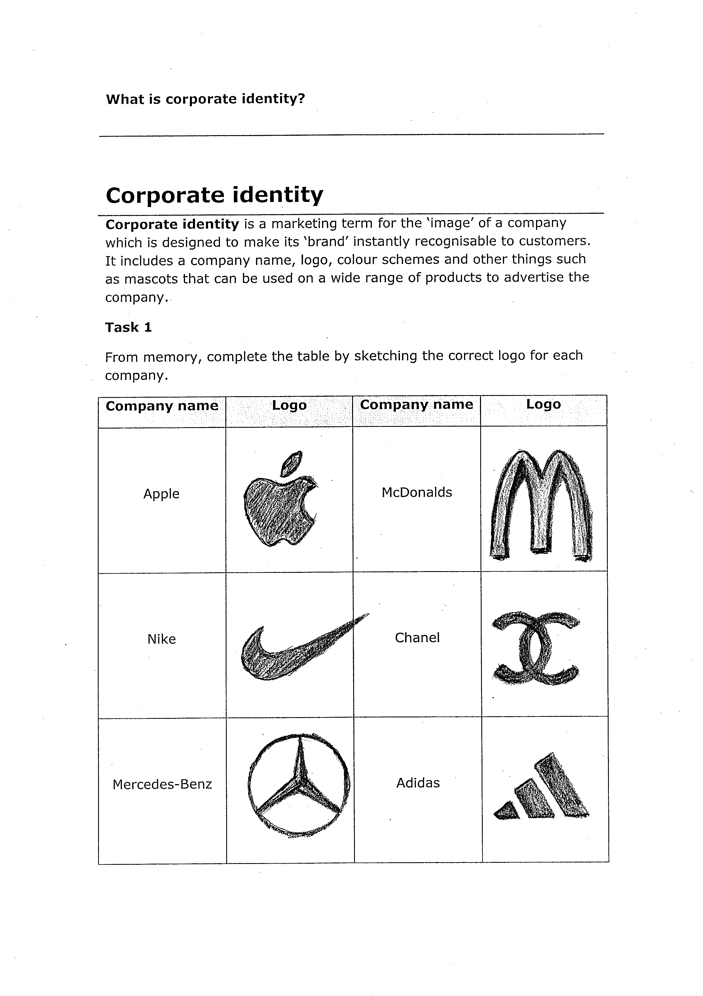 | McDonalds
Nike | 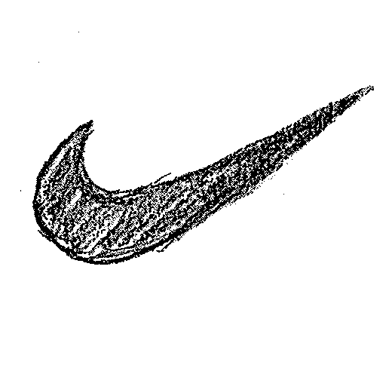 | Chanel
Mercedes-Benz |  | Adidas

Product Design/Business
Product analysis (Learner Activity Pack page 219)
Description of the activity/task
The aim of this task is for learners to use a simple set of criteria to analyse any product.
Level
Level 1
Time needed to complete task(s)
Approximately 45 minutes:
Task 1 (discussions) – allow 15 minutes
Task 2 (product scoring) – allow 30 minutes
Prior learning
n/a
Resources needed
Task sheets (1-2) for learners
Activity sheet
Materials: products for analysis (can use photographs)
Tutor notes
Task 1 – In a group, learners should consider and then describe the difference between a need and a want. Learners should then consider whether we NEED everything that we WANT, and how this can be used in design.
Task 2 – Learners should choose two similar products (e.g. two mobile phones) and analyse and compare using the ACCESS FM guidance supplied on Learner Activity Pack page 219.
Answers
There are no set answers for these tasks
Links to other skills development
English – Take part in discussions
Maths – Compare scores

This activity can be contextualised to suit any skills sector.
Follow-up / adaptation
Learners could:
- Use ACCESS FM to design a new product

Product Design/Business
Design specifications (Learner Activity Pack page 221)
Description of the activity/task
The aim of this task is for learners to use a specification to start the design process.
Level
Level 1
Time needed to complete task(s)
Approximately 45 minutes:
Task 1 (planning) – allow 10-15 minutes
Task 2 (design ideas) – allow 30 minutes
Prior learning
n/a, but learners may need an example of a specification statement
Resources needed
Task sheets (1-2) for learners
Materials: colouring pencils
Answers
Task 1 – No specific answers however, learners should identify five appropriate considerations to what could be required from a pair of trainers
Task 2 – No specific answers, however, learners should produce two different design ideas for the packaging that meet the specifications stated.
Links to other skills development
English – Plan ideas
PLTS – Think creatively

This activity can be contextualised to suit any skills sector.
Follow-up / adaptation
Learners could:
- Present the design ideas to a panel from a design agency using the task 2 specifications as a checklist

Product Design/Business
Batch production (Learner Activity Pack page 223)
Description of the activity/task
The aim of this task is for learners to simulate a batch production line.
Level
Level 1
Time needed to complete task(s)
Approximately 60 minutes:
Task 1 (planning) – allow 10 minutes
Task 2 (production) – allow 30 minutes
Task 3 (inspection) – allow 10 minutes
Task 4 (profit & loss) – allow 10 minutes
Prior learning
Introduction to key terms/concepts: batch production; inspection; profit & loss; break even
Resources needed
Task sheets (1-4) for learners
Activity sheet
Materials: carton templates (nets) photocopied onto card; scissors; glue sticks; colouring pencils
Tutor note
Learners will need to work in teams of four to simulate the batch production of a carton.
You will need to photocopy enough carton templates so that each group can make as many as possible in 30 minutes.

- Teams have just 30 minutes to make as many cartons as they can.
- Each carton needs to be inspected for quality. If accepted, it is ready to be sold. However, if it is rejected, it will be scrapped as it is not of a good enough quality.
- Each team will have to pay for the raw materials, equipment, overheads and wages in order to make their cartons.
- At the end, the whole team will complete a profit and loss account to see if they have made a profit.

Task 1 – Learners must first agree as a team their individual roles from the four provided, and then produce a quick plan of how they are going to make their cartons as quickly as possible.
Task 2 – The teams need to produce as many cartons as possible within 30 minutes, undertaking the job roles agreed in Task 1.
Task 3 – The team leader/inspector will examine each carton and determine whether it is of a good enough quality to be sold.
Task 4 - Using the activity sheet provided, the whole team will need to perform a profit/loss analysis
Answers
n/a – answers are dependent on learner performance. Calculations on the profit & loss account must be checked for accuracy.

Product Design/Business
Batch production (Learner Activity Pack page 223) cont…
Links to other skills development
English – Follow instructions, plan ideas, justify decisions in writing
Maths – Perform calculations
Working with others – Work effectively as a team

This activity can be contextualised to suit any skills sector.
Follow-up / adaptation
Learners could:
- Use this activity as a feasibility study/trial run for a new product range. Learners can give a presentation to the company directors based on their findings from the trial. Should the company start producing the new product?

Product Design/Business
Industry sectors (Learner Activity Pack page 229)
Description of the activity/task
The aim of this task is for learners to understand the roles of the three main industry sectors: primary, secondary and tertiary.
Level
Level 1
Time needed to complete task(s)
Approximately 45 minutes:
Task 1 (identifying companies in each sector) – allow10 minutes
Task 2 (list) – allow 5 minutes
Task 3 (interdependence grid) - allow 10 minutes
Task 4 (graphs) – allow15 -20 minutes
Prior learning
Introduction to key terms/concepts: primary; secondary; tertiary; interdependencies
Resources needed
Task sheets (1-4) for learners
Computer/graph paper
Tutor notes
Task 1 – Learners will need to search on the internet for examples of Primary, Secondary and Tertiary companies/organisations. Suggested websites include:
http://www.lse.co.uk/uk-sectors.asp
http://www.swslim.org.uk/labourmarket/sectors/index.asp
Task 2: Learners need to think about the types of raw materials from the primary sector that are used within the fast food industry.

should search on the use the
Answers
Task 1 – example answers sheet supplied
Task 2 – list of example answers supplied
Task 3 - list of example answers supplied
Task 4 – answer sheet supplied
Links to other skills development
English – Write clear and concise answers
Maths – Create a bar chart
ICT – Use MS Excel (optional), use search engines

This activity can be contextualised to suit any skills sector.
Follow-up/adaptation
Learners could:
- Simplify the tasks by providing the names of companies/originations for tasks 1-3
Task 1 – additional resource information

What are industry sectors?
Industries are often referred to as goods (producing a product) or service (providing a service) industries. Industries are classified according to the main Standard Industrial Classification (SIC) as follows:

- Goods-producing industries include: agriculture, fishing, forestry, mining, construction, and manufacturing
- Service-producing industries include: trade, transportation, communications and other public utilities, finance, insurance and real estate, community, personal and business services (includes health care, education, police services, etc.) and public administration.

Industries are also often referred to as being in the primary, secondary or tertiary sector.

- The primary sector includes agriculture, fishing, forestry and mining. The last three industries are sometimes referred to as the "other primary industries".
- The secondary sector includes construction and the manufacturing industries.
- The tertiary sector covers the service-producing industries.

* Content adapted from the South West Observatory: Skills and Learning Intelligence Module (SLIM) www.swslim.org.uk/labourmarket/sectors/index.asp
Task 1 - (example answers in bold)

Industry Sector | What it does | Examples | Company/  organisation
Primary | The primary sector is the first stage where the extraction of raw materials takes place. | Mining, oil drilling farming, fishing | UK coal,
Secondary | The secondary sector is where the products are made. It involves converting raw materials into components and assembling them into finished products. | Manufacturing industries, construction industries, food processing | Tate & Lyle, Balfour Beatty
Tertiary | The tertiary sector consists of the commercial services that support the production and distribution of products. | Insurance, transport, advertising, warehousing, public services (education, healthcare etc) | Aviva, Whitbread

Task 2
Suitable answers could include:
- Fish, Meat, Fruit, Vegetables
- Gas (for cooking)
- Card, paper, plastic – used in packaging

Task 3 - (example answers in bold)

Production phase |  | Example of product, service or industry
A | Primary to Secondary | Meat to Sausages
B | Secondary to Tertiary | New mobile phone advertised by advertising agency
C | Tertiary to Primary | Warehouse company provides storage for farmers crops
D | Primary to Tertiary | Crops (e.g. apples) delivered to supermarket
E | Tertiary to Secondary | Insurance company provides insurance to construction company
F | Secondary to Primary | Animal feed producer to farmer

Task 4 answer sheet
- Employment in Primary Industries has decreased between 1985 and 2005 by 2.7%
- Employment in Secondary Industries has decreased between 1985 and 2005 by 12.6%
- Employment in Tertiary Industries has increased between 1985 and 2005 by 15.3%

Product Design/ Business
Advertising your products (Learner Activity Pack page 233)
Description of the activity/task
The aim of this task is for learners to understand how and why a business advertises its products.
Level
Entry 3/Level 1
Time needed to complete task(s)
Approximately 45 minutes:
Task 1 (advertising methods ) – allow 10-15 minutes
Task 2 (word search) – allow 10 minutes
Task 3 (top 10 advertiser cards) – allow 5-10 minutes
Task 4 (top 10 reason cards) – allow 5-10 minutes
Prior learning
n/a
Resources needed
Task sheets for learners
Materials: top 10 advertiser cards; top 10 reason cards
Answers
Task 1 answer sheet supplied
Task 2 answer sheet supplied
Task 3 answer sheet supplied
Task 4 –suggested example answer sheet supplied
Links to other skills development
English – Give definitions

Learners can find adverts for companies in their chosen skills sector. Do they use all the advertising methods mentioned?
Follow-up / adaptation
Learners could:
- Complete a learner survey of the most popular brands. Are they the same as the most advertised brands?
Task 1 - answer sheet

Ways to advertise | What is the right answer | What does it mean?
anslog | slogan | A short and striking or memorable phrase used in advertising.
stoper | poster | A large printed picture or notice used for decoration or advertisement.
divoe | video | The recording, reproducing, or broadcasting of moving visual images.
refly | flyer | A small handbill advertising an event or product.
nabner | banner | A long strip of cloth bearing a slogan or design, carried in a demonstration or procession or hung in a public place  A heading or advertisement appearing on a web page in the form of a bar, column, or box
teafell | leaflet | A printed sheet of paper containing information or advertising and usually distributed free
rickest | sticker | An adhesive label or notice, generally printed or illustrated
boardbill | billboard | A large outdoor board for displaying advertisements

Task 2 answer sheet

e | c | d | p | c | w | o | r | l | d | p | e | o | k | i | t
c | x | h | b | f | t | e | m | o | c | s | s | h | w | e | g
l | i | b | a | n | d | q | p | a | h | f | c | d | k | r | i
i | e | s | o | r | t | i | a | w | d | n | e | r | i | a | y
a | w | l | b | q | o | n | s | f | i | x | a | m | n | p | l
m | j | s | y | r | r | u | c | a | r | m | s | c | o | m | l
y | t | h | e | s | u | n | r | f | e | v | a | d | q | o | e
l | c | b | m | z | g | q | e | h | c | f | d | o | m | c | s
i | d | r | e | a | m | s | t | f | t | n | s | n | l | o | a
a | k | n | o | i | a | e | r | i | l | a | a | a | f | g | b
d | s | b | h | l | r | l | h | o | i | r | l | l | s | a | e
o | v | j | g | a | t | z | c | v | n | g | t | d | j | l | m
i | a | v | p | k | l | s | d | p | e | o | a | s | g | u | o
k | p | m | c | l | e | o | q | s | y | s | u | g | v | d | h
f | o | a | u | t | z | c | h | u | r | c | h | i | l | l | d
c | b | a | f | s | r | e | v | a | s | c | e | p | s | e | k

Argos  ASDA  B and Q  Churchill  Comet  Compare the Market  Currys  Daily Mail  DFS  Direct Line | Dreams  Go Compare  Homebase  KFC  McDonalds  Specsavers  Tesco  The Sun  Waitrose

Task 3 answer sheet - Top spending TV brands/products *

Rank | Brand | £ Spend | % Change YOY
1 | DFS | 34,565,863 | 5.6
2 | McDonalds | 29,089,216 | 32.6
3 | Dreams | 23,664,369 | -0.2
4 | Argos | 22,308,593 | 33.6
5 | ASDA | 22,283,299 | -15.8
6 | B and Q | 17.964,205 | 36.6
7 | Compare the Market | 16,514,132 | 32.6
8 | Tesco | 15,910,523 | 32.0
9 | KFC | 15,757,546 | 20.0
10 | Daily Mail | 15,282,164 | 196.0
11 | Currys / PC World | 14,984,787 | 0.0
12 | Direct Line (Motor) | 14,929.388 | 8.6
13 | Direct Line (Home) | 14,832,367 | 70.2
14 | Homebase | 14,027,888 | 24.5
15 | Comet | 12,837,115 | 59.9
16 | The Sun | 11,825,849 | 48.4
17 | Waitrose | 11,456,903 | 290.4
18 | Specsavers | 11,159,746 | -5.1
19 | Churchill | 10,885,569 | 36.5
20 | Go Compare | 10,773,863 | -33.9

*Source – Nelson Media Research. Period: 01.01.10 – 31.12.10

Task 4 – suggested order answer sheet*

*The list below is based on findings from © thinkbox 2011

1 | It gives the best return for the money spent
2 | We are watching more TV than before
3 | You can reach 70% of people in one day on commercial TV!
4 | Everyone discusses adverts on TV
5 | TV makes people do things, e.g. voting or going on line
6 | People see the advert and then go online to buy
7 | They are the best way to advertise to young people
8 | We fall in love with the brand
9 | Companies use a variety of advertising campaigns but the TV is at the centre of them all
10 | Everyone gets to know the name and advertising often means that people remember the name.

Product Design/Business
Designing a supermarket (Learner Activity Pack page 239)
Description of the activity/task
The aim of this task is for learners to design the layout of a supermarket
Level
Entry 3/Level 1
Time needed to complete task(s)
Approximately 20 minutes:
Task 1 (supermarket design) – allow 15 minutes
Task 2 (product choice cards) – allow 5 minutes
Prior learning
n/a
Resources needed
Task sheets (1-2) for learners
Activity sheet
Materials: supermarket floor plan; aisle cards; product cards (in a different colour to the aisle cards
Tutor notes
Task 1 – Learners will design their own supermarket layout based on there they think products should be placed to make as much profit as possible. Learners will need to cut out the different types of aisles and place them on the supermarket layout resource sheet included in this guide. Learners should also identify two additional aisles that are not already listed to add to their layout. Once the first part of task has been completed, learners can be given the following page (240), which gives guidance around the profitability of the different types of aisles. Learners should consider whether they agree with these statements, review whether the supermarket layouts that they have designed fit in with these statements and analyse what changes they might make to their design.
Task 2 – Learners will cut out the list of products in task 2 and match these to the aisles in task one. There are some foods that will not match with the aisles given e.g. Frozen chips, so learners will also need to identify additional aisle categories.
Answers
Task 1 – there are no specific answers however, learners consider how to make as much profit as possible when deciding product placement
Task 2 – suggested example answers supplied
Links to other skills development
English – Use reading material to make decisions

This activity can be used to decide where to locate equipment in a care home (Health and Social Care), salon (Hair & Beauty), leisure centre (Sport & Leisure), farm (Land based), etc.
Follow-up / adaptation
Learners could:
- Use the instructions to label a given supermarket layout
- Visit a local supermarket
Task 1 – Resource Sheet – Supermarket layout

Entrance/Exit

Task 2 – suggested answers

Aisle | Suggested products
Baking supplies | Flour
Bread and Cakes | Bread  Rolls
Cash tills | Batteries
Canned goods
Cleaning materials | Detergent  Shampoo  Toothpaste
Convenience foods and ready-made meals | Frozen chips  Pizza  Sandwiches
Drinks | Bottled water
Fresh fruit and vegetables | Apples
Meat | Salami  Fish  Hamburgers
Milk and dairy products | Yogurt  Cheese
Paper products | Paper hankies  newspapers
Snacks and cereals | Crisps  Cereals  Peanuts
Sweets | Chocolate  Biscuits

Product Design/Business
Quality (Learner Activity Pack page 241)
Description of the activity/task
The aim of this task is for learners to understand the need for quality when designing and making products.
Level
Level 1
Time needed to complete task(s)
Approximately 45 minutes
Task 1 (examples of high/low quality products) – allow 5-10 minutes
Task 2 (important features for quality) – allow 5-10 minutes
Task 3 (production) – allow15 minutes
Task 4 (quality control check) – allow 10 minutes
Prior learning
n/a
Resources needed
Task sheets (1-4) for learners
Materials: cube nets photocopied onto card (different colours for different teams); scissors; glue sticks
Tutor notes
N.B. Learners will need to be split into small groups before beginning this activity.

Task 1 – Using the table supplied, learners should give individual examples of a high quality product, and a poor quality product with explanations of why they think it is of that quality. The learners should then discuss and analyse their answers within their groups.
Task 2 – Keeping in mind the answers given in Task 1, learners should individually identify five features that would be important in a high quality pair of trainers. The learners should then discuss and analyse their answers within their groups.
Task 3 – In their groups the learners need to cut out and assemble seven cubes to spell the word quality.
N.B Learners will need to cut out and assemble cubes using both cube nets provided in order to have all the letters required! It is easier if the cube nets are photocopied onto card that is stronger as paper may be too thin.

Instructions:
- Cut out your cube nets carefully, using scissors.
- Score the fold lines using the blunt part of the scissors or a ball point pen. This will make it easier to fold. Be careful not to cut the fold lines.
- Fold the paper to make right angles, and you will see the cube start to appear.
- Glue the cube together, using small dabs of glue on the glue tabs to stick it together.
- Put your seven cubes into a line to form the word QUALITY.
Task 4 – Learners should individually complete the table to test and evaluate their set of assembled cubes. Learners should then discuss

Product Design/Business
Quality (Learner Activity Pack page 241) cont…
Tutor notes cont…
their individual suggestions as to how they could make their cubes better within their groups.
Answers
Task 1 – Example answers provided
Task 2 – No specific answers however, the learners’ five features should reflect the examples of high quality products discussed in Task 1
Task 3 – No specific answers however, learners should cut out and produce seven cubes in order to spell out the word ‘Quality’
Task 4 – No specific answers, however learners should identify any ways they could have made their cubes better
Links to other skills development
English – Write clear and concise answers, take part in a discussion
Working with others – working effectively as a team

This activity can be used to identify high quality hand tools (Construction)
Follow-up / adaptation
Learners could:
- Write a brief product review, giving marks out of 5 for the product
Task 1 – example answers in bold

An example of a high-quality product is: | An example of a poor-quality product is:
It’s high-quality because:  - Made of the best materials, suitable to the purpose of the product – the product will perform better than others on the market  - The product is fit for purpose - does the job well  - Manufactured to a high standard – it is strong and will not break/wear out easily | It’s poor-quality because:  - Made of inadequate or unsuitable materials – the product will perform poorly compared to others on the market  - The product is not fit for purpose - does not do the job it was intended to do  - Manufactured to a poor standard – may break/wear out easily

Publication code: FL031273

