Name: _______________________________________________
GCE Stats section 9
Contingency tables
practice questions from GCE Maths
Date:
Question parts in red cover content in the GCE Statistics specification but outside this section of the scheme of work

Time:
Total marks available:
Total marks achieved: ______

Questions
Q1.
A doctor takes a random sample of 100 patients and measures their intake of saturated fats in their food and the level of cholesterol in their blood. The results are summarised in the table below.
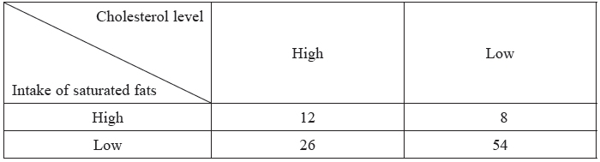
Using a 5% level of significance, test whether or not there is an association between cholesterol level and intake of saturated fats. State your hypotheses and show your working clearly.
(Total 10 marks)

Q2.
A new drug to vaccinate against influenza was given to 110 randomly chosen volunteers. The volunteers were given the drug in one of 3 different concentrations, A, B and C, and then were monitored to see if they caught influenza. The results are shown in the table below.
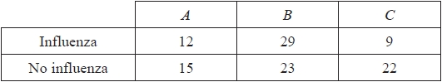
Test, at the 10% level of significance, whether or not there is an association between catching influenza and the concentration of the new drug. State your hypotheses and show your working clearly. You should state your expected frequencies to 2 decimal places.
(Total for question = 10 marks)

Q3.
A survey asked a random sample of 200 people their age and the main use of their mobile phone.
The results are shown in Table 1 below.
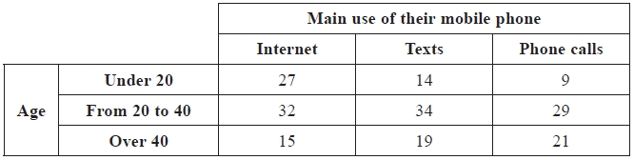
Table 1
The data are to be used to test whether or not age and main use of their mobile phone are independent.
Table 2 shows the expected frequencies for each group, assuming people's age and main use of their mobile phone are independent.
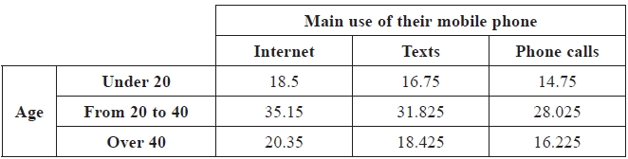
Table 2
(a) For users under 20 choosing the Internet as the main use of their mobile phone,
(i) verify that the expected frequency is 18.5
(ii) show that the contribution to the χ² test statistic is 3.91 to 3 significant figures.
(2)
(b) Given that the χ² test statistic for the data is 9.893 to 3 decimal places, test at the 5% level of significance whether or not age and main use of their mobile phone are independent. State your hypotheses clearly.
(5)
(Total 7 marks)

Q4.
A number of males and females were asked to rate their happiness under the headings "not happy",
"fairly happy" and "very happy".
The results are shown in the table below
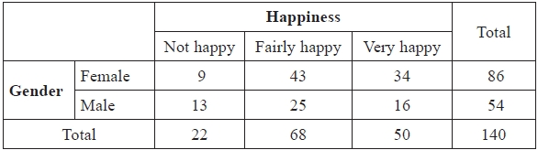
Stating your hypotheses, test at the 5% level of significance, whether or not there is evidence of an association between happiness and gender. Show your working clearly.
(Total 10 marks)

Q5.
A factory manufactures batches of an electronic component. Each component is manufactured in one of three shifts. A component may have one of two types of defect, D₁ or D₂ , at the end of the manufacturing process. A production manager believes that the type of defect is dependent upon the shift that manufactured the component. He examines 200 randomly selected defective components and classifies them by defect type and shift. The results are shown in the table below.
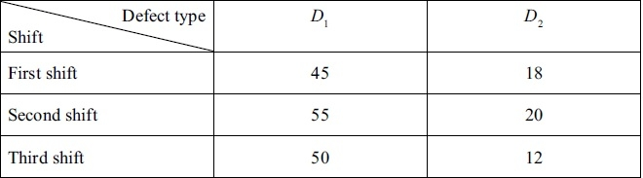
Stating your hypotheses, test, at the 10% level of significance, whether or not there is evidence to support the manager's belief. Show your working clearly.
(Total 10 marks)

Q6.
A psychologist carries out a survey of the perceived body weight of 150 randomly chosen people. He asks them if they think they are underweight, about right or overweight. His results are summarised in the table below.
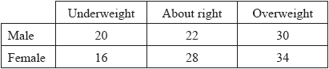
The psychologist calculates two of the expected frequencies, to 2 decimal places, for a test of independence between perceived body weight and gender. These results are shown in the table below.
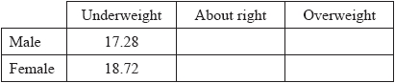
(a) Complete the table of expected frequencies shown above.
(2)
(b) Test, at the 10% level of significance, whether or not perceived body weight is independent of gender. State your hypotheses clearly.
(7)
The psychologist now combines the male and female data to test whether or not body weight types are chosen equally.
(c) Find the smallest significance level, from the tables in the formula booklet, for which there is evidence of a preference.
(5)
(Total for question = 14 marks)

Q7.
John thinks that a person's eye colour is related to their hair colour. He takes a random sample of
600 people and records their eye and hair colours. The results are shown in Table 1.
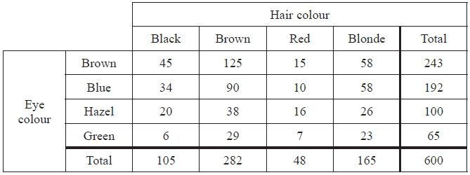
Table 1
John carries out a χ² test in order to test whether eye colour and hair colour are related. He calculates the expected frequencies shown in Table 2.
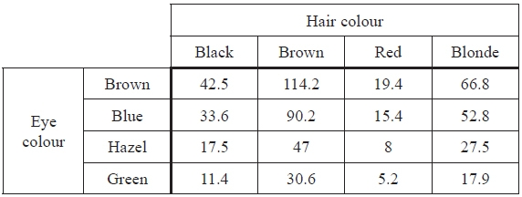
Table 2
(a) Show how the value 47 in Table 2 has been calculated.
(1)
(b) Write down the number of degrees of freedom John should use in this χ² test.
(1)
Given that the value of the χ² statistic is 20.6, to 3 significant figures,
(c) find the smallest value of α for which the null hypothesis will be rejected at the α% level of significance.
(1)
(d) Use the data from Table 1 to test at the 5% level of significance whether or not the proportions of people in the population with black, brown, red and blonde hair are in the ratio 2:6:1:3
State your hypotheses clearly.
(9)
(Total 12 marks)
Q8.
Two breeds of chicken are surveyed to measure their egg yield. The results are shown in the table below.
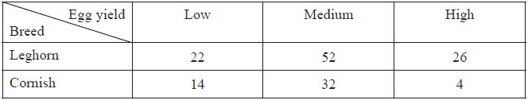
Showing each stage of your working clearly, test, at the 5% significance level, whether or not there is an association between egg yield and breed of chicken. State your hypotheses clearly.
(Total 10 marks)

Q9.
A random sample of 100 people were asked if their finances were worse, the same or better than this
time last year. The sample was split according to their annual income and the results are shown in
the table below.
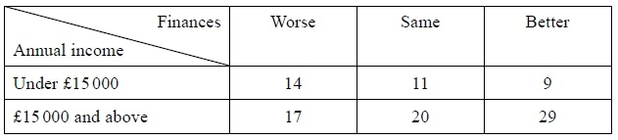
Test, at the 5% level of significance, whether or not the relative state of their finances is independent of their income range. State your hypotheses and show your working clearly.
(Total 10 marks)

Q10.
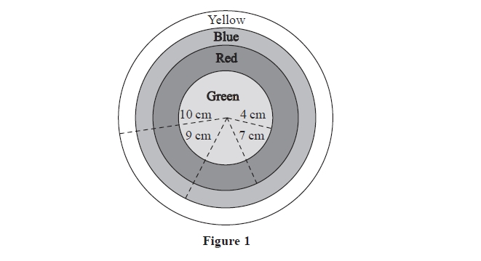
The sketch in Figure 1 represents a target which consists of 4 regions formed from 4 concentric circles of radii 4 cm, 7 cm, 9 cm and 10 cm. The regions are coloured as labelled in Figure 1.
A random sample of 100 children each choose a point on the target and their results are summarised in the table below.
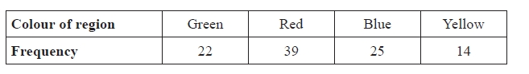
Caitland is trying to model the distribution of the points chosen by the children. She defines the random variable D to be the distance, in cm, of a point from the centre of the target and assumes D ~ U0, 10.
(a) Stating your hypotheses clearly and using a 1% level of significance, test whether or
not U 0, 10 is a suitable model for these data.
(9)
Henry claims that the points are randomly distributed over the target and the probability of a point
being in any particular region is proportional to the area of that region. He calculates expected
frequencies and obtains the following table.
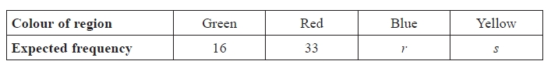
(b) Find the value of r and the value of s.
(3)

Henry obtained a test statistic of 6.188 and no groups were pooled.
(c) State what conclusion Henry should make about his claim.
(2)
Phoebe believes that the children chose the region of the target according to colour. She believes that boys and girls would favour different colours and splits the original data by gender to obtain the following table.
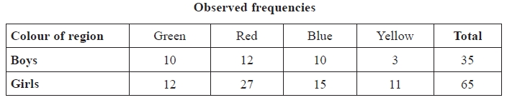
(d) State suitable hypotheses to test Phoebe's belief.
(1)
Phoebe calculated the following expected frequencies to carry out a suitable test.
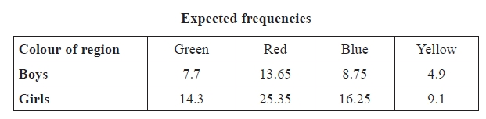
(e) Show how the value of 25.35 was obtained.
(1)
Phoebe carried out the test using 2 degrees of freedom and a 10% level of significance.
She obtained a test statistic of 1.411
(f) Explain clearly why Phoebe used 2 degrees of freedom.
(1)
(g) Stating your critical value clearly, determine whether or not these data support Phoebe's belief.
(2)
(Total for question = 19 marks)

Examiner's Report
Q1.
This proved to be a friendly opening to the paper with very few failing to show sufficient working and many scoring full marks. Some lost marks for the hypotheses either through laziness (simply stating "no association" for the null hypothesis is not sufficient as we want to see the variables under consideration being mentioned) or for stating them the wrong way around. The calculations were usually correct but some mistakes occurred in the degrees of freedom and the conclusion was not always given in context.

Q2.
Hypotheses and final conclusions were usually stated correctly although some were imprecise, missing out either 'concentration' or 'drug'. Many students were accurate in their calculations and most had the correct degrees of freedom. A few, however, read the critical value from the wrong column in the tables. Not all students are showing the calculation needed for expected values, but the majority gave a correct explicit statement regarding their null hypothesis based on their values.

Q3.
Full marks were often awarded in question (a) as the methods were well understood and were calculated accurately. Some confusion was evident in the formulation of the hypotheses in question (b), but again full marks here was not unusual.

Q4.
This was a routine question for the majority of students. Both the hypotheses and the result of the test were usually given in context and many fully correct solutions were seen here.
Premature rounding proved costly in some solutions offered and typically these students did not show all their calculations

Q5.
This was done very well by most candidates. Calculations were accurate and well set out, hypotheses clearly stated and a correct critical value was common. Some candidates used the easier calculation method and very few confused the solution with correlation.

Q6.
Part (a) was fully correct for the majority of students who were able to state their hypotheses using the correct context and key words. However, some are still incorrectly writing there is an 'association'. All but the very weakest of students were able to calculate the correct test statistic, but students should be advised to check every calculation thoroughly as incorrect answers were generally down to a misplaced digit in one of their calculations.
Part (c) was more of a challenge. Those who attempted it generally managed to get to a correct test statistic, but were then unsure how to proceed or simply stated 1% was the lowest significance level with little understanding of how to check this. If a student set off on a route with O and E the same, this method usually resulted in no marks being awarded.

Q7.
The χ² tests were only examined in this one question on this paper and a number of candidates failed to identify the fairly straightforward goodness of fit test in part (d). The first three parts were answered well and most scored full marks although a few misread the tables and thought α was 1 and some gave α as 0.025. In part (d) the common error was to simply calculate the test statistic for a test of association between hair colour and eye colour rather than using the column totals from Table 1 to conduct the goodness of fit test on the hair colour ratios. Those who did attempt the correct test could usually calculate the expected frequencies and often completed the test accurately.

Q8.
This was a ready source of marks to the great majority of candidates. The only common error seen was in the statement of the hypotheses and the conclusion, which were sometimes incomplete.

Q9.
For most candidates this question was a good source of marks. Hypotheses were usually correctly phrased in terms of "independence" or "association" and the calculations were usually clearly set out although some inappropriate rounding sometimes gave an answer of 3.56. The degrees of freedom and critical value caused few problems and most gave a correct conclusion in context.

Q10.
This question allowed competent students to score very well. Far too many students did the first test with an assumption of equal expected values. This probably was a result of not having read the question carefully enough. Students found part (b) and part (e) a good source of marks and part (c) only marginally less so. Too many students were unable to express their hypotheses precisely enough in part (d) but were able to successfully give the correct interpretation of the test result in part (g). Most students were able to explain the calculation of the degrees of freedom in part (f), but too many thought that the pooling of two columns would simply lead to the loss of 1 degree of freedom from the original number.

Mark Scheme

Section 9 | Contingency tables
qu.1 | June 2013 S3 - Q1
qu.2 | May 2016 S3 - Q2
qu.3 | May 2014 S3R - Q2
qu.4 | May 2014 S3 - Q3
qu.5 | June 2011 S3 - Q3
qu.6 | May 2017 S3 - Q4
qu.7 | June 2013 S3R - Q4abc
qu.8 | June 2012 S3 - Q4
qu.9 | June 2010 S3 - Q5
qu.10 | May 2015 S3 - Q6defg

Q1.
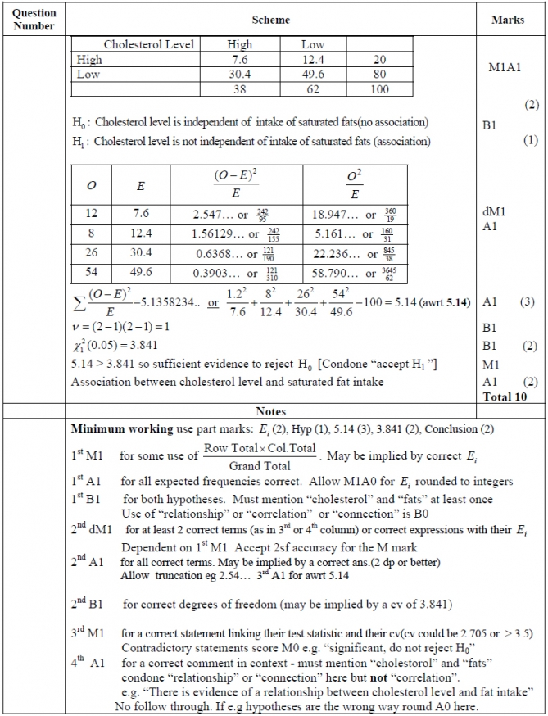

Q2.
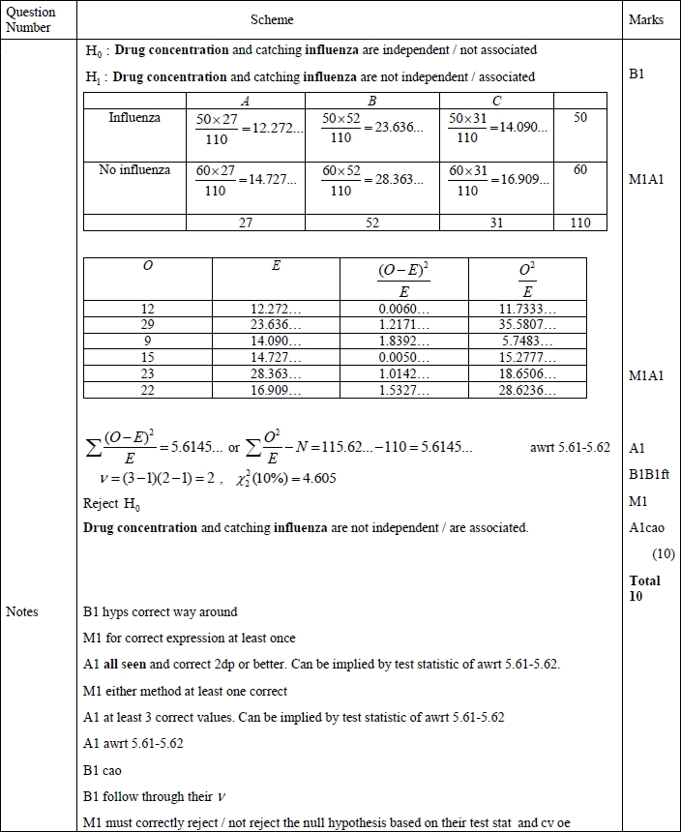

Q3.
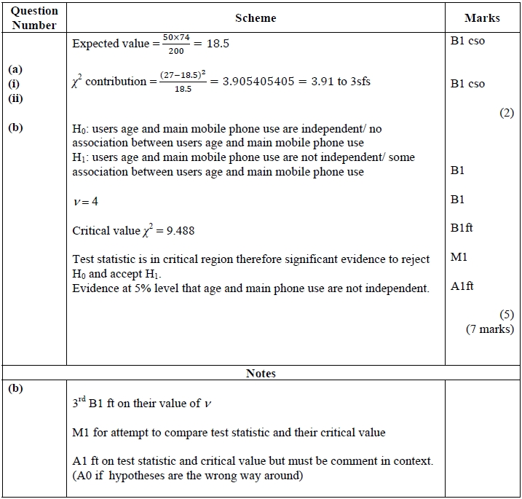

Q4.
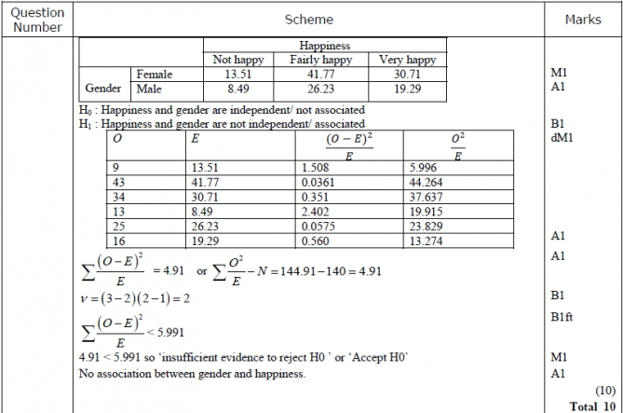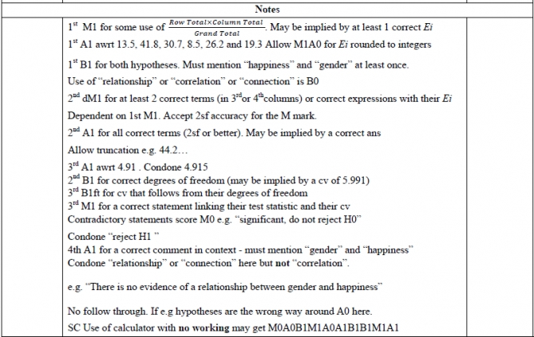

Q5.
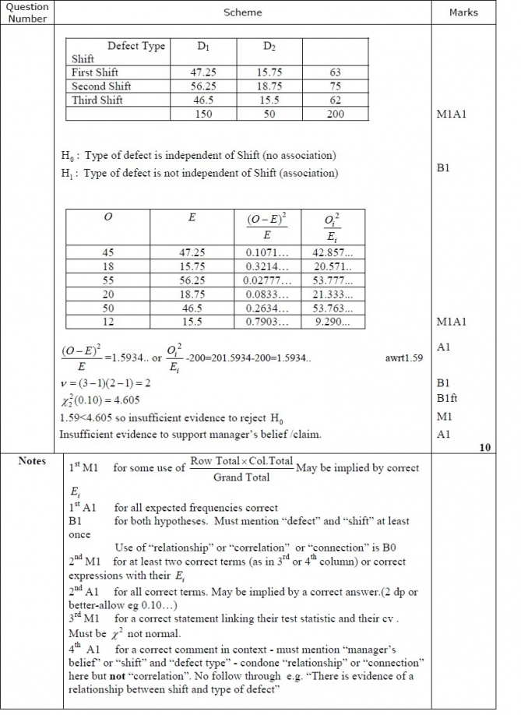

Q6.
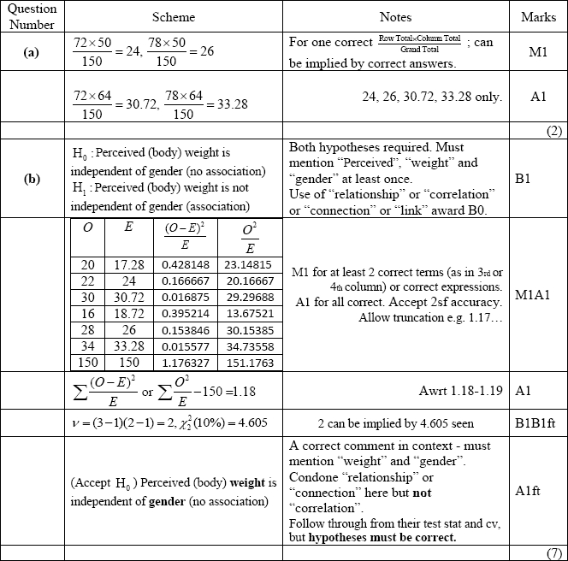
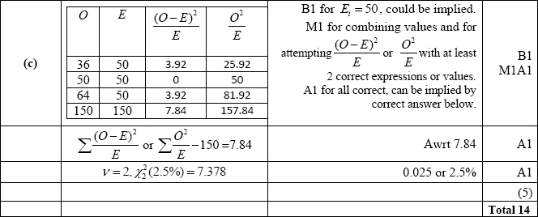
Q7.
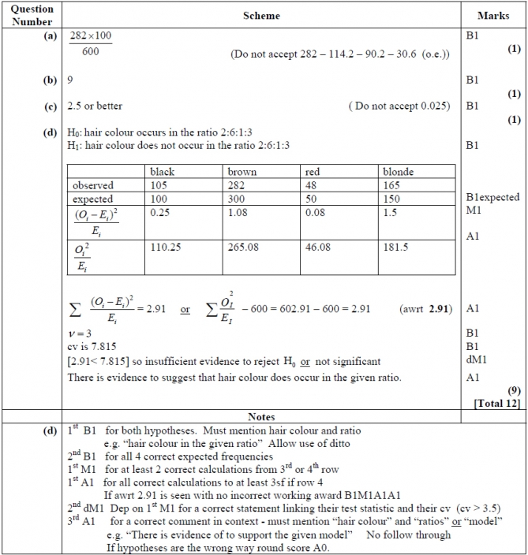

Q8.
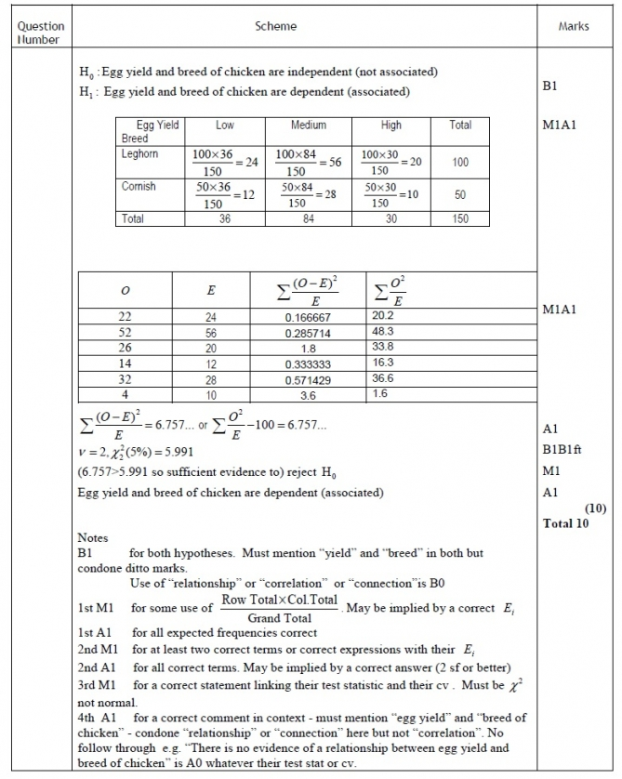

Q9.
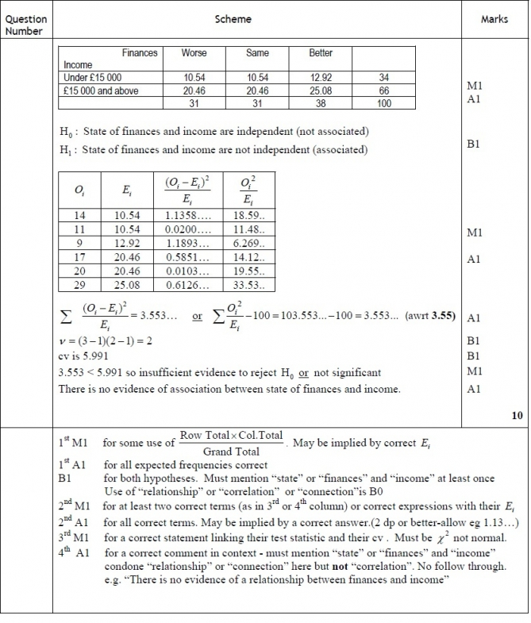

Q10.
