Name: _______________________________________________
GCE Stats section 7
Correlation and linear regression
practice questions from GCE Maths part 2
Date:
Question parts in red cover content in the GCE Statistics specification but outside this section of the scheme of work

Time:
Total marks available:
Total marks achieved: ______

Questions
Q21.
A mobile library has 160 books for children on its records. The librarian believes that books with fewer pages are borrowed more often. He takes a random sample of 10 books for children.
(a) Explain how the librarian should select this random sample.
(2)
The librarian ranked the 10 books according to how often they had been borrowed, with 1 for the book borrowed the most and 10 for the book borrowed the least. He also recorded the number of pages in each book. The results are in the table below.
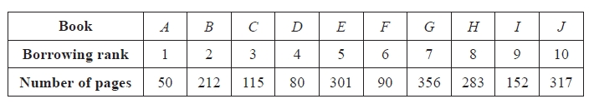
(b) Calculate Spearman's rank correlation coefficient for these data.
(4)
(c) Test the librarian's belief using a 5% level of significance. State your hypotheses clearly.
(3)
(Total for question = 9 marks)

Q22.
A journalist is investigating factors which influence people when they buy a new car. One possible factor is fuel efficiency. The journalist randomly selects 8 car models. Each model's annual sales and fuel efficiency, in km/litre, are shown in the table below.
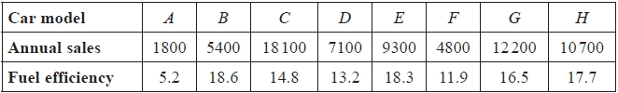
(a) Calculate Spearman's rank correlation coefficient for these data.
(5)
The journalist believes that car models with higher fuel efficiency will achieve higher sales.
(b) Stating your hypotheses clearly, test whether or not the data support the journalist's belief.
Use a 5% level of significance.
(4)
(c) State the assumption necessary for a product moment correlation coefficient to be valid in this case.
(1)
(d) The mean and median fuel efficiencies of the car models in the random sample are 14.5 km/litre and 15.65 km/litre respectively. Considering these statistics, as well as the distribution of the fuel efficiency data, state whether or not the data suggest that the assumption in part (c) might be true in this case. Give a reason for your answer. (No further calculations are required.)
(1)
(Total 11 marks)

Q23.
Interviews for a job are carried out by two managers. Candidates are given a score by each manager and the results for a random sample of 8 candidates are shown in the table below.
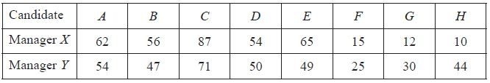
(a) Calculate Spearman's rank correlation coefficient for these data.
(5)
(b) Test, at the 5% level of significance, whether there is agreement between the rankings awarded by each manager. State your hypotheses clearly.
(5)
Manager Y later discovered he had miscopied his score for candidate D and it should be 54.
(c) Without carrying out any further calculations, explain how you would calculate Spearman's rank correlation in this case.
(2)
(Total 12 marks)
Q24.
The table below shows the number of students per member of staff and the student satisfaction scores for 7 universities.
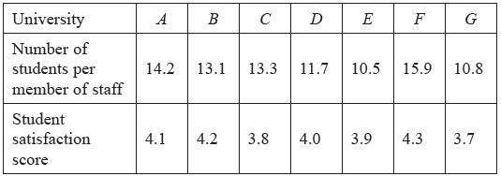
(a) Calculate Spearman's rank correlation coefficient for these data.
(5)
(b) Stating your hypotheses clearly test, at the 5% level of significance, whether or not there is evidence of a correlation between the number of students per member of staff and the student satisfaction score.
(3)
(Total 8 marks)

Q25.
A county councillor is investigating the level of hardship, h, of a town and the number of calls per 100 people to the emergency services, c. He collects data for 7 randomly selected towns in the county. The results are shown in the table below.
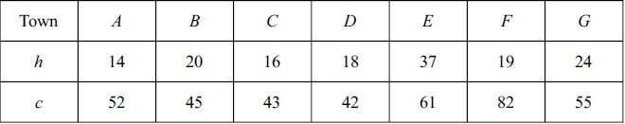
(a) Calculate the Spearman's rank correlation coefficient between h and c.
(6)
After collecting the data, the councillor thinks there is no correlation between hardship and the number of calls to the emergency services.
(b) Test, at the 5% level of significance, the councillor's claim. State your hypotheses clearly.
(4)
(Total 10 marks)

Q26.
A junior judge is being trained by a senior judge to learn how to assess ice skaters. After the training, the judges each assess 6 ice skaters A, B, C, D, E and F. They each list them in order of preference with the best ice skater first. The results are shown in the table below.
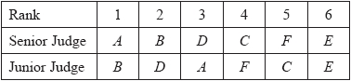
(a) Calculate Spearman's rank correlation coefficient for these data.
(5)
(b) Test, at the 5% level of significance, whether or not there is evidence of a positive correlation between the rankings of the junior judge and the senior judge. State your hypotheses clearly.
(4)
(c) Comment on the effectiveness of the training delivered by the senior judge.
(1)
(Total for question = 10 marks)

Q27.
(a) Describe when you would use Spearman's rank correlation coefficient rather than the product moment correlation coefficient to measure the strength of the relationship between two variables.
(1)
A shop sells sunglasses and ice cream. For one week in the summer the shopkeeper ranked the daily sales of ice cream and sunglasses. The ranks are shown in the table below.
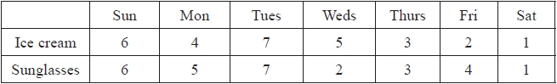
(b) Calculate Spearman's rank correlation coefficient for these data.
(3)
(c) Test, at the 5% level of significance, whether or not there is a positive correlation between sales of ice cream and sales of sunglasses. State your hypotheses clearly.
(4)
The shopkeeper calculates the product moment correlation coefficient from his raw data and finds r = 0.65
(d) Using this new coefficient, test, at the 5% level of significance, whether or not there is a positive correlation between sales of ice cream and sales of sunglasses.
(2)
(e) Using your answers to part (c) and part (d), comment on the nature of the relationship between sales of sunglasses and sales of ice cream.
(1)
(Total for question = 11 marks)
Q28.
The table below shows the population and the number of council employees for different towns and villages.
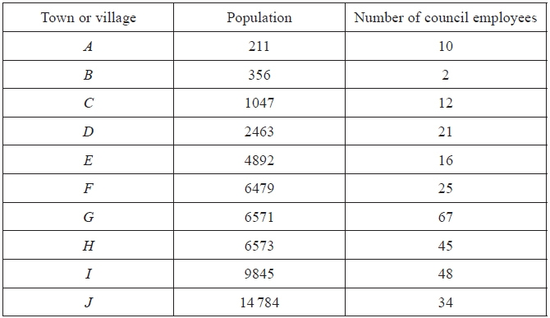
(a) Find, to 3 decimal places, Spearman's rank correlation coefficient between the population and the number of council employees.
(5)
(b) Use your value of Spearman's rank correlation coefficient to test for evidence of a positive correlation between the population and the number of council employees. Use a 2.5% significance level. State your hypotheses clearly.
(4)
It is suggested that a product moment correlation coefficient would be a more suitable calculation in this case. The product moment correlation coefficient for these data is 0.627 to 3 decimal places.
(c) Use the value of the product moment correlation coefficient to test for evidence of a positive correlation between the population and the number of council employees. Use a 2.5% significance level.
(2)
(d) Interpret and comment on your results from part (b) and part (c).
(2)
(Total 13 marks)

Q29.
A researcher claims that, at a river bend, the water gradually gets deeper as the distance from the inner bank increases. He measures the distance from the inner bank, b cm, and the depth of a river, s cm, at seven positions. The results are shown in the table below.
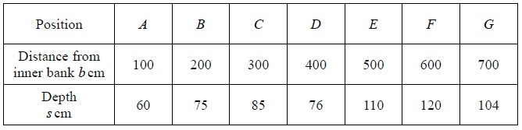
(a) Calculate Spearman's rank correlation coefficient between b and s.
(6)
(b) Stating your hypotheses clearly, test whether or not the data provides support for the researcher's claim. Use a 1% level of significance.
(4)
(Total 10 marks)

Q30.
The heights, in metres, and weights, in kilograms, of a random sample of 9 men are shown in the table below
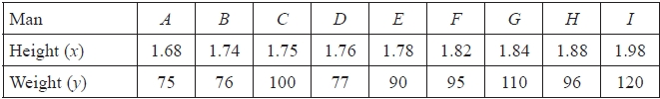
(a) Given that S_{xx} = 0.0632, S_{yy} = 1957.5556 and S_{xy} = 9.3433 calculate, to 3 decimal places, the product moment correlation coefficient between height and weight for these men.
(2)
(b) Use your value of the product moment correlation coefficient to test whether or not there is evidence
of a positive correlation between the height and weight of men. Use a 5 % significance level.
State your hypotheses clearly.
(4)
Peter does not know the heights or weights of the 9 men. He is given photographs of them and asked to put them in order of increasing weight. He puts them in the order
A C E B G D I F H
(c) Find, to 3 decimal places, Spearman's rank correlation coefficient between Peter's order and the
actual order.
(6)
(d) Use your value of Spearman's rank correlation coefficient to test for evidence of Peter's ability to correctly order men, by their weight, from their photographs. Use a 5% significance level and state your hypotheses clearly.
(4)
(Total 16 marks)
Examiner's Report
Q21.
A straightforward starter question dealing with correlation with most students managing the coefficient easily. They carried out the test well and typically gave its result in context.
The sampling only caused problems to those who are content with text book answers or who decided to go down the systematic route.

Q22.
This was a productive start to the paper for the majority of students with completely correct responses seen often in question (a). The hypothesis test in question (b) usually had the correct critical value, but common errors were the hypotheses being badly formed in words. Weaker responses usually missed the final conclusion in context. Question (c) was known to more students than might have been expected and if the correct terms were not known in question (d), a justification by describing skewness was not uncommon.

Q23.
This was a good start to the paper for the majority of candidates with part (a) usually being awarded full marks. In part (b) some candidates chose a two-tailed test when a one-tailed test was expected. There were very few attempts that scored both marks in part (c) with the majority being unaware of the need to use the product moment correlation coefficient and some deciding to simply ignore the tied ranks.

Q24.
The calculation of rs was, as usual, completed very well with only small minorities making slips in ranking or forgetting the "1 – " when evaluating their answer. There were a good number of fully correct responses to part (b) too although some still fail to state their hypotheses in terms of ρ. A number of candidates did not ensure that their critical value matched their alternative hypothesis and of course there were the usual crop of conclusions that did not include a reference to the context.

Q25.
This question was answered very well by the majority of candidates, with all but the very weakest candidates offering complete solutions. There was the occasional solution that gave hypotheses only in words, but this was unusual.

Q26.
Most students found part (a) straightforward scoring full marks with arithmetic slips or incorrect use of formula rarely seen. Pleasingly, reversed ranks were rarely seen. The most common error from a number of students was to 'code' the letters (A=1, B=2, etc.) and use these as ranks, leading to a wholly incorrect solution.
In part (b), there were many good answers here with most students able to identify the correct critical value from the tables and compare with their value to reject the null hypothesis. Most had correct hypotheses with very few in terms of r or simply stating them in words. The most common mark to be missed was for the final conclusion lacking some context e.g. no references to Judges, or referencing correlation but omitting 'positive'.
Part (c) was usually correct stating in various ways that the training was not effective.
Q27.
Many students are able to offer a correct reason in part (a), usually referencing normality or less often linearity. Some answers incorrectly referred to tied ranks or vaguely to discrete or subjective data. Calculations in part (d) were correct most of the time. In part (c), hypotheses were usually stated correctly in terms of ρ rather than r although a few erroneously stated in words. The correct critical values were usually found in parts (c) and (d) and most explicitly stated a correct decision for the null hypothesis. However, the mark most commonly lost was for concluding in context; too many were incomplete referring only to correlation rather than positive correlation. A majority of students realised that the difference in the results from part (c) and part (d) meant there was a non-linear relationship. There are a number, however, who appear unaware of the distinction between the two coefficients.

Q28.
Part (a) was answered very well and most scored full marks too for the hypothesis test in part (b) but a few failed to give their hypotheses in terms of ρ. Part (c) was answered well but then in part (d) few knew how to interpret these results. A handful realized that the product moment correlation coefficient (pmcc) was measuring the degree of a linear relationship and because Spearman's used ranks a non-linear relationship between the variables could be present. A few more mentioned that a bivariate normal distribution is needed to use pmcc but this assumption is not required for Spearman's.

Q29.
Most candidates secured full marks in part (a) with only a small number making arithmetic errors and a tiny minority failing to use ranks or using an incorrect formula.
The hypothesis test in part (b) was often answered very well too. Some did not use ρ for the hypotheses and some failed to give a full conclusion in context but most had the correct critical value and gave a correct statement about H₀.

Q30.
Question (a) was well done by the great majority but a mark was often lost carelessly by not giving the answer as required. The test in question (b) was usually done well with most students speaking of positive correlation in their answer. Ranking accurately was an issue in question (c), with many ranking height rather than weight, but the required technique was clearly evident. The test in question (d) was also well done by most students with good answers in context using key words. There were more two tailed tests attempted here and a failure to relate their result to the question was more evident that earlier in the question.

Mark Scheme

Section 7 | Correlation and linear regression part 2
qu.21 | May 2015 S3 - Q1bc
qu.22 | May 2014 S3R - Q1
qu.23 | June 2012 S3 - Q1
qu.24 | June 2013 S3 - Q2
qu.25 | June 2011 S3 - Q2
qu.26 | May 2017 S3 - Q3 all (c*)
qu.27 | May 2016 S3 - Q3
qu.28 | June 2013 S3R - Q3
qu.29 | June 2010 S3 - Q4
qu.30 | May 2014 S3 - Q8

Q21.
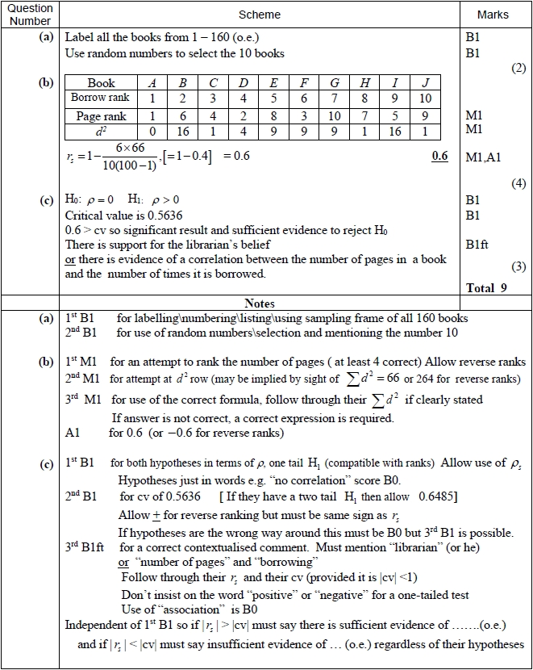

Q22.
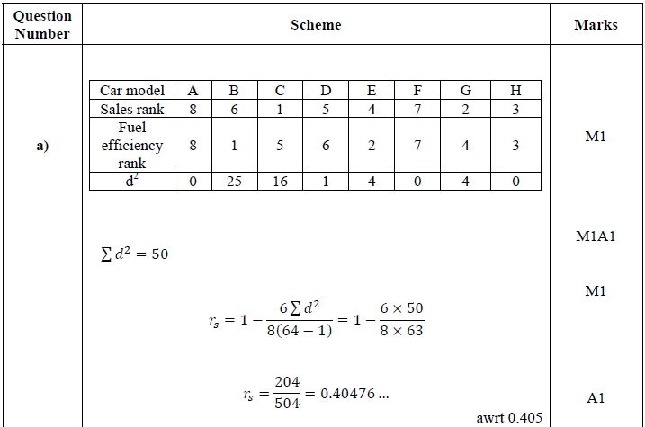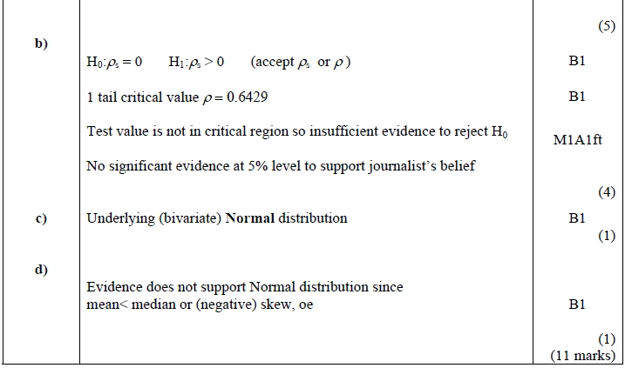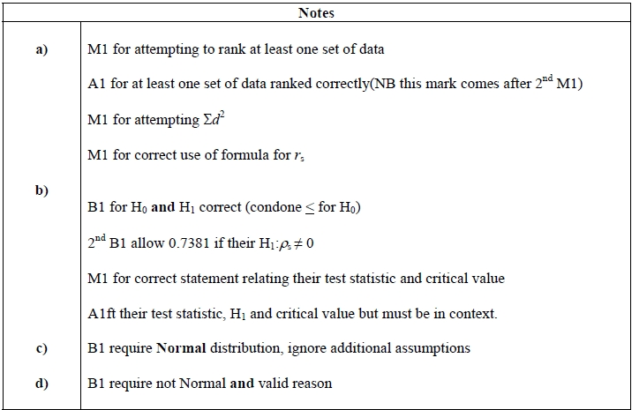

Q23.
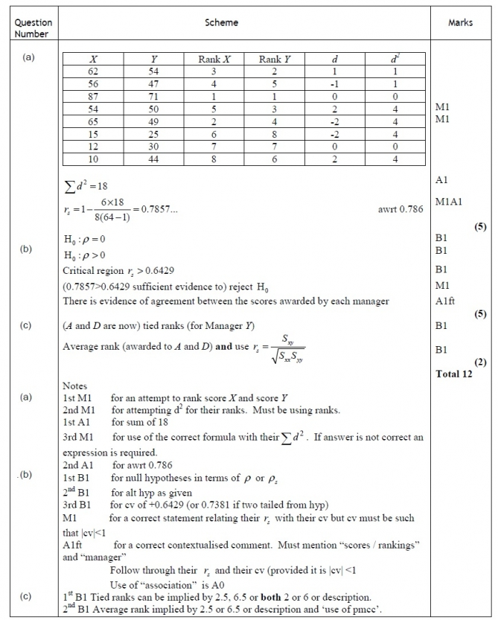

Q24.
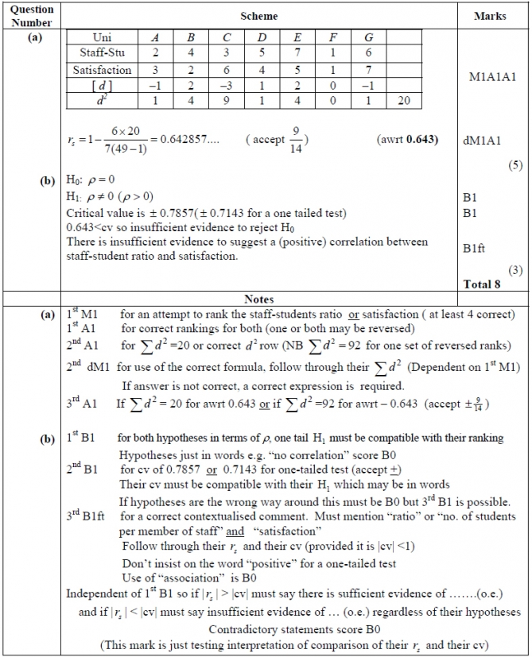

Q25.
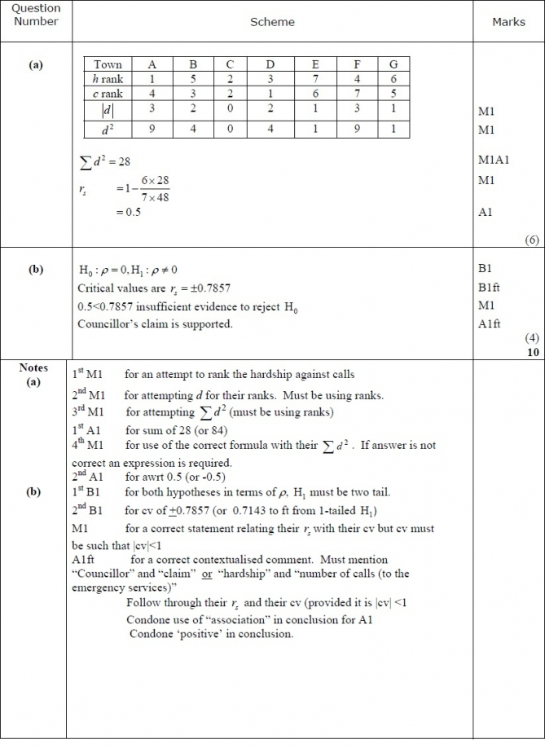

Q26.
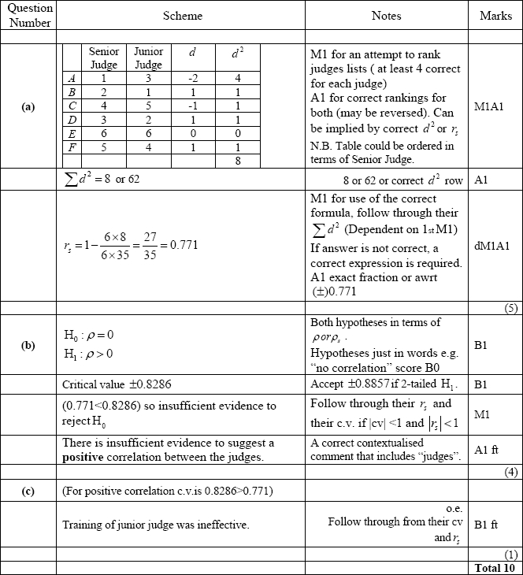

Q27.
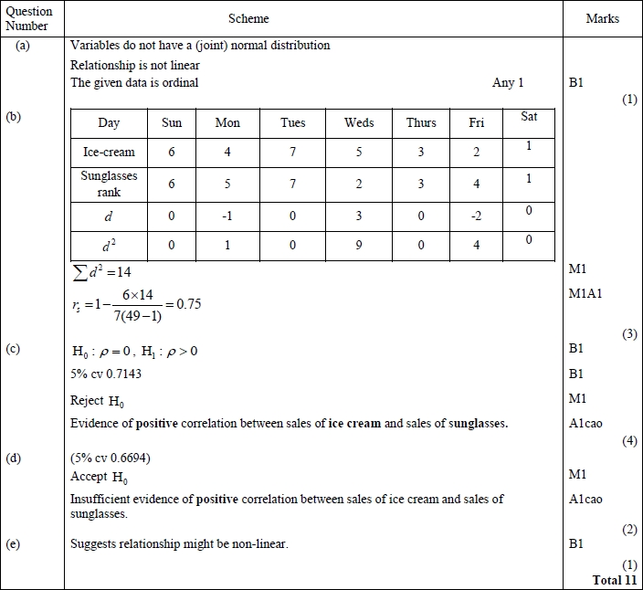
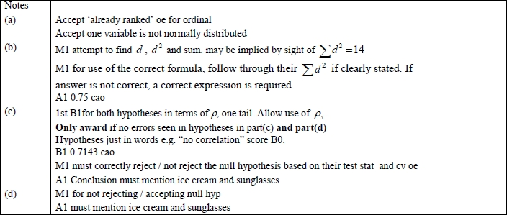
Q28.
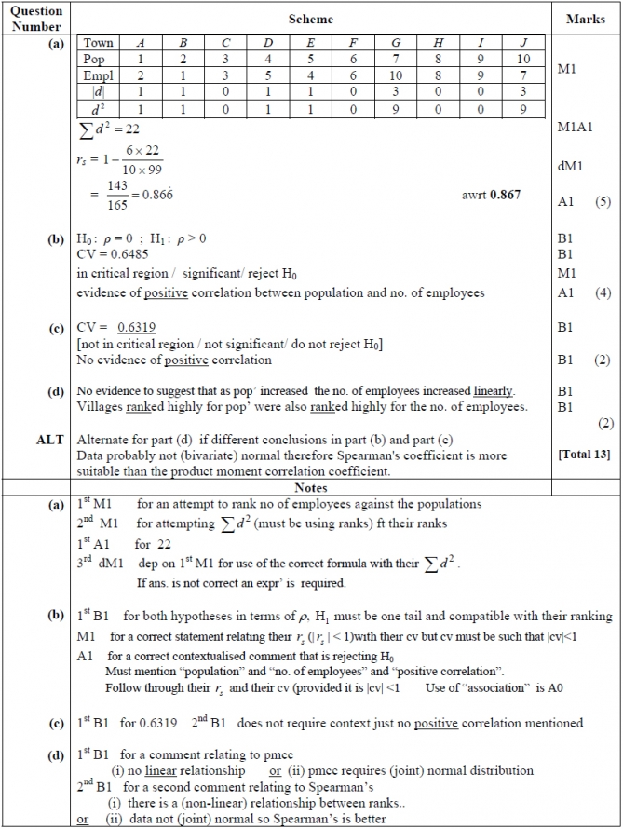

Q29.
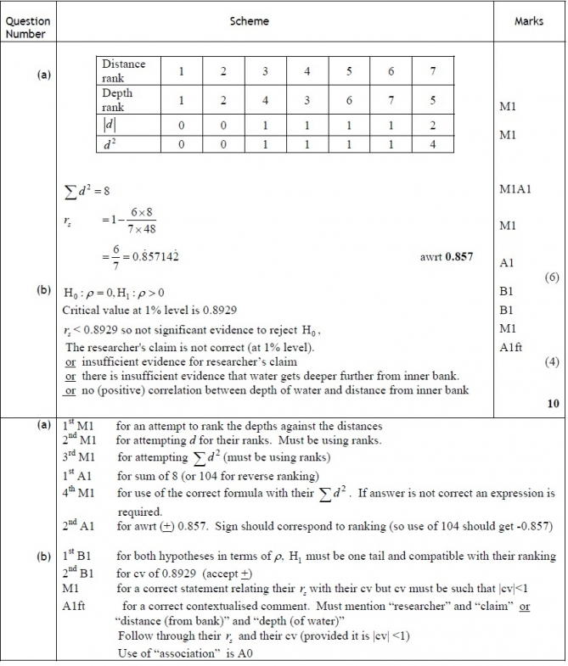

Q30.
