Name: _______________________________________________
GCE Stats section 7
Correlation and linear regression
practice questions from GCE Maths part 1
Date:
Question parts in red cover content in the GCE Statistics specification but outside this section of the scheme of work

Time:
Total marks available:
Total marks achieved: ______

Questions
Q1.
A clothes shop manager records the weekly sales figures, £ s, and the average weekly temperature, t °C, for 6 weeks during the summer. The sales figures were coded so that
The data are summarised as follows
(a) Find S_{wt} and S_{tt}
(3)
(b) Write down the value of S_{ss} and the value of S_{st}
(2)
(c) Find the product moment correlation coefficient between s and t.
(2)
The manager of the clothes shop believes that a linear regression model may be appropriate to describe these data.
(d) State, giving a reason, whether or not your value of the correlation coefficient supports the manager's belief.
(1)
(e) Find the equation of the regression line of w on t, giving your answer in the form w = a + bt
(3)
(f) Hence find the equation of the regression line of s on t, giving your answer in the form s = c + dt, where c and d are correct to 3 significant figures.
(2)
(g) Using your equation in part (f), interpret the effect of a 1°C increase in average weekly temperature on weekly sales during the summer.
(1)
(Total for question = 14 marks)

Q2.
A biologist is studying the behaviour of bees in a hive. Once a bee has located a source of food, it returns to the hive and performs a dance to indicate to the other bees how far away the source of the food is. The dance consists of a series of wiggles. The biologist records the distance, d metres, of the food source from the hive and the average number of wiggles, w, in the dance.
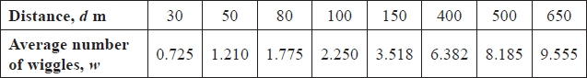
[You may use ∑ w = 33.6 ∑ dw 13 833 S_{dd} = 394 600 S_{ww} = 80.481 (to 3 decimal places)]
(a) Show that S_{dw} = 5601
(2)
(b) State, giving a reason, which is the response variable.
(1)
(c) Calculate the product moment correlation coefficient for these data.
(2)
(d) Calculate the equation of the regression line of w on d, giving your answer in the form w = a + bd
(4)
A new source of food is located 350 m from the hive.
(e) (i) Use your regression equation to estimate the average number of wiggles in the
corresponding dance.
(ii) Comment, giving a reason, on the reliability of your estimate.
(2)
(Total for question = 11 marks)

Q3.
A meteorologist believes that there is a relationship between the height above sea level, h m, and the air temperature, t °C. Data is collected at the same time from 9 different places on the same mountain. The data is summarised in the table below.
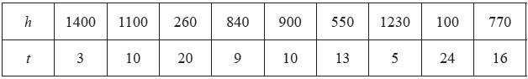
[You may assume that ∑h = 7150, ∑t = 110, ∑h² = 7171500, ∑t² = 1716, ∑th = 64 980 and S_{tt} = 371.56]
(a) Calculate S_{th} and S_{hh}. Give your answers to 3 significant figures.
(3)
(b) Calculate the product moment correlation coefficient for this data.
(2)
(c) State whether or not your value supports the use of a regression equation to predict the air temperature at different heights on this mountain. Give a reason for your answer.
(1)
(d) Find the equation of the regression line of t on h giving your answer in the form t = a + bh.
(4)
(e) Interpret the value of b.
(1)
(f) Estimate the difference in air temperature between a height of 500 m and a height of 1000 m.
(2)
(Total 13 marks)

Q4.
Sammy is studying the number of units of gas, g, and the number of units of electricity, e, used in her house each week. A random sample of 10 weeks use was recorded and the data for each week were coded so that and . The results for the coded data are summarised below
(a) Find the equation of the regression line of y on x in the form y = a + bx.
Give the values of a and b correct to 3 significant figures.
(4)
(b) Hence find the equation of the regression line of e on g in the form e = c + dg.
Give the values of c and d correct to 2 significant figures.
(4)
(c) Use your regression equation to estimate the number of units of electricity used in a week when
100 units of gas were used.
(2)
(Total 10 marks)

Q5.
A teacher asked a random sample of 10 students to record the number of hours of television, t, they watched in the week before their mock exam. She then calculated their grade, g, in their mock exam.
The results are summarised as follows.
∑t = 258 ∑t² = 8702 ∑g = 63.6 S_{gg} = 7.864 ∑gt = 1550.2
(a) Find S_{tt} and S_{gt}
(3)
(b) Calculate, to 3 significant figures, the product moment correlation coefficient between t and g.
(2)
The teacher also recorded the number of hours of revision, v, these 10 students completed during the week before their mock exam. The correlation coefficient between t and v was −0.753
(c) Describe, giving a reason, the nature of the correlation you would expect to find between v and g.
(2)
(Total 7 marks)

Q6.
On a particular day the height above sea level, x metres, and the mid-day temperature, y ºC, were recorded in 8 north European towns. These data are summarised below
(a) Find S_{yy}
(2)
(b) Calculate, to 3 significant figures, the product moment correlation coefficient for these data.
(2)
(c) Give an interpretation of your coefficient.
(1)
A student thought that the calculations would be simpler if the height above sea level, h, was measured in kilometres and used the variable instead of x.
(d) Write down the value of S_{hh}
(1)
(e) Write down the value of the correlation coefficient between h and y.
(1)
(Total 7 marks)

Q7.
A random sample of 50 salmon was caught by a scientist. He recorded the length l cm and weight w kg of each salmon.
The following summary statistics were calculated from these data.
(a) Find S_{ll} and S_{lw}
(3)
(b) Calculate, to 3 significant figures, the product moment correlation coefficient between l and w.
(2)
(c) Give an interpretation of your coefficient.
(1)
(Total 6 marks)

Q8.
Gary compared the total attendance, x, at home matches and the total number of goals, y, scored at home during a season for each of 12 football teams playing in a league. He correctly calculated:
S_{xx} = 1022500 S_{yy} = 130.9 S_{xy} = 8825
(a) Calculate the product moment correlation coefficient for these data.
(2)
(b) Interpret the value of the correlation coefficient.
(1)
Helen was given the same data to analyse. In view of the large numbers involved she decided to divide the attendance figures by 100. She then calculated the product moment correlation coefficient between and y.
(c) Write down the value Helen should have obtained.
(1)
(Total 4 marks)

Q9.
An estate agent recorded the price per square metre, p £/m², for 7 two–bedroom houses.
He then coded the data using the coding , where a and b are positive constants.
His results are shown in the table below.
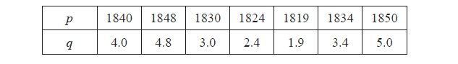
(a) Find the value of a and the value of b
(2)
The estate agent also recorded the distance, d km, of each house from the nearest train
station. The results are summarised below.
S_{dd} = 1.02 S_{qq} = 8.22 S_{dq} = –2.17
(b) Calculate the product moment correlation coefficient between d and q
(2)
(c) Write down the value of the product moment correlation coefficient between d and p
(1)
The estate agent records the price and size of 2 additional two–bedroom houses, H and J.

(d) Suggest which house is most likely to be closer to a train station. Justify your answer.
(3)
(Total for question = 8 marks)

Q10.
A bank reviews its customer records at the end of each month to find out how many customers have become unemployed, u, and how many have had their house repossessed, h, during that month. The bank codes the data using variables and
The results for the 12 months of 2009 are summarised below.
(a) Calculate the value of the product moment correlation coefficient for x and y.
(3)
(b) Write down the product moment correlation coefficient for u and h.
(1)
The bank claims that an increase in unemployment among its customers is associated with an increase in house repossessions.
(c) State, with a reason, whether or not the bank's claim is supported by these data.
(2)
(Total 6 marks)

Q11.
Before going on holiday to Seapron, Tania records the weekly rainfall (x mm) at Seapron for 8 weeks during the summer. Her results are summarised as
(a) Find the standard deviation, σ_{x}, for these data.
(3)
Tania also records the number of hours of sunshine (y hours) per week at Seapron for these 8 weeks and obtains the following
(b) Show that S_{yy} = 716 (correct to 3 significant figures)
(1)
(c) Find S_{xy}
(2)
(d) Calculate the product moment correlation coefficient, r, for these data.
(2)
During Tania's week-long holiday at Seapron there are 14 mm of rain and 70 hours of sunshine.
(e) State, giving a reason, what the effect of adding this information to the above data would be on the value of the product moment correlation coefficient.
(2)
(Total for question = 10 marks)
Q12.
The table shows data on the number of visitors to the UK in a month, v (1000s), and the amount of money they spent, m (£ millions), for each of 8 months.
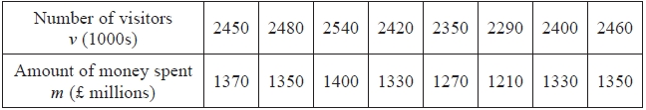
You may use
S_{vv} = 42587.5 S_{vm} = 31512.5 S_{mm} = 25187.5 ∑v = 19390 ∑m = 10610
(a) Find the product moment correlation coefficient between m and v.
(2)
(b) Give a reason to support fitting a regression model of the form m = a + bv to these data.
(1)
(c) Find the value of b correct to 3 decimal places.
(2)
(d) Find the equation of the regression line of m on v.
(2)
(e) Interpret your value of b.
(2)
(f) Use your answer to part (d) to estimate the amount of money spent when the number of visitors to
the UK in a month is 2 500 000
(2)
(g) Comment on the reliability of your estimate in part (f). Give a reason for your answer.
(2)
(Total 13 marks)

Q13.
A large company is analysing how much money it spends on paper in its offices every year. The number of employees, x, and the amount of money spent on paper, p (£ hundreds), in 8 randomly selected offices are given in the table below.
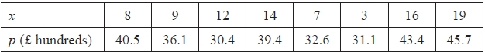
(You may use ∑ x² = 1160 ∑ p = 299.2 ∑ p² = 11 422 ∑ xp = 3449.5
(a) Show that S_{pp} = 231.92 and find the value of S_{xx} and the value of S_{xp}
(5)
(b) Calculate the product moment correlation coefficient between x and p.
(2)
The equation of the regression line of p on x is given in the form p = a + bx.
(c) Show that, to 3 significant figures, b = 0.824 and find the value of a.
(4)
(d) Estimate the amount of money spent on paper in an office with 10 employees.
(2)
(e) Explain the effect each additional employee has on the amount of money spent on paper.
(1)
Later the company realised it had made a mistake in adding up its costs, p. The true costs were actually half of the values recorded. The product moment correlation coefficient and the equation of the linear regression line are recalculated using this information.
(f) Write down the new value of
(i) the product moment correlation coefficient,
(ii) the gradient of the regression line.
(2)
(Total 16 marks)

Q14.
A biologist is comparing the intervals (m seconds) between the mating calls of a certain species of tree frog and the surrounding temperature (t ºC). The following results were obtained.
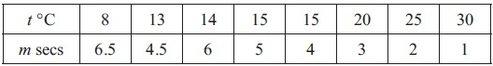
(You may use ∑tm = 469.5, S_{tt} = 354, S_{mm} = 25.5)
(a) Show that S_{tm} = −90.5
(4)
(b) Find the equation of the regression line of m on t giving your answer in the form m = a + bt.
(4)
(c) Use your regression line to estimate the time interval between mating calls when the surrounding temperature is 10 ºC.
(1)
(d) Comment on the reliability of this estimate, giving a reason for your answer.
(1)
(Total 10 marks)

Q15.
A scientist is researching whether or not birds of prey exposed to pollutants lay eggs with thinner shells. He collects a random sample of egg shells from each of 6 different nests and tests for pollutant level, p, and measures the thinning of the shell, t. The results are shown in the table below.
p | 3 | 8 | 30 | 25 | 15 | 12
t | 1 | 3 | 9 | 10 | 5 | 6
[You may use ∑ p² = 1967 and ∑ pt = 694]
(a) Draw a scatter diagram on the axes on page 7 to represent these data.
(2)
(b) Explain why a linear regression model may be appropriate to describe the relationship between
p and t.
(1)
(c) Calculate the value of S_{pt} and the value of S_{pp}.
(4)
(d) Find the equation of the regression line of t on p, giving your answer in the form t = a + bp.
(4)
(e) Plot the point and draw the regression line on your scatter diagram.
(2)
The scientist reviews similar studies and finds that pollutant levels above 16 are likely to result in the death of a chick soon after hatching.
(f) Estimate the minimum thinning of the shell that is likely to result in the death of a chick.
(2)
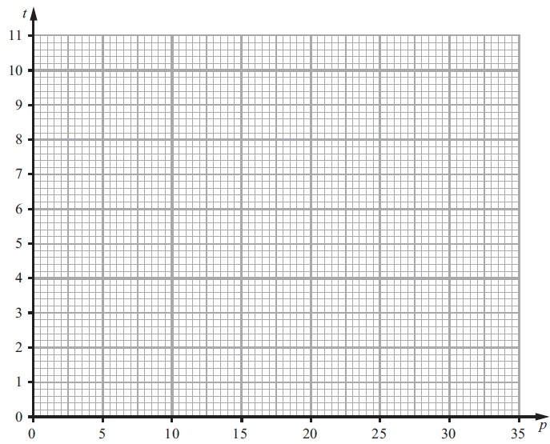
(Total 15 marks)

Q16.
Statistical models can provide a cheap and quick way to describe a real world situation.
(a) Give two other reasons why statistical models are used.
(2)
A scientist wants to develop a model to describe the relationship between the average daily
temperature, x °C, and her household's daily energy consumption, y kWh, in winter.
A random sample of the average daily temperature and her household's daily energy
consumption are taken from 10 winter days and shown in the table.
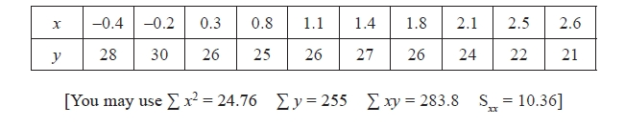
(b) Find S_{xy} for these data.
(3)
(c) Find the equation of the regression line of y on x in the form y = a + bx
Give the value of a and the value of b to 3 significant figures.
(4)
(d) Give an interpretation of the value of a
(1)
(e) Estimate her household's daily energy consumption when the average daily temperature is 2°C
(2)
The scientist wants to use the linear regression model to predict her household's energy
consumption in the summer.
(f) Discuss the reliability of using this model to predict her household's energy
consumption in the summer.
(2)
(Total for question = 14 marks)

Q17.
A farmer collected data on the annual rainfall, x cm, and the annual yield of peas, p tonnes per acre.
The data for annual rainfall was coded using and the following statistics were found.
(a) Find the equation of the regression line of p on v in the form p = a + bv.
(4)
(b) Using your regression line estimate the annual yield of peas per acre when the annual rainfall is 85 cm.
(2)
(Total 6 marks)

Q18.
A researcher believes that parents with a short family name tended to give their children a long first name. A random sample of 10 children was selected and the number of letters in their family name, x, and the number of letters in their first name, y, were recorded.
The data are summarised as:
(a) Find S_{yy} and S_{xy}
(3)
(b) Calculate the product moment correlation coefficient, r, between x and y.
(2)
(c) State, giving a reason, whether or not these data support the researcher's belief.
(2)
The researcher decides to add a child with family name "Turner" to the sample.
(d) Using the definition S_{xx} = , state the new value of S_{xx} giving a reason for your answer.
(2)
Given that the addition of the child with family name "Turner" to the sample leads to an increase in S_{yy}
(e) use the definition S_{xy} = to determine whether or not the value of r will increase, decrease or stay the same. Give a reason for your answer.
(2)
(Total 11 marks)
Q19.
The age, t years, and weight, w grams, of each of 10 coins were recorded. These data are summarised below.
t² = 2688 tw = 1760.62 t = 158 w =111.75 S_{ww} = 0.16
(a) Find S_{u} and S_{tw} for these data.
(3)
(b) Calculate, to 3 significant figures, the product moment correlation coefficient between t and w.
(2)
(c) Find the equation of the regression line of w on t in the form w = a + bt
(4)
(d) State, with a reason, which variable is the explanatory variable.
(2)
(e) Using this model, estimate
(i) the weight of a coin which is 5 years old,
(ii) the effect of an increase of 4 years in age on the weight of a coin.
(2)
It was discovered that a coin in the original sample, which was 5 years old and weighed 20 grams, was a fake.
(f) State, without any further calculations, whether the exclusion of this coin would increase or decrease the value of the product moment correlation coefficient. Give a reason for your answer.
(2)
(Total 15 marks)

Q20.
A teacher took a random sample of 8 children from a class. For each child the teacher recorded the length of their left foot, f cm, and their height, h cm. The results are given in the table below.
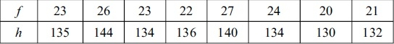
(You may use f = 186 h = 1085 S_{ff} = 39.5 S_{hh} =139.875 fh = 25291)
(a) Calculate S_{fh}
(2)
(b) Find the equation of the regression line of h on f in the form h = a + bf. Give the value of a and the value of b correct to 3 significant figures.
(5)
(c) Use your equation to estimate the height of a child with a left foot length of 25 cm.
(2)
(d) Comment on the reliability of your estimate in (c), giving a reason for your answer.
(2)
The left foot length of the teacher is 25 cm.
(e) Give a reason why the equation in (b) should not be used to estimate the teacher's height.
(1)
(Total 12 marks)

Examiner's Report
Q1.
This proved to be a good opening question with nearly all the students making some progress. Part (a) was answered very well but in part (b), few could work out the effect of the coding on S_{ss} although more were successful with S_{st}. Some reminded us that coding had no effect on the correlation coefficient and assumed that this must also apply to these values as well, whereas others embarked on long, and usually totally incorrect, calculations having missed the significance of the instruction to "write down...".
In part (c) most tried using a correct formula and many, quite sensibly, used the variables w and t but often their values of S_{ss} and S_{st} gave an answer of |r| > 1 and this also meant they lost then chance of scoring in part (d). It is disappointing that many students still don't seem to realise that |r| cannot be greater than 1 and use this fact to try and fix their previous errors. Those who had a valid answer for r were usually able to give a suitable comment in part (d) though some failed to emphasise that it was the magnitude of the correlation, rather than the sign, that was significant. Part (e) was often fully correct but common errors were to use b = 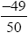 presumably caused by a failure to identify the response and explanatory variables correctly. The usual loss of a mark for accuracy occurred where students prematurely rounded their gradient. A few students still don't appreciate that values of a and b given as fractions are inappropriate but it was encouraging to see very few cases of students giving their final equation in terms of x and y rather than t and w as required. There were many correct responses to part (f), but some did not spot the simple link to part (e) and attempted to calculate a new regression equation usually with little success. The responses to part (g) were disappointing with many simply substituting
t = 1 into their equation rather than giving a suitable interpretation of the gradient. Others failed to give a full enough interpretation and simply said "a decrease" whilst other were confused over the units and were happy to quote a loss of 6.5p per week.

Q2.
This proved to be a good opening question with nearly all students making some progress. Part (a) was answered successfully with most writing down a correct expression which was, of course, required for a "show that" question. Some forgot to write down the "= 5601" and lost the second mark.
In part (b), most chose the variable w but their reasons were not always precise enough. The question was phrased using the word "response" and so the examiners were looking for an explanation of this, rather than a statement such as "w responds to d". The key idea is that the number of wiggles depends on the distance of the food supply from the hive and this was all that was required. Some gave good descriptions of correlation but failed to mention the underlying causal relationship.
Part (c) was, as usual, answered very well but there were still a number of students only giving their answer to 2 significant figures and not the 3 significant figures that is standard on S1. More than 3 significant figures is fine, but answers given with fewer than 3 significant figures will lose a mark.
The calculations for part (d) were carried out confidently but a number lost the final accuracy mark by failing to carry enough figures in their calculations to achieve 3sf accuracy in the final equation and a few confused 3 significant figures with 3 decimal places. Most had a sufficiently accurate regression equation to obtain the mark in part (e) (i) and many gave a correct answer to (ii) too: some referring to interpolation and others stating clearly that the distance was in the range of the data. Common reasons for failing to score this mark were simply stating that "it" was in the range of the data without specifying that "it" is the independent variable we are interested in.

Q3.
Part (a) was, as usual, answered very well but a number of candidates lost the final A1 because they did not round their answers to 3sf or, more worryingly, they thought that S_{hh} = 149 to 3sf. Most knew how to calculate r in part (b) too but few gave a full answer to part (c). Many stated that there was negative correlation (although some thought this meant that the use of a regression equation was not suitable) but few stated clearly that the use of a regression equation was suitable because there was strong correlation. Some simply said that "the points were close to a straight line" but there was no scatter diagram to support this and without a clear statement that the strong correlation suggests this the examiners could not award the mark.
Most candidates (even those who felt that a regression equation was not appropriate!) could carry out the calculations in part (d) although a sizeable minority used S_{tt} instead of S_{hh} which gave them a somewhat unrealistic gradient of − 60.3. Most found a correct gradient but often rounded their answer before calculating the intercept and the final mark was frequently lost. Full interpretations in part (e) were rare with candidates failing to mention the drop in temperature or the rise in height above sea level or give their value. The final part was answered quite well with most candidates substituting values of 500 and 1000 into their equation, only the better candidates realized that the answer was easily found from 500b. A number of candidates seemed perfectly content with a final answer of around 30 000 °C here (due to their incorrect gradient in part (d)) and lost the final mark. Candidates should be encouraged to try and engage with the context of the questions and this can help them both in interpreting their statistical calculations and assessing the reasonableness of their answers.

Q4.
Part (a) was answered very well although some only rounded their value of b to 3 decimal places rather than 3 significant figures as required. Most knew how to start part (b) and made a correct substitution but errors often occurred when simplifying to the required form. The final part was answered well with most substituting g = 100 into their answer for part (b) however earlier errors meant that the correct answer was less frequently seen.

Q5.
(a) proved an accessible opening to the paper and nearly all the candidates answered this correctly. Most also knew how to find r in part (b) but a number still gave their final answer as −0.71 rather than the
3 significant figures requested. In (c) many identified that the required correlation would be positive and gave a simple argument based on the context, although a few linked the variables v and g via the third variable t. A number of candidates seemed to misread this part of the question and gave a description of the negative correlation between t and v.

Q6.
Part (a) was answered well with only a small minority using 4305 − 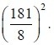 Substitution into the formula for r was carried out successfully but a number of candidates gave their final answer to only
2 significant figures instead of the standard 3 significant figures we look for on S1. Most candidates now realised that the instruction "interpret" requires a contextualised comment but there were a number of nonsensical comments such as "temperature increases as sea level decreases" which gained no credit. Most candidates knew that coding had no effect on the correlation coefficient and picked up the mark for part (e) but very few scored the mark for part (d) with the commonest error being to divide by 1000. It appears that the effect of coding is being remembered as a fact rather than being deduced from an understanding of the structure of the formula.

Q7.
This proved to be a friendly starter for most candidates with many scoring all 5 marks in part (a) and (b). Most errors here were arithmetic such as writing S_{n} = 596.666... rather than 569.666... or accuracy problems in part (b) where an answer of 0.57 was often seen, rather than the 3sf accuracy that we look for. A minority still have difficulty in using the printed formulae and or instead of in were sometimes seen.
Part (c) caused problems for many candidates who simply wrote "positive correlation" but did not interpret this statement in the context by mentioning that longer salmon usually weigh more. Some candidates tended to "overstate" their conclusion by implying that as a salmon grows it gets longer (not strictly true in this instance as the study was of 50 different salmon not one salmon at 50 different time intervals) and others referred to a proportionate relationship such as "for every cm increase in length the salmon weighs 0.572 kg more". Whilst such indiscretions were overlooked for the single mark on this occasion, these examples should provide useful points of discussion for teachers with future cohorts of students.

Q8.
Typically candidates successfully used the correct formula in order to calculate the product moment correlation coefficient in part (a). However, a number of candidates lost the accuracy mark by only giving a rounded answer to 2 decimal places. Providing an interpretation of their value of the correlation coefficient was less straightforward. Most frequently candidates made general remarks and described the correlation as positive without relating this to the context of the question. Of those who did attempt to provide an interpretation, many failed to appreciate that it was the attendance at the matches being compared to the total number of goals scored and not the number of home matches that were played.
Part (c) was answered well overall and correct answers were often justified by accompanying statements which indicated that linear coding does not affect the product moment correlation coefficient. Some candidates, however, seemed unaware of this fact and a common mistake was to divide their original product moment correlation coefficient by 100. In addition many candidates failed to recognise the significance of them being asked to write down their answer and chose to perform a full calculation in order to obtain the product moment correlation coefficient, which sometimes led to processing errors.

Q9.
Most realised what was required in part (a) and although some went "round the houses" to solve their two simultaneous equations the correct answers were usually obtained. Part (b) was a simple application of the formula but sadly a number of students gave their answer as – 0.75 rather than an answer rounded to 3 sf. Most answered part (c) correctly with only a minority re-calculating the coefficient. Part (d) was not answered very well with many not appreciating that the correlation they had established was between distance from the station and price per square metre. Many thought they were looking at negative correlation between price and distance from the station and understandably chose J. Some students though did calculate the price/m² for each house but then some still chose house J as they could not interpret the negative correlation correctly but there were plenty of fully correct answers showing a thorough understanding of the situation. A few students ignored all the statistics and based their choice on other reasons such as it is "noisy near the station" and therefore the house would be cheaper.

Q10.
This question was on familiar territory and was answered well. Most candidates could carry out the calculations in part (a) successfully although a small minority seemed unfamiliar with the formulae in the formula booklet and we had some using 23070 on the numerator of r. Some lost the accuracy mark for rounding to 0.82, or even 0.8, without first stating a more accurate value.
Part (b) was usually answered correctly but a significant minority launched into some complex decoding calculations or simply left it blank. The wording "write down" and the tariff of just 1 mark should indicate that complex calculations are not required.
In part (c) most recognised that a positive correlation suggested support for the bank's claim and scored both marks. Some just stated that the correlation was strong (failing to appreciate the importance of it being positive) and a few gave sociological rather than statistical reasons.

Q11.
There seemed to be a slightly improved understanding of the calculation of standard deviation this summer and many correct responses to part (a) were seen. The usual errors still occurred though: forgetting the square root, or failing to divide the 985.88 by 8 or simply confusing S_{xx} with the variance.
The responses to part (b) confirmed that few students are aware of the simple relationship between S_{yy} and standard deviation as many attempted to find ∑ y² by "unpacking" the value for δ_{y} with varying degrees of success. The calculation for S_{xy} in part (c) was carried out successfully by most students and many completed part (d) correctly too, usually by first finding Sxx rather than using their answer to
part (a).
Responses to part (e) were very mixed. Some simply quoted a statement about coding not affecting correlation and therefore expected no change. Others realised that the new point was breaking the trend (both values above their means conflicting with the negative correlation) but were not precise enough about the effect on the value of the correlation coefficient. The examiners were looking for a statement about the value that told us that the correlation was weaker, i.e. that the value was closer to zero:
r "increases" or r is "less negative" were not deemed to be satisfactory.

Q12.
The calculations were generally carried out very well here but the final 3 parts, requiring the students to engage with the context, were answered less well.
Despite mentioning the expectation of 3sf accuracy a number of students lost a mark here as the only evaluated answer they gave was 0.96 rather than 0.962. In question (b) most gave a comment about strong correlation or commented that the value of r was close to 1 but some misinterpreted the question and explained why linear regression was a useful tool rather than justifying its use in this situation.
In question (c) a number gave an answer of 0.74 rather than 0.740 as required but this value was allowed for the final equation in question (d) which many obtained correctly. It was rare to see a student give their equation in terms of y and x rather than m and v.
Question (e) was found to be challenging. Many confused the gradient with correlation and simply said that as the number of visitors increased so did the amount of money spent. Those who did get the idea of rate often failed to give the correct numerical values or they had visitors and money the wrong way around e.g. "for every £1000 spent the number of visitors increased by 740" . The better answers identified that b represented the amount of money spent per visitor and gave simple answers such as "each visitor spends £740".
The most common error in question (f) was for students to simply substitute 2 500 000 into their equation but those who realised that 2500 should be substituted usually arrived at the correct answer and often went on to affirm the reliability of their estimate by pointing out that 2500 was within the range of the given data in question (g). Stating "it is within the range of the data" in part question (g) did not secure the marks unless the students made it clear that their "it" referred to the number of visitors and not the amount of money spent.

Q13.
Question (a) was answered very well by almost all the students but some missed the "show that" part of the demand and only scored 4 of the 5 marks here. Question (b) and question (c) were answered well and most knew how to tackle question (d) but some forgot to multiply their answer by 100 and gave an answer of £37 rather than £ 3700. A similar problem arose in question (e) with few explaining that the cost increases by £82.40 for each additional employee. Most knew the answer to question (f)(i) but question (f)(ii) was more challenging and only the more able students realised that the value of b would be halved.

Q14.
(a) was answered very well and only a handful of candidates did not secure the 4 marks here. Most knew how to find the equation of the regression line but sometimes candidates failed to use a sufficiently accurate value of b to ensure that their value of a was accurate to three significant figures and they therefore lost the final accuracy mark. A growing number of candidates are giving their coefficients as fractions, presumably because their calculators are set in this mode. Whilst such answers were accepted, they are not as useful as coefficients of a regression line and arguably not really appropriate in this branch of statistics.
(c) was answered very well but in (d) some candidates' responses were vague: a comment that "it is reliable because it is in the range" was not accepted because "it" does not clearly refer to the temperature. Some candidates used the technical terms of "interpolation" or "not extrapolation" correctly and these were accepted.

Q15.
Everyone could get started on this question but part (b) and drawing the line in (d) proved challenging for all but the best candidates.
Part (a) was answered well with only minor accuracy errors from some.
Few answered part (b) correctly with most trying to explain the purpose of linear regression rather than justifying its use in this instance.
Part (c) was answered very well and most knew how to use their answers in part (d) to find the gradient and intercept. A failure to work with sufficient figures on their calculators meant that many gave a as 0.738 which was acceptable for the first mark but not the 3sf, or better, accuracy we were looking for in the final answer. Very few gave their line as an equation of y on x.
In part (e) most plotted the mean point correctly but drawing the regression line accurately defeated many. A common error was to draw a line of best fit "by eye" that passed through the origin and a few weaker candidates simply joined up the dots.
In part (f) many correct answers were seen, mostly from substituting into the equation. Some used their graph (showing clearly on the diagram the line from p = 16 and from the regression line to the t axis) but this approach often lost the accuracy mark.

Q16.
There was plenty in this question for all of the students with parts (b), (c) and (e) providing a good source of marks for everyone but (a), (d) and (f) proving to be more challenging.
In part (a) the first mark was available for a sensible reason and many were prepared to have a go at giving an answer here. Better students gave 2 clear reasons for using statistical models whereas many started mentioning reasons for carrying out statistical tests. Most scored full marks in part (b) but a number mis-read 255 as 225 and lost accuracy and others lost time by calculating S_{xx}. The calculations required in part (c) were well rehearsed but a few did not use the negative value of b correctly and some failed to write down the final equation or left their values of a or b as fractions. There were many correct answers to part (d) but some gave an interpretation of the gradient not the intercept and others simply said that 28.1 was the "y intercept" without attempting to give any "contextualised" interpretation.
Part (e) was straightforward and nearly everyone scored the M mark here. Part (f) was often answered well as students realised that because the model was based on data collected in winter it would be unreliable to use it for summer temperatures as these would be different or involve extrapolation. The word "discuss" prompted some to surmise what the effect of airconditioning units would be in the summer, and this often led to contradictory statements, whilst others felt that they needed to calculate the product moment correlation coefficient and then deduced that the model was reliable.

Q17.
Part (a) was answered well by many but a number still have difficulties in determining which variable corresponds to y and which to x and then using the formulae given in the booklet. The question clearly stated that the regression line of p on v was required and this was further emphasised by giving the form as p = a + bv but despite this a number calculated 1.688/1.168 for b and some used a = 4.42 − 3.32b. There was the usual crop of accuracy errors with candidates failing to work accurately enough to give their final coefficients to the usual 3sf (or better) accuracy. A significant number of candidates simply substituted 85 into their equation and received no marks for part (b) but a good many did appreciate the need to find the value for v and often went on to obtain an answer rounding to 4.3 as well.

Q18.
Parts (a) and (b) were answered very well with only minor slips causing a loss of marks in a few cases. In part (c) most candidates realized there was positive correlation but some went on to state that this suggested support for the researcher's belief and only the more astute explaining that the researcher should have been expecting a negative correlation and these data therefore did not offer support. Parts (d) and (e) were challenging. In part (d) many stated that S_{xx} would remain the same but they were unable to provide an adequate reason. In part (e) most thought that r would stay the same giving the text book reason that "it is not affected by coding" but a few did realize that S_{xy} would stay the same and so the increase in S_{yy} meant that r would in fact decrease.

Q19.
This question proved to be a good discriminator for the highest achieving candidates.
Part (a) and part (b) were well completed by most candidates, the biggest problem being giving r as −0.91 despite being told to give the answer to 3 significant figures.
Part (c) was generally very well answered but early rounding or lack of understanding of the difference between decimal places and significant figures led to the final equation not being stated accurately. Some candidates clearly did not know what an explanatory variable was in part (d), preferring to ignore the question and state what the dependent and independent variables were instead. A significant minority did not know what a variable was and suggested a or b.
In part (e) candidates who had the right equation had no problem getting the first answer, but a number then went on to find the answer when t = 4, rather than finding the change over four years. Some candidates seemed to think that they were just required to say whether the weight increased or decreased rather than find an amount, whilst others wrote a 'decrease of minus 0.1'. A few candidates believed that the coin could have increased in weight.
In part (f) some candidates just stated decrease or increase with no reason given. A number responded that it would increase and clearly understood that that the correlation would be stronger, but ignored that the result would make r closer to −1. A number of candidates said that the correlation was not affected by outliers and some thought that the removal of the fake coin constituted coding and so would have 'no effect on the product moment correlation coefficient'.

Q20.
Parts (a) and (b) were answered well by the majority of candidates. Only a small minority used for b and there were few cases of the incorrect sign being used for finding a. Premature rounding and a failure to write their final answer in terms of f and h to 3significant figures meant a number lost the final accuracy mark. Part (c) was answered very well but in part (d) the candidates comments were often a little confused. The question was looking for a comment that the value of the independent variable f was within the range of the data and therefore the estimate should be reliable. A number of candidates seemed to focus their comments on the value of the dependent variable h and others were just a little vague referring to "it" was within the range of the data.
There were many clear and thorough answers to part (e) that showed the candidates had a good understanding of the limitations of the equation they had calculated (namely that it was based on data for children not adults). Questions of this type are simply looking for the candidates to engage with the context and give a sensible comment.

Mark Scheme

Section 7 | Correlation and linear regression part 1
qu.1 | June 2017 S1 - Q1 all (d*)
qu.2 | June 2016 S1 - Q1 all (e*)
qu.3 | May 2013 S1 - Q1
qu.4 | May 2013 S1R - Q1
qu.5 | January 2013 S1 - Q1
qu.6 | May 2011 S1 - Q1
qu.7 | January 2011 S1 - Q1
qu.8 | May 2010 S1 - Q1
qu.9 | June 2015 S1 - Q2
qu.10 | May 2012 S1 - Q2
qu.11 | June 2016 S1 - Q3bcde*
qu.12 | June 2014 S1 - Q3 all (g*)
qu.13 | June 2014 S1R - Q3 all (f*)
qu.14 | January 2013 S1 - Q3
qu.15 | May 2012 S1 - Q3
qu.16 | June 2015 S1 - Q4 all (f*)
qu.17 | January 2011 S1 - Q4
qu.18 | May 2013 S1R - Q5
qu.19 | January 2012 S1 - Q5 all (f*)
qu.20 | May 2011 S1 - Q7 all (d*)

Q1.
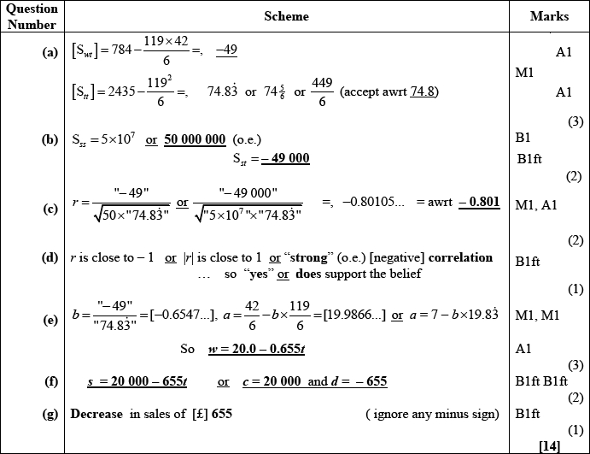
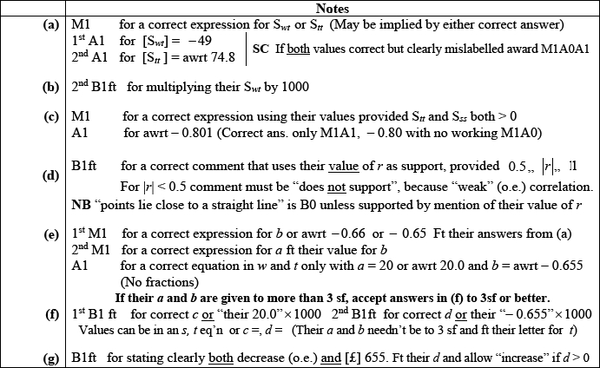

Q2.
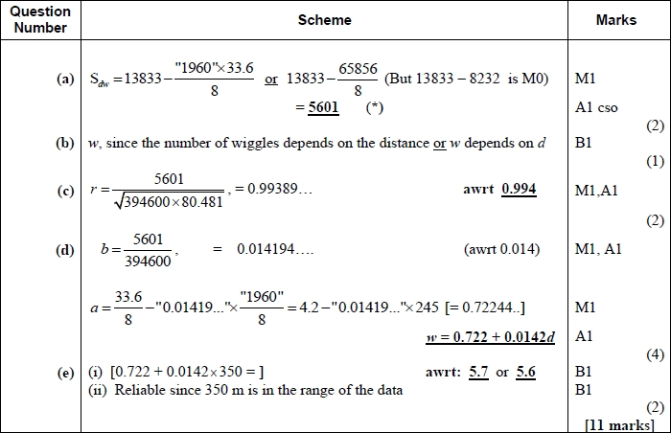
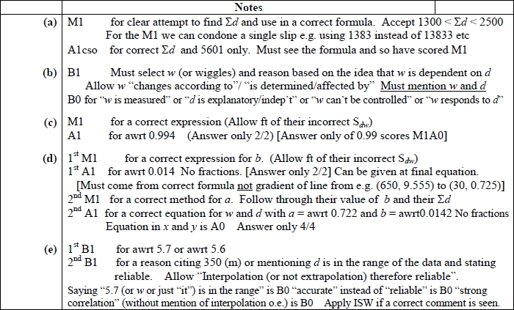

Q3.
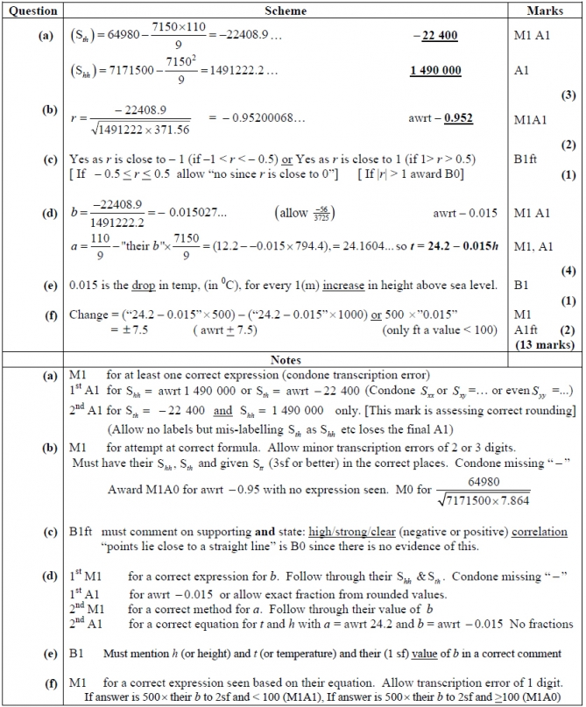

Q4.
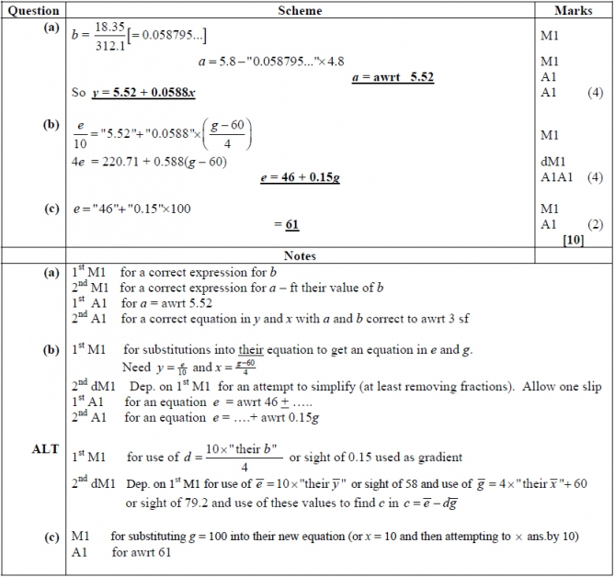

Q5.
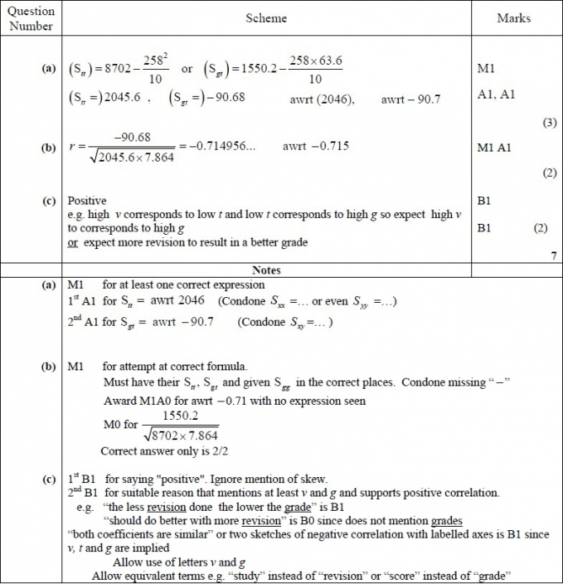

Q6.
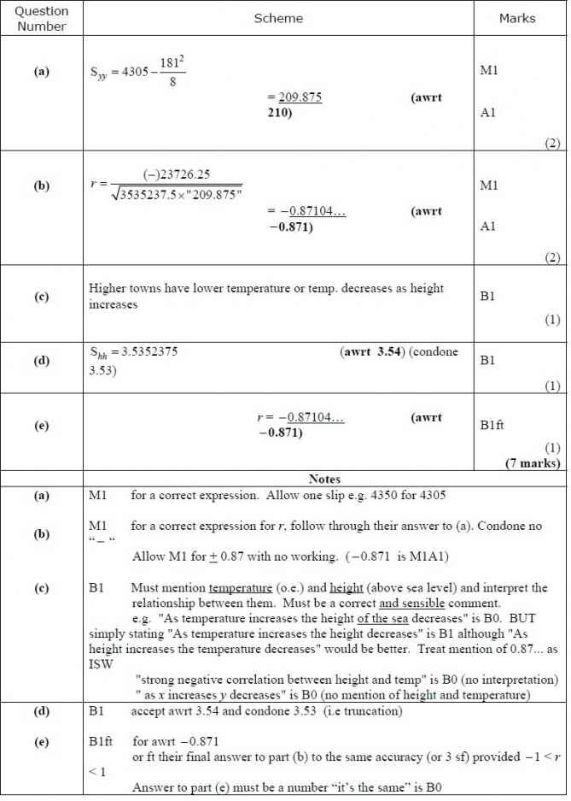
Q7.
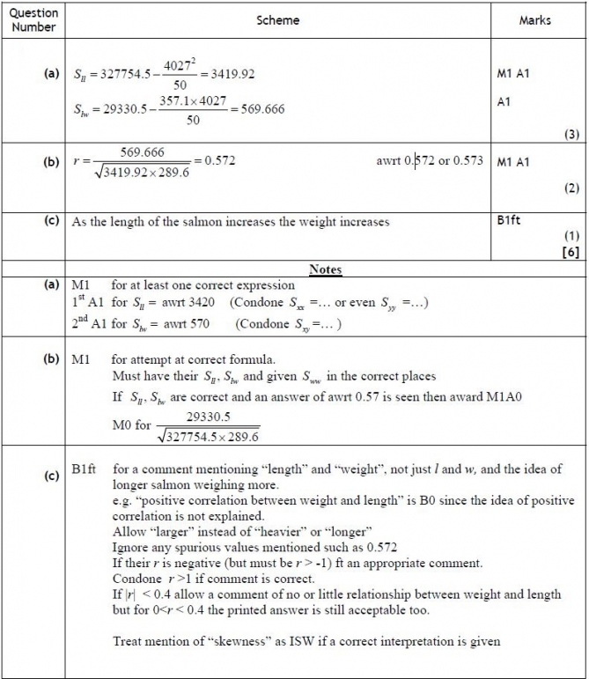

Q8.
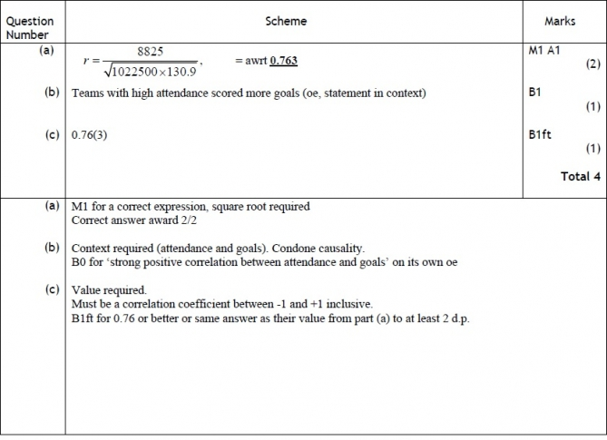

Q9.
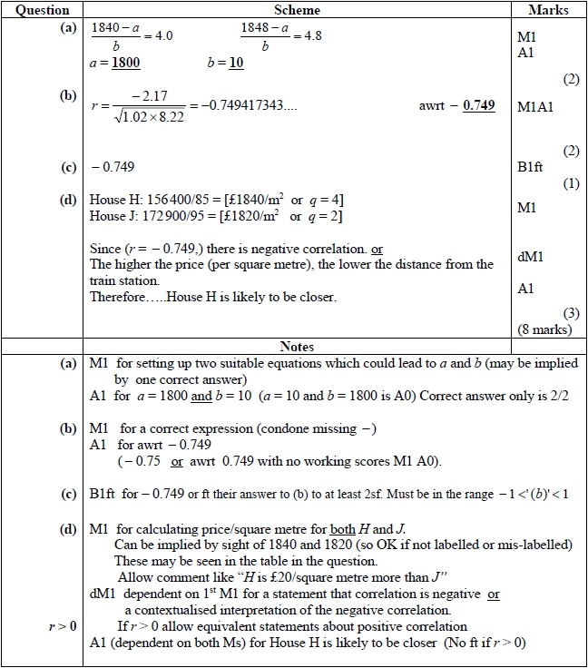

Q10.
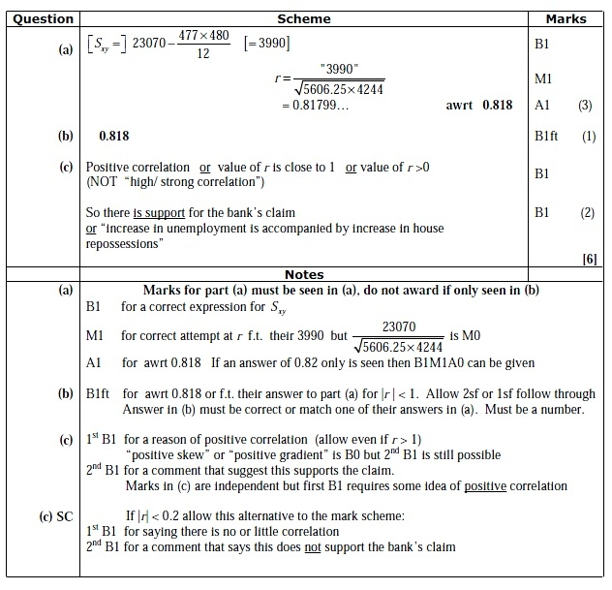

Q11.
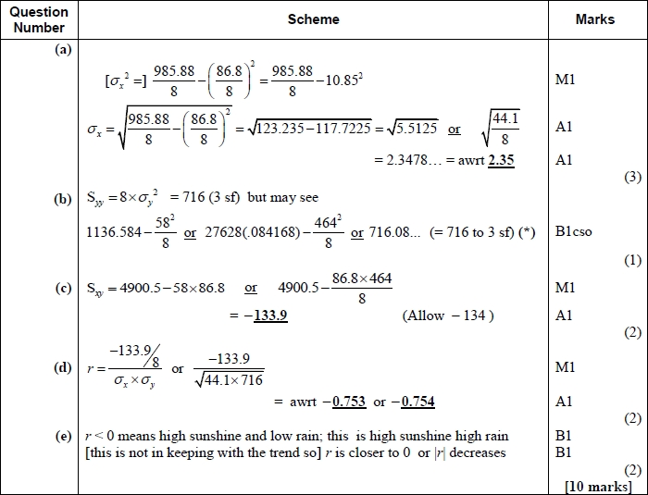
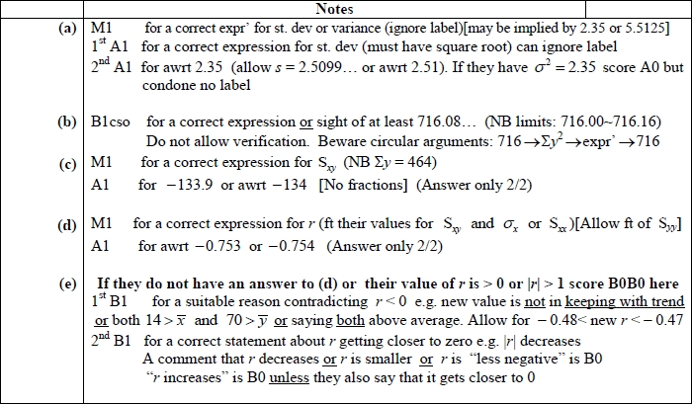
Q12.
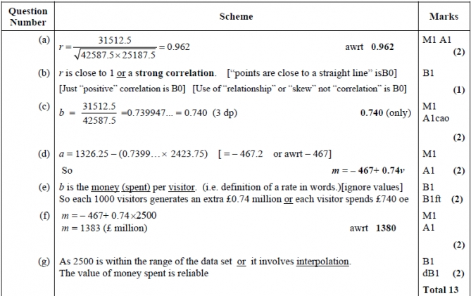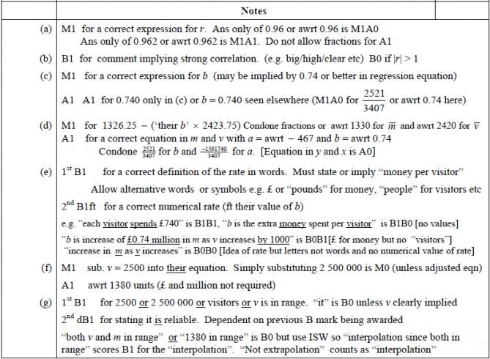

Q13.
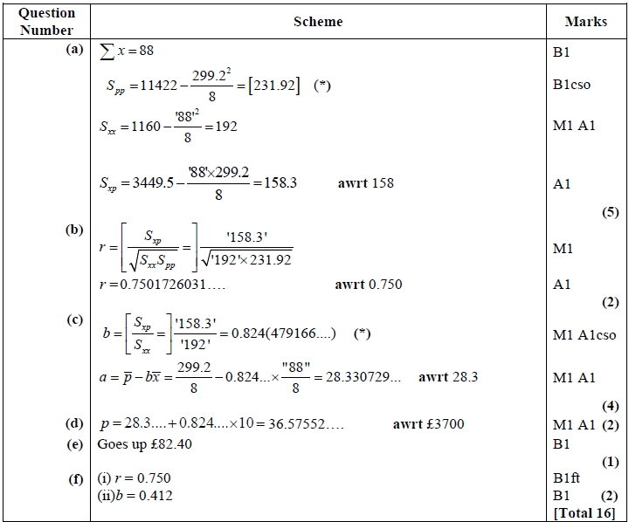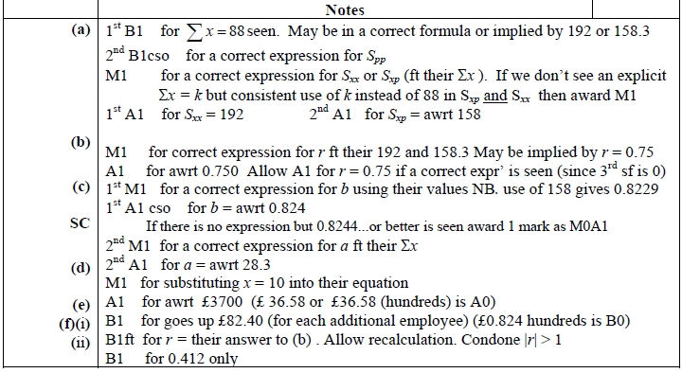

Q14.
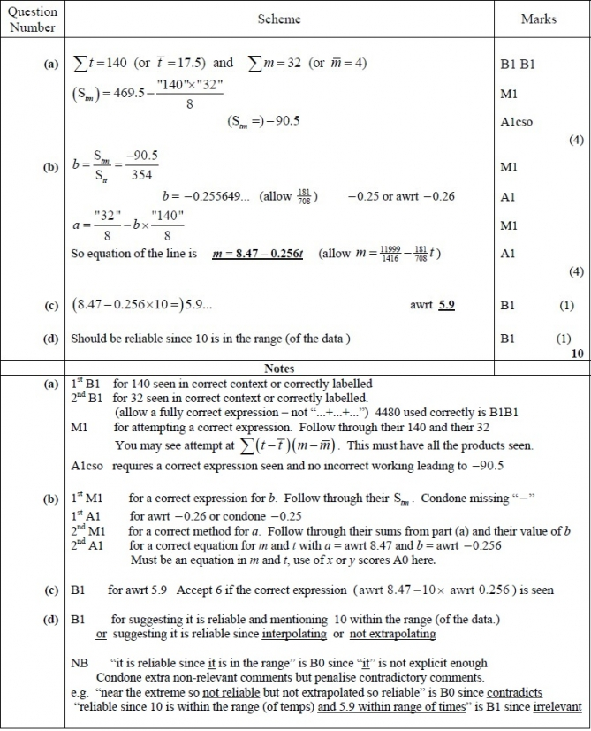

Q15.
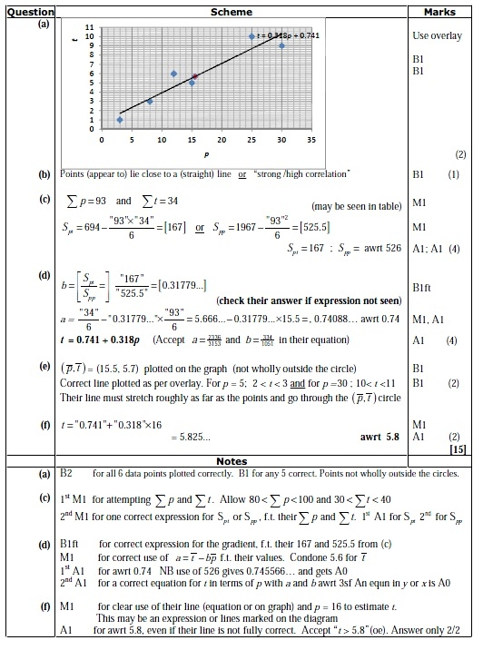

Q16.
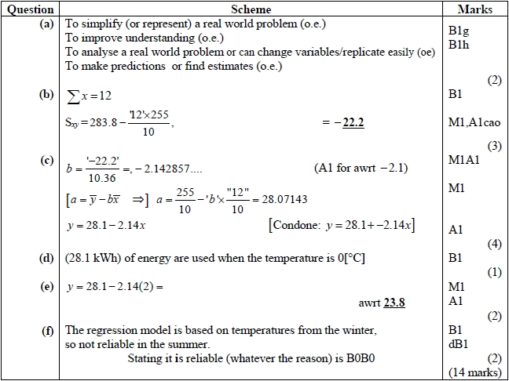
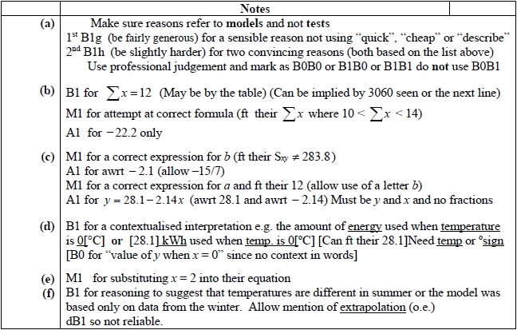

Q17.
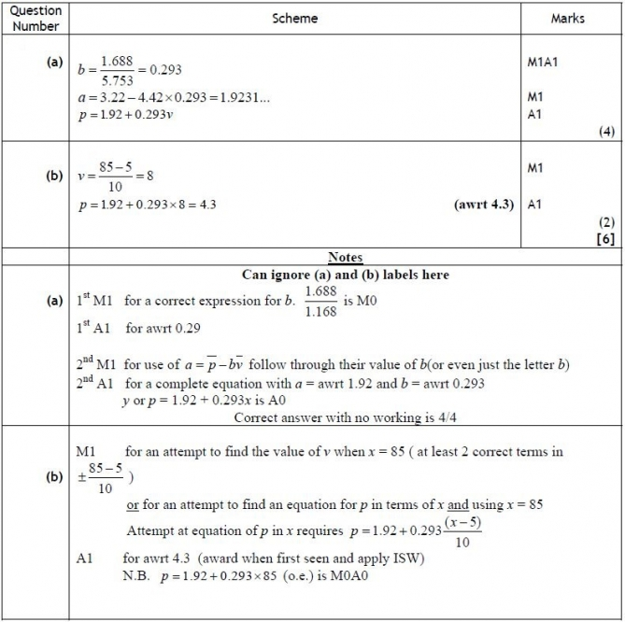

Q18.
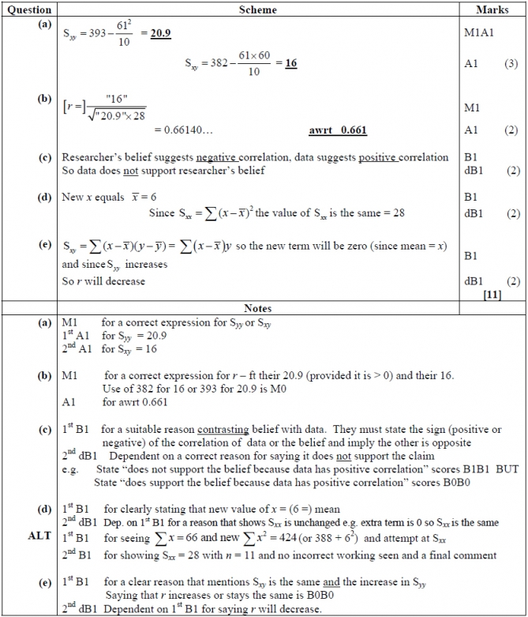

Q19.
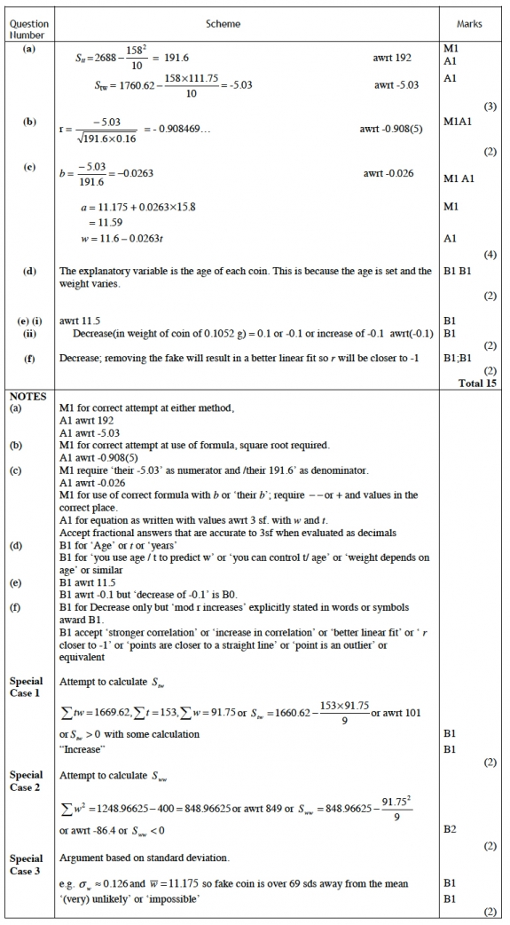
Q20.
