Name: _______________________________________________
GCE Stats section 6
Normal distribution
practice questions from GCE Maths part 2
Date:
Question parts in red cover content in the GCE Statistics specification but outside this section of the scheme of work
Time:
Total marks available:
Total marks achieved: ______

Questions
Q19.
A cadet fires shots at a target at distances ranging from 25 m to 90 m. The probability of hitting the target with a single shot is p. When firing from a distance d m, p = (90 − d).
Each shot is fired independently.
The cadet fires 10 shots from a distance of 40 m.
(a) (i) Find the probability that exactly 6 shots hit the target.
(ii) Find the probability that at least 8 shots hit the target.
(5)
The cadet fires 20 shots from a distance of x m.
(b) Find, to the nearest integer, the value of x if the cadet has an 80% chance of hitting the target at
least once.
(4)
The cadet fires 100 shots from 25 m.
(c) Using a suitable approximation, estimate the probability that at least 95 of these shots hit the target.
(5)
(Total 14 marks)

Q20.
The number of houses sold by an estate agent follows a Poisson distribution, with a mean of 2 per week.
(a) Find the probability that in the next 4 weeks the estate agent sells,
(i) exactly 3 houses,
(ii) more than 5 houses.
(5)
The estate agent monitors sales in periods of 4 weeks.
(b) Find the probability that in the next twelve of these 4 week periods there are exactly nine periods in which more than 5 houses are sold.
(3)
The estate agent will receive a bonus if he sells more than 25 houses in the next 10 weeks.
(c) Use a suitable approximation to estimate the probability that the estate agent receives a bonus.
(6)
(Total 14 marks)

Q21.
The time taken for a randomly selected person to complete a test is M minutes, where M ~ N (14, σ²)
Given that 10% of people take less than 12 minutes to complete the test,
(a) find the value of σ
(3)
Graham selects 15 people at random.
(b) Find the probability that fewer than 2 of these people will take less than 12 minutes to complete
the test.
(3)
Jovanna takes a random sample of n people.
Using a normal approximation, the probability that fewer than 9 of these n people will take less than 12 minutes to complete the test is 0.3085 to 4 decimal places.
(c) Find the value of n.
(8)
(Total for question = 14 marks)

Q22.
In a large school, 20% of students own a touch screen laptop. A random sample of n students is chosen from the school. Using a normal approximation, the probability that more than 55 of these n students own a touch screen laptop is 0.0401 correct to 3 significant figures.
Find the value of n.
(8)
(Total for question = 8 marks)

Q23.
(a) State the conditions under which the normal distribution may be used as an approximation to the binomial distribution.
(2)
A company sells seeds and claims that 55% of its pea seeds germinate.
(b) Write down a reason why the company should not justify their claim by testing all the pea seeds they produce.
(1)
To test the company's claim, a random sample of 220 pea seeds was planted.
(c) State the hypotheses for a two-tailed test of the company's claim.
(1)
Given that 135 of the 220 pea seeds germinated,
(d) use a normal approximation to test, at the 5% level of significance, whether or not the company's claim is justified.
(7)
(Total 11 marks)

Q24.
Defects occur at random in planks of wood with a constant rate of 0.5 per 10 cm length. Jim buys a plank of length 100 cm.
(a) Find the probability that Jim's plank contains at most 3 defects.
(2)
Shivani buys 6 planks each of length 100 cm.
(b) Find the probability that fewer than 2 of Shivani's planks contain at most 3 defects.
(5)
(c) Using a suitable approximation, estimate the probability that the total number of defects on Shivani's
6 planks is less than 18.
(6)
(Total 13 marks)

Q25.
A shopkeeper knows, from past records, that 15% of customers buy an item from the display next to the till. After a refurbishment of the shop, he takes a random sample of 30 customers and finds that only
1 customer has bought an item from the display next to the till.
(a) Stating your hypotheses clearly, and using a 5% level of significance, test whether or not there has been a change in the proportion of customers buying an item from the display next to the till.
(6)
During the refurbishment a new sandwich display was installed. Before the refurbishment 20% of customers bought sandwiches. The shopkeeper claims that the proportion of customers buying sandwiches has now increased. He selects a random sample of 120 customers and finds that 31 of them have bought sandwiches.
(b) Using a suitable approximation and stating your hypotheses clearly, test the shopkeeper's claim.
Use a 10% level of significance.
(8)
(Total 14 marks)

Q26.
A random sample of size n is to be taken from a population that is normally distributed with mean 40 and standard deviation 3. Find the minimum sample size such that the probability of the sample mean being greater than 42 is less than 5%.
(5)
(Total 5 marks)

Q27.
A woodwork teacher measures the width, w mm, of a board. The measured width, X mm, is normally distributed with mean w mm and standard deviation 0.5 mm.
(a) Find the probability that X is within 0.6 mm of w.
(2)
The same board is measured 16 times and the results are recorded.
(b) Find the probability that the mean of these results is within 0.3 mm of w.
(4)
Given that the mean of these 16 measurements is 35.6 mm,
(c) find a 98% confidence interval for w.
(4)
(Total 10 marks)

Q28.
A machine fills packets with X grams of powder where X is normally distributed with mean μ. Each packet is supposed to contain 1 kg of powder.
To comply with regulations, the weight of powder in a randomly selected packet should be such that
P(X < μ − 30) = 0.0005
(a) Show that this requires the standard deviation to be 9.117 g to 3 decimal places.
(3)
A random sample of 10 packets is selected from the machine. The weight, in grams, of powder in each packet is as follows
999.8 991.6 1000.3 1006.1 1008.2 997.0 993.2 1000.0 997.1 1002.1
(b) Assuming that the standard deviation of the population is 9.117 g, test, at the 1% significance level, whether or not the machine is delivering packets with mean weight of less than 1 kg. State your hypotheses clearly.
(7)
(Total 10 marks)

Examiner's Report
Q19.
The majority of students were able to use the correct model in question (a)(i) and calculated P(X = 6) correctly. In question (a)(ii) many students found the correct answer but not always by the quickest method which was using B(10,0.25) and finding P(X ≤ 2) . Others found P(8) + P(9) + P(10) and used the formula for B(10,0.75) or even used the formula to calculate P)(X ≤ 7) and then subtract from 1. Some students incorrectly changed their model to Po(7.5) .
Question (b) was frequently solved efficiently and completely correctly. However, a significant minority of students did not recognise that they should take 0.2^{1/20} to obtain 1 − p instead choosing to use the tables to obtain an estimate for p , usually obtaining 0.1. Other students incorrectly thought that 0.8 (or 0.2) was the value of p and not 1 − P(X = 0) .
Question (c) proved to be challenging. Most students were able to see that the exact distribution was B(100, 0.975) for the number of times the cadet hits the target. Few realised that they should define B(100,0.025) as the model for the number of times the cadet misses the target and then follow this with an approximation to the Poisson obtaining Po(2.5) . Even when they used Po(2.5) many were unable to change " the cadet hits at least 95 " to " the cadet misses at most 5 ". Those that stayed with
B(100, 0.975) approximated to the normal, saying things like "mean = 97.5 this is too big for the tables so approximate to the normal".

Q20.
A high proportion of the candidates attempted all parts of this question successfully. Those less successful in part (a) either used Po(2) instead of Po(8), or used Po(8) but found the answer, using Poisson tables, to P(X ≤ 3) instead of P(X = 3). A common error seen in part (a)(ii) was to write and use P(X > 5) = 1 − P(X ≤ 4).
In part (b) many candidates were able to find P(Y = 9) using their answer to (a)(ii) but, for a small minority, incorrect calculations included calculating (0.8088)⁹ or using Po(λ) with λ = 8, 9 or 24. Overall, many exemplary answers were evident for the solution to part (c) reflecting sound preparation on this topic. Marks were lost occasionally for using an incorrect, or no, continuity correction or for finding an incorrect area.

Q21.
In part (a), most students showed a good knowledge of how to standardise. However, surprisingly few were able to complete part (a) accurately and hence be awarded all 3 marks. The most common error was using a z-value not from the percentage points table, and hence lost the B mark due to their value being only 3.s.f.
Other errors were: adding an unnecessary continuity correction, using the variance instead of the standard deviation in their standardisation, equating to a probability rather than a z-value, not using the correct sign of the z-value and sometimes ending up on a negative standard deviation, and lastly, leaving their answer as an exact fraction.
Part (b) was well answered with the vast majority of students scoring full marks. Even if they could not find the correct model most managed to gain the method mark by writing P(X < 2).
Part (c) was a challenge, with very few students scoring full marks. Most students correctly identified the mean and variance for the normal approximations but many did not use the correct continuity correction.
Most students managed the correct z-value but a number used the wrong sign in their equation. Again, some students incorrectly used a probability as their z-value.
The majority of students were able to form a quadratic of some sort from their standardisation equation, and many were able to attain the M mark for a correct method of solving this. However, far too many simply produced solutions to their quadratic from no working and hence lost marks if they had used an incorrect equation.
Clearly having a quadratic in was challenging, and many students had no method to deal with this – often failing to identify how it mapped to a "standard" quadratic. Some students showed good initiative and exhibited useful methods such as squaring both sides or using a substitution.

Q22.
The question was of an unusual type, requiring working backwards from an answer. Overall, candidates responded well to the initial part of the question, dealing with the normal distribution. However, algebra was then required and some surprising attempts were seen. Many candidates appeared to be unhappy with the 'disguised' quadratic, 0.2n + 0.7 – 55.5 = 0 , that is the result of correct standardisation. Some candidates recognised this as a quadratic in : some even wrote "let a = ", to give the equation 0.2a² + 0.7a – 55.5 = 0. All three of the standard methods were seen (formula, completing the square, factorisation), the first being by far the most common, and the other two very rarely.
It was not uncommon for candidates to deal with the discomfort of their by rearranging and squaring. This result, if performed correctly, is a different quadratic equation: 0.04n² – 22.69n + 3080.25 = 0 which nevertheless gives the same final answer of 225 (directly, rather than via 15²). However, this alternative method involves additional work, and therefore the opportunity for things to go wrong. It was disconcerting to note that attempts to square equivalent to (a – b)² = a² – b² and (a + b)² = a² + b² were often seen. A minority of candidates who used their calculators lost marks in this question because they showed no working while solving an incorrect quadratic equation. Since the equation comes later in the question, it is perhaps unwise just to assume that your equation is correct. The only sensible option is to use a standard method, such as 'the formula', showing full details of the method used.
There was another small group of candidates who dealt with the presence of in another way. These candidates had already 'standardised' correctly using mean and standard deviation of 0.2n and They dealt with the troublesome root by going back to the beginning and deliberately standardising incorrectly: this time using 0.16n (i.e. variance) for standard deviation. This conveniently resolves their difficulty: there is now only a linear equation in n to solve. However, they lost more marks by incorrect standardisation than they would have done by failing to solve a quadratic equation.
Q23.
Correct responses to question (a) were seen from the majority of students, although p "small" was sometimes offered. Students who stated that np > 5,nq > 5 usually did so in addition to, rather than instead of, the only accepted response of n is large and p is close to 0.5.
Question (b) elicited a mixed response, ranging from a null response, through "too time consuming and too expensive" to the accepted answer that there would be no pea seeds left to sell. The words "it" and "they" sometimes were used without any reference as to context.
The correct hypotheses were correctly given by a large majority of students in question (c). Sometimes they appeared in question (d), which was accepted, but occasionally different hypotheses appeared in question (c) and question (d). Occasionally either a letter other than p was used or hypotheses for a 1-tailed test were given.
In question (d) a large majority of students correctly calculated the values of the two parameters of the normal distribution, although 121 sometimes appeared as both the mean and variance following a normal approximation to the Poisson distribution Po(121).
The application of a continuity correction caused problems to many students; some were unaware that one should be used, whilst others used 135.5 instead of 134.5. Students ought to be made aware that the omission of a continuity correction resulted in the loss of at least 4 marks. A significant minority of students were able to obtain 0.0336. Few students chose to find the upper critical value. The standardisation was virtually always correctly done with the students' values.
Although nearly all students were using a 2-tailed test, it was not uncommon to see students comparing 0.0336 with 0.05 (instead of 0.025), and hence arriving at the wrong conclusion. Nevertheless, a large majority of students knew that they were expected to give a statement and contextual conclusion. The latter was sometimes marred by a failure to give a complete conclusion; in particular, the words "company's" or "seeds" were sometimes omitted.

Q24.
This question was well answered with many candidates gaining full marks. Part (b) required considerable attention to detail, and it is commendable that so many candidates were able to achieve all 5 marks. There were a small number of candidates who earned four of these five marks despite an incorrect answer to part (a). These candidates demonstrated the importance of showing one's method and including all relevant details. It is often not possible to earn 'follow through' marks unless the method and necessary detail is made explicit. The most common errors were to muddle up p and q or forget the 6 in the calculation of P(X = 1).
Candidates generally gave clear, confident and accurate responses to part (c) that demonstrated mastery of both theory and detail. Although there were the usual errors of not using a continuity correction, using the wrong continuity correction or using the wrong mean and variance there were many fully correct solutions.

Q25.
This appeared to be generally a fairly straightforward question and there were many fully correct and clear solutions. In part (a) a number of candidates chose the wrong H₁ : p < 0.15. There are two main methods for conducting this significance test. It was noticeable that the candidates who chose the 'Critical Region' approach were generally less successful than those who evaluated the probability of obtaining an outcome 'as bad or worse' than that observed. It is advised that using the Critical Region method for hypothesis tests should be discouraged. The main errors generally involved comparing the probability found with an incorrect value. It was not uncommon to see the correct probability of 0.0480 compared with 0.05, instead of with 0.025 when a two tail test had been indicated by the hypotheses. Others incorrectly found P(X = 1).
Part (b) appeared to be a lot easier than part (a) and many were able to accurately find the p value and gave good conclusions in context, Some candidates approximated to the Poisson and then to the normal so having the wrong variance for their distribution. Whilst most candidates attempted the continuity correction a substantial number wrongly used 31.5 instead of 30.5. A very small minority of the candidates attempted to use a 'Critical Region' approach however these were mostly incorrect and gained few marks and were not as successful as those who calculated a probability.

Q26.
Although many candidates clearly defined their variable there were some who wrote X N 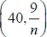 but clearly meant as their standardization indicated. Most used a z value of 1.6449 but a number used an incorrect inequality and ended up with n < 6.087...and gave a final answer of 6.

Q27.
The first two parts of this question proved quite challenging for many candidates who were unable to handle the modulus. Many simply missed the significance of the phrase "…is within…" and others misinterpreted the ranges dividing by 2. Those who did interpret the question correctly usually had few problems in calculating the required probabilities although there were some errors with the variance in part (b).
The confidence interval in part (c) was answered very well by most candidates and many correct solutions were seen. Few failed to use z = 2.3263 and only a small minority used an incorrect standard error.

Q28.
Marks were lost by some students in question (a) by failing to have consistency in the use of signs. The test was well done by all but the weaker students who usually failed to use the correct standard error. However the incorrect use of signs too often lost a mark in the actual test, but these students usually recovered to come to a correct conclusion. Most students gave the result well in context but some lost a mark by not using the key words and /or not concentrating on the "less than" idea. Standardising correctly also proved to be an issue here, but many students scored well on this part.

Mark Scheme

Section 6 | Normal distribution part 2
qu.19 | June 2014 S2 - Q4c
qu.20 | May 2012 S2 - Q4c
qu.21 | June 2017 S2 - Q5ac
qu.22 | June 2016 S2 - Q5
qu.23 | June 2014 S2 - Q5a
qu.24 | May 2011 S2 - Q5c
qu.25 | May 2011 S2 - Q6b
qu.26 | June 2013 S3R - Q2
qu.27 | June 2010 S3 - Q3
qu.28 | May 2014 S3 - Q7a

Q1.
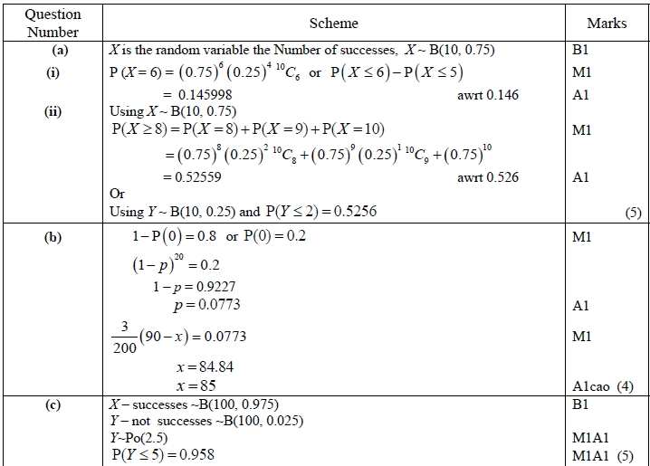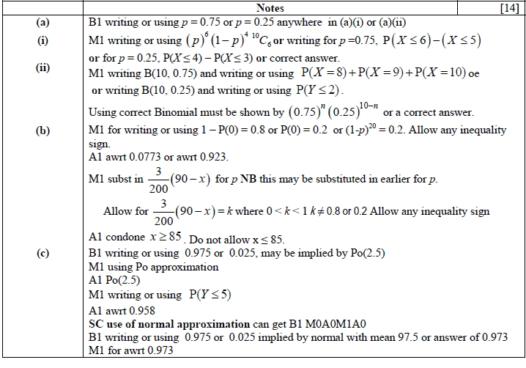
Q20.
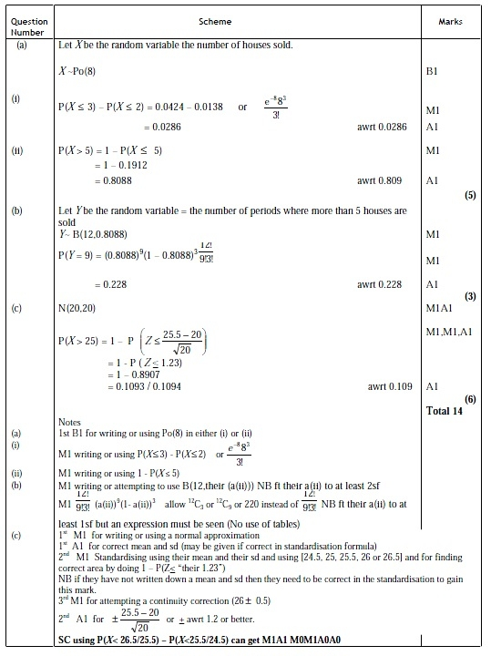

Q21.
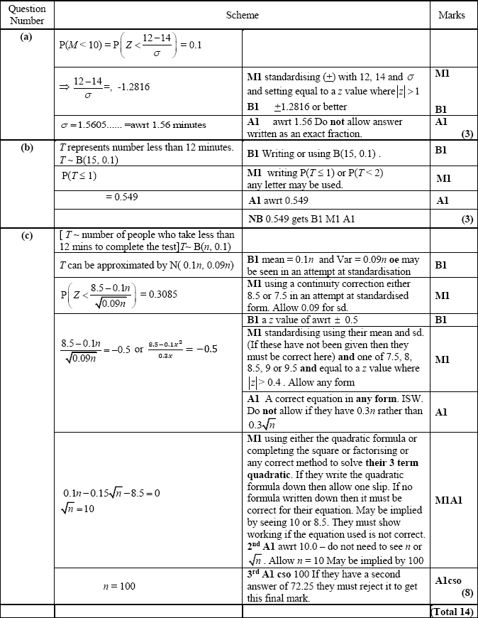

Q22.
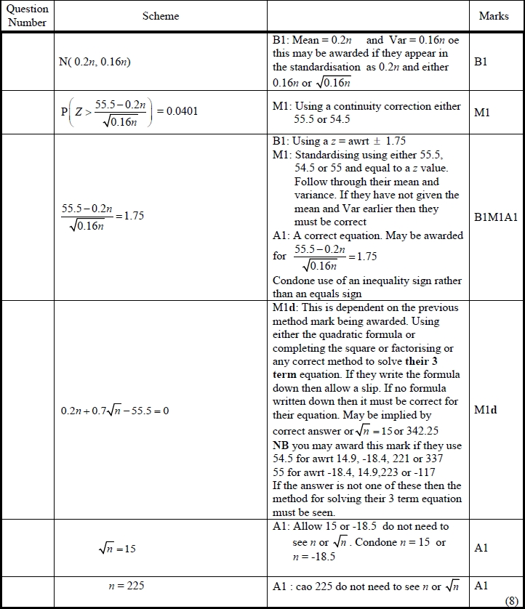
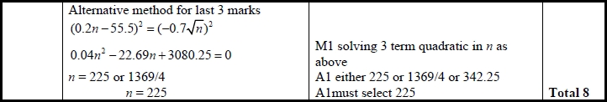
Q23.
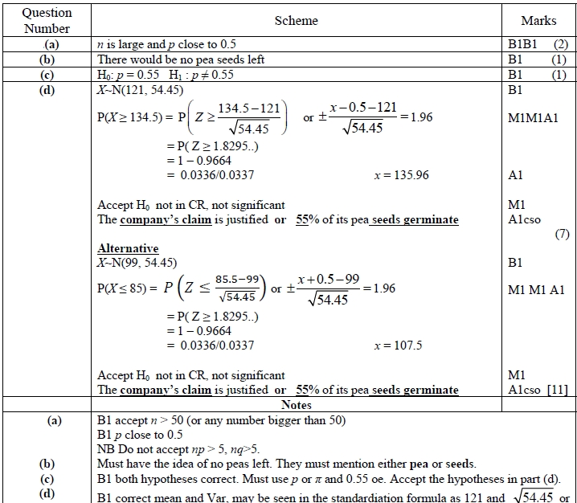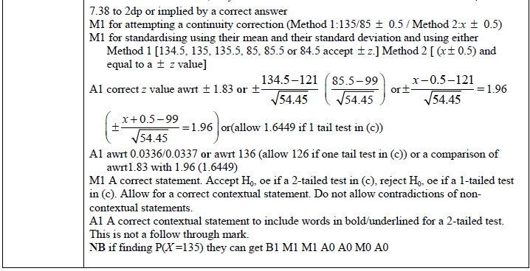

Q24.
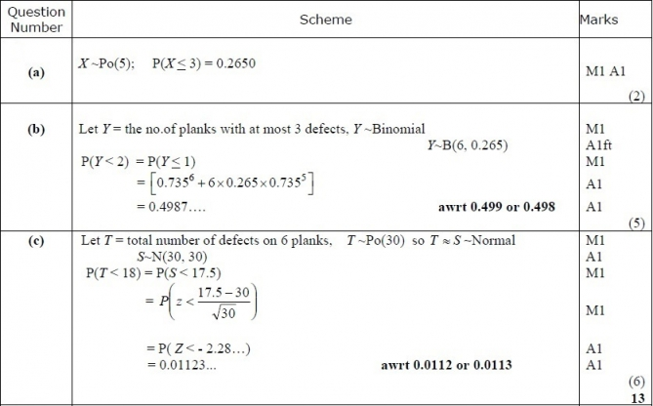
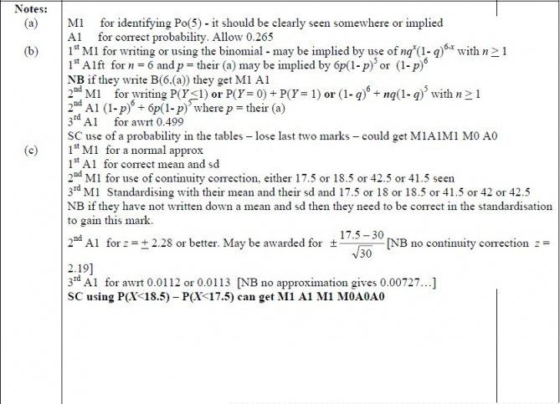

Q25.
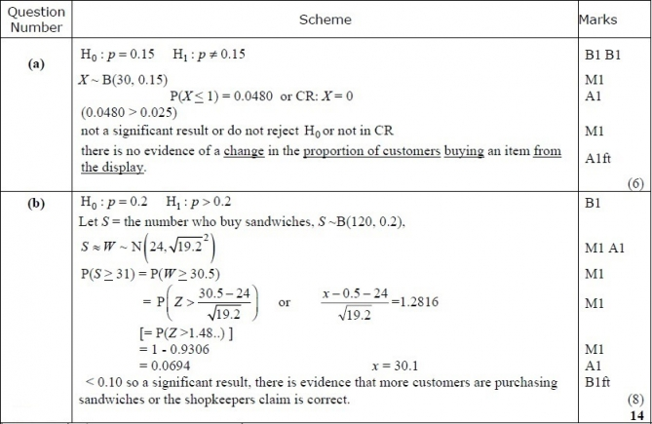
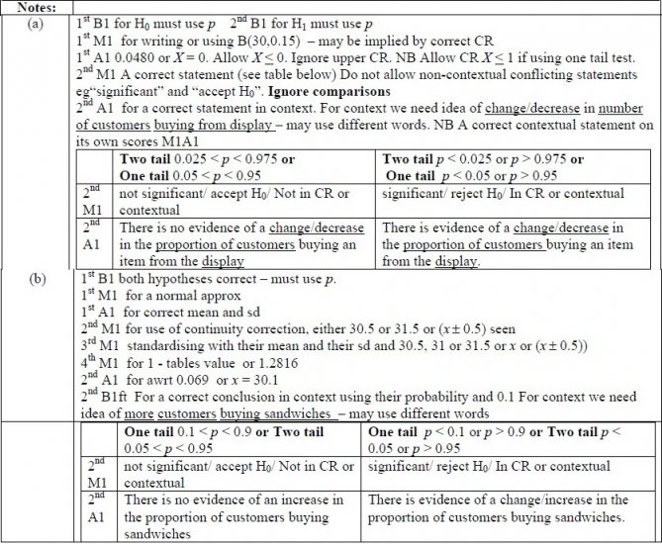

Q26.
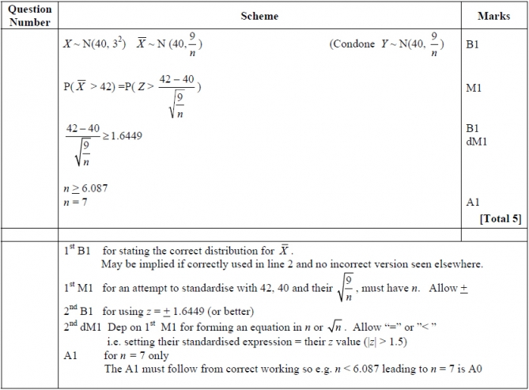

Q27.
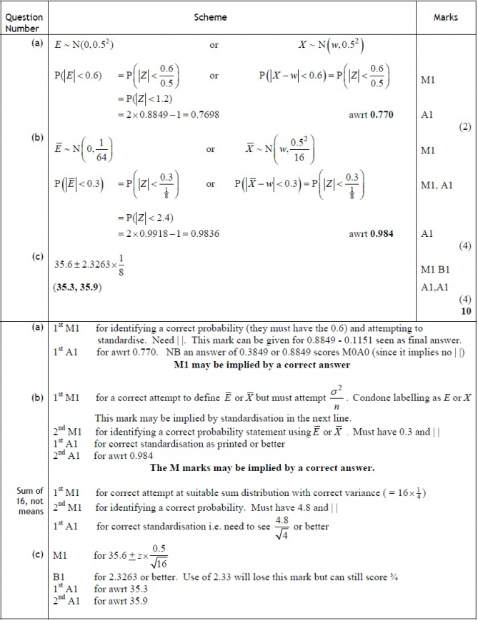

Q28.
