Name: _______________________________________________
GCE Stats section 6
Normal distribution
practice questions from GCE Maths part 1
Date:
Question parts in red cover content in the GCE Statistics specification but outside this section of the scheme of work

Time:
Total marks available:
Total marks achieved: ______

Questions
Q1.
An estate agent is studying the cost of office space in London. He takes a random sample of 90 offices and calculates the cost, £x per square foot. His results are given in the table below.
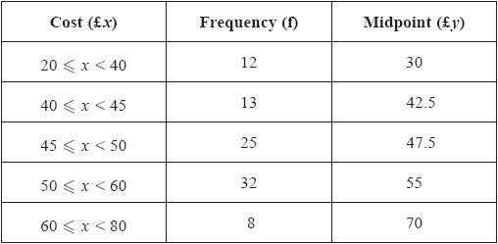
A histogram is drawn for these data and the bar representing 50 ≤ x < 60 is 2cm wide and 8cm high.
(a) Calculate the width and height of the bar representing 20 ≤ x < 40
(3)
(b) Use linear interpolation to estimate the median cost.
(2)
(c) Estimate the mean cost of office space for these data.
(2)
(d) Estimate the standard deviation for these data.
(2)
(e) Describe, giving a reason, the skewness.
(1)
Rika suggests that the cost of office space in London can be modelled by a normal distribution with mean £50 and standard deviation £10
(f) With reference to your answer to part (e), comment on Rika's suggestion.
(1)
(g) Use Rika's model to estimate the 80th percentile of the cost of office space in London.
(3)
(Total for question = 14 marks)

Q2.
The discrete random variable X has probability distribution
P(X = x) = x = 1, 2, 3, ... 10
(a) Write down the name given to this distribution.
(1)
(b) Write down the value of
(i) P(X = 10)
(ii) P(X < 10)
(2)
The continuous random variable Y has the normal distribution N(10, 2²)
(c) Write down the value of
(i) P(Y = 10)
(ii) P(Y < 10)
(2)
(Total 5 marks)

Q3.
The time, in minutes, taken to fly from London to Malaga has a normal distribution
with mean 150 minutes and standard deviation 10 minutes.
(a) Find the probability that the next flight from London to Malaga takes less than 145 minutes.
(3)
The time taken to fly from London to Berlin has a normal distribution with mean 100 minutes and
standard deviation d minutes.
Given that 15% of the flights from London to Berlin take longer than 115 minutes,
(b) find the value of the standard deviation d.
(4)
The time, X minutes, taken to fly from London to another city has a normal distribution
with mean μ minutes.
Given that P(X < μ − 15) = 0.35
(c) find P(X > μ + 15 | X > μ − 15).
(3)
(Total 10 marks)

Q4.
The length of time, L hours, that a phone will work before it needs charging is normally distributed with a mean of 100 hours and a standard deviation of 15 hours.
(a) Find P(L > 127).
(3)
(b) Find the value of d such that P(L < d) = 0.10
(3)
Alice is about to go on a 6 hour journey.
Given that it is 127 hours since Alice last charged her phone,
(c) find the probability that her phone will not need charging before her journey is completed.
(4)
(Total 10 marks)

Q5.
Past records show that the times, in seconds, taken to run 100 m by children at a school can be modelled by a normal distribution with a mean of 16.12 and a standard deviation of 1.60
A child from the school is selected at random.
(a) Find the probability that this child runs 100 m in less than 15 s.
(3)
On sports day the school awards certificates to the fastest 30% of the children in the 100 m race.
(b) Estimate, to 2 decimal places, the slowest time taken to run 100 m for which a child will be awarded a certificate.
(4)
(Total 7 marks)

Q6.
Yuto works in the quality control department of a large company. The time, T minutes, it takes Yuto to analyse a sample is normally distributed with mean 18 minutes and standard deviation 5 minutes.
(a) Find the probability that Yuto takes longer than 20 minutes to analyse the next sample.
(3)
The company has a large store of samples analysed by Yuto with the time taken for each analysis recorded. Serena is investigating the samples that took Yuto longer than 15 minutes to analyse.
She selects, at random, one of the samples that took Yuto longer than 15 minutes to analyse.
(b) Find the probability that this sample took Yuto more than 20 minutes to analyse.
(4)
Serena can identify, in advance, the samples that Yuto can analyse in under 15 minutes and in future she will assign these to someone else.
(c) Estimate the median time taken by Yuto to analyse samples in future.
(5)
(Total for question = 12 marks)

Q7.
A midwife records the weights, in kg, of a sample of 50 babies born at a hospital. Her results are given in the table below.
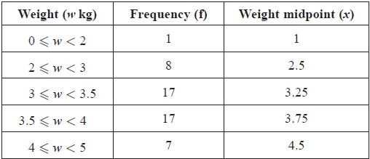
[You may use ∑ fx² = 611.375]
A histogram has been drawn to represent these data.
The bar representing the weight 2 ≤ w < 3 has a width of 1 cm and a height of 4 cm.
(a) Calculate the width and height of the bar representing a weight of 3 ≤ w < 3.5
(3)
(b) Use linear interpolation to estimate the median weight of these babies.
(2)
(c) (i) Show that an estimate of the mean weight of these babies is 3.43 kg.
(ii) Find an estimate of the standard deviation of the weights of these babies.
(3)
Shyam decides to model the weights of babies born at the hospital, by the random variable W, where
W ~ N(3.43, 0.65²)
(d) Find P(W < 3)
(3)
(e) With reference to your answers to (b), (c)(i) and (d) comment on Shyam's decision.
(3)
A newborn baby weighing 3.43 kg is born at the hospital.
(f) Without carrying out any further calculations, state, giving a reason, what effect the addition of this newborn baby to the sample would have on your estimate of the
(i) mean,
(ii) standard deviation.
(3)
(Total for question = 17 marks)

Q8.
A survey of 100 households gave the following results for weekly income £y.
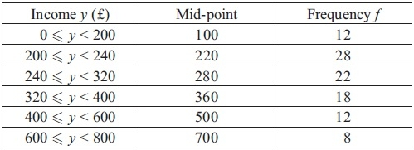
(You may use ∑ fy² = 12 452 800)
A histogram was drawn and the class 200 ≤ y < 240 was represented by a rectangle of width 2 cm and height 7 cm.
(a) Calculate the width and the height of the rectangle representing the class 320 ≤ y < 400
(3)
(b) Use linear interpolation to estimate the median weekly income to the nearest pound.
(2)
(c) Estimate the mean and the standard deviation of the weekly income for these data.
(4)
One measure of skewness is .
(d) Use this measure to calculate the skewness for these data and describe its value.
(2)
Katie suggests using the random variable X which has a normal distribution with mean 320 and
standard deviation 150 to model the weekly income for these data.
(e) Find P(240 < X < 400).
(2)
(f) With reference to your calculations in parts (d) and (e) and the data in the table, comment on Katie's suggestion.
(2)
(Total 15 marks)

Q9.
A class of students had a sudoku competition. The time taken for each student to complete the sudoku was recorded to the nearest minute and the results are summarised in the table below.
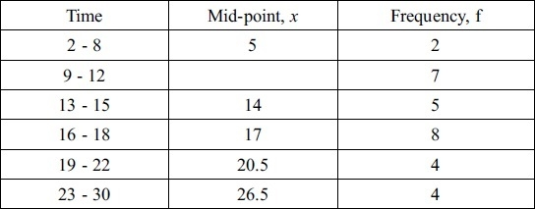
(You may use ∑ fx² = 8603.75)
(a) Write down the mid-point for the 9 - 12 interval.
(1)
(b) Use linear interpolation to estimate the median time taken by the students.
(2)
(c) Estimate the mean and standard deviation of the times taken by the students.
(5)
The teacher suggested that a normal distribution could be used to model the times taken by the students to complete the sudoku.
(d) Give a reason to support the use of a normal distribution in this case.
(1)
On another occasion the teacher calculated the quartiles for the times taken by the students to complete a different sudoku and found
Q₁ = 8.5 Q₂ =13.0 Q₃ = 21.0
(e) Describe, giving a reason, the skewness of the times on this occasion.
(2)
(Total 11 marks)

Q10.
The time, in minutes, taken by men to run a marathon is modelled by a normal distribution with
mean 240 minutes and standard deviation 40 minutes.
(a) Find the proportion of men that take longer than 300 minutes to run a marathon.
(3)
Nathaniel is preparing to run a marathon. He aims to finish in the first 20% of male runners.
(b) Using the above model estimate the longest time that Nathaniel can take to run the marathon and achieve his aim.
(3)
The time, W minutes, taken by women to run a marathon is modelled by a normal distribution with
mean μ minutes.
Given that P(W < μ + 30) = 0.82
(c) find P(W < μ – 30 | W < μ)
(3)
(Total for question = 9 marks)

Q11.
The random variable Z ~ N(0, 1)
A is the event Z > 1.1
B is the event Z > –1.9
C is the event –1.5 < Z < 1.5
(a) Find
(i) P(A)
(ii) P(B)
(iii) P(C)
(iv) P(A ∪ C)
(6)
The random variable X has a normal distribution with mean 21 and standard deviation 5
(b) Find the value of w such that P(X > w | X > 28) = 0.625
(6)
(Total for question = 12 marks)

Q12.
The time taken, in minutes, by children to complete a mathematical puzzle is assumed to be normally distributed with mean μ and standard deviation σ. The puzzle can be completed in less than 24 minutes by 80% of the children. For 5% of the children it takes more than 28 minutes to complete the puzzle.
(a) Show this information on the Normal curve below.
(2)
(b) Write down the percentage of children who take between 24 minutes and 28 minutes to complete the puzzle.
(1)
(c) (i) Find two equations in μ and σ.
(ii) Hence find, to 3 significant figures, the value of μ and the value of σ.
(7)
A child is selected at random.
(d) Find the probability that the child takes less than 12 minutes to complete the puzzle.
(3)
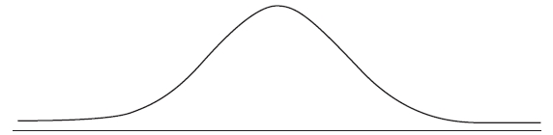
(Total 13 marks)

Q13.
The weight, in grams, of beans in a tin is normally distributed with mean μ and standard deviation 7.8
Given that 10% of tins contain less than 200 g, find
(a) the value of μ
(3)
(b) the percentage of tins that contain more than 225 g of beans.
(3)
The machine settings are adjusted so that the weight, in grams, of beans in a tin is normally distributed with mean 205 and standard deviation σ.
(c) Given that 98% of tins contain between 200 g and 210 g find the value of σ.
(4)
(Total 10 marks)

Q14.
The heights of an adult female population are normally distributed with mean 162 cm and
standard deviation 7.5 cm.
(a) Find the probability that a randomly chosen adult female is taller than 150 cm.
(3)
Sarah is a young girl. She visits her doctor and is told that she is at the 60th percentile for height.
(b) Assuming that Sarah remains at the 60th percentile, estimate her height as an adult.
(3)
The heights of an adult male population are normally distributed with standard deviation 9.0 cm.
Given that 90% of adult males are taller than the mean height of adult females,
(c) find the mean height of an adult male.
(4)
(Total 10 marks)

Q15.
The heights of adult females are normally distributed with mean 160 cm and standard deviation 8 cm.
(a) Find the probability that a randomly selected adult female has a height greater than 170 cm.
(3)
Any adult female whose height is greater than 170 cm is defined as tall.
An adult female is chosen at random. Given that she is tall,
(b) find the probability that she has a height greater than 180 cm.
(4)
Half of tall adult females have a height greater than h cm.
(c) Find the value of h.
(5)
(Total 12 marks)

Q16.
A manufacturer fills jars with coffee. The weight of coffee, W grams, in a jar can be modelled by a normal distribution with mean 232 grams and standard deviation 5 grams.
(a) Find P(W < 224).
(3)
(b) Find the value of w such that P(232 < W < w) = 0.20
(4)
Two jars of coffee are selected at random.
(c) Find the probability that only one of the jars contains between 232 grams and w grams of coffee.
(3)
(Total 10 marks)
Q17.
The distances travelled to work, D km, by the employees at a large company are normally distributed
with D N(30, 8² ).
(a) Find the probability that a randomly selected employee has a journey to work of more than 20 km.
(3)
(b) Find the upper quartile, Q₃, of D.
(3)
(c) Write down the lower quartile, Q₁ , of D.
(1)
An outlier is defined as any value of D such that D < h or D > k where
h = Q₁ − 1.5 × (Q₃ − Q₁) and k = Q₃ + 1.5 × (Q₃ − Q₁)
(d) Find the value of h and the value of k.
(2)
An employee is selected at random.
(e) Find the probability that the distance travelled to work by this employee is an outlier.
(3)
(Total 12 marks)

Q18.
The weight, X grams, of soup put in a tin by machine A is normally distributed with a mean of 160 g and a standard deviation of 5 g. A tin is selected at random.
(a) Find the probability that this tin contains more than 168 g.
(3)
The weight stated on the tin is w grams.
(b) Find w such that P(X < w) = 0.01
(3)
The weight, Y grams, of soup put into a carton by machine B is normally distributed with mean μ grams and standard deviation σ grams.
(c) Given that P(Y < 160) = 0.99 and P(Y > 152) = 0.90 find the value of μ and the value of σ.
(6)
(Total 12 marks)

Examiner's Report
Q1.
Most could find the correct width in part (a) but the height calculation is still causing problems. The common error was to compare frequencies rather than frequency densities and an incorrect answer of 3 was fairly common. Part (b) was answered well by the majority of students with very few cases of students using (n + 1) and most choosing to work upwards from 45 rather than down from 50. The interpolation technique is understood but there were still a number of errors made in determining the appropriate class boundaries with 44.5 being used instead of 45 quite often.
As expected, part (c) was answered very well by the majority of students but there were still some who simply added the 5 midpoints and divided by 5 which is disappointing for students at this level. Many students didn't seem to be familiar with the convention that answers involving money should be given to
2 decimal places and some lost a mark for simply writing down £49.1 without any correct working being seen. There were many fully correct answers to part (d) as well, but some forgot to use the square root and a number lost accuracy by using 49.1 or the mean rather than the full expression.
In part (e), all that was required was a simple comparison of Q₂ with but a number used a formula for skewness and that was, of course fine. The expected conclusion was that there was very little skewness since Q₂ ≈ but many concluded that since > Q₂ there was positive skew and this was allowed. The idea of using a normal distribution to model these data being an acceptable approach because there was only a little skewness was not appreciated by many students who simply trotted out a standard response that a normal was not a suitable model because the data was skew. Students should be encouraged to consider the magnitude of the skewness and realise that, with such a small amount of skew, to model the situation with a normal distribution may be a reasonable thing to do. Some students completely missed the need to reference part (e) in their answer to part (f) and simply compared their mean and standard deviation to Rika's values of £50 and £10. The final part (g) defeated many students despite being a fairly standard normal distribution question, presumably because it was not part of the question on the normal distribution. The three common errors were: standardising with their mean and standard deviation rather than the given values of 50 and 10, equating 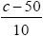 to a probability rather than a z-value or using 0.84 rather than 0.8416 from the percentage points tables.

Q2.
Some students could not recall the name of the distribution for X with several students calling it the discrete distribution rather than the discrete uniform distribution. The probabilities in question (b) were usually tackled well with only the less able students giving answers of 1 and 9 rather than 0.1 and 0.9. Question (c)(i) was challenging for a few but question (ii) was answered more successfully.

Q3.
The normal distribution was handled well by most candidates on this paper. Part (a) caused few problems although some candidates failed to subtract their tables' value from 1 and most made good progress in part (b) too although some failed to use the table of percentage points of the normal distribution and had a z value of 1.04 or 1.03 rather than 1.0364. Part (c) was more challenging requiring the identification of a conditional probability and then the correct evaluation of the numerator using the symmetry of the distribution but there were a good number of correct responses seen.

Q4.
A small minority were still unsure whether the final answer was 0.9641 or 1 − 0.9641. There were 3 common sources of error in (b). Some candidates simply set their standardised expression equal to 0.1 or 0.5398 and lost all 3 marks. Others realised that the standardised expression should be set equal to a z value but did not use the percentage points table and lost a mark. The final problem was choosing the correct sign on their z value and a number of answers of 119 were seen. Some candidates gave an answer of 80.776… from their calculators and gained all 3 marks.
(c) was not answered well and most attempts did not notice the usual prompt (the wording "given that…") and thus did not attempt a conditional probability. Common solutions were simply a calculation of
P(L > 133) or P(127 < L < 133).

Q5.
Part (a) was tackled well by the majority of candidates although some were still unsure whether to give the answer as 0.7580 or 1 − 0.7580. There were a surprising number who mis-read the 16.12 value as 16.2 and lost the final accuracy mark.
In part (b) a number of candidates are still not using the table of percentage points to obtain the more accurate z value of 0.5244 but, as usual this only incurred a one mark penalty. Those who standardised and equated to a z value often failed to consider the sign of this value carefully and obtained the commonly seen answer of 16.96.

Q6.
This was the most challenging question on the paper. Part (a) was a simple use of the normal distribution and most students scored full marks here. A sizeable group though standardised correctly but then confused the two tables and wrote down the z-value corresponding to a probability of 0.4 (i.e. 0.2533) and used this as their probability. There were also a number of cases of students miscopying the tables and 0.3466 instead of 0.3446 was seen quite frequently. The usual errors of standardising with 5² or were very rare though a number were still unsure whether or not to subtract their tables figure from 1.
In part (b), few wrote down a conditional probability statement but launched straight into a ratio of probabilities. This was fine if the ratio was correct but, whilst most had P(T > 15) = 0.7257 on the denominator, those who thought the numerator was simply P(T > 15)×P(T > 20) would score no marks. Those who did have a correct numerator were often able to score all of the marks here. Part (c) proved too demanding for most students and only a few of those who eventually arrived at a correct answer did so from a clearly argued solution. Some students assumed that linear interpolation was required and made no headway. Very few started by considering a conditional probability but some did realise that they required the value d such that P(T > d) = 0.5 × 0.7257 and some then realised they were trying to find d from P(T < d) = 0.63715. Those who got this far usually realised that they needed to use a z-value of 0.35, though some did not know how to deal with a probability in-between two values in the tables and simply took the midpoint, and were able to form a correct equation and arrive at the correct answer but under 10% scored full marks on this question.

Q7.
The comment requirements in parts (e) and (f) made the latter stages of this question quite demanding but many were able to pick up marks in parts (b), (c) and (d). In part (a) most identified the width as
0.5 cm but, as usual, the height caused some difficulties. A number of students still seem to think that the height represents the frequency and some managed to make the statement that 4 cm² represents 8 babies but were still unable to use this to find the correct height.
The linear interpolation in part (b) was usually carried out very well but a few used the midpoints or made errors with class boundaries or used incorrect cumulative frequencies such as 10 or 27 instead of 9
and 26.
In part (c)(i), some students did not show how to use the midpoints to find ∑ fx, simply using the value of 171.5; a "show that" question always requires a full explanation of the method used. More students now seem to know a suitable formula for standard deviation but some are still a little uncertain about whether or not a square root is required and some wasted time by calculating ∑ fx² (not always successfully) rather than using the value given in the question.
Part (d) was a simple normal distribution probability calculation and the success rate amongst students with this standard application has improved considerably. A small minority are still uncertain about whether or not to subtract the value from the tables from 1 but there were many fully correct responses to this part
In part (e), a number made a correct observation about the mean and median and possible skewness and could relate this to the suitability of using the normal distribution. Far fewer, though, were able to compare their answer to part (d) with the equivalent proportion from the table and so missed out on the other two marks. In part (f), most stated that the mean would not change and often gave a correct reason for this but fewer knew that the standard deviation would decrease and fewer still were able to give a convincing reason to support this.

Q8.
In (a) there is still some uncertainty about the concept of histograms. Most candidates could find the width of the required bar but a number still failed to consider frequency densities to find the height. Some attempts were on the right lines but used the interval [240, 320); others assumed height was linked to frequency alone and 4.5 cm was a common incorrect answer. There has been a clear improvement in the use of interpolation to calculate the median in recent sessions and many had × 80 (with only a small minority using 10.5 instead of 10). The common error was to use 239.5 rather than 240 as the class boundary but there were many fully correct answers seen.
The calculation of the mean in (c) was usually correct but the standard deviation still causes difficulties for some who failed to use a correct formula.(d) was straightforward although some failed to secure the second mark because they did not give a description (e.g. "positive") of their skewness.
In (e) the insertion of a normal calculation in this context seemed to fox some candidates but many were able to carry out this routine calculation correctly. However the interpretation in (f) was not answered so well. Some drew the connection between their answer to (e) and the proportion in the table and deduced that a normal distribution was reasonable (over this range). Slightly more focussed on the fact that in (d) they had stated that the distribution was skewed and therefore a normal distribution was probably not a suitable model (overall) but few were able to marry these statements up and secure both marks.

Q9.
Part (a) was, unsurprisingly, answered very well and most candidates were able to use the mid-points to find the mean in part (c). The calculation of standard deviation is still causing problems though: an incorrect formula, premature rounding and forgetting the square root were the typical errors. The technique of interpolation required in part (b) is now better understood but incorrect class widths still caused problems here. A common response to part (d) was to simply state that the data was continuous rather than using the calculations they have just performed in parts (b) and (c).
Part (e) was usually answered well with most using Q₃ − Q₂ > Q₂ − Q₁ but a small minority gave the wrong conclusion despite giving the correct comparison.

Q10.
Overall, the standard of work on the normal distribution was much better compared to previous years. Most students now standardise correctly, although the notation is not always handled well, and the distinction between probabilities and z-values still causes problems for some students.
Part (a) was answered well by most students but fewer secured all 3 marks in part (b). Some used a z-value of 0.84 rather than the more accurate value of 0.8416 from the percentage points table. The other problem was a misunderstanding about the concept of "high performance". To finish in the top 20% of runners, Nathaniel would be aiming for an answer less than the mean of 240 minutes. A number of students made a sign error and obtained an answer of 274 minutes and failed to realise that this must be incorrect.
Part (c) caused difficulties for many students. The best and simplest solutions were based on a diagram and appropriate use of symmetry. Others used their definitions of conditional probabilities but were unable to identify that their numerator of P([W < 30 – μ ]∩[W < μ ]) simplifies to P(W < μ – 30) and often tried multiplying two probabilities to obtain the numerator. A significant minority of students did not attempt this part but this appeared more to do with the difficulty of the question as opposed to an issue of time.

Q11.
Students who had been taught to use a diagram alongside the normal distribution tables were often able to make good progress in part (a). In part (ii) the common error was to find 1 − 0.9713 = 0.0297 and some mis-read the tables in the first two parts with answers of 0.1335 being quite common for (i). A clear diagram was usually a great help in part (iii) and there were a good number of correct answers here but part (iv) caused some problems. Some tried to use the addition formula given in the formula booklet but thought that P(AC) was P(A) × P(C) and the incorrect 0.8845 was common. Those who were able to interpret AC in terms of the inequalities could simply write down P(Z < 1.5) and hence find the correct answer from the tables.
Part (b) proved to be a good discriminator but many students failed to make progress due to poor handling of the notation or an inability to interpret the conditional probability. Most realised that at some stage they would need to standardise and find P(X > 28) but this was often the only mark scored. Those who realised that the given probability statement reduced to 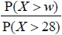 = 0.625 were usually able to make significant progress, the difficulty for many was appreciating that P([X > w] [X > 28]) = P(X > w). Once they had got as far as P(X > w) = 0.625 × 0.0808 or P(X < w) = 0.9495 they were usually able to standardise and set equal to 1.64 and solve for w. Some used 1.6449 instead of 1.64 but this only cost them 1 mark and a reasonable number of correct answers were seen.
The notation for the normal distribution is still not handled well by many students at this level and there was a clear difference between those who gave a correct and rigorous argument leading to 29.2 and those who stumbled their way through despite several "nonsense" statements to arrive at the correct answer. This time the mark scheme did not differentiate between them but this is an area that the examiners should aim to address in future.
Q12.
A number of students failed to label their diagram correctly in question (a) and a few gave an answer of 25% for question (b) but there was plenty of fully correct answers here. There were many correct answers to question (c) but although many used the value of 1.6449 for the equation based on 28, they only used 0.84 (rather than 0.8416) for the other equation. Question (d) was a relatively straightforward application of the normal distribution and even those with incorrect answers from question (c) could secure the method marks here.

Q13.
As usual the normal distribution posed serious problems for some candidates. There were two major reasons for lost marks. The first was a failure to use the table of percentage points of the normal distribution where appropriate and many candidates lost marks for using z values of 1.28 or 2.32 or even 2.33 rather than the 4dp values available. The second problem is a fundamental one of understanding where candidates confuse probabilities (areas) with z values (points on the horizontal axis).
In part (a) many could standardize correctly and often set their expression equal to a suitable z value but often there was a sign error and this led to an answer of 190 for the mean. Other candidates stated that the mean was 210 which was correct but this didn't follow from their equation and accuracy marks will not be awarded in such cases. Part (b) was more straightforward and provided a correct mean was found in part (a) full marks were usually obtained. Many left their answer as a probability rather than the percentage asked for in the question but this was condoned on this occasion. The final part proved quite challenging. Some drew a diagram but were unable to represent the information in the question in a useful way. Others tried subtracting two standardizations and ended up with = z which was of little use to them. Those who realized that just using the value of 210 along with the mean of 205 and z = 2.3263 was all that was required usually formed a simple equation for σ and were able to solve it successfully.

Q14.
Most candidates now can standardise with confidence but there is still some confusion when using the tables for negative z values and a number of candidates are still not clear about the difference between a probability (area under the curve) and a z value (the point on the horizontal axis). The notation is still not handled well and statements such as "P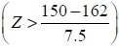 = −1.6" or "0.4 = 0.2533" are often seen as candidates stumble towards a correct answer.
In part (a) the majority gained the first 2 marks for standardising and arriving at a correct value for z but many lost the final mark for subtracting 0.9452 from 1. A clearly labelled diagram may have helped them avoid this error. In part (b) some were confused by the reference to 60th percentile and simply found 60% of 162. Whilst many could standardise correctly equations such as 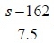 = 0.6 were quite common. Those who did realise that 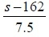 should be set equal to a z value often used 0.25 rather than the more accurate 0.2533 available from the table of percentage points.
Similar problems arose in part (c) and there was the added complication of obtaining compatible signs for a correct equation. Some candidates made double sign errors when solving 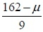 = 1.2816 to arrive at an answer of 174 and this lost the accuracy marks as their answer did not follow from their equation. The use of ± 1.28 was condoned here if the candidates had already lost a mark for using 0.25 rather than 0.2533 in part (b).

Q15.
Most students standardised correctly although the notation, and especially the distinction between probabilities and z values, was not handled well.
In question (a) a small minority are still unclear when and when not to subtract the value found in the tables from 1.
In question (b) many found P(H > 180) but they did not appreciate that question (b) wanted a conditional probability and so just left their answer as P(H > 180) instead of dividing this by their answer to question (a). Some of those who did identify the conditional probability could not interpret their numerator
P(H > 180 ∩ H > 170) correctly and simply wrote P(H > 180) × P(H > 170) .
Question (c) was often not attempted but those who did could usually obtain a probability of 0.0528 for P(H > h). Unfortunately a number of students then used a rounded probability of 0.05 and therefore a
z value of 1.6449 rather than the correct value of 1.62. Standardising and forming a suitable equation for h were usually accomplished correctly by those who reached this stage and the correct answer was seen from a number of students.

Q16.
It was pleasing to see fewer blank pages than in the past although full marks were rarely gained for this question. Part (a) was answered well, if it was incorrect it was usually because candidates standardised with 25 as the standard deviation instead of 5 or did not subtract their probability from 1.
Part (b) was less well done and very few drew a diagram which helped with the areas and probabilities. Those who knew what to do often forgot to use the percentage points table and it was rare to see
z = 0.5244 used. Some candidates used probabilities instead of z values, and some used the z value of 0.8416, although sign errors were few.
Part (c) was challenging for a large number of candidates and was not attempted if they had struggled with the earlier parts. The value of 0.16 was often seen in the scripts of those who tried it, ignoring the different ways of selection. Some candidates tried using the normal distribution to solve this part, or used values from part (b) such as 0.5793 in their work with lots of elaborate wrong calculations. Those who drew a tree diagram usually scored full marks.

Q17.
This question proved to be quite challenging for a high proportion of candidates. A significant number either made no attempt at the question or offered very little in the way of creditable solutions, with many unable to progress beyond part (a). Time issues may have been a contributing factor in some cases.
The majority of candidates however, were able to earn some credit at least in part (a), for their standardisation, although whilst this was often completely correct, a fairly common mistake was to give 1−0.8944 = 0.1056 as their final answer.
Many students did not recognise that they needed to actually use the normal distribution in part (b) and part (c), giving rise to extremely poor attempts by numerous candidates. Of these, many merely gave 45 and 15 as their quartiles, whilst others calculated ¾ of some value as their upper quartile (for example
¾ × 60) and ¼ of the same value as their lower quartile. Alternatively, of those who understood that they were required to use the normal distribution, most attempts were successful, though there were some instances of their setting their standardisation equal to a probability, usually 0.75 or P(Z < 0.75), and not a z-value. Unfortunately 0.68 was used fairly frequently as the z value. The majority of candidates were however able to follow through their value of the upper quartile to find their lower quartile using symmetry, though some performed a second calculation involving standardisation. Some candidates miscalculated their lower quartile as 1/3 of their upper quartile.
Despite previous errors most candidates tended to be successful in substituting their values correctly into at least one of the given formulae. However, a few seemed unaware of the order of the operations.
The final part of the question also proved difficult for many candidates with some running into trouble as a consequence of previous errors in part (b), part (c) and part (d) and others providing no attempt at all. Indeed, for numerous candidates, incorrect values for h and k led to probabilities of 0 being calculated from results such as P(Z > 7) and thus many creditable attempts lost marks through earlier inaccuracies.

Q18.
Part (a) was answered well and it was good to see diagrams being used to assist the candidates. Part (b) still causes problems for many candidates. They can usually standardise but then far too often equate this expression to 0.01 or 0.99. Those who did use a z value often used the "small" table and found the 2.3263 value but the minus sign was often missed and the final answer was therefore incorrect. Most seemed to try part (c) and the standardising was usually correct and suitable z values were often seen (use of 2.32 or 2.33 and 1.28 were acceptable here) but, when suitable equations were formed, a minus sign was often missing from the second equation. Solving their two linear equations was carried out quite well but full marks were only secured by those who worked carefully and accurately throughout this part.

Mark Scheme

Section 6 | Normal distribution part 1
qu.1 | June 2017 S1 - Q2fg
qu.2 | June 2014 S1R - Q2c
qu.3 | May 2013 S1R - Q4
qu.4 | January 2013 S1 - Q4
qu.5 | May 2011 S1 - Q4
qu.6 | June 2017 S1 - Q5
qu.7 | June 2016 S1 - Q5de*
qu.8 | January 2013 S1 - Q5ef*
qu.9 | May 2011 S1 - Q5de*
qu.10 | June 2016 S1 - Q6
qu.11 | June 2015 S1 - Q6
qu.12 | June 2014 S1R - Q6
qu.13 | May 2013 S1 - Q6
qu.14 | May 2012 S1 - Q6
qu.15 | June 2014 S1 - Q7
qu.16 | January 2012 S1 - Q7
qu.17 | May 2010 S1 - Q7
qu.18 | January 2011 S1 - Q8

Q1.
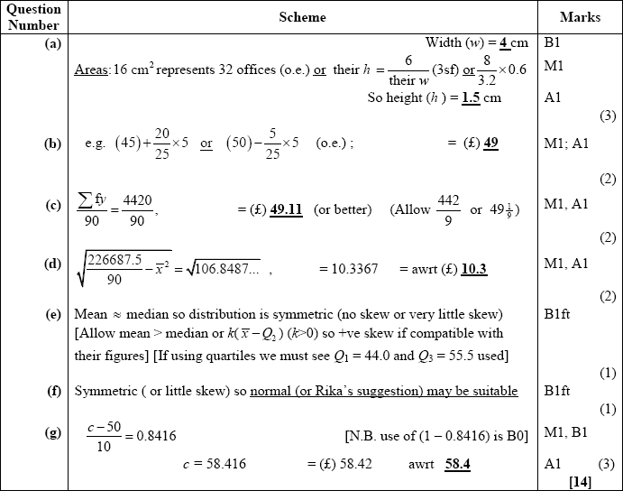
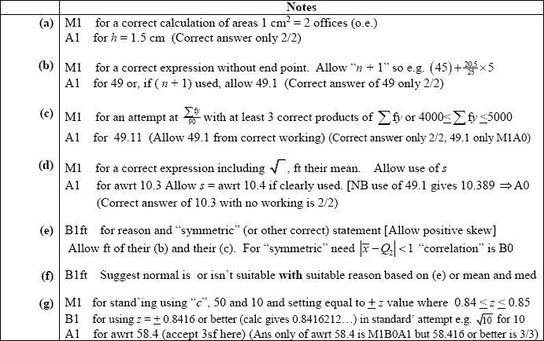

Q2.
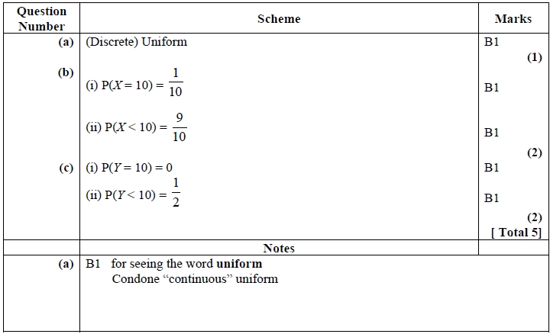

Q3.
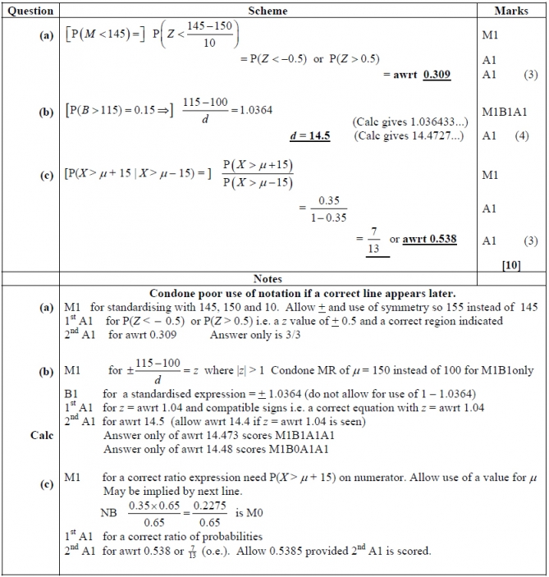

Q4.
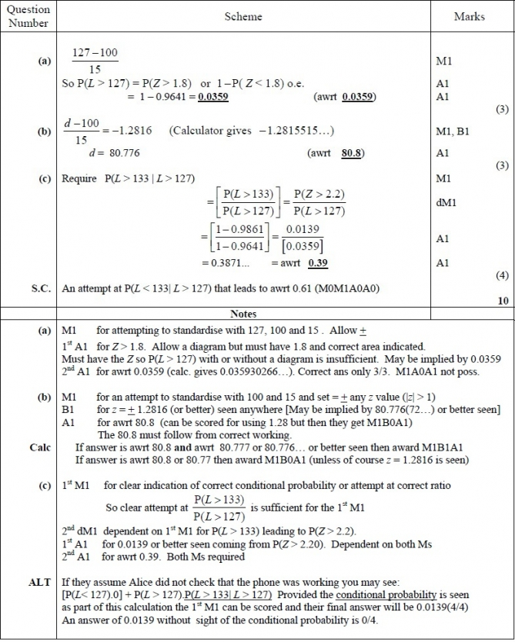

Q5.
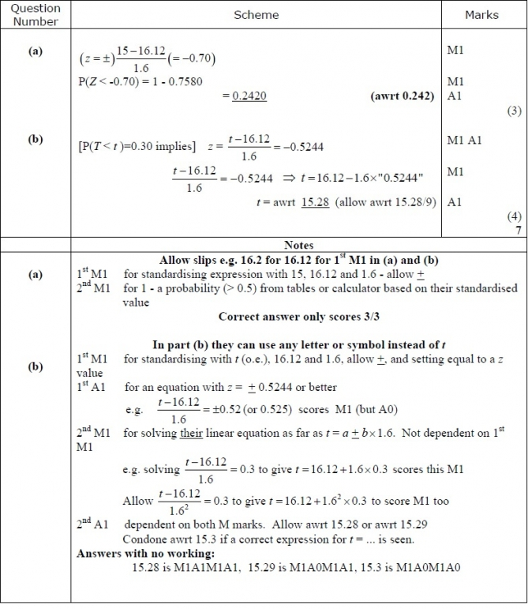

Q6.
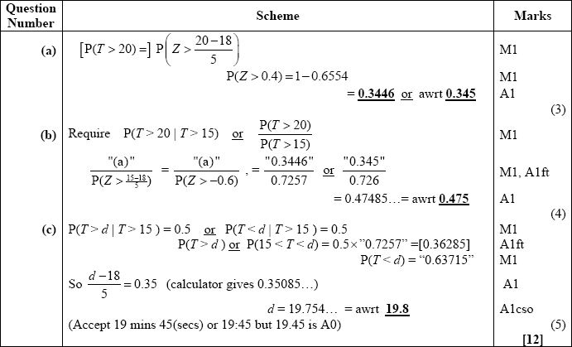
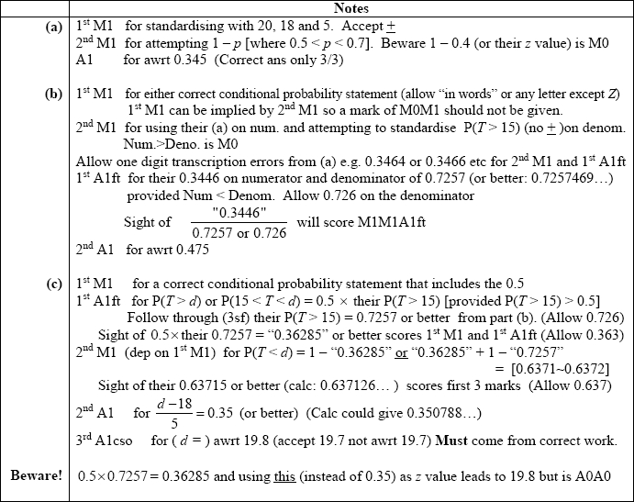

Q7.
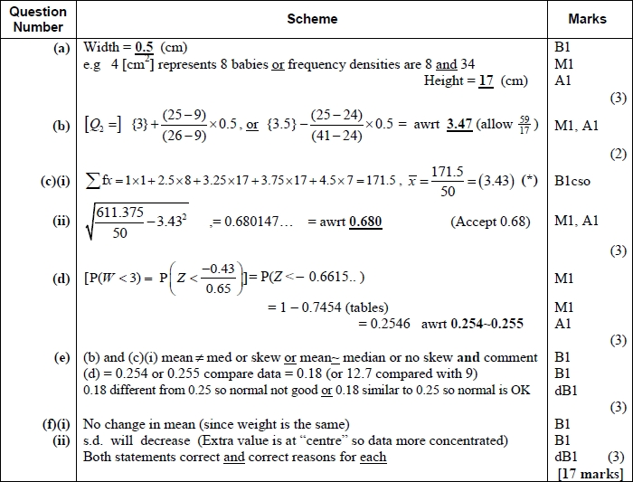
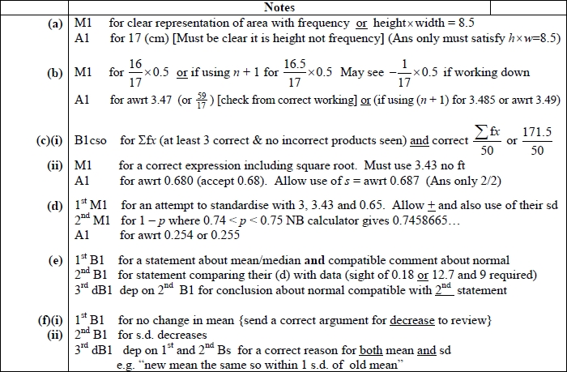
Q8.
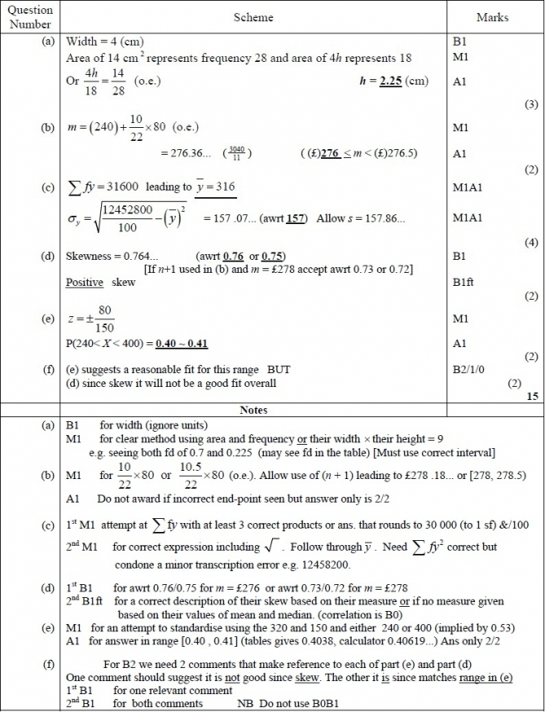

Q9.
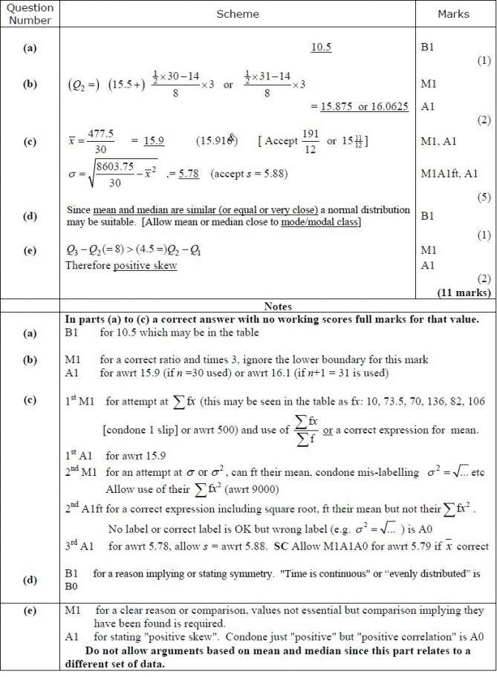

Q10.
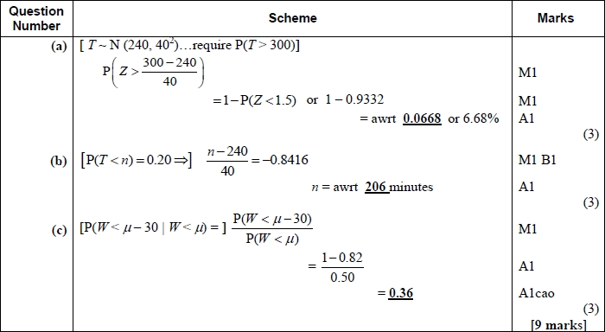
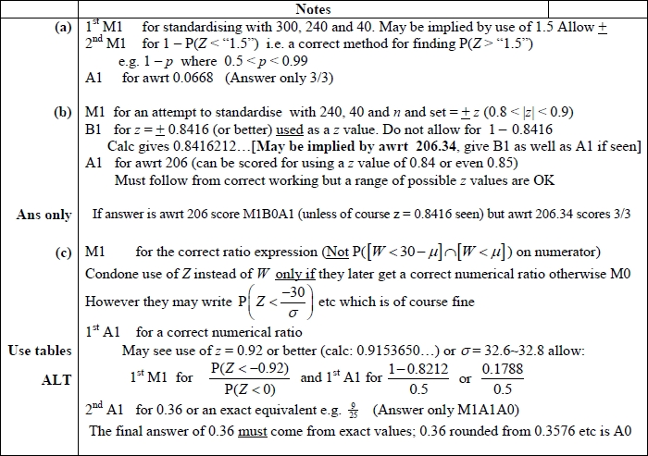

Q11.
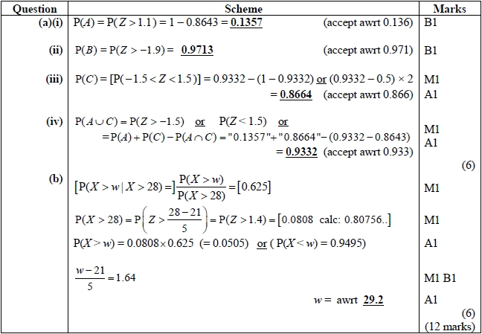
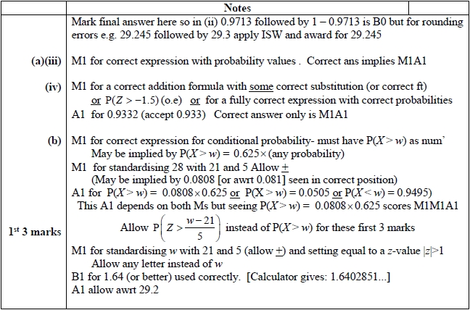

Q12.
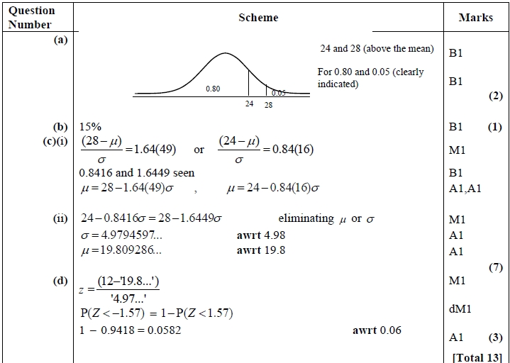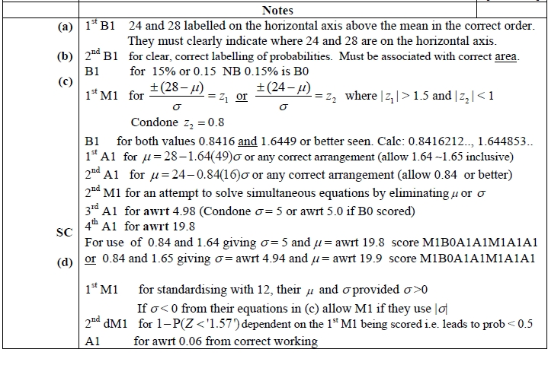

Q13.
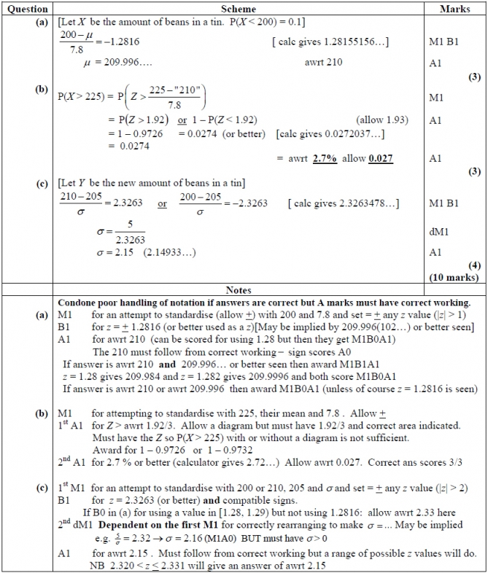

Q14.
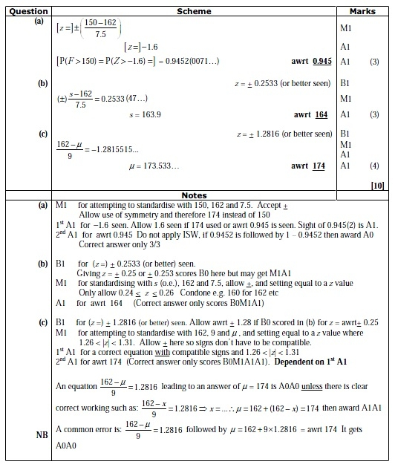

Q15.
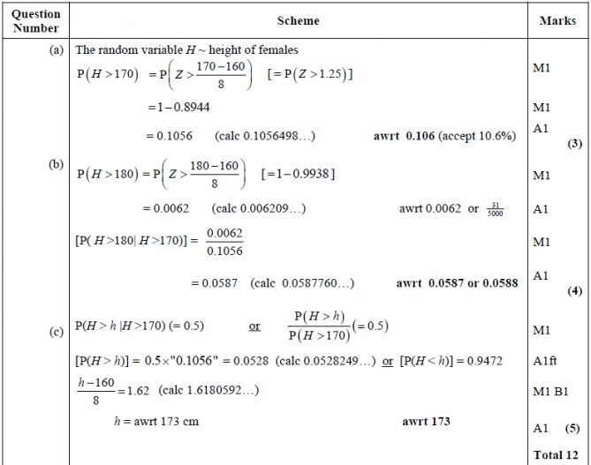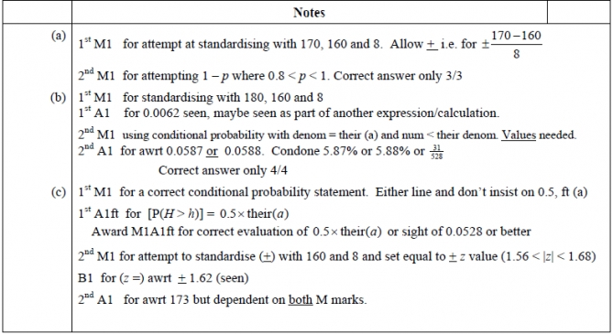

Q16.
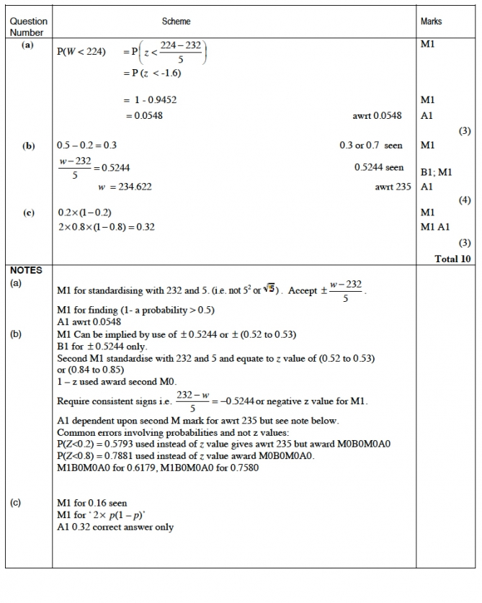

Q17.
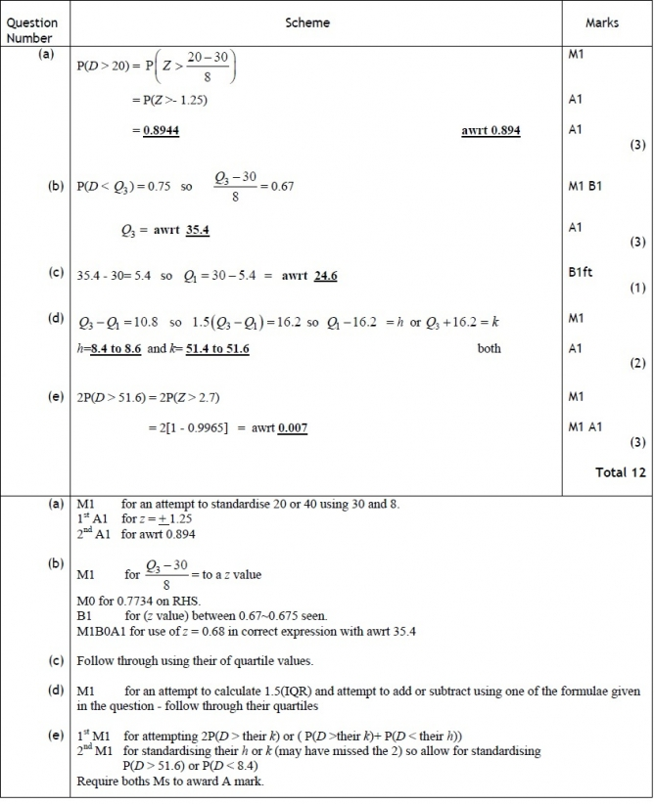

Q18.
