Name: _______________________________________________
GCE Stats section 5
Binomial distribution
practice questions from GCE Maths
Date:
Question parts in red cover content in the GCE Statistics specification but outside this section of the scheme of work
Time:
Total marks available:
Total marks achieved: ______

Questions
Q1.
A disease occurs in 3% of a population.
(a) State any assumptions that are required to model the number of people with the disease in a
random sample of size n as a binomial distribution.
(2)
(b) Using this model, find the probability of exactly 2 people having the disease in a random sample
of 10 people.
(3)
(c) Find the mean and variance of the number of people with the disease in a random sample of 100 people.
(2)
A doctor tests a random sample of 100 patients for the disease. He decides to offer all patients a vaccination to protect them from the disease if more than 5 of the sample have the disease.
(d) Using a suitable approximation, find the probability that the doctor will offer all patients a vaccination.
(3)
(Total 10 marks)

Q2.
In a region of the UK, 5% of people have red hair. In a random sample of size n, taken from this region, the expected number of people with red hair is 3
(a) Calculate the value of n.
(2)
A random sample of 20 people is taken from this region.
Find the probability that
(b) (i) exactly 4 of these people have red hair,
(ii) at least 4 of these people have red hair.
(5)
Patrick claims that Reddman people have a probability greater than 5% of having red hair.
In a random sample of 50 Reddman people, 4 of them have red hair.
(c) Stating your hypotheses clearly, test Patrick's claim. Use a 1% level of significance.
(5)
(Total for question = 12 marks)

Q3.
The proportion of houses in Radville which are unable to receive digital radio is 25%. In a survey of a random sample of 30 houses taken from Radville, the number, X, of houses which are unable to receive digital radio is recorded.
(a) Find P(5 X < 11)
(3)
A radio company claims that a new transmitter set up in Radville will reduce the proportion of houses which are unable to receive digital radio. After the new transmitter has been set up, a random sample of
15 houses is taken, of which 1 house is unable to receive digital radio.
(b) Test, at the 10% level of significance, the radio company's claim. State your hypotheses clearly.
(5)
(Total 8 marks)

Q4.
Bhim and Joe play each other at badminton and for each game, independently of all others, the probability that Bhim loses is 0.2
Find the probability that, in 9 games, Bhim loses
(a) exactly 3 of the games,
(3)
(b) fewer than half of the games.
(2)
Bhim attends coaching sessions for 2 months. After completing the coaching, the probability that he loses each game, independently of all others, is 0.05
Bhim and Joe agree to play a further 60 games.
(c) Calculate the mean and variance for the number of these 60 games that Bhim loses.
(2)
(d) Using a suitable approximation calculate the probability that Bhim loses more than 4 games.
(3)
(Total 10 marks)

Q5.
Accidents occur randomly at a road junction at a rate of 18 every year.
The random variable X represents the number of accidents at this road junction in the next 6 months.
(a) Write down the distribution of X.
(2)
(b) Find P(X > 7).
(2)
(c) Show that the probability of at least one accident in a randomly selected month is 0.777
(correct to 3 decimal places).
(3)
(d) Find the probability that there is at least one accident in exactly 4 of the next 6 months.
(3)
(Total 10 marks)

Q6.
A random variable X has the distribution B(12, p).
(a) Given that p = 0.25 find
(i) P(X < 5)
(ii) P(X ≥ 7)
(3)
(b) Given that P(X = 0) = 0.05, find the value of p to 3 decimal places.
(3)
(c) Given that the variance of X is 1.92, find the possible values of p.
(4)
(Total 10 marks)

Q7.
The probability of a telesales representative making a sale on a customer call is 0.15
Find the probability that
(a) no sales are made in 10 calls,
(2)
(b) more than 3 sales are made in 20 calls.
(2)
Representatives are required to achieve a mean of at least 5 sales each day.
(c) Find the least number of calls each day a representative should make to achieve this requirement.
(2)
(d) Calculate the least number of calls that need to be made by a representative for the probability of at least 1 sale to exceed 0.95
(3)
(Total 9 marks)

Q8.
A cadet fires shots at a target at distances ranging from 25 m to 90 m. The probability of hitting the target with a single shot is p. When firing from a distance dm, p = ³⁄₂₀₀(90 − d).
Each shot is fired independently.
The cadet fires 10 shots from a distance of 40 m.
(a) (i) Find the probability that exactly 6 shots hit the target.
(ii) Find the probability that at least 8 shots hit the target.
(5)
The cadet fires 20 shots from a distance of x m.
(b) Find, to the nearest integer, the value of x if the cadet has an 80% chance of hitting the target at
least once.
(4)
The cadet fires 100 shots from 25 m.
(c) Using a suitable approximation, estimate the probability that at least 95 of these shots hit the target.
(5)
(Total 14 marks)

Q9.
The number of houses sold by an estate agent follows a Poisson distribution, with a mean of 2 per week.
(a) Find the probability that in the next 4 weeks the estate agent sells,
(i) exactly 3 houses,
(ii) more than 5 houses.
(5)
The estate agent monitors sales in periods of 4 weeks.
(b) Find the probability that in the next twelve of these 4 week periods there are exactly nine periods in which more than 5 houses are sold.
(3)
The estate agent will receive a bonus if he sells more than 25 houses in the next 10 weeks.
(c) Use a suitable approximation to estimate the probability that the estate agent receives a bonus.
(6)
(Total 14 marks)

Q10.
The time taken for a randomly selected person to complete a test is M minutes, where M ~ N (14, σ²)
Given that 10% of people take less than 12 minutes to complete the test,
(a) find the value of σ
(3)
Graham selects 15 people at random.
(b) Find the probability that fewer than 2 of these people will take less than 12 minutes to complete
the test.
(3)
Jovanna takes a random sample of n people.
Using a normal approximation, the probability that fewer than 9 of these n people will take less than
12 minutes to complete the test is 0.3085 to 4 decimal places.
(c) Find the value of n.
(8)
(Total 14 marks)

Q11.
Defects occur at random in planks of wood with a constant rate of 0.5 per 10 cm length. Jim buys a plank of length 100 cm.
(a) Find the probability that Jim's plank contains at most 3 defects.
(2)
Shivani buys 6 planks each of length 100 cm.
(b) Find the probability that fewer than 2 of Shivani's planks contain at most 3 defects.
(5)
(c) Using a suitable approximation, estimate the probability that the total number of defects on
Shivani's 6 planks is less than 18.
(6)
(Total 13 marks)

Q12.
A company claims that a quarter of the bolts sent to them are faulty. To test this claim the number of faulty bolts in a random sample of 50 is recorded.
(a) Give two reasons why a binomial distribution may be a suitable model for the number of faulty bolts in the sample.
(2)
(b) Using a 5% significance level, find the critical region for a two-tailed test of the hypothesis that the probability of a bolt being faulty is . The probability of rejection in either tail should be as close as possible to 0.025
(3)
(c) Find the actual significance level of this test.
(2)
In the sample of 50 the actual number of faulty bolts was 8.
(d) Comment on the company's claim in the light of this value. Justify your answer.
(2)
The machine making the bolts was reset and another sample of 50 bolts was taken. Only 5 were found to be faulty.
(e) Test at the 1% level of significance whether or not the probability of a faulty bolt has decreased. State your hypotheses clearly.
(6)
(Total 15 marks)

Q13.
A telesales operator is selling a magazine. Each day he chooses a number of people to telephone. The probability that each person he telephones buys the magazine is 0.1
(a) Suggest a suitable distribution to model the number of people who buy the magazine from the telesales operator each day.
(1)
(b) On Monday, the telesales operator telephones 10 people. Find the probability that he sells at least
4 magazines.
(3)
(c) Calculate the least number of people he needs to telephone on Tuesday, so that the probability of selling at least 1 magazine, on that day, is greater than 0.95
(3)
A call centre also sells the magazine. The probability that a telephone call made by the call centre sells a magazine is 0.05
The call centre telephones 100 people every hour.
(d) Using a suitable approximation, find the probability that more than 10 people telephoned by the call centre buy a magazine in a randomly chosen hour.
(3)
(Total 10 marks)

Q14.
In a large restaurant an average of 3 out of every 5 customers ask for water with their meal.
A random sample of 10 customers is selected.
(a) Find the probability that
(i) exactly 6 ask for water with their meal,
(ii) less than 9 ask for water with their meal.
(5)
A second random sample of 50 customers is selected.
(b) Find the smallest value of n such that
P(X < n) ≥ 0.9
where the random variable X represents the number of these customers who ask for water.
(3)
(Total 8 marks)

Q15.
A research station is doing some work on the germination of a new variety of genetically modified wheat.
They planted 120 rows containing 7 seeds in each row.
The number of seeds germinating in each row was recorded. The results are as follows
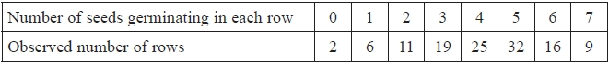
(a) Write down two reasons why a binomial distribution may be a suitable model.
(2)
(b) Show that the probability of a randomly selected seed from this sample germinating is 0.6
(2)
The research station used a binomial distribution with probability 0.6 of a seed germinating. The expected frequencies were calculated to 2 decimal places. The results are as follows
(c) Find the value of s and the value of t.
(2)
(d) Stating your hypotheses clearly, test, at the 1% level of significance, whether or not the data can be modelled by a binomial distribution.
(7)
(Total 13 marks)

Examiner's Report
Q1.
This question proved to be a very good start to the paper for a large majority of candidates. In part (a) the assumptions were written "in context". However, there are still too many scripts where there was no mention of context at all. Many simply wrote a list of reasons as to why a Poisson distribution should be used rather than stating the assumptions that had been made.
In parts (b) and (c) fully correct solutions were seen in a large majority of candidates. However, there were a small number who failed to spot the change in the value of the parameter n from (b) to (c).
In part (d) most candidates provided a clear and accurate solution. However, there were a few candidates who used a Normal approximation, which is clearly inappropriate in this situation since "n is large and p is small" applies in this case and therefore indicates the use of a Poisson approximation. A small but significant number of candidates used a Binomial distribution despite the question requesting that a suitable approximation be used. A common error from those using a Poisson approximation was the use of P(X ≤ 4) instead of P(X ≤ 5).

Q2.
This question proved a good source of marks. A large majority of candidates earned the first seven marks (from parts (a) and (b)). The use of the Binomial distribution and the handling of inequalities was generally confident and accurate. The most common error in part (c)(ii) (admittedly quite rare) was to interpret "at least 4" as P(X > 4) = 1 – P(X ≤ 4)
It can also be noted that many candidates had a solid grasp of the principles of hypothesis testing. A few candidates completed all the stages up until the last, and then made no attempt at a 'conclusion in context'. It is perhaps worth reminding centres and candidates that while hypothesis testing may involve sophisticated theory and techniques, it both starts and finishes in the real world.
Common errors were finding: P(X = 4) and P(X ≤ 4) .

Q3.
The response to part (a) was disappointing. A significant number of students were unable to cope with the expression P(5 ≤ X < 11) . There were students who translated this expression into the more convenient form P(5 ≤ X < 10) and then in turn transformed this into an equivalent form that can be applied to the table of cumulative probabilities: P(X ≤ 10) − P(X ≤ 4). However, there were also many instances of incorrect versions such as: P(X < 11) − P(X ≥ 5), P(X ≤ 10) + P(X ≥ 5) , P(X ≤ 10) − (1 − P(X ≥ 5)) and
P(X ≤ 11) – either P(X ≤ 5) or P(X ≤ 4) .
Full marks for part (b) occurred relatively rarely. Many students seemed to omit or slip up on at least one detail: forgetting the hypotheses, or using the wrong letter, or forgetting a 'conclusion in context'. Perhaps the most serious error, fortunately not too common, was the use of P(X = 1). The central feature of a hypothesis test is to establish the probability of an event 'as bad or worse than that observed' under the conditions of the null hypothesis. In this case, the relevant event is P(X ≤ 1) .

Q4.
This question was well answered by the majority of candidates with many scoring full marks. There were, of course, candidates who failed to score full marks. This was usually the result of inaccurate details, rather than lack of knowledge. In particular, manipulation of inequalities requires concentration and attention to detail. In part (a) the most common error seen was using P(X = 3) = P(X ≤ 4) − P(X ≤ 3) .
Parts (b) and (c) were usually correct. The most common error was to find P(X≤ 3) rather than P(X≤ 4) in part (b). A minority of candidates used the Normal as their approximation in part (d). The simple rule "n is large, p is small: use Poisson" clearly applies in this case.

Q5.
Question (a) and question (b) were well answered although in question (a) a few students wrote down Poisson but forgot to give the value of λ .
Since question (c) is a 'show that' question students were required to write down all the steps needed to reach 0.777. Many students went straight from 1 − P(Y = 0) to 0.7769. To gain full marks they were required to write down the figures between these two stages (1 − 0.2231) .
Most students identified the Binomial with n = 6 and p = 0.777 in question (d) but few could progress any further. Many who did try either omitted ⁶C₄ or used (0.777)² (1 − 0.777)⁴

Q6.
Part (a)(i) again tested candidates' ability to handle inequalities which they often found challenging. This was shown by incorrect answers such as P(X ≤ 5) = 0.9456 or those finding 1 − P(X ≤ 5). Part (b) challenged a significant number of candidates although the majority who attempted this question were able to state (1 − p)¹² = 0.05. The final solution to this part, however, often proved beyond the ability of many candidates. Successful candidates were adept at finding roots using calculators or using logs to get the solution whereas those less successful made several attempts before admitting defeat.
Common errors seen involved using a mix of common and natural logs or having written correctly
log(1 − p) = 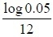 then not being able to write an expression for '1 − p = ……'. A high proportion of candidates answered part (c) confidently and successfully, with the majority of candidates gaining at least one mark for writing Variance = 12p(1 − p) or for 12pq = 1.92 and attempting to solve their quadratic. Errors were quite often due to writing/using the quadratic formula incorrectly due to errors in basic arithmetical calculations.

Q7.
Parts (a) to (c) of this question seemed straightforward for candidates with many fully correct answers. A significant minority of candidates incorrectly used a Poisson approximation. A common error in part (b) was to find P(X > 3) =1− P(X ≤ 2) . Part (c) was well answered with the majority of candidates solving
n × 0.15 = 5.
Part (d) proved challenging to many candidates, with many not being able to identify an appropriate method to use. Overall, most candidates attempting this showed that they needed to find a value which would satisfy 1− P(X = 0) > 0.95 or P(X = 0) < 0.05 and used various methods to solve this including logs and 'trial and improvement'. Candidates who used tables rather than solving 0.85n < 0.05 to find a value for 'n' usually gave a solution n = 20. Incorrect methods included solving 0.15n > 0.95 and using 0.95^{n} .

Q8.
The majority of students were able to use the correct model in question (a)(i) and calculated P(X = 6) correctly. In question (a)(ii) many students found the correct answer but not always by the quickest method which was using B(10,0.25) and finding P(X ≤ 2) . Others found P(8) + P(9) + P(10) and used the formula for B(10,0.75) or even used the formula to calculate P)(X ≤ 7) and then subtract from 1. Some students incorrectly changed their model to Po(7.5) .
Question (b) was frequently solved efficiently and completely correctly. However, a significant minority of students did not recognise that they should take 0.2^{1/20} to obtain 1 − p instead choosing to use the tables to obtain an estimate for p , usually obtaining 0.1. Other students incorrectly thought that 0.8 (or 0.2) was the value of p and not 1 − P(X = 0) .
Question (c) proved to be challenging. Most students were able to see that the exact distribution was B(100, 0.975) for the number of times the cadet hits the target. Few realised that they should define B(100,0.025) as the model for the number of times the cadet misses the target and then follow this with an approximation to the Poisson obtaining Po(2.5) . Even when they used Po(2.5) many were unable to change " the cadet hits at least 95 " to " the cadet misses at most 5 ". Those that stayed with
B(100, 0.975) approximated to the normal, saying things like "mean = 97.5 this is too big for the tables so approximate to the normal".

Q9.
A high proportion of the candidates attempted all parts of this question successfully. Those less successful in part (a) either used Po(2) instead of Po(8), or used Po(8) but found the answer, using Poisson tables, to P(X ≤ 3) instead of P(X = 3). A common error seen in part (a)(ii) was to write and use P(X > 5) = 1 − P(X ≤ 4).
In part (b) many candidates were able to find P(Y = 9) using their answer to (a)(ii) but, for a small minority, incorrect calculations included calculating (0.8088)⁹ or using Po(λ) with λ = 8, 9 or 24. Overall, many exemplary answers were evident for the solution to part (c) reflecting sound preparation on this topic. Marks were lost occasionally for using an incorrect, or no, continuity correction or for finding an incorrect area.

Q10.
In part (a), most students showed a good knowledge of how to standardise. However, surprisingly few were able to complete part (a) accurately and hence be awarded all 3 marks. The most common error was using a z-value not from the percentage points table, and hence lost the B mark due to their value being only 3.s.f.
Other errors were: adding an unnecessary continuity correction, using the variance instead of the standard deviation in their standardisation, equating to a probability rather than a z-value, not using the correct sign of the z-value and sometimes ending up on a negative standard deviation, and lastly, leaving their answer as an exact fraction.
Part (b) was well answered with the vast majority of students scoring full marks. Even if they could not find the correct model most managed to gain the method mark by writing P(X < 2).
Part (c) was a challenge, with very few students scoring full marks. Most students correctly identified the mean and variance for the normal approximations but many did not use the correct continuity correction.
Most students managed the correct z-value but a number used the wrong sign in their equation. Again, some students incorrectly used a probability as their z-value.
The majority of students were able to form a quadratic of some sort from their standardisation equation, and many were able to attain the M mark for a correct method of solving this. However, far too many simply produced solutions to their quadratic from no working and hence lost marks if they had used an incorrect equation.
Clearly having a quadratic in was challenging, and many students had no method to deal with this – often failing to identify how it mapped to a "standard" quadratic. Some students showed good initiative and exhibited useful methods such as squaring both sides or using a substitution.

Q11.
This question was well answered with many candidates gaining full marks. Part (b) required considerable attention to detail, and it is commendable that so many candidates were able to achieve all 5 marks. There were a small number of candidates who earned four of these five marks despite an incorrect answer to part (a). These candidates demonstrated the importance of showing one's method and including all relevant details. It is often not possible to earn 'follow through' marks unless the method and necessary detail is made explicit. The most common errors were to muddle up p and q or forget the 6 in the calculation of P(X = 1).
Candidates generally gave clear, confident and accurate responses to part (c) that demonstrated mastery of both theory and detail. Although there were the usual errors of not using a continuity correction, using the wrong continuity correction or using the wrong mean and variance there were many fully correct solutions.

Q12.
Part (a) was well answered as no context was required.
In part (b) candidates identified the correct distribution and with much of the working being correct. However although the lower limit for the CR was identified the upper limit was often incorrect. It is disappointing to note that many candidates are still losing marks when they clearly understand the topic thoroughly and all their work is correct except for the notation in the final answer.
It cannot be overstressed that P(X ≤ 6) is not acceptable notation for a critical region. Others gave the CR as 6 ≤ X ≤ 19.
In part (c) the majority of candidates knew what to do and just lost the accuracy mark because of errors from part (b) carried forward.
Part (d) tested the understanding of what a critical region actually is, with candidates correctly noting that 8 was outside the critical region but then failing to make the correct deduction from it. Some were clearly conditioned to associate a claim with the alternative hypothesis rather than the null hypothesis. A substantial number of responses where candidates were confident with the language of double-negatives wrote "8 is not in the critical region so there is insufficient evidence to disprove the company's claim". Other candidates did not write this, but clearly understood when they said, more simply "the company is correct".
Part (e) was generally well done with correct deductions being made and the contextual statement being made. A few worked out P(X = 5) rather than P(X ≤ 5) .

Q13.
A significant proportion of candidates obtained full marks on parts (a), (b) and (d). The main exceptions were to refer to the Poisson distribution featured in part (a) and use it in part (b). Attempts to use the Normal distribution appeared occasionally in part (d).
Part (c) proved to be a challenge for many candidates. A significant number failed to make a serious attempt at solving the problem. The next most commonly appearing error was made by those candidates who believed that the cumulative Binomial table should be used and gave an answer of n = 30, the closest number to the true answer that appears in the table.
Many candidates adopted a formal approach 0.9^{n} < 0.05. On the other hand, there were candidates who adopted a less rigorous approach, writing 0.9^{n} = 0.05. They were then able to write n = 28.4, and conclude, on the grounds of common sense, that the answer must be 29. It is pleasing to report that some candidates were able to handle the inequality signs correctly (reversing the inequality when dividing by a negative). However, some did not: they arrived (as the result of incorrect work) at n < 28.4. Many of these candidates, unfortunately, also used 'common sense' to conclude that the answer must be 29, despite the fact that an answer of 29 is not consistent with the statement n < 28.4. In this case the final A mark could not be awarded.

Q14.
There were many correct answers to part (a). However, this was not a unanimous response. The theme of this question was probability distributions that do not appear in the tables. There were many candidates whose strategy was to work around this problem by using a Poisson approximation to the Binomial. For this particular Binomial distribution, X ∼B(10, 0.6), it is not appropriate to use a Poisson approximation. The candidates who were confident using the formula for Binomial probability were most successful, obtaining the required probabilities in (i) and (ii) without the use of the cumulative probability tables. The candidates who felt they must use the tables and considered the related distributionY∼ B(10,0.4)were not quite as successful. Not all candidates made the necessary amendments: for instance, in (a)(ii) we require P(X ≤ 8) , but cannot just look up P(Y ≤ 8) in the tables. It is essential to realise that X and Y are related by X + Y = 10 . We can therefore replace X by 10 − Y, and rewrite P(X ≤ 8) as P(Y ≥ 2), and then evaluate this using the standard strategy of 1 − P(Y ≤ 1) .
In part (b) many candidates appreciated that they needed to use either B(50, 0.6) or B(50, 0.4). However, many were unable to proceed further. Success in part (b) relied on using the relationship X + Y = 50 so that X can be replaced by 50 − Y. After some algebraic manipulation, the inequality in the question,
P(X < n) ≥ 0.9, is transformed into P(Y ≤ 50 − n) ≤ 0.1. This proved elusive to the great majority of candidates and the final two marks were often not awarded. Very common incorrect answers were 15, 16, 24, 25, 26 and 34.

Q15.
Many students failed to give Binomial conditions in context in question (a) but question (b) and question (c) were done well. Many students still wanted to include the probability in their hypotheses but most then went on to perform the test satisfactorily and arrived at the correct conclusion. There were very few students who failed to combine some classes, usually correctly. Also, most students managed to arrive at the correct degrees of freedom. Too many students lost marks at the end of this question by failing to show adequate working when their test statistic lacked accuracy.

Mark Scheme

Section 5 | Binomial distribution
qu.1 | January 2011 S2 - Q1abc
qu.2 | June 2016 S2 - Q2ab
qu.3 | June 2015 S2 - Q2a
qu.4 | June 2010 S2 - Q2abc
qu.5 | June 2014 S2R - Q3d
qu.6 | January 2013 S2 - Q3
qu.7 | January 2012 S2 - Q3
qu.8 | June 2014 S2 - Q4
qu.9 | May 2012 S2 - Q4b
qu.10 | June 2017 S2 - Q5b
qu.11 | May 2011 S2 - Q5b
qu.12 | June 2010 S2 - Q6a
qu.13 | May 2013 S2 - Q7abc
qu.14 | May 2012 S2 - Q8a
qu.15 | May 2014 S3 - Q5

Q1.
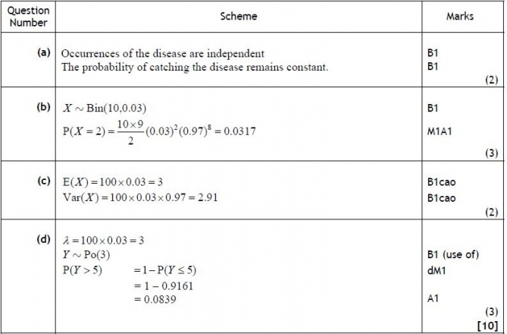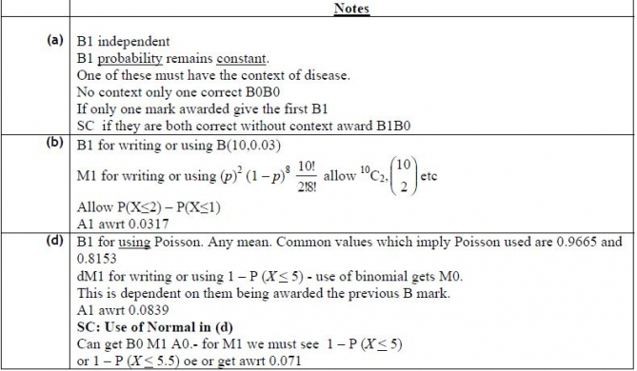

Q2.
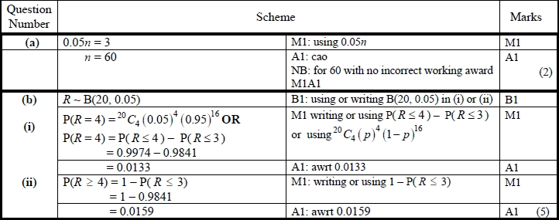
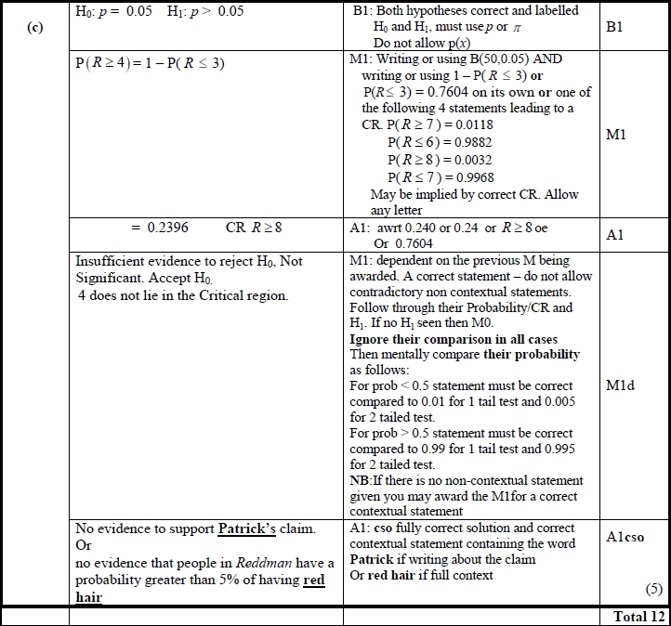

Q3.
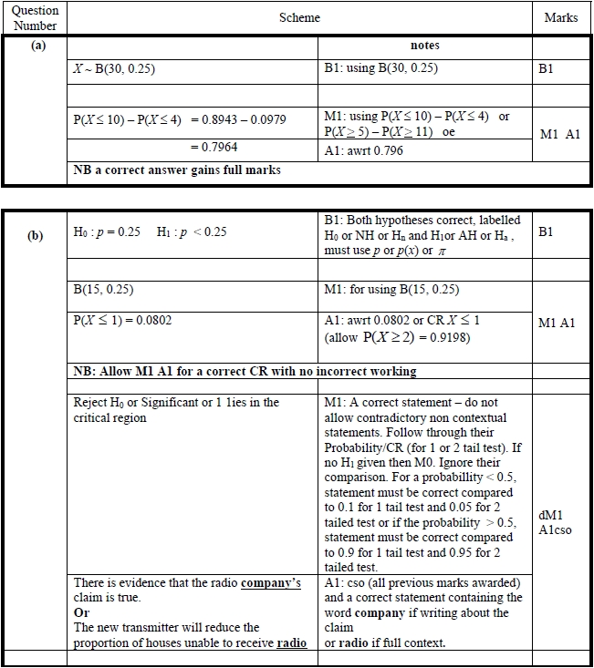

Q4.
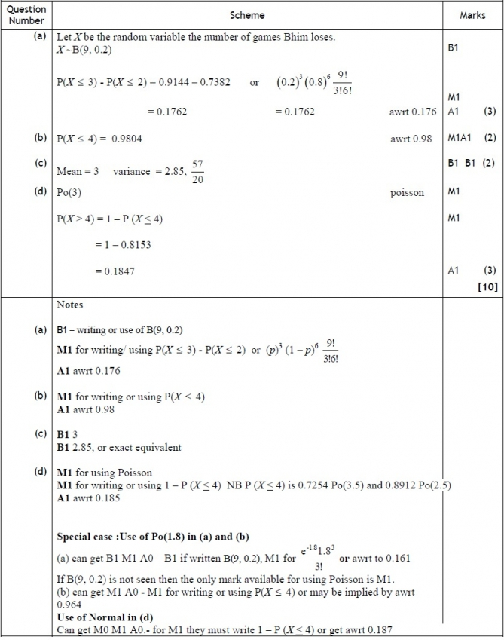

Q5.
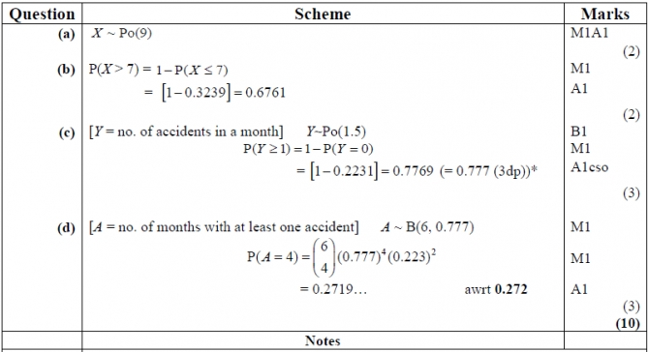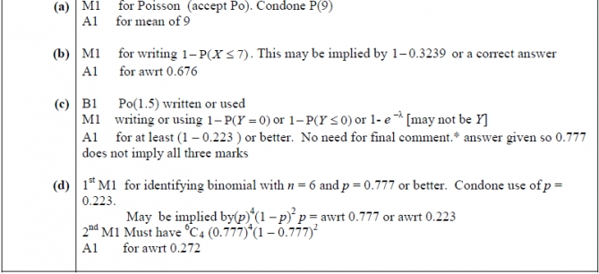

Q6.
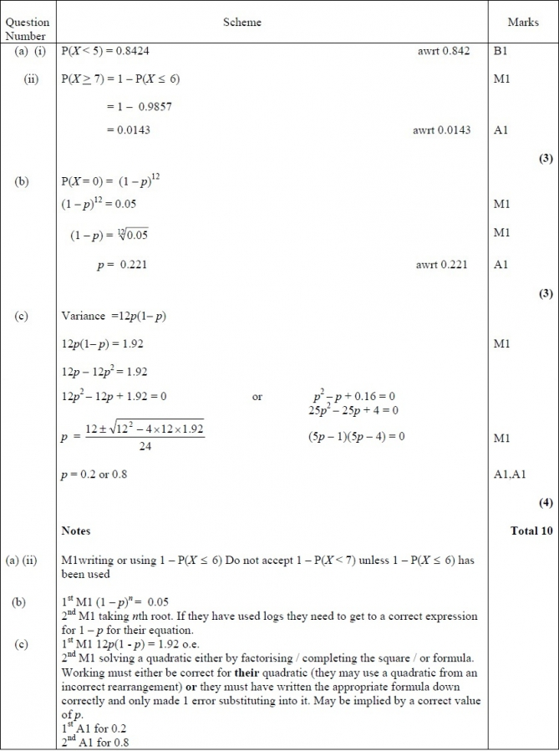

Q7.
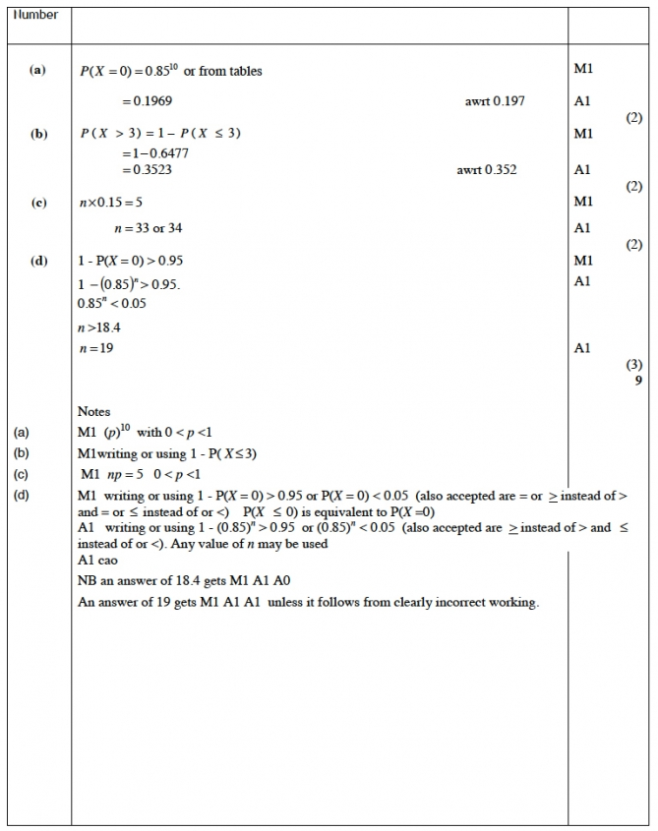

Q8.
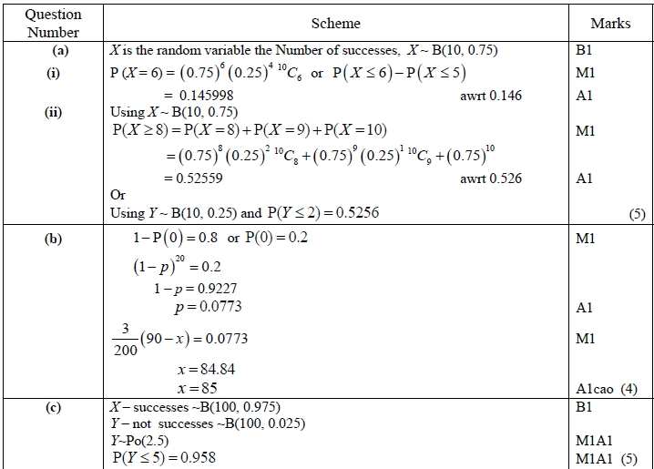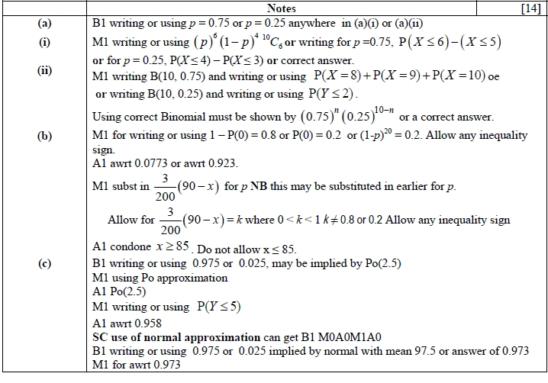
Q9.
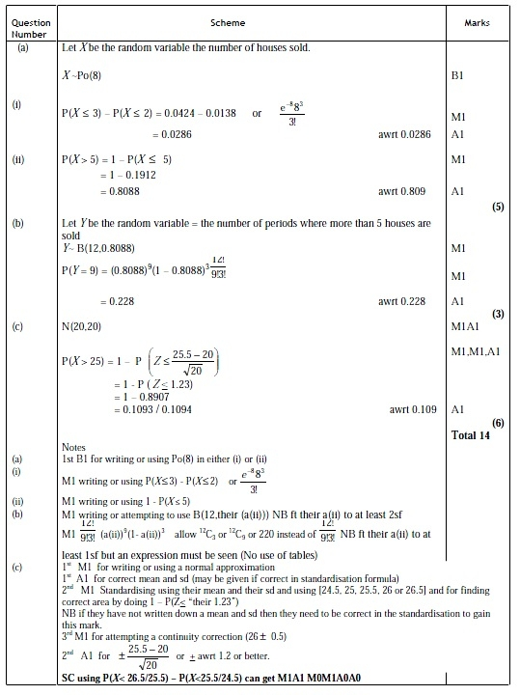

Q10.
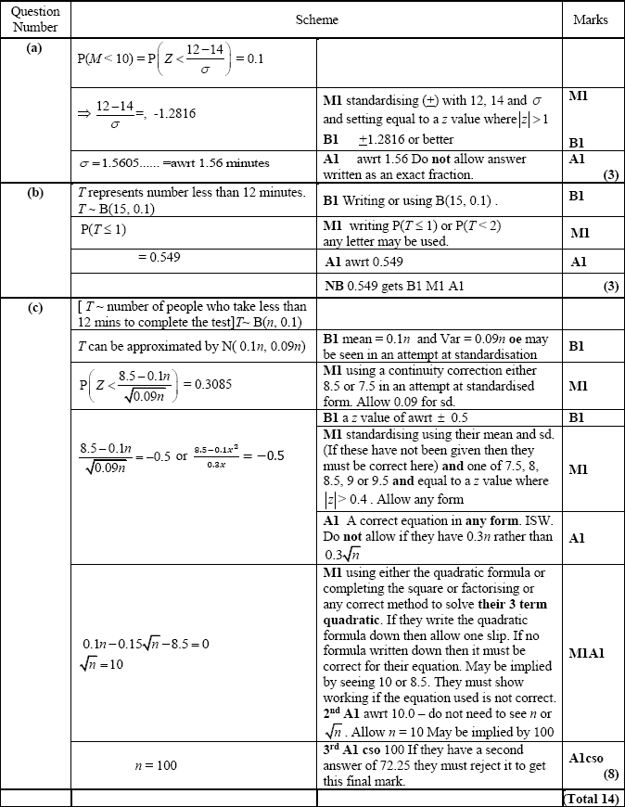

Q11.
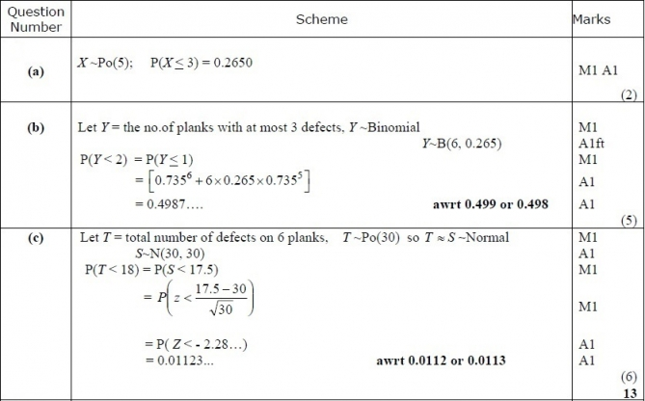
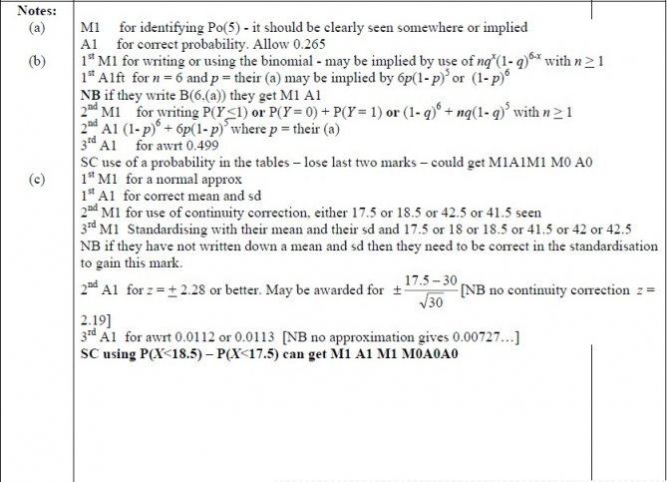

Q12.
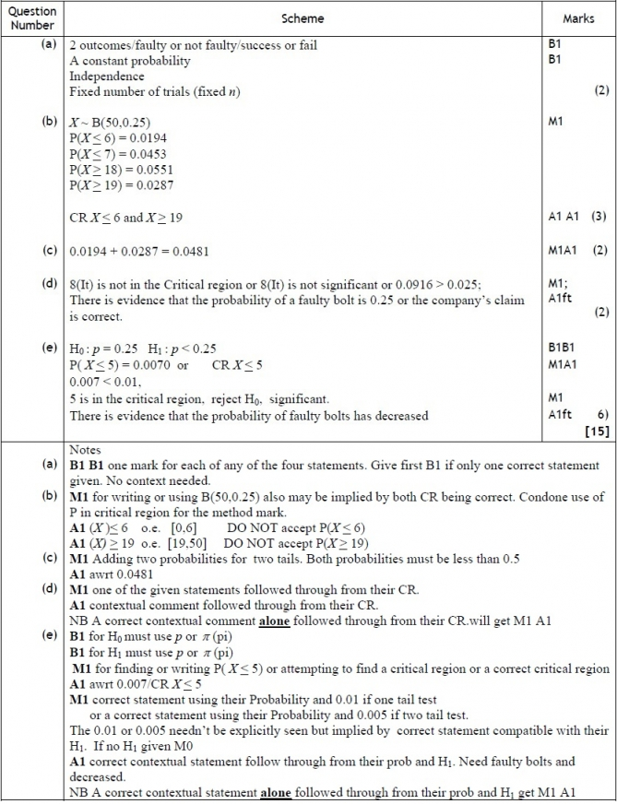

Q13.
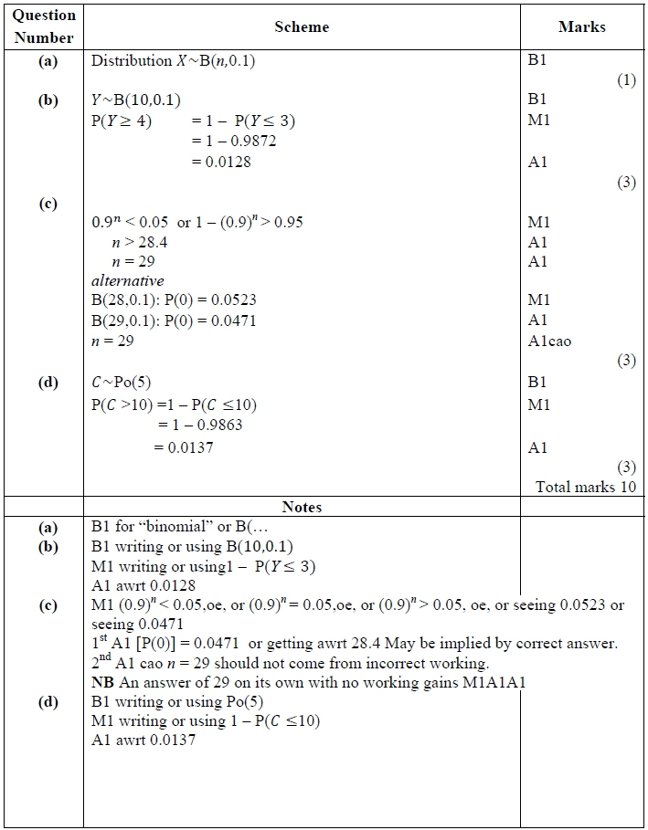

Q14.
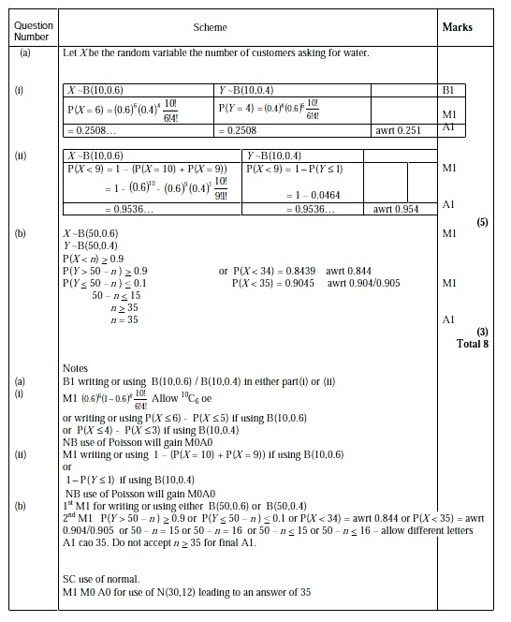

Q15.
