Name: _______________________________________________
GCE Stats section 4
Introduction to probability distributions
practice questions from GCE Maths
Date:
Question parts in red cover content in the GCE Statistics specification but outside this section of the scheme of work
Time:
Total marks available:
Total marks achieved: ______

Questions
Q1.
The discrete random variable X has probability distribution
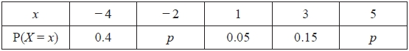
(a) Show that p = 0.2
(2)
Find
(b) E(X)
(2)
(c) F(0)
(1)
(d) P(3X + 2 > 5)
(2)
Given that Var(X) = 13.35
(e) find the possible values of a such that Var(aX + 3) = 53.4
(2)
(Total 9 marks)

Q2.
A discrete random variable X has the probability function
P(X = x) = 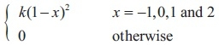
(a) Show that k =
(3)
(b) Find E(X)
(2)
(c) Show that E(X²) =
(2)
(d) Find Var(1 − 3X)
(3)
(Total 10 marks)
Q3.
The discrete random variable X has the following probability distribution, where p and q are constants.
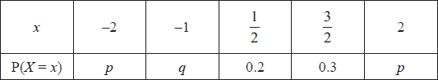
(a) Write down an equation in p and q
(1)
Given that E(X) = 0.4
(b) find the value of q
(3)
(c) hence find the value of p
(2)
Given also that E(X²) = 2.275
(d) find Var(X)
(2)
Sarah and Rebecca play a game.
A computer selects a single value of X using the probability distribution above.
Sarah's score is given by the random variable S = X and Rebecca's score is given by the
random variable
(e) Find E(R)
(3)
Sarah and Rebecca work out their scores and the person with the higher score is the winner. If the scores are the same, the game is a draw.
(f) Find the probability that
(i) Sarah is the winner,
(ii) Rebecca is the winner.
(4)
(Total for question = 15 marks)

Q4.
The discrete random variable X has probability distribution
P(X = x) = ¹⁄₁₀ x = 1, 2, 3, ... 10
(a) Write down the name given to this distribution.
(1)
(b) Write down the value of
(i) P(X = 10)
(ii) P(X < 10)
(2)
The continuous random variable Y has the normal distribution N(10, 2²)
(c) Write down the value of
(i) P(Y = 10)
(ii) P(Y < 10)
(2)
(Total 5 marks)

Q5.
The discrete random variable X takes the values 1, 2 and 3 and has cumulative distribution function F(x) given by
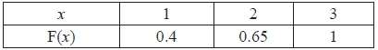
(a) Find the probability distribution of X.
(3)
(b) Write down the value of F(1.8).
(1)
(Total 4 marks)

Q6.
The discrete random variable X can take only the values 1, 2 and 3. For these values the cumulative distribution function is defined by
F (x) = x = 1,2, 3
(a) Show that k = 13
(2)
(b) Find the probability distribution of X.
(4)
Given that Var(X) =
(c) find the exact value of Var(4X − 5).
(2)
(Total 8 marks)

Q7.
The discrete random variable X can take only the values 2, 3, 4 or 6. For these values the probability distribution function is given by
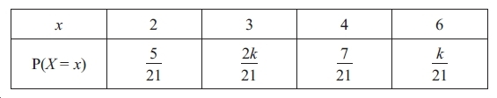
where k is a positive integer.
(a) Show that k = 3
(2)
Find
(b) F(3)
(1)
(c) E(X)
(2)
(d) E(X²)
(2)
(e) Var(7X − 5)
(4)

(Total 11 marks)
Q8.
The discrete random variable Y has probability distribution
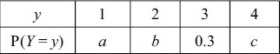
where a, b and c are constants.
The cumulative distribution function F(y) of Y is given in the following table
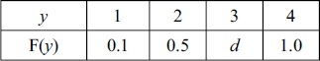
where d is a constant.
(a) Find the value of a, the value of b, the value of c and the value of d.
(5)
(b) Find P(3Y + 2 ≥ 8).
(2)
(Total 7 marks)

Q9.
The discrete random variable X has probability distribution given by
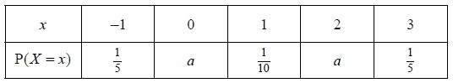
where a is a constant.
(a) Find the value of a.
(2)
(b) Write down E( X ).
(1)
(c) Find Var( X ).
(3)
The random variable Y = 6 − 2X
(d) Find Var(Y).
(2)
(e) Calculate P(X ≥ Y).
(3)
(Total 11 marks)
Q10.
The discrete random variable X has probability distribution
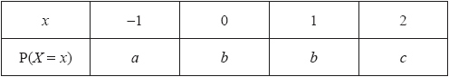
The cumulative distribution function of X is given by
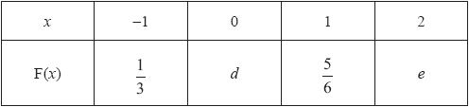
(a) Find the values of a, b, c, d and e.
(5)
(b) Write down the value of P(X² = 1).
(1)
(Total 6 marks)

Q11.
In a quiz, a team gains 10 points for every question it answers correctly and loses 5 points for every question it does not answer correctly. The probability of answering a question correctly is 0.6 for each question. One round of the quiz consists of 3 questions.
The discrete random variable X represents the total number of points scored in one round.
The table shows the incomplete probability distribution of X
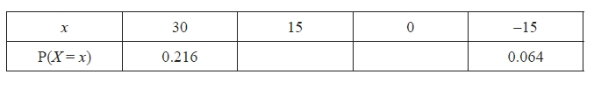
(a) Show that the probability of scoring 15 points in a round is 0.432
(2)
(b) Find the probability of scoring 0 points in a round.
(1)
(c) Find the probability of scoring a total of 30 points in 2 rounds.
(3)
(d) Find E(X)
(2)
(e) Find Var(X)
(3)
In a bonus round of 3 questions, a team gains 20 points for every question it answers
correctly and loses 5 points for every question it does not answer correctly.
(f) Find the expected number of points scored in the bonus round.
(3)
(Total 14 marks)

Q12.
The discrete random variable X has the probability function
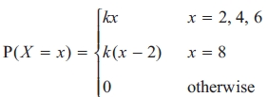
where k is a constant.
(a) Show that k =
(2)
(b) Find the exact value of F(5).
(1)
(c) Find the exact value of E(X).
(2)
(d) Find the exact value of E(X²).
(2)
(e) Calculate Var(3 − 4X) giving your answer to 3 significant figures.
(3)
(Total 10 marks)

Q13.
A biased die with six faces is rolled. The discrete random variable X represents the score on the uppermost face. The probability distribution of X is shown in the table below.
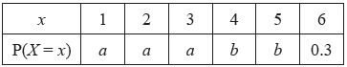
(a) Given that E(X) = 4.2 find the value of a and the value of b.
(5)
(b) Show that E(X²) = 20.4
(1)
(c) Find Var(5 − 3X)
(3)
A biased die with five faces is rolled. The discrete random variable Y represents the score which is uppermost. The cumulative distribution function of Y is shown in the table below.
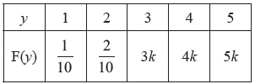
(d) Find the value of k.
(1)
(e) Find the probability distribution of Y.
(3)
Each die is rolled once. The scores on the two dice are independent.
(f) Find the probability that the sum of the two scores equals 2
(2)
(Total 15 marks)

Q14.
The score, X, for a biased spinner is given by the probability distribution
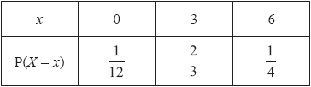
Find
(a) E(X)
(2)
(b) Var(X)
(3)
A biased coin has one face labelled 2 and the other face labelled 5
The score, Y, when the coin is spun has
P(Y = 5) = p and E(Y) = 3
(c) Form a linear equation in p and show that p =
(3)
(d) Write down the probability distribution of Y.
(1)
Sam plays a game with the spinner and the coin.
Each is spun once and Sam calculates his score, S, as follows
if X = 0 then S = Y²
if X ≠ 0 then S = XY
(e) Show that P(S = 30) =
(2)
(f) Find the probability distribution of S.
(3)
(g) Find E(S).
(2)
Charlotte also plays the game with the spinner and the coin.
Each is spun once and Charlotte ignores the score on the coin and just uses X² as her score.
Sam and Charlotte each play the game a large number of times.
(h) State, giving a reason, which of Sam and Charlotte should achieve the higher total score.
(2)
(Total for question = 18 marks)

Q15.
A fair blue die has faces numbered 1, 1, 3, 3, 5 and 5. The random variable B represents the score when the blue die is rolled.
(a) Write down the probability distribution for B.
(2)
(b) State the name of this probability distribution.
(1)
(c) Write down the value of E(B).
(1)
A second die is red and the random variable R represents the score when the red die is rolled.
The probability distribution of R is
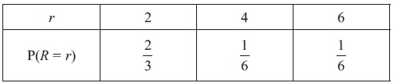
(d) Find E(R).
(2)
(e) Find Var(R).
(3)
Tom invites Avisha to play a game with these dice.
Tom spins a fair coin with one side labelled 2 and the other side labelled 5. When Avisha sees the number showing on the coin she then chooses one of the dice and rolls it. If the number showing on the die is greater than the number showing on the coin, Avisha wins, otherwise Tom wins.
Avisha chooses the die which gives her the best chance of winning each time Tom spins the coin.
(f) Find the probability that Avisha wins the game, stating clearly which die she should use in each case.
(4)
(Total 13 marks)

Q16.
The discrete random variable X has the probability distribution
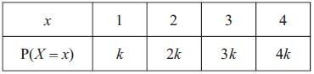
(a) Show that k = 0.1
(1)
Find
(b) E(X)
(2)
(c) E( X² )
(2)
(d) Var(2 − 5 X )
(3)
Two independent observations X₁ and X₂ are made of X.
(e) Show that P(X₁ + X₂ = 4) = 0.1
(2)
(f) Complete the probability distribution table for X₁ + X₂
(2)
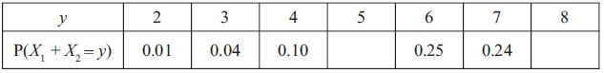
(g) Find
(2)
(Total 14 marks)

Q17.
The score S when a spinner is spun has the following probability distribution.
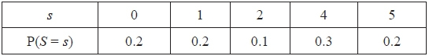
(a) Find E(S).
(2)
(b) Show that E(S²) = 10.4
(2)
(c) Hence find Var(S).
(2)
(d) Find
(i) E(5S − 3),
(ii) Var(5S − 3).
(4)
(e) Find P(5S − 3 > S + 3)
(3)
The spinner is spun twice.
The score from the first spin is S₁ and the score from the second spin is S₂
The random variables S₁ and S₂ are independent and the random variable X = S₁ × S₂
(f) Show that P(S₁ = 1 ∩ X < 5) = 0.16
(2)
(g) Find P(X < 5).
(3)
(Total 18 marks)

Q18.
A spinner is designed so that the score S is given by the following probability distribution.
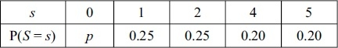
(a) Find the value of p.
(2)
(b) Find E(S).
(2)
(c) Show that E(S² ) = 9.45
(2)
(d) Find Var(S).
(2)
Tom and Jess play a game with this spinner. The spinner is spun repeatedly and S counters are awarded on the outcome of each spin. If S is even then Tom receives the counters and if S is odd then Jess receives them. The first player to collect 10 or more counters is the winner.
(e) Find the probability that Jess wins after 2 spins.
(2)
(f) Find the probability that Tom wins after exactly 3 spins.
(4)
(g) Find the probability that Jess wins after exactly 3 spins.
(3)
(Total 17 marks)

Examiner's Report
Q1.
This proved to be an accessible start to the paper. Most students could clearly show that p = 0.2 and the majority went on to find E(X) correctly. Many students though did not know what to do for F(0) and responses to question (c) were poor. Question (d) had a mixed response, some could simplify the inequality to reach P(X > 1) but were then unable to link this with the correct probabilities from the table but plenty of students were able to secure full marks here. Most students knew the formula for
Var(aX + 3) but some failed to realise that a = + 2 and just gave the answer 2.

Q2.
This proved an accessible opening question to the paper. Part (a) was a "show that" and some candidates failed to show sufficient steps. There were two stages required: firstly the probabilities needed evaluating from the given probability function and most managed this successfully. Secondly there should be an explicit application of ∑ P(X = x) =1 and some candidates failed to show this step clearly.
Most knew how to find E(X) in part (b) but some simply added their probabilities and a small minority divided their answer by 4.
Part (c) was another "show that " but most knew what to include here and full marks were often awarded. The use of notation was poor with a large number writing (−1² ) when they actually meant (−1)² . This was not penalised here but more attention to detail will be required as they progress to more advanced mathematical units.
For the final part most candidates now know the effect of coding on the variance and most realised that they needed first to find Var(X) and then multiply by (−3)² and many correct solutions were seen.

Q3.
Most students found the first four parts of this question accessible and appeared to have been well prepared for it. Almost everyone was able to use the sum of the probabilities condition to obtain a first equation in part (a) and there was often a correct expression for E(X) seen too, although sometimes this was set equal to 1 not 0.4
Errors in solving the equations in part (b) sometimes led to negative values for the probabilities of p and q and it is disappointing to see students still using these impossible values in later stages of their working. One would hope that they would realise that an error had been made and then try to correct it.
The variance calculation in part (d) was usually correct with only a small number of students making slips, such as subtracting the mean instead of the mean squared, or dividing by 5.
Part (e) caused problems for a significant number of students. A surprising number did not try listing the probability distribution for R and there were many cases of students trying to use the reciprocals of the probabilities or simply thinking that 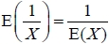.
Part (f) was only answered successfully by the more able students. Some students embarked on a correct approach but failed to correctly identify the cases where Sarah or Rebecca would win, a few forgot that there could be a draw and having found a correct answer to part (i) simply subtracted this from 1 to give their answer to part (ii). A number did not read the question carefully enough and thought that there were two independent values of X being used: some then assumed that all 25 cases were equally likely but others battled through to obtain a correct response to this situation and a special case in the mark scheme enabled them to have some credit.

Q4.
Some students could not recall the name of the distribution for X with several students calling it the discrete distribution rather than the discrete uniform distribution. The probabilities in question (b) were usually tackled well with only the less able students giving answers of 1 and 9 rather than 0.1 and 0.9. Question (c)(i) was challenging for a few but question (ii) was answered more successfully.

Q5.
Candidates for S1 often find the Cumulative Distribution Function a challenging topic but there were many fully correct responses seen to part (a) here with the answers simply summarized in a table. A few weaker candidates attempted a calculation for E(X) by finding xF(x). In part (b) a number of candidates interpolated and gave an answer of 0.6 failing to appreciate the nature of a discrete random variable.

Q6.
Although over 40% of the candidates scored full marks on this question there were a large number who were still confused about the cumulative distribution function F(x). In (a) many used F(1) + F(2) + F(3) = 1 and arrived at k = and others did not give sufficient working to secure both marks. A "show that" question requires some clear explanation and in this case we needed to see an explicit reference to
F(3) = 1 as well as the solution of the equation 27 + k = 40. Due to little understanding of the meaning of F(x) many couldn't find the correct probability distribution in (b) but there were plenty of correct answers seen often given in a table.(c) was answered well and the Var (aX + b) formula was known and used correctly by a good number of candidates.

Q7.
Part (a) was answered well with a large majority setting out the solution as expected. A small number tried to verify the value, but most only did the substitution and did not say that it showed k = 3, thus losing the final accuracy mark.
Part (b) was poorly answered with a large number finding P(3) instead. A small number gave the answer as an inexact decimal instead of a fraction.
Part (c) and part (d) were both well answered with complete methods shown. Only a few candidates confused [E(X)]² with E(X²) . In part (e) some of those candidates who got E(X²)wrong still got Var(X) right here, as they did not realise the link and started again. Most realised that they needed to find Var(X) but many did not know the link with Var(7X − 5) . Some candidates worked out 7Var(X) − 5 , some 7Var(X) and others 52Var(X) . The result for Var(7X - 5) was often not awarded the final accuracy mark as some candidates had used rounded answers in their working.

Q8.
The quality of responses to this question varied considerably. Most candidates stated that a = 0.1 and deduced that a + b + c = 0.7 but many were unable to proceed sensibly beyond this point. Some assumed a, b and c were all equal, others had b = 0.2 and c = 0.4 and some tried to consider E(Y) which led to some complicated and unhelpful equations. Finding d produced a number of errors: some confused
P(Y = y) with F(y) and gave answers of 0.3 or 0.7 whilst others used F(1) + F(2) + P(Y = 3) to obtain 0.9.
Part (b) proved challenging for many. Some solved the inequality to arrive at P(Y ≥ 2) and others created lists of all possible values for 3Y + 2 before deciding which cases to include. Obtaining the answer from this point should have been straightforward but some simply stopped at this point or then found
P(Y = 1) + P(Y = 2). Some candidates were confusing E(3Y + 2) and P(3Y + 2).

Q9.
Finding the correct value of a in the first part of the question proved to be relatively straightforward for most candidates. Few errors were seen although some candidates provided very little in the way of working out and did not always make it explicit that they were using the fact that the sum of the probabilities equals one. Similarly, most candidates were able to obtain the correct value of E(X), though not many deduced this fact by recognising the symmetry of the distribution.
The majority opted to use the formula to calculate E(X), which resulted in processing errors in some cases. Common errors seen in calculating Var(X) included forgetting to subtract [E(X)]² from E(X²) or calculating E(X²) − E(X), although on the whole the correct formula was successfully applied.
Most candidates were able to correctly apply Var(aX + b) = a²Var (X) to deduce Var(Y) = 4Var(X), although Var(Y) = 6 − 2Var(X) was a typical error. Quite a number of candidates attempted to calculate E(Y²) − [E(Y)]² with varying degrees of success. Occasionally, candidates divided their results in part (b), part (c) and part (d) by 5.
The final part of the question proved to be the most challenging of all and was often either completely omitted or poorly attempted with little or no success. Only a minority of candidates knew they would need to equate 6−2X to X in order to obtain the corresponding values of X and of those who did, only a small number scored full marks, as candidates were generally unable to identify the correct values of X.

Q10.
This question clearly divided the students into two groups: those who understood the concept of the cumulative distribution function and in particular the difference between P(X = x) and F(x) and those who did not. Nearly 40 % gained full marks here but over 15% scored zero. Part (a) was often fully correct though a common error was to have b = and c = but these students often picked up a follow through mark for d and sometimes the mark in part (b) as well.
Part (b) proved quite challenging with 30% of students scoring all the marks in part (a) but then failing to get part (b). The problem seemed to be students not realising that P(X² = 1) meant P(X = 1 or X = −1 ) and common incorrect answers were from [P(X = 1)]² = ()² or from P(X = −1)×P(X = 1) rather than P(X = −1)+P(X = 1).

Q11.
In part (a) many realised that a score of 15 came from getting 2 correct answers and one incorrect answer but they just gave the probability as 0.6 × 0.6 × 0.4 omitting the multiplication by 3. Others thought that the probability of 0.432 came from 2 × 0.216 and scored zero. Most obtained 0.288 in part (b) though usually, though not exclusively, by using the fact that the sum of the probabilities equalled 1. Some students argued in circles, using the given value of 0.432 to find 0.288 and then using their derived value of 0.288 to "find" 0.432, they of course, scored no marks for part (a). Part (c) proved to be quite discriminating. Many could identify some of the required cases and 0.216×0.288 was often seen or sometimes 0.432² but it was less common to see all 3 cases included. Some attempted to consider the situation as a set of 6 questions but they rarely considered all 6C4 = 15 arrangements. There was some evidence that students were mis-interpreting "a total of 30 points in 2 rounds" to mean "30 points in each of 2 rounds" and giving their answer as simply 0.216² : they should be encouraged to read and interpret the questions carefully. The methods for part (d) and (e) were well known and many scored well here. A number failed to use brackets carefully and found −15² × 0.064 rather than (−15²) × 0.064 but there were fewer cases than sometimes of students forgetting to square the mean before subtracting or thinking that 2 Var(X) = E(X²) in part (e). In the final part most chose to form the distribution of Y = the number of points in a bonus round and hence find E(Y) using the given formula. A common mistake was to have 0 instead of 10 and a few students gave an answer of 35 since this value had the highest probability. A handful of students spotted that Y = X + 10 and were able to write down the answer quite simply but this was very rare.

Q12.
This was another accessible question with only question (b) being challenging to some.
In question (a) most chose to write down the sum of the probabilities in terms of k and then set this equal to 1 and deduce the value of k . Some chose a "verification" route but often failed to give the final statement "therefore k = ¹⁄₈" and lost the final mark. Many students still do not recognise the cumulative distribution function F(x) and there were many blank or incorrect responses here. Some confused F(5) with P(X = 5) and gave the answer 0 and others gave ⁵⁄₁₈. Finding E(X) and E(X²) caused few problems although some students ignored the instruction to give the exact values and rounded their decimal answers.
In question (e) most knew how to find Var (X), although a few forgot to square E(X), and many knew how to deal with the Var(3 − 4X) formula with only some students trying 3 − 4 Var(X).

Q13.
In part (a) most attempted an equation in a and b based on E(X) and, apart from those who forgot to multiply 6 and 0.3, this was usually correct. Many though failed to write down a second equation based on the sum of the probabilities although this often didn't deter them from "solving" for a and b and often arriving at the correct values although justification for this choice was rarely seen. Those who did obtain
2 simultaneous equations could usually solve them and a variety of methods were used. Those who had correct values for a and b had few difficulties in establishing the result in (b) and part (c) was answered well too with only a small number trying 5 − 3 Var(X) or 5²Var(X). The cumulative distribution function is still not understood very well by many S1 candidates and correct answers to parts (d) and (e) were rare. A common error was to assume the table was a probability distribution, set the sum of the F(y) values equal to 1 and arrive at k = . A number did write P(Y = 1) = 0.1 and occasionally P(Y = 2) = F(2) − F(1) was used too but few achieved fully correct answers. Some candidates continued this process to find P(Y = 3) with their value of k = and seemed unperturbed by the negative value this gave.
The final part (f) was usually answered well and it is pleasing to see candidates carrying on to the end of a question even when they had encountered difficulties in earlier parts. Some simply added 0.1 and 0.1 and a few insisted on multiplying a correct 0.01 by 2 but the correct answer was often seen.

Q14.
Although the final part of this question was quite challenging most students were able to get started and most scored at least half marks. Parts (a) and (b) were straightforward and nearly all scored full marks here. A small minority confused E(X²) with Var(X) and some forgot to square the E(X) term when finding the variance. Part (c) should have been straightforward but some students ignored the instruction to form a linear equation in p and simply substituted p = and q = into the formula for E(Y) but gained no marks. Some used p + q = 1 and started with two simultaneous equations which made the question a little more complicated than intended.
Part (d) was usually answered correctly but some were incorrectly using a random variable X here. Many were less successful in part (e) because they failed to present a clearly argued "show that" solution. Simply multiplying × was not sufficient. We required some indication that the event S = 30 was achieved when X = 6 and Y = 5 as well as the multiplication of × . Many students made no attempt at the remainder of the question but those who did could usually make some progress. Those who drew up a distribution table in part (f) usually scored at least the first mark but there were often errors in P(S = 4) or P(S = 25) and sometimes extra values crept in too such as S = 0. Those with a correct table in (f) were usually able to find E(S) correctly although a small number failed to give an exact answer which we always expect for work on discrete random variables. Part (h) was the most difficult part of the question. Many students ignored the fact that Sam and Charlotte play the game a large number of times and compared individual outcomes or the probability of achieving a higher score rather than comparing the expected scores for each. Some did not realise that Charlotte's expected score had already been calculated in part (b) and found E(X²) again, sometimes incorrectly this time, and others thought they should compare E(S) with [E(X)]² but a very competent 10% of the students gave a fully correct solution to this question.

Q15.
(a) was answered well and most gave the distribution in a table with values 1, 3 and 5 and probabilities of for each. Labelling each face as 1, 1, 3, 3, 5, 5 was quite common too, usually accompanied by probabilities of for each face, but some gave probabilities of for each face and others had values of 1, 2 and 3.
(b) was not answered well with many candidates only having one of the two words "discrete" and "uniform" in their answer. An answer of "discrete random distribution" was quite common but some candidates did not know the correct terms, describing it as an "equal" distribution.
Very few candidates used the symmetry of the distribution to "write down" the answer to (c) but they were still able to gain the mark by calculating E(B). Some candidates could not answer part (d) correctly but in part (e) although a number found E(R)² = some thought this was Var(R), others only subtracted 3, despite having previously quoted a correct formula, and some rounded their answer to 2.33 without first giving the exact value. In the final part of the question many candidates did not seem to understand what was required. Some drew complete tree diagrams but then did not realise that Avisha always chose the die that gave her the best chance of winning. Others identified which die she should choose without taking account of the probability of 0.5 for the outcomes of the spin of the coin. Nevertheless a small number of candidates did complete this part of the question successfully.

Q16.
Most candidates showed us clearly that they were using the sum of the probabilities to reach 10k = 1 from which they showed that k = 0.1 and the calculation of E(X) was usually correct too. In part (c) some confusion between E( X² ) and Var(X) and also over what to square (some choosing the probabilities rather than the values of x) caused difficulties and a few simply squared their answer to part (b). Part (d) was a fairly standard request and most knew that Var(2 − 5X) = 25Var(X) and were sometimes able to recover from errors made in part (c) but then many solutions ground to a halt.

Q17.
Parts (a), (b), (c) and (d) were answered very well and most candidates scored well here. In part (e) most knew they had to solve the inequality and arrived at S > 1.5 but some misinterpreted this and gave
P(S > 1) rather than P(S > 2). The final 2 parts caused problems for many candidates. A popular approach was to calculate a sample space showing all 25 products of S₁ and S₂ but they often thought that these 25 cases were all equally likely. Unfortunately this false assumption would lead to the correct answer in part (f), but not of course the available marks, and many candidates never properly considered the correct distribution of X. Some candidates did list the 15 required cases and were able to obtain the correct probability but such cases were rare.

Q18.
The first 4 parts of this question were usually answered very well by most candidates. Very few confused E(S² ) with [E(S)]² and the mean was usually squared when calculating Var(S). Part (e) was attempted by a good number of candidates and many realised that they needed to combine 0.2 and 0.2. Some gave 0.2 + 0.2 = 0.4 and others 0.2 − 0.2 = 0.4 but there were a number of correct solutions seen. Those who attempted part (f) often identified some of the cases such as P(4 ∩ 4 ∩ 2) = 0.01 and occasionally the 3 arrangements of 4, 4 and 2 but then they often missed P(4 ∩ 4 ∩ 4).
Part (g) proved to be a challenging final part to the paper. Some tried listing all the possible cases for Jess to win. Their listing was usually extremely inefficient and they invariably missed one or more cases. Only a handful of candidates seemed to realise that only two probabilities needed to be considered namely P( ∩ 5 ∩ 5) and P(5 ∩ ∩ 5) and the probabilities could then be found quite easily.

Mark Scheme

Section 4 | Introduction to probability distributions
qu.1 | June 2014 S1R - Q1
qu.2 | May 2012 S1 - Q1
qu.3 | June 2016 S1 - Q2
qu.4 | June 2014 S1R - Q2ab
qu.5 | May 2013 S1R - Q2
qu.6 | January 2013 S1 - Q2
qu.7 | January 2012 S1 - Q3
qu.8 | May 2011 S1 - Q3
qu.9 | May 2010 S1 - Q3
qu.10 | June 2017 S1 - Q4
qu.11 | June 2015 S1 - Q5
qu.12 | June 2014 S1 - Q5
qu.13 | May 2013 S1 - Q5
qu.14 | June 2017 S1 - Q6
qu.15 | January 2013 S1 - Q6
qu.16 | January 2011 S1 - Q6
qu.17 | May 2013 S1R - Q7
qu.18 | May 2011 S1 - Q8

Q1.
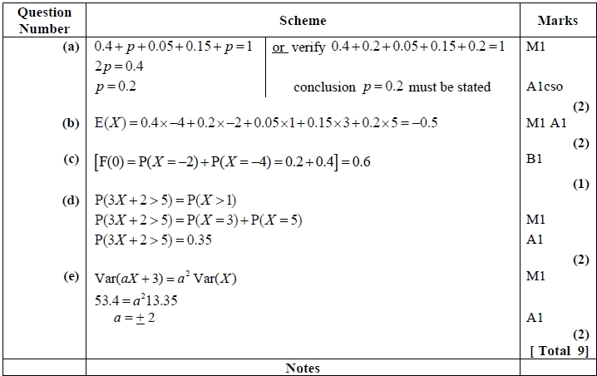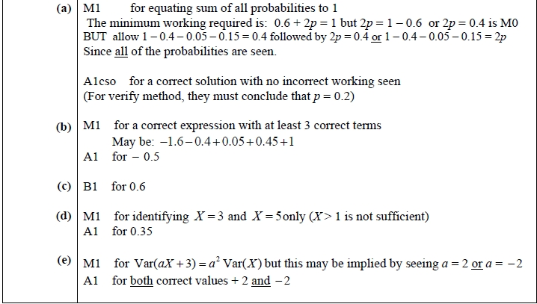

Q2.
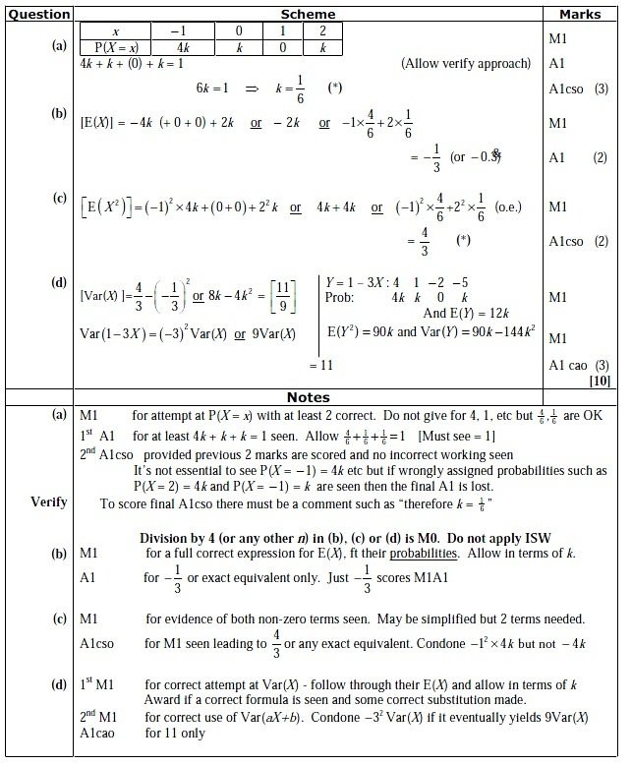

Q3.
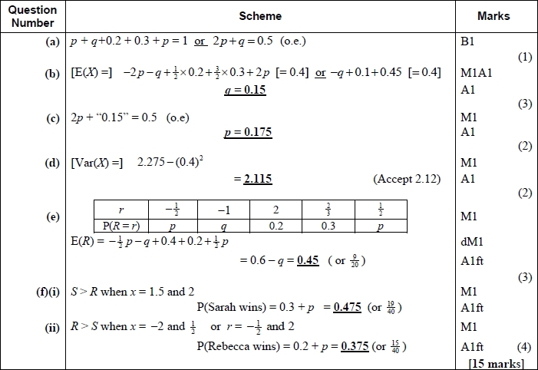
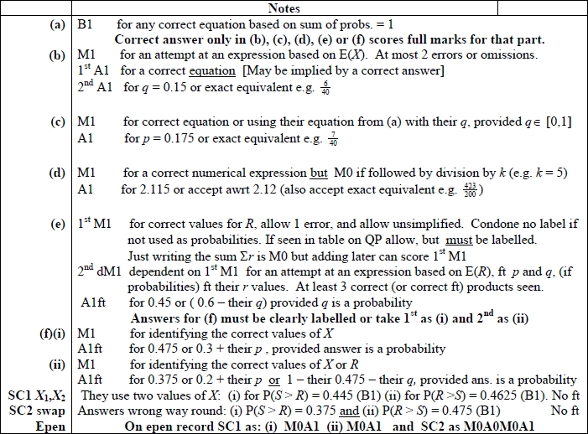
Q4.
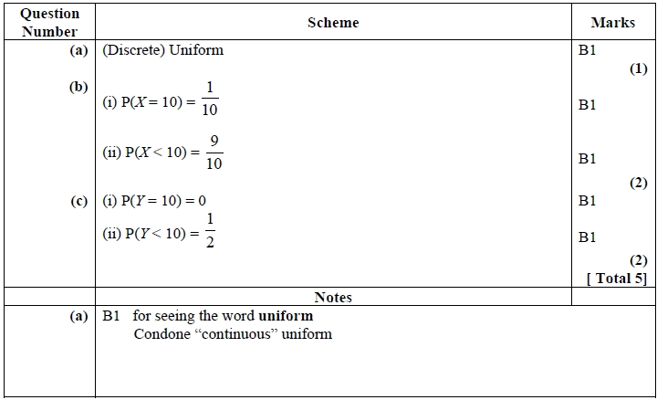

Q5.
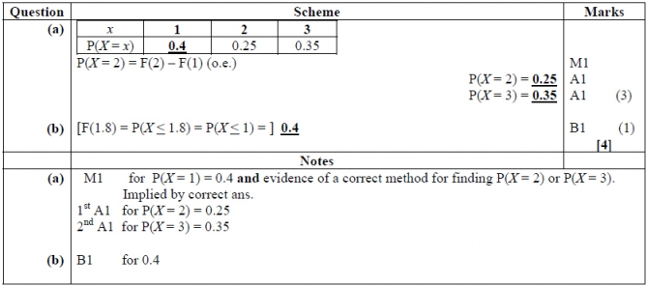

Q6.
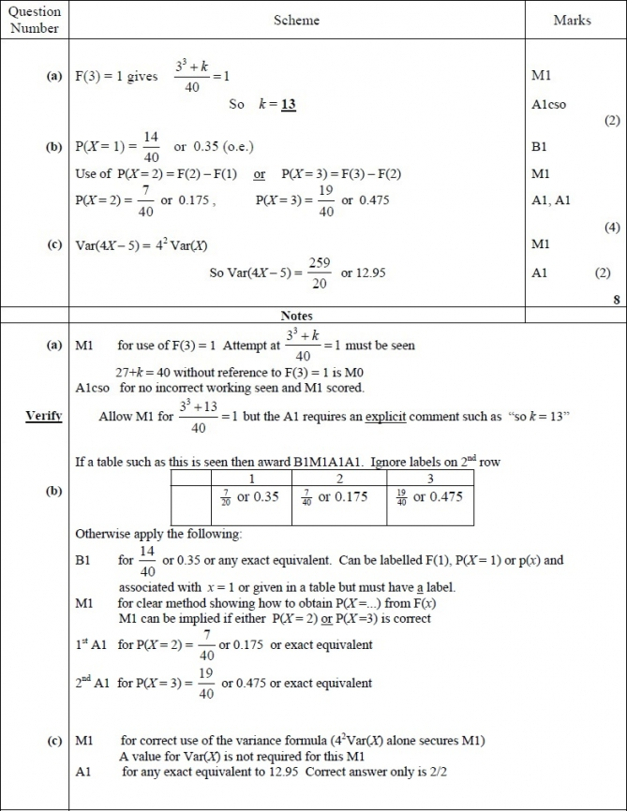

Q7.
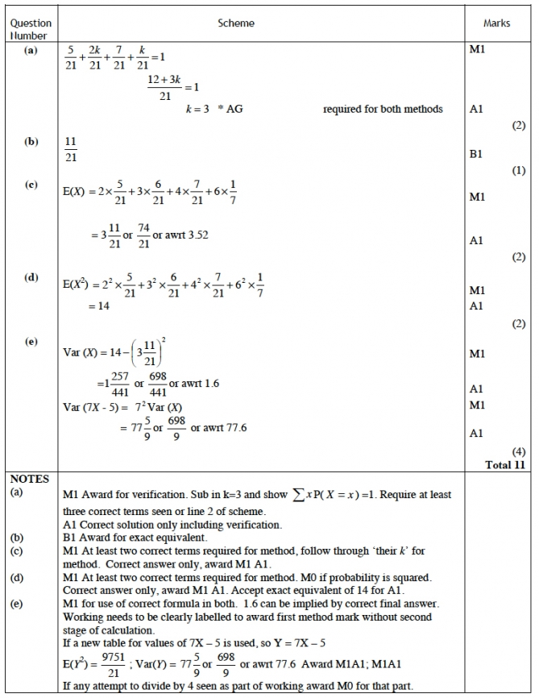

Q8.
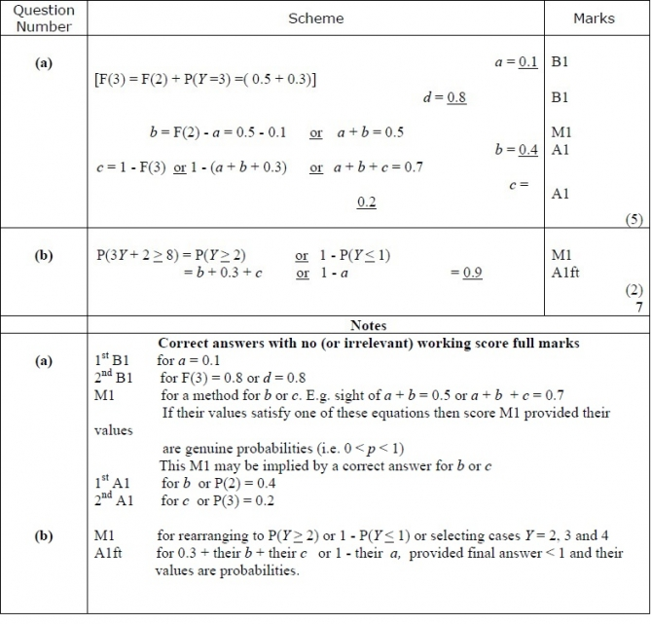

Q9.
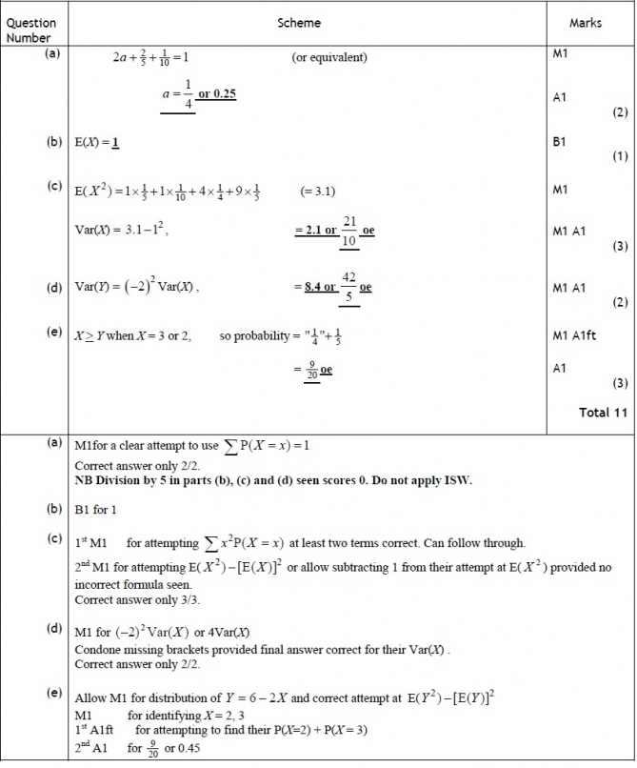

Q10.
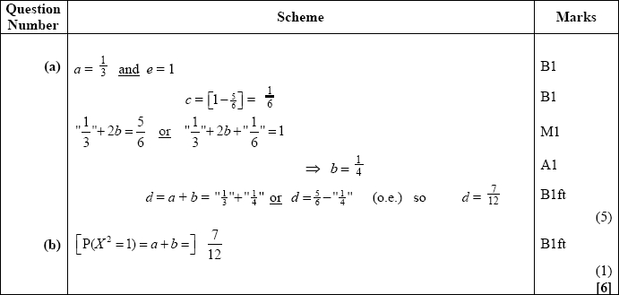
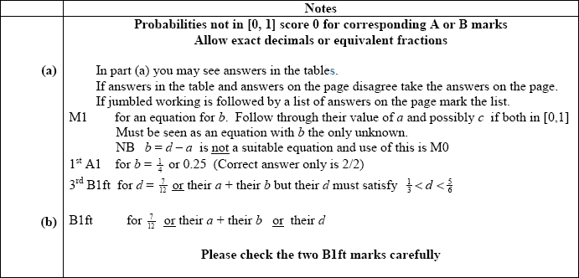

Q11.
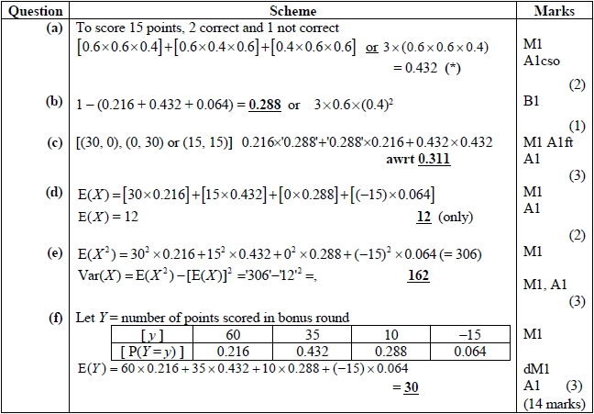
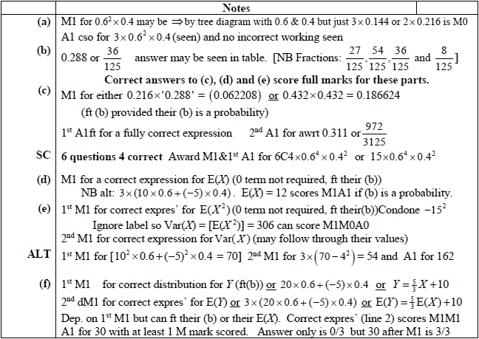

Q12.
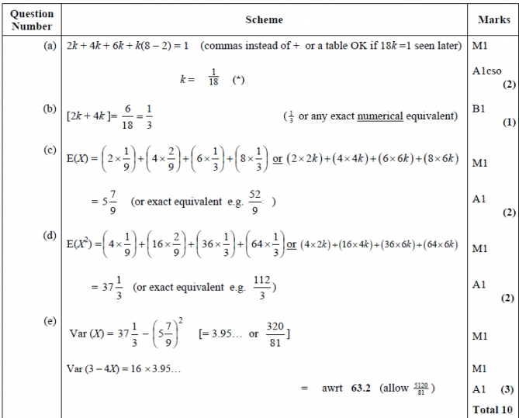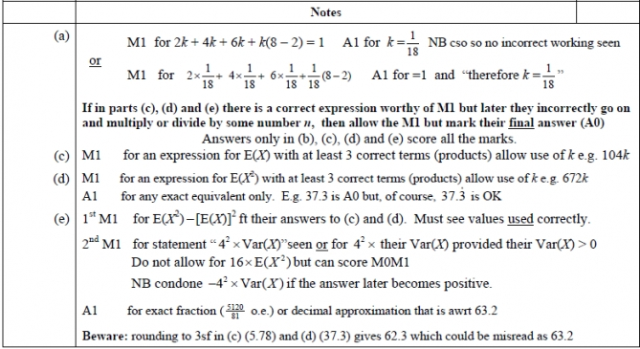

Q13.
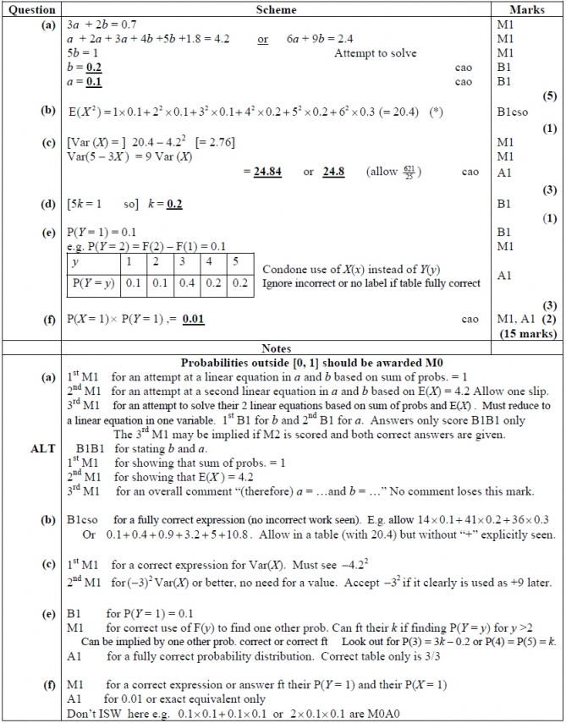

Q14.
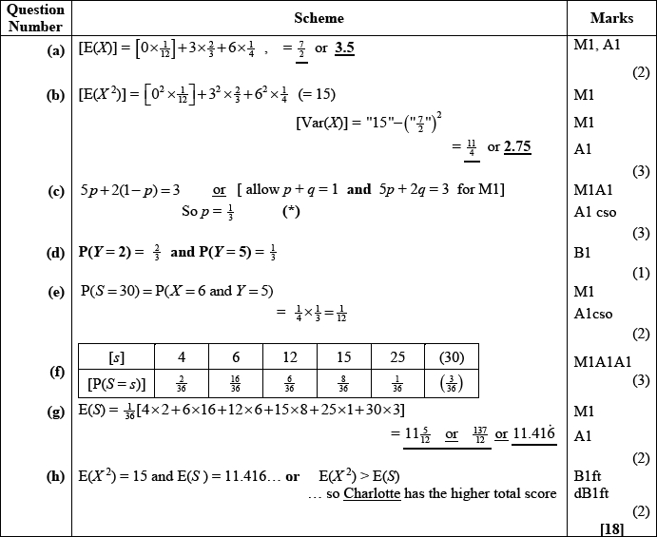
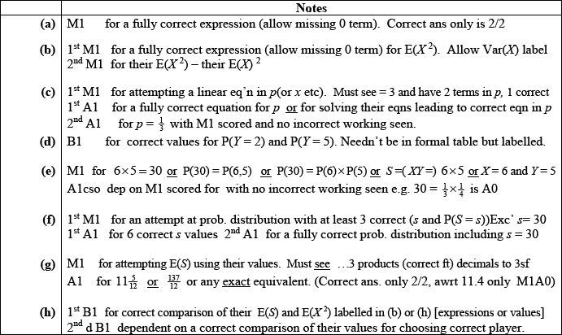

Q15.
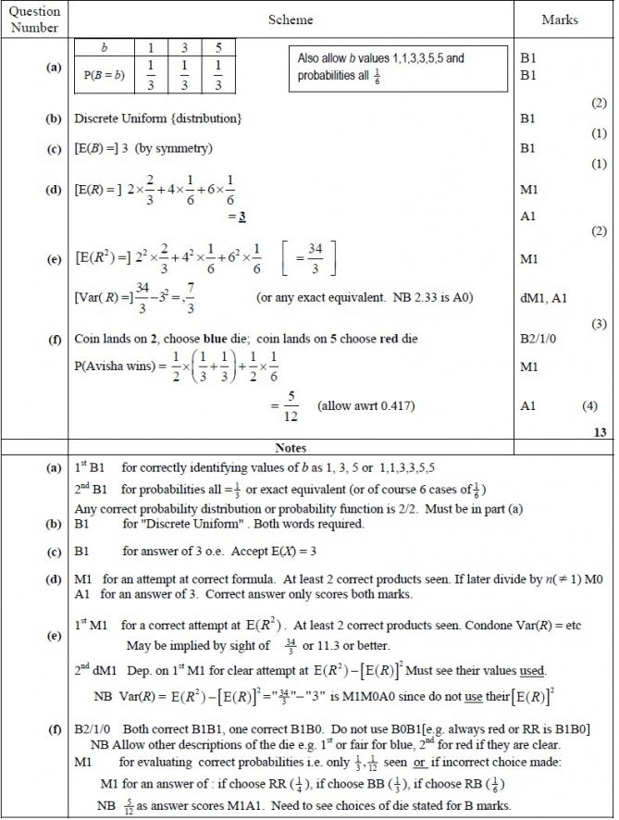

Q16.
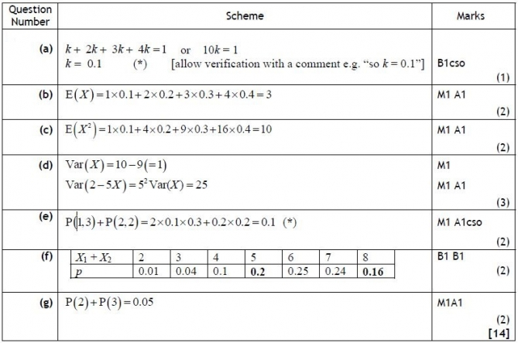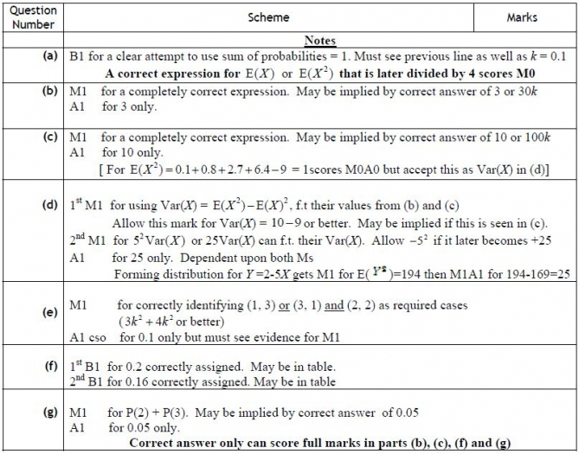
Q17.
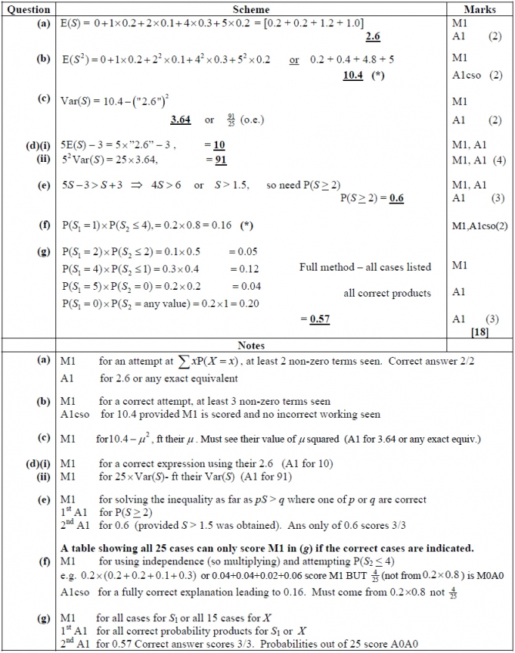

Q18.
