Name: _______________________________________________
GCE Stats section 3
Population and samples
practice questions from GCE Maths
Date:
Question parts in red cover content in the GCE Statistics specification but outside this section of the scheme of work
Time:
Total marks available:
Total marks achieved: ______

Questions
Q1.
A company director decides to survey staff about changes to the company calendar. The company has staff in 4 different job roles
72 managers, 108 drivers, 180 administrators and 360 warehouse staff.
The director decides to take a stratified sample.
(a) Write down one advantage of using a stratified sample rather than a simple random sample for this survey.
(1)
(b) Find the number of staff in each job role that will be included in a stratified sample of 40 staff.
(3)
(c) Describe how to choose managers for the stratified sample.
(2)
(Total for question = 6 marks)

Q2.
(a) State two reasons why stratified sampling might be a more suitable sampling method than
simple random sampling.
(2)
(b) State two reasons why stratified sampling might be a more suitable sampling method than
quota sampling.
(2)
(Total for question = 4 marks)

Q3.
A mobile library has 160 books for children on its records. The librarian believes that books with fewer pages are borrowed more often. He takes a random sample of 10 books for children.
(a) Explain how the librarian should select this random sample.
(2)
The librarian ranked the 10 books according to how often they had been borrowed, with 1 for the book borrowed the most and 10 for the book borrowed the least. He also recorded the number of pages in each book. The results are in the table below.
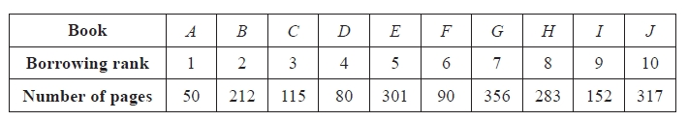
(b) Calculate Spearman's rank correlation coefficient for these data.
(4)
(c) Test the librarian's belief using a 5% level of significance. State your hypotheses clearly.
(3)
(Total 9 marks)

Q4.
(a) Explain what you understand by a random sample from a finite population.
(1)
(b) Give an example of a situation when it is not possible to take a random sample.
(1)
A college lecturer specialising in shoe design wants to change the way in which she organises practical work.
She decides to gather ideas from her 75 students.
She plans to give a questionnaire to a random sample of 8 of these students.
(c) (i) Describe the sampling frame that she should use.
(ii) Explain in detail how she should use a table of random numbers to obtain her sample.
(3)
(Total 5 marks)

Q5.
A gym club has 400 members of which 300 are males.
Explain clearly how a stratified sample of size 60 could be taken.
(3)
(Total 3 marks)

Q6.
A lake contains 3 species of fish. There are estimated to be 1400 trout, 600 bass and 450 pike in the lake. A survey of the health of the fish in the lake is carried out and a sample of 30 fish is chosen.
(a) Give a reason why stratified random sampling cannot be used.
(1)
(b) State an appropriate sampling method for the survey.
(1)
(c) Give one advantage and one disadvantage of this sampling method.
(2)
(d) Explain how this sampling method could be used to select the sample of 30 fish.
You must show your working.
(4)
(Total 8 marks)

Q7.
A nursery has 16 staff and 40 children on its records. In preparation for an outing the manager needs an estimate of the mean weight of the people on its records and decides to take a stratified sample of size 14.
(a) Describe how this stratified sample should be taken.
(3)
The weights, x kg, of each of the 14 people selected are summarised as
∑ x = 437 and ∑ x² = 26983
(b) Find unbiased estimates of the mean and the variance of the weights of all the people
on the nursery's records.
(4)
(c) Estimate the standard error of the mean.
(2)
The estimates of the standard error of the mean for the staff and for the children
are 5.11 and 1.10 respectively.
(d) Comment on these values with reference to your answer to part (c) and give a reason
for any differences.
(2)
(Total for question = 11 marks)
Q8.
A college manager wants to survey students' opinions of enrichment activities. She decides to survey the students on the courses summarised in the table below.
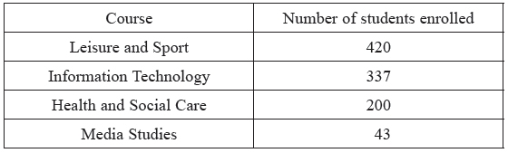
Each student takes only one course.
The manager has access to the college's information system that holds full details of each of the enrolled students including name, address, telephone number and their course of study. She wants to compare the opinions of students on each course and has a generous budget to pay for the cost of the survey.
(a) Give one advantage and one disadvantage of carrying out this survey using
(i) quota sampling,
(ii) stratified sampling.
(2)
The manager decides to take a stratified sample of 100 students.
(b) Calculate the number of students to be sampled from each course.
(3)
(c) Describe how to choose students for the stratified sample.
(2)
(Total 7 marks)

Q9.
A student believes that there is a difference in the mean lengths of English and French films. He goes to the university video library and randomly selects a sample of 120 English films and a sample of 70 French films. He notes the length, x minutes, of each of the films in his samples. His data are summarised in the table below.
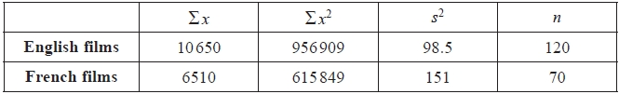
(a) Verify that the unbiased estimate of the variance, s², of the lengths of English films is 98.5 minutes²
(2)
(b) Stating your hypotheses clearly, test, at the 1% level of significance, whether or not the mean lengths of English and French films are different.
(7)
(c) Explain the significance of the Central Limit Theorem to the test in part (b).
(1)
(d) The university video library contained 724 English films and 473 French films. Explain how the student could have taken a stratified sample of 190 of these films.
(3)
(Total 13 marks)

Q10.
A large company surveyed its staff to investigate the awareness of company policy. The company employs 6000 full time staff and 4000 part time staff.
(a) Describe how a stratified sample of 200 staff could be taken.
(3)
(b) Explain an advantage of using a stratified sample rather than a simple random sample.
(1)
A random sample of 80 full time staff and an independent random sample of 80 part time staff were given a test of policy awareness. The results are summarised in the table below.
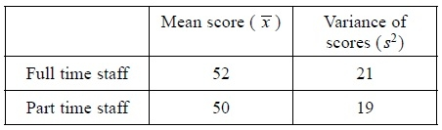
(c) Stating your hypotheses clearly, test, at the 1% level of significance, whether or not the mean policy awareness scores for full time and part time staff are different.
(7)
(d) Explain the significance of the Central Limit Theorem to the test in part (c).
(2)
(e) State an assumption you have made in carrying out the test in part (c).
(1)
After all the staff had completed a training course the 80 full time staff and the 80 part time staff were given another test of policy awareness. The value of the test statistic z was 2.53
(f) Comment on the awareness of company policy for the full time and part time staff in light of this result. Use a 1% level of significance.
(2)
(g) Interpret your answers to part (c) and part (f).
(1)
(Total 17 marks)

Examiner's Report
Q1.
Part (a) made a reasonable start for many students. However, there were those who clearly understood the term 'stratified sampling', but missed the point of the question. The question required an advantage of stratified sampling. For example, some students stated that the proportions of each job role are the same in the sample as in the whole population. This explains how a stratified sample is created but not why.
Part (b) was answered very well by the majority of students.
There were many excellent answers to part (c) and typical answers in this category were succinct and precise. All the required detail was often contained in two short sentences. In contrast, there were some lengthy paragraphs from other students that did not always score both marks. A minority of students wrote vague responses. The question required some indication of how a random sample was to be achieved, using either random number tables or a random number generator on a calculator or a computer.

Q2.
For some students, the clarity of expression was poor, showing a lack of clear understanding and making it difficult to give credit. In part (a), the most common comments to gain credit related to representation of all groups, appropriateness for large samples or reflecting the population structure. The most common incorrect responses referred to large populations instead of samples or were too vague e.g. referring to better representation of 'the population' without reference to subgroups or structure. In part (b), common correct comments referred to interviewer bias for quota sampling and to calculation of sampling errors. Most common responses not scoring referred to sampling frames, recording of non-responses, or were too vague with simple reference to randomness

Q3.
A straightforward starter question dealing with correlation with most students managing the coefficient easily. They carried out the test well and typically gave its result in context.
The sampling only caused problems to those who are content with text book answers or who decided to go down the systematic route.

Q4.
This question was not answered particularly well, even by the best students. Problems and misunderstandings in describing how to take a sample were common and many students preferred the equal probability for each element approach in question (a). Marks were lost by students failing to be sufficiently precise in their descriptions in later parts. Many students gave an example rather than the lack of a sampling frame in question (b) .Only weaker students suggested systematic or quota sampling methods. In question (c)(i) many students failed to distinguish between the units and the list, whilst others were penalised for not specifying all the students. Generally the best answered part was question (c)(ii), however students need to pay attention to the detailed requirements.

Q5.
There were three stages required here and many candidates missed at least one of them. A number of candidates failed to mention the need to label the males and females separately but most did state the need to select their samples using random numbers and the calculations (45 males and 15 females) were usually seen although a few only mentioned one group.

Q6.
This question proved to be a challenge to many candidates. There were a large number of responses that showed little understanding of how to carry out a survey or take a sample in practice. There were many answers that offered lists of advantages and disadvantages that related little, if at all, to the context of the question. The fact that a large number of candidates thought a practical solution involved enumerating the population and that many thought that they would 'interview' the fish showed how little this topic is understood.

Q7.
For all but the least able of students the calculations were easily and accurately carried out. However, very few students had any idea about what the comparison of standard errors was all about. Many of the students who scored poorly here would have used a standard error readily to calculate a sample size or confidence interval, but they have little or no idea of the underlying theory. The sampling was a source of easy marks to most apart from those who resorted to the text book again.

Q8.
Most candidates had a stab at part (a) but their responses were sometimes rather too brief or vague. Many quoted standard responses from textbooks or past mark schemes and, although a suitable pair of such answers was acceptable on this occasion candidate should really be aiming to address the question with reference to the context in the question. For example the access to a database means that a sampling frame is readily available.
The candidates were on much more familiar ground in part (b) and most scored full marks although a few failed to round 33.7 and 4.3 to suitable integers.
In part (c) there was some confusion with systematic sampling here and others failed to mention the need for a suitable sampling frame for each course although many did score the mark for using random numbers for the selection from each course.

Q9.
This question proved to be very well answered and it was pleasing to see so many fully correct solutions to question (a) and question (b), including conclusions in sufficient context to be awarded the marks available. question (c) and question (d), however, often lacked detail with values being calculated accurately in question (d) with no mention of a list being required. Students often stated 'at random' rather than describing how this might be achieved.

Q10.
Most candidates knew how to take a stratified sample by taking simple random samples in each stratum but they often forgot to describe how to label the members of the strata.
In (b) the commonest correct response was about the sample being more representative of the population but some missed the point and simply said that stratified sampling was "easier".
The calculation in part (c) was carried out very well by most candidates. There were few errors with the standard error and most correctly concluded that there was evidence of a difference in policy awareness between the types of staff.
In part (d) most knew that the Central Limit Theorem had something to do with the normal distribution but they did not mention that it was the mean scores of full time and part time staff that can be assumed to be normally distributed.
There were some correct responses to part (e) but many just mentioned independence despite this being given in the stem to part (c) of the question.
Most gave a correct conclusion in part (f) and some correctly inferred in the final part that the training course had been effective.
Some had the correct idea in part (g) although their conclusions went further than the evidence suggested: they claimed that the scores of the part time staff had increased, which may well be the case, but the evidence presented was only sufficient to conclude that the "gap" between policy awareness of the types of staff has been closed.

Mark Scheme

Section 3 | Population and samples
qu.1 | May 2017 S3 - Q1
qu.2 | May 2016 S3 - Q1
qu.3 | May 2015 S3 - Q1a
qu.4 | May 2014 S3 - Q1
qu.5 | June 2013 S3R - Q1
qu.6 | June 2012 S3 - Q2
qu.7 | May 2015 S3 - Q3a
qu.8 | June 2013 S3 - Q3
qu.9 | May 2014 S3R - Q5d
qu.10 | June 2010 S3 - Q7ab

Q1.
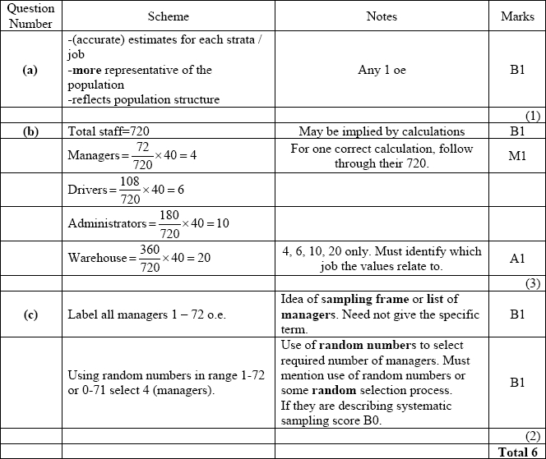

Q2.
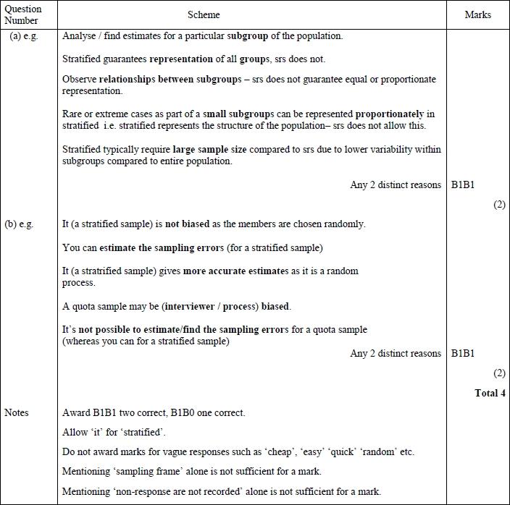

Q3.
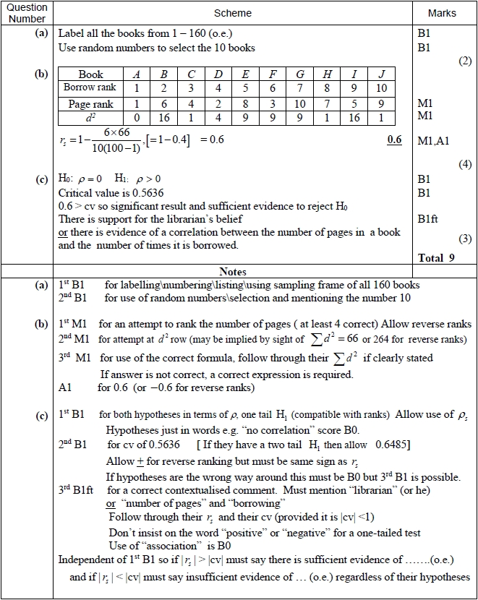

Q4.
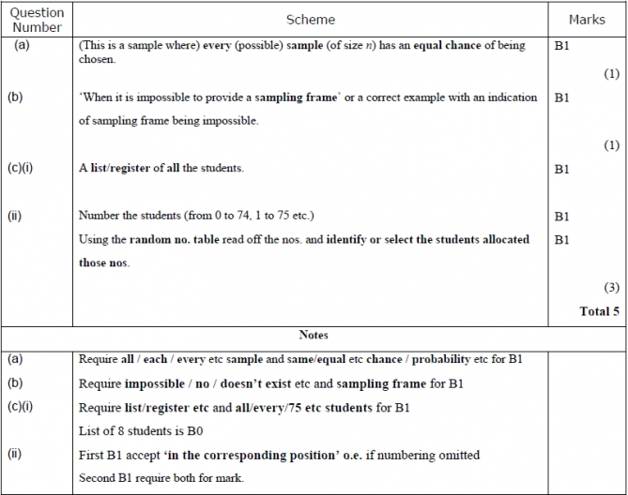

Q5.
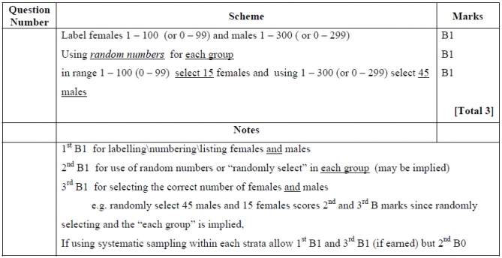

Q6.
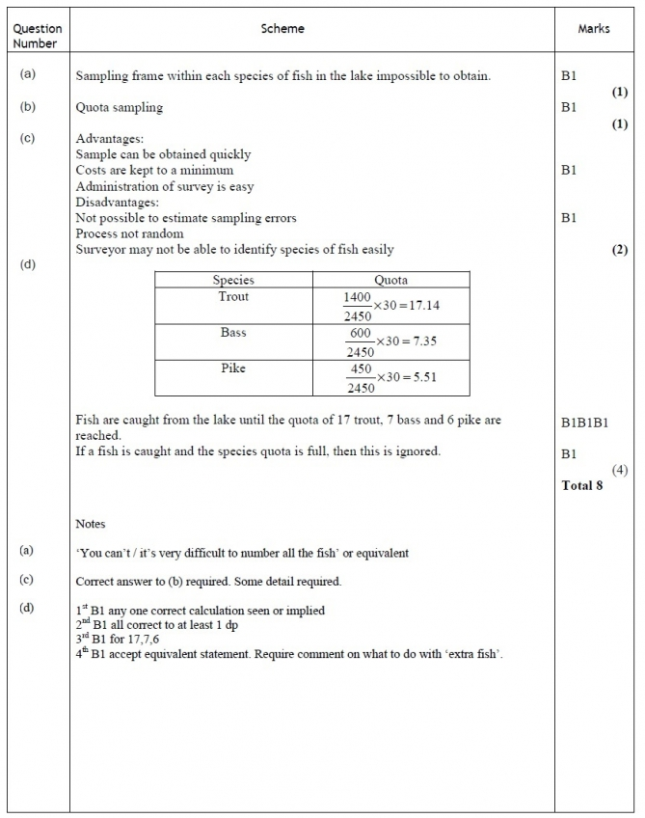

Q7.
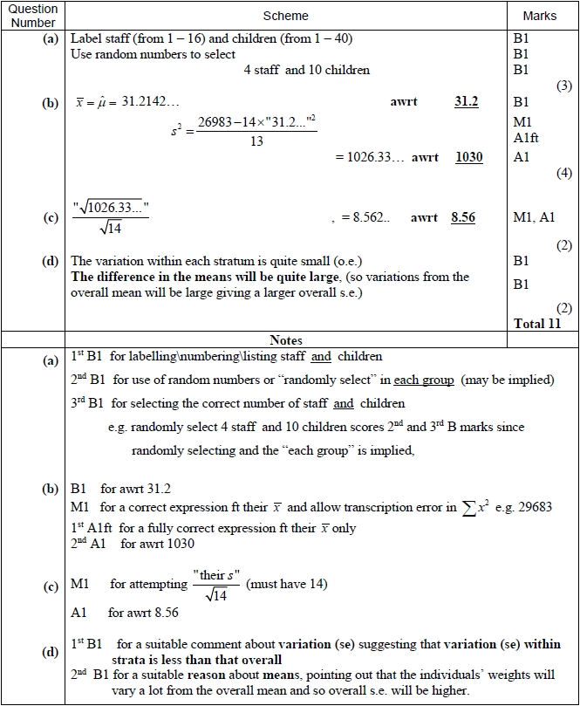

Q8.
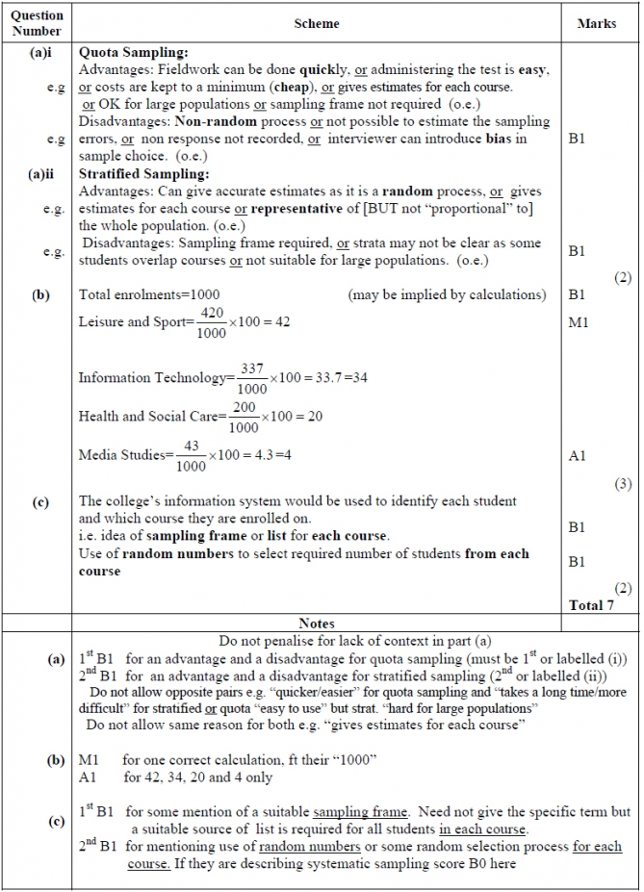

Q9.
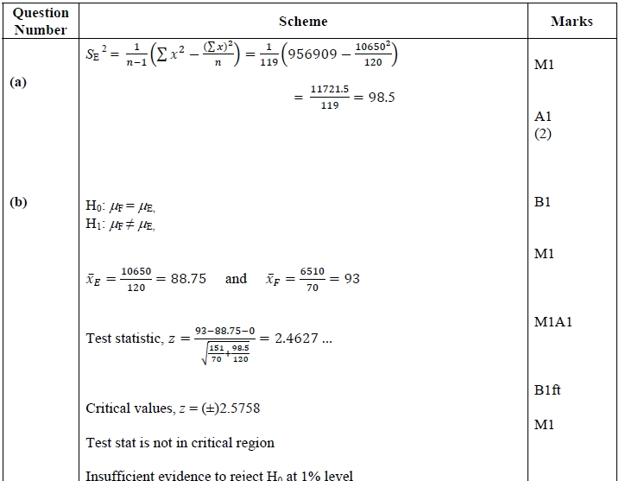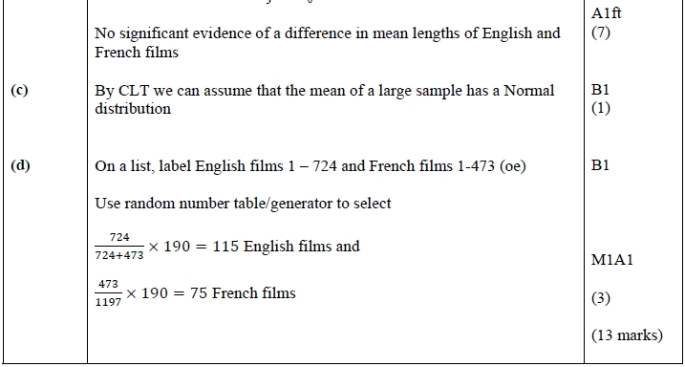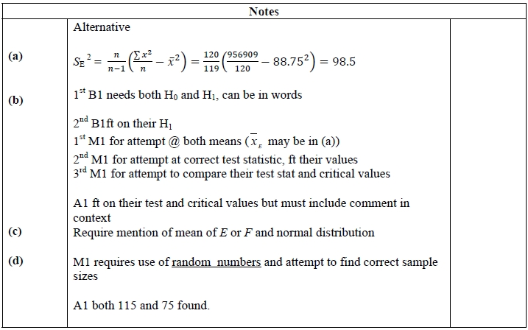

Q10.
