Name: _______________________________________________
GCE Stats section 2
Probability
practice questions from GCE Maths
Date:
Question parts in red cover content in the GCE Statistics specification but outside this section of the scheme of work
Time:
Total marks available:
Total marks achieved: ______

Questions
Q1.
The discrete random variable X has the following probability distribution, where p and q are constants.
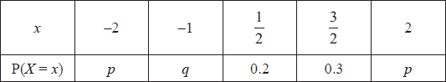
(a) Write down an equation in p and q
(1)
Given that E(X) = 0.4
(b) find the value of q
(3)
(c) hence find the value of p
(2)
Given also that E(X²) = 2.275
(d) find Var(X)
(2)
Sarah and Rebecca play a game.
A computer selects a single value of X using the probability distribution above.
Sarah's score is given by the random variable S = X and Rebecca's score is given by the random
variable
(e) Find E(R)
(3)
Sarah and Rebecca work out their scores and the person with the higher score is the winner. If the scores are the same, the game is a draw.
(f) Find the probability that
(i) Sarah is the winner,
(ii) Rebecca is the winner.
(4)
(Total for question = 15 marks)

Q2.
(a) State in words the relationship between two events R and S when P(R∩S) = 0
(1)
The events A and B are independent with P(A) = and P(A∪B) =
Find
(b) P(B)
(4)
(c) P(A'∩B)
(2)
(d) P(B'A)
(2)
(Total 9 marks)

Q3.
An experiment consists of selecting a ball from a bag and spinning a coin. The bag contains 5 red balls and 7 blue balls. A ball is selected at random from the bag, its colour is noted and then the ball is returned to the bag.
When a red ball is selected, a biased coin with probability of landing heads is spun. When a blue ball is selected a fair coin is spun.
(a) Complete the tree diagram below to show the possible outcomes and associated probabilities.
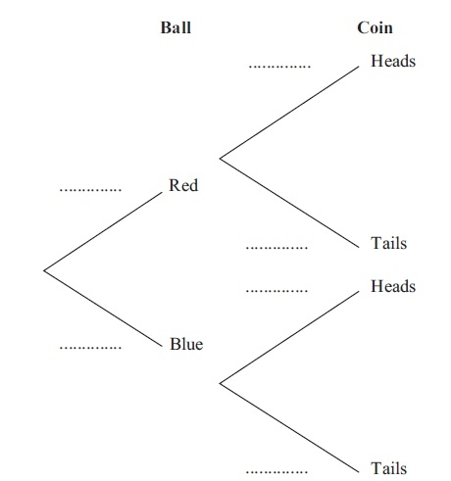
(2)
Shivani selects a ball and spins the appropriate coin.
(b) Find the probability that she obtains a head.
(2)
Given that Tom selected a ball at random and obtained a head when he spun the appropriate coin,
(c) find the probability that Tom selected a red ball.
(3)
Shivani and Tom each repeat this experiment.
(d) Find the probability that the colour of the ball Shivani selects is the same as the colour of the ball Tom selects.
(3)
(Total 10 marks)
Q4.
The Venn diagram shows three events A, B and C, where p, q, r, s and t are probabilities.
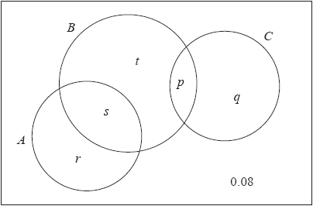
P(A) = 0.5, P(B) = 0.6 and P(C) = 0.25 and the events B and C are independent.
(a) Find the value of p and the value of q.
(2)
(b) Find the value of r.
(2)
(c) Hence write down the value of s and the value of t.
(2)
(d) State, giving a reason, whether or not the events A and B are independent.
(2)
(e) Find P(B | A ∪ C).
(3)
(Total for question = 11 marks)

Q5.
A college has 80 students in Year 12.
20 students study Biology
28 students study Chemistry
30 students study Physics
7 students study both Biology and Chemistry
11 students study both Chemistry and Physics
5 students study both Physics and Biology
3 students study all 3 of these subjects
(a) Draw a Venn diagram to represent this information.
(5)
A Year 12 student at the college is selected at random.
(b) Find the probability that the student studies Chemistry but not Biology or Physics.
(1)
(c) Find the probability that the student studies Chemistry or Physics or both.
(2)
Given that the student studies Chemistry or Physics or both,
(d) find the probability that the student does not study Biology.
(2)
(e) Determine whether studying Biology and studying Chemistry are statistically independent.
(3)
(Total for question = 13 marks)

Q6.
In a company the 200 employees are classified as full-time workers, part-time workers or contractors.
The table below shows the number of employees in each category and whether they walk to work or use some form of transport.
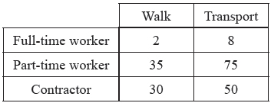
The events F, H and C are that an employee is a full-time worker, part-time worker or contractor respectively. Let W be the event that an employee walks to work.
An employee is selected at random.
Find
(a) P(H)
(2)
(b) P([F ∩ W]')
(2)
(c) P(W | C)
(2)
Let B be the event that an employee uses the bus.
Given that 10% of full-time workers use the bus, 30% of part-time workers use the bus and 20% of contractors use the bus,
(d) draw a Venn diagram to represent the events F, H, C and B,
(4)
(e) find the probability that a randomly selected employee uses the bus to travel to work.
(2)
(Total 12 marks)

Q7.
The Venn diagram shows the probabilities of customer bookings at Harry's hotel.
R is the event that a customer books a room
B is the event that a customer books breakfast
D is the event that a customer books dinner
u and t are probabilities.
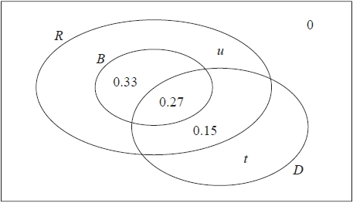
(a) Write down the probability that a customer books breakfast but does not book a room.
(1)
Given that the events B and D are independent
(b) find the value of t
(4)
(c) hence find the value of u
(2)
(d) Find
(i) P(D|R ∩ B)
(ii) P(D|R ∩ B′ )
(4)
A coach load of 77 customers arrive at Harry's hotel.
Of these 77 customers
40 have booked a room and breakfast
37 have booked a room without breakfast
(e) Estimate how many of these 77 customers will book dinner.
(2)
(Total for question = 13 marks)

Q8.
In a factory, three machines, J, K and L, are used to make biscuits.
Machine J makes 25% of the biscuits.
Machine K makes 45% of the biscuits.
The rest of the biscuits are made by machine L.
It is known that 2% of the biscuits made by machine J are broken, 3% of the biscuits made by machine K are broken and 5% of the biscuits made by machine L are broken.
(a) Draw a tree diagram to illustrate all the possible outcomes and associated probabilities.
(2)
A biscuit is selected at random.
(b) Calculate the probability that the biscuit is made by machine J and is not broken.
(2)
(c) Calculate the probability that the biscuit is broken.
(2)
(d) Given that the biscuit is broken, find the probability that it was not made by machine K.
(3)
(Total 9 marks)

Q9.
A and B are two events such that
P(B) = ¹⁄₂ P(A | B) = ²⁄₅ P(A ∪ B) = ¹³⁄₂₀
(a) Find P(A ∩ B).
(2)
(b) Draw a Venn diagram to show the events A, B and all the associated probabilities.
(3)
Find
(c) P(A)
(1)
(d) P(B | A)
(2)
(e) P(A' ∩ B)
(1)
(Total 9 marks)

Q10.
The time, in minutes, taken to fly from London to Malaga has a normal distribution with mean 150 minutes and standard deviation 10 minutes.
(a) Find the probability that the next flight from London to Malaga takes less than 145 minutes.
(3)
The time taken to fly from London to Berlin has a normal distribution with mean 100 minutes and
standard deviation d minutes.
Given that 15% of the flights from London to Berlin take longer than 115 minutes,
(b) find the value of the standard deviation d.
(4)
The time, X minutes, taken to fly from London to another city has a normal distribution with
mean μ minutes.
Given that P(X < μ − 15) = 0.35
(c) find P(X > μ + 15 | X > μ − 15).
(3)
(Total 10 marks)

Q11.
The length of time, L hours, that a phone will work before it needs charging is normally distributed with a mean of 100 hours and a standard deviation of 15 hours.
(a) Find P(L > 127).
(3)
(b) Find the value of d such that P(L < d) = 0.10
(3)
Alice is about to go on a 6 hour journey.
Given that it is 127 hours since Alice last charged her phone,
(c) find the probability that her phone will not need charging before her journey is completed.
(4)
(Total 10 marks)

Q12.
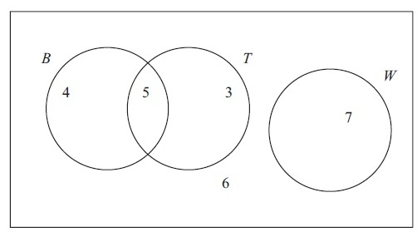
Figure 1
Figure 1 shows how 25 people travelled to work.
Their travel to work is represented by the events
B bicycle
T train
W walk
(a) Write down 2 of these events that are mutually exclusive. Give a reason for your answer.
(2)
(b) Determine whether or not B and T are independent events.
(3)
One person is chosen at random.
Find the probability that this person
(c) walks to work,
(1)
(d) travels to work by bicycle and train.
(1)
(e) Given that this person travels to work by bicycle, find the probability that they will also take the train.
(2)
(Total 9 marks)

Q13.
The Venn diagram in Figure 1 shows the number of students in a class who read any of 3 popular magazines A, B and C.
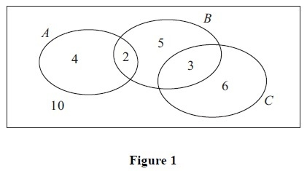
One of these students is selected at random.
(a) Show that the probability that the student reads more than one magazine is
(2)
(b) Find the probability that the student reads A or B (or both).
(2)
(c) Write down the probability that the student reads both A and C.
(1)
Given that the student reads at least one of the magazines,
(d) find the probability that the student reads C.
(2)
(e) Determine whether or not reading magazine B and reading magazine C are statistically independent.
(3)
(Total 10 marks)

Q14.
Yuto works in the quality control department of a large company. The time, T minutes, it takes Yuto to analyse a sample is normally distributed with mean 18 minutes and standard deviation 5 minutes.
(a) Find the probability that Yuto takes longer than 20 minutes to analyse the next sample.
(3)
The company has a large store of samples analysed by Yuto with the time taken for each analysis recorded. Serena is investigating the samples that took Yuto longer than 15 minutes to analyse.
She selects, at random, one of the samples that took Yuto longer than 15 minutes to analyse.
(b) Find the probability that this sample took Yuto more than 20 minutes to analyse.
(4)
Serena can identify, in advance, the samples that Yuto can analyse in under 15 minutes and in future she will assign these to someone else.
(c) Estimate the median time taken by Yuto to analyse samples in future.
(5)
(Total for question = 12 marks)

Q15.
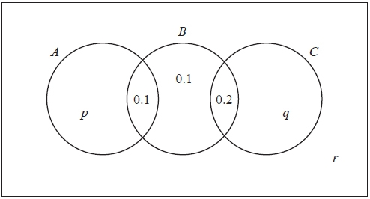
Figure 1
The Venn diagram in Figure 1 shows three events A, B and C and the probabilities associated with each region of B. The constants p, q and r each represent probabilities associated with the three separate regions outside B.
The events A and B are independent.
(a) Find the value of p.
(3)
Given that P(B | C) =
(b) find the value of q and the value of r.
(4)
(c) Find P(A ∪ C | B).
(2)
(Total 9 marks)

Q16.
A fair blue die has faces numbered 1, 1, 3, 3, 5 and 5. The random variable B represents the score when the blue die is rolled.
(a) Write down the probability distribution for B.
(2)
(b) State the name of this probability distribution.
(1)
(c) Write down the value of E(B).
(1)
A second die is red and the random variable R represents the score when the red die is rolled.
The probability distribution of R is
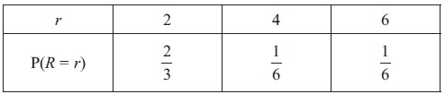
(d) Find E(R).
(2)
(e) Find Var(R).
(3)
Tom invites Avisha to play a game with these dice.
Tom spins a fair coin with one side labelled 2 and the other side labelled 5. When Avisha sees the number showing on the coin she then chooses one of the dice and rolls it. If the number showing on the die is greater than the number showing on the coin, Avisha wins, otherwise Tom wins.
Avisha chooses the die which gives her the best chance of winning each time Tom spins the coin.
(f) Find the probability that Avisha wins the game, stating clearly which die she should use in each case.
(4)
(Total 13 marks)

Q17.
The following shows the results of a survey on the types of exercise taken by a group of 100 people.
65 run
48 swim
60 cycle
40 run and swim
30 swim and cycle
35 run and cycle
25 do all three
(a) Draw a Venn Diagram to represent these data.
(4)
Find the probability that a randomly selected person from the survey
(b) takes none of these types of exercise,
(2)
(c) swims but does not run,
(2)
(d) takes at least two of these types of exercise.
(2)
Jason is one of the above group.
Given that Jason runs,
(e) find the probability that he swims but does not cycle.
(3)
(Total 13 marks)

Q18.
Jake and Kamil are sometimes late for school.
The events J and K are defined as follows
J = the event that Jake is late for school
K = the event that Jake is late for school
P(J ) = 0.25, P(J ∩ K) = 0.15 and P(J' ∩ K') = 0.7
On a randomly selected day, find the probability that
(a) at least one of Jake or Kamil are late for school,
(1)
(b) Kamil is late for school.
(2)
Given that Jake is late for school,
(c) find the probability that Kamil is late.
(3)
The teacher suspects that Jake being late for school and Kamil being late for school are linked in
some way.
(d) Determine whether or not J and K are statistically independent.
(2)
(e) Comment on the teacher's suspicion in the light of your calculation in (d).
(1)
(Total 9 marks)

Q19.
The discrete random variable X has the probability distribution
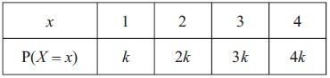
(a) Show that k = 0.1
(1)
Find
(b) E(X)
(2)
(c) E( X² )
(2)
(d) Var(2 − 5 X )
(3)
Two independent observations X₁ and X₂ are made of X.
(e) Show that P(X₁ + X₂ = 4) = 0.1
(2)
(f) Complete the probability distribution table for X₁ + X₂
(2)
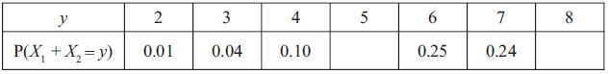
(g) Find
(2)
(Total 14 marks)

Q20.
In a large company,
78% of employees are car owners,
30% of these car owners are also bike owners,
85% of those who are not car owners are bike owners.
(a) Draw a tree diagram to represent this information.
(3)
An employee is selected at random.
(b) Find the probability that the employee is a car owner or a bike owner but not both.
(2)
Another employee is selected at random.
Given that this employee is a bike owner,
(c) find the probability that the employee is a car owner.
(3)
Two employees are selected at random.
(d) Find the probability that only one of them is a bike owner.
(3)
(Total 11 marks)

Q21.
Given that
P(A) = 0.35 , P(B) = 0.45 and P(A ∩ B) = 0.13
find (A ∪ B)
(2)
(b) P( A′ | B′)
(2)
The event C has P(C) = 0.20
The events A and C are mutually exclusive and the events B and C are independent.
(c) Find P(B ∩ C)
(2)
(d) Draw a Venn diagram to illustrate the events A, B and C and the probabilities for each region.
(4)
Tom invites Avisha to play a game with these dice.
(e) Find P([B ∪ C]′)
(2)
(Total 12 marks)
Q22.
A manufacturer carried out a survey of the defects in their soft toys. It is found that the probability of a
toy having poor stitching is 0.03 and that a toy with poor stitching has a probability of 0.7 of splitting open. A toy without poor stitching has a probability of 0.02 of splitting open.
(a) Draw a tree diagram to represent this information.
(3)
(b) Find the probability that a randomly chosen soft toy has exactly one of the two defects, poor stitching or splitting open.
(3)
The manufacturer also finds that soft toys can become faded with probability 0.05 and that this defect is independent of poor stitching or splitting open. A soft toy is chosen at random.
(c) Find the probability that the soft toy has none of these 3 defects.
(2)
(d) Find the probability that the soft toy has exactly one of these 3 defects.
(4)
(Total 12 marks)

Q23.
The bag P contains 6 balls of which 3 are red and 3 are yellow. The bag Q contains 7 balls of which 4 are red and 3 are yellow. A ball is drawn at random from bag P and placed in bag Q. A second ball is drawn at random from bag P and placed in bag Q. A third ball is then drawn at random from the 9 balls in bag Q.
The event A occurs when the 2 balls drawn from bag P are of the same colour. The event B occurs when the ball drawn from bag Q is red.
(a) Complete the tree diagram shown below.
(4)
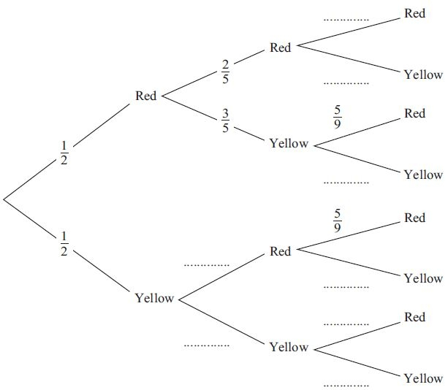
(b) Find P(A)
(3)
(c) Show that
(3)
(d) Show that
(2)
(e) Hence find
(2)
(f) Given that all three balls drawn are the same colour, find the probability that they are all red.
(3)
(Total 17 marks)
Q24.
For the events A and B,
P(A' ∩ B) = 0.22 and P(A' ∩ B') = 0.18
(a) Find P(A).
(1)
(b) Find P(A ∪ B).
(1)
Given that P(A | B) = 0.6
(c) find P(A ∩ B).
(3)
(d) Determine whether or not A and B are independent.
(2)
(Total 7 marks)

Q25.
A spinner is designed so that the score S is given by the following probability distribution.
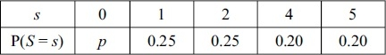
(a) Find the value of p.
(2)
(b) Find E(S).
(2)
(c) Show that E(S² ) = 9.45
(2)
(d) Find Var(S).
(2)
Tom and Jess play a game with this spinner. The spinner is spun repeatedly and S counters are awarded on the outcome of each spin. If S is even then Tom receives the counters and if S is odd then Jess receives them. The first player to collect 10 or more counters is the winner.
(e) Find the probability that Jess wins after 2 spins.
(2)
(f) Find the probability that Tom wins after exactly 3 spins.
(4)
(g) Find the probability that Jess wins after exactly 3 spins.
(3)
(Total 17 marks)
Examiner's Report
Q1.
Most students found the first four parts of this question accessible and appeared to have been well prepared for it. Almost everyone was able to use the sum of the probabilities condition to obtain a first equation in part (a) and there was often a correct expression for E(X) seen too, although sometimes this was set equal to 1 not 0.4
Errors in solving the equations in part (b) sometimes led to negative values for the probabilities of p and q and it is disappointing to see students still using these impossible values in later stages of their working. One would hope that they would realise that an error had been made and then try to correct it.
The variance calculation in part (d) was usually correct with only a small number of students making slips, such as subtracting the mean instead of the mean squared, or dividing by 5.
Part (e) caused problems for a significant number of students. A surprising number did not try listing the probability distribution for R and there were many cases of students trying to use the reciprocals of the probabilities or simply thinking that 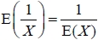.
Part (f) was only answered successfully by the more able students. Some students embarked on a correct approach but failed to correctly identify the cases where Sarah or Rebecca would win, a few forgot that there could be a draw and having found a correct answer to part (i) simply subtracted this from 1 to give their answer to part (ii). A number did not read the question carefully enough and thought that there were two independent values of X being used: some then assumed that all 25 cases were equally likely but others battled through to obtain a correct response to this situation and a special case in the mark scheme enabled them to have some credit.

Q2.
Despite the question using R and S in part (a) and A and B for the rest of the question, candidates assumed A and B were mutually exclusive and made no use of independence. In part (a) candidates were let down by their inability to express in unambiguous English "mutually exclusive". A number of candidates just restated the question, writing that it meant the probability of the intersection was 0 rather than describing the relationship between R and S.
Part (b) was not as well done as it ought to have been by the majority of candidates. Many didn't realise that the letters R and S were replaced from part (a) by A and B and so confused independence with mutually exclusive. Many candidates did write the full formula and substituted at least one probability correctly, although far fewer candidates realised the "independent" statement in the question meant that P(A ∩ B) could be replaced with P(A) × P(B) Of those who successfully used the Addition Rule and independence, it was very disappointing to see some who could not handle the resulting linear equation because it had fractions in it. Those who did not start by quoting a formula and assumed exclusivity scored no marks.
Part (c) was answered well, with either a correct answer (even if part (b) incorrect) or a correct follow through.
In part (d) most knew that they had to use conditional probability, with only a few dividing by P(B') by mistake. The ability to find P(B'∩A) for the numerator from previous working was often lacking and very few candidates used the fact that A and B were independent to simply state P(B'A) = P(B').

Q3.
Overall there were very few errors made when candidates completed their tree diagrams. A small number of candidates repeated their probabilities of 2/3 (for obtaining a head) and 1/3 (for obtaining a tail) on the second branches for the fair coin. Occasionally the 5/12 and 7/12 probabilities were placed on the wrong branches and, in a few instances, quantities rather than probabilities were used. The vast majority of candidates were able to calculate the probability that Shivani selects a head correctly, or at least follow through the correct method from their tree diagrams, with few errors seen.
In contrast the quality of candidates' attempts at part (c) was extremely varied. Very few candidates quoted the correct formula despite it being given in the formula booklet, and of those who did, few realised that the numerator should be 5/12 × 2/3. The numerator was quite often seen as 5/12 alone, and a number of candidates failed to recognise that their denominator should be their answer to part (b), leading in some cases to a repeated fraction in the numerator and denominator. P(H/R) was sometimes calculated instead of P(R/H).
The final part of the question was attempted fairly successfully overall. Indeed, many of the candidates who had erred in previous parts of the question were able to gain some credit, as most could identify at least one of (5/12)² or (7/12)². The special case pertaining to no replacement was occasionally seen.

Q4.
Although over a quarter of the students scored full marks, clearly reasoned and fully correct answers to this question were relatively rare. Most started correctly in part (a) and the correct values for p and q were often seen. Frequently there followed in parts (b) and (c) a string of equations linking r, s and t often accompanied by failed attempts to solve them correctly. The most common error though was to assume that A and B were independent which quickly gave an incorrect value for s and an easy route to find wrong answers for r and t. This also meant that any argument they used in (d) was flawed and marks were lost here too.
In part (d) those who had a correct (or nearly correct) Venn diagram were familiar with the two approaches to determining independence but by far the most popular was to compare
P(A)×P(B) = 0.5×0.6 = 0.3 with P(A∩B) = s = 0.28 and conclude that A and B were not independent. In the final part (e), most realised that a ratio of probabilities was required and many had a suitable denominator from P(A) + P(C) or their (r + s + p + q) but the numerator was often incorrect. A common error was simply to use P(B) and many also used P(B)×P(A∪C) and a few lost the final accuracy mark for simplifying 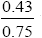 to 0.57.

Q5.
Part (a) was usually answered very well but a significant number did not appreciate that those who studied all 3 subjects were also included in the numbers studying a pair of subjects. Most could score the mark in part (b), even if their Venn diagram was incorrect, but some muddled their denominators and gave an answer of rather than . In part (c) most wrote down a fraction based on their Venn diagram: this was fine if their diagram and answer were correct but otherwise a correct expression was required before the examiners could award any marks.
In part (d) the examiners were often able to follow through a suitable numerator based on the student's Venn diagram and a denominator from their answer to part (c) and those who had scored both marks in (c) often did so again in (d). Some students though are still not spotting the conditional probability and denominators of 80 were quite common here. Some answers to part (e) simply lacked sufficient detail or explanation to award the marks. The examiners expect to see the relevant probabilities required for the test clearly stated and a correct test used with a concluding comment; simply writing " so independent" is not sufficient. The most popular test was based on comparing P(B) × P(C) with , though some used a conditional probability, but was a common error. A small number of students confused "independence" with "mutually exclusive".

Q6.
Part (a) was answered very well but in part (b) a number of candidates failed to spot or consider the complement (giving an answer of 0.01) and others confused the 200 with 100 and gave an answer of 0.98. The conditional probability in part (c) was answered quite well but a few had P(W) on their denominator and some assumed independence when calculating the numerator and used
P(C)×P(W) = P(C ∩ W). Part (d) was a little different from the usual Venn diagram and candidates had to consider carefully how to represent the 4 events. Three overlapping circles or 3 separate circles with no indication of set B was quite common and those who did have a correct shape sometimes struggled to place the frequencies or probabilities. Those using frequencies were usually more successful as the probabilities were not always out of 200. A Venn diagram such as this should, of course, always have a box defining the universal set [and ideally a 0 for the region (F ∪ C ∪ H ∪ B)'] and a few candidates missed this out. Despite their difficulties with the structure of the diagram for part (d) many candidates were able to interpret the table correctly and score the marks in part (e).

Q7.
Again it was disappointing to see some students working with negative probabilities but most could at least make a start here. Some floundered over the idea of B being a subset of R whilst also intersecting D and the final part proved quite challenging, enabling the more able students to shine.
Part (a) was usually answered correctly with 0.33 or 0.6 being the common incorrect answers. Many were successful in part (b) too but a common error arose from poor use of brackets: students arrived at 0.6(0.42 + t) = 0.27 but then forgot to multiply the "t" by 0.6. Part (c) usually followed as most realised that u + t = 0.25.
The conditional probabilities in part (d) proved to be beyond some students and a common error in part (i) was forgetting to add the 0.33 to the 0.27 for the denominator and just giving an answer of 0.27/0.33 or . Part (ii) was generally answered more successfully than part (i) but an incorrect denominator was often seen here too. Part (e) discriminated well with many simply trying 77 × 0.45 or 0.27 × 40 + 0.15 × 37 and only the more able students using their answers from part (d) as required.

Q8.
The tree diagram was answered very well with only occasional errors on the branches for broken or not broken biscuits e.g P(B | J) = ²⁄₂₅ rather than ²⁄₁₀₀.
Question (b) and question (c) were usually correct although there were a number of transcription errors such as 0.335 instead of 0.0335 in question (c).
Question (d) was a slightly more challenging conditional probability and it caused difficulties for some students. Some misinterpreted it and simply found P(K' ∩ B) whilst others found P(K | B) and the error of having a numerator of P(K') × P(B) rather than P(K' ∩ B) was not uncommon.

Q9.
This question was answered very well. Question (a) could be answered quite readily by using the formula in the formula booklet and the given values for P(B) and P(A | B) and then it should have been a straightforward step to complete the Venn diagram in question (b). However some forgot to subtract
P(A ∩ B) when completing their diagram but the follow through marks meant that some credit could still be given for the later parts. Question (c) and question (d) were usually answered well but in question (e) some tried to use a formula (which was often incorrect) rather than their Venn diagram and made the question much more complicated.

Q10.
The normal distribution was handled well by most candidates on this paper. Part (a) caused few problems although some candidates failed to subtract their tables' value from 1 and most made good progress in part (b) too although some failed to use the table of percentage points of the normal distribution and had a z value of 1.04 or 1.03 rather than 1.0364. Part (c) was more challenging requiring the identification of a conditional probability and then the correct evaluation of the numerator using the symmetry of the distribution but there were a good number of correct responses seen.

Q11.
A small minority were still unsure whether the final answer was 0.9641 or 1 − 0.9641. There were 3 common sources of error in (b). Some candidates simply set their standardised expression equal to 0.1 or 0.5398 and lost all 3 marks. Others realised that the standardised expression should be set equal to a z value but did not use the percentage points table and lost a mark. The final problem was choosing the correct sign on their z value and a number of answers of 119 were seen. Some candidates gave an answer of 80.776… from their calculators and gained all 3 marks.
(c) was not answered well and most attempts did not notice the usual prompt (the wording "given that…") and thus did not attempt a conditional probability. Common solutions were simply a calculation of
P(L > 133) or P(127 < L < 133).

Q12.
In part (a) T and W or B and W were often stated as a mutually exclusive pair and a sensible reason given in words or symbols such as P(T∩W ) = 0. Some candidates mixed up mutually exclusive and independent events and gave B and T as their pair with a reason that they could both happen together.
The test for independence in part (b) caused problems for some. The examiners were looking for a clear application of a suitable test which was usually P(B∩T ) ≠ P(B) × P(T ) , although some used a conditional probability successfully. We would also expect to see the required probabilities stated and this was a problem for some: a minority simply used integers and others gave P(B) = or P(T) = . Those who carried out a correct test with correct probabilities usually gave a correct conclusion too and secured all 3 marks.
Part (c) was nearly always correct but a few gave as their answer to part (d). Most candidates now can identify a conditional probability and only a few attempted P(B|T) in part (e). It was quite possible to write down this final answer from the Venn diagram but many used the conditional probability formula from the formula booklet which if their P(B) was incorrect meant they could at least score the M1.

Q13.
Overall this question proved to be quite challenging for candidates and incorrect interpretation of the Venn diagram lost many candidates marks. In spite of this, most candidates had no trouble proving the given probability in part (a).
In part (b), however, quite a number of candidates neglected one of the four components of the numerator, usually the 3, and 11/30 was consequently an extremely common wrong answer. Other wrong answers included 9/30, 13/30 and 16/30. Some candidates chose to use the addition rule, which was generally written down correctly, although quite often P(A) was given as 4/30 and P(B) as 5/30, giving rise to P(AUB) = 7/30.
In contrast, the majority of candidates were able to deduce that P(A∩C) = 0 and quite a few gave explanations as part of their answer, such as 'there is no overlap', or 'no intersection' and some even discussed the idea of mutual exclusivity. A small proportion of candidates had the right idea but failed to give a probability, giving their answer as 'nobody' or in a few cases 'the empty set'. However, not all of the candidates realised that mutually exclusive events have a probability of 0 of occurring together and some mistakenly thought that P(A∩C) equalled P(A)P(C) here.
Answers to part (d) were extremely varied. Most candidates did not recognise that a conditional probability was required and consequently did not obtain the correct denominator. Common wrong answers were 6/30, 6/20 and 3/20. A significant number attempted to perform some complex calculations in which they tried unsuccessfully to use the formula for conditional probability. Very few candidates used the Venn diagram to calculate the probability directly.
Testing for independence was generally performed successfully overall, with the majority of candidates carrying out suitable tests. However, some candidates did find this challenging and often the wrong probabilities were compared and some incorrect probabilities were obtained. A number of candidates appeared to be confusing independence with mutual exclusivity. Some candidates merely provided a comment on the perceived nature of independence without performing any calculations at all. Of those candidates who were successful, the most common approach was to test whether P(B∩C) = P(B)P(C), although there were a few cases where P(A∩C) was compared with P(A)P(C) by mistake. Rather worryingly, a surprisingly high number of candidates failed to recognise 3/30 and 1/10 as equivalent fractions and thus concluded that the events were not independent.

Q14.
This was the most challenging question on the paper. Part (a) was a simple use of the normal distribution and most students scored full marks here. A sizeable group though standardised correctly but then confused the two tables and wrote down the z-value corresponding to a probability of 0.4 (i.e. 0.2533) and used this as their probability. There were also a number of cases of students miscopying the tables and 0.3466 instead of 0.3446 was seen quite frequently. The usual errors of standardising with 5² or were very rare though a number were still unsure whether or not to subtract their tables figure from 1.
In part (b), few wrote down a conditional probability statement but launched straight into a ratio of probabilities. This was fine if the ratio was correct but, whilst most had P(T > 15) = 0.7257 on the denominator, those who thought the numerator was simply P(T > 15)×P(T > 20) would score no marks. Those who did have a correct numerator were often able to score all of the marks here. Part (c) proved too demanding for most students and only a few of those who eventually arrived at a correct answer did so from a clearly argued solution. Some students assumed that linear interpolation was required and made no headway. Very few started by considering a conditional probability but some did realise that they required the value d such that P(T > d) = 0.5 × 0.7257 and some then realised they were trying to find d from P(T < d) = 0.63715. Those who got this far usually realised that they needed to use a z-value of 0.35, though some did not know how to deal with a probability in-between two values in the tables and simply took the midpoint, and were able to form a correct equation and arrive at the correct answer but under 10% scored full marks on this question.

Q15.
In part (a) most used the independence property correctly to show that P(A) = 0.25 but some mistakenly assumed p = P(A). The conditional probability formula was usually used correctly in part (b) to find P(C) and often the value of q as well and many were also able to find the value of r too although occasionally candidates seemed to miss this demand. There were some good responses to part (c) despite the rather unusual nature of the conditional probability. Many candidates were able to write down a correct ratio of probabilities and there weren't too many cases of candidates attempting to evaluate the numerator as 0.69 × 0.4.

Q16.
(a) was answered well and most gave the distribution in a table with values 1, 3 and 5 and probabilities of for each. Labelling each face as 1, 1, 3, 3, 5, 5 was quite common too, usually accompanied by probabilities of for each face, but some gave probabilities of for each face and others had values of 1, 2 and 3.
(b) was not answered well with many candidates only having one of the two words "discrete" and "uniform" in their answer. An answer of "discrete random distribution" was quite common but some candidates did not know the correct terms, describing it as an "equal" distribution.
Very few candidates used the symmetry of the distribution to "write down" the answer to (c) but they were still able to gain the mark by calculating E(B). Some candidates could not answer part (d) correctly but in part (e) although a number found E(R)² = some thought this was Var(R), others only subtracted 3, despite having previously quoted a correct formula, and some rounded their answer to 2.33 without first giving the exact value. In the final part of the question many candidates did not seem to understand what was required. Some drew complete tree diagrams but then did not realise that Avisha always chose the die that gave her the best chance of winning. Others identified which die she should choose without taking account of the probability of 0.5 for the outcomes of the spin of the coin. Nevertheless a small number of candidates did complete this part of the question successfully.

Q17.
Construction of the Venn diagram was nearly always correct. Occasional errors were mainly the omission of the box and failure to subtract frequencies accurately. Unfortunately, several candidates left the region for R∩S ∩C so small that it was extremely difficult to decipher the number written there.
In part (b) there were relatively few incorrect solutions. Occasionally an incorrect subtraction from 100 to find n(R'∩S'∩C') was seen.
Part (c) and part (d) were very well answered by the majority of candidates. However, in part (d), was not an uncommon response, with the central frequency of 25 being omitted. This stems from a failure to understand the phrase "at least" in the question. Conditional probability in part (e) continues to be a problem for many candidates. Perhaps greater emphasis on the restricted sample space would produce better and quicker rewards.

Q18.
It was encouraging to see many candidates drawing a correct Venn diagram for the start of this question but the wording "at least one" in part (a) was often misinterpreted as the intersection and some gave the probability of "only K" in part (b).
There were many correct answers seen in part (c) although many candidates simply wrote down the correct probability ratio without attempting an expression in symbols. Inevitably some wrote P(JK) but the identification and calculation of conditional probabilities seems to be improving.
In part (d) most candidates opted for the P(K ∩ J) = P( K ) × P( J ) test whilst others attempted other incorrect comparisons such as P(K ∩ J) = 0 or even P(K ∩ J) = P( K ) + P( J ). Some merely quoted a standard formula in terms of A and B which, without some identification of what their A and B represented gained no credit. Only the very best realised that they had just calculated P(KJ) and P( K) and since these two were not equal the two events were not independent.
Part (e) discriminated very well with good candidates engaging with the context and showing they clearly understood the concept of independence.

Q19.
Most candidates showed us clearly that they were using the sum of the probabilities to reach 10k = 1 from which they showed that k = 0.1 and the calculation of E(X) was usually correct too. In part (c) some confusion between E( X² ) and Var(X) and also over what to square (some choosing the probabilities rather than the values of x) caused difficulties and a few simply squared their answer to part (b). Part (d) was a fairly standard request and most knew that Var(2 − 5X) = 25Var(X) and were sometimes able to recover from errors made in part (c) but then many solutions ground to a halt.

Q20.
Most students scored all the marks for drawing the tree diagram and could then use this to answer question (b). In question (c) the conditional probability discriminated more with some failing to obtain the correct denominator. Question (d) caused difficulties for a number of students: some did not realise they needed a probability of the form p(1 − p) where p was their denominator from question (c) and those who did secure this first mark often failed to multiply by 2 to account for both possible cases.

Q21.
(a) was answered very well with only a small minority adding P(A ∩ B) rather than subtracting it. In (b) although most could quote a correct formula, some thought that P(A′ ∩ B′) = 1 − P(A ∩ B) and then had a numerator greater than their denominator. Others assumed independence and used
PP(A′ ∩ B′) = P(A′) × P(B′).(c) was usually correct although a small number of candidates confused independence with mutually exclusive and gave an answer of zero.
Most candidates gave a correct arrangement of the events in (d) and few omitted the "box". There were a number of errors in the calculations of the other probabilities, in particular the probability for B only, but a large number of fully correct diagrams were seen.(e) was usually answered quite well with many demonstrating a correct understanding of the method by using the values from their Venn diagram and others avoiding any problems with the Venn diagram by using 1 − P(B ∪ C) = 1 − [0.45 + 0.20 − 0.09] or occasionally P(B′) × P(C′) .

Q22.
This question was answered well by most candidates. There were a number of accuracy errors with the wrong positioning of the decimal point with 0.03×0.3 giving rise to 0.9, 0.09 or even 0.0009 and 0.047... was sometimes copied from a calculator as 0.47...
Part (a) proved a straightforward start to the question and most candidates completed a correct tree diagram.
Most completed part (b) correctly too but some found P(a split) and others found P(at least one of the defects) but many correct answers were seen here.
In part (c) the majority were able to multiply together the 3 required probabilities but a small minority just gave the answer as 0.97×0.98.
Numerous candidates found the correct products of three probabilities in part (d) but some just added 0.05 to their answer to part (b). Most candidates though found this question a very rewarding end to the paper.

Q23.
Many candidates were able to complete the tree diagram correctly but common errors were to have probabilities of 5/9 and 4/9 on the top two and bottom two branches. Part (b) was often answered correctly and even those with incorrect tree diagrams could achieve 2 or even all 3 marks here. Few candidates explained which four probabilities they were using to answer part (c) and the examiners were often left trying to deduce this from their tree diagram. Simply writing P(RRR) + P(RYR) + P(YRR) + P(YYR) would have earned them the first mark and made their solution much clearer. Some students failed to appreciate that a sum of 4 products of 3 probabilities from their tree diagram was required and a popular "fiddle" was to calculate 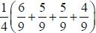 using the probabilities from the third branches and magically dividing by 4 to reach the printed answer. Part (d) was answered poorly with most attempts assuming that A and B were independent events (they were but this was never justified). Part (e) though was usually answered well with candidates clearly using the addition rule and the given answers. In the final part many candidates failed to identify the conditional probability and those who did often did not clearly state what their ratio of probabilities represented: once again a statement such as ("P"(RRR)) / ("P"(RRR) + "P"(YYY)) with some suitable probabilities attempted would have secured the first mark.

Q24.
This question was found to be challenging. A clear Venn diagram would have helped some to get started.
Those who tried to draw a Venn diagram could quickly find P(A) from 1 − 0.18 − 0.22 to answer question (a) and question (b) would either follow from P(A) + 0.22 or 1 − 0.18 . After this the students needed a clear argument to answer question (c) that did not assume that A and B were independent. Some students set off in the right direction by quoting the conditional probability formula P(A|B) = 0.6 = ^{P(A ∩ B)}⁄_{P(B)} but to make further progress they needed a second equation with P(B) and P(A ∩ B) which they could obtain by using the addition formula and their answers from question (a) and question (b). The more able students were able to successfully solve these two equations to find P(B) or P(A ∩ B) . Some students noted that since P(A) = 0.6 then if P(A ∩ B) = 0.6as well then A and B are independent, thus answering question (d) first. They could then use the given information
0.22 = P(A'∩ B) = P(A') × P(B) = [1 − 0.6] P(B) to obtain P(B) = 0.55and then their Venn diagram to see that P(A∩ B) = 0.33. Those who obtained P(B) = 0.55 from a more conventional route nearly always chose to answer question (d) by checking that P(AA) × P(B) = P(A ∩ B) and giving a correct conclusion.

Q25.
The first 4 parts of this question were usually answered very well by most candidates. Very few confused E(S² ) with [E(S)]² and the mean was usually squared when calculating Var(S). Part (e) was attempted by a good number of candidates and many realised that they needed to combine 0.2 and 0.2. Some gave 0.2 + 0.2 = 0.4 and others 0.2 − 0.2 = 0.4 but there were a number of correct solutions seen. Those who attempted part (f) often identified some of the cases such as P(4 ∩ 4 ∩ 2) = 0.01 and occasionally the 3 arrangements of 4, 4 and 2 but then they often missed P(4 ∩ 4 ∩ 4).
Part (g) proved to be a challenging final part to the paper. Some tried listing all the possible cases for Jess to win. Their listing was usually extremely inefficient and they invariably missed one or more cases. Only a handful of candidates seemed to realise that only two probabilities needed to be considered namely P( ∩ 5 ∩ 5) and P(5 ∩ ∩ 5) and the probabilities could then be found quite easily.

Mark Scheme

Section 2 | Probability
qu.1 | June 2016 S1 - Q2f
qu.2 | January 2012 S1 - Q2
qu.3 | May 2010 S1 - Q2
qu.4 | June 2017 S1 - Q3
qu.5 | June 2015 S1 - Q3
qu.6 | May 2013 S1 - Q3
qu.7 | June 2016 S1 - Q4
qu.8 | June 2014 S1 - Q4
qu.9 | June 2014 S1R - Q4
qu.10 | May 2013 S1R - Q4c
qu.11 | January 2013 S1 - Q4
qu.12 | May 2012 S1 - Q4
qu.13 | May 2010 S1 - Q4
qu.14 | June 2017 S1 - Q5b
qu.15 | May 2013 S1R - Q6
qu.16 | January 2013 S1 - Q6
qu.17 | January 2012 S1 - Q6
qu.18 | May 2011 S1 - Q6
qu.19 | January 2011 S1 - Q6
qu.20 | June 2014 S1R - Q7
qu.21 | January 2013 S1 - Q7
qu.22 | May 2012 S1 - Q7
qu.23 | January 2011 S1 - Q7
qu.24 | June 2014 S1 - Q8
qu.25 | May 2011 S1 - Q8

Q1.
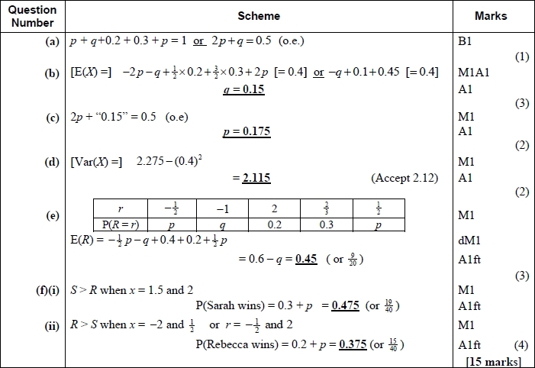
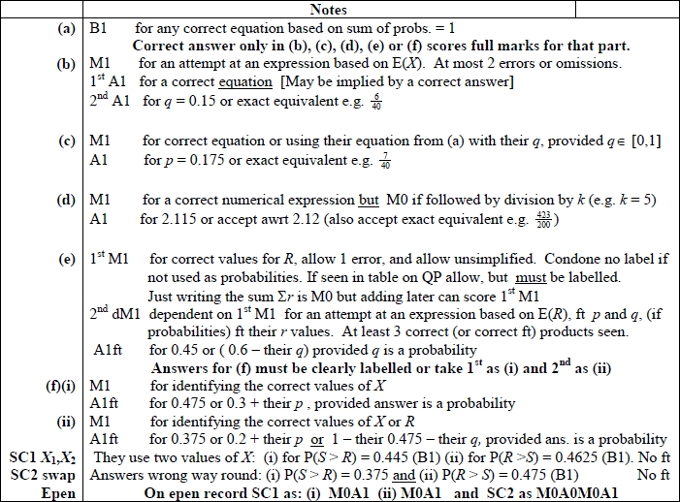

Q2.
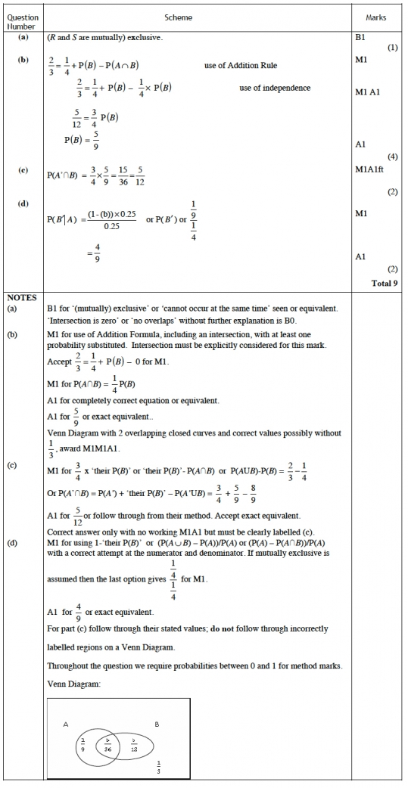
Q3.
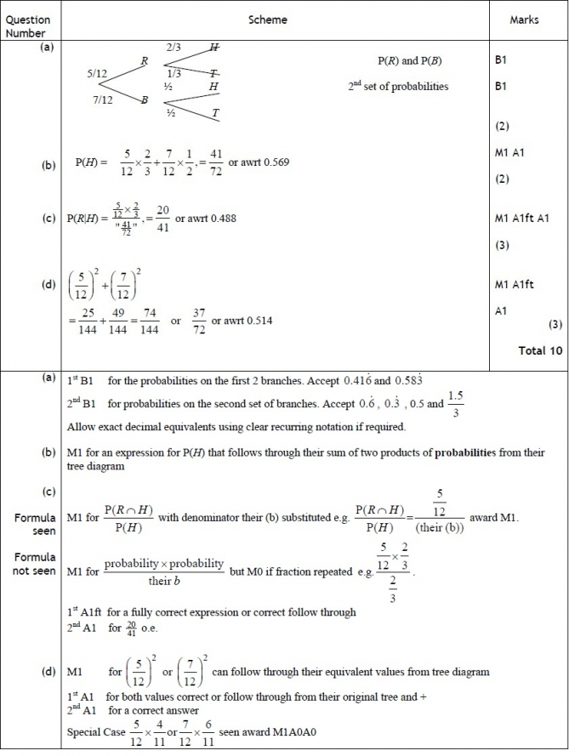

Q4.
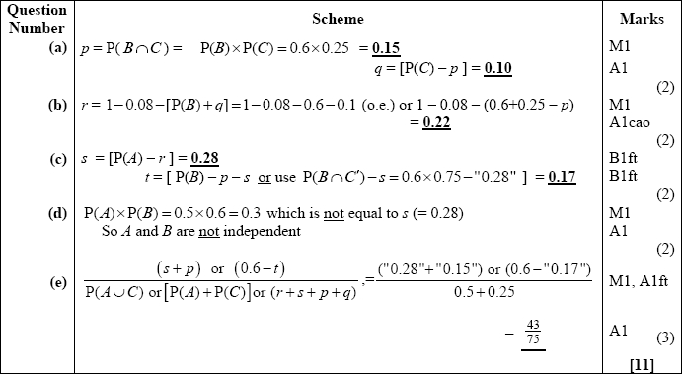
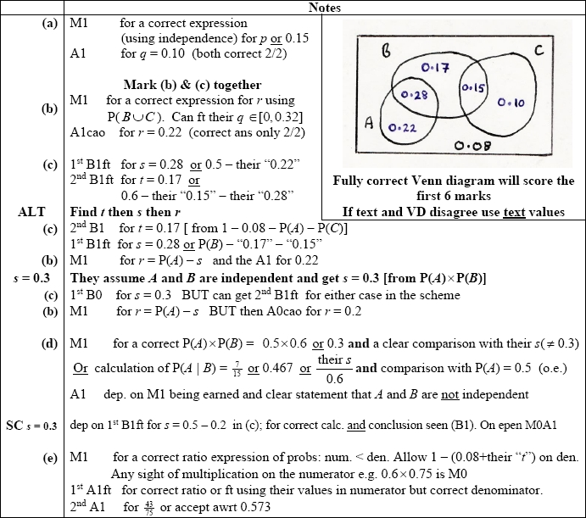
Q5.
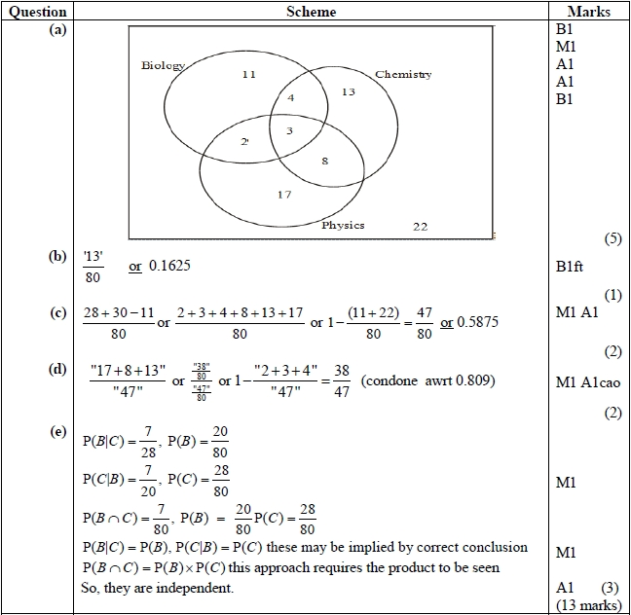
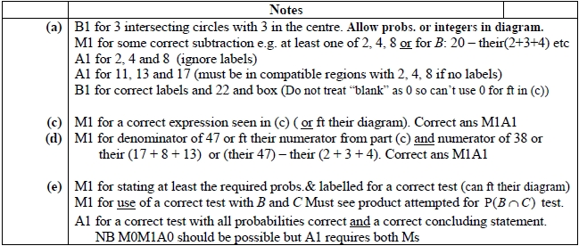

Q6.
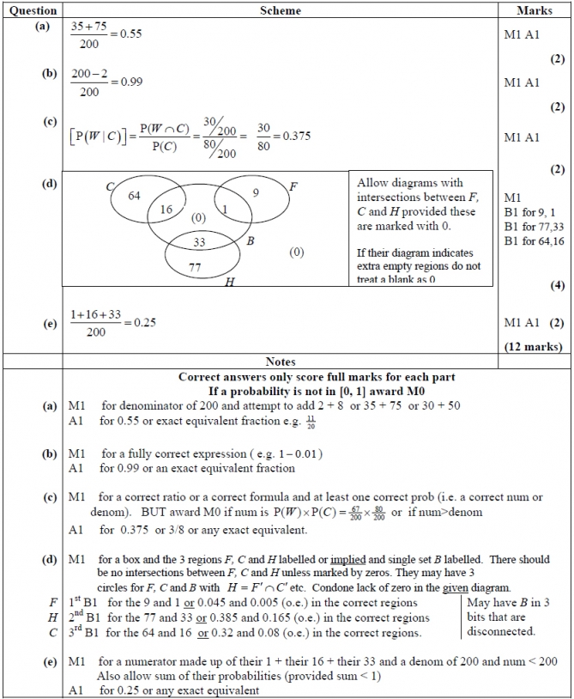

Q7.
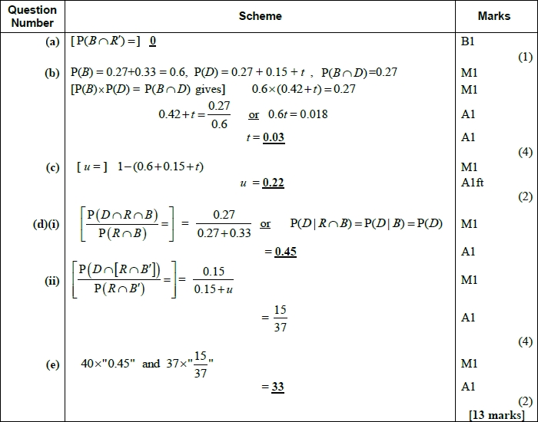
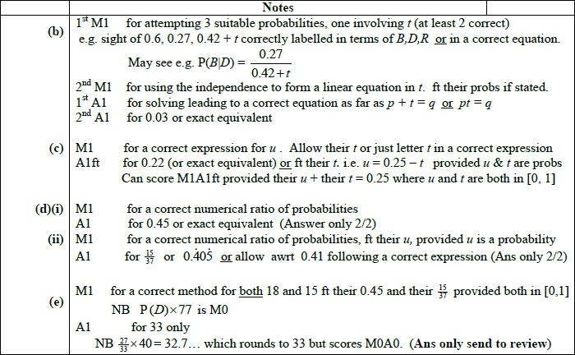

Q8.
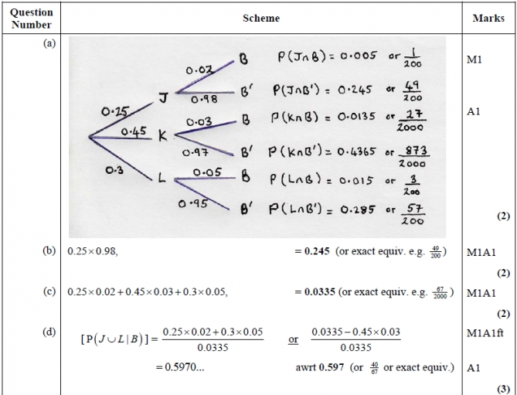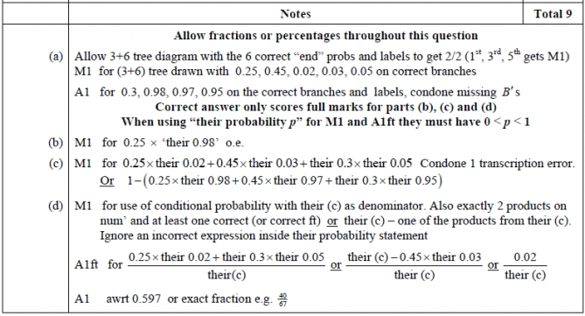

Q9.
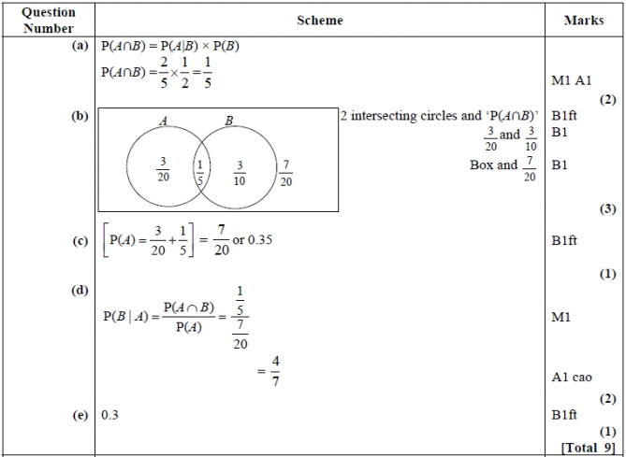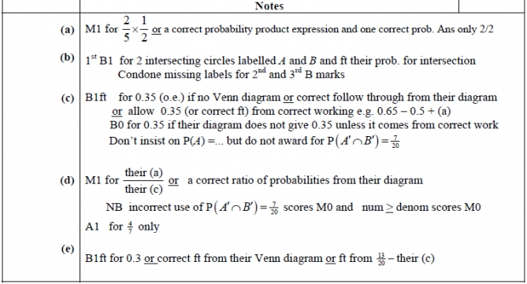

Q10.
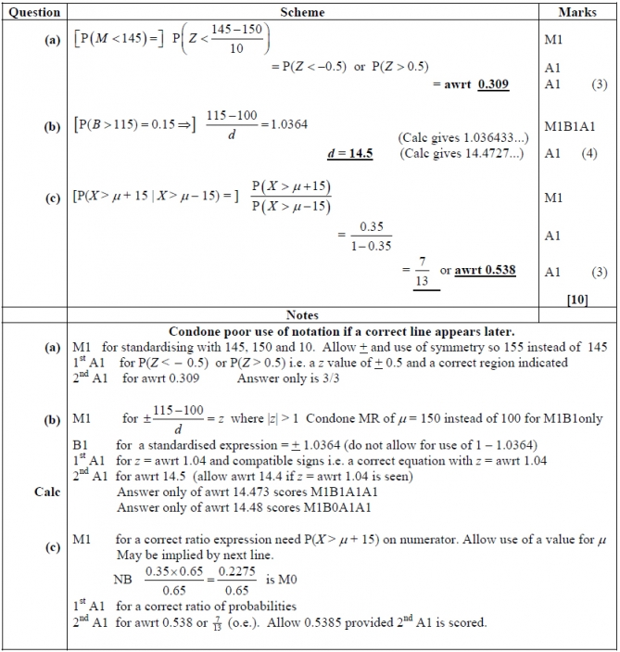

Q11.
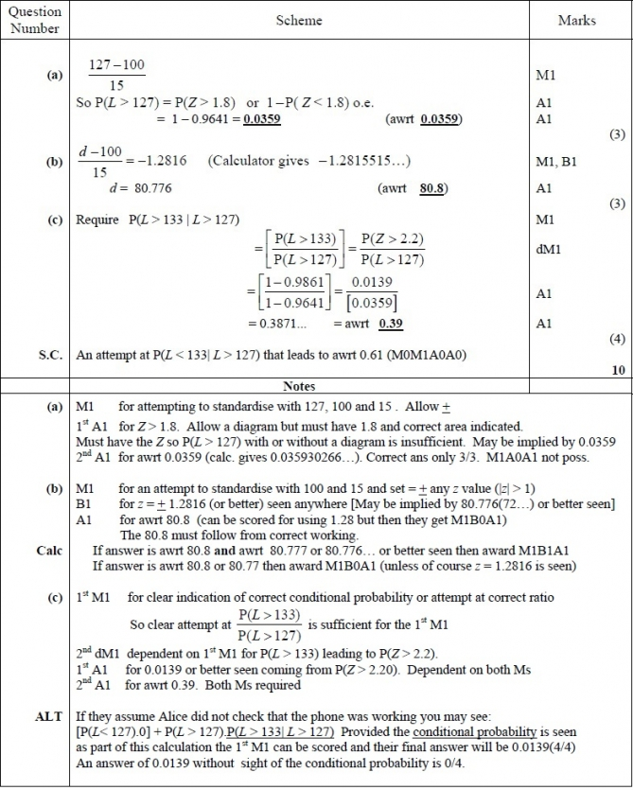

Q12.
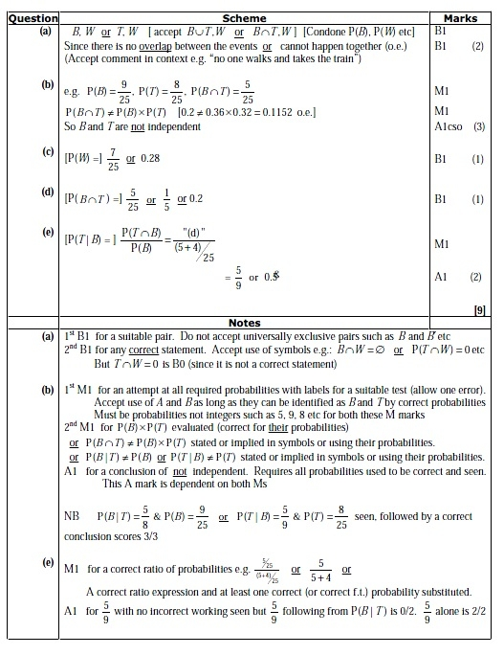

Q13.
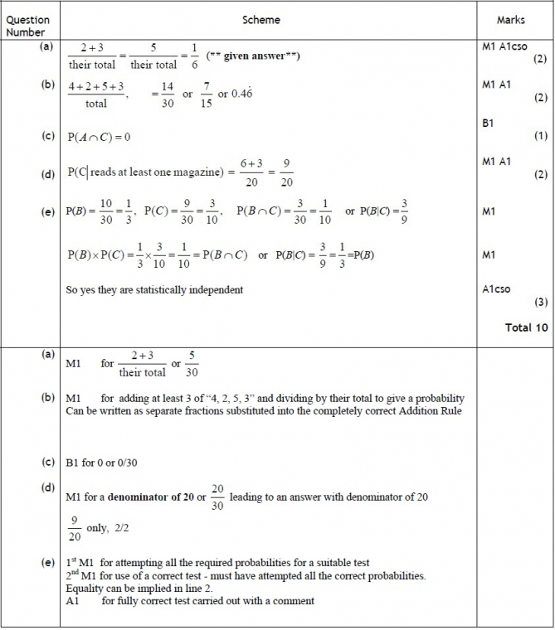

Q14.
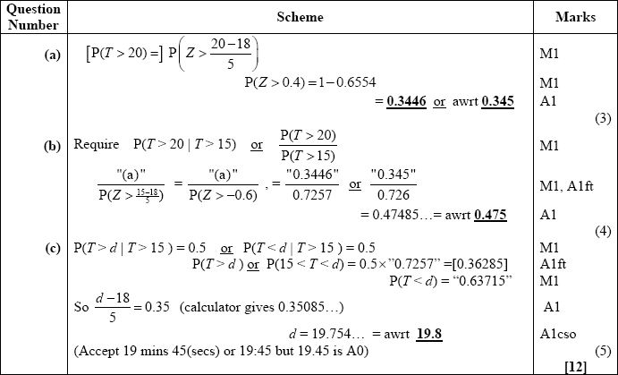
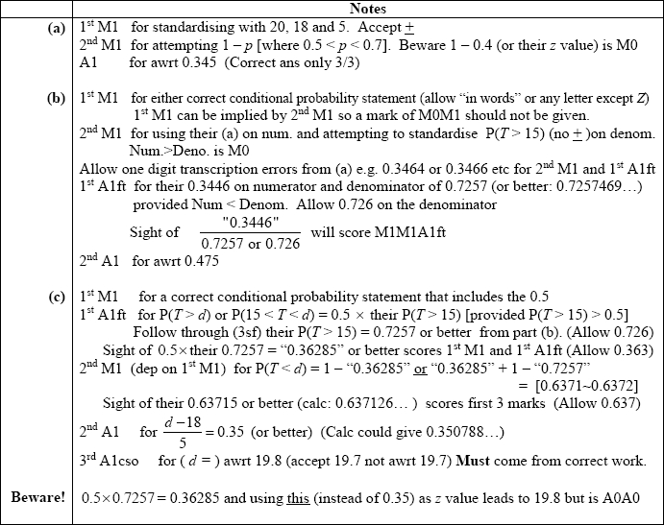

Q15.
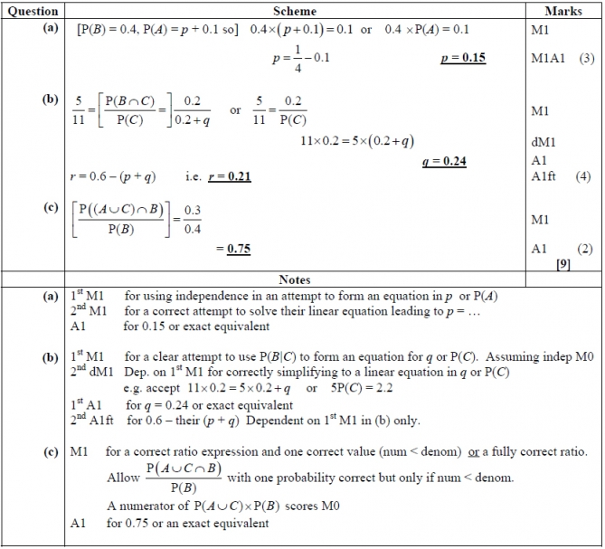

Q16.
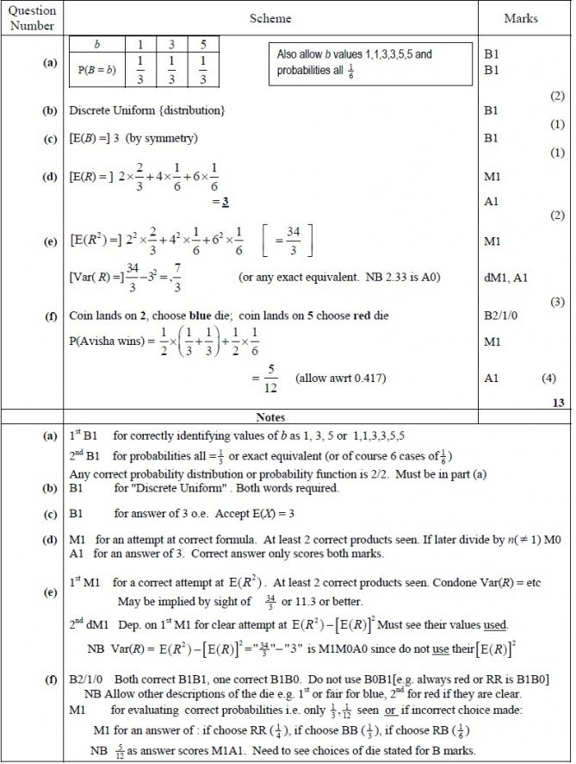

Q17.
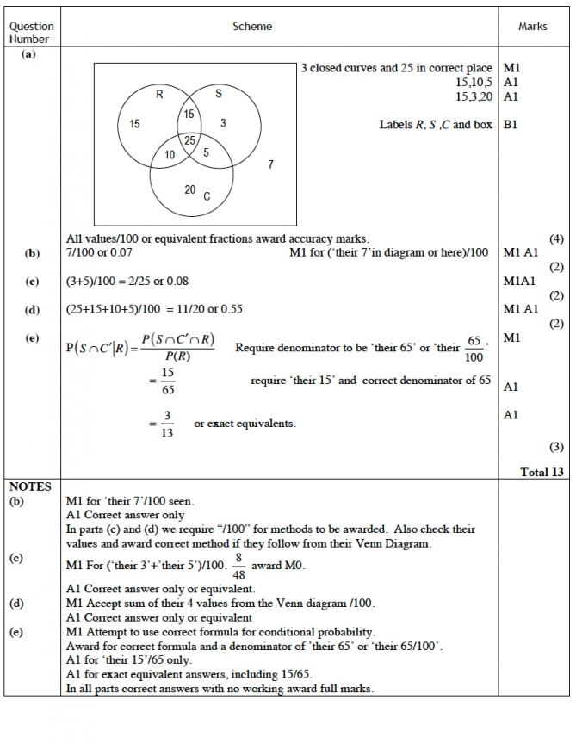

Q18.
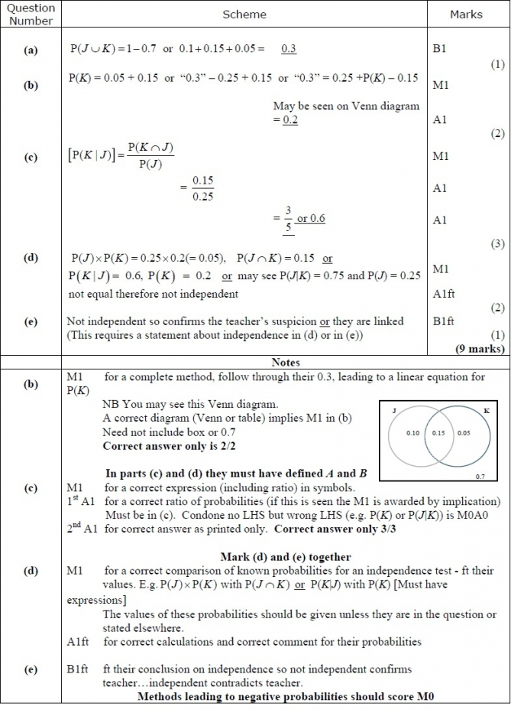

Q19.
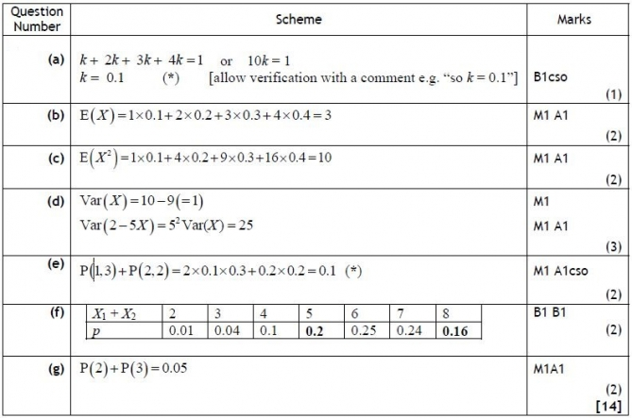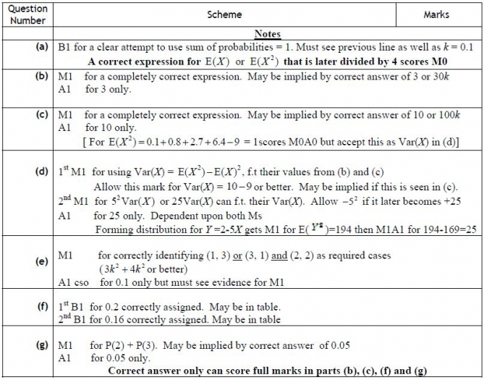
Q20.
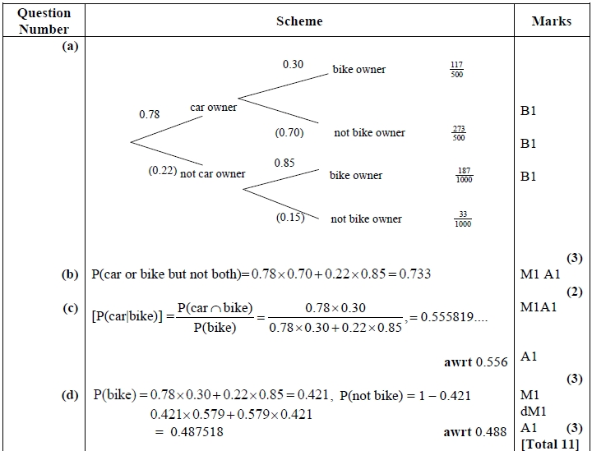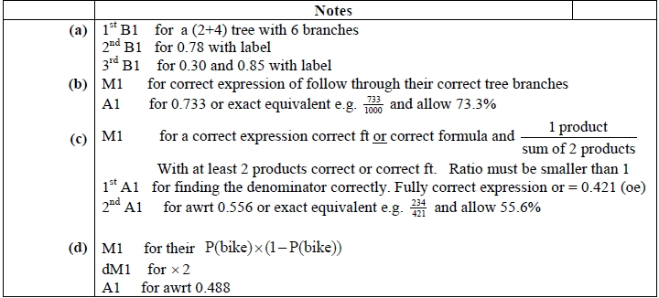

Q21.
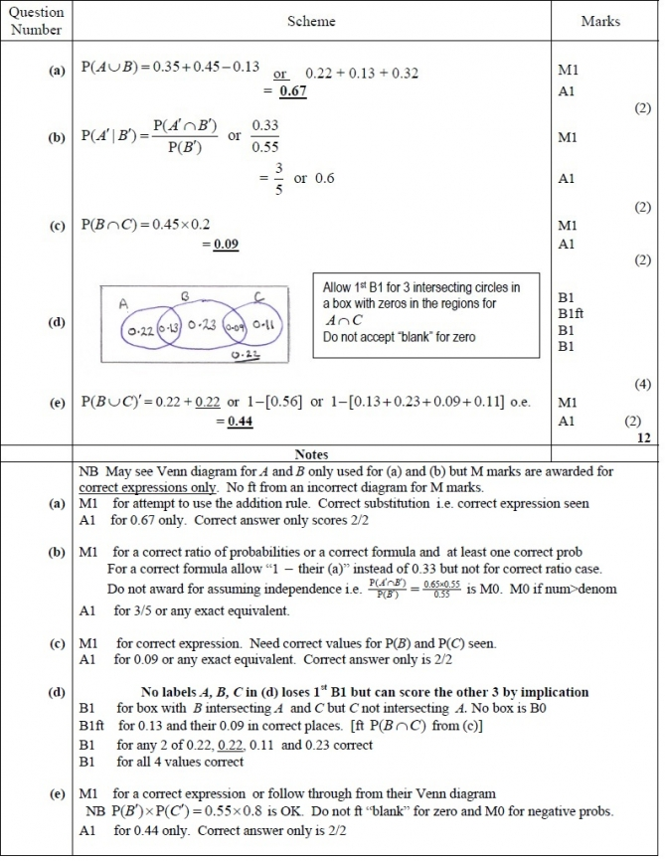

Q22.
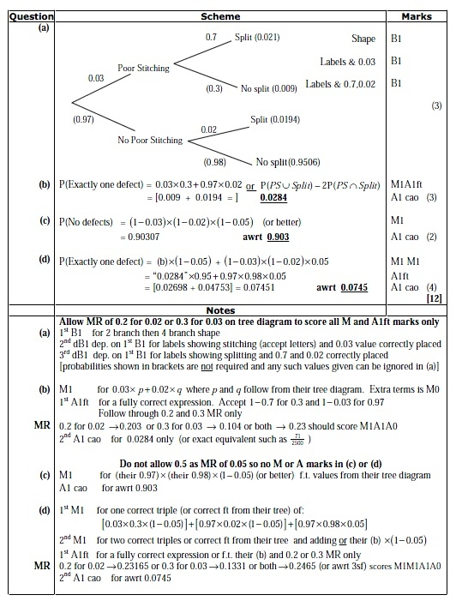

Q23.
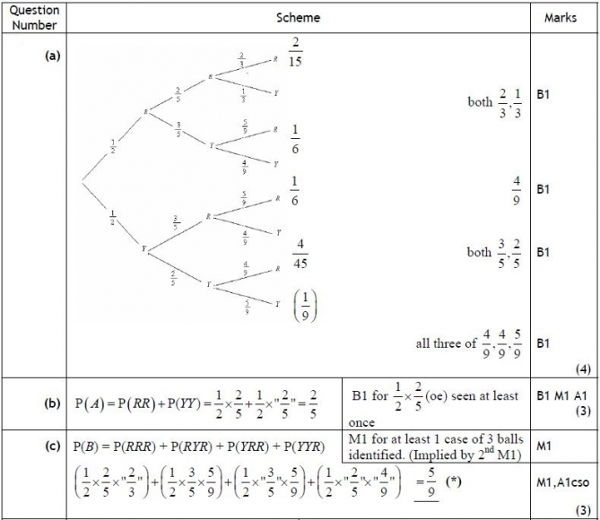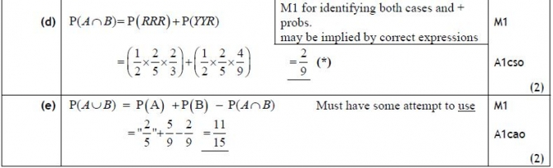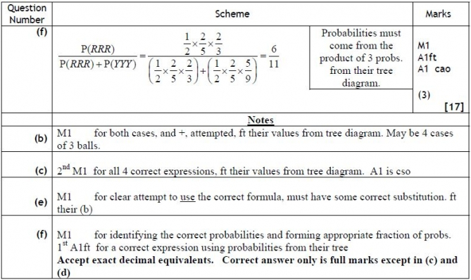

Q24.
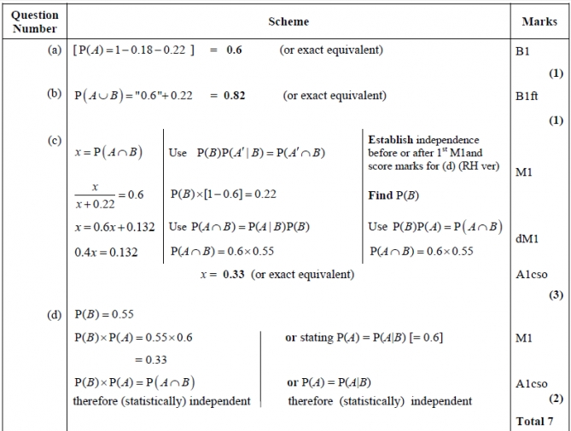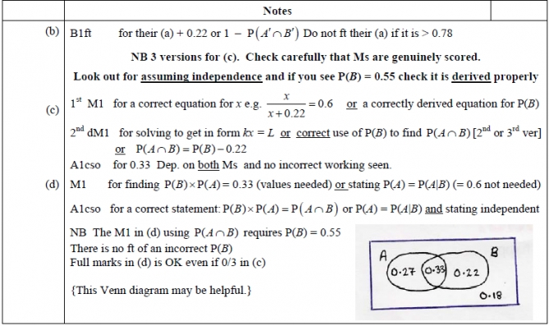

Q25.
