Name: _______________________________________________
GCE Stats section 1
Numerical measures, graphs and diagrams
practice questions from GCE Maths
Date:
Question parts in red cover content in the GCE Statistics specification but outside this section of the scheme of work
Time:
Total marks available:
Total marks achieved: ______

Questions
Q1.
Each of 60 students was asked to draw a 20° angle without using a protractor. The size of
each angle drawn was measured. The results are summarised in the box plot below.
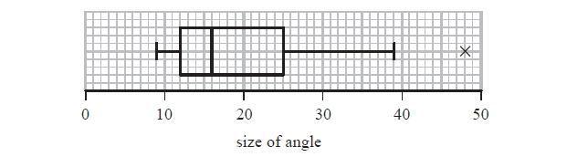
(a) Find the range for these data.
(1)
(b) Find the interquartile range for these data.
(1)
The students were then asked to draw a 70° angle.
The results are summarised in the table below.
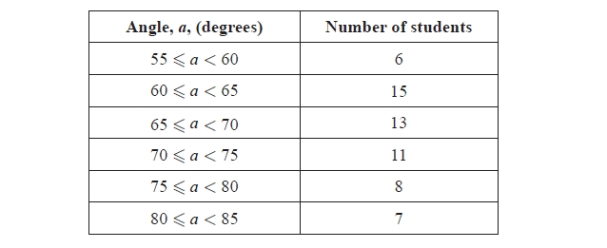
(c) Use linear interpolation to estimate the size of the median angle drawn. Give your
answer to 1 decimal place.
(2)
(d) Show that the lower quartile is 63°
(2)
For these data, the upper quartile is 75°, the minimum is 55° and the maximum is 84°
An outlier is an observation that falls either
more than 1.5 × (interquartile range) above the upper quartile or
more than 1.5 × (interquartile range) below the lower quartile.
(e) (i) Show that there are no outliers for these data.
(ii) Draw a box plot for these data on the grid on page 3.
(5)
(f) State which angle the students were more accurate at drawing. Give reasons for
your answer.
(3)
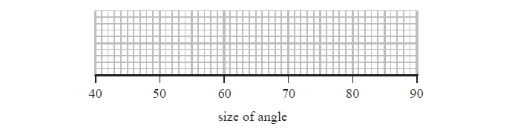
(Total for question = 14 marks)

Q2.
A random sample of 35 homeowners was taken from each of the villages Greenslax and Penville and their ages were recorded. The results are summarised in the back-to-back stem and leaf diagram below.
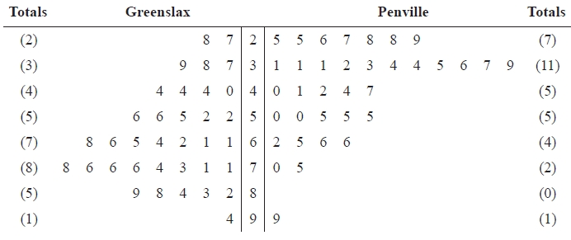
Key: 7 | 3 | 1 means 37 years for Greenslax and 31 years for Penville
Some of the quartiles for these two distributions are given in the table below.
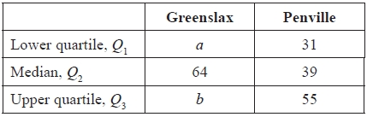
(a) Find the value of a and the value of b.
(2)
An outlier is a value that falls either
more than 1.5 × (Q₃ − Q₁) above Q₃
or more than 1.5 × (Q₃ − Q₁) below Q₁
(b) On the graph paper opposite draw a box plot to represent the data from Penville.
Show clearly any outliers.
(4)
(c) State the skewness of each distribution. Justify your answers.
(3)
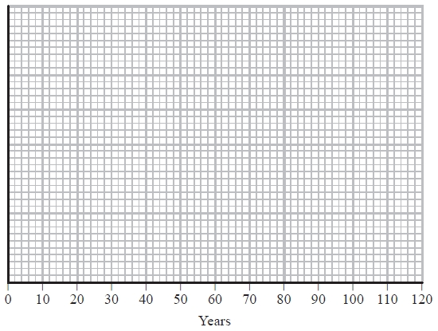

(Total 9 marks)

Q3.
The histogram in Figure 1 shows the time, to the nearest minute, that a random sample of 100 motorists were delayed by roadworks on a stretch of motorway.
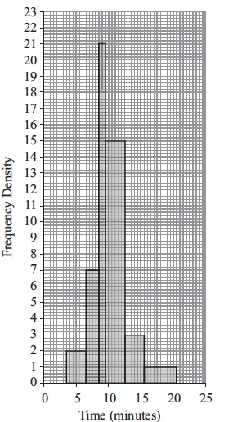
Figure 1
(a) Complete the table.
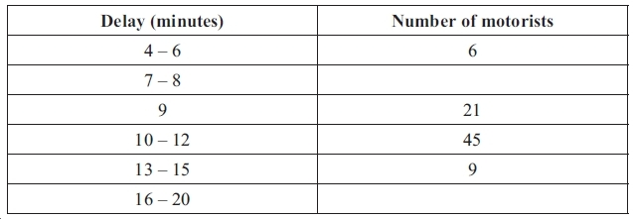
(2)
(b) Estimate the number of motorists who were delayed between 8.5 and 13.5 minutes by the roadworks.
(2)
(Total 4 marks)
Q4.
An estate agent is studying the cost of office space in London. He takes a random sample of 90 offices and calculates the cost, £x per square foot. His results are given in the table below.
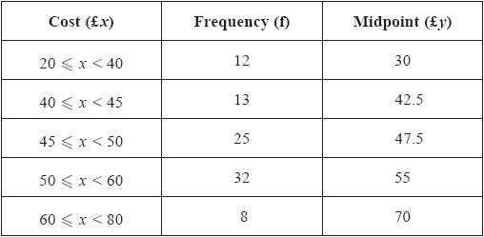
A histogram is drawn for these data and the bar representing 50 ⩽ x < 60 is 2cm wide and 8cm high.
(a) Calculate the width and height of the bar representing 20 ⩽ x < 40
(3)
(b) Use linear interpolation to estimate the median cost.
(2)
(c) Estimate the mean cost of office space for these data.
(2)
(d) Estimate the standard deviation for these data.
(2)
(e) Describe, giving a reason, the skewness.
(1)
Rika suggests that the cost of office space in London can be modelled by a normal distribution
with mean £50 and standard deviation £10
(f) With reference to your answer to part (e), comment on Rika's suggestion.
(1)
(g) Use Rika's model to estimate the 80th percentile of the cost of office space in London.
(3)
(Total for question = 14 marks)

Q5.
The marks of a group of female students in a statistics test are summarised in Figure 1
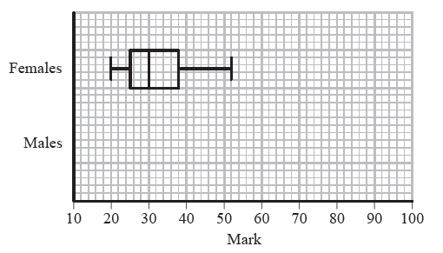
Figure 1
(a) Write down the mark which is exceeded by 75% of the female students.
(1)
The marks of a group of male students in the same statistics test are summarised by the stem and leaf diagram below.
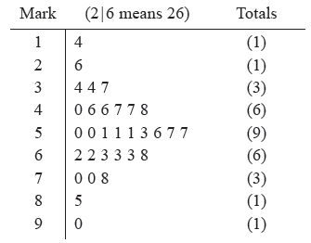
(b) Find the median and interquartile range of the marks of the male students.
(3)
An outlier is a mark that is
either more than 1.5 × interquartile range above the upper quartile
or more than 1.5 × interquartile range below the lower quartile.
(c) In the space provided on Figure 1 draw a box plot to represent the marks of the male students, indicating clearly any outliers.
(5)
(d) Compare and contrast the marks of the male and the female students.
(2)
(Total 11 marks)
Q6.
Keith records the amount of rainfall, in mm, at his school, each day for a week.
The results are given below.
Jenny then records the amount of rainfall, x mm, at the school each day for the following 21 days.
The results for the 21 days are summarised below.
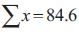
(a) Calculate the mean amount of rainfall during the whole 28 days.
(2)
Keith realises that he has transposed two of his figures. The number 9.4 should have been 4.9 and
the number 0.5 should have been 5.0
Keith corrects these figures.
(b) State, giving your reason, the effect this will have on the mean.
(2)
(Total 4 marks)

Q7.
Before going on holiday to Seapron, Tania records the weekly rainfall (x mm) at Seapron for 8 weeks during the summer. Her results are summarised as
(a) Find the standard deviation, σ_{x}, for these data.
(3)
Tania also records the number of hours of sunshine (y hours) per week at Seapron for these 8 weeks and obtains the following
(b) Show that S_{yy} = 716 (correct to 3 significant figures)
(1)
(c) Find S_{xy}
(2)
(d) Calculate the product moment correlation coefficient, r, for these data.
(2)
During Tania's week-long holiday at Seapron there are 14 mm of rain and 70 hours of sunshine.
(e) State, giving a reason, what the effect of adding this information to the above data would be on the value of the product moment correlation coefficient.
(2)
(Total for question = 10 marks)
Q8.
An agriculturalist is studying the yields, y kg, from tomato plants. The data from a random sample of
70 tomato plants are summarised below.
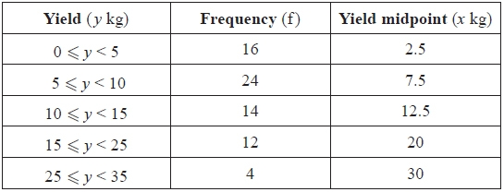
A histogram has been drawn to represent these data.
The bar representing the yield 5 ⩽ y < 10 has a width of 1.5 cm and a height of 8 cm.
(a) Calculate the width and the height of the bar representing the yield 15 ⩽ y < 25
(3)
(b) Use linear interpolation to estimate the median yield of the tomato plants.
(2)
(c) Estimate the mean and the standard deviation of the yields of the tomato plants.
(4)
(d) Describe, giving a reason, the skewness of the data.
(2)
(e) Estimate the number of tomato plants in the sample that have a yield of more than 1 standard deviation above the mean.
(2)
(Total 13 marks)

Q9.
Over a long period of time a small company recorded the amount it received in sales per month.
The results are summarised below.
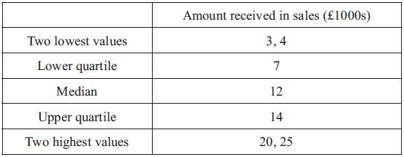
An outlier is an observation that falls
either 1.5 × interquartile range above the upper quartile
or 1.5 × interquartile range below the lower quartile.
(a) On the graph paper below, draw a box plot to represent these data, indicating clearly any outliers.
(5)
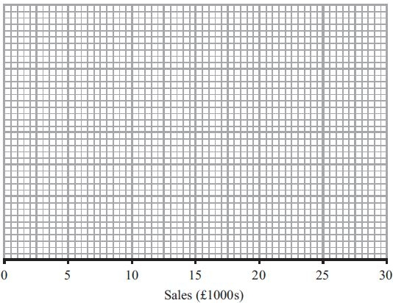
(b) State the skewness of the distribution of the amount of sales received. Justify your answer.
(2)
(c) The company claims that for 75% of the months, the amount received per month is greater
than £10 000. Comment on this claim, giving a reason for your answer.
(2)
(Total 9 marks)
Q10.
The following table summarises the times, t minutes to the nearest minute, recorded for a group of students to complete an exam.
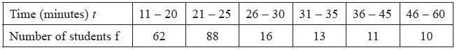
[You may use = 134281.25]
(a) Estimate the mean and standard deviation of these data.
(5)
(b) Use linear interpolation to estimate the value of the median.
(2)
(c) Show that the estimated value of the lower quartile is 18.6 to 3 significant figures.
(1)
(d) Estimate the interquartile range of this distribution.
(2)
(e) Give a reason why the mean and standard deviation are not the most appropriate summary statistics to use with these data.
(1)
The person timing the exam made an error and each student actually took 5 minutes less than the times recorded above. The table below summarises the actual times.
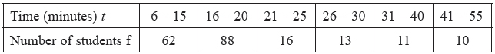
(f) Without further calculations, explain the effect this would have on each of the estimates found in
parts (a), (b), (c) and (d).
(3)
(Total 14 marks)

Q11.
The marks, x, of 45 students randomly selected from those students who sat a mathematics examination are shown in the stem and leaf diagram below.
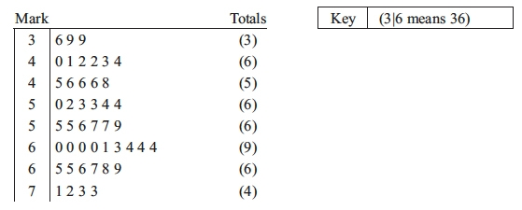
(a) Write down the modal mark of these students.
(1)
(b) Find the values of the lower quartile, the median and the upper quartile.
(3)
For these students = 2497 and = 143 369
(c) Find the mean and the standard deviation of the marks of these students.
(3)
(d) Describe the skewness of the marks of these students, giving a reason for your answer.
(2)
The mean and standard deviation of the marks of all the students who sat the examination were 55
and 10 respectively. The examiners decided that the total mark of each student should be scaled by subtracting 5 marks and then reducing the mark by a further 10%.
(e) Find the mean and standard deviation of the scaled marks of all the students.
(4)
(Total 13 marks)

Q12.
A midwife records the weights, in kg, of a sample of 50 babies born at a hospital. Her results are given in the table below.
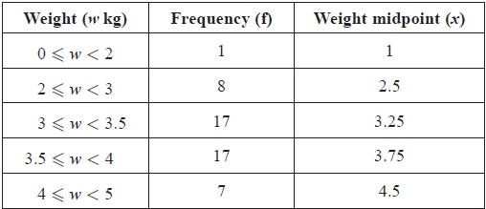
[You may use = 611.375]
A histogram has been drawn to represent these data.
The bar representing the weight 2 ⩽ w < 3 has a width of 1 cm and a height of 4 cm.
(a) Calculate the width and height of the bar representing a weight of 3 ⩽ w < 3.5
(3)
(b) Use linear interpolation to estimate the median weight of these babies.
(2)
(c) (i) Show that an estimate of the mean weight of these babies is 3.43 kg.
(ii) Find an estimate of the standard deviation of the weights of these babies.
(3)
Shyam decides to model the weights of babies born at the hospital, by the random variable W,
where W ~ N(3.43, 0.65²)
(d) Find P(W < 3)
(3)
(e) With reference to your answers to (b), (c)(i) and (d) comment on Shyam's decision.
(3)
A newborn baby weighing 3.43 kg is born at the hospital.
(f) Without carrying out any further calculations, state, giving a reason, what effect the addition of this newborn baby to the sample would have on your estimate of the
(i) mean,
(ii) standard deviation.
(3)
(Total for question = 17 marks)

Q13.
The table shows the time, to the nearest minute, spent waiting for a taxi by each of 80 people one
Sunday afternoon.
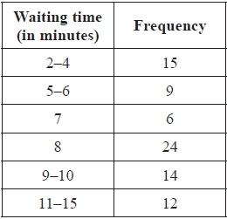
(a) Write down the upper class boundary for the 2–4 minute interval.
(1)
A histogram is drawn to represent these data. The height of the tallest bar is 6 cm.
(b) Calculate the height of the second tallest bar.
(3)
(c) Estimate the number of people with a waiting time between 3.5 minutes and 7 minutes.
(2)
(d) Use linear interpolation to estimate the median, the lower quartile and the upper quartile of the
waiting times.
(4)
(e) Describe the skewness of these data, giving a reason for your answer.
(2)
(Total 12 marks)

Q14.
A survey of 100 households gave the following results for weekly income £y.
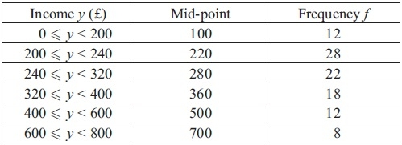
(You may use = 12 452 800)
A histogram was drawn and the class 200 ⩽ y < 240 was represented by a rectangle of width 2 cm
and height 7 cm.
(a) Calculate the width and the height of the rectangle representing the class 320 ⩽ y < 400
(3)
(b) Use linear interpolation to estimate the median weekly income to the nearest pound.
(2)
(c) Estimate the mean and the standard deviation of the weekly income for these data.
(4)
One measure of skewness is .
(d) Use this measure to calculate the skewness for these data and describe its value.
(2)
Katie suggests using the random variable X which has a normal distribution with mean 320 and
standard deviation 150 to model the weekly income for these data.
(e) Find P(240 < X < 400).
(2)
(f) With reference to your calculations in parts (d) and (e) and the data in the table, comment on Katie's suggestion.
(2)
(Total 15 marks)

Q15.
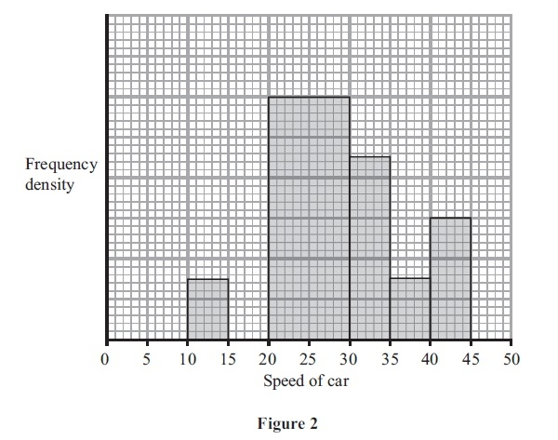
A policeman records the speed of the traffic on a busy road with a 30 mph speed limit. He records the speeds of a sample of 450 cars. The histogram in Figure 2 represents the results.
(a) Calculate the number of cars that were exceeding the speed limit by at least 5 mph in the sample.
(4)
(b) Estimate the value of the mean speed of the cars in the sample.
(3)
(c) Estimate, to 1 decimal place, the value of the median speed of the cars in the sample.
(2)
(d) Comment on the shape of the distribution. Give a reason for your answer.
(2)
(e) State, with a reason, whether the estimate of the mean or the median is a better representation
of the average speed of the traffic on the road.
(2)
(Total 13 marks)

Q16.
A class of students had a sudoku competition. The time taken for each student to complete the sudoku was recorded to the nearest minute and the results are summarised in the table below.
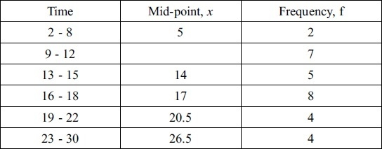
(You may use = 8603.75)
(a) Write down the mid-point for the 9 - 12 interval.
(1)
(b) Use linear interpolation to estimate the median time taken by the students.
(2)
(c) Estimate the mean and standard deviation of the times taken by the students.
(5)
The teacher suggested that a normal distribution could be used to model the times taken by the students to complete the sudoku.
(d) Give a reason to support the use of a normal distribution in this case.
(1)
On another occasion the teacher calculated the quartiles for the times taken by the students to complete
a different sudoku and found
Q₁ = 8.5 Q₂ =13.0 Q₃ = 21.0
(e) Describe, giving a reason, the skewness of the times on this occasion.
(2)
(Total 11 marks)

Q17.
On a randomly chosen day, each of the 32 students in a class recorded the time, t minutes to the nearest minute, they spent on their homework. The data for the class is summarised in the following table.
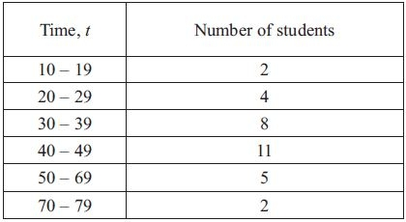
(a) Use interpolation to estimate the value of the median.
(2)
Given that
(b) find the mean and the standard deviation of the times spent by the students on their homework.
(3)
(c) Comment on the skewness of the distribution of the times spent by the students on their homework. Give a reason for your answer.
(2)
(Total 7 marks)

Q18.
A teacher selects a random sample of 56 students and records, to the nearest hour, the time spent watching television in a particular week.
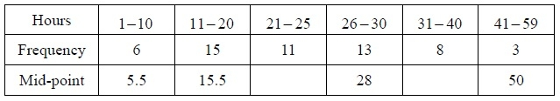
(a) Find the mid-points of the 21-25 hour and 31-40 hour groups.
(2)
A histogram was drawn to represent these data. The 11-20 group was represented by a bar of width 4 cm and height 6 cm.
(b) Find the width and height of the 26-30 group.
(3)
(c) Estimate the mean and standard deviation of the time spent watching television by these students.
(5)
(d) Use linear interpolation to estimate the median length of time spent watching television by
these students.
(2)
The teacher estimated the lower quartile and the upper quartile of the time spent watching television
to be 15.8 and 29.3 respectively.
(e) State, giving a reason, the skewness of these data.
(2)
(Total 14 marks)

Q19.
The times, in seconds, spent in a queue at a supermarket by 85 randomly selected customers,
are summarised in the table below.
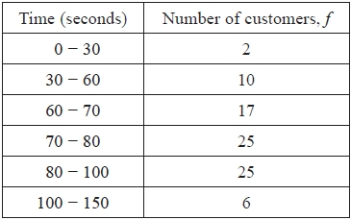
A histogram was drawn to represent these data. The 30 – 60 group was represented by a bar of
width 1.5 cm and height 1 cm.
(a) Find the width and the height of the 70 – 80 group.
(3)
(b) Use linear interpolation to estimate the median of this distribution.
(2)
Given that x denotes the midpoint of each group in the table and
= 6460 = 529 400
(c) calculate an estimate for
(i) the mean,
(ii) the standard deviation,
for the above data.
(3)
One measure of skewness is given by
coefficient of skewness =
(d) Evaluate this coefficient and comment on the skewness of these data.
(3)
(Total 11 marks)

Q20.
The distances travelled to work, D km, by the employees at a large company are normally distributed
with D N(30, 8² ).
(a) Find the probability that a randomly selected employee has a journey to work of more than 20 km.
(3)
(b) Find the upper quartile, Q₃, of D.
(3)
(c) Write down the lower quartile, Q₁ , of D.
(1)
An outlier is defined as any value of D such that D < h or D > k where
h = Q₁ − 1.5 × (Q₃ − Q₁) and k = Q₃ + 1.5 × (Q₃ − Q₁)
(d) Find the value of h and the value of k.
(2)
An employee is selected at random.
(e) Find the probability that the distance travelled to work by this employee is an outlier.
(3)
(Total 12 marks)

Q21.
A student is investigating the numbers of cherries in a Rays fruit cake. A random sample of Rays fruit cakes is taken and the results are shown in the table below.
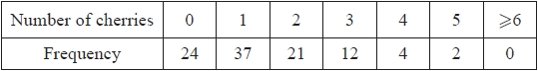
(a) Calculate the mean and the variance of these data.
(3)
(b) Explain why the results in part (a) suggest that a Poisson distribution may be a suitable model for the number of cherries in a Rays fruit cake.
(1)
The number of cherries in a Rays fruit cake follows a Poisson distribution with mean 1.5
A Rays fruit cake is to be selected at random.
Find the probability that it contains
(c) (i) exactly 2 cherries,
(ii) at least 1 cherry.
(4)
Rays fruit cakes are sold in packets of 5
(d) Show that the probability that there are more than 10 cherries, in total, in a randomly selected packet of Rays fruit cakes, is 0.1378 correct to 4 decimal places.
(3)
Twelve packets of Rays fruit cakes are selected at random.
(e) Find the probability that exactly 3 packets contain more than 10 cherries.
(3)
(Total for question = 14 marks)

Q22.
Paul takes the company bus to work. According to the bus timetable he should arrive at work at 08 31. Paul believes the bus is not reliable and often arrives late. Paul decides to test the arrival time of the bus and carries out a survey. He records the values of the random variable
X = number of minutes after 08 31 when the bus arrives.
His results are summarised below.
(a) Calculate unbiased estimates of the mean, μ, and the variance of X.
(3)
Using the mean of Paul's sample and given X ~ N(μ, 10²)
(b) (i) calculate a 95% confidence interval for the mean arrival time at work for this company bus.
(ii) State an assumption you made about the values in the sample obtained by Paul.
(5)
(c) Comment on Paul's belief. Justify your answer.
(2)
(Total for question = 10 marks)

Examiner's Report
Q1.
In part (a) a large number of students ignored the outlier and gave an answer of 30 instead of 39. Others failed to score the mark because they left their answer as 48 − 9 or they gave two answers: one with and one without the outlier. Part (b) on the other hand was answered very well with most students scoring the mark. Part (c) caused problems for some students who did not use a correct lower class boundary with 64.5 being a common error. Some of these students managed to correct this error in part (d) and most were successful here. The given answer tempted some to take the midpoint of the 60-65 interval and round up to get 63. We allow students to use (n + 1) instead of n when calculating the cumulative frequency to use in the interpolation. Most used 9.5 correctly in part (c) but in part (d) few choosing this approach used the correct value of 15.25. In part (e)(i) many students were able to find the correct limits of 93 and 45 and make a suitable comment about the outliers. A sizeable minority though used the interquartile range from part (b) instead of the correct value of 12 and lost these marks. The box and whisker plots were usually correct with only a few making careless errors such as plotting the top whisker at 85 instead of 84. The final part proved to be a good discriminator with many revealing a lack of understanding about how to interpret the statistics they had calculated. Most achieved two of the 3 marks for choosing the 70° angle and giving a suitable reason based on the closeness of the median to this value or the smaller range or inter quartile range but few gave both reasons. Some surmised that a value in the range 60-65 would be more accurate based on this being the modal class, others referred to the absence of outliers or tried to use symmetry to justify their choice.

Q2.
Most students had a thorough understanding of box-plots and skewness and there were many fully correct answers. In question (a) the correct values were usually given but a = 40 and b = 73 were common incorrect answers where students failed to read the "leaves" from right to left .
In question (b) most students calculated the upper limit of 91 for outliers correctly and there were few errors in reading the scale and plotting 25, Q₁, Q₂ and Q₃ correctly. The upper whisker did cause some problems. An upper whisker stopping at 91 (the upper limit for outliers) or stopping at 75 (the next non-outlier in the data set) and then an outlier clearly shown by a cross or ∗ at 99 was all that was required. Common errors were to draw both whiskers or to plot the outlier at 91 or simply to extend the whisker to 99 and indicate the outlier there too.
In question (c) most comments about the skewness of Penville were correct but some did not realise that they needed to comment on Greenslax too. The reasons were usually based on a comparison of the differences in the quartiles and were often correct although a number still think that Q₃ − Q₂ > Q₂ − Q₁ means negative skewness. Some students elected to calculate the means to compare with the medians, which was accepted if the means were correct, but others tried an argument based on the mode failing to realise that the distributions were bimodal and therefore this approach was invalid.

Q3.
Part (a) was generally well answered, with most candidates getting the correct values. Only a few stated 7 and 1 (frequency density) and a few quoted other figures. A simple check that the total number of motorists should add to 100 would have told candidates if their calculations were incorrect. Some could not cope with the different interval widths and/or intervals starting and ending in ".5". This was more evident in part (b) where many struggled. The most common error was simply adding 21 and 45 not realising that 13.5 took them into the next group. A large number of candidates did realise that they needed to add three different frequencies together, although some found it difficult to get the correct fraction of the third class. Some ignored the third class or used its whole frequency.

Q4.
Most could find the correct width in part (a) but the height calculation is still causing problems. The common error was to compare frequencies rather than frequency densities and an incorrect answer of 3 was fairly common. Part (b) was answered well by the majority of students with very few cases of students using (n + 1) and most choosing to work upwards from 45 rather than down from 50. The interpolation technique is understood but there were still a number of errors made in determining the appropriate class boundaries with 44.5 being used instead of 45 quite often.
As expected, part (c) was answered very well by the majority of students but there were still some who simply added the 5 midpoints and divided by 5 which is disappointing for students at this level. Many students didn't seem to be familiar with the convention that answers involving money should be given to
2 decimal places and some lost a mark for simply writing down £49.1 without any correct working being seen. There were many fully correct answers to part (d) as well, but some forgot to use the square root and a number lost accuracy by using 49.1 or the mean rather than the full expression.
In part (e), all that was required was a simple comparison of Q₂ with but a number used a formula for skewness and that was, of course fine. The expected conclusion was that there was very little skewness since Q₂ ≈ but many concluded that since > Q₂ there was positive skew and this was allowed. The idea of using a normal distribution to model these data being an acceptable approach because there was only a little skewness was not appreciated by many students who simply trotted out a standard response that a normal was not a suitable model because the data was skew. Students should be encouraged to consider the magnitude of the skewness and realise that, with such a small amount of skew, to model the situation with a normal distribution may be a reasonable thing to do. Some students completely missed the need to reference part (e) in their answer to part (f) and simply compared their mean and standard deviation to Rika's values of £50 and £10. The final part (g) defeated many students despite being a fairly standard normal distribution question, presumably because it was not part of the question on the normal distribution. The three common errors were: standardising with their mean and standard deviation rather than the given values of 50 and 10, equating 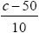 to a probability rather than a z-value or using 0.84 rather than 0.8416 from the percentage points tables.

Q5.
There were many incorrect answers of 38 given to part (a) where candidates, presumably, thought the question wanted the value that 75% of candidates exceeded rather than the value exceeded by 75% of the candidates. They should be encouraged to read the question carefully.
Part (b) was answered very well and where they showed some calculations to determine the outliers they usually scored well on part (c) too. A surprisingly large number though failed to show any working for the outliers and their diagram showed no evidence of them either. There was still some uncertainty about where to end the whiskers (either at the outlier limits or at the next non-outlier value are acceptable) and there was some evidence that candidates had been using previous mark schemes as "model solutions" and were drawing both sets of whiskers which is, of course, incorrect. There were many good answers to part (d) but some candidates failed to secure marks as they did not use the appropriate terms. The use of "mean" or "average" or "spread" are not sufficiently clear: we require use of the correct terms such as "median", "range" or "Inter Quartile Range".

Q6.
Again the majority of the candidates encountered few problems here and many scored 3 or 4 marks, although a number in part (a) found both means and then simply added them and divided by 2 rather than taking the weighted average. Most chose to find the sum of all 28 records and then simply divided this by 28. A few candidates misinterpreted the 84.6 as the mean for the 21 days despite what should have been an obvious discrepancy with Keith's data.
In part (b) many realised that the changes would have no effect on the mean but sometimes they failed to give any numerical values to support this claim. There were many excellent answers though showing clearly that 9.4 + 0.5 = 4.9 + 5.0 or some other suitable calculation.

Q7.
There seemed to be a slightly improved understanding of the calculation of standard deviation this summer and many correct responses to part (a) were seen. The usual errors still occurred though: forgetting the square root, or failing to divide the 985.88 by 8 or simply confusing S_{xx} with the variance.
The responses to part (b) confirmed that few students are aware of the simple relationship between S_{yy} and standard deviation as many attempted to find ∑ y² by "unpacking" the value for δ_{y} with varying degrees of success. The calculation for S_{xy} in part (c) was carried out successfully by most students and many completed part (d) correctly too, usually by first finding Sxx rather than using their answer to
part (a).
Responses to part (e) were very mixed. Some simply quoted a statement about coding not affecting correlation and therefore expected no change. Others realised that the new point was breaking the trend (both values above their means conflicting with the negative correlation) but were not precise enough about the effect on the value of the correlation coefficient. The examiners were looking for a statement about the value that told us that the correlation was weaker, i.e. that the value was closer to zero:
r "increases" or r is "less negative" were not deemed to be satisfactory.

Q8.
In part (a) some candidates could not calculate the widths of the intervals and therefore lost all the marks. In part (b) the technique of linear interpolation is understood well but a number of candidates could not find the correct end-points. Candidates should look carefully at tables of grouped data and determine carefully the end points and widths of the intervals.
Parts (c) and (d) were answered well without quite so many false attempts at standard deviation as is often the case on S1. Part (e) was not answered so well as many candidates didn't appreciate the need to interpolate. Those who did usually arrived at the correct answer quite efficiently.

Q9.
There were many fully correct box plots in part (a) that gained full marks but also a number of almost correct plots with no supporting working that scored very few marks. Those who did show their calculations for determining the outliers usually got the 24.5 value correct but a large number had 3.5 rather than − 3.5 as their lower limit. Some candidates drew two upper whiskers one ending at 20 (the next highest non-outlier data point) and one ending at 24.5 (the outlier limit). A correct answer should only have one whisker and it appears that some candidates had been copying the practice on the mark scheme of illustrating both alternatives for the benefit of the examiners. It should be remembered that the published mark schemes are not model solutions and they should not be offered to candidates as such.
In part (b) most candidates stated that Q₂ − Q₁ > Q₃ − Q₂ or something equivalent though some then claimed that the skewness was positive but this was usually answered well.
Part (c) caught many candidates out with a large number agreeing with the company's claim because
Q₃ = £14 000 which is greater than £10 000. Those who did appreciate that the lower quartile was the significant figure to be considering often gave excellent answers but the success rate here was lower than expected.

Q10.
A small number of candidates still failed to calculate the mean correctly in part (a). For some this was due to errors with the midpoints but the more extreme errors involved dividing by 6 rather than 200 or using the class widths rather than the mid-points. The standard deviation formula still causes problems for some: forgetting the square root and failing to divide ∑ft 2 by 200 were common errors and some candidates used their rounded value of the mean and lost the final accuracy mark as their answer was not accurate to 3 significant figures. The calculation of the median in part (b) was answered well but applying the same principles to part (c) caused difficulties for some with many of those attempting the (n + 1) approach using 50.5 instead of 50.25 and others using incorrect end points. In part (d) a few spotted that Q₃ was on the class boundary and gave the value of 25.5 but others encountered similar problems to those with Q₁ but most were able to find their interquartile range. Part (e) was not answered well with many mentioning "continuous data" or "extreme values" and only a few stating that their data was skewed. Most candidates scored some marks in part (f) but many failed to secure all the marks because they did not deal with all of the estimates; in particular the standard deviation was often omitted.

Q11.
The first three parts were generally completed with confidence and fluency. Only a few candidates found incorrect values for the median (as they did and then looked for the 22.5th value) or the quartiles. The standard deviation was particularly well answered, but the usual errors of not dividing sum of x² by 45 or forgetting the square root were the most common.
In part (d) most candidates knew a rule to apply but a few got muddled with what exactly it was, using
Q₃ − Q₁ or Q₁ − Q₂ or incorrectly for example. Having managed to apply the rule, some then got muddled in their reasoning, stating it showed positive skew or put the inequality signs the wrong way around which led to an incorrect conclusion. Those who simply used mean < median tended to fare better.
Part (e) was poorly answered, with some candidates not even attempting an answer. Perhaps they did not realise that this question considered a 'new' data set meaning it had little to do with previous work, with many performing calculations on the sample of 45 rather than considering the population. There were many scripts containing long and elaborate wrong calculations. The scaled mean was done better than the scaled standard deviation. On finding the new mean many candidates correctly subtracted 5 but multiplied their answer by 0.1 and did not subtract. A large number of those who attempted decoding applied the same rule to both the mean and standard deviation or stated incorrectly that the standard deviation was not affected by coding. Only a few candidates had intrinsic understanding that a measure of spread was only affected by the 'multiplier'. Those candidates who knew what to do produced short, efficient solutions.

Q12.
The comment requirements in parts (e) and (f) made the latter stages of this question quite demanding but many were able to pick up marks in parts (b), (c) and (d). In part (a) most identified the width as
0.5 cm but, as usual, the height caused some difficulties. A number of students still seem to think that the height represents the frequency and some managed to make the statement that 4 cm² represents
8 babies but were still unable to use this to find the correct height.
The linear interpolation in part (b) was usually carried out very well but a few used the midpoints or made errors with class boundaries or used incorrect cumulative frequencies such as 10 or 27 instead of 9
and 26.
In part (c)(i), some students did not show how to use the midpoints to find ∑ fx, simply using the value of 171.5; a "show that" question always requires a full explanation of the method used. More students now seem to know a suitable formula for standard deviation but some are still a little uncertain about whether or not a square root is required and some wasted time by calculating ∑ fx² (not always successfully) rather than using the value given in the question.
Part (d) was a simple normal distribution probability calculation and the success rate amongst students with this standard application has improved considerably. A small minority are still uncertain about whether or not to subtract the value from the tables from 1 but there were many fully correct responses to this part
In part (e), a number made a correct observation about the mean and median and possible skewness and could relate this to the suitability of using the normal distribution. Far fewer, though, were able to compare their answer to part (d) with the equivalent proportion from the table and so missed out on the other two marks. In part (f), most stated that the mean would not change and often gave a correct reason for this but fewer knew that the standard deviation would decrease and fewer still were able to give a convincing reason to support this.

Q13.
Most students secured the mark in question (a) although a few gave the boundaries for the whole interval. Question (b) was seen to be challenging. Many students were not confident with the calculations for the height of bars on a histogram and in this case some could not deduce which bar was the second tallest. In question (c) some found the correct fraction of the upper or lower group but often they failed to do this for both groups. Most knew the correct technique to tackle question (d) but errors often occurred with the lower class boundaries or when rounding. Question (e) was answered well with most using their calculated quartiles to justify their answer although a few calculated the mean and compared this to the median.

Q14.
In (a) there is still some uncertainty about the concept of histograms. Most candidates could find the width of the required bar but a number still failed to consider frequency densities to find the height. Some attempts were on the right lines but used the interval [240, 320); others assumed height was linked to frequency alone and 4.5 cm was a common incorrect answer. There has been a clear improvement in the use of interpolation to calculate the median in recent sessions and many had × 80 (with only a small minority using 10.5 instead of 10). The common error was to use 239.5 rather than 240 as the class boundary but there were many fully correct answers seen.
The calculation of the mean in (c) was usually correct but the standard deviation still causes difficulties for some who failed to use a correct formula.(d) was straightforward although some failed to secure the second mark because they did not give a description (e.g. "positive") of their skewness.
In (e) the insertion of a normal calculation in this context seemed to fox some candidates but many were able to carry out this routine calculation correctly. However the interpretation in (f) was not answered so well. Some drew the connection between their answer to (e) and the proportion in the table and deduced that a normal distribution was reasonable (over this range). Slightly more focussed on the fact that in (d) they had stated that the distribution was skewed and therefore a normal distribution was probably not a suitable model (overall) but few were able to marry these statements up and secure both marks.

Q15.
This question was not answered very well. Many candidates either made a poor attempt at part (a) and then abandoned the question or just left it blank and moved on. Those who correctly formed a frequency table often scored well, whilst others who failed to complete part (a) struggled to make any headway with the remainder of the question.
In part (a) there needed to be some attempt to count squares and 22.5, 562.5 or 112.5 (small squares greater than or equal to 35 mph) were frequently seen. However many candidates did not appreciate the key idea that area is proportional to frequency and there was no attempt to combine this figure with the total frequency of 450. Those who did combine their figures and were able to come up with a correct relationship between area and number of cars (e.g. 1 large square represents 20 cars) were usually able to complete this part successfully although a few found the number of cars speeding above 30 mph instead of 35 mph as required. A few candidates stumbled upon 90 by dividing the 450 cars by the 5 bars of the histogram but this, of course, received no credit.
In part (b) most attempts tried to use mid-points but many struggled to find suitable frequencies and a few were unsure of the class widths (using 6 and 11). Some used the number of squares as frequencies but they rarely had a compatible denominator for their expression for the mean.
Most attempts at part (c) realised that interpolation was required but many promising solutions used 19.5 or 20.5 as class boundaries rather than 20.
Although they may not have had the correct values for the mean and median many had some values which they could use to answer part (d). A simple comparison of their values (e.g. mean greater than median) earned them the first mark and then an appropriate comment about the skewness (such as positive skew) the second. Some attempted to calculate the quartiles and invariably these were incorrect. Candidates should consider the amount of work involved in finding these values and compare it with the tariff for the question: 2 marks for a comment and a reason should not involve half a page of calculations. Other candidates tried to justify their comment from the shape of the histogram ignoring the calculations in (b) and (c).
In part (e) we required a choice of mean or median that was compatible with their conclusion in (d). Some candidates who had correctly concluded that the distribution was skewed in (d) still chose the mean, because it uses all the data, but there were many correct answers seen to this part.

Q16.
Part (a) was, unsurprisingly, answered very well and most candidates were able to use the mid-points to find the mean in part (c). The calculation of standard deviation is still causing problems though: an incorrect formula, premature rounding and forgetting the square root were the typical errors. The technique of interpolation required in part (b) is now better understood but incorrect class widths still caused problems here. A common response to part (d) was to simply state that the data was continuous rather than using the calculations they have just performed in parts (b) and (c).
Part (e) was usually answered well with most using Q₃ − Q₂ > Q₂ − Q₁ but a small minority gave the wrong conclusion despite giving the correct comparison.

Q17.
The use of interpolation, which was expected in part (a), is improving and many candidates made a reasonable attempt. Some failed to use correct class limits and had a width of 9 rather than 10 but the correct answer was often seen. Despite the values for Σt and Σt² being given in the question a number of candidates chose to estimate these values from the table and subsequently obtained an incorrect estimate for the mean but the mark scheme did permit them to obtain the remaining marks. The question did not ask for estimates of the mean and standard deviation and so using the mid-points was inappropriate in this question. The usual crop of errors arose when calculating the standard deviation with many failing to divide the 69378 by 32. Candidates can usually calculate S_{xx} correctly using the given formula and they may find it helpful to simply remember that standard deviation is simply 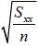 but few seem to use this approach.
In part (c) most compared the mean and median and correctly concluded that the skewness was positive. Some used a formula which, apart from the extra work, was fine but those who used a (median - mean) formula rarely gave the correct conclusion. Some candidates went to great lengths to calculate the quartiles and conducted a quartile test for skewness which, if correct, led to a conclusion of negative skewness. This was allowed but was clearly not the intended approach for 2 marks.

Q18.
Finding the midpoints of the given groups was predominantly carried out correctly with very few errors seen. In contrast, attempts at finding the width and height of the 26-30 group were extremely varied, with most candidates finding this particularly challenging, especially in finding the height. In the majority of cases, candidates obtained the wrong width and height, mostly with no clear strategy, although these did multiply together to make 20.8 in some cases. Calculation of the mean was carried out successfully on the whole, although there were some apparent misconceptions, with quite a few candidates merely summing the midpoints (without multiplying by the frequency) and dividing this by 56.
The standard deviation proved to be more problematic, with frequent mistakes in both the formula and in their calculations. Some candidates used the sum of the f²x's and others the sum of the (fx)² or the sum of the fx's all squared in their formula. Very few candidates calculated s. Most candidates were able to use the correct interpolation technique to obtain the median, although many lost the accuracy mark through their use of 21 as the lower class boundary (which was relatively common) and /or 4 as the class width. Quite a few candidates worked with 28.5. A few candidates tried to apply the correct formula to the wrong class interval, however. Some candidates appeared to have a limited understanding of the class boundaries and failed to recognise the continuous nature of the data.
The majority of candidates were able to carry out a suitable test to determine the skewness of the data correctly. This mostly involved comparing Q₃ − Q₂ to Q₂ − Q₁ (with or without explicit substitutions), although the wrong conclusion was often drawn, either following on from a previous error in evaluating the median or from a lack of understanding of what their result was showing. A few students evaluated 3(mean-median)/standard deviation. Quite often the result of their test was described in words not figures, for example Q₂ is closer to Q₃ than Q₁. Some candidates merely attempted to describe the skewness without carrying out any test.

Q19.
Many students are still unsure about calculating the heights of bars in histograms but the work on linear interpolation and even standard deviation seems to be improving.
Most were able to state the correct width of the bar but few used frequency densities correctly to find the height, some finding the frequency density of ¹⁄₃ but then calculating ¹⁄₃ × 2.5 rather than ^{2.5}⁄¹_{⁄3}. Some identified that 2 1.5 cm represented 10 customers but were then unable to use this correctly to find the height. Question (b) was answered well but some students had an incorrect class width because they did not realize that the lower class boundary was 70 not 69.5. question (c) the mean was usually correct, although a few weaker students divided 6460 by 6 (the number of groups), and there were fewer errors made in calculating the standard deviation: some forgot the square root and others forgot to divide ∑ fx² by 85. A few students ignored these given values and recalculated ∑ fx and ∑ fx² (often incorrectly!) and wasted valuable time. In question (d) most were able to use the given formula with their values and most gave a sensible comment based on their evaluation.

Q20.
This question proved to be quite challenging for a high proportion of candidates. A significant number either made no attempt at the question or offered very little in the way of creditable solutions, with many unable to progress beyond part (a). Time issues may have been a contributing factor in some cases.
The majority of candidates however, were able to earn some credit at least in part (a), for their standardisation, although whilst this was often completely correct, a fairly common mistake was to give 1−0.8944 = 0.1056 as their final answer.
Many students did not recognise that they needed to actually use the normal distribution in part (b) and part (c), giving rise to extremely poor attempts by numerous candidates. Of these, many merely gave 45 and 15 as their quartiles, whilst others calculated ¾ of some value as their upper quartile (for example
¾ × 60) and ¼ of the same value as their lower quartile. Alternatively, of those who understood that they were required to use the normal distribution, most attempts were successful, though there were some instances of their setting their standardisation equal to a probability, usually 0.75 or P(Z < 0.75), and not a z-value. Unfortunately 0.68 was used fairly frequently as the z value. The majority of candidates were however able to follow through their value of the upper quartile to find their lower quartile using symmetry, though some performed a second calculation involving standardisation. Some candidates miscalculated their lower quartile as 1/3 of their upper quartile.
Despite previous errors most candidates tended to be successful in substituting their values correctly into at least one of the given formulae. However, a few seemed unaware of the order of the operations.
The final part of the question also proved difficult for many candidates with some running into trouble as a consequence of previous errors in part (b), part (c) and part (d) and others providing no attempt at all. Indeed, for numerous candidates, incorrect values for h and k led to probabilities of 0 being calculated from results such as P(Z > 7) and thus many creditable attempts lost marks through earlier inaccuracies.

Q21.
Part(a) of this question was poorly answered. A significant proportion of candidates were unable to find the mean and variance of a frequency distribution in part (a). Almost all candidates obtained the sums of fx and . However, some candidates did not perform any division. Other candidates divided by seven.
In part (b). there were some candidates who were aware why the evidence in this case (mean ≈ variance) suggests that a Poisson distribution may be appropriate. However, many candidates chose instead to mention the conditions under which one might consider a Poisson distribution in the first place, without any knowledge of any actual data.
Part (c), however, was a good source of marks for a very large number of candidates. Even those who had lost the first four marks of the question were able to respond to the challenge of S2 material by recalling the knowledge and performing the skills required by the question.
It was pleasing that almost all candidates provided full detail of the method and working for part (d): this approach is always advisable, but essential when the final answer is given in the question.
Part (e) was also a good source of marks for the vast majority of candidates. A minority of candidates used a Binomial distribution with n = 10.

Q22.
Most students were able to gain the marks for part (a). Very few found the sample variance without multiplying by (n+1)/n.
In part (b) it was most common for students to gain the first three marks here for a correct attempt at the confidence interval, with very few not using 1.96 for the z-value. A small number lost an accuracy mark for using their s instead of the stated standard deviation of 10. It was very common however for the CI not be stated in terms of the arrival time as required in the question, with most leaving it in terms of minutes late, hence missing the final mark in part (i). Part (ii) was not well answered with few giving assumptions about the bus arrival times. Often they just referred to 'values' being independent with no context. A number of students did not understand what they were being asked in this context and stated various textbook answers referring to the Central Limit Theorem.
Part (c) was the least successful part of the question with only a minority explicitly stating that the stated arrival time was in the interval. Some trivially stated that the mean was in the interval. Some students focussed solely on the bottom end of the interval being negative or below the stated time, without stating the time was contained in the interval. Many students felt that the most significant feature was that the time was near the lower limit so that even if they did say it was in the interval they typically decided that Paul was correct and that the bus was more often late i.e. they did not demonstrate an understanding of the meaning of a confidence interval.

Mark Scheme

Section 1 | Numerical measures, graphs and diagrams
qu.1 | June 2015 S1 - Q1
qu.2 | June 2014 S1 - Q1
qu.3 | January 2012 S1 - Q1
qu.4 | June 2017 S1 - Q2abcdg
qu.5 | May 2013 S1 - Q2
qu.6 | January 2011 S1 - Q2
qu.7 | June 2016 S1 - Q3a
qu.8 | May 2013 S1R - Q3abc
qu.9 | January 2011 S1 - Q3
qu.10 | May 2013 S1 - Q4 all (f*)
qu.11 | January 2012 S1 - Q4abce
qu.12 | June 2016 S1 - Q5abcf*
qu.13 | June 2014 S1R - Q5
qu.14 | January 2013 S1 - Q5abc
qu.15 | May 2012 S1 - Q5 all (e*)
qu.16 | May 2011 S1 - Q5ab
qu.17 | January 2011 S1 - Q5ab
qu.18 | May 2010 S1 - Q5abcd
qu.19 | June 2014 S1 - Q6abc
qu.20 | May 2010 S1 - Q7
qu.21 | June 2016 S2 - Q1a
qu.22 | May 2017 S3 - Q5a

Q1.
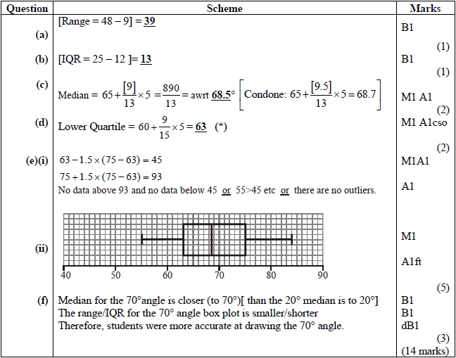
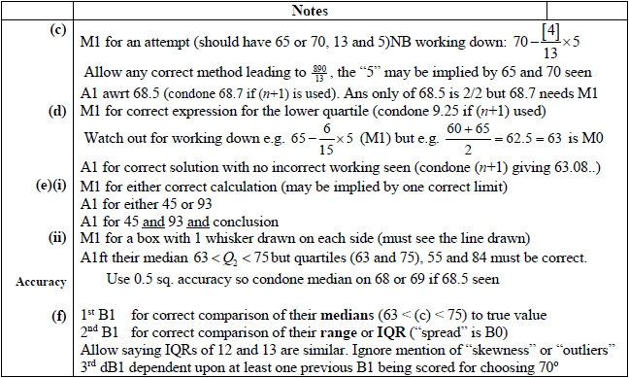
Q2.
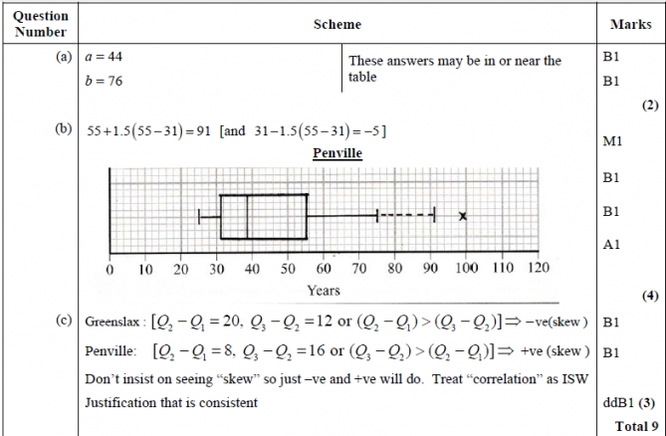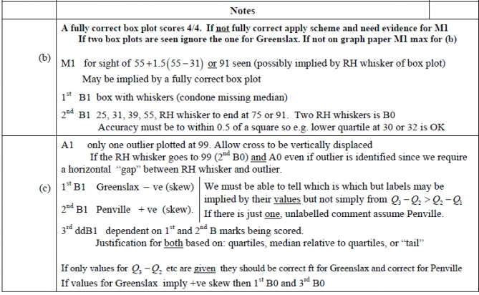

Q3.
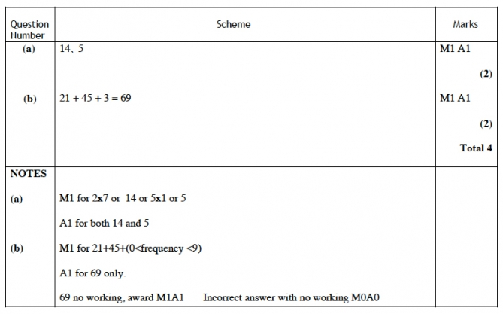

Q4.
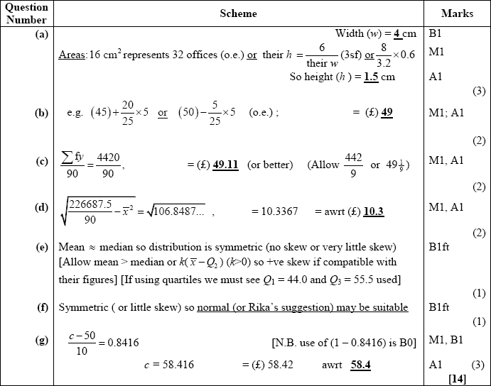
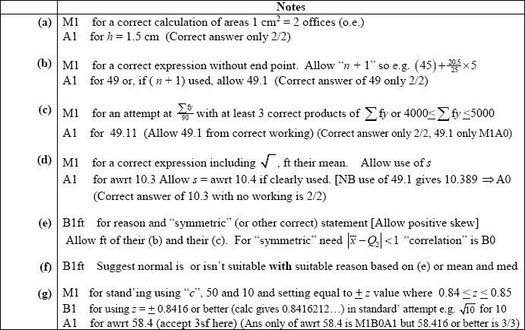
Q5.
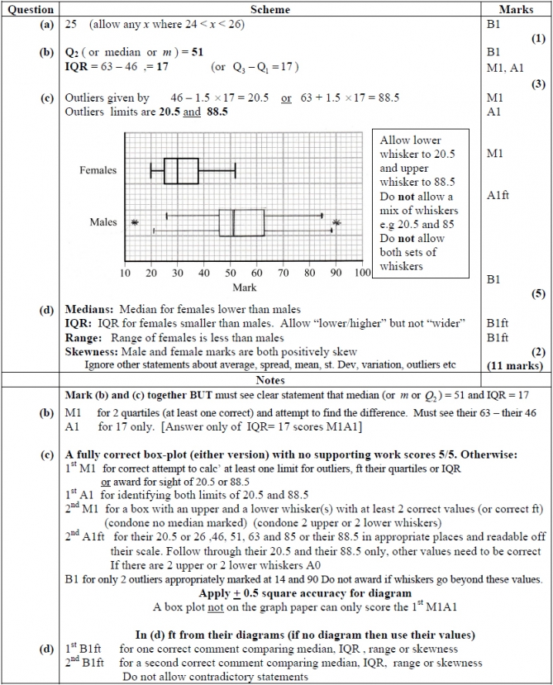

Q6.
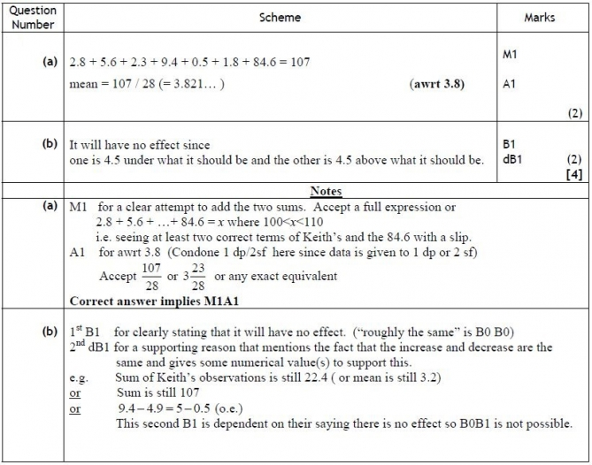

Q7.
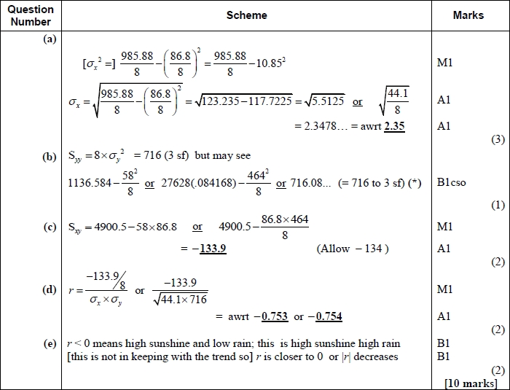
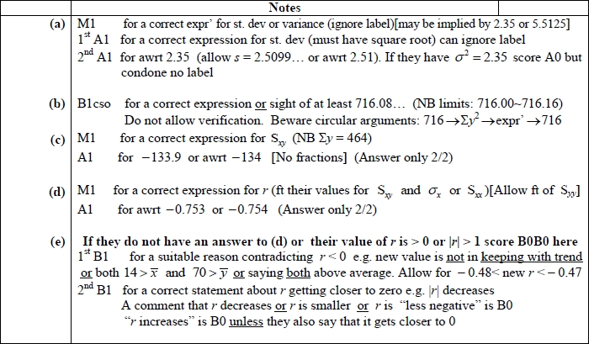
Q8.
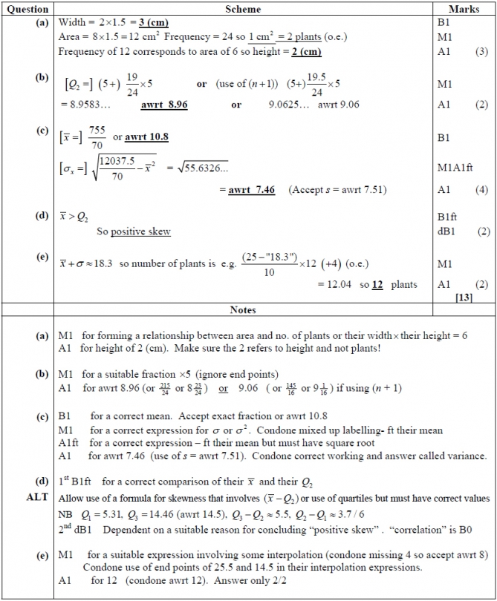

Q9.
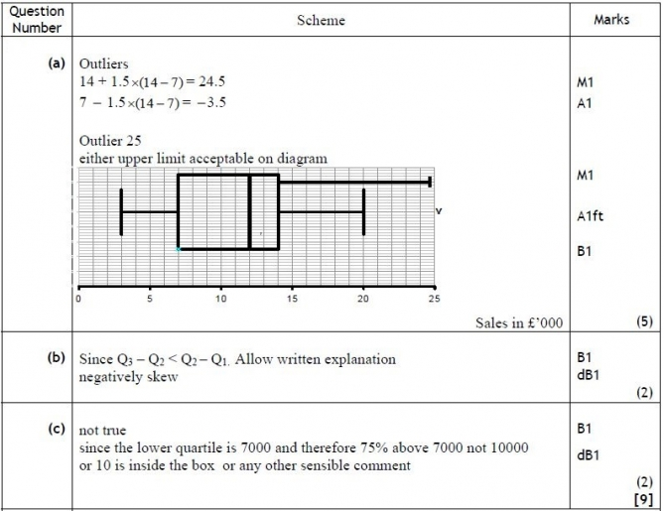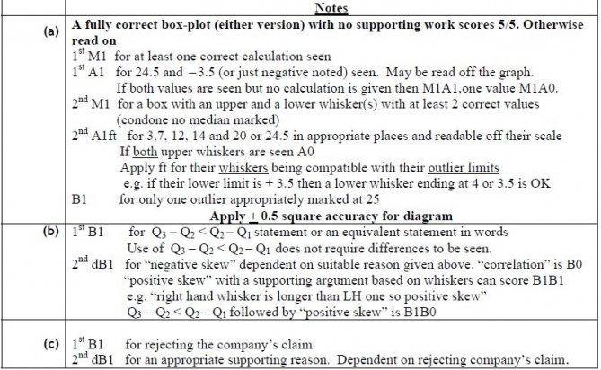

Q10.
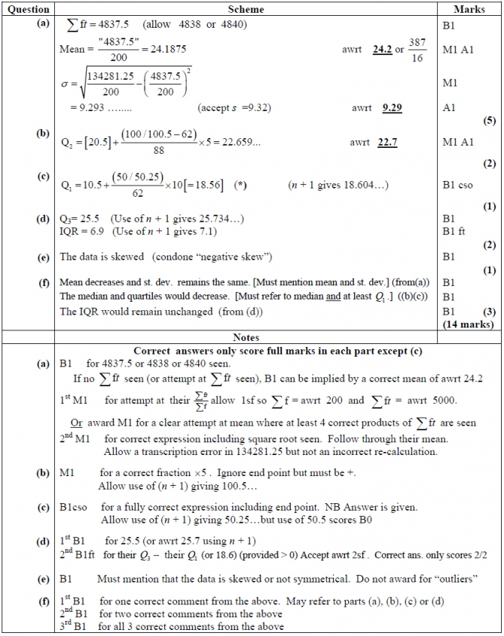

Q11.
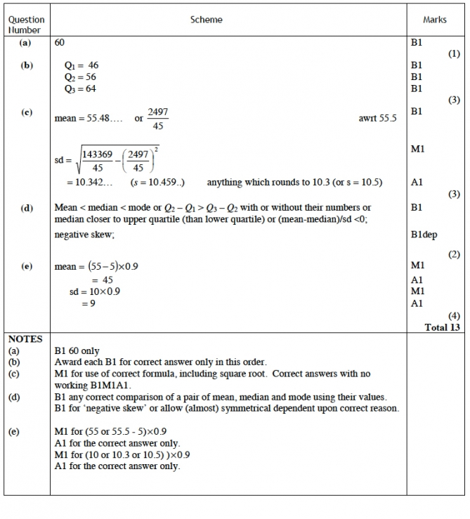

Q12.
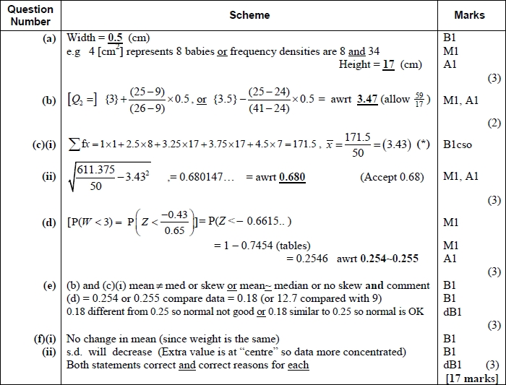
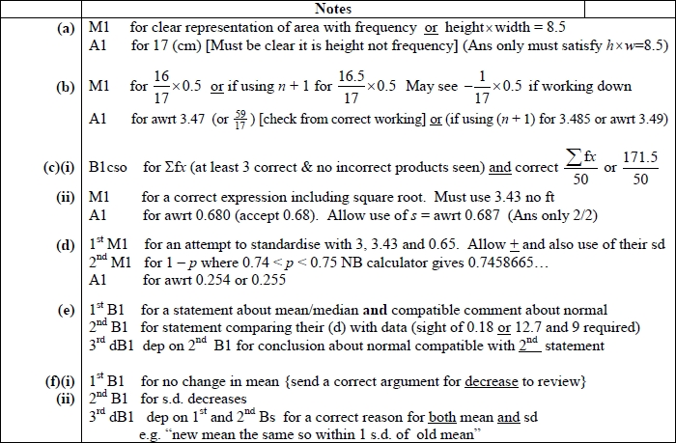
Q13.
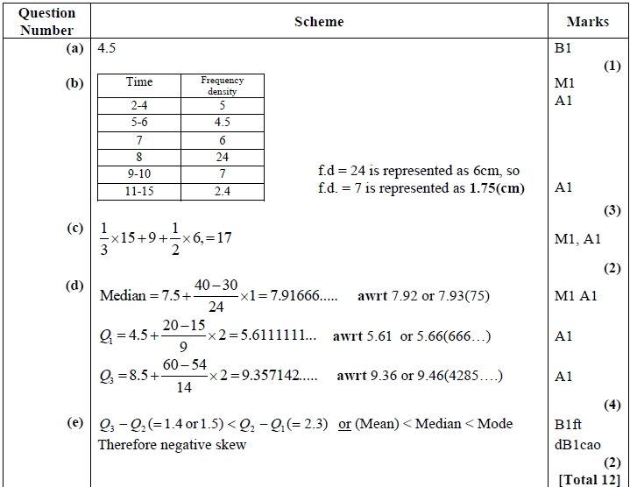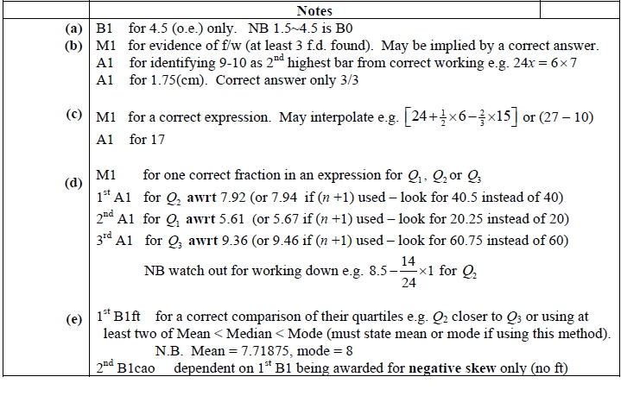
Q14.
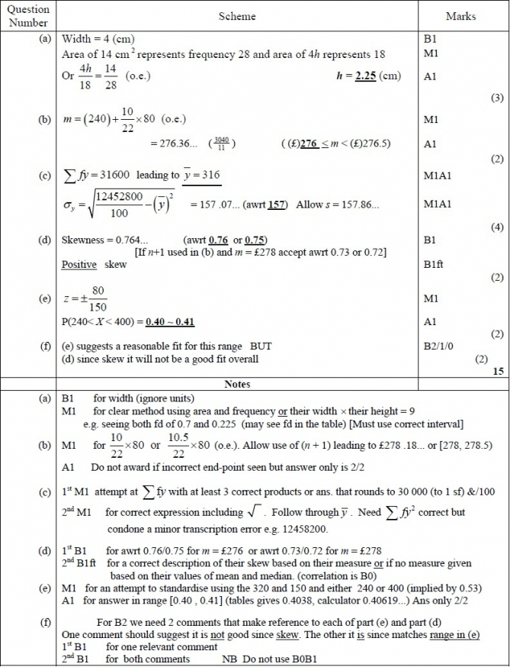

Q15.
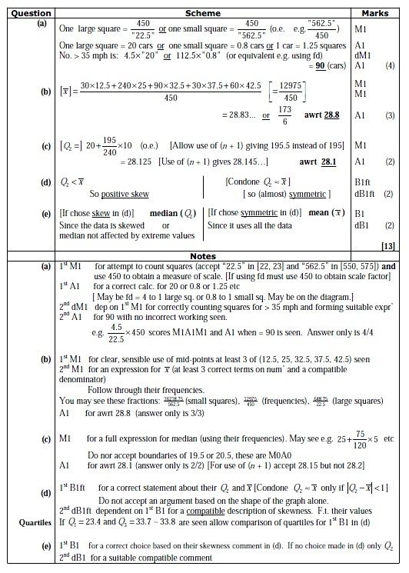

Q16.
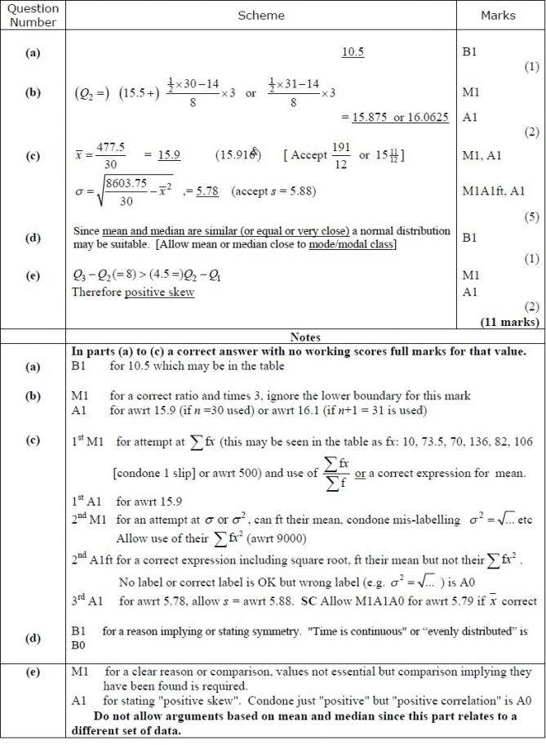

Q17.
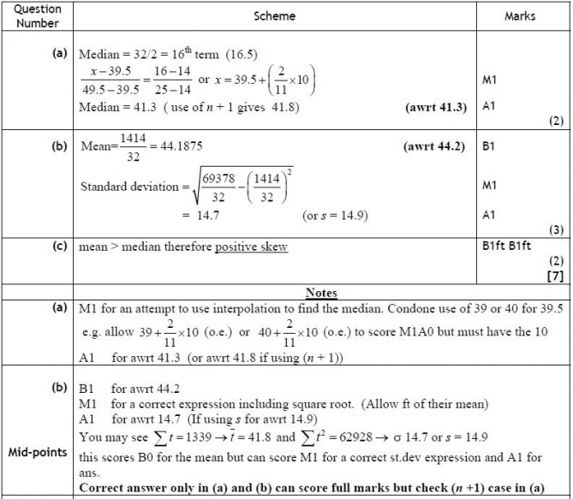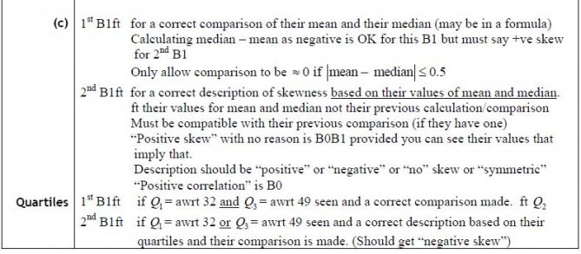

Q18.
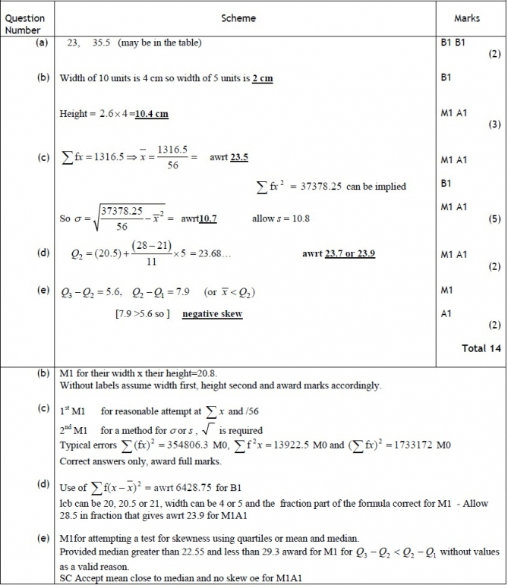

Q19.
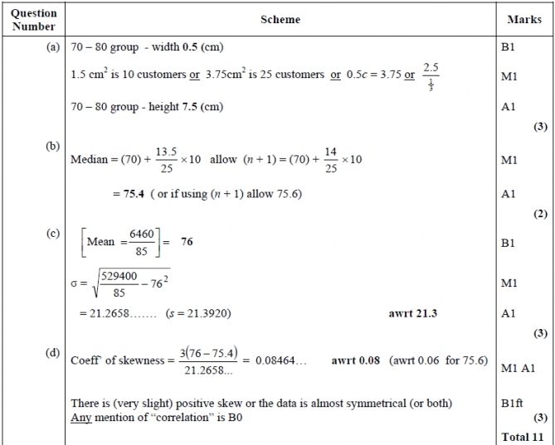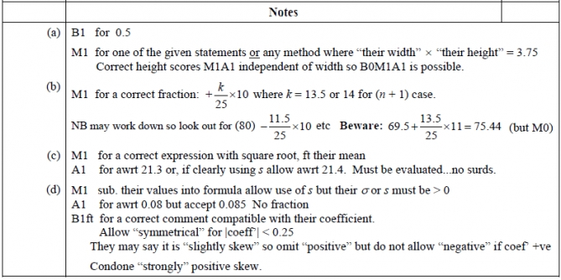

Q20.
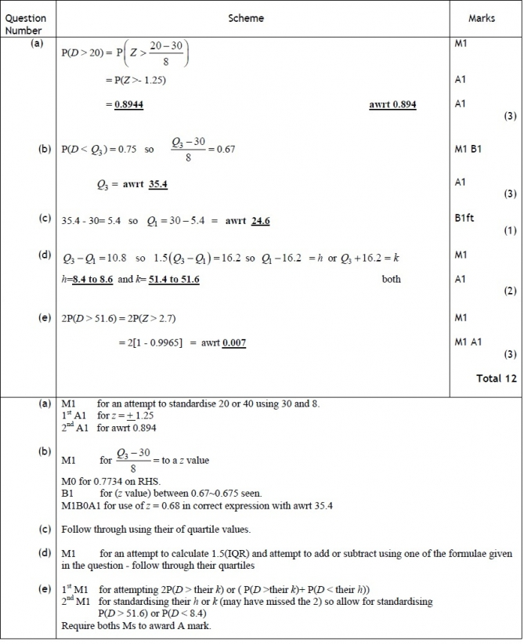

Q21.
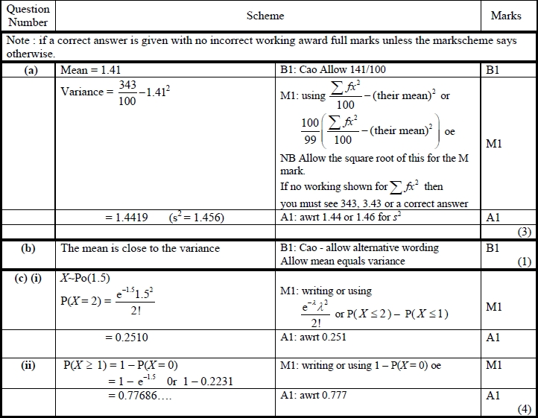
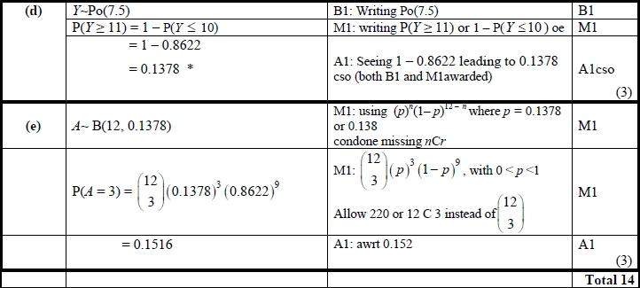

Q22.
