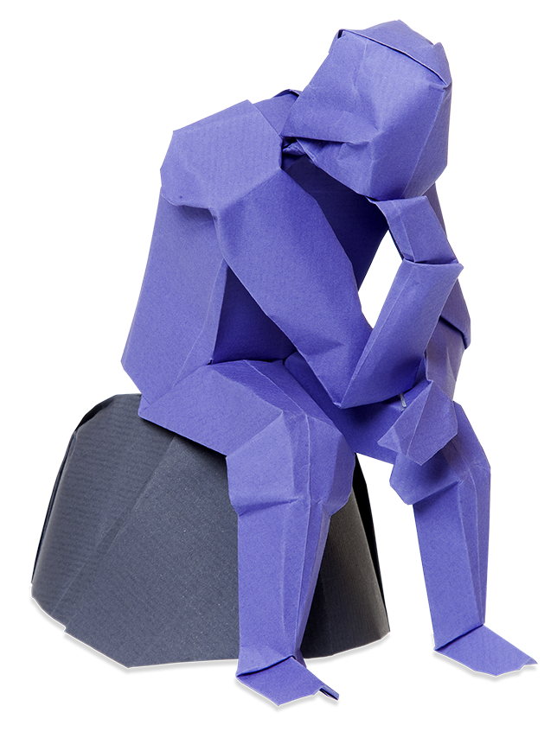
f
NEA/Coursework
Investigating and Creating Texts
Student Planner and Log

Name:
A level
English Language and
Literature

© artwork: Mark Bolitho | Origami photography Pearson Education Ltd/Naki Kouyioumtzis

Essential information for Investigating and Creating Texts

- Your coursework component is worth 20% of your total grade.
- The final deadline for completed portfolios is:

- Your coursework portfolio must consist of three pieces of writing with a total, combined word count of between 2,500 and 3,250 words (not including the bibliography).

1) A piece of original fiction writing based on your chosen theme.

Deadline draft 1: ____________________________________________

Final deadline: _____________________________________________

2) A piece of original non-fiction writing also inspired by your theme.

Deadline draft 1: ____________________________________________

Final deadline: _____________________________________________

3) An analytical commentary.
This must reflect on the ways in which your studied text, wider reading and knowledge of genre contributed to the language choices you made when producing your own original texts.

Deadline draft 1: ____________________________________________

Final deadline: _____________________________________________

Other requirements

Bibliography
You must also provide a bibliography at the end of your portfolio which should refer to your primary stimulus texts and provide details of any research and wider reading.
- This is an important element of your coursework and is a compulsory part of the submission.
- It is NOT included in the word count.
- Do not leave this until the last minute!

Completed portfolios must be:
- clear font (size 12)
- formatted correctly
- double or 1.5 spaced
- single sided printing.

Fiction vs Non-Fiction

Fiction
This should deal with events which are imaginary i.e. invented by YOU.
This will also pertain to original creations in non-current time frames, for example, a newspaper article written in the 1920s will constitute fiction, not non-fiction.

Non-fiction
This must be created using information from the real world rather than invented by you.
The text MUST be in a non-fiction genre and it is important to have an awareness of the conventions of the genre to which your piece belongs.
Examples might include, but are not solely limited to, those prescribed in the Voices in Speech and Writing: anthology: article, reportage, speech, script, diary etc.
Genres may also be created in hybrid form combining features of different genres which appeal to audiences in more subtle ways.

Some key tips for Non-Fiction:
Set the text ‘now’ (not in the past).
You are the author. (You cannot imagine you are a middle-aged journalist, for example)
Interviews: if you want to include one in a piece, the interview must be with a real person whom you have interviewed.
Speeches should be in a context that you could deliver, such as a TED talk or an address to fellow students.
Biographies must be of a person whom you have interviewed yourself.
Memoirs must be about your own experiences.

Using the following table, list all the texts that you can remember reading

Highlight any text that could be a possible core text for your coursework.
If you do not have appropriate suggestions, list some texts that you could read to help inspire you.
Texts from a range of modes and functions can be listed here, for example: websites, blogs, travel pieces, scripts.

Fiction | Non-fiction
Coursework Proposal
Complete a proposal for your coursework
You can use the information on the following pages to help with this.
Outline your intentions as clearly as you can.
Theme
Fiction stimulus text
Non-fiction stimulus text
Tasks

Sample proposal suggestions
- Use the following options to help make your decision. Your two stimulus texts need to be linked by your theme.
- For each of the following suggestions consider the potential audience, purpose, and context for each task.
Theme | Gender
Fiction stimulus text | Emma, Jane Austen  OR  A Thousand Splendid Suns, Khaled Hosseini
Non-fiction stimulus text | Men are from Mars Women are from Venus, John Gray  OR  Cupcakes and Kalashnikov’s, Various
Suggested tasks | Fiction task: use a scenario from a stimulus text to inspire a short story.  Non-fiction task: produce an opinion piece article about the risks of online dating.

Theme | Justice/racial prejudice
Fiction stimulus text | To Kill a Mockingbird, Harper Lee
Non-fiction stimulus text | Just Mercy, Bryan Stevenson
Suggested tasks | Fiction task: create an opening speech from the prosecution or defence attorney based on a similar trial to the one depicted in your stimulus texts.  Non-fiction task- Write an op-ed piece for The Guardian exploring how race/ justice is still an issue in society.

Theme | Madness
Fiction stimulus text | The Secret Scripture, Sebastian Barry
Non-fiction stimulus text | The Psychopath Test, Jon Ronson
Suggested tasks | Fiction task: create a diary extract from a character incarcerated in an asylum.  Non-fiction task: write a journalistic piece about the depiction of psychopathic behaviour in TV or film.

Non-fiction book suggestions
Remember that your wider reading can be drawn from any genre/platform.

Travelogue
Notes from a Small Island, Bill Bryson
The Life and Times of The Thunderbolt Kid, Bill Bryson
American Notes, Charles Dickens
Pictures from Italy, Charles Dickens

Diary
The Faber Book of Diaries, Simon Brett
The Blair Years/The Alastair Campbell Diaries, Alastair Campbell
The Diary of Samuel Pepys, Samuel Pepys
The Diary of Anne Frank, Anne Frank
The Collected Letters of Mary Wollstonecraft, Ralph Wardle (ed.)
The Letters of Ted Hughes, Christopher Reid (ed.)

Reportage
The Road to Wigan Pier, George Orwell
A Short Walk in the Hindu Cush, Eric Newby
Cities, Jan Morris
The Faber Book of Reportage, John Carey
London Labour and the London Poor, Henry Mayhew

Biography/autobiography
Testament of Youth, Vera Brittain
Bad Blood, Lorna Sage
The Long Walk to Freedom, Nelson Mandela
The Art of Being Happy, The Dali Lama
The Prime of Life, Simone de Beauvoir

Speeches
The Penguin Book of Historic Speeches, Brian MacArthur
Speeches That Changed the World, Simon Sebag Montefiore

Wider reading log
Wider reading must demonstrate the extra work and research that you have done to complete your two tasks.
You could refer to relevant articles that you have read, any source of information (online/offline) that you have used, as well as other examples of texts in that genre.
Look to include 10 samples in your bibliography, including your core stimulus texts
This table will be used to help you compile your bibliography at the end of each task. Certain information needs to be present in a bibliography so make sure that you can fill in all the sections for each text.
Writer’s full name | Title of the text | Date of publication | Place of publication/ publisher | Form of the text | When you accessed it (digital text only)

Referencing Texts in your Bibliography

A good recommendation is to use The Modern Language Association (MLA) referencing system.

Here is an example of how your reference citation should look using this system:

If you used a printed text:
Stoker, Bram. Dracula. Penguin Books. 2003. London. Print.

If you used a web page:
Brooker, Charlie. Too much talk for one planet: why I’m reducing my word emissions. The Guardian. Web. 7/12/2015.

There are also several reference builder websites online you may want to use as well. Make sure that they use an established referencing system, such as MLA or the Harvard reference system.

Feedback on drafts
Your teacher is likely to view your work only once prior to the submission of your final draft. Before submitting the first draft of any of your three pieces, please make sure it is as good as you can make it.
Your teacher is only permitted to give you guidance on your work at a general level. They will not be able to point out your errors and give specific information about what you need to change. The full rules on feedback can be found on pages 7–8 of this document.

Mark Scheme for Original Writing

Each piece of original writing (fiction /non-fiction) is assessed using the marking grid below.
Each piece is marked separately with a maximum mark of 18.
Assessment Objective AO5 assesses your ability to ‘Demonstrate expertise and creativity in the use of English to communicate in different ways’.
 |  | Creating and Investigating Texts: Original Writing
Level | Mark | Descriptor (AO5)
Level 1 | 1–3 | Low skill level  - Writing has frequent errors and technical lapses. Limited control of genre and mode, with inappropriate style used for audience and function.  - Writing is formulaic and predictable.
Level 2 | 4–6 | General/ imprecise skill  - Writing has some errors and technical lapses. Shows general understanding of genre, mode and the requirements of audience and function.  - Writing has evidence of an engaging individual voice. Able to see obvious, though not always successful, attempts at crafting language for effect.
Level 3 | 7–10 | Clear skills  - Writing has minor errors and technical lapses. Applies clear understanding of genre, mode and the requirements of audience and function.  - Writing has an individual voice, with clear engaging attempts at crafting language.
Level 4 | 11–14 | Controlled skills  - Writing is precisely edited and controlled. Demonstrates effective understanding of genre, mode and the requirements of audience and function.  - Writing uses an individual voice that crafts an engaging response. Displays a skilful selection of techniques for effect.
Level 5 | 15–18 | Assured Skills  - Writing is assured, accurate and highly effective. Displays an assured control of genre, mode, and the requirements of audience and function.  - Writing employs a clearly individual voice that differentiates in terms of audience and function. Crafts a highly engaging response, with sophisticated selection of techniques.

Planning your fiction writing.
Literary devices are important, but you also need to be original and inventive with the type of devices that you incorporate.
You should ultimately enjoy your own writing, challenge yourself to create something new and always stay focused on your reader.
Read three extracts/ texts in the same genre that you want to write in and complete the following table.
 | Text 1 | Text 2 | Text 3
Which devices have been used skilfully by the writer?

What do you think the writer’s intentions are with the whole text?
Which structural devices help to convey meaning in the text?

Which devices could be incorporated into your writing?

Form
Structure
Language

Draft 1 feedback
Things I am doing well
Things I need to improve
Targets for draft 2

Planning your non-fiction writing
Find at least three examples of the type of text that you want to write and complete the table:

 | Text 1 | Text 2 | Text 3
What is the Audience/ Purpose?

What devices has the writer used deliberately and effectively?

How is the writer’s purpose achieved?

Is the text different from other texts in this form/ why?

What devices could you use in your text? (List at least five)

1.
2,
3.
4.
5.

Draft 1 feedback

Things I am doing well
Things I need to improve
Targets for draft 2

Critical Commentary
It is important, in this section, that you critically explore the construction of your own writing in relation to the theme and the stimulus texts you read during your research. Looking back at the observations you have made about the crafting process in this booklet, you will need to analyse the most effective ways you feel your text engages its reader due to the language choices you have made.
When producing your commentary, it is crucial that you offer specific analysis of your language choices.
The Principal Moderator states that the Commentary is often the key discriminator when assessing folders.
Here is an extract from the 2019 Moderator’s Report:
‘The best examples were concise, focused, and able to evaluate all aspects of the candidate’s research as well as their shaping of the text to meet the specific requirements of a carefully identified audience. Candidates are getting better at focusing on AO2 in terms of analysing their own writing, rather than just identifying techniques. The use of polysyllabic linguistic terms does not guarantee high marks unless there is evaluation and analysis of effect in terms of purpose and audience. Merely identifying linguistic and literary techniques will ensure that a commentary stays in the middle bands. Unsuccessful commentaries often described the content of work or quoted at length without developed analysis at either word, sentence, or whole text level. Conclusions about particular choices were often limited to superficial references about making the work easy to relate or making the reader want to read on.’
The Commentary is assessed against AOs 1, 2, 3 and 4.

 |  | Creating and Investigating Texts: Commentary
 |  | AO1 – bullet  point 1 | AO2 – bullet  point 2 | AO3 – bullet  point 3 | AO4 – bullet  point 4
Level | Mark | Descriptor (AO1, AO2, AO3, AO4)
Level 1 | 1–4 | Descriptive  - Knowledge of concepts and methods is largely unassimilated. Recalls limited range of terminology and makes frequent errors and technical lapses.  - Uses a descriptive or narrative approach with little understanding of crafting of texts. Makes simple comments on how meaning is shaped in own writing.  - Shows limited understanding of how contextual factors can affect own writing.  - Makes limited links between stimulus texts and own writing. Recalls limited concepts and methods in own writing.
Level 2 | 5–9 | General understanding  - Recalls concepts and methods of analysis that show general understanding. Organises and expresses ideas with some clarity, though has lapses in use of terminology.  - Shows superficial understanding of how meaning is shaped when describing own writing.  - Has general understanding of how contextual factors affect own writing, though this is not always securely applied.  - Describes obvious connections between stimulus texts and own writing.
Level 3 | 10–14 | Clear relevant application  - Applies relevant concepts and methods of analysis to texts with clear examples. Ideas are structured logically and expressed with few lapses in clarity and transitioning. Clear use of terminology.  - Demonstrates clear understanding of how meaning is shaped when describing and explaining own writing.  - Explains clearly how contextual factors affect construction of meaning in own writing.  - Identifies connections between stimulus texts and own writing. Uses relevant concepts and methods to support this.

 |  | Creating and Investigating Texts: Commentary
 |  | AO1 – bullet  point 1 | AO2 – bullet  point 2 | AO3 – bullet  point 3 | AO4 – bullet  point 4
Level | Mark | Descriptor (AO1, AO2, AO3, AO4)
Level 4 | 15–19 | Discriminating controlled approach  - Applies controlled discussion of concepts and methods supported with use of discriminating examples. Controls the structure of response with effective transitions, carefully chosen language and use of terminology.  - Discriminating analysis of how meaning shaped when explaining own writing.  - Shows a secure awareness of how contextual factors affect own writing.  - Discriminating analysis of connections between stimulus texts and own writing. Uses appropriate concepts and methods.
Level 5 | 20–24 | Critical evaluative approach  - Presents critical application of language analysis with sustained examples. Uses sophisticated structure and expression with appropriate register and style, including use of appropriate terminology.  - Exhibits critical evaluation of linguistic and literary choices in own writing. Evaluates their effects on shaping meaning.  - Critically examines context in own writing by looking at subtleties and nuances. Examines multi-layered nature of own writing.  - Evaluates connections between stimulus texts and own writing. Critically applies concepts and methods.

Introduction
Write approximately 200 words outlining your intentions from when you began writing the texts.
How did your reading of the source texts inspire and what was your purpose for both texts?
Once you have completed your introduction you should look critically and analytically at your own original pieces. The commentary should be AT LEAST 1000 words.

Write the draft of the introduction to your Commentary here:

Planning the body of your Commentary

Which devices were used successfully in your fiction piece?

Quotation | Devices | Effect on the reader | How does this link back to your original purpose?

Which devices were used successfully in your non-fiction piece?

Quotation | Devices | Effect on the reader | How does this link back to your original purpose?

Draft 1 feedback

Things I am doing well
Things I need to improve
Targets for draft 2

