Course Title:  Apprenticeship programme | Curriculum reference: | Subject: Functional Mathematics  Level: Entry level 3 | Time: 9.00 – 12.00  Date: 00/00/0000  Room: 16
Tutor Name: |  | Lesson Number: | Lesson Number
Tutor Name: |  | Assignment Number: | Task number 004
Tutor Name: |  | Task activity | Car costing activity
Resources: | Learner resources  Department store assignment and resource doc 004  Paper Pens, pencils, ruler, calculator | Tutor resources  Wipe board, flipchart, pens, task sheets, additional worksheets where required, card sorts etc  Note: all timings are approximate activities can be shortened/extended to meet the session demands
Aims:  - to consider and compare the cost of running different cars  - to look at and use the information provided and make appropriate choices to enable the learners to select and choose a car  - to use appropriate ways on how to check your calculations  - understand the differences and the implications when selecting a suitable car in an everyday context  - to use problem solving skills to arrive at an appropriate solution |  | Learning outcomes:  - Identify what it will cost to purchase a car  - to be able to select information from given data and be aware of different choices available to suit the differing needs  - be able to identify cost effective solutions using mathematics  - to use suitable mathematical solutions to support you findings  - to be able to present your findings and explain the results  - to show that you can check your work for accuracy  - to be able to identify the skills learned and transfer them into different situations or scenarios

Curriculum reference: | Differentiation |  | Functional skills reference/coverage |  |  |  |  | Tick if covered in this session
Entry Level | Entry 2 | Level 1 | Skills Standards | T  1 | T  2 | T  3 | Coverage and range | Task 1 | Task 2 | Task  3
N1/E3.2 |  |  | Representing information |  |  |  | Add and subtract using three-digit numbers |  | x | x
N1/E3.4/5  N1/E3.6 |  |  | understand practical problems in familiar contexts and situations (R1) | x | x | X | Solve practical problems involving multiplication and division by 2, 3, 4, 5 and 10 |  | x | x
N1/E3.7 |  |  | begin to develop own strategies for solving simple problems (R2) | x | x | x | Round to the nearest 10 or 100
N2/E3.1 / 3 |  |  | select mathematics to obtain answers to simple given practical problems that are clear and routine( (R3) | x | x | x | Understand and use simple fractions |  | x
MSS1/E3.5/6  MSS1/E3.7/8 |  |  | Analysing Information |  |  |  | Understand, estimate, measure and compare length, capacity, weight and temperature |  | x | x
N2/E3.3 |  |  | apply mathematics to obtain answers to simple given practical problems that are clear and routine (A1) | x | x | x | Understand decimals to two decimal places in practical contexts | x | x | x
N1/E3.1 |  |  |  |  |  |  | Recognise and describe number patterns | x | x | x
MSS1/L1.4 |  |  | use simple checking procedures  (A2) |  | x |  | Complete simple calculations involving money and measures | x | x | x
MSS1/E3.1 |  |  | Interpreting information |  |  |  | Recognise and name simple 2D and 3D shapes and their properties
MSS1/E3.4 to E3.9 |  |  | interpret and communicate solutions to practical problems in familiar contexts and situations (I1) | x | x | x | Use metric units in everyday situations | x | x | x
HD1/E3.1 |  |  |  |  |  |  | Extract, use and compare information from lists, tables, simple charts and simple graphs | x | x | x

Time | Teacher Activity |  |  | Learner Activity / skills standards covered |  | Resources
40-50 mins  5 minutes  10 minutes  5 minutes  10 minutes  10 Minutes | Complete register/attendance  Icebreaker  Car identification quiz sheet  Aims and objectives  Tutor overview of assignment task and the activity that is going to be undertaken  Tutor to explain the importance of selecting accurate information or data from tables and charts and the possible consequences, possible discussion could be opened up around the types of cars people dream about |  |  | Sign in  Learners to complete a car quiz to identify make, model  To participate in discussions and gain an understanding as to the hidden cost about buying a car and that although a car may seem very cheap the Insurance tax and running cost could make a huge difference to the initial cost of buying a car |  | Sign in sheet  Quiz sheet  PowerPoint slides or explanation
10 minutes |  | Problem solving activity, give the learners a simple problem solving activity to work on in pairs or small groups.  Discuss the different solutions to the problem |  | Card sort activity  Different cars an prices learners try to match the price with the car |  | Problem solving activity  Car images and cost worksheet/cards
Break Time/New Session
60 – 90 mins  10/20 mins  20/30 mins  50/60 mins |  | Task 1 in assignment  Identifying the costs of a car  Tutor to discuss the different cost in running a car, and what the pitfalls might be, details of car prices tax, MOT and service cost are all part and parcel of running cost also explain the reason for Insurance and the cost of petrol, emissions  Learners are asked to look at different cars in task 1 and calculate the cost of the car and the tax  Tutor explains and shows ways to check calculation using addition/ subtraction  Tutor explains huge variation in insurance cost  Tutor also reiterates the importance of budgeting  Tutor could point the learners to DVLA website and see prices/tables and cost,  Tutor explains the reasons for the different prices and what emissions cost  Learners then work on the rest of task 1 |  | Learners are asked questions to ascertain understanding of buying a car, some may share experiences or problems that they may have had, additional discussions may include theft Insurance companies etc  Learners to read prices off car tax and cost of car and stay within a given budget  They are then asked to calculate the differences between cars  Learners look at and identify the differences with the cost of insurance  Activity Tutor gives learners 3 registration numbers and are asked to go on DVLA website and find the price of road tax  In addition learners look at the cost and differences in prices of tax  Learners participate in task 1 | Pens, paper pencils, calculator  Assignment and resource document  Wipe board flipchart as required  Some vehicle registration numbers
Lunch Time/New Session
60 - 90 minutes  15/20 mins  10 mins  15 mins  30 mins  30- 40 mins |  | Task 2 in assignment travel/running costs  The tutor begins the session by talking about fuel economy and explains that the fuel is one of the biggest running cost to keep your car moving  Explain the differences between petrol and diesel and the prices Give an example of a typical car and how much petrol a tank holds and what it cost to fill it up, point out that it is easy to put £5/10 on regular occasions and that it soon mounts up also include efficient driving  Give learners relevant handouts and ask them to complete the assignment task with task 2usinng the resources provided, tutor to provided 1-1 support where required  Instruct learners to check calculations using different methods  Learners then complete task 2 questions 1 - 5 | Learners, listen and participate in discussion, some may wish to contribute by drawing on own experiences  Learners respond to questions and complete calculations  Learners would discuss the steps needed to take to work out the calculations  learners will work on task 2 Q 1-5 |  | Pens, paper pencils, calculator  Assignment and resource document  Wipe board flipchart as required  TV quiz sheets  Times table grids  Multiplication sheets  Estimate sheets Ruler/tape measures  Loan tables, printouts  Credit card payment tables
Break/New Session
60 – 90 mins  15/20 mins  30/60 mins |  | Task 3 in assignment  Calculating the cost of journey times  Icebreaker give learners a simple map and ask them to work out the distance between a number of given points  Ask learners to calculate distances for each journey at 30 miles to a gallon  Issue task 3 and ask learners to complete calculations  Instruct learners to check calculations using different methods | Learners participate in the activity, alternative would be to use cards and ask learners to identify mileage against trip and match cards together  Learners use and apply division and addition |  | Pens, paper pencils, calculator  Assignment and resource document  Wipe board flipchart as required

Review and Close
Recap on what has been learned

Check on Learners’ Learning

Session Evaluation

Differentiation
Tables or groups could be streamed for different activities around the same task at different levels, different tables could complete different aspects of the task to meet learners capabilities

Entry 2
For Entry 2 or lower adjust the task accordingly, take out activities, simplify the questions or just give specific resource pages
examples: could include using repeated addition, price list could be simplified and rounded to extract from simple lists prices could be altered to calculate whole numbers, less information and just 1 insurance quote for each car to simplify the task

Learners could be given website pages to search for different prices e.g petrol cost and car companies to look at emissions in addition it is an advantage for learners to use and understand DVLA

Level 1 or higher
Could include additional cost, the introduction of ICT, they could produce a spreadsheet and produce graphs ICT, in addition they could calculate the mean prices calculate the range look at lager sets for statistics, include mental methods of calculation, additional activities may include spending money calculating interest payments on buying cars through different ways and producing graphical representations Level 2 activities could be more complex including conversion measurement, , comparison of stats in with more cars

You should have, the following to help you
- Paper, pens and pencils
- A ruler
- A calculator
- A resource document

Candidates Name: ________________________________

Candidate’s registration number: ________________________________

Date of completion: ________________________________

Introduction

Candidates Instructions

Contained within this assessment paper is a series of tasks, please use the resource document to help you

The resource document contains
- Car details
- Car Insurance/Petrol cost
- Car tax details/Journey map

Task 1

You have a budget of £5000 to buy a car look at the cars that are for sale

1. Calculate which car would be the cheapest to buy including car tax

Show your calculations

2. show how you would check your calculations

3. Work out the cost of car insurance for each car and the difference between paying cash or paying by monthly installments for quote 1. Which insurance company charges the most to pay by installments?

4. Calculate which insurance quote is the cheapest for each car quote 1, or quote 2 including legal assistance

5. which tax band has the biggest difference if you pay for tax every 6 months rather than 12 months

Task 1 additional calculation sheet

Task 2

You normally travel about 10,000 miles a year in a car
The cars hold the following amount of fuel
- Road Ranger 8 gallons
- Sports saloon 10 gallons
- ECO car 6 gallons
- Family car 8 gallons

1. How many miles will each car have done by if you kept them for 3 years ?
Show your calculations

2. The Road Ranger and the Family hold 8 gallons of fuel how much does it cost to fill up the tanks?
Show your calculations

3. What is the total cost to fill up the Sports Saloon and the Eco car? Out of the 4 cars which cost the cheapest to fill with fuel

4. The car dealer has promised to put 3 gallons of fuel in whichever car you decide to buy. Which car will go the furthest?

5. If each car is filled up with 3 gallons of fuel show as a fraction in its lowest form how full each tank will be

Task 2 additional calculation sheet

Task 3

Before you decide to buy your car you want to calculate some journey times to see how economical the cars are.

1. Calculate the cost of driving 450 miles in each car
Show your calculations

2. You are planning a trip from Riverside to Appleton (see map) to visit your relatives how much would it cost to go there and back

3. You plan to keep your next car for 3 years. Work out how much your running cost will be for your chosen car. Include the cost for tax, the cheapest insurance for each year, and in addition, take into account 10,000 miles each year.
Show your calculations

4. Explain why you chose this car and show how you can check your results

Task 3 additional calculation sheet

Contents
Page 2 Car Details
Page 3 Car Insurance/petrol cost
Page 4 Car tax details/ journey map


Please look at the following cars for sale

Sports Saloon
Simply stunning
Price £4,300.00

Tax not included, 12 months MOT

Tax band M

15 Miles to the Gallon

Petrol car

Group 20 Insurance

Only 12,000 miles on the clock

Look the part!

Road Ranger
Nearly new
Price £4,500.00

6 month tax included, MOT due

Tax band K

20 Miles to the Gallon

Diesel car

Group 16 Insurance

Only 3,000 miles on the clock

Grab yourself a bargain!

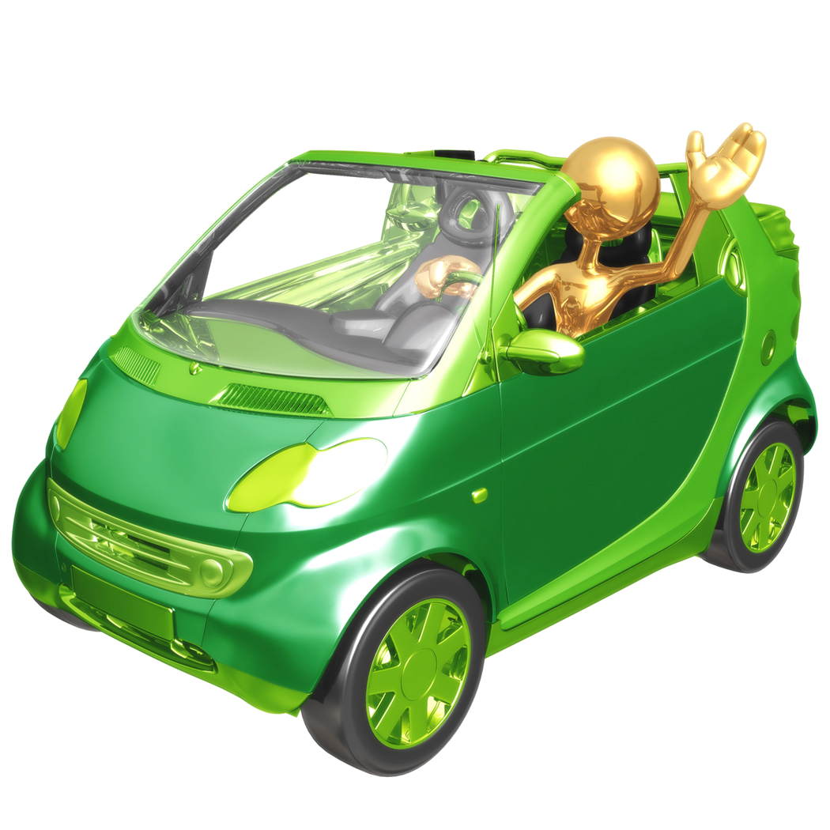


ECO Car
Nearly new
Price £4,600.00

Tax not included, 12 months MOT

Tax band c

60 Miles to the gallon

Diesel car

Group 4 Insurance

Only 18,000 miles on the clock

A fun car to drive round town!

Family Car
Nearly new
Price £4,400.00

12 month tax and MOT included

Tax band f

30 Miles to the gallon

Petrol car

Group 8 Insurance

Only 8,000 miles on the clock

A good all round car!

Car Insurance quotes
Road Ranger | Sports Saloon | ECCO Car | Family car
Fully comprehensive | Fully comprehensive | Fully comprehensive | Fully comprehensive
Insurance quote 1 | Insurance quote 1 | Insurance quote 1 | Insurance quote 1
Cost £895.00 | Cost £1300.00 | Cost £650.00 | Cost £555.00
If paying monthly | If paying monthly | If paying monthly | If paying monthly
10 payments of  £95.00 | 10 Payments of  £145.00 | 10 payments of £75.00 | 10 payments  £65.00
Legal assistance free | Legal assistance £25.00 | Legal assistance £10.00 | Legal assistance £15.00
Insurance quote 2 | Insurance quote 2 | Insurance quote 2 | Insurance quote 2
Fully comprehensive | Fully comprehensive | Fully comprehensive | Fully comprehensive
Cost £910.00 | Cost £1400.00 | Cost £600.00 | Cost £580.00
If paying monthly | If paying monthly | If paying monthly | If paying monthly
10 payments of £92.00 | 10 payments of £140.00 | 10 payments of  £75.00 | 10 payments of £70.00
Legal assistance £22.00 | Free legal assistance | Legal assistance £25.00 | Legal assistance £15.00


Car tax details
Fuel Costs

Petrol
Cost LitreCost Gallon

£1.25 per Litre £5.68 per Gallon

Diesel

Cost LitreCost Gallon

£1.35 per Litre£6.12 per Gallon

Band | CO2 emission (g/km) | 12 months rate | 6 months rate
A | Up to 100 | £0.00 | Not available
B | 101-110 | £10.00 | Not available
C | 111-120 | £25.00 | Not available
D | 121-130 | £95.00 | £55.00
E | 131-140 | £115.00 | £65.00
F | 141-150 | £135.00 | £75.00
G | 151-165 | £150.00 | £85.00
H | 166-175 | £170.00 | £89.00
I | 176-185 | £210.00 | £112.00
J | 186-200 | £225.00 | £130.00
K | 201-225 | £240.00 | £130.00
L | 226-255 | £410.00 | £220.00
M | Over 255 | £430.00 | £225.00


Riverside
Appleton
60 Miles

