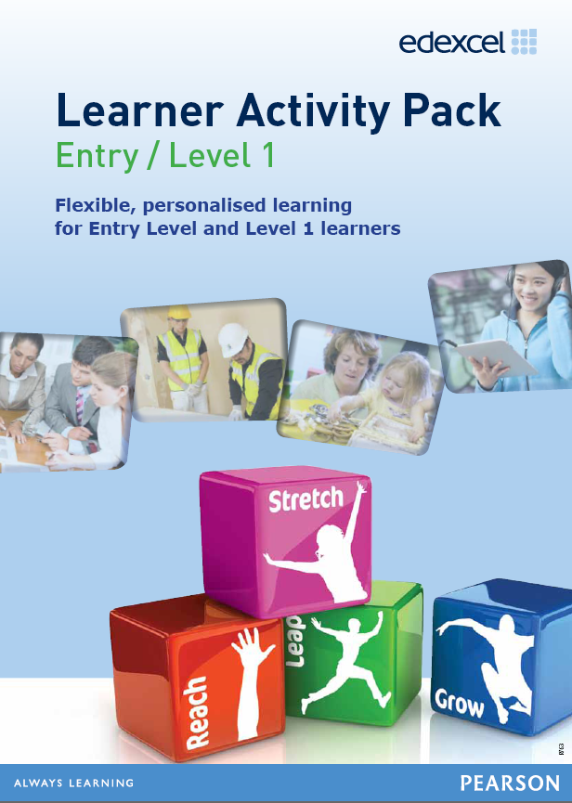
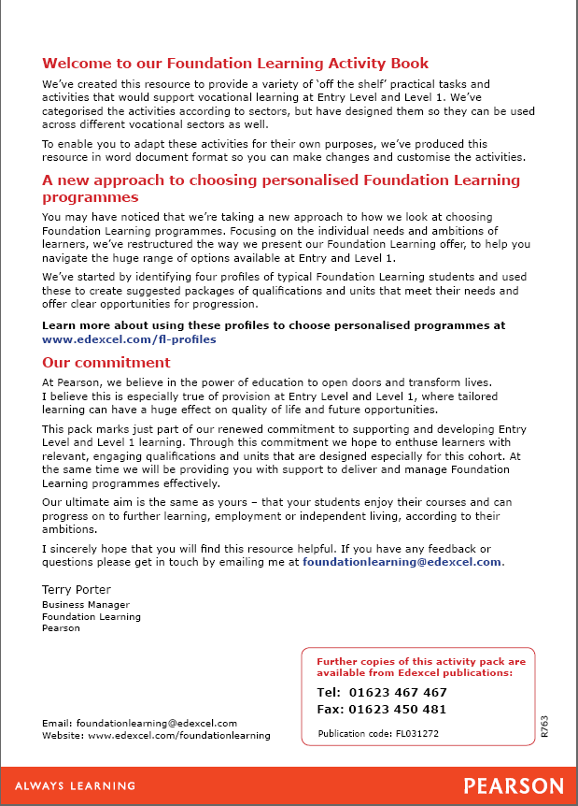

Contents
Page no
Health & Social Care
Researching a topic on the internet – Health and Social Care - 7 -
Working with others in Health and Social Care - 9 -
Childcare
Researching a topic on the internet – caring for children and young people - 13 -
A day out with the children - 15 -
Sport & Leisure
Making your case - 19 -
Making the best use of space - 23 -
Rules and regulations - 27 -
What the customer thinks - 29 -
Sports Centre activities - 35 -
Construction
Basic woodworking - 41 -
Engineering
Bridge structures - 49 -
Basic metal working - 61 -
Car crash - 67 -
Hair & Beauty
Planning time - 75 -
Making money - 79 -
Land Based
Recycling - 87 -
Well groomed - 91 -
Saddle up and ride your pony! - 95 -
Animal needs - 99 -
Healthy calves - 103 -
Farm animal families - 105 -
Does your animal need the vet? - 121 -
Planning a visit - 125 -
Feeding time - 129 -
Move it! - 131 -
Planting bulbs - 135 -
Plant it - 139 -
Soil - 143 -
Health & Safety
Hazards in the workplace - 151 -
Health and safety signs - 153 -
It’s a risky business - 155 -
Employment
What rights do you have at work? - 171 -
You’re hired - 175 -
Getting there on time - 181 -
Planning a trip - 187 -
Job Skills - 189 -
Preparing for a job interview - 195 -
Job hunting - 199 -
Product Design/Business
Department names - 203 -
Getting the right brand - 205 -
Corporate identity - 215 -
Product analysis - 219 -
Design specifications - 221 -
Batch production - 223 -
Industry sectors - 229 -
Advertising your products - 233 -
Designing a supermarket - 239 -
Quality - 241 -

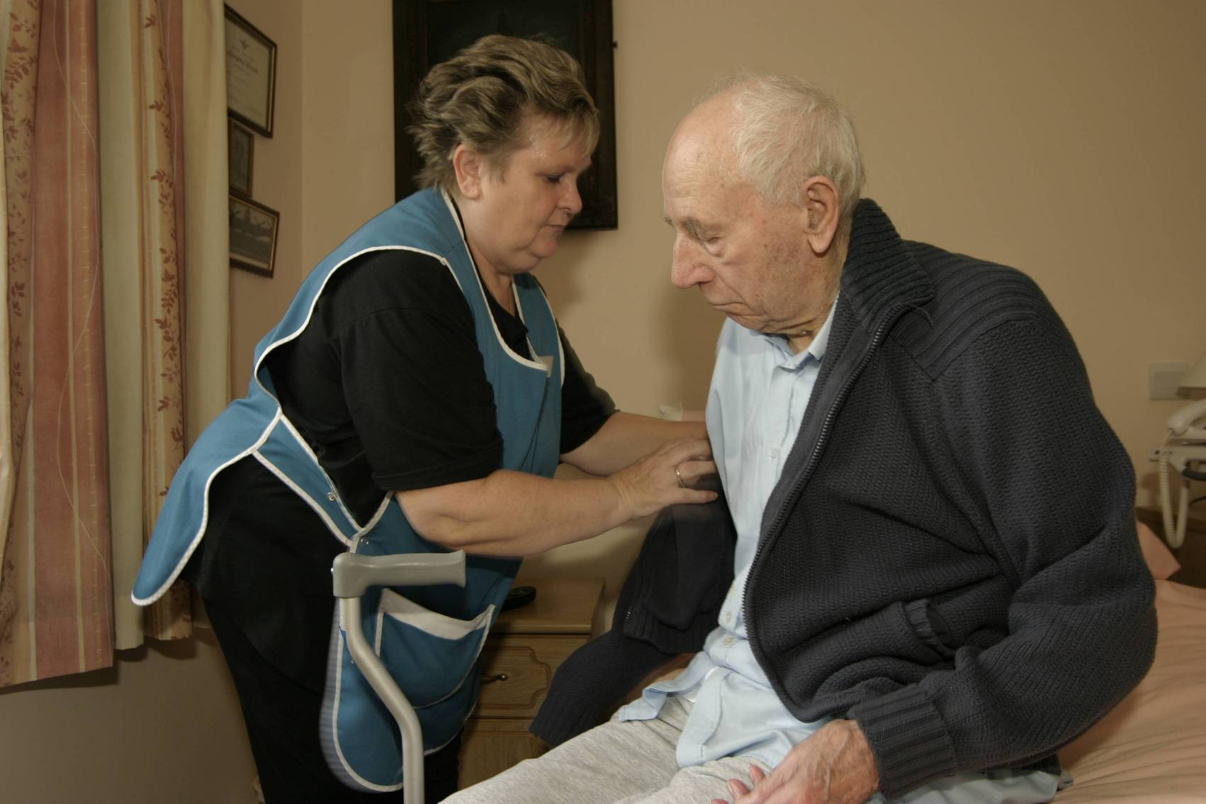

Health & Social Care

Researching a topic on the internet – Health and Social Care
- You want to support your neighbours. Their elderly mother lives alone in a house in the same town. She is no longer coping at home, and either needs lots of support to stay at home, or needs to go into residential care.
- You decide to help by researching information from the internet about the options available. You only have an hour to spare at the moment.
- You need to look up the kinds of help that are available, and get some idea of the likely cost involved (see activity sheet for hints).
Once you have started to find information, use the boxes on the activity sheet to record what you have found. Try to use your own words rather than copying chunks of information.
Search ideas:
Try typing the ideas below into the search engine (e.g. Google)
- Types of elderly care
- Adult Social Services (plus the name of the area that you live)
- Care Agencies
- Residential homes

 | Internet address | Summary of information
Types of elderly support
Places to get more information (including telephone number of your local social services)
Examples of costs per week for home care
Examples of costs per week for residential care

Now you will be able to explain what you have found to your neighbours. They will now be able to find out more because they will have the internet addresses that you used.

Working with others in Health and Social Care
Read through and think about the information in the case study below.
Lucy works in a residential home for the elderly. Today she is caring for Mr Neville Hall, a West Indian gentleman. Mr Hall has lived in the home for only three weeks since moving from his own home, where he lived alone. He seems friendly, and talks quite a lot about his early life in Trinidad.
During the afternoon, his daughter and son-in-law come to visit. After a while they come to talk to Lucy about their concerns. They seem worried and concerned rather than angry.
They make three main points:
- Mr Henry appears confused and doesn’t seem to remember things that were talked about just a few minutes before.
- His shirt has stains down the front. Lucy noticed that he spilt some of his lunch whilst eating earlier.
- He seems depressed to them.
Discuss the information above with another person in your group. Then, between you, try to answer the following questions. Make notes of your answers so that you are ready to discuss them with the whole class afterwards.
- What should Lucy say to the family members?
- What should Lucy do straight away?
- What should she report to her manager?
Your tutor will lead a whole class discussion to talk about the points that you have made.

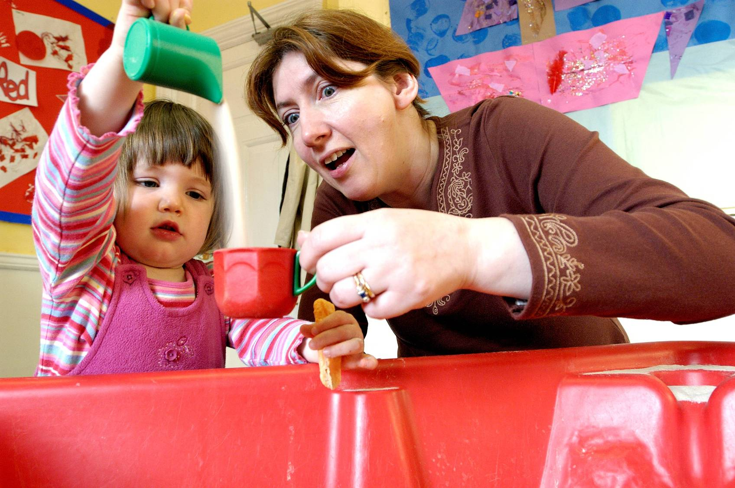

Childcare

Researching a topic on the internet – caring for children and young people
You have been asked by a friend who has become pregnant to help her look into childcare options for when the baby is 6 months old. You decide to do some internet research to help you with this task. You only have about an hour available – so you want to plan your time well.
You need to look up the kinds of childcare available, and get some idea of the likely cost involved. Once you have started to find information, use the boxes on the activity sheet to record what you have found. Try to use your own words rather than copying down chunks of information
Search ideas:
Try typing the ideas below into the search engine (e.g. Google)
- Types of childcare
- Family information service (plus the name of the area that you live)
- Day nurseries
- Childminders
- Going back to work after childbirth

 | Internet address | Summary of information
Types of childcare
Things to think about e.g. full or part-time care
Places to get more information (including telephone number of Family Information Service)
Examples of costs per week for childcare

Now you will be able to explain what you have found to your friend. They will be able to find out more because they will have the internet addresses that you used.

A day out with the children
Your friend who has two children has asked you to help to plan a day out for the children. You suggest a visit to an Animal Farm or City Farm.
You need to think about the value of the trip to the children, and how you will prepare them before, and follow up afterwards.
- Read through and think about the information in the case study below:
Your friend has two children. They are non-identical twins aged 3 years. Abi loves active games and likes climbing. She also enjoys listening to stories, and concentrates quite well. Toby likes to ride on his tricycle. He loves imaginative games and dressing up. He quite likes listening to stories, but doesn’t like to sit still for too long.
- Your friend would like to take the children out for the day and has asked you to help with the planning. She has also asked you to come with her on the trip. You suggest a day out at an Animal Farm (or a City Farm, depending on where you live).
- Now, answer the following questions.
  - Why would a trip to an Animal Farm / City Farm be a good idea for 3 year old twins?
  - What would you want them to get out of the trip?
  - What would you want to do with the children before the day out to prepare them?
  - What would you do with children after the visit to follow up the day out?

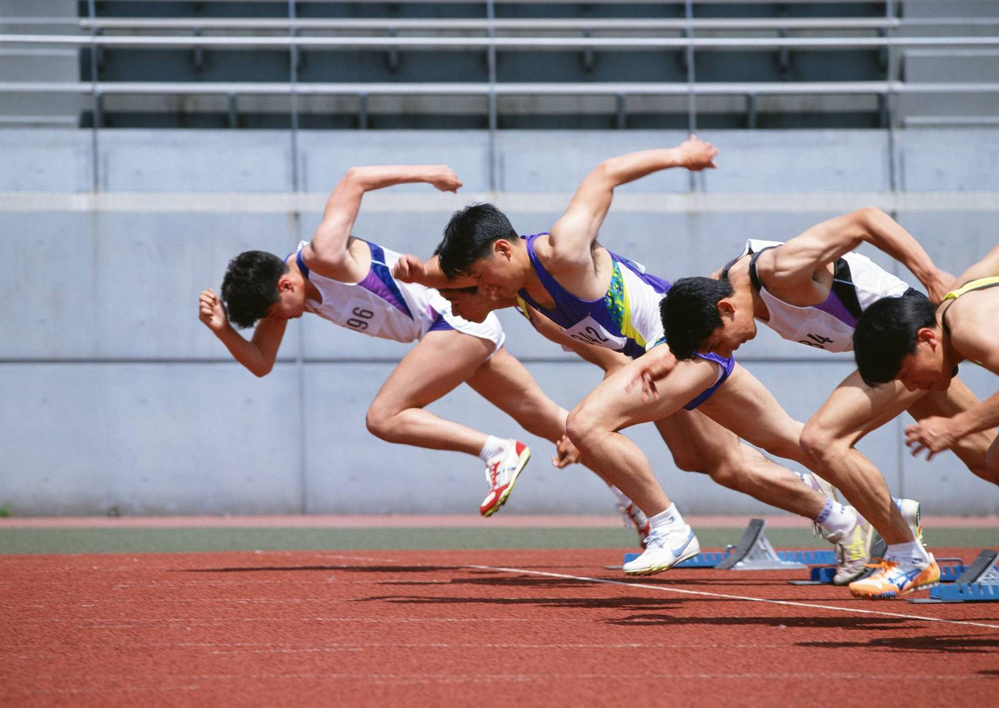

Sport & Leisure

Making your case
As a sports student, you know the advantages of regular exercise. The Sports Centre does not currently have a lot of facilities specifically for young people. They are planning on building the Vitality SHOKK Interactive Youth Gym.
Vitality SHOKK Interactive Youth Gym
Are you between 8 and 15 years of age? Then the Vitality SHOKK Interactive Youth Gym is for you. We know you like using PlayStation and playing games. You also like to keep fit. Vitality SHOKK is a place to exercise and have fun. We have all the latest equipment for you to use. Our specially designed gym equipment suits your age range.
- Fully fitted with bikes, rowers, free weights, treadmills
- Full time qualified instructors
- Free expert advice on health and diet
- Increase your strength and mobility
- Increase your confidence
- We can enhance your sports performance
- Improve your overall health
What will it cost?
One SHOKK class will cost you £4.00. 12 sessions at a SHOKK class will cost you £40.00.

- The next page gives a number of benefits to develop the SHOKK Youth Gym and a number of reasons not to. Use the shaded cards as headings. Match the cards to the most appropriate headings. Add your own ideas.
- When you have finished, share your answers with others in the group. You will need to be able to explain your answers.
- Write an article for a local newspaper, highlighting the findings of your discussion. You can write your article as a group, but it should not have more than 100 words and no less than 75 words.

Sports Centre  Reasons for |  | Sports Centre  Reasons against
General Public  Reasons for |  | General Public  Reasons against
Attract new customers |  | Keep young people active
Bring more money into the sport centre |  | Hire out the facility to schools and colleges during the day
Interest young people in keeping fit |  | Rooms are empty for many hours of the day. The centre is losing money.
Need to buy the specialist equipment |  | Give young people an interest
Too expensive for young people to use |  | Learn to use gym equipment safely

Making the best use of space

Task 1
Use the information below to label the map of the new Sports Centre.
- The main hall is the largest area shown on the plan.
- The café is between the main hall and the conference rooms.
- The reception area is beside the conference rooms and the main entrance.
- The main swimming pool is to the left of the main entrance as you go in.
- There are two parking areas. Parking for the disabled is to the left of the main parking area.
- The changing area for the swimming pools is to the left of the main building as you go in.
- There are squash courts at the back of the sports centre.
- There are two changing areas at the back of the sports centre.
- The other area at the back of the sports centre is a small hall.

The main hall is for playing team games and activities that need space such as badminton.
The fitness centre has a variety of fitness equipment such as weights, tread mills and cross-trainers.
The small hall has activities that need floor space but no fixed equipment.

Conference rooms
Learner Pool
Main entrance


Parking

Task 2
Find the 12 activities in the word search.
Weight training | Aerobics | Swimming | Football
Badminton | Handball | Skipping | Circuits
Pilates | Biking | Zumba | Yoga

f | h | p | b | i | o | c | s | s | o | r | o | m | g | s
o | a | i | i | e | n | b | a | o | h | a | m | n | i | p
o | n | l | k | a | e | a | s | s | r | o | i | i | z | e
t | d | a | i | e | p | d | n | k | e | n | f | e | u | h
b | b | t | n | e | m | m | e | e | i | h | s | e | m | e
a | a | e | g | c | f | i | c | a | p | p | b | a | b | i
l | l | s | m | e | e | n | r | i | h | f | p | l | a | r
l | l | y | o | g | a | t | a | e | r | o | b | i | c | s
n | o | u | t | r | t | o | l | r | t | c | w | n | n | l
i | e | e | o | h | o | n | p | r | l | h | u | a | g | g
t | h | e | g | s | w | i | m | m | i | n | g | i | a | t
m | e | i | f | r | a | e | e | e | n | c | o | e | t | s
w | e | a | f | r | t | e | y | e | o | e | o | t | c | s
w | c | n | i | a | t | a | l | a | r | u | r | e | h | r

- Where would you find these activities in the Sports Centre?
- Which activity will not take place in the Sports Centre?
- Find out what the words in the shaded boxes mean.

Rules and regulations

Every organisation needs to have a set of rules. The rules are there to make the work place safe and to let people know what is expected of them.
Task 1
Create a set of no more than 5 rules for members of the public using the Sports Centre, to be displayed in the Sports Centre.
Task 2
For each of the following, give your opinion on what action the Sports Centre staff should take if they find a member of the public carrying out the following activities. You would get a manager to make the decision. Which decision should they make? Choose from the following:
Talk to the person | Call the police
Ask the person to leave and not come back | Ignore the incident

- Smoking on the premises | - Scribbling graffiti on the Sports Centre’s walls
- Using sexist or racist language | - Stealing from another member of the public
- Being noisy and disruptive in the centre | - Dropping litter or spitting in the Sports Centre
- Using a mobile phone in the Sports Centre | - Threatening a member of staff
- Bringing drugs onto the premises | - Selling or passing drugs to someone in the Sports Centre
- Bringing alcohol onto the premises | - In possession of an offensive weapon

Task 3
For each of the following, give your opinion on what action the Sports Centre Management should take if they find a member of their staff carrying out the following. You can choose from:
A verbal warning | Written warning
Instant dismissal | Call the police

- Smoking on the premises | - Scribbling graffiti on the Sports Centre’s walls
- Using sexist or racist language | - Stealing from a member of the public
- Being noisy and disruptive in the centre | - Dropping litter or spitting in the Sports Centre
- Using a mobile phone in the Sports Centre | - Threatening another member of staff
- Bringing drugs onto the premises | - Selling or passing drugs to someone in the Sports Centre
- Bringing alcohol onto the premises | - In possession of an offensive weapon
- Falling asleep at work | - Arriving at work drunk
- Arriving late for work on a regular basis

What the customer thinks

In large organisations, the marketing department often carries out surveys to find out what their customers need and would like from the company, in this case the leisure centre. Below are the results of a survey that marketing have carried out. They asked people leaving the centre. They asked 50 men and 50 women.
Task 1
Complete the grid below.
 | Men agreeing | Men disagreeing | Women agreeing | Women disagreeing | Total agreeing | Total disagreeing
The staff are friendly | 35 |  | 40 |  | 75
Good service at the tills | 46 |  | 36 |  | 82
Wide range of activities to take part in | 14 |  | 45 |  | 59
High quality equipment | 42 |  | 45 |  | 87
Helpful advice from the staff | 35 |  | 46 |  | 81
Centre is clean | 48 |  | 50 |  | 98
Swimming pool is warm | 45 |  | 50 |  | 95
Café has good opening hours | 25 |  | 45 |  | 70
There are sufficient activities for teenagers | 40 |  | 30 |  | 70
Good value for money | 40 |  | 40 |  | 80

Task 2
Answer the following questions:
- Which group thinks there are too few activities?
- Which group thinks the staff could be more helpful?
- Which group thinks the swimming pool is just the right temperature?
- The café is open between 10am and 4pm. Which group thinks the café needs to increase its opening hours? When do you think this group uses the Sports Centre?
- Which group thinks there are not enough activities for teenagers?

Task 3
Design a questionnaire to find out what teenagers think about the facilities at the centre.
You want to find out what they like about the centre and what facilities they would like to see at the centre.
Listed below are 15 questions. You need to choose the best 10 for your questionnaire. Give reasons for your choice of 10 questions.
- What age are you?
- When do you visit the centre?
- What activities do you take part in?
- How often do you visit the centre?
- When did you last visit the centre?
- Who do you come to the centre with?
- Is the café open when you visit?
- Are the prices too high?
- Would you like to join a class to improve your skills?
- Are the prices reasonable for the activity you take part in?
- Can you hire equipment?
- Is equipment available to hire for the sport you wish to take part in?
- What activities would you like at the centre?
- What additional activities should be on offer at the centre?
- How do you get to the centre?

Task 4
Finding out how people feel about the services the Leisure Centre offers is very important. It is also important to show your customers that you take the findings seriously and are prepared to let others know the results of your surveys.
Using the information from the customer feedback grid create a series of bar graphs or pie charts for display in the Leisure Centre.

Sports Centre activities

Task 1
You need to decide which events should be held in the various sports halls. Read the information sheet to help you decide. Complete the table below.
Activity | Main Hall | Small Hall | Fitness Studio | Swimming Pool | Who is the activity for?  (Men, ladies, young people)
Aqua aerobics
All over body workout
Badminton
Basketball
Boxercise
Circuits
Introduction to the gym
Indoor football
Indoor hockey
Kids street dance
Low impact aerobics
Pilates
Total floor workout
Weight training
Yoga
Zumba

Task 2
You need to create a Frequently Asked Questions (FAQ) sheet to help the people working on the reception desk. Use the Information Sheet on the next page to help you.
- Which activities involve being part of a team?
- Which activities take place in the swimming pool?
- Which activities involve working out to music?
- I have never been in a fitness studio. Which class could I join to find out more about fitness?
- Which classes are suitable for children?
- Which classes have age restrictions?
- I am elderly but I would like to keep fit. Which class would you suggest I join and why?
- What is the difference between Zumba and Pilates?
- I cannot lift heavy weights. Is there any point in joining the weight training class?
- Which class would help me relax and find out how to meditate?

Information sheet about each class
All exercise classes are 50 minutes long.
Aqua aerobics | All over body workout | Badminton | Basketball
Energetic workout in the water, suitable for anyone aged 16+ | Toning class combining aerobic and resistance toning exercises  Suitable for all | Learn how to play this fast moving game  Minimum age 15 | Take part in a fast and active sport
Boxercise | Circuits | Introduction to the gym | Indoor football
A choreographed aerobic work-out with a boxing theme using non-combat movements | Intensive workout involving working around a large number of different activities  Minimum age 15 | Find out how to use the gym equipment safely  Suitable for 16+ | Bring your team of 5 players and have a game
Indoor hockey | Kids street dance | Low impact aerobics | Pilates
Bring your team along, or join a team here | An upbeat class based on jazz dance themes and the latest chart tunes | A great aerobic workout with low impact on your joints | Focusing on inner core (mat work), designed to give you longer and leaner muscles to improve posture.
Total floor workout | Weight training | Yoga | Zumba
A class dedicated to getting the best tone and strength out of your body | Use weights safely to improve muscle strength.  Minimum age 16 | Tones muscles and improves flexibility whilst exploring relaxation and meditation techniques | Use Latin American music to get fit

Task 3
Look at the price list for the Sports Centre.
- How much of a saving is there if you pay for 12 sessions?
- How much do you save if you have a ‘Leisure – over 50’ card for 12 sessions?
- How much is an annual season ticket?
- How many classes would you need to attend to make it worthwhile?
- How many classes would you need to attend to make it worthwhile per week?

Price list for Play and Pay users

Adult (55 minutes) | £5.90
Adult (12 sessions) | £59
Leisure - over 50 card holder | £5
Leisure - over 50 card holder (12 sessions) | £50
Annual ticket (access to all classes) |  | £600



Construction

Basic woodworking

Woodworking Hand Tools
Name the missing hand tools and their uses.
Hand Tools | Name | Use
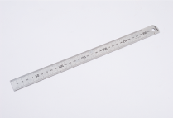 |  |  | For measuring
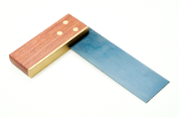 | Tri-square
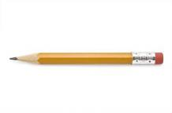 |  |  | For marking out work

Hand Tools | Name | Use
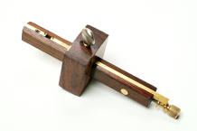 |  | For marking lines parallel to the edge of a piece of wood
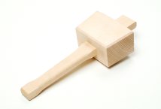 | Mallet
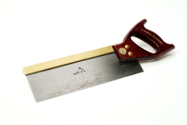 |  | For cutting wood
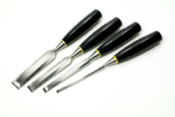 | Chisels
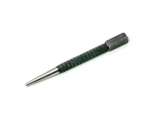 |  | For knocking-in nails below the surface

Hand Tools | Name | Use
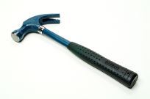 |  | For knocking-in nails and removing nails
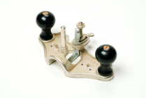 |  | For cutting a channel in a piece of wood
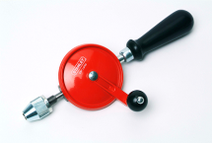 | Wheel brace
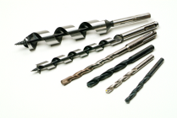 |  | Used in a drill to drill holes
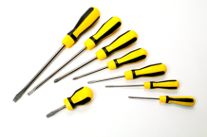 | Screwdrivers

Hand Tools | Name | Use
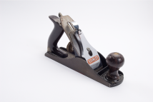 |  | For smoothing the surfaces of wood
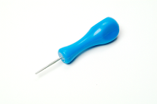 | Bradawl
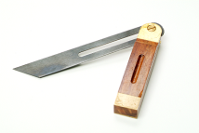 |  | For marking or measuring a line at an angle
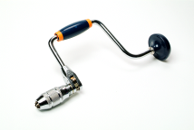 | Carpenter’s brace
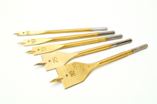 |  | Used in a drill to drill larger diameter holes
Woodworking Joints and Wood-Screws
Name the following woodworking joints.
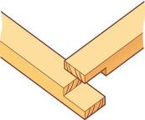 | 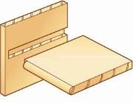
Name: | Name:
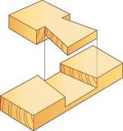 | 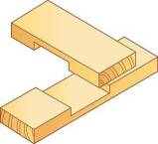
Name: | Name:

Name the different types of wood-screws.
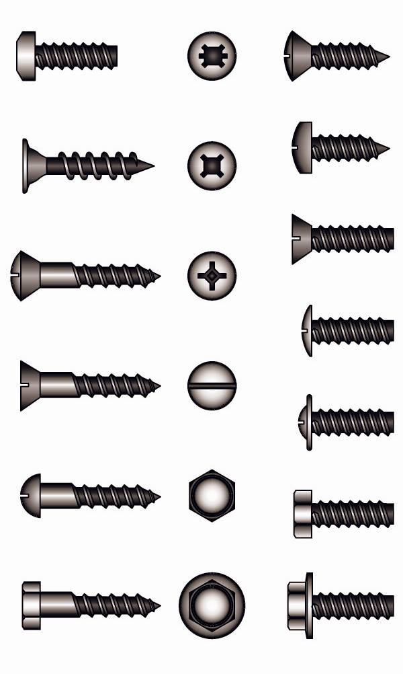
Name: | Name:
Name: | Name:

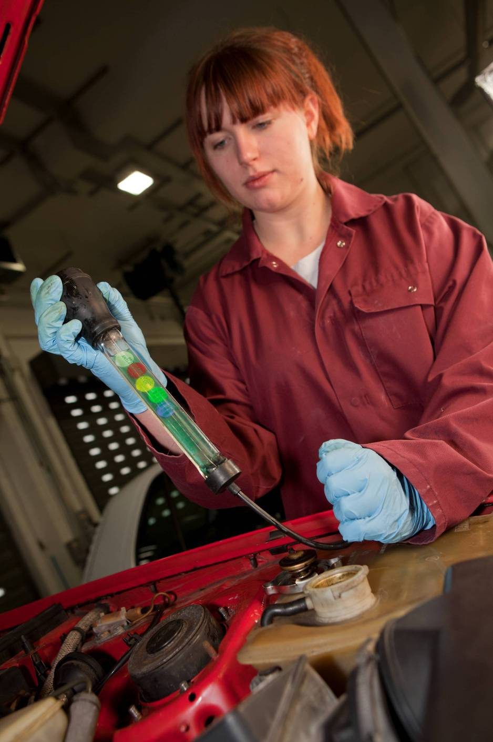

Engineering

Bridge structures

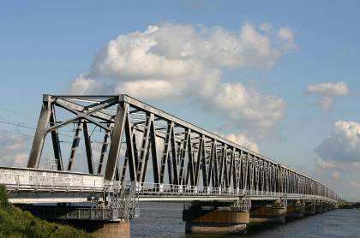
Truss Bridges
A truss bridge is an example of a frame structure. They use triangles which make the frame extremely strong.
They are one of the oldest types of steel bridges, often used to carry railway lines and roads.
There are a wide range of truss bridge designs – you can see some examples below:
Bridge Structures
Pratt | Baltimore
Howe | Warren
Fink | Warren (with Verticals)
Waddell “A” Truss | Double Intersection Warren
Double Intersection Pratt | Lattice

Task 1
In pairs or small groups, build a truss bridge using art straws. You should use one of the templates provided for a Warren, Pratt, Howe or K-Truss type of bridge design.
- You need to carefully measure each part and accurately cut your art straws to size.
- Construct two identical sides using the templates as a guide.
- Join the two sides together 10 cm apart using more art straws.
Which type of truss bridge design do you think will hold the most weight without breaking?

Warren Truss Bridge Template

Pratt Truss Bridge Template

Howe Truss Bridge Template

K-Truss Bridge Template

Bridge Testing
Task 2
Test each truss bridge model by spanning a gap between two tables and hanging weights from them until they fail (break).
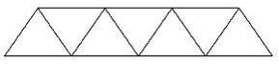

Record all the results in the table below:
Type of bridge & Team | Weight held before failure | Reason for failure

What was the most successful truss bridge design?
Why do you think it was the best?

Basic metal working

Metalworking Hand Tools
Task 1: Name the missing hand tools and their uses.
Hand Tools | Name | Use
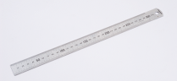 |  | For measuring
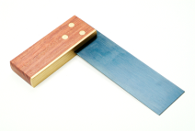 | Engineer’s square
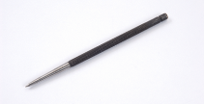 |  | For marking out on the surface of metal
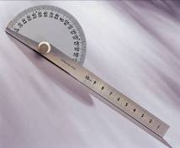 | Bevel protractor

Hand Tools | Name | Use
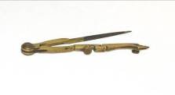 | Odd-leg callipers
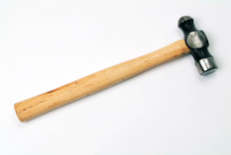 |  | Used to strike a centre punch
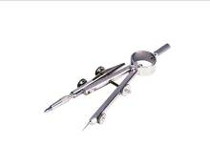 |  | For marking arcs and diameters
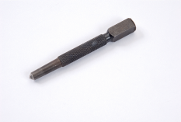 | Centre punch
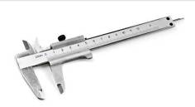 |  | For taking precise measurements

Hand Tools | Name | Use
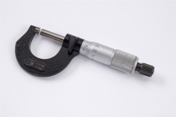 |  | For taking precise measurements of external diameters
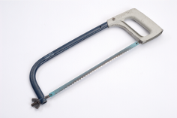 | Hacksaw
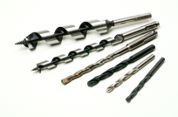 |  | Used in a drill to drill holes
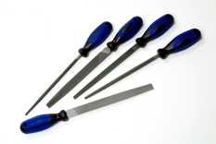 | Files
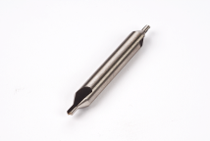 |  | To make a starting hole for a larger sized drill bit

Hand Tools | Name | Use
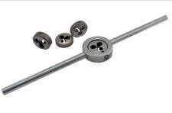 | Die set
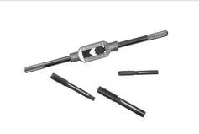 |  | For cutting internal threads
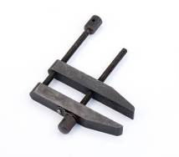 | Toolmaker’s clamp
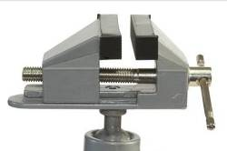 |  | Attached to a work bench to hold work securely

Name the parts of the pillar drill.
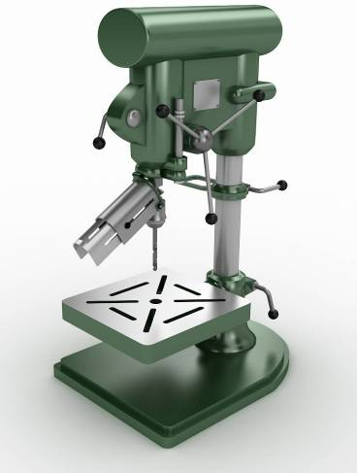
Lever A
Lever B
What does lever A do?
What does lever B do?

Name these two work-holding devices used on a pillar drill.
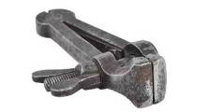 | 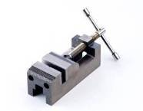
Name: | Name:

Car crash

Car Structures
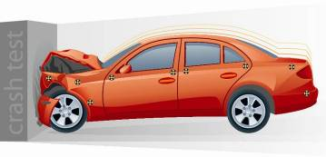
Most cars are made up of a reinforced internal structure that protects the occupants in a crash. The body panels are attached to this structure. Some racing cars also have an internal roll cage for added protection.
Euro NCAP testing provides drivers and the automotive industry with a realistic and independent assessment of the safety performance of cars.
The picture shows a frontal impact test.

Task 1
What happens to a car in a frontal impact test? What protects the driver?
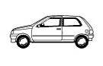

Car Crash Test
Task 2
In pairs, build a paper model car that can withstand an impact.
Carefully cut out and assemble the paper net of the car. However, paper is not very strong, so you will have to design and make an internal structure that will absorb the impact of a crash. Use art straws to build your structure.

If you have time, you could even decorate your car in team colours.

Car Template

Task 3
Test and evaluate your model paper car.
Your teacher will randomly select the type of crash test that you will be given.
Impact test: (please circle) | Rear Impact Test | Frontal Impact Test |  | Side Impact Test
Describe the damage to your car:
What worked well? |  |  | What needs to be improved?



Hair & Beauty

Planning time

Task 1
Scissors is a hair and beauty salon. Below is a list of some of the services that they offer their clients.
Beside each service, you will see the time that needs to be given to the client for the service. For example, if you are asked to book in a client for a child aged 10 for a cut then you would give them an appointment for 30 minutes.
The Scissors salon is open between 9.00am and 5.30pm each day.
Scissors | Time needed for appointment
Cuts
Women’s cuts and blow dry  Women’s wet cut  Gents  Children 0 - 7  Children 8 - 15 | 45 minutes  15 minutes  15 minutes  30 minutes  30 minutes
Blow dry and straightening
Short to medium lengths  Long | 30 minutes  45 minutes
Beauty
Manicure | 30 minutes
Pedicure | 30 minutes
Wax | 30 minutes

Read the information below before starting the task.
Your manager wants you to look after the appointment book for the Scissors salon. You will make appointments for your clients. You will need to log the appointments in the appointments page given below. The phone calls are on the post-it sheets.
You will need to remember that the two stylists and beautician have an afternoon break of 15 minutes, the lunch break and morning break are already on the appointments page. If possible, the afternoon breaks should not be at the same time.
Emma and Mark are the hair stylists and Jen is the beautician. Try to make sure that Emma and Mark have the same number of appointments. Here is the appointments page with some appointments already booked in.
Each line in the book shows 15 minutes of time.
- A 15-minute appointment would take up one line.
- A 30-minute appointment takes up 2 lines.
- A 45-minute appointment takes up 3 lines.

Scissors appointment book
Time | Emma - Hair stylist | Mark - Hair stylist | Jen - Beautician
9.00 | Wet cut and blow dry
9.15
9.30 |  | Wet cut and blow dry short hair
9.45 | Wet cut and blow dry short hair | Wet cut and blow dry short hair
10.00 | Wet cut and blow dry short hair | Wet cut and blow dry short hair
10.15 | Wet cut and blow dry short hair
10.30
10.45 | BREAK
11.00 |  | BREAK | BREAK
11.15 |  |  | Manicure
11.30 |  |  | Manicure
11.45 |  |  | Pedicure
12.00 |  | Lunch | Pedicure
12.15 |  | Lunch
12.30 |  | Lunch | Lunch
12.45 |  | Lunch | Lunch
1.00pm | Lunch | Wet cut and blow dry | Lunch
1.15 | Lunch | Wet cut and blow dry | Lunch
1.30 | Lunch | Wet cut and blow dry | Wax
1.45 | Lunch |  | Wax
2.00 | Wet cut and blow dry long hair |  | Manicure
2.15 | Wet cut and blow dry long hair |  | Manicure
2.30 | Wet cut and blow dry long hair
2.45 | Wet cut and blow dry long hair
3.00
3.15 | Child hair cut
3.30 | Child hair cut
3.45
4.00 | Blow dry and straightening long hair
4.15 | Blow dry and straightening long hair
4.30 | Blow dry and straightening long hair
4.45
5.00 |  | Gents dry cut
5.15 |  | Gents dry cut | Pedicure
5.30 |  |  | Pedicure


Name of Client:
1
Name of Stylist:
Jen
What they want done:
Wax
Preferred time of day:
Late Morning
Name of Client:
2
Name of Stylist:
Jen
What they want done:
Pedicure
Preferred time of day:
9.30am
Name of Client:
3
Name of Stylist:
Mark
What they want done:
Wet cut, blow dry, short hair
Preferred time of day:
10.30am

Name of Client:
5
Name of Stylist:
Mark
What they want done:
Cut and blow dry
Preferred time of day:
Afternoon
Name of Client:
4
Name of Stylist:
Any
What they want done:
They have two children needing haircuts both at the same time.
Preferred time of day:
Late morning
Name of Client:
6
Name of Stylist:
Mark
What they want done:
Gents cut and lady wet cut same time if possible
Preferred time of day:
Morning

Name of Client:
8
Name of Stylist:
Mark
What they want done:
Blow dry and straightening long hair
Preferred time of day:
After 1.30pm
Name of Client:
7
Name of Stylist:
Emma
What they want done:
Ladies wet cut
Preferred time of day:
Afternoon
Name of Client:
10
Name of Stylist:
Jen
What they want done:
Wax
Preferred time of day:
Afternoon
Name of Client:
9
Name of Stylist:
Emma and Jen
What they want done:
Wet cut and blow dry and a manicure
Preferred time of day:
Late Afternoon

Making money
Read the information given in the appointment book for one day.

Scissors appointment book
Time | Emma - Hair stylist | Mark - Hair stylist | Jen - Beautician
9.00 | Wet cut and blow dry
9.15
9.30 |  | Wet cut and blow dry short hair | Pedicure
9.45 | Wet cut and blow dry short hair | Wet cut and blow dry short hair | Pedicure
10.00 | Wet cut and blow dry short hair | Wet cut and blow dry short hair
10.15 | Wet cut and blow dry short hair | Wet cut and blow dry short hair
10.30 |  | Wet cut and blow dry short hair | Wax
10.45 | BREAK |  | Wax
11.00 |  | BREAK | BREAK
11.15 | Lady wet cut | Gent wet cut | Manicure
11.30 | Child’s hair cut - 5 year old | Child’s hair cut - 9 year old | Manicure
11.45 | Child’s hair cut - 5 year old | Child’s hair cut - 9 year old | Pedicure
12.00 |  | Lunch | Pedicure
12.15 |  | Lunch
12.30 |  | Lunch | Lunch
12.45 |  | Lunch | Lunch
1.00pm | Lunch | Wet cut and blow dry | Lunch
1.15 | Lunch | Wet cut and blow dry | Lunch
1.30 | Lunch | Wet cut and blow dry | Wax
1.45 | Lunch | Blow dry and straightening long hair | Wax
2.00 | Wet cut and blow dry long hair | Blow dry and straightening long hair | Manicure
2.15 | Wet cut and blow dry long hair | Blow dry and straightening long hair | Manicure
2.30 | Wet cut and blow dry long hair | BREAK
2.45 | Wet cut and blow dry long hair |  | Wax
3.00 | BREAK |  | Wax
3.15 | Child hair cut 6yr old |  | BREAK
3.30 | Child hair cut 6yr old
3.45 | Lady’s Wet hair cut | Wet cut and blow dry | Manicure
4.00 | Blow dry and straightening long hair | Wet cut and blow dry | Manicure
4.15 | Blow dry and straightening long hair | Wet cut and blow dry
4.30 | Blow dry and straightening long hair
4.45 | Wet cut and blow dry |  | Manicure
5.00 | Wet cut and blow dry | Gents dry cut | Manicure
5.15 | Wet cut and blow dry | Gents dry cut | Pedicure
5.30 |  |  | Pedicure

Task 1
Work out how much the hairdressing side of the salon made for that day. It may help you to complete the table below.
 | Cost | Number done by Emma | Number done by Mark | Total completed | Takings - total x cost | Total
Example – gent’s cut | £10 | 0 | 3 | 3 | 3 x £10 | £30
Cut and blow dry | £15
Wet cut | £12
Gents cut | £10
Children’s cut 0-7 | £8
Children’s cut 8 – 15 | £10
Blow dry and straightening short hair | £15
Blow dry and straightening long hair | £20
Total takings for the day |  |  |  |  | £

Task 2
- Emma’s clients are very generous and give her tips of 10%. How much did she make today?
- How much will you earn in tips if you get 50p for every wash that you do for Emma and Mark’s clients?

Task 3
- Scissors is having a special promotion, linked to the Leisure Centre. Members of the Leisure Centre will receive a 10% discount on all the Salon’s prices when they show their membership card. Create a poster showing the original prices and the discount prices for display in the Salon and in the Leisure Centre.
- The owner of Scissors has decided to offer regular customers a special discount. They will each receive 15% off the standard rates. Complete the table below showing the discounted prices for regular customers.
Scissors price list
Cuts |  |  | Tints
 | Cost | Special rate for regular customers |  | Cost | Special rate for regular customers
Women’s cuts and blow dry  Women’s wet cut  Gents  Children 0 - 7  Children 8 - 15 | £15  £12  £10  £8  £10 |  | Tints short  Tints long  Tints with flashes short  Tints with flashes long | £20  £25  £30  £35
Blow dry and straightening |  |  | Foils
Short to medium lengths  Long | £10  £15 |  | T-bar short  T-bar long  Half head short  Half head long  Full head short  Full head long | £25  £30  £30  £35  £40  £45

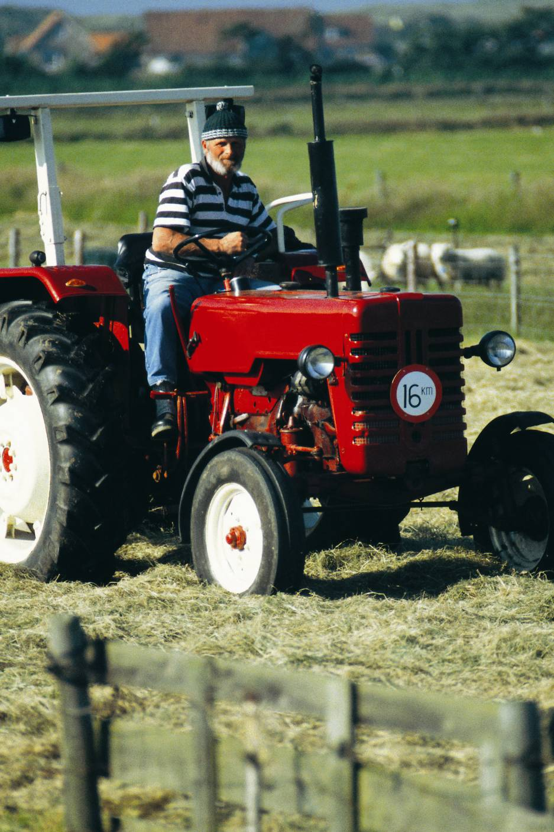

Land Based

Recycling
Each household produces around one tonne of rubbish every year. It is important that we recycle more waste as most of it simply ends up in landfill.
Task 1
Complete the following word search using the recycling key words. The words may be vertical, horizontal, diagonal, forwards or backwards in the grid.

j | r | e | d | u | c | e | k | g | l | a | l | a | k | b
q | v | r | y | t | w | t | a | j | s | h | s | l | r | x
m | u | i | e | o | p | t | k | k | y | s | t | b | o | a
f | a | t | r | c | c | j | e | y | a | n | q | r | s | b
h | s | e | n | e | y | r | r | l | i | n | x | i | s | i
a | h | y | v | e | b | c | g | e | o | w | t | n | e | f
z | x | b | h | s | m | o | l | i | u | a | c | g | c | e
a | w | r | i | a | v | n | t | e | d | s | z | b | o | n
r | u | d | h | l | t | c | o | n | d | t | e | a | r | d
d | e | o | h | a | e | c | a | r | f | e | a | n | p | d
o | y | i | o | l | v | r | e | h | i | c | p | k | e | o
u | f | y | l | x | l | y | m | v | v | v | m | w | r | k
s | f | o | x | j | d | l | l | i | f | d | n | a | l | r
q | c | g | m | h | v | q | n | f | x | a | g | e | i | q
c | l | q | k | y | s | q | c | o | m | p | o | s | t | k

Kerbside | Bring bank | Reprocessor | Environment
Landfill | Collection | Reuse | Glass
Recycle | Compost | Waste | Hazardous
Reduce

Recycled Furniture
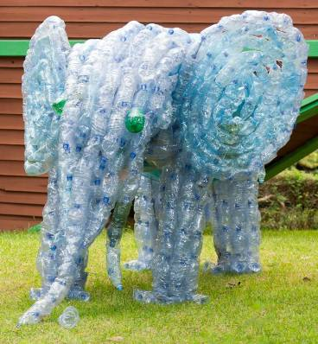
Many designers are now recycling materials and products to produce new creative pieces of art, furniture and other objects.


Task 2
CPUs (Central Processing Units) from outdated computers contain gold and copper, which can be recycled. But what can we do with the plastic casings?
In small teams, design and model a piece of furniture that reuses computer CPUs.
Carefully cut out and assemble as many CPUs as you need.
Try building a chair out of these CPU nets. You’ll need approximately 6 CPUs.

CPU Nets
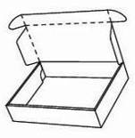
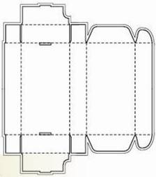
CPU

Well groomed
When you are grooming an animal, you need to know what tools to use for each task. Fill in the missing words.
de-matting comb |  | scissors | nail clippers | comb
grooming table |  | undercoat rake | soft brush | slicker brush
grooming arm
1 | When you are going to groom an animal, it is useful to have a _____________________________________. This helps you to reach each part of the animal easily. It will also make it easier to see which parts need to be groomed or trimmed.
2 | If you are grooming dogs, a _________________________________ makes it easier to restrain the dog.
3 | If a small animal needs its claws or nails clipping use ________________________________.  Light coloured nails are the easiest as you can see the “quick” (the blood supply).
4 | If you need to trim delicate areas, such as around the paws or face, a pair of ______________________ can help you to do this accurately.
5 | If the animal is prone to tangles, they need regular grooming. A ____________ can help to reduce tangles, especially for short or medium length breeds. If the hair is long, a _______________________________________ can be more suitable, and this also smoothes the coat.
6 | If tangles are left and have become matted, you may need a special _______________________.
7 | A ______________________________________ does not remove tangles, but will smooth the coat to give a glossy finish.
8 | Sometimes it is useful to be able to remove the fluffy undercoat and reduce tangles. An __________________________________________ is a useful tool for this.

Draw lines to link the correct name with each picture. Then draw a second set of lines to link each picture with the grooming task each one is most suited to.
Comb |  | 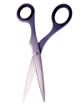 |  | Remove fluffy undercoat to reduce tangles
Soft brush |  | 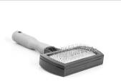 |  | Trimming delicate areas, for example the face
Scissors |  | 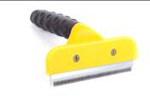 |  | Reduce tangles, especially for short or medium haired breeds
Slicker brush |  | 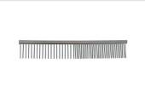 |  | Help to keep proper control of dogs while grooming
Undercoat Rake |  | 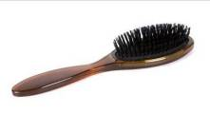 |  | Smooth or lift the coat for smooth, short breeds

Nail clippers |  | 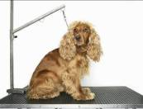 |  | Smooth the coat and reduce tangles, especially for long, curly or woolly breeds
Grooming table |  | 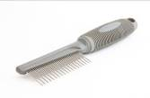 |  | For the animal to stand or lie on to make grooming easier
Grooming arm |  | 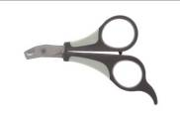 |  | Removes difficult matts, knots and tangles
De-matting comb |  | 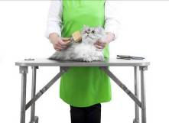 |  | Clip claws and toe nails

Saddle up and ride your pony!
There are two tasks:
- Complete the gaps on the labels of the parts of the saddle using the words from the word box.
- Find the names of the parts of the saddle in the word search puzzle. The words may be horizontal, vertical, diagonal, forwards or backwards.

Fill in the blanks to label the parts of the saddle using the correct words from the word box
Word box
Sea_
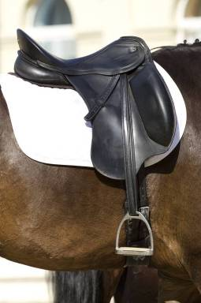
Stirrup
Girth
Pommel
Seat
Cantle
Knee roll
Skirt
Stirrup leather
Numnah
P_ mmel
_kirt
C_ nt_e

Kn _ _
r_ ll
Sti _ _ up
lea_ _ er

G_ _th
Nu _ n _h

S _irr_p

Saddle up and ride your pony: Word search
Find the words shown at the bottom of the page and circle them in the puzzle. The words may be vertical, horizontal, diagonal, forwards or backwards.
d | c | a | k | t | r | i | k | s | u | u | r | z | w
m | a | y | f | f | w | x | m | t | d | e | y | y | q
k | n | e | l | j | t | n | k | i | y | y | a | x | s
k | t | t | p | w | h | s | c | r | q | n | s | e | z
u | l | h | r | l | s | m | l | r | w | r | a | k | h
d | e | p | x | e | y | g | l | u | s | t | d | v | t
k | n | u | a | m | m | r | o | p | a | g | u | t | r
r | q | r | n | m | u | o | r | l | d | u | g | o | i
v | k | r | b | o | z | v | e | e | d | o | n | t | g
c | u | i | k | p | r | s | e | a | l | v | y | g | z
y | t | t | h | k | n | y | n | t | e | o | r | g | x
j | v | s | y | z | i | c | k | h | h | d | h | b | t
i | f | h | a | n | m | u | n | e | k | d | b | c | z
e | d | o | m | o | h | s | k | r | x | f | p | w | z

Words to find:
Saddle | Pommel | Seat | Cantle | Skirt
Knee Roll | Girth | Stirrup Leather | Numnah | Stirrup

Animal needs
In your group, cut up the answer cards and decide which of the answer cards need to fit in each square on the animal templates. Stick the cards into the squares once you have agreed which ones go where.
Lots of the squares can have more than one answer.
Small animal needs
Animals | Type of feed | Method of feeding | Type of water drinker | Type of bedding | Method of cleaning out
A group of guinea pigs
A cat
A pair of rats
Three budgerigars

Farm animal needs
 | Type of feed | Method of feeding | Type of water drinker | Type of bedding | Method of mucking out
A herd of dairy cattle over winter
A lactating sow
A calf
A flock of sheep wintered outside

Answer cards – to cut up before starting
Bowl | Bowl | Bowl | Bowl | Bowl | Trough | Trough | Trough | Trough | Bucket
Bottle | Bottle | Bowl | Feed passage | Bowl drinker | Trough | Greens | Greens | Hayrack | Trough
Bowl drinker | Bowl drinker | Straw | Bite drinker | Bird sand | Hay | Hay | Hay | Hay | Straw
Straw | Straw | Straw | Grass | Grass | Brush and dustpan | Concentrates | Grazing | Shavings | Grazing
Grazing | Bowl drinker | Silage | Rubber matting | Shredded paper | Shredded paper | Fleece bed | Shavings | Brush and dustpan | Water drinker
None | High protein pellets | Tractor and muck scraper | Fruit | Shovel | Shovel | Fork | Shovel | Fork | Fork
Teated bucket | Litter scoop | Seed mix | Fruit | Specialist dry food | Specialist wet food | Specialist dry food | Specialist dry food | Fruit | Grit
Concentrates | Concentrates | Milk replacer+ water | Brush and dustpan | Vegetables | Vegetables | Vegetables | On floor | On floor | On floor

Healthy calves
Cut out the cards and then sort them into two groups – cards with the characteristics of a healthy animal and cards with the characteristics of an unhealthy animal.
Bright eyes | Lively
Drinking milk well | Alert and interested
Breathing slowly and evenly | Moist nose
Shiny coat | Erect ears
Sunken eyes | Shivering
Refusing milk | Fast breathing
Coat looks dull | Listless (no energy)
Limping | Scours (diarrhoea)
Wet, swollen navel | Coughing

Farm animal families
Game rules – farm animal families
The object of the game – to have as many matched pairs (farm animal name plus its meaning) as possible. The winner is the player who has the most correct pairs at the end of the game.
To play:
Shuffle the cards well and deal 5 cards to each player. Put the remaining cards face down in a stockpile.
Put the farm animals happy families answer sheet somewhere where all players can see it to refer to if needed.
Players look at their cards, and if they have been dealt a matching pair (i.e. the animal name plus its meaning) they can place this in a pile in front of them.
The player to the left of the dealer starts. The player asks any other player for a card that will match one they already hold. For example, if they hold “cow” they can ask for “an adult female cow that has had at least one calf”. If they already hold “an adult female cow that has had at least one calf” they need to ask for “cow”.
If the player they asked has the card, they must hand it to the first player, who can then place the matched pair in front of them. The first player can then have another turn, and can keep going until they ask for a card that a player does not have.
If the other player does not have the card then they say “go farm!” The turn then moves to the next person on the left.
Once a player has grouped all their cards into pairs, they pick up 5 more cards from the stockpile, and play continues until all cards are gone.
Alternative play:
Instead of shuffling all the cards, shuffle the farm animal terms and their meanings separately. Deal out 3 terms cards and 3 meanings cards to each player – this way each player has a balanced mix of both type of cards.

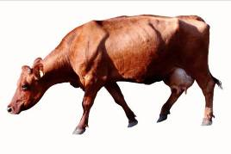  Cow | An adult female cow that has had at least one calf
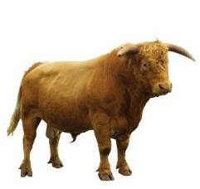  Bull | An adult male cow
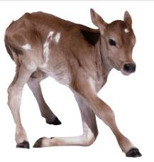  Calf | A young cow

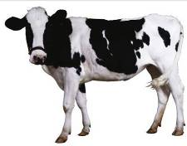  Heifer | A female cow before her first calf
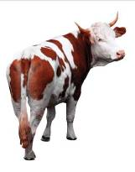  Bullock | A castrated male cow used for beef production
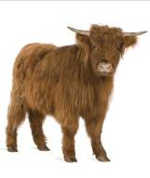  Steer | A castrated male cow used for beef production

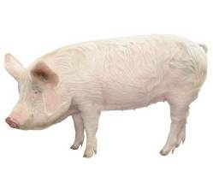  Sow | An adult female pig that has had at least one litter
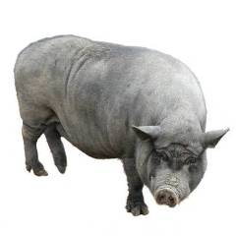  Boar | An adult male pig
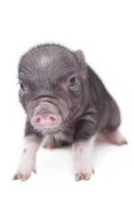  Piglet | A young pig

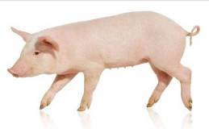  Gilt | A female pig who has not yet had her first litter
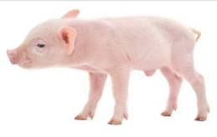  Weaner | A piglet for the first eight weeks after weaning
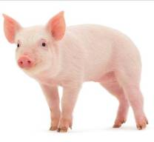  Grower | A pig between eight weeks old and sale

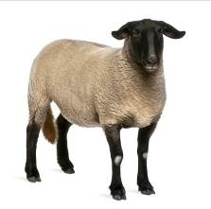  Ewe | An adult female sheep
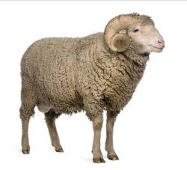  Ram | An adult male sheep
Tup | An adult male sheep

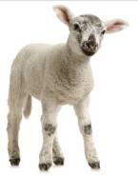  Lamb | A young sheep
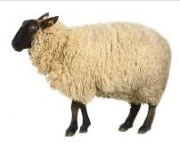  Wether | A castrated male sheep
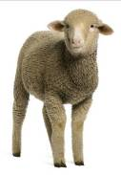  Store lamb | A lamb sold in the autumn for further feeding

Farm animal families reference sheet

Cow | An adult female cow who has had at least one calf
Bull | An adult male cow
Calf | A young cow
Heifer | A female cow before her first calf
Bullock | A castrated male cow used for beef production
Steer | A castrated male cow used for beef production
Sow | An adult female pig who has had at least one litter
Boar | An adult male pig
Piglet | A young pig
Gilt | A female pig who has not yet had her first litter
Weaner | A piglet for the first eight weeks after weaning
Grower | A pig between eight weeks old and sale
Ewe | An adult female sheep
Ram | An adult male sheep
Tup | An adult male sheep
Lamb | A young sheep
Wether | A castrated male sheep
Store lamb | A lamb sold in the autumn for further feeding

Fill in the gaps with the correct farm animal term. All the terms are in the word box.
piglet | bull | lamb | ewe | cow
growers | ram | sow | gilt | calf
steer | weaner | store | lambs | bullock
boar | tup | wether | heifer

- An adult female sheep is called a ______________
- A young cow is called a _______________
- A female pig is called a _______________ before she has had her first litter
- An adult male cow used for breeding is called a ______________
- A _____________ is a piglet after it has been weaned from its mother
- A young sheep is called a _______________
- An adult female pig who has had at least one litter is called a _________
- A female cow who has not yet had a calf is a ________________
- A ___________ and a __________ are both terms used for an adult male sheep
- A young pig is called a _______________________
- A _______________________ is a castrated male sheep
- An adult female cow who has had at least one calf is called a _________
- An adult male pig is called a ____________________
- A _______________________ and a ___________________ are both names for a castrated male cow used for beef production
- Pigs being kept for meat production are called weaners first and then _______________________________
- When lambs are sold in the autumn for further fattening they are called ______________________________________

Does your animal need the vet?

Choose which cards go on the picture of the healthy dog and which cards go on the dog that is unhealthy.

Bright and shiny eyes | Ears are light pink and clean
Eating and drinking normally | Alert and interested
Breathing slowly and evenly | Stools are firm and brown
Shiny/glossy coat | Pink gums
Cool, moist nose | Smooth skin
Walking normally | Clear yellow urine
Runny watery eyes | Shivering
Excessive drinking | Fast breathing
Coat looks dull | Listless (no energy)
Limping | Loose or bloody stools
Yellow discharge from nose | Redness inside ears
Whining (for no apparent reason) | Scabs on skin

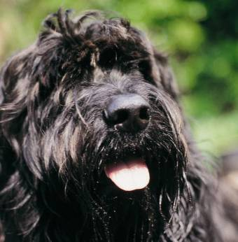
Healthy dog
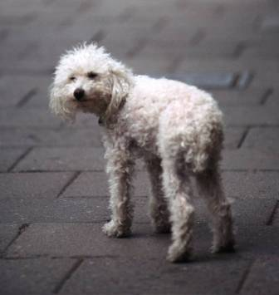
Dog in poor health

Planning a visit
Task 1
Group Activity
You are going to be working as a group to carry out an activity. Before you start the activity, you need to decide on some ground rules for your group that will make sure you can work together as a team. Spend the first ten minutes agreeing these, and make sure they are written down or drawn where everyone can see them.
The main part of the activity is to plan a visit for a group of school children to a land based centre. There are a few tasks, so it is likely you will need to divide the group up to do them. The children can see the centre in any order, finishing with lunch, but their visit needs to include:
  - A visit to the beef calf shed
  - A visit to the milking parlour
  - A walk around the historic trees in the gardens
  - A visit to the small mammal room (rabbits, guinea pigs, mice and chinchillas)
  - A visit to the pygmy goat enclosure, where they can go in and feed a goat
  - A visit to the stables to see the horses
  - Lunch
    - Look at the farm map and plan the order of the visit
    - Mark on the map any areas where there might be a risk of an accident
    - Create a poster for part of the visit. This should include any interesting information about that area of the visit, plus any health and safety information. For example, if you choose the stables, include some interesting information about horses plus any health and safety information about the risks in the stables and around horses.
Historic Trees Garden
Pygmy Goat Enclosure

Horse Stables

Lunch (Picnic Area)

Milking Parlour
Beef Calf Shed
Small Mammal Room

Task 2
Group Activity Review Sheet
On your own, look at the statements below and circle any of the things that took place in your group work.
We split all the work up |  | We worked on everything together
We split some of the work up |  | We worked on some parts together
Someone became our leader |  | We all had a specific role
We completed the whole task on time |  | We argued during the task
We ran out of time before the end |  | Everything went well
I think our poster is good quality |  | We had some problems
I think our poster could have been better |  | We agreed our ground rules
Some people didn’t stick to our ground rules |  | I enjoyed the group work
Everyone stuck to our ground rules |  | I didn’t enjoy the group work

Feeding time
Although animals need different food and are fed in different ways, there are some important steps in feeding any animal. This activity helps you to learn more about this important task.
Feeding an animal
There are some words missing from the following steps in feeding. Choose the right word from the list and write it into the gap. You can cross each word out when you have used it.
weigh | feed | animal
write | clothes | feed
wash | hands | place

- First put on any protective _________________
- Make sure you wash your ______________
- Check what sort of ____________ the animal needs
- Check how much _____________ the animal needs
- ______________ the feed out carefully
- Take the feed to the _______________________ using correct lifting/carrying methods
- Feed the animal in the correct _____________, e.g. trough, floor or bowl
- ________________ down how much you fed in the record book
- ________________ your hands again.

Reasons for the steps in feeding
Look at the reasons below for carrying out the steps in feeding. Match each reason with a step from the previous task by writing the step number in the box below.
Step in feeding (number) | Reason
 | To make sure you know how much feed to give the animal
 | To make sure you give the animal the type of feed it needs
 | To make sure you don’t become ill with a stomach upset
 | To make sure your clothes stay clean
 | To make sure you give the animal the correct amount
 | To help you to check how much feed the animal is eating
 | To make sure you keep the animal’s feed clean
 | To make sure the animal can reach the feed to eat it
 | To make sure you don’t damage your back

Move it!

Task 1
You have been asked to help move a group of 10 pigs from weaner pen A to grower pen B. You have 5 barriers you can use and 2 people. Each of the pens has a gate at the front.
Work in pairs to decide where you will put the barriers and people, and any gates you will open or close before you move the pigs. Draw the barriers, people and show the open and closed gates on the picture below. You will be asked to explain why you chose the positions afterwards. Then draw the route the pigs should take.
Barriers (x5):
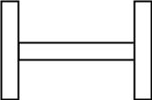
People:


Task 2
Which of the following should you wear when moving animals? Put a tick next to any that you think would be best, a cross next to any that are definitely not suitable and a question mark next to any you are not sure about.

Sandals

Shorts

Wellington boots

Safety boots

Trainers

Overalls

Necklace

Watch

Casual shoes

Warm hat

Planting bulbs
Cut out the cards and sort them into two groups. The first group should include the cards which are helpful when planting bulbs. The second group should include cards which are not a good idea when planting bulbs.
Shoot facing upwards | Shoot facing downwards
Deep hole (2-3 times depth of the bulb) | Shallow hole (just under the surface)
Firm bulb | Soft bulb
Good drainage | Lots of water to sit in
Plant in October | Plant in February
Plant in a sunny spot | Plant in the shade
Plant in a sheltered position | Plant in an exposed position

Best for bulbs activity cards
Cut out the cards and think about the order of tasks you need to do when planting bulbs. Sort the cards into order, starting with the first task you would do.
Put on protective clothing | Choose tools from tool shed
Choose bulbs for planting | Choose a location for planting
Dig over the soil | Dig a hole big enough for your bulbs
Mix some bone meal or bulb compost into the soil at the bottom of the hole | Plant the bulbs with their shoot facing upwards
Cover the bulbs over with the soil | Gently firm in the bulbs
Label where the bulbs are planted

Plant it
- Choose your container:
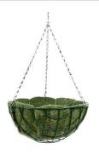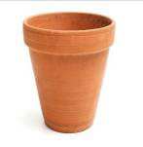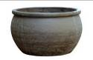
Hanging basket Tall narrow plant pot Low wide plant pot

- a) Choose which of the following you would like to put in first:
Moss | Gravel | Polythene
b) Why did you choose this?

- Which of the following would you like to add? Circle each one that you want and give a reason for using it. For those you do not choose, give a reason for not using it instead.
Compost
Reason:
Fertiliser
Reason:
Water retaining gels
Reason:

- Choose four plants to use in your container:

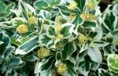 | Euonymus fortunei “Silver Queen”: versatile evergreen shrub, tolerates shade or sun. Attractive green leaves with silver edging.
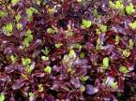 | Pittosporum “Tom Thumb”: evergreen shrub with bronze-purple leaves, grows in full sun or partial shade
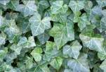 | Hedera helix (Ivy): evergreen climber, will also trail over a container, easy to trim, fast growing, will grow in full sun, shade or partial shade. Mixed green leaves.
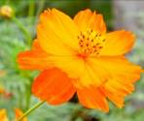 | Cosmos sulphureus “Cosmic orange”: easy to grow, needs full sun, bushy plants with large orange flowers on tall stems.
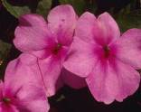 | Impatiens (“Busy Lizzie”) New Guinea Group - summer flowering, lasts into autumn, prefers a warm sheltered spot in either sun or shade. Bright purple/pink flowers.
 | Petunia “Rosy Wave” – flowers July to October in full sun, a trailing plant with pink flowers which flowers non stop.

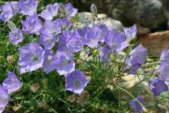 | Campanula carpatica “Chewton Joy” (bellflower) – low mounds of foliage with upward facing blue bells for weeks in summer. Needs full sun or partial shade.
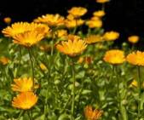 | Calendula officinalis (marigolds) – bright yellow/orange flowers June to October in full sun or partial shade. Needs deadheading to keep flowers going. Height 30cm.
 | Viola x wittrockiana (pansies) – grow well in sun or partial shade. Pinch off flowers after they start to wither to prolong flowering. Height 21-40 cm. Mixed colours.

- For TWO of the plants you have chosen, give a reason for choosing that plant:
Plant 1
Reason: ____________________________________________________________
Plant 2
Reason: ____________________________________________________________
Example reasons: size, height, colour, leaf type, leaf colour, goes well with other plants

- a) Which of these two specimens looks the most healthy to add to your container?
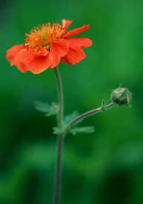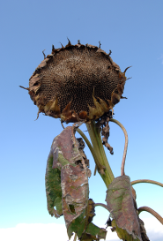
b) Why?
___________________________________________________________
___________________________________________________________
- Now that you have planted your container, what are you going to do? Circle all those that you think you should do.

Put the container in the shade | Put the container in a sunny spot | Water the plants
Put plant material (e.g. leaves) in the compost heap | Throw away plant material (e.g. leaves) | Put equipment away
Clean equipment | Wash your hands | Use plant supports
Put compost away | Leave any spare compost out for next time

Task 1
Cut out the cards and sort them into two groups. One group should contain cards which show characteristics of a sandy soil. The other group should show characteristics of a clay soil. Place the cards onto wither the sandy soil template or clay soil template.

Soil

Small particles | Holds water | Can get compacted
Small air gaps | Slow to warm up | Hard to dig
High nutrient levels | Can get waterlogged | Sticky to touch
Gritty to touch | Large particles | Drains well
Large air gaps | Dries out quickly | Easy to dig
Low nutrient levels | Warms up quickly | Needs extra watering

Sandy soil

Clay soil

Task 2
Which plants grow best in which types of soil?
There is a gap in each sentence. Fill in the gap with either sandy or clay.
- Carrots like to grow in soil that drains well. They are likely to do best in a _________________ soil.
- Cistus is a plant that likes warmth and does not need much water. It will prefer a _____________ soil.
- Hydrangea is a plant that needs plenty of water. It will grow best in a ____________ soil.
- Poppies prefer a free draining soil. They will grow best in a _________________ soil.
- The anemone prefers rich, fertile soil. It is likely to do best in _____________ soil.
- Roses need a good supply of water and nutrients. They are likely to prefer a ___________ soil.
- Lavender is a plant that likes loose, well draining soil. It will do best in a _____________ soil.
- Cabbages need to get many nutrients from the soil. They are likely to do best in a ______________ soil.
- Apple trees need to have plenty of water from the soil. They are likely to have the best crop in a ____________ soil.
10.The care instructions on a type of geranium say “tolerates any soil except boggy”. This plant will prefer a ______________ soil.


Health & Safety

Hazards in the workplace

A hazard is anything that might cause injury or ill health to anyone in a workplace.
Task 1
Identify the hazards that could cause injury or ill health in the workplace shown in the cartoon. Write a description of all the hazards you have identified.
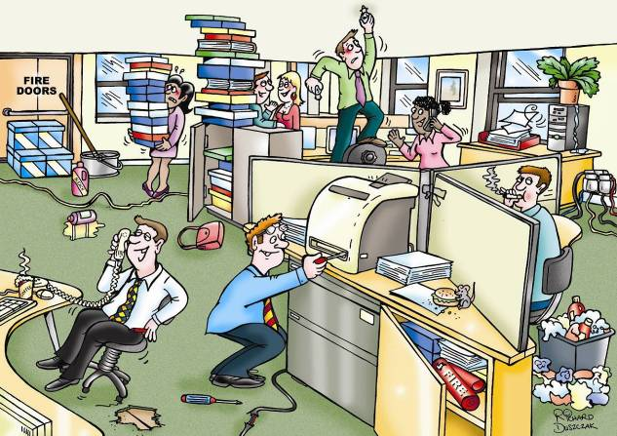

Risk Assessment
All workplaces must carry out risk assessments to identify any hazards to employees and put in place control measures to reduce the risk of injury.
Hazard |  | Risk |  | Control Measures
Potential risk from a substance, machine or operation |  | Actual injury or harm from the hazard |  | Actions taken to minimise the risks to people

This is an example of a risk assessment when using a computer:
Hazard | Risk | People at Risk | Control Measures
Using a computer | Eye strain | User | - Adjust glare from screen using brightness and contrast controls  - Tilt or swivel screen to reduce reflections  - Take regular breaks to rest eyes
Using a computer | Repetitive strain injury (RSI) | User | - Keyboard should tilt to provide a comfortable typing position  - Use an ergonomic keyboard with wrist support  - Use an ergonomic mouse  - Take regular breaks to rest hands

Task 2:
Complete a risk assessment for two more work activities.
Hazard | Risk | People at Risk | Control Measure

Health and safety signs

Employers must use a safety sign where there is a risk to health and safety. There are five main categories of signs.
Category | Meaning | Shape/Colours | Example of Symbol
Safe Procedure | SAFE emergency escape or first aid | Square or oblong. White symbol and text on a green background | 
Mandatory | YOU MUST carry out an action | Circular. White symbol and text on a blue background | 
Fire Equipment | FIRE – location of fire fighting equipment | Square or oblong. White symbol and text on a red background. | 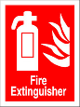
Warning | BE CAREFUL of possible dangers | Triangular. Black symbol and text on a yellow background surrounded by a black triangular band | 
Prohibition | DO NOT – danger of injury | Circular with a cross band. Black symbol on a white background, inside a red circle with a red cross bar. | 
Health and Safety Signs
Task 1
What do these signs mean?
 | 
Meaning: | Meaning:
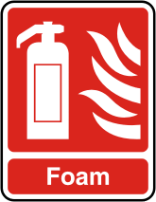 | 
Meaning: | Meaning:
 | 
Meaning: | Meaning:
 | 
Meaning: | Meaning:

It’s a risky business

Cut out the risk cards and prevention cards below. Decide which risk goes with each hazard and then decide how that hazard could have been prevented. Choose the correct prevention card and put it on the correct hazard.
You can use the separate or combined hazard sheets.

Risks cards – cut out and give one set per group (NB there are some repeats in each set). Get the groups to put their group name on each card, or use different coloured sets.
Someone tripping and falling
Someone tripping and falling
Someone slipping and falling
Someone getting cut and injured
Someone getting cut and injured
Someone getting a stomach upset
Someone damaging their back
Someone falling from a height
Someone getting poisoned

Prevention cards – cut out and give one set per group (NB there are some repeats in each set). Get the groups to put their group name on each card, or use different coloured sets.
Put tools away safely
Clear up spillages quickly
Lock away in a cabinet
Report it so it can be mended
Don’t try to lift it
Wash your hands carefully
Always do this job in pairs
Put a sign up to warn of accident risk
Use a wheelbarrow to carry it

Rake lying on the ground
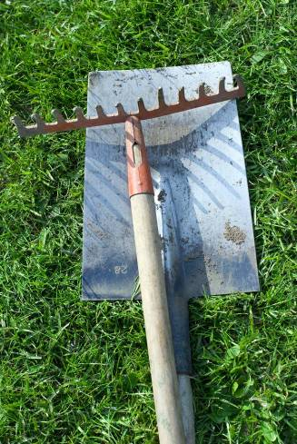

Broken window
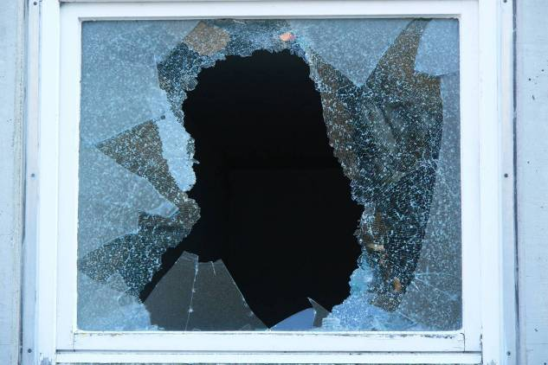

Heavy sack of animal feed
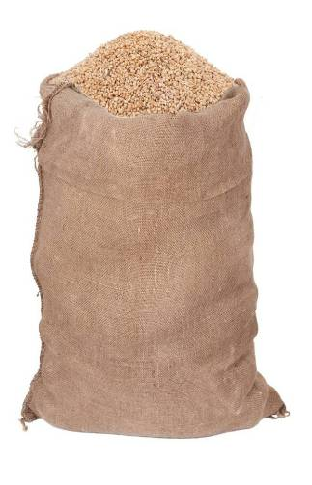

Ladder against a wall


Animal medicines


Spilt oil


Combined hazard sheet
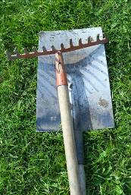 Rake lying on the ground
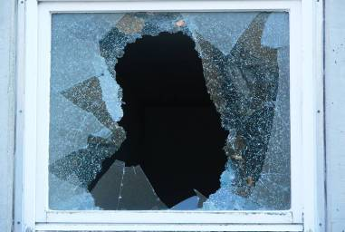 Broken window
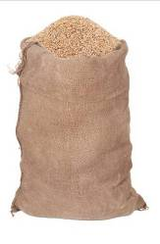 Heavy sack of animal feed

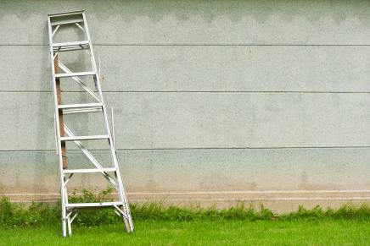 Ladder against a wall
 Animal medicines
 Spilt oil


Work &

Employment

What rights do you have at work?

Employment law can be confusing but you need to know what rights you have when you are at work. You need to use the information below to help you answer the questions.
National Minimum Wage
There are different levels of National Minimum Wage (NMW) depending on your age and whether you are an apprentice. The current rates (from 1 October 2011) are:
£6.08 - the main rate for workers aged 21 and over
£4.98 - the 18-20 rate
£3.68 - the 16-17 rate for workers above school leaving age but under 18
£2.60 - the apprentice rate, for apprentices under 19 or 19 or over and in the first year of their apprenticeship. If you are of compulsory school age you are not entitled to the NMW.

Working hours

You should not have to work more than an average of 48 hours in a working week unless you choose to. This includes any overtime. You can have a minimum of one day off per week. If you work for more than six hours a day you should have a rest break of at least 20 minutes.

Your employment contract

An employment contract is an agreement between you and your employer. If you have been employed for over one month, by law, you must be given a written statement of your terms and conditions. You should receive this within two months of starting work, even if you are going to work for them for less than two months.

Itemised pay slip

You should receive an individual written pay slip on or before the day you are paid. This must show your 'gross pay' (before tax) and your 'take home pay' (after tax and other deductions).

Health and safety

Your employer has a legal responsibility for your health and safety at work. Free of charge, you should receive:
- health and safety information
- training
- protective clothing.

Are these statements true or false?
National Minimum Wage
- If you are 19 you will earn a minimum of £4.98 an hour.
- If you are still at school you are not entitled to the minimum wage.
- The apprentice rate is the same as the minimum wage.
- If you are 25 you are entitled to earn a minimum of £6.08 an hour.

Working hours
- The average working week is 48 hours.
- If you work for 5 hours a day you are entitled to a rest break of 20 minutes.
- Overtime is optional.
- You are entitled to one day off each week.

Your employment contract
- Your employment contract is an agreement between you and your employer.
- The employment contract gives you information about your working terms and conditions.
- You must receive an employment contract within one month of starting a new position.
- You will not receive an employment contract if you only work with the company for 3 weeks.

Itemised pay slip
- The pay slip shows you what you have earned before deductions and what your take home pay is.
- You must get a copy of the pay slip before you receive your pay.

Health and safety
- Your employer can charge you for Health and Safety training.
- Your employer should provide protective clothing if you need it.

Complete the crossword about your rights in work.
 |  |  |  | 1
2 |  |  | 3
4 |  | 5
 |  |  |  |  |  | 6 |  | 7
 |  | 8

Across
3 Health and _ _ _ _ _ _
4 Stands for National Minimum Wage
8 The company or person you work for

Down
1 It shows what you earn
2 Terms and conditions
5 What you earn
6 Your total earnings with no deductions
7 What you get if you work for 6 hours

You’re hired

What do you need to do?
- For the first set of cards, work in pairs or small groups to decide whether they will help you to get a job, stop you from getting a job, or don’t matter.
Stick each card on the right poster
  - “You’re hired” for the cards that will help you get a job,
  - “You’re NOT hired” for the cards that will stop you getting a job, and
  - “It doesn’t matter” for those you don’t think matter in an interview.
    - In small groups, come up with at least 2 answers for each of the interview questions your tutor has given you.
    - In your groups, take it in turns to ask the interview questions and watch each other doing this. Use the Observation Sheet to note down your observations.

Task 1
Activity cards
You look smart | You have clean hands
You have clean clothes | You have dirty hands
You have dirty clothes | You use swear words
You have eye contact with the interviewer | You look at the floor
You smile | You tell a joke
Any long hair is tied back | You play with your hands or your hair or your watch
You talk clearly | You are late for the interview

The interviewer may ask you these questions.
Why are you interested in this job?
What skills do you have?
What did you enjoy doing at school or college?
What did you learn from your course?
What experience do you have of work?
A question you can’t answer
What kind of work do you enjoy doing?
Do you have any questions for us?
What do you enjoy doing in your spare time?
What is a situation where you have worked as part of a team?
How do you make sure you are on time for important things?
What is a situation where you have shown you can be trusted?

Observation sheet
Observer: _______________________________
Person answering the questions: ___________________________
Good eye contact with interviewer | Yes/No/Not sure
Answered the first question well | Yes/No/Not sure
Answered the second question well | Yes/No/Not sure
Spoke clearly | Yes/No/Not sure
Used suitable language | Yes/No/Not sure
Looked keen about the job | Yes/No/Not sure
Did anything distracting, for example: ____________________ | Yes/No/Not sure
Playing with hair/hands/watch | Yes/No/Not sure
Looked confident | Yes/No/Not sure

Observation sheet
Observer: _____________________________
Person answering the questions: _____________________________
Good eye contact with interviewer | Yes/No/Not sure
Answered the first question well | Yes/No/Not sure
Answered the second question well | Yes/No/Not sure
Spoke clearly | Yes/No/Not sure
Used suitable language | Yes/No/Not sure
Looked keen about the job | Yes/No/Not sure
Did anything distracting, for example: ____________________ | Yes/No/Not sure
Playing with hair/hands/watch | Yes/No/Not sure
Looked confident | Yes/No/Not sure

Getting there on time

Getting to a place on time is very important. Use the map and timetables to answer the questions.
For the first task, you will need to use the map and the two timetables.
Leisure Centre
Swift Street
Robin Road
Thrush Terrace
Duck Drive

Timetable 1
Duck Drive | 9.00 | 10.00 | Every hour until | 21.00
Thrush Terrace | 9.10 | 10.10 |  | 21.10
Leisure Centre | 9.20 | 10.20 |  | 21.20
Leisure Centre | 9.40 | 10.40 | Every hour until | 21.40
Thrush Terrace | 9.50 | 10.50 |  | 21.50
Duck Drive | 10.00 | 11.00 |  | 22.00

Timetable 2
Robin Road | 9.00 | 10.00 | Every hour until | 21.00
Swift Street | 9.10 | 10.10 |  | 21.10
Leisure Centre | 9.15 | 10.15 |  | 21.15
Leisure Centre | 9.25 | 10.25 | Every hour until | 21.25
Robin Road | 9.35 | 10.35 |  | 21.35
Swift Street | 9.45 | 10.45 |  | 21.45
Leisure Centre | 9.50 | 10.50 |  | 21.50

Use the information on the map and the timetables to complete the timetable below for the hours of 11am and 3pm. You will need to know what 3pm is on a 24-hour clock.
Timetable 1
Duck Drive | 9.00 | 10.00 | 11.00 | Every hour until |  |  | 15.00 | 21.00
Thrush Terrace | 9.10 | 10.10 |  |  |  |  |  | 21.10
Leisure Centre | 9.20 | 10.20 |  |  |  |  |  | 21.20
Leisure Centre | 9.40 | 10.40 |  | Every hour until |  |  |  | 21.40
Thrush Terrace | 9.50 | 10.50 |  |  |  |  |  | 21.50
Duck Drive | 10.00 | 11.00 |  |  |  |  |  | 22.00

Now answer the questions.
- When does the driver have their break and for how long?
- Can you go directly from Robin Hood Road to the Leisure Centre?
- What is the difference about the route between Timetable 1 and Timetable 2?
- When does the last bus leave the Leisure Centre?

For the next set of questions, you need to imagine that you live in Thrush Terrace.
- You live in Thrush Terrace and wish to go to an activity at the Leisure Centre starting at 11am. Which bus would be the best one to get?
- You are attending the swimming club that meets at 8pm. Which bus would you need to get? Remember to give yourself at least 10 minutes to change your clothes and get ready for the swimming club.
- The fitness centre has a spinning class that you want to attend. It starts at 7.30pm. Which bus will you need to get? Remember you will need 10 minutes to change.
For the next two questions, imagine that you live in Duck Drive.
- Which bus would you need to catch if you were going to a running club meeting starting at 10.am?
- Which bus would you get home if the running club lasts for an hour and you need 30 minutes to change and shower?
Timetable 2

Robin Road | 9.00 | 10.00 | Every hour until | 12.00 | 14.00 | 19.00 | 21.00
Swift Street | 9.10 | 10.10 |  |  |  |  | 21.10
Leisure Centre | 9.15 | 10.15 |  |  |  |  | 21.15
Leisure Centre | 9.25 | 10.25 | Every hour until |  |  |  | 21.25
Robin Road | 9.35 | 10.35 |  |  |  |  | 21.35
Swift Street | 9.45 | 10.45 |  |  |  |  | 21.45
Leisure Centre | 9.50 | 10.50 |  |  |  |  | 21.50
- What times are 14.00 hours and 19.00 hours in pm?
- How long does it take to get from Robin Road to Swift Street?
- How long does it take to travel from Swift Street to the Leisure Centre?
The Sports Centre has asked you to suggest the best times for activities to start. The classes run for 50 minutes and start every hour at the same time. For example, all the classes start at 10 minutes past the hour. Look at the timetables and give what you think would be the best time to start classes with a reason.
The Leisure Centre has a Hair and Beauty Salon. Some customers like to have their hair washed and blown dry before going home after their swim or time in the Fitness Club. The leisure activity finishes at 1pm. They need 20 minutes to shower and dress. The hair appointment takes 45 minutes.
- What time should they make an appointment with the Hair and Beauty Salon?
- Which is the first bus they will be able to get to go to Swift Street?
- Which is the first bus they will be able to get to go to Duck Drive?
- Which is the first bus they will be able to get to go to Robin Road?

Planning a trip

Your friends are going on a trip and they have asked you for advice. Your friends are travelling by plane from Stansted Airport on Tuesday afternoon, and want to know what time they should have the taxi arrive to take them to Tottenham Hale Station.
Here are the details that you will need.
 | Time
Home to station by taxi | 15 mins
Time needed at airport | 2 hours
Departure time of plane | 16.00

Your friends are going by train to Stansted airport and will go from Tottenham Hale Station.

London Liverpool St - Stansted Airport (via Tottenham Hale)
Monday to Friday | From | Until | Minutes past each hour
Departs Liverpool St | 03.40 04.10 04.40 05.10 | 22.55 23.25 | 10 - 25 - 40 - 55
Saturday | From | Until | Minutes past each hour
Departs Liverpool St | 04.10 04.40 05.10 | 22.55 23.25 | 10 - 25 - 40 - 55
Sunday | From | Until | Minutes past each hour
Departs Liverpool St | 04.10 04.40 05.10 05.40 06.10 | 22.55 23.25 | 10 - 25 - 40 - 55
Trains call at Tottenham Hale approximately 11 minutes after the timetabled departure from London Liverpool Street.
Average journey time on Stansted Express is 46 minutes so please allow yourself plenty of time for a relaxed journey and comfortable check-in.

Task 1
- Work out which train they should take.
- Work out when the taxi should meet them.
Task 2
Your friends have decided to take their car to the airport. The car trip should take about 1 hour.
You have carried out some research on the prices and transfer times and put them together in the table below.
 | Cost per day | Transfer time | Frequency of buses
Long stay | £10.85 | 8 – 10 minutes | Every 15 minutes
Mid stay | £11.85 | 5 – 6 minutes | Every 10 minutes
Short stay | £31.50 | 0 minutes
Valet parking | £39.75 | 0 minutes

You will need to answer your friend’s questions.
- Which is the cheapest option?
- How much will it cost for 6 days for each of the options?
- Which car park is closest to the airport?
- Where is the Valet parking?
Your friends have decided to use the long stay car park, when will they need to arrive?
If the return train fare to the airport is £27.30 and the taxi to the station costs £15.00, work out which is the best deal - taking the car or taking the train? Your friends are travelling alone.

Job Skills

The leisure industry is a ‘people industry’. This means you work with people. You will need to demonstrate a number of qualities and skills.
Find the personal qualities hidden below.
e | o | r | g | a | n | i | s | e | d | e | f | e | f | e
n | s | r | e | l | a | t | f | t | f | r | a | u | v | w
t | r | t | o | l | i | v | e | l | y | n | a | i | n | f
h | o | r | e | c | s | s | p | s | i | g | t | y | c | t
u | o | u | t | g | o | i | n | g | t | r | a | g | h | g
s | e | h | t | r | u | s | t | w | o | r | t | h | y | d
i | r | o | h | t | e | r | e | p | e | n | l | h | e | c
a | e | n | o | n | i | l | p | l | e | r | s | n | c | r
s | l | e | h | a | b | u | b | i | r | i | i | e | a | e
t | i | s | f | i | s | a | c | e | t | m | n | n | l | a
i | a | t | x | r | i | i | c | a | r | i | n | g | m | t
c | b | e | r | c | f | r | i | e | n | d | l | y | t | i
c | l | c | o | f | m | o | t | i | v | a | t | e | d | v
f | e | s | e | g | t | e | t | a | c | t | f | u | l | e
(Not all qualities are in the wordsearch above – 5 are missing!)
enthusiastic fun honest creative
trustworthy calm tactful friendly
supportive fair efficient flexible
determined lively sociable outgoing
confident caring reliable organised
motivated responsible optimistic considerate
Which 5 qualities are missing from the wordsearch?

For the job roles given below, choose the 5 most important qualities for each position. Some qualities will be suitable for more than one role.
Customer service | Sports coach | Front desk receptionist
Task 3
As well as qualities you will have a number of skills. Some of the most important skills are shown below.
Communication | Numeracy | Using IT
Caring for others | First aid | Selling
Working with others | Languages | Teamwork
Managing your time | Creativity | Taking responsibility
Decision making | Managing tasks | Problem solving
Which skills are needed for each job activity shown below? Some skills will be used in more than one job activity. Try to use all the skills.
Job activity | Skills needed
Working behind the counter in a café
Working in a sports centre giving out hired equipment
Working in a hairdresser, washing hair
Working the till in a supermarket

Task 4
You work in the café in the Sports Centre. A new café is opening in the nearby Leisure Centre. What skills and qualities are you going to need to show, if you want to keep your customers and your job!

Task 5
You work in Human Resources and you have a copy of one of the attendance records for an employee. You manager wants some information about the employee. Answer the following questions. All the information you need is on the attendance record on the next page.
- How many days holiday is this employee able to take?
- Have they taken all their holiday leave?
- How many days did they work in April?
- How many days did they work in September?
- How many days absence did they have over the year?
- Did they have any accidents at work?
- When did they start work with the company?
- Did they have an accident in October?
- Were they sick in January?
- Why might you be suspicious about the absence in January?
- When were they absent without giving reason?
- How many unexplained absences are there throughout the year?
- Why might you be suspicious about one of these unexplained absences?
- Were they at work on May 1st?
- How many days were they absent in the second half of the year?
- Were there any months when they worked every day?
- Name the months where they worked every day.
- Do you think this employee has a good working record?
- How long have they worked for the company?
- How many public holidays are there?
Employee Attendance Record for 2011
2011 | M | T | W | T | F | S | S | M | T | W | T | F | S | S | M | T | W | T | F | S | S | M | T | W | T | F | S | S | M | T | W | T | F | S | S | M | T
January |  |  |  |  |  | 1 | 2 | 3 | 4 | 5 | 6 | 7 | 8 | 9 | 10 | 11 | 12 | 13 | 14  S | 15 | 16 | 17  S | 18 | 19 | 20 | 21 | 22 | 23 | 24 | 25 | 26 | 27 | 28 | 29 | 30 | 31
February |  | 1 | 2 | 3 | 4  X | 5 | 6 | 7 | 8 | 9 | 10 | 11 | 12 | 13 | 14 | 15 | 16 | 17 | 18 | 19 | 20 | 21 | 22 | 23 | 24 | 25 | 26 | 27 | 28
March |  | 1 | 2 | 3 | 4 | 5 | 6 | 7  H | 8  H | 9  H | 10  H | 11  H | 12 | 13 | 14 | 15 | 16 | 17 | 18 | 19 | 20 | 21 | 22 | 23  X | 24 | 25 | 26 | 27 | 28 | 29 | 30 | 31
April |  |  |  |  | 1 | 2 | 3 | 4 | 5 | 6 | 7 | 8 | 9 | 10 | 11 | 12 | 13 | 14 | 15 | 16 | 17 | 18 | 19 | 20 | 21 | 22 | 23 | 24 | 25 | 26 | 27 | 28 | 29 | 30
May |  |  |  |  |  |  | 1 | 2 | 3 | 4 | 5 | 6 | 7 | 8 | 9 | 10 | 11  S | 12 | 13 | 14 | 15 | 16 | 17 | 18 | 19 | 20 | 21 | 22 | 23 | 24 | 25 | 26 | 27 | 28 | 29 | 30 | 31
June |  |  | 1 | 2 | 3 | 4 | 5 | 6 | 7 | 8 | 9 | 10 | 11 | 12 | 13  H | 14 | 15 | 16 | 17 | 18 | 19 | 20 | 21 | 22 | 23 | 24 | 25 | 26 | 27 | 28 | 29 | 30
July |  |  |  |  | 1 | 2 | 3 | 4 | 5 | 6 | 7 | 8  X | 9 | 10 | 11  H | 12  H | 13  H | 14  H | 15  H | 16 | 17 | 18 | 19 | 20 | 21 | 22 | 23 | 24 | 25 | 26 | 27 | 28 | 29 | 30 | 31
August | 1 | 2 | 3 | 4 | 5 | 6 | 7 | 8  A | 9  S | 10  S | 11 | 12 | 13 | 14 | 15 | 16 | 17 | 18 | 19 | 20 | 21 | 22 | 23 | 24 | 25 | 26  X | 27 | 28 | 29 | 30 | 31
September |  |  |  | 1 | 2 | 3 | 4 | 5 | 6 | 7 | 8 | 9 | 10 | 11 | 12  H | 13  H | 14  H | 15  H | 16  H | 17 | 18 | 19 | 20 | 21 | 22 | 23 | 24 | 25 | 26 | 27 | 28 | 29 | 30
October |  |  |  |  |  | 1 | 2 | 3  H | 4  H | 5  H | 6  H | 7  H | 8 | 9 | 10 | 11 | 12 | 13 | 14 | 15 | 16 | 17 | 18 | 19 | 20 | 21 | 22 | 23 | 24 | 25 | 26 | 27 | 28 | 29 | 30 | 31
November |  | 1 | 2 | 3 | 4 | 5 | 6 | 7 | 8 | 9 | 10 | 11 | 12 | 13 | 14 | 15  S | 16  S | 17  S | 18 | 19 | 20 | 21 | 22 | 23 | 24 | 25 | 26 | 27 | 28 | 29 | 30
December |  |  |  | 1 | 2 | 3 | 4 | 5 | 6 | 7 | 8 | 9 | 10 | 11 | 12 | 13 | 14 | 15 | 16 | 17 | 18 | 19 | 20 | 21 | 22  H | 23  H | 24 | 25 | 26 | 27 | 28 | 29 | 30 | 31
Started employment with company on 01.04.2009
Holiday days due - 25 days
Key
 | Weekend and Public Holidays | A | Accident at work | X | Absence with no reason given
S | Sickness | H | Holiday leave

Preparing for a job interview
- You are going for an interview next Tuesday morning for a job in a hotel restaurant.
Think for a few minutes about the following points:
  - You want to be well prepared for the questions they are going to ask.
  - Your friend had an interview for a job in the same hotel yesterday.
  - She was asked to tell the interviewer about her strengths and why they were well matched to the job.
  - How can you prepare to answer the same question, which is very likely to be asked of you?
- Look at the headings on Planning Sheet – question 2. Write a little more about each point saying how and why they are important.
- Now, talk to one other person in your group about your answers. Check their ideas and add to your own list.
- Think about the skills and abilities that you have that will be useful for working in a hotel restaurant. Look at the headings on Planning Sheet – question 4. Write something about yourself next to each point.
- Look at what you have written in the two sections – then - discuss with the same person you have already spoken, thinking about the question …‘How does what the hotel wants, and what you have got, fit together’?
- Now use Planning Sheet – question 6 to write some notes about how you will answer the question in the interview.

Planning Sheet – question 2
You’ve got a job interview next week – it’s time to prepare!
What will the people in charge of the hotel want me to be able to do well if I am working in their restaurant?
Skill or Ability: | Comment:  How and why are these skills and abilities important?
Talking to people
Being friendly and polite
Being careful when presenting or removing plates and dishes
Your personal appearance (being smart, looking clean and tidy)
Listening to customers
Paying attention to customer needs
Waiter/waitress skills
Listening to the person in charge and following instructions
Planning Sheet – question 4

What am I good at that will be useful in this job? Write comments next to the list below.
Skill or Ability: | Comment:  What can you say about yourself next to each of these skills or abilities?
Talking to people
Being friendly and polite
Being careful when presenting or removing plates and dishes
Your personal appearance (being smart, looking clean and tidy)
Listening to customers
Paying attention to customer needs
Waiter/waitress skills
Listening to the person in charge and following instructions

Planning Sheet – question 6
What am I going to say in the interview about my strengths and how they fit in with what they need?

Think about the skill or ability needed by the employer | What have you got that they want (your strengths)

Job hunting
You are coming to the end of your course and want to find a job that uses your skills. You decide to see what you can find out about job opportunities in your area by researching on the internet. You need to find websites that advertise jobs that might be of interest to you.
Once you have started to find information, use the boxes on the activity sheet to record what you have found. Remember to record the web address of the sites that have useful information, so that you can go back to them later.
Search ideas:
Try typing the ideas below into a search engine (e.g. Google)
- Jobs in the area you are interested in (add your local area to the search)
- Providers of the job you are interested in (then find their jobs or vacancies section)
- Local newspaper (then find jobs section)
- Suitable journals or magazines (then find appointments or jobs section)
- Family Information Service (add your local borough or county name - then find the jobs section)
- Jobcentre Plus (then search for a job in your area)

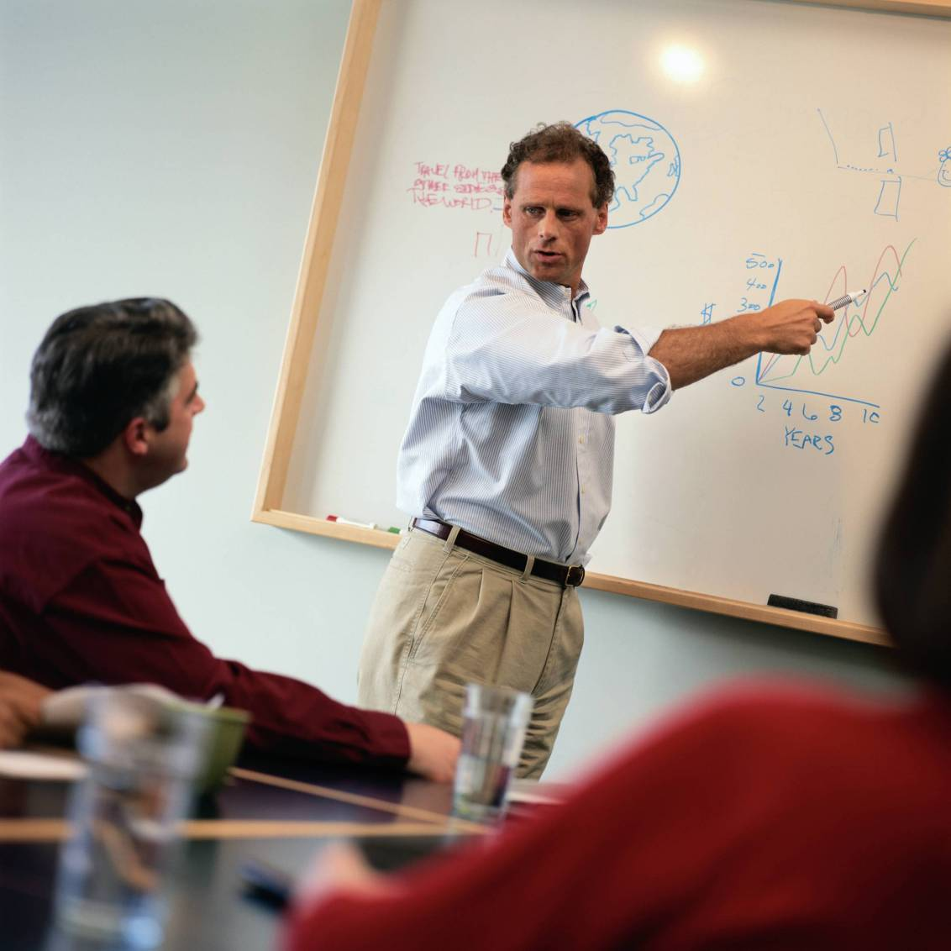

Product Design/Business

Department names

Every business, whether it is a Leisure Centre, Sports Centre, Hair and Beauty Salon or a supermarket has a number of different sections or departments. In larger companies these are often separate departments, but in a small company one person may be in charge of a number of sections.
Task 1: Find the department names. The words go straight across or down.
h | l | m | i | t | s | e | r | v | i | c | e | s | s | t
i | c | a | a | x | c | d | f | i | n | a | n | c | e | e
q | l | i | s | p | v | s | b | i | s | d | u | k | c | a
g | q | n | b | a | w | a | w | d | x | d | p | l | u | d
q | m | t | r | q | j | u | u | n | l | g | g | o | r | v
a | b | e | z | c | p | a | y | r | o | l | l | g | i | e
k | r | n | f | e | b | l | v | c | m | s | d | i | t | r
i | v | a | a | m | k | r | z | c | h | i | x | s | y | t
c | w | n | j | j | d | j | k | c | m | u | t | t | s | i
z | v | c | e | v | x | q | n | b | z | j | b | i | m | s
u | s | e | l | x | a | t | u | d | p | d | m | c | t | i
n | p | r | o | d | u | c | t | i | o | n | x | s | v | n
a | s | o | s | m | a | r | k | e | t | i | n | g | s | g
j | w | o | h | n | c | a | c | c | o | u | n | t | s | i
h | u | m | a | n | r | e | s | o | u | r | c | e | s | m

IT Services | Finance | Payroll | Production
Marketing | Accounts | Human Resources | Maintenance
Advertising | Logistics | Security

Task 2
Your next task is to match the department name with the definition explaining what the department does.
Match the department names with the correct definition.
Accounts and Finance | Human Resources
Payroll | Health and Safety
Marketing | Production
Logistics | IT Services
Maintenance | Customer Service
Advertising | Security

Definitions:
Paying the bills and sending out invoices
Letting people know what the company is offering
Dealing with enquiries and complaints
Making sure that the building is a safe place to work
Making sure there are enough staff with the needed skills
Keeping the computers working
Getting the goods delivered to the customer and receiving raw materials or stock
Repairs to production line and facilities
Finding out what the customer wants and needs
Paying the staff at the correct time
Making the goods to sell
Keeping the building safe

Getting the right brand

Are you creative?
Can you develop a new brand for a soft drink?
You need to work through a number of different tasks.
Working in a small group
- Think of a name for your company, and choose which jobs each person in the group is going to have.
- Brainstorm your ideas in order to start developing your soft drink brand.
- Brainstorm a number of possible brand names – then make a group decision as to which is best.
- Create two teams: a creative team and a business team.

The creative team will need to:
- think of at least 3 logo and slogan ideas for your soft drink
- design the packaging for your soft drink.

The business team will need to work out:
- the production costs for your product
- what it has cost you to make the product and how much money you may have lost.

Read the brief before you start to work on the tasks.

Your brief

Pro-Sport Ltd would like you to come up with a new soft drink brand that is inspired by a sporting event.
- Imagine that you will be selling the drink in the lead up to and during a sporting event
- You can either make a drink to refresh the fans or to keep the players/ athletes performing
- The drink must be original – with an original brand name, logo and slogan.
- It must be presented in a 500ml package
- You must work out and show what the cost is

Task 1
Forming your company
You are a creative company. You are about to develop a new soft drink brand to present to the board at Pro-Sport Ltd. Think of a name for your company.
Company name:

Now have a look at the job roles and decide as a team who is going to be responsible for what. Think about your skills, your areas of interest and strengths. Everyone will be involved in the task and everyone will have a chance to lead – so do not be too hung up on this.

Job Roles
You have 5 job roles to choose from. There is a business team and a creative team.
Head of New Product Development (Business) | Name:
- Responsible for overseeing the development of new products
- Need to have a clear vision of consumer trends. What tastes and types of drink sell well?
- A passion for healthy living may help
- A knowledge of dietary needs, food and cooking may be of benefit
Corporate Responsibility Manager (Business) | Name:
- Responsible for ‘responsible business practice’
- Need to minimise impact of business on environment and maximise positive contribution to community
- Requires a knowledge and/or passion for environmental and community issues
- Needs to work with Head of New Product Development to ensure the product is sustainable
Finance Director (Business) | Name:
- Responsible for finances
- Needs to liaise closely with creative team to make sure they do not get carried away!
- Needs to be good with figures and communicating them
- Needs to be good at meeting deadlines and working under pressure
Marketing Creative Director (Creative) | Name:
- Responsible for overseeing creative elements to marketing mix
- Need to liaise closely with the Strategic Director
- Need to be creative and possibly artistic
- Needs to be a good delegator
Marketing Strategic Director (Creative) | Name:
- Responsible for pulling marketing ideas together and ensuring marketing activity has a clear and logical objective
- Needs to liaise closely with the Creative Director
- Requires good organisation, reasoning and time management

Defining your Brand (business and creative teams)
Task 2
Ask yourselves the following questions to develop your soft drink brand.
What flavour is your drink?
What are the key ingredients?
Who is your target market?
Is it still or carbonated (fizzy)?
What are the benefits of your drink to the consumer?
Does it provide an energy boost?

Brand Name (business and creative teams)
Task 3
You should now know what your drink brand represents and what the actual drink tastes like. Decide on a number of possible brand names, by completing the brainstorming diagram below. Then, make a group decision on which name is best.

Possible brand names

This is the brand name we have chosen

Logo and Slogan (creative team)
Task 4
Now that you are clear about what your brand name is, the creative team should come up with at least three logo and slogan ideas for your soft drink. Sketch your ideas below.
You should get the whole team back together and make a final joint decision as to which logo and slogan is best.
Idea 1: | Idea 2:
Idea 3: | Idea 4:
Final joint decision – design idea:

Packaging (creative team)
Task 5
What sort of packaging are you going to use for your product? Look at the packaging type table with your business team to help you decide.
Perhaps you have an innovative design idea you would like to use. What labels and colour schemes are you are going to use?
Use the space below to sketch some ideas: (continue on blank paper if you need to)

Packaging Type Table (business and creative teams)
Use the decision matrix below to help you decide on your type of packaging.
This table will be important when you come to decide how much to charge for your drink.
Type of package | Environment | Location | Saleability | Unit cost
Recycled plastic 50% | 5 | GB | 2 | 25p
Recycled plastic 35% | 3 | GB | 4 | 15p
Recycled plastic 25% | 2 | Far East | 5 | 10p
Recycled aluminium 50% | 5 | GB | 2 | 15p
Recycled aluminium 25% | 3 | GB | 4 | 0.5p
Recycled glass 50% | 4 | GB | 3 | 20p
Recycled glass 25% | 3 | Far East | 4 | 10p
Recycled card 50% | 4 | GB | 3 | 10p

Scale: 1 = POOR 5 = EXCELLENT
(All based on 500ml packaging)

Production Costs (business team)
Task 6
Work out the production costs for your product.
The table below shows the quantities needed to make 20,000 litres:
Syrup/Fruit Concentrate | Sweetener | Water | TOTAL
4,000 litres | 2,000 litres | 14,000 litres | 20,000 litres
Complete the table below putting the quantities of each raw material you need to make 900,000 litres of your product.
Raw Material | Quantity
Syrup/Fruit Concentrate
Sweetener
Water
500ml packaging
Here is some more information that will help you complete the table below:
- Your production line will make 500 products per minute
- You need 10 operators who work at £12 per hour
Description | Cost | Quantity | Total cost
500ml packaging | See packaging type table
Water (purified) | £150 per 5000 litres
Syrup/fruit concentrate | £200 per 1000 litres
Sweetener | £150 per 1000 litres
Labour | Work out production time first, then £12 per hour x team of 10
TOTAL PRODUCTION COSTS:

Profit and Loss Account (business team)
Task 7
Complete the following profit and loss account to work out your final profit.
Expenditure (the things you had to pay for) | Costs
Production costs (from activity 6) | £
Distribution costs | £1,671
Marketing costs | £350,000
Total expenditure: | £

Profit and Loss Statement (this is how you work out your final profit) | Costs
Suggested selling price per 500ml (x quantity) | £ x
TOTAL sales (if all of your products are sold): | £
MINUS total expenditure (above) | -£
TOTAL profit: | £

What would your total profits be if you did not sell all your products?
TOTAL profit if you sold 80% of your products | £
TOTAL profit if you sold 60% of your products | £

Corporate identity
What is corporate identity?
Corporate identity is a marketing term for the ‘image’ of a company which is designed to make its ‘brand’ instantly recognisable to customers. It includes a company name, logo, colour schemes and other things such as mascots that can be used on a wide range of products to advertise the company.
Task 1
From memory, complete the table by sketching the correct logo for each company.
Company name | Logo | Company name | Logo
Apple |  | McDonalds
Nike |  | Chanel
Mercedes-Benz |  | Adidas

Task 2
Design two different design ideas for a new company of your choice. Think about your target market group – the people who will buy your products. What would they like to see? Tip: The most effective logos are simple and use only a few colours so don’t overcomplicate yours.
Design idea 1
Design idea 2
Corporate identity
Task 3
Apply your favourite logo to the side, front and rear views of your delivery van. Think of an appropriate colour scheme and other graphics that would appeal to your target market group.
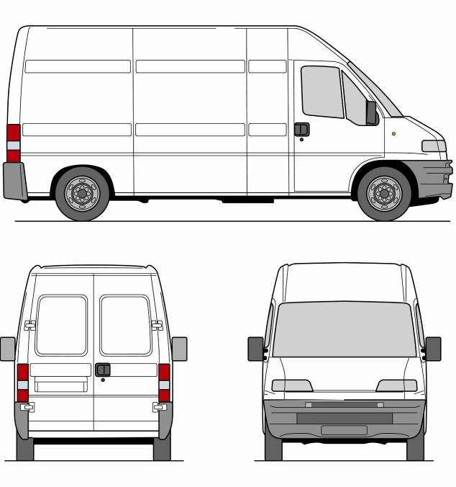

Product analysis

Product Analysis: ACCESS FM
Product analysis is about studying how well a product does its job, by looking closely at different features. It is useful as it can help you understand how and why design decisions have been made.
ACCESS FM is a simple way to analyse any product.
A is for Aesthetics | What does the product look like? (style, shape, colour, texture)
C is for Cost | How much does the product cost to buy? Is it value for money?
C is for Customer | Who would buy the product? What do they like? What are their needs and what do they want?
E is for Environment | Is it environmentally friendly? Can it be recycled or reused?
S is for Size | What is the size of the product? Are there other important measurements that influence the design?
S is for Safety | How safe is the product during normal use? What could cause harm?
F is for Function | What is the product designed to do? How does the product work?
M is for Materials | What materials have been used to make the product? Why were these materials used instead of others?

You can also score products like this to get a quick reaction. | 0 | No, I don’t think the product does this very well.
 | ½ | Okay, the product does it quite well.
 | 1 | Yes, the product does this very well indeed.

Task 1
As a whole group, discuss the following questions:
- What is the difference between a NEED and a WANT? Give some examples of what you need and what you want.
- Do we NEED everything that we WANT? Give some examples.
- Is it important to design for people’s WANTS?
Task 2
In pairs, each of you choose a similar product (i.e. two different mobile phones) and analyse them using ACCESS FM.
Product:

 | Comments | Score
A
C
C
E
S
S
F
M
 | TOTAL SCORE:

Discuss your findings with your partner to see which product is the best.

Design specifications

What is a Specification?
A specification is a checklist of criteria that your designs must address. In other words, what must your design ‘specifically’ do?
It is a really important list because you have to keep it in mind when designing and then use it to evaluate your final design.
Task 1
What would the designer of a new pair of trainers have to consider before they started designing? Brainstorm a few key terms below – some have been started for you.
Comfort
New trainers
Which sport?
Materials

Now write five appropriate specification points for a new pair of trainers.
The new trainers must:
- ______________________________________________________________
- ______________________________________________________________
- ______________________________________________________________
- ______________________________________________________________
- ______________________________________________________________

Designing to a Specification
Task 2
A toy company requires two cartoon action figures to be packaged for sale. The pictures below show the two cartoon action figures called POCO and LOCO.


POCO LOCO
The specification for the packaging is that it must:
- contain two cartoon action figures
- hold both figures securely whilst in transit
- allow both figures to be clearly visible within the package
- display the names of the two cartoon figures
- allow the package to either hang on racks or stack on shelves for display
- allow customers to easily remove the figures from the package
- be manufactured using appropriate materials
- be manufactured using processes suitable for mass production.
On a separate piece of paper, use sketches and, where appropriate, brief notes to show two different design ideas for the packaging that meet the specification points above.

Batch production
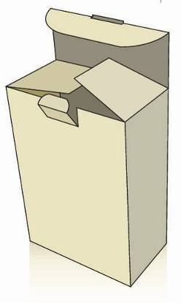
Batch Production
Batch production is the manufacture of hundreds or thousands of identical products of the same high quality.
You are going to work as part of a team of FOUR to simulate the batch production of a carton:
- You have just 30 minutes to make as many cartons as you can.
- Each carton needs to be inspected for quality. If accepted, it is ready to be sold. However, if it is rejected, it will be scrapped as it is not of a good enough quality.
- Your team will have to pay for the raw materials, equipment, overheads and wages in order to make your cartons.
- At the end, your whole team will complete a profit and loss account to see if you have made a profit.

Task 1
The first thing you need to do is to decide who is going to do the following jobs:
Job Role | Job Description | Who got the job?
Cutter | You have to carefully but accurately cut out all of the nets for your cartons.
Assembler | You need to accurately score, fold and glue each net.
Decorator | You need to design a logo and decorate each net.
Team leader/ inspector | You have one of the toughest jobs. You must make sure that your team has everything in order for them to start working and to supervise the smooth running of the production process. Finally, you have the task of accepting or rejecting the quality of work produced at each stage of production.
Accountants | You will all help complete the final profit and loss account for your team. | Whole team

Now you need to make a quick plan of how you are going to make your cartons.
For example, can each net be decorated before it is assembled? Do two team members have to start cutting out nets in the first place, in order to speed up the process?

Carton Template (net)
Task 2
Your team has just 30 minutes to produce as many identical cartons as possible.
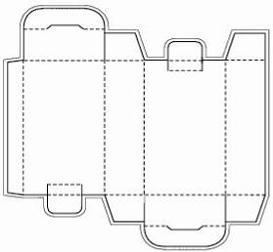

REMEMBER: Your decorator must design a team logo and apply it identically to each carton made
.

Inspection Record
Task 3
Your team leader/inspector must examine each carton and decide whether it is of a good enough quality to be sold. They could stop production of a carton at any stage of production, for example, if the cutting out was inaccurate.
Team name:

Carton Number | Pass | Fail | Reason for failure
1
2
3
4
5
6
7
8
9
10
11
12
Profit and Loss Account
Task 4
As a whole team, complete the following profit and loss account to work out your final profit.
Team name:

Expenditure (the things you had to pay for, including all scrap materials)
Raw materials and equipment costs: | Quantity: | Total Cost:
A4 card: 20p per sheet |  | £
Glue sticks: £1.00 per stick |  | £
Scissors: £3.00 per pair |  | £
Colouring pens/pencils: £2.00 per colour |  | £
Overheads (inc heating and lighting) | 1 session | £5.00
Wages: £5.00 per hour per person |  | £
Total expenditure: |  | £

Profit and Loss Statement (this is how you work out your final profit)
TOTAL sales (imagine you sold every carton you made at £2.00 each) | £
MINUS total expenditure (above) | -£
TOTAL profit: | £

If you failed to make a profit, how many cartons would you have to sell in order to break even?

Industry sectors
There are three main industry sectors. They form a chain of production which provides customers with finished products or services.
Task 1
Complete the table by giving examples of specific companies or organisations that are part of each industry sector.
Industry Sector | What it does | Examples | Company/  organisation
Primary | The primary sector is the first stage where the extraction of raw materials takes place. | Mining, oil drilling farming, fishing
Secondary | The secondary sector is where the products are made. It involves converting raw materials into components and assembling them into finished products. | Manufacturing industries, construction industries, food processing
Tertiary | The tertiary sector consists of the commercial services that support the production and distribution of products. | Insurance, transport, advertising, warehousing, public services (education, healthcare etc)

Task 2
Fast food restaurants need a wide range of raw materials from the primary sector. Can you name five of them?
- ……………………………………………………………………………………………………………………………….
- ……………………………………………………………………………………………………………………………...
- ……………………………………………………………………………………………………………………………...
- ……………………………………………………………………………………………………………………………….
- ……………………………………………………………………………………………………………………….………
Clue: think about the types of food they sell and the types of packaging they need.

Industry Sectors
Industry sectors are interdependent. This means that companies rely on other businesses in different sectors for raw materials, components or distribution.
Task 3
Write down a product, service or industry that fits into each of the dotted circles on the diagram below.
A
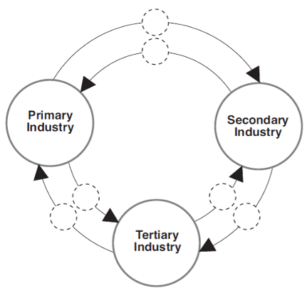
B
C
D
E
F
Production phase |  | Example of product, service or industry
A | Primary to Secondary
B | Secondary to Tertiary
C | Tertiary to Primary
D | Primary to Tertiary
E | Tertiary to Secondary
F | Secondary to Primary

Industry Sectors
Look at the employment figures of people working in industry sectors in the UK.
Year/Sector | Primary | Secondary | Tertiary
1985 | 4.5 % | 32.5 % | 63 %
2005 | 1.8 % | 19.9 % | 78.3 %
Table 1: Employment in the UK economy 1985 – 2005 (% employment levels)
Task 4
- Draw a bar chart that compares the employment figures for different industry sectors in the UK between 1985 and 2005.
- Describe what has happened in the UK between 1985 and 2005.

Advertising your products

Any business needs advertising to let people know what is on offer.
Listed below are a number of ways that companies use to advertise. The letters are muddled, so you will need to sort them out. Then write a definition for each.
Ways to advertise | What is the right answer | What does it mean?
anslog
stoper
divoe
refly
nabner
teafell
rickest
boardbill

In the word search below are hidden 20 of the most common TV advertisers. How many can you find?
e | c | d | p | c | w | o | r | l | d | p | e | o | k | i | t
c | x | h | b | f | t | e | m | o | c | s | s | h | w | e | g
l | i | b | a | n | d | q | p | a | h | f | c | d | k | r | i
i | e | s | o | r | t | i | a | w | d | n | e | r | i | a | y
a | w | l | b | q | o | n | s | f | i | x | a | m | n | p | l
m | j | s | y | r | r | u | c | a | r | m | s | c | o | m | l
y | t | h | e | s | u | n | r | f | e | v | a | d | q | o | e
l | c | b | m | z | g | q | e | h | c | f | d | o | m | c | s
i | d | r | e | a | m | s | t | f | t | n | s | n | l | o | a
a | k | n | o | i | a | e | r | i | l | a | a | a | f | g | b
d | s | b | h | l | r | l | h | o | i | r | l | l | s | a | e
o | v | j | g | a | t | z | c | v | n | g | t | d | j | l | m
i | a | v | p | k | l | s | d | p | e | o | a | s | g | u | o
k | p | m | c | l | e | o | q | s | y | s | u | g | v | d | h
f | o | a | u | t | z | c | h | u | r | c | h | i | l | l | d
c | b | a | f | s | r | e | v | a | s | c | e | p | s | e | k

Waitrose | Dreams | Go Compare | PC World
DFS | KFC | Compare the Market | Argos
McDonalds | Tesco | The Sun | Currys
Specsavers | Comet | ASDA | Churchill
Homebase | Daily Mail | Direct Line | BandQ

Here are the top twenty advertisers on TV. By top twenty, we mean the companies that spend the most money on advertising on TV. Who do you think spends the most? Cut out the cards and put them into what you think is the correct order.
DFS | Compare the Market
Tesco | KFC
PC World/Currys | Homebase
McDonalds | Direct Line – Motor Insurance
Daily Mail | Waitrose
Specsavers | Churchill
Dreams | Go Compare
B&Q | Direct Line – Home Insurance
ASDA | The Sun
Argos | Comet

Why do companies advertise on TV? Below are 10 reasons. Can you put them into the correct order? The most important should go first.
We fall in love with the brand
Everyone discusses adverts on TV
Companies use a variety of advertising campaigns but the TV is at the centre of them all
Everyone gets to know the name. Advertising often means that people remember the name
They are the best way to advertise to young people
It gives the best return for the money spent
You can reach 70% of people in one day on commercial TV!
We are watching more TV than before
People see the advert and then go online to buy
TV makes people do things, e.g. voting or going online

Designing a supermarket
Use the cards to design your own mini supermarket. You will need to think about the best place to put the various aisles. The blanks are for your own ideas of goods for sale in your supermarket. You will need to consider where to place the products to make as much profit as possible.
Bread and cakes |  | Paper products |  | Baking supplies
Convenience foods and ready-made meals |  | Milk and dairy products |  | Cleaning materials
Canned goods |  | Sweets |  | Snacks and cereals
Fresh fruit and vegetables |  | Cash tills |  | Meat
Drinks

Now that you have designed your supermarket, read the following page. Do you agree with it? Did your supermarket plan match the information given?

How to design a supermarket

Near the door

There are beautiful colours that are hard to ignore, even if you walk on by. This is usually fruit and vegetables and flowers

The Deli and Bakery

Baked goods and rotisserie chicken are important as there's nothing like the smell of fresh bread to make you feel hungry. Many stores will have produce, floral and bakery/deli/coffee all in the same section, leading you deep into their territory.

Store perimeter - the parts around the outside of the supermarket

The perimeter also holds conveniences such as a cafe, the pharmacy and ATM machines. The ends of each aisle are important. Your eye notices the bargains that they sign here.

Back of the store

This is always for meats and dairy products. This is to lead you through the aisles even if you are only there for a pint of milk.

Frozen food aisles

Hundreds of items line these aisles and represent the store's highest profit margin. It is not surprising that they are usually located right in the middle of the store for easy access no matter which entrance a shopper comes in through.
Task 2
Which area would you place the following products in?
yoghurt | salami | paper hankies | detergent
batteries | cheese | frozen chips | chocolate
fish | bottled water | flour | bread
hamburgers | crisps | rolls | cereals
biscuits | apples | peanuts | toothpaste
shampoo | newspapers | pizza | sandwiches

Quality

What is quality? We can all name a product that we consider to be of a high quality, but what qualities does it actually have?
Task 1
Give one example of a high-quality product and a poor-quality product and explain why you think it is of that quality.
Discuss your examples with the rest of your group. Do they agree with you?
An example of a high-quality product is: | An example of a poor-quality product is:
It’s high-quality because: | It’s poor-quality because:

Why do high-quality products often cost more? It’s not just the logo – it includes the quality of the design, the materials used and their manufacture.
Task 2
List five features that you think are important for a high-quality pair of trainers.
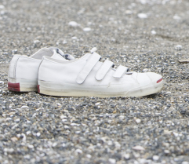

Quality Control
Manufacturers use quality control to make sure that every product they produce is of the highest possible standard.
Task 3
In small groups, cut out and assemble SEVEN identical cubes to form the word QUALITY. Remember to cut out and assemble cubes using both cube nets provided to make sure that you have all the letters required!
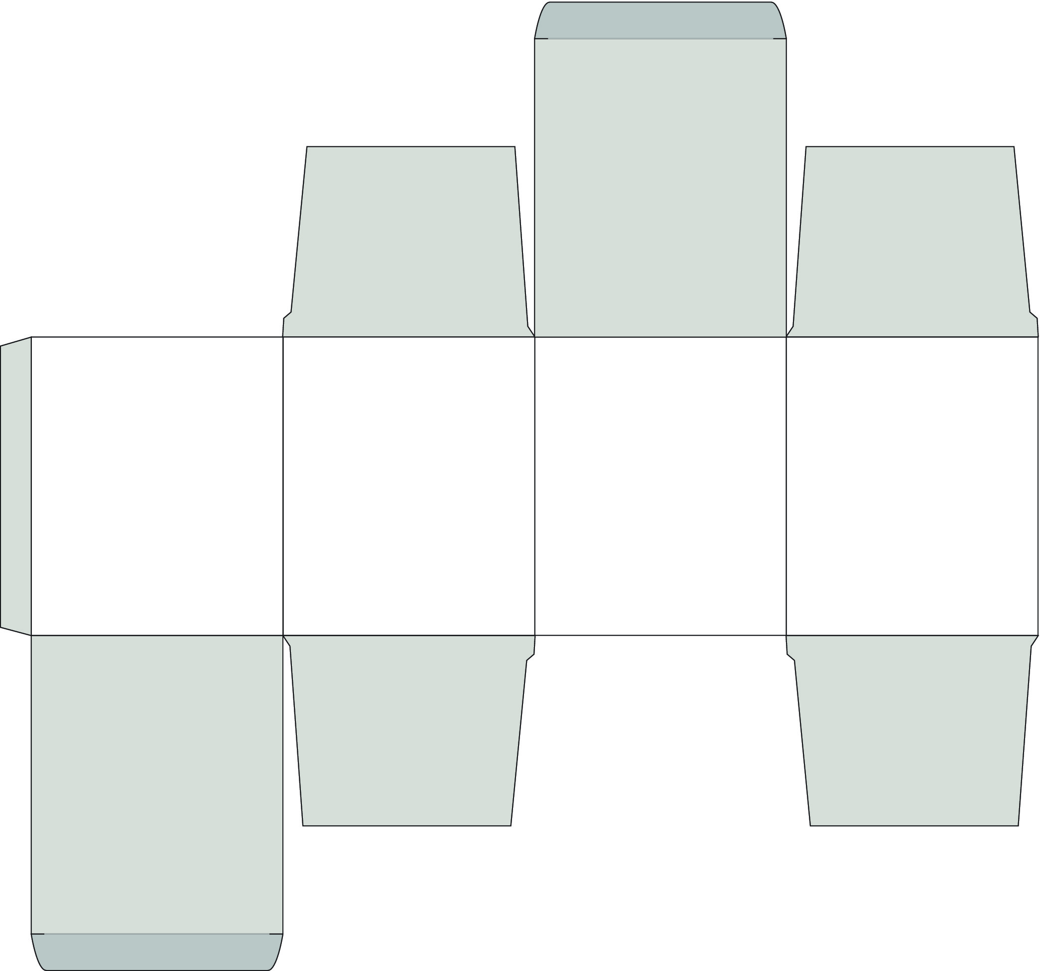



Instructions:
It is easier if the cube nets are photocopied onto card that is stronger. Paper may be too thin and could be easily squashed.
- Cut out your cube nets carefully, using scissors.
- Score the fold lines using the blunt part of the scissors or a ball point pen. This will make it easier to fold. Be careful not to cut the fold lines.
- Fold the paper to make right angles, and you will see the cube start to appear.
- Glue the cube together, using small dabs of glue on the glue tabs to stick it together.
- Put your seven cubes into a line to form the word QUALITY.
Quality Control Activity – cube nets

Task 4
Complete the following table to test and evaluate your final set of assembled cubes.
How many cubes did your team make? |  |  | How many cubes were scrapped?
How many of your team’s final cubes are of an identical quality? | 1 | 2 | 3 | 4 | 5 | 6 | 7
What could you have done to make your team’s cubes better?

Picture Credits
The publisher would like to thank the following for their kind permission to reproduce their photographs:
(Key: b-bottom; c-centre; l-left; r-right; t-top)
Alamy Images: blickwinkel / Koenig 142/1, David J Green 64-3/3, 65br, 274/5, 275/3, Plantography 142/2; Datacraft Co Ltd: 244; Imagemore Co., Ltd: 94t/1, Imagemore 61b; Imagestate Media: John Foxx Collection 109t/1, 111c/2; John Foxx Images: 86, 125, Imagestate 125b; Jon Attwood 68 KPT Power Photos: 142/5; Pearson Education Ltd: Studio 8 47, Gareth Boden 41c/2, 42, 42/3, 42/4, 42t/1, 42tl/2, 43/2, 43/3, 43/4, 43/5, 43t/1, 44/4, 44tl/2, 44l/4, 44c/3, 44b/5, 60/2, 61/6, 61tl/2, 62l/2, 63l/3, 63l/4, Malcolm Harris 144r, Naki Photography 40, Jules Selmes 11, 63l/5, Richard Smith 5, Sozaijiten 18, 144, 171, Trevor Clifford 41t/1, 44t/1, 61t/1, 61l/3, 62l/4, 63t/1, 63l/2; PhotoDisc: 109b/3, 111t/1, Keith Brofsky 205, Photolink. F. Schussler 62c/3; Photolibrary.com: Fancy 151; Richard Duszczak, Cartoon Motivators 153 Shutterstock.com: a_v_d 64t/1, Antonio S. 167, 170/2, Arcady 155/3, 156/8, argonaut 143/1, artcasta 95b, chantal de bruijne 62t/1, Cio 143/3, Colour 64/4, Danilo Sanino 225/1, 225/2, danymages 163, 169/1, DCP 49, Diana Taliun 141c, Dragana Gerasimoski 45b, Eric Isselée 113t/1, 117/1, 117c/2, 117b, 119t/1, 119c/2, 119b/3, faberfoto 220, fdimeo 113b/3, Fejas 156/5, Fortish 94/3, Hellen Sergeyeva 65bl/1, Julia Ivantsova 41b/3, Kaspri 156/7, Kesu 113/2, labrador33 98, Lusoimages 95l/3, maminez 94/4, Menna 164/1, 169/2, Mino Surkala 167/1, 170/3, Nescereckis 95/2, oksix 94/2, olegbush 60/7, Ontario Ltd. 94/5, Paul Palladin 62/5, Pavel Kirichenko 64l/2, Sarawut 142/4, SeDmi 165, 169/3, Sergey Karpov 88, Skalapendra 67, Soundsnaps 141, Susie Prentice 142/3, Taurus 60/4, Tompet 142/6, tratong 166, 170/1, Trent Townsend 141r, Tsekhmister 115t/1, 115c/2, 115b/3, Tsekhmister 115t/1, 115c/2, 115b/3, v1adut 226, v1adut 226, Valenta 109c/2, Vasyl Helevachuk 110/1, Wilee Cole 24, Yalayama 95t, Yobidaba 152/6; www.imagesource.com: 74, 224
All other images © Pearson Education
Every effort has been made to trace the copyright holders and we apologise in advance for any unintentional omissions. We would be happy to insert the appropriate acknowledgement in any subsequent edition of this publication.
Publication code: FL031272

